

**Library Management System**

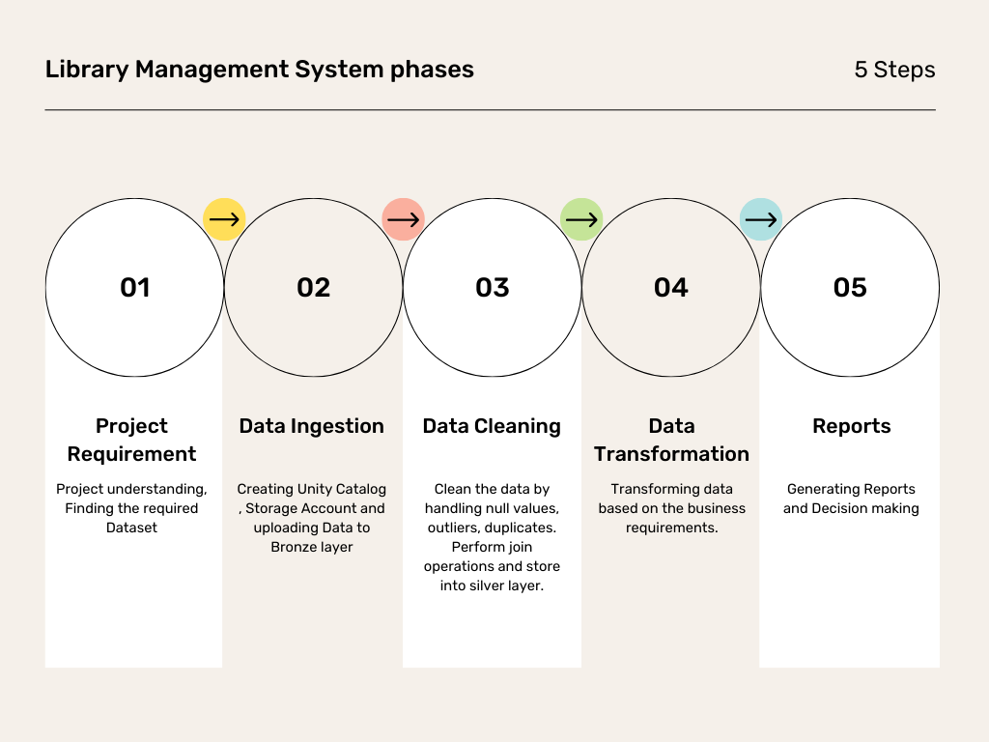

**Library Utilization Metrics 📊**

* 📈 Total Number of Transactions → Metric Card *(Count of transaction_id)*
* 📊 Monthly/Yearly Transaction Trends → Bar Chart/Line Chart *(issue_date, Count of transaction_id grouped by month/year)*

**Book Insights 📚**

* 📖 Most Borrowed Books → Bar Chart *(Top book_id by count of transaction_id from transaction_table)*
* 🏷 Books by Department → Pie Chart/Bar Chart *(department from books_table, Count of book_id borrowed)*
* 🔁 Average Borrowing Duration → Box Plot/Bar Chart *(return_date - issue_date for transaction_id)*

**Student Engagement & Fines 🎓**

* 🎓 Top Borrowing Students → Bar Chart *(Top student_id by count of transaction_id from transaction_table)*
* 💰 Total Fine Collected → Metric Card *(Sum of fine_amount from transaction_table)*
* ⏳ Late Return Rate (%) → Pie Chart *(On-time vs Late returns → return_date > due_date from transaction_table)*
* 📌 Most Fined Students → Bar Chart *(Top student_id by total fine_amount from transaction_table)*

**Book Condition & Maintenance 🔄**

* 📦 Books Returned as Damaged (%) → Pie Chart *(final_status = damaged vs final_status = good from transaction_table)*
* 📕 Copies Needing Replacement → Bar Chart *(Books with the highest number of damaged status from transaction_table)*