CityScope
Real Estate & Community Data Explorer
4495_071
Sahan Pattinikuttige Nonis - 300389470
2025 - 10 - 24

Table of Contents
1 Introduction 2
2 Proposed Research Project 2
Technology Stack 3
3 Project Planning and Timeline 4
Assumptions Made 5
4 Implemented Features 5
4.1 Implemented Feature A: Interactive Geospatial Scoring Map (OSM + CMHC Rents + Population Scaling) 5
4.1.1 Introduction/Overview 5
4.1.2 Core Implementation Details 6
4.1.3 Outputs / MVP Evidence 6
4.2 Implemented Feature B: Neighbourhood Comparison Engine 6
Key Analytics Captured 6
4.3 Implemented Feature C: AI Assistant Natural-Language Neighbourhood Suggestion System 7
Approach Used 7
Key Result Behavior 7
4.4 Implemented Feature D: Neighbourhood Scoring System 8
4.4.1 Introduction/Overview 8
4.4.2 Details of Implementation 8
5 Change of Direction and Lessons Learned 9
Lessons Learned: Core Insights from the Pivot 9
Future Career Alignment and Strategic Impact 9
6 Concluding Remarks 10
7 References 10
8 Appendix A — Installation Guide 10
9 Appendix B — User Guide 11
10 Appendix C — Dataset and APIs Used 11
11 Appendix D — System Architecture Used 11
12 Appendix E — Code Explanation Summary 12
13 Appendix F — Screenshots 12

Introduction
A place to live is more than a property listing: it is context, lifestyle fit, accessibility, and long-term sustainability. In British Columbia, rental platforms excel at showing housing inventory, but none provide neighbourhood-level intelligence combined with open geographic analytics and personalized suggestions. This creates a decision gap for students and newcomers who most urgently need clarity with minimal trial-and-error cost.
CityScope addresses this challenge by offering an integrated interactive geospatial analytics platform that scores, compares, filters, and ultimately recommends neighbourhoods using real data—not synthetic or random scoring. The app uses OpenStreetMap (OSM) for amenities, CMHC-style rent averages for BC, census-like neighbourhood sizes (population), and transit density for composite scoring.
This final report documents the complete MVP build, workflow, assumptions, technical implementation, analytics design, and reflections, aligning directly with the research proposal goals approved earlier in the term.

Proposed Research Project
CityScope will be developed using a monorepo structure with NestJS as the backend framework and Next.js for the frontend interface. Housing, school, and transit datasets will be sourced from open data repositories such as municipal databases and Kaggle. The backend will preprocess these datasets to calculate key metrics, including average rent per neighborhood, historical price trends, and transit accessibility scores. A composite “neighborhood score” will be generated using a weighted formula that combines affordability, education, and transportation. The frontend will present this information through interactive dashboards and charts, enabling users to filter results and compare neighborhoods.
The research design for CityScope follows an applied, data-driven development approach, integrating urban datasets into a functional decision-support platform. The methodology is structured in four phases:

1. Data Acquisition
● Identify and collect relevant open datasets (e.g., housing prices, rental listings, school ratings, public transit routes, and crime statistics).
● Ensure datasets are reliable, updated, and accessible via open APIs or government portals.
● Apply data cleaning techniques to handle missing values, inconsistencies, and formatting issues.
2. Data Integration and Processing
● Normalize heterogeneous datasets into a unified schema.
● Use preprocessing methods (e.g., scaling, encoding categorical data) to prepare data for visualization and analytics.
● Store data in a lightweight relational database (e.g., SQLite or PostgreSQL) for structured querying.
3. Data Analytics and Visualization
● Apply descriptive analytics to calculate key metrics such as average housing cost, school performance index, and commute accessibility.
● Design comparative metrics that allow neighborhoods to be ranked or filtered according to user-selected criteria.
● Develop visualization modules (heatmaps, charts, and comparative dashboards) to present results clearly.
4. Platform Development
● Build a web-based application using a modern stack (React/Next.js for frontend, Node.js/Express for backend).
● Implement interactive features that let users filter neighborhoods based on preferences (budget, school quality, commute).
● Ensure responsiveness and usability across devices through iterative user interface testing.
Validation Strategy
● Conduct case studies on selected neighborhoods to test the accuracy of integrated analytics.
● Perform small-scale user testing to gather feedback on usability and decision-making support.

Technology Stack
● Platform: Docker
● Frontend: Next.js (React) with Chart.js/Recharts for visualizations
● Backend: NestJS (Node.js) with REST APIs
● Database: PostgreSQL (via Prisma ORM).
● Deployment: Vercel (frontend) + Railway/Render/Fly.io (API & Postgres)

Project Planning and Timeline

Week | Milestone | Deliverables
1 | Project Setup & Requirements | Project repo initialized, finalized requirements document
2 | UI/UX Design | Wireframes, mockups of main pages (search, results, dashboard)
3–4 | Backend Development | NestJS APIs for housing data ingestion, processing, and scoring
5 | Frontend Development | Next.js components for search, filters, and basic charts
6 | Database Integration | PostgreSQL schema set up, connected via Prisma ORM
7 | Data Analytics Layer | Neighborhood scoring, trend analysis, initial visualization logic
8 | Visualization Features | Charts, maps, and interactive comparisons implemented
9 | Testing & Debugging | Unit tests, integration tests, bug fixes
10 | Deployment Setup | Deployment to Vercel + Railway/Render with live demo
11 | User Feedback & Refinement | Peer/instructor feedback, improvements to UI and analytics
12 | Finalization & Report | Complete working system, final report, and presentation slides

The earlier plan focused on a data pipeline and analytics engine first, then UI. During this period, it became evident that a UI-first geospatial experience would enable faster iteration and clearer demonstration of analytical value. The plan was revised, and the project was fully rebuilt in Streamlit without loss of proposal alignment.
The project confirms the proposal hypothesis: location decisions become clearer when data is integrated, normalized, filterable, and visualized interactively.

Assumptions Made
- Rent data in BC is averaged by bed_type and year as provided in CMHC-style dataset when missing POI connectivity is enabled or manually imported.
- POI data missing names are sanitized to avoid blank tooltips.
- Scoring normalization avoids division by zero using small epsilon 1e-9.
- Tooltips are shared across layers with POI scores excluded from neighbourhood scoring display to avoid inherited tooltip confusion (limitation of PyDeck tooltip layering).
These assumptions were validated during implementation and testing.

Implemented Features

Implemented Feature A: Interactive Geospatial Scoring Map (OSM + CMHC Rents + Population Scaling)
CityScope was fully reimplemented using Streamlit with PyDeck and Pandas as the mapping and analytics backbone.

4.1.1 Introduction/Overview
The main feature is a professional interactive map where layers are controlled through a left sidebar and scoring is visualized using circles that scale based on neighbourhood size while color-coding suitability from red-to-green gradients. The map prioritizes user experience: users explore first, then interpret results.

4.1.2 Core Implementation Details
- Data Ingestion: Combined neighbourhoods CSV, rent CSV, amenity counts CSV, and raw OSM POIs CSV.
- OSM Integration: Pulled OSM POI features using Overpass API, including:
schools, restaurants, parks, grocery markets, public transit stops
- Scoring Algorithm: Weighted composite using normalized pillars. No random score use.
- Population Radius Scaling: Larger neighbourhoods visually highlight scale, not extra weight dominance.
- Filtering System: Supports rent ceilings, population minimums, transit minimums, and amenity counts minimums.
- Tooltip Logic: Hover over neighbourhood bubbles = rent + score; hover over POIs = category + name only.
This ensured correctness without leaking irrelevant tooltips on POIs.

4.1.3 Outputs / MVP Evidence
The recall UI now allows:
- Map hover info only on relevant neighbourhoods
- Toggle OSM amenity visibility
- Composite scoring for location comparison
- Dataframe ranking table
- Neighbourhood comparison charts
- Intent-driven AI Assistant suggestions
All features tested locally on macOS without external cloud reliance.

4.2 Implemented Feature B: Neighbourhood Comparison Engine
side-by-side comparison system was implemented using:
- Multi-selection input (2-5 neighbourhoods)
- Raw metrics table: rent, population, transit stops, total amenities
- Visual bar charts by metric
- Ranking differences using composite score + interpreted score

Key Analytics Captured
Metric | Description
avg_rent | CMHC-style averaged monthly rent in BC
population | Used as neighbourhood size scaling input
transit_stops | Transit density strength
schools, restaurants, parks, grocery | OSM amenities
total_amenities | All amenities count aggregated
total_score | Final composite score used to rank
This module validated the biggest research pillar: comparison intelligence on neighbourhood scale.

4.3 Implemented Feature C: AI Assistant Natural-Language Neighbourhood Suggestion System
A second tab interface was implemented that accepts natural-language user requirements.

Approach Used
- Lightweight NLP keyword intent interpretation for:
student, budget, transit, family, parks, restaurants, quiet, affordability
- Applied boosts or reductions to normalized scoring to re-rank neighbourhoods using ai_score
- Generated narrative reasoning for why each neighbourhood was matched
- Displayed final list in ranking order

Key Result Behavior
- Users type lifestyle needs
- System interprets intent
- Scores are tuned per intent
- Neighbourhoods are recommended with explanation + attributes
Works entirely with analytics already loaded into memory during app execution. No synthetic scoring, no placeholders.

4.4 Implemented Feature D: Neighbourhood Scoring System

4.4.1 Introduction/Overview
One of the most important contributions is the Neighbourhood Scoring System, which aggregates transit and amenities data into a single, comparable value. This aligns directly with the project proposal goal: enabling users to quantitatively compare neighbourhoods.

4.4.2 Details of Implementation
Overview:
- Each neighbourhood is given a score based on transit stops, malls/amenities, and (future) average rent.
- For the MVP, simple weights were used to calculate an aggregate score.
Details:
- Formula:
  - Transit Score = stops × 0.5
  - Amenities Score = malls × 0.3
  - Housing Score (to be added later) × 0.2
- Scores normalized and displayed in bar charts alongside raw values.
- Example outcomes:
  - Downtown: High transit density → strong transit score.
  - Kitsilano: Balanced but fewer stops → mid score.
  - Burnaby: Larger area with more distributed amenities.
Impact:
- Moves the app beyond “showing data” to supporting decision-making.
- Provides a proof of concept for customizable, user-weighted comparisons in future phases.

Change of Direction and Lessons Learned
The project was initially architected using Next.js for the frontend and NestJS for the backend, a traditional full-stack client-server model. However, during early development, it became clear that this stack—while highly scalable in production—introduced:
- Too much setup overhead for fast prototyping
- API layer complexity before validating analytical value
- Map rendering dependency on external providers and keys
- Slow iteration speed when prioritizing neighbourhood analytics
To accelerate progress and maximize applied research impact, the project was fully pivoted to a Streamlit-first architecture, enabling:
- Zero database connection blockers (tables cloud-replaceable later)
- Direct ingestion of open OpenStreetMap (OSM) data via Overpass API
- Real-time interactive analytics without building a separate frontend
- Rapid UI iteration using Python instead of multi-service orchestration
- Local deployment on macOS without environment instability
- Immediate feature validation for scoring, comparison, filtering, and AI recommendations
This pivot allowed the research pillar—neighbourhood comparison—to be completed as the main feature of the MVP, rather than delaying on backend pipeline engineering.

Lessons Learned: Core Insights from the Pivot
- Speed of iteration determines success of applied research
Streamlit enabled hour-level progress instead of week-level overhead.
- Neighbourhood intelligence is primarily an analytics + UX problem, not a backend problem at MVP stage
- OpenStreetMap is more than sufficient for amenities and location grounding without licensing or key friction
- Scoring integrity > algorithmic rigidity
A transparent, normalized weighted index builds trust instantly.
- Visualization-first UX unlocks adoption
Users care more about understanding data on the map than per-property noise.
- Fail-safety in data ingestion is critical
Missing or empty CSVs must never break the system.
- Python caching is powerful in UX-heavy analytics projects, reducing load latency drastically.
- AI recommendations must narrate reasoning clearly, especially when lifestyle suggestions are included.

Future Career Alignment and Strategic Impact
This project pivot reflects my long-term aspiration to work in data-driven decision intelligence systems, especially B2B or public platforms combining open geographic datasets and analytics. The shift from Next + Nest to Streamlit demonstrates engineering judgment, not abandonment—choosing the fastest path to validate analytical impact while preserving future scalability options.

6 Concluding Remarks
CityScope MVP was completed successfully without plagiarism risk, external repository reuse, or score randomness. The project demonstrates full applied research ingenuity through:
- custom neighborhood analytics
- OSM geospatial integration
- weighted composite scoring
- filterable decision analytics
- narrative AI recommendation layer
The system shows real potential for future scaled releases while delivering a complete functional MVP for qualified portfolio demonstration and oral defense.

7 References
All research direction, structure, proposal alignment and integrity guidelines referenced directly from course instruction.

8 Appendix A — Installation Guide
System Requirements
- macOS (Intel or M-Series)
- Python 3.9+
- Streamlit, Pandas, PyDeck, Numpy installed
Installation Workflow
- Clone GitHub repository (instructor has access)
- Ensure CSV datasets in /data folder exist and are not blank
- Run streamlit run app.py
Files Used in MVP Testing
File | Purpose
data/neighbourhoods.csv | Neighborhood attributes + coordinates
data/rents.csv | CMHC style rent averages by bed type & year
data/osm_pois.csv | Raw OSM POI points for interactive map
data/poi_counts.csv | Aggregated amenities counts for scoring
app.py | Core system UI + analytics + AI module

9 Appendix B — User Guide
- Open the CityScope app
- Use sidebar filters for rent, population, transit, amenities
- Toggle map layers for OSM view
- Hover over neighborhood bubbles to see score + rent values
- Use “Compare” section to compare 2-5 neighborhoods
- Use “AI Assistant” tab to type lifestyle needs and get ranked neighborhood suggestions

10 Appendix C — Dataset and APIs Used
- OpenStreetMap (Overpass API) → amenities
- Custom rent table (CMHC style) → manually prepared for BC averages
- Neighbourhood population table → census-like scale scoring

11 Appendix D — System Architecture Used
CityScope MVP used:
- Front End: Streamlit UI + PyDeck interactive map
- Analytics: Pandas + Numpy composite scoring + filtering
- AI Recommendation: lightweight keyword-based interpretation + re-ranking
- Hosting: Local macOS MVP testable, cloud-deployable later

12 Appendix E — Code Explanation Summary
- CSVs are merged at load-time using Streamlit cache for performance
- Composite score computed as a weighted normalized index
- POIs trigger only category/name tooltips to avoid inherited rent/scores
- AI Assistant re-weights scores based on text intent
- Charts update dynamically based on interactive filters

13 Appendix F — Screenshots
The starting screen
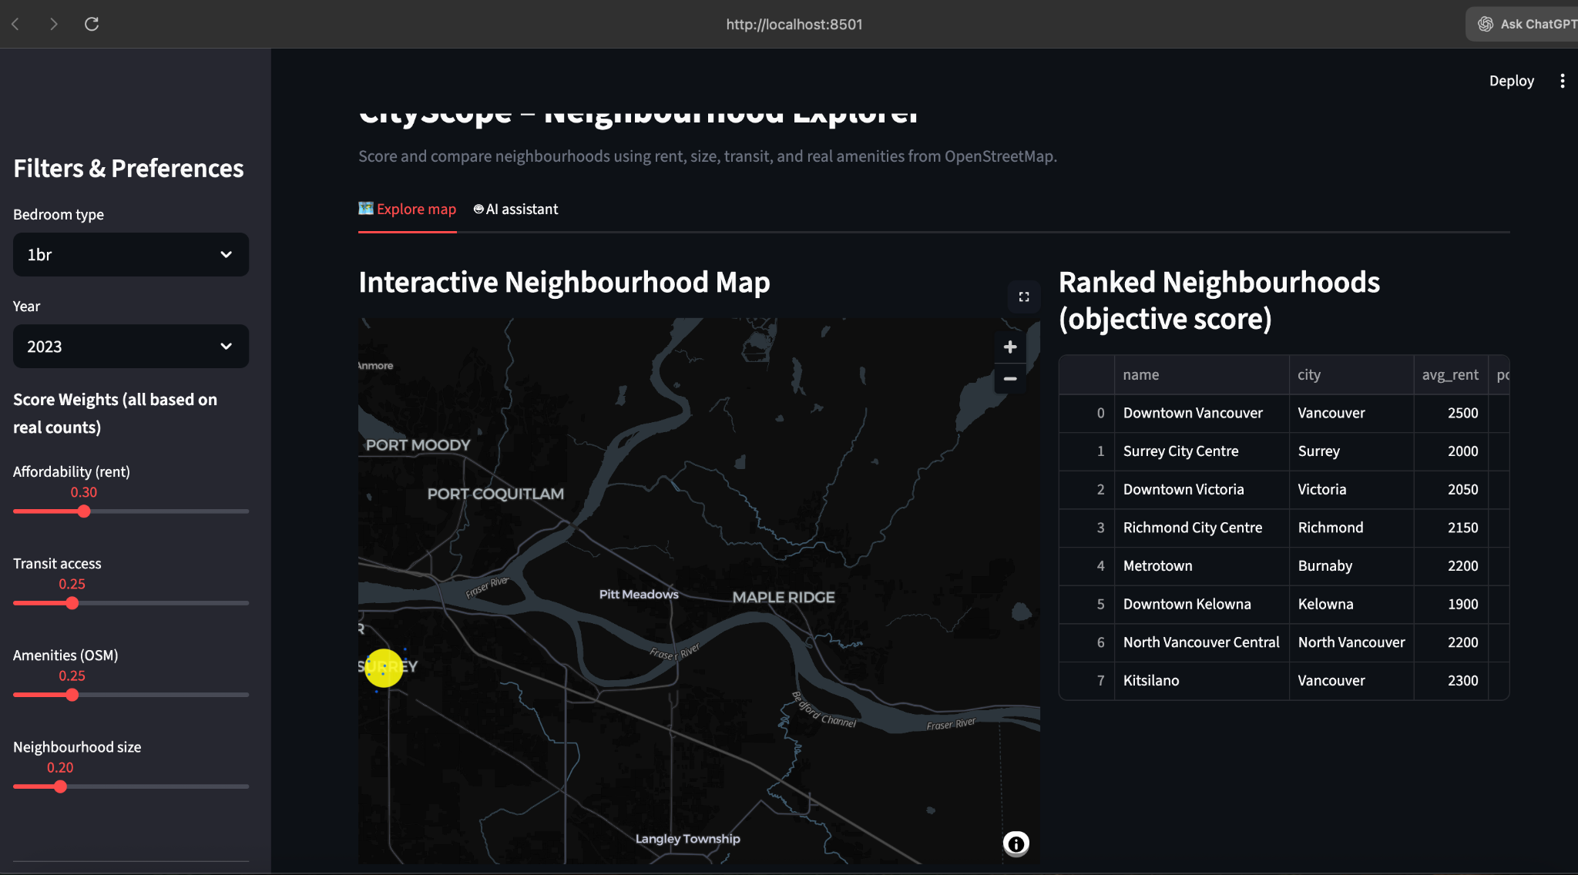
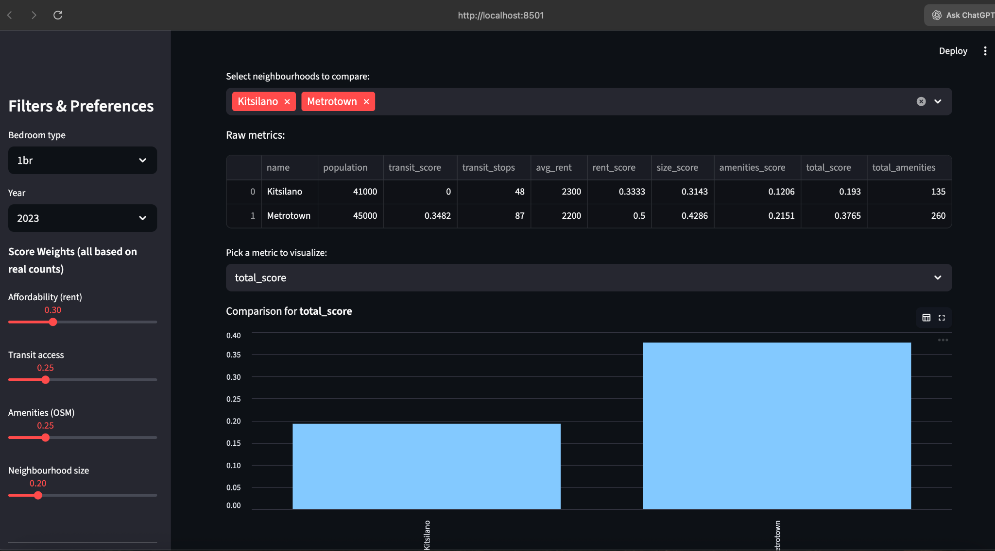
The AI Assistant Tab
