CityScope
Real Estate & Community Data Explorer
4495_071
Sahan Pattinikuttige Nonis - 300389470
2025 - 10 - 24

Table of Contents
1 Introduction 2
2 Proposed Research Project 2
Technology Stack 4
3 Project Planning and Timeline 4
4 Implemented Features 5
4.1 Implemented Feature A: Interactive Map with Neighbourhoods 5
4.1.1 Introduction/Overview 5
4.1.2 Details of Implementation 5
4.2 Implemented Feature B: Transit Stops Integration 6
4.2.1 Introduction/Overview 6
4.2.2 Details of Implementation 1 6
4.3 Implemented Feature C: Malls and Amenities Integration 6
4.3.1 Introduction/Overview 6
4.3.2 Details of Implementation 2 6
4.4 Implemented Feature D: Neighbourhood Scoring System 7
4.4.1 Introduction/Overview 7
4.4.2 Details of Implementation 7
5 Change of Direction and Lessons Learned 8
6 Appendix 8

Introduction
The rising cost of living has made housing decisions increasingly complex, especially for students, families, and individuals relocating to new cities. While real estate websites provide listings, they often fail to integrate key contextual data such as school quality, transit accessibility, and neighborhood affordability. CityScope addresses this gap by creating a web application that leverages data analytics to provide a holistic view of neighborhoods. Rather than simply displaying listings, the system highlights patterns and tradeoffs to help users make informed housing choices.
Problem Statement
Urban residents often struggle to evaluate neighborhoods due to fragmented and non-transparent information on housing affordability, school quality, and transportation access. This makes decision-making about where to live time-consuming and uncertain.
Knowledge Gap
While real estate platforms provide listings, they rarely integrate multiple datasets (housing, schools, transit) into a single, data-driven view. There is also limited focus on user-friendly analytics that allow comparison across neighborhoods beyond price alone.
Hypothesis
By integrating diverse urban datasets into a centralized web platform and applying analytics, users will be able to make more informed decisions about neighborhood suitability, improving transparency and reducing time spent searching.
Contribution to Knowledge
CityScope contributes by demonstrating how open data and visualization techniques can be combined into a practical decision-support tool. This project highlights the value of applying data analytics in urban studies, creating a replicable model for combining public data sources into actionable insights.

Proposed Research Project
CityScope will be developed using a monorepo structure with NestJS as the backend framework and Next.js for the frontend interface. Housing, school, and transit datasets will be sourced from open data repositories such as municipal databases and Kaggle. The backend will preprocess these datasets to calculate key metrics, including average rent per neighborhood, historical price trends, and transit accessibility scores. A composite “neighborhood score” will be generated using a weighted formula that combines affordability, education, and transportation. The frontend will present this information through interactive dashboards and charts, enabling users to filter results and compare neighborhoods.
The research design for CityScope follows an applied, data-driven development approach, integrating urban datasets into a functional decision-support platform. The methodology is structured in four phases:

1. Data Acquisition
● Identify and collect relevant open datasets (e.g., housing prices, rental listings, school ratings, public transit routes, and crime statistics).
● Ensure datasets are reliable, updated, and accessible via open APIs or government portals.
● Apply data cleaning techniques to handle missing values, inconsistencies, and formatting issues.
2. Data Integration and Processing
● Normalize heterogeneous datasets into a unified schema.
● Use preprocessing methods (e.g., scaling, encoding categorical data) to prepare data for visualization and analytics.
● Store data in a lightweight relational database (e.g., SQLite or PostgreSQL) for structured querying.
3. Data Analytics and Visualization
● Apply descriptive analytics to calculate key metrics such as average housing cost, school performance index, and commute accessibility.
● Design comparative metrics that allow neighborhoods to be ranked or filtered according to user-selected criteria.
● Develop visualization modules (heatmaps, charts, and comparative dashboards) to present results clearly.
4. Platform Development
● Build a web-based application using a modern stack (React/Next.js for frontend, Node.js/Express for backend).
● Implement interactive features that let users filter neighborhoods based on preferences (budget, school quality, commute).
● Ensure responsiveness and usability across devices through iterative user interface testing.
Validation Strategy
● Conduct case studies on selected neighborhoods to test the accuracy of integrated analytics.
● Perform small-scale user testing to gather feedback on usability and decision-making support.

Technology Stack
● Platform: Docker
● Frontend: Next.js (React) with Chart.js/Recharts for visualizations
● Backend: NestJS (Node.js) with REST APIs
● Database: PostgreSQL (via Prisma ORM).
● Deployment: Vercel (frontend) + Railway/Render/Fly.io (API & Postgres)

Project Planning and Timeline

Week | Milestone | Deliverables
1 | Project Setup & Requirements | Project repo initialized, finalized requirements document
2 | UI/UX Design | Wireframes, mockups of main pages (search, results, dashboard)
3–4 | Backend Development | NestJS APIs for housing data ingestion, processing, and scoring
5 | Frontend Development | Next.js components for search, filters, and basic charts
6 | Database Integration | PostgreSQL schema set up, connected via Prisma ORM
7 | Data Analytics Layer | Neighborhood scoring, trend analysis, initial visualization logic
8 | Visualization Features | Charts, maps, and interactive comparisons implemented
9 | Testing & Debugging | Unit tests, integration tests, bug fixes
10 | Deployment Setup | Deployment to Vercel + Railway/Render with live demo
11 | User Feedback & Refinement | Peer/instructor feedback, improvements to UI and analytics
12 | Finalization & Report | Complete working system, final report, and presentation slides

Implemented Features

Implemented Feature A: Interactive Map with Neighbourhoods

4.1.1 Introduction/Overview
The first core feature implemented was the interactive map, which allows users to visually explore neighbourhoods in the CityScope application. This is a critical component because it establishes the foundation for all future comparisons. The map is built with Next.js and Leaflet, providing dynamic markers and region highlighting.
This directly supports the proposal’s main vision: making neighbourhood comparison intuitive and visual rather than just statistical.

4.1.2 Details of Implementation
- Overview:
  - Map centered on Vancouver region.
  - Displays markers representing neighbourhoods such as Downtown, Burnaby, and Kitsilano.
- Details:
  - Implemented using Leaflet’s MapContainer and Marker components.
  - Integrated with Prisma database so that neighbourhoods are dynamically retrieved rather than hardcoded.
  - Each marker includes a popup with details about the neighbourhood.
  - Future work: allow users to click a neighbourhood to view full analytics.

4.2 Implemented Feature B: Transit Stops Integration

4.2.1 Introduction/Overview
Public transit availability is a key factor when deciding where to live. To showcase this, we added a feature that visualizes transit stops on the map. This gives users insight into accessibility in different neighbourhoods.

4.2.2 Details of Implementation 1
- Overview:
  - Transit stop data imported from TransLink GTFS dataset (stops.txt).
  - Stops for Downtown Vancouver loaded and plotted as additional markers on the map.
- Details:
  - CSV/GTFS file processed and converted into usable JSON for the frontend.
  - Each stop displayed with a smaller, distinct marker from the neighbourhood markers.
  - Integrated counter on charts to show number of stops per neighbourhood.
  - Future work: expand beyond downtown to cover other Vancouver regions.

4.3 Implemented Feature C: Malls and Amenities Integration

4.3.1 Introduction/Overview
In addition to transit, nearby amenities are crucial for real estate decisions. To demonstrate this, we implemented a feature that maps out malls and shopping centers.

4.3.2 Details of Implementation 2
- Overview:
  - Mall data sourced from OpenStreetMap Overpass API (export.json → converted to CSV).
  - Malls displayed as markers on the map.
- Details:
  - Processed raw JSON data into CSV/structured form.
  - Displayed malls with unique marker icons on the Leaflet map.
  - Connected to neighbourhood analytics: the number of malls per neighbourhood now contributes to scoring.

4.4 Implemented Feature D: Neighbourhood Scoring System

4.4.1 Introduction/Overview
One of the most important contributions is the Neighbourhood Scoring System, which aggregates transit and amenities data into a single, comparable value. This aligns directly with the project proposal goal: enabling users to quantitatively compare neighbourhoods.

4.4.2 Details of Implementation
Overview:
- Each neighbourhood is given a score based on transit stops, malls/amenities, and (future) average rent.
- For the MVP, simple weights were used to calculate an aggregate score.
Details:
- Formula:
  - Transit Score = stops × 0.5
  - Amenities Score = malls × 0.3
  - Housing Score (to be added later) × 0.2
- Scores normalized and displayed in bar charts alongside raw values.
- Example outcomes:
  - Downtown: High transit density → strong transit score.
  - Kitsilano: Balanced but fewer stops → mid score.
  - Burnaby: Larger area with more distributed amenities.
Impact:
- Moves the app beyond “showing data” to supporting decision-making.
- Provides a proof of concept for customizable, user-weighted comparisons in future phases.

Change of Direction and Lessons Learned
Database: Moved from Docker/Postgres to local SQLite for simplicity.
Scope: Narrowed neighbourhoods to three sample regions (Downtown, Kitsilano and Burnaby) for MVP demonstration.
Data Approach: Switched from live API queries to static dataset ingestion for reliability.
Key Lesson: Demonstrating a working pipeline is more important than perfect datasets; the architecture can easily be extended to real APIs later.

Appendix
This appendix includes supporting information that complements the main implemented features.
- Change of Direction: Initially planned with PostgreSQL in Docker, we switched to SQLite for easier setup and faster local testing.
- Screenshots: Map interface with neighbourhoods, transit stops, and malls; analytics chart comparing amenities.

Current Web App View
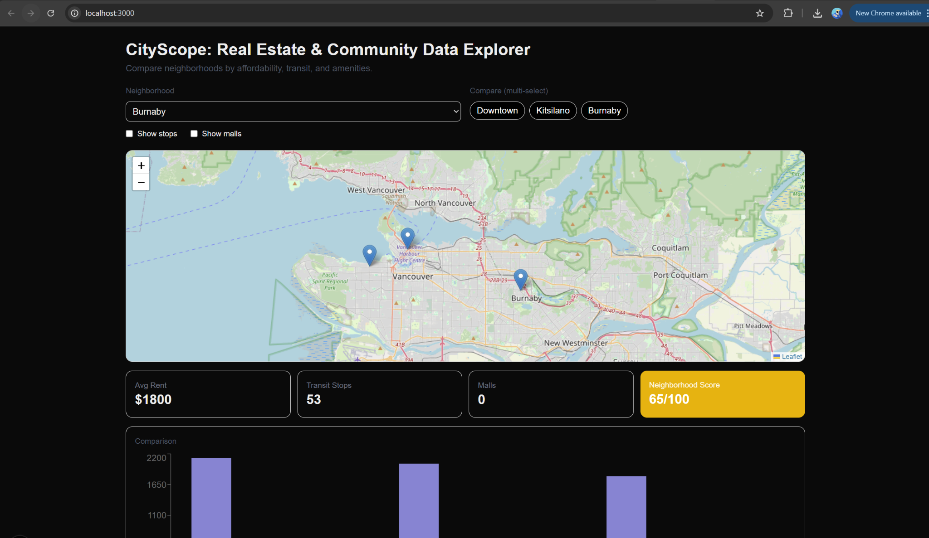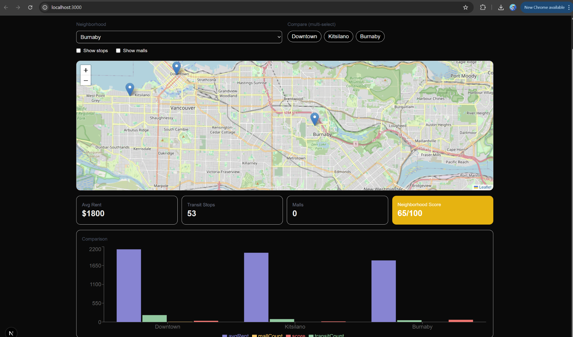

Code File Structure
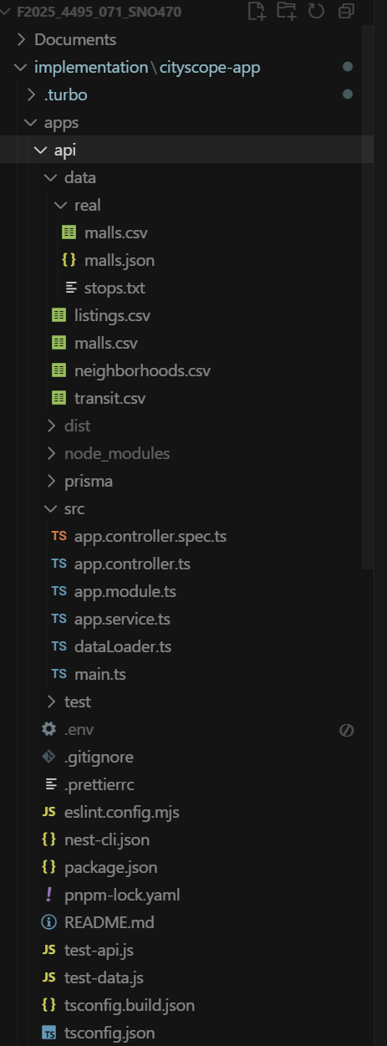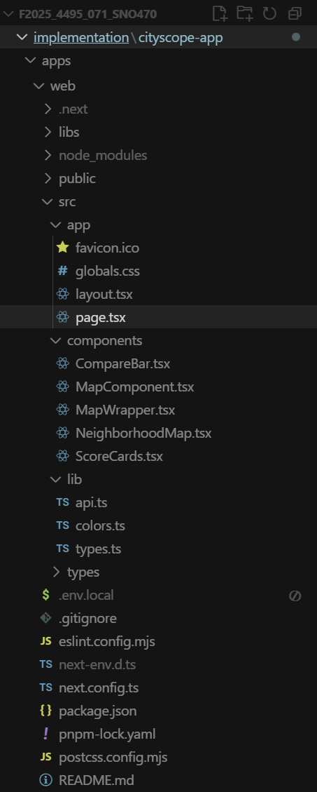
- Datasets: Transit stops from TransLink GTFS, malls extracted from OpenStreetMap, and neighbourhoods (Burnaby, Downtown, Kitsilano) added manually with mock rent data.
- Implementation Notes: Prisma seed script was used to populate the database, and endpoints were tested successfully with both backend (pnpm --filter api run start:dev) and frontend (pnpm --filter web dev).

