Sri Lanka Institute of Information Technology
Faculty of Computing · BSc (Hons) in Information Technology – Software Engineering
Year 3 Semester 1 – 2026
SE3090 Software Engineering Frameworks
Assignment 2 – Software Testing Report
Software Testing and Quality Evaluation of the SE3090 Integrated System
Family Veda — Longitudinal Family Health Context and Agentic Clinical Triage Platform
Ref | Student name | IT number | Owned component | Testing role
S1 | Samaranayaka S.G.V.S | IT23544154 | Family, Identity and Consent | Security testing (OWASP ZAP, xUnit auth/consent)
S2 | Fernando K.R.N | IT24101875 | Health Records and OCR Extraction | Database and parsing tests (xUnit, flutter_test)
S3 | Karunathilaka K.D.J.C (Group Leader) | IT24100551 | Symptoms, Triage and Agent Orchestration | Performance and AI evaluation
S4 | Wasala W.M.S.S.B | IT24100559 | Familial Risk and Clinical Approval | E2E and safety-gate tests

Group: SE_016 Submission date: 8 October 2026
Repository: https://github.com/sahansbandara/Family-Veda-SEF-Project (branch develop, evidence under docs/QMSE)
Lecturer / lab group: [ADD: lecturer in charge and lab/batch group if your cover page needs it]

BEFORE UPLOAD — DELETE THIS PAGE
Every item still needing your input is written in the document in red inside square brackets. Search for “[” in Word to jump between them. Replace each with your own text in black, then delete this page.
# | Where | What to add
1 | Cover page | Lecturer / lab group; change the submission date if you upload after 8 October 2026.
2 | 2.4 Responsibilities | Confirm the allocation matches what each member actually did.
3 | 2.5 Schedule | Real dates for phases 1 and 2 (planning and test-case design).
7 | 8.2 Defects found 8 Oct | Member who supervised the 8 October runs (4.1) and who reviewed each fix (8.2).
8 | 9 Individual contribution | Four fields per member, written by that member in their own words.
9 | 10 AI declaration | Each member’s CLEAR declaration using the module template.
11 | Whole document | Update the table of contents (right-click → Update field) and export to PDF.

Contents

[In Word: right-click the table of contents → Update field → Update entire table. Delete this line.]

1. Introduction

1.1 Purpose
This report records how Group SE_016 tested Family Veda, the integrated system built for the SE3090 Main Assignment. It contains the test plan, the testing scope, the test case document, the execution summary, the defect report with retest evidence, and an index of the tool-generated evidence held in the repository. No separate application was built; every result comes from the group’s own system.

1.2 System under test
Component | Technology
Backend API | ASP.NET Core Web API, Clean Architecture (Domain, Application, Infrastructure, Api)
Database | PostgreSQL 16 with Entity Framework Core migrations
Web application | React, TypeScript, Vite, Redux Toolkit
Mobile application | Flutter / Dart with Riverpod
Agentic AI subsystem | Five application agents (Context, Analysis, Extraction, Familial Risk, Safety/Validation) using hosted Gemini / Groq models, with deterministic C# rule engines and a doctor approval gate

1.3 Testing objectives
- Verify the business workflows (authentication, consent, health records, symptom triage, clinical approval) on the web and mobile clients.
- Verify that both clients work through the single shared API and database.
- Verify the clinical safety guardrails: no AI output reaches a patient without doctor approval, emergency wording halts the pipeline, and prohibited content is blocked.
- Measure performance under concurrent load and scan the API for security weaknesses (both required by the specification).
- Evaluate the agentic AI subsystem: schema-valid output, tool allow-list enforcement, provider-failure fallback and safe failure.

1.4 Quality risks that drove the plan
Risk | Why it matters | How it is tested
AI guidance reaches a patient without doctor approval | Clinical safety | Approval-gate integration tests; connected-client and hosted-agent journeys (Sections 5, 7)
One user reads another member’s or family’s health data | Privacy of health records | Access-control, case-grant and consent tests; ZAP scans with three roles (Section 6.2)
A triage case is lost or replayed after a failure | Reliability | Worker-recovery, provider-failure and safe-failure tests (Section 7)
Web and mobile drift apart on the shared API contract | Integration | Connected Flutter → API → React → Flutter run (Section 5)
Slow or failing read paths under load | Usability of both portals | ApacheBench load profile, write-path and ramp runs (Section 6.1)

2. Test Plan

2.1 Testing scope, areas and tools
Testing area | What was tested | Tool / framework
Backend / API | Unit, service and business-logic, validation, controller, authentication and authorization tests | xUnit, Moq, WebApplicationFactory
Database | Integration against real PostgreSQL, constraints, concurrency, migrations and rollback | xUnit + Testcontainers for .NET (PostgreSQL 16), EF Core
React web application | Component, form-validation, protected-route, UI-state and error-state tests | Vitest, React Testing Library, jsdom
Flutter mobile application | Unit, widget, form-validation, navigation and API-service tests | flutter_test
Integration / End-to-End | Three-role API journey; connected Flutter → API/DB/agents → React approval → Flutter; hosted-agent golden journey | xUnit integration suite; Python journey scripts in scripts/e2e; iOS simulator + Chrome
Non-functional: performance (required) | Read-path load profile, write-path latency, concurrency ramp | ApacheBench driven by scripts/e2e/local_load_profile.py and local_write_load_profile.py
Non-functional: security (required) | Dynamic API scan for three roles, access-control tests, dependency audits, request hardening | OWASP ZAP 2.17.0 API scan, xUnit, npm audit, dotnet list package --vulnerable
Agentic AI testing and evaluation | Structured-output validation, tool selection and denial, approval enforcement, failure recovery, safe failure | xUnit deterministic tests; hosted_agent_golden_journey.py against hosted Gemini

2.2 Non-functional test selection and justification
Type | Selected | Justification
Performance / load | Yes (required) | Both portals depend on the read endpoints; the profile shows which are slowest and whether any fail under concurrency.
Security | Yes (required) | The system holds health records with cross-profile access, so access control, token handling and malformed-input handling carry the highest risk.
Reliability and recovery | Yes | A triage case must never be lost or silently replayed; worker restart, provider failure and safe-failure paths are tested automatically.
Stress (ramp) | Partly | One endpoint was ramped to 100 concurrent connections to find the first saturating resource. A full stress test of the free-tier hosting would describe the hosting plan, not the application.
Compatibility | Partly | Mobile app run on an Android API 36 emulator and an iOS 27.0 simulator (iPhone 18 Pro Max); web captured at 375, 390, 768 and 1440 px. No physical device.
Usability and accessibility | No | No tool-based run (Lighthouse or axe) was executed, so none is claimed.
ApacheBench was chosen instead of k6 or JMeter because the requirement was a reproducible, authenticated baseline of throughput, latency percentiles and failures on local infrastructure. The specification lists k6 and JMeter as suggestions and allows other appropriate tools.

2.3 Test environment
Item | Value
Host | macOS development machine; Docker 29.8.0 for Testcontainers
Runtimes | .NET SDK 10.0.302, Node.js 22.23.2, Flutter 3.47.5 / Dart 3.13.4, Python 3
Database | Disposable PostgreSQL 16 instance per run, migrations and synthetic seed applied
Clients | Chrome (React dev server), iOS 27.0 simulator (iPhone 18 Pro Max), Android API 36 emulator
Continuous integration | GitHub Actions (.github/workflows/ci.yml): backend build and test, web lint and test, Flutter analyze and test on push and pull request; CodeQL workflow
Test data | Synthetic accounts and records only. No real patient identity, NIC or SLMC number is used. Performance and security scans target disposable local environments, never the hosted service.

2.4 Responsibilities
Ref | Member | Component tested | Tools | Viva demonstration focus
S1 | Samaranayaka S.G.V.S | Family, Identity and Consent | OWASP ZAP, xUnit, Vitest, flutter_test | API security scan, token lifecycle, consent state machine, tool-dispatcher denial
S2 | Fernando K.R.N | Health Records and OCR Extraction | xUnit + PostgreSQL, Vitest, flutter_test | Lab-extraction parser boundary and failure cases, records UI tests
S3 | Karunathilaka K.D.J.C | Symptoms, Triage and Agent Orchestration | ApacheBench load scripts, xUnit AI suite, flutter_test | Load profile and ramp results, schema-violation and provider-failure handling
S4 | Wasala W.M.S.S.B | Familial Risk and Clinical Approval | xUnit integration, journey scripts, Vitest, flutter_test | Integrated workflow, approval gate, case-grant isolation, safety validation
[CONFIRM: this allocation comes from the planning draft and docs/OWNERSHIP.tsv. Each member must check that their row matches what they actually did and can demonstrate; edit any row that does not.]

2.5 Schedule
Phase | Activity | Output | Dates
1 | Test planning and environment setup | Test plan | [ADD dates]
2 | Test case design (normal, invalid, boundary, failure) | Test case document | [ADD dates]
3 | Test implementation | Test code and scripts in the repository | 22 Sep – 8 Oct 2026 (test commits in the repository)
4 | Execution and evidence collection | Logs, TRX, coverage, ZAP and load output (28 Sep, 5 Oct, 8 Oct runs) | 28 Sep – 8 Oct 2026
5 | Defect logging, fixing and retesting | Defect report | 28 Sep – 8 Oct 2026
6 | Report compilation | This report | 8 Oct 2026

2.6 Entry and exit criteria
Entry: commit recorded, runtimes and tool versions recorded, disposable PostgreSQL target, synthetic fixtures, Docker healthy for Testcontainers, credentials kept out of the repository and evidence.
Exit: selected normal, invalid, boundary and failure tests executed; command, date, log and coverage retained; failures recorded with an independent retest; one correlated integrated workflow plus the required performance and security evidence completed. Anything unmet is reported as Partial, not Pass.

2.7 Defect management
Severity | Meaning
Critical | Crash, data corruption, unauthorized data access, or a violation of a clinical safety rule
High | Major functional defect, blocked workflow, failed build, or unhandled HTTP 500 on a core endpoint
Medium | Misleading behaviour or non-blocking edge-case failure
Low | Cosmetic issue, hardening gap or test-only defect
Lifecycle: Identified → Logged → Root cause diagnosed → Fix developed → Retested with the same tool → Closed.

3. Test Case Document
Table 1 lists the designed test cases. TC-01 to TC-28 are individual automated tests, named by their test method so they can be rerun; A2-* cases are the wider integrated, non-functional, device and AI cases. All named xUnit tests are recorded as Passed in the 8 October TRX files. The standing precondition for every automated case is the environment in Section 2.3 with synthetic data.
Table 1 – Test case document
ID | Feature | Type | Preconditions and steps / input | Expected result | Actual result | Status
TC-01 | Registration (S1) | Normal | Submit a complete Family Head registration — ValidFamilyHead_Passes | Validation passes | Passed | Pass
TC-02 | Registration (S1) | Invalid | Family Head registration with no family name — FamilyHead_RequiresFamilyName | Validation error on family name | Error returned | Pass
TC-03 | Registration (S1) | Invalid | Mismatched password and confirmation — ConfirmPassword_MustMatch | Validation error | Error returned | Pass
TC-04 | Registration (S1) | Boundary | Date of birth below the adult threshold, and a future date — DateOfBirth_RequiresAdult, DateOfBirth_RejectsFuture | Both rejected | Both rejected | Pass
TC-05 | Consent (S1) | Boundary | Guardian-granted consent for a member who turns eighteen — RequiresReaffirmation_WhenGuardianGrantedAndMemberTurnsEighteen_ReturnsTrue | Reaffirmation required | Reaffirmation required | Pass
TC-06 | Authentication (S1) | Failure | Same refresh token submitted concurrently — RefreshToken_IsSingleUse_WhenSubmittedConcurrently | Only one request succeeds | One succeeded | Pass
TC-07 | Tool dispatch (S1) | Failure | Agent requests a tool outside its allow-list — DeniedTool_IsPersisted_AndThrowsHardError | Denial persisted; processing stops | Denial persisted; error raised | Pass
TC-08 | Tool dispatch (S1) | Normal | Familial Risk Agent reads relatives’ flags — FamilialRisk_ReadsOnlyBiologicalRelativesWithCurrentConsent | Only consented biological relatives returned | As expected | Pass
TC-09 | Lab extraction (S2) | Normal | Parse a recognised report table — ParseValues_ExtractsStructuredRows_AndIgnoresFreeText | Structured rows extracted; free text ignored | As expected | Pass
TC-10 | Lab extraction (S2) | Invalid | Text containing appointment times — ParseValues_DoesNotTreatAppointmentTimesAsLabResults | No lab value created | None created | Pass
TC-11 | Lab extraction (S2) | Invalid | Rows with malformed fields or no recognised header — ParseValues_TableRows_UseCurrentValueAndRejectMalformedFields, ParseValues_DoesNotParseTableRowsWithoutRecognizedHeader | Malformed rows rejected | Rejected | Pass
TC-12 | Lab extraction (S2) | Failure | Extraction recognises zero rows — ExtractAsync_WhenRecognizedRowsAreZero_FailsWithoutWritingValuesOrFlags | Fails without writing values or flags | Nothing written | Pass
TC-13 | Lab extraction (S2) | Failure | Re-extract a report holding manually confirmed data — ExtractAsync_WhenReportContainsManuallyConfirmedData_RejectsAndPreservesConfirmedRows | Rejected; confirmed rows preserved | Preserved | Pass
TC-14 | Agent orchestration (S3) | Failure | Agent returns output that violates its schema — InvalidAgentSchema_FailsSafe_AndStopsRemainingAgents | Case fails safe; later agents do not run | Failed safe | Pass
TC-15 | Emergency gate (S3) | Failure | Emergency wording in free-text notes — EmergencyGate_AlsoChecksFreeTextNotes_BeforeEveryLlmAgent | Halt before every LLM agent | Halted | Pass
TC-16 | LLM client (S3) | Failure | Provider returns rate-limit responses twice — RateLimitedTwice_FailsClosed | Client fails closed | Failed closed | Pass
TC-17 | LLM client (S3) | Invalid | Provider returns a schema violation once — SchemaViolation_RetriesOnce_ThenReturnsValidOutput | One retry, then valid output | As expected | Pass
TC-18 | Worker recovery (S3) | Boundary | More queued cases than channel capacity at start-up — Recovery_ReturnsMoreThanChannelCapacity_WithoutBlockingStartup | Start-up not blocked | Not blocked | Pass
TC-19 | Case grant (S4) | Boundary | Grant expired or exactly at its expiry time — HasAccess_WhenGrantIsExpiredOrAtExpiryBoundary_ReturnsFalse | Access denied | Denied | Pass
TC-20 | Case grant (S4) | Invalid | Grant was revoked — HasAccess_WhenGrantWasRevoked_ReturnsFalse | Access denied | Denied | Pass
TC-21 | Safety validation (S4) | Failure | Emergency red flag present — Validate_WhenEmergencyRedFlagExists_HaltsBeforeLlmAndReturnsReferralOnly | Referral only; no AI output | Referral only | Pass
TC-22 | Safety validation (S4) | Invalid | Evidence contains prohibited content — Validate_WhenLabEvidenceContainsMedicationContent_StillBlocksContent | Content blocked | Blocked | Pass
TC-23 | Approval gate (S4) | Normal | Complete synthetic golden case — SyntheticGoldenCase_RequiresApprovalBeforeFamilyCanReadGuidance | Guidance unreadable before approval, readable after | As expected | Pass
TC-24 | Doctor verification (S4) | Invalid | Unverified doctor calls clinical routes — PendingDoctor_IsForbiddenFromEveryClinicalQueueAndDecisionSurface | Forbidden on every route | Forbidden | Pass
TC-25 | Request hardening (S1) | Invalid | Query string containing a NUL character — NulCharacterInQueryString_IsRejectedAsBadRequest_NotServerError | HTTP 400 problem details, not HTTP 500 | HTTP 400 | Pass
TC-26 | Request hardening (S1) | Normal | Request the health route and an API route — EveryResponse_TellsBrowsersNotToSniffContentType | X-Content-Type-Options: nosniff on each | Present | Pass
TC-27 | Patient privacy (S4) | Failure (regression) | Doctor approves a case with an internal note; patient reads the case — ApprovedCase_NeverReturnsInternalDoctorNotes_AndClearsStaleDelayMarker | Internal note absent from patient response; no stale delay marker | Failed before fix; passed after fix (QMSE-20261008-01/02) | Pass (after retest)
TC-28 | Family tabs, Flutter (S1) | Invalid | Adult opens My Family — widget test “hides Head-only tabs and never calls Head-only providers for an Adult” | Head-only tabs hidden; no Head-only request made | Failed before fix; 2 of 2 passed after fix (QMSE-20261008-03) | Pass (after retest)
A2-API-01 | Three-role API journey | Normal | Synthetic Head, Adult and Doctor on local API and PostgreSQL 16; run scripts/e2e/synthetic_portal_journey.py | Journey completes; Head cannot see an adult’s private records | Join by code, doctor acceptance, 45-minute booking, dashboards and notifications passed; Head received an empty list (no private data) | Pass
A2-API-02 | Doctor acceptance | Failure (regression) | Doctor already assigned plus a legacy pending request; accept the request | No duplicate assignment | HTTP 200, one assignment, request Accepted | Pass
A2-DB-02 | Doctor concurrency constraints | Boundary | Competing writes for pending requests and active primary assignments; concurrent accept and decline | At most one of each; one decision with matching audit | One write won each pair; one 200 and one 409 with one audit row | Pass
A2-DB-03 | Idempotent migration | Normal | Fresh PostgreSQL 16; apply first two migrations, then the doctor-constraint script twice | Both runs succeed; one history row per migration | Both exited 0; three distinct migration IDs | Pass
A2-DB-04 | Populated migration and rollback | Failure | Legacy database with history; conflicting legacy database; repeated assignment after upgrade | Rows preserved; conflicting upgrade rejected atomically; unsafe rollback refused | Confirmed by integration tests | Pass
A2-MOB-02 | Android appointment booking | Normal | Synthetic Head on Android API 36 emulator; select 45 minutes and 10:00 AM; submit | Same local time shown in the list | duration_minutes=45 stored; list showed 10:00 AM after the time-zone fix (D-004) | Pass
A2-MOB-03 | Hosted-API Android APK | Normal | Build with the production API URL; install on emulator; sign in as synthetic Head | APK builds, installs and reaches the dashboard | Built, installed, signed in; dashboard, appointments and notifications loaded. Approved-guidance journey on the hosted site not run | Partial
A2-E2E-01 | Complete integrated workflow | Normal and failure | Flutter → API, database and agents → React doctor approval → Flutter result | Golden case and safe-failure case shown across both clients | Connected run found two High defects (fixed, PR #176). Hosted-agent golden journey then passed 11 of 11 checks through the API. Visual repeat after the fix not captured | Pass (API), Partial (visual)
A2-PERF-01 | Performance | Normal | ApacheBench, 1,000 requests at concurrency 25 on each of 14 read endpoints; scripts/e2e/local_load_profile.py | Zero failed or non-2xx responses | 14,000 completed, 0 failed, 0 non-2xx; slowest endpoint 90 ms mean, 331 ms p99 (Table 6) | Pass (local)
A2-PERF-02 | Write path and ramp | Boundary | 20 symptom episodes and 20 triage submissions; ramp GET /dashboard/family at concurrency 10, 25, 50, 100 | All writes accepted; no failures while ramping | 20 × 201 and 20 × 202; zero failures at every step; throughput levels at about 430–450 requests/s | Pass (local)
A2-SEC-01 | Access control | Invalid | Unauthenticated GET on three protected live routes; preflight from an untrusted origin | 401 on each route; no allow-origin header | 401 three times; no allow-origin header | Pass
A2-SEC-02 | Web dependency audit | Normal | npm audit --omit=dev --audit-level=high | No known vulnerabilities | found 0 vulnerabilities | Pass
A2-SEC-03 | API dependency audit | Normal | dotnet list package --vulnerable --include-transitive | No vulnerable packages | None reported | Pass
A2-SEC-04 | Dynamic security scan | Normal and invalid | OWASP ZAP API scan over the OpenAPI definition with Head, Doctor and Admin tokens on disposable local APIs | No High or Medium alert | 117 passed, 0 failed, 2 Low warnings for each role; first run found D-011 and D-012 (fixed) | Pass
A2-AI-01 | Hosted agents, seeded member | Normal | hosted_agent_golden_journey.py with recorded vitals and labs; hosted Gemini | Schema-valid steps, allow-listed tools only, guidance gated until approval | PendingDoctorReview in 30.1 s; 11 checks passed, 0 failed | Pass
A2-AI-02 | Hosted agents, no health data | Boundary | Same script with a newly registered member | Agents report no data; no draft advisory produced | LowConfidence in 20.2 s; 10 checks passed, 0 failed | Pass
A2-AI-03 | Provider unavailable | Failure | Submit a case from Flutter with no working provider configuration | Case fails safe; guidance stays unavailable | FailedSafe / AGENT_UNAVAILABLE; guidance HTTP 404 | Pass
A2-WEB-01 | Vitals panel (web) | Normal | Run VitalsPanel.test.tsx | All tests pass | First run two of four failed (D-008); after the tests were aligned, three of three passed | Pass (after retest)
A2-WEB-02 | Web quality gate | Normal | npm run lint and npm run build | Both exit 0 | First run lint exit 1, build exit 2 (D-009); after fix both exit 0 | Pass (after retest)

Of the 47 cases, 45 are Pass (four of them after a fix and retest), one is Pass at API level and Partial visually (A2-E2E-01), and one is Partial (A2-MOB-03). No case remains failed. By type the set covers normal, invalid, boundary and failure cases in every component.

4. Test Execution Summary

4.1 Automated suite results
Table 2 – Automated suite results across three execution rounds
Suite | Tool | 28 Sep 2026 | 5 Oct 2026 | 8 Oct 2026 | Evidence (8 Oct)
Backend unit | xUnit + Moq | 91 / 91 | 337 / 337 | 430 / 430 | backend-unit.txt, .trx
PostgreSQL integration | xUnit + Testcontainers | 11 / 11 | 29 / 29 | 30 / 30; 31 / 31 after the regression test for PR #176 | backend-integration.txt, .trx; 02-after-fix-integration.txt
React web | Vitest + React Testing Library | 41 / 41 | First run 306 / 308; retest 308 / 308 | 343 / 343 (57 files) | web-tests.txt
Flutter mobile | flutter_test | 69 / 69 | 214 / 214 | 256 / 256; 258 / 258 after the QMSE-20261008-03 fix | flutter-tests.txt; 06-after-fix-flutter-adult-family.txt
Web lint and build | ESLint, tsc, Vite | Passed | First run failed; retest exit 0 | Exit 0 (bundle-size warning) | web-lint.txt, web-build.txt
Flutter analyze | flutter analyze | No issues | No issues | No issues | flutter-analyze.txt

The 8 October run totals 430 + 30 + 343 + 256 = 1,059 passing tests, 0 failed. The growth between rounds reflects tests added with the features delivered between the dates. The 5 October round is kept because its first run failed (two web tests, lint and build), which is the origin of defects D-008 and D-009.
The Flutter suite passes but its output contains missed-tap warnings in some widget tests; they are retained in the log and not hidden.
The 8 October suites, scans and journeys were run with an AI coding agent on the MacBook of the repository account ImSahanS (Apple M4, macOS 27.0.1; Flutter 3.47.5, Node 22.23.2, .NET SDK 10.0.302 building the net8.0 projects). The suite logs above were taken at commit 3bb6c19; the fixes and evidence described in sections 5 and 8 were merged afterwards, and develop is at commit 4ed0c28. [ADD: name of the member who supervised these runs.]
After the fixes the suites were rerun on 8 October: the full React suite passed 344 of 344 tests in 57 files (08-after-fix-web-full-suite.txt), the backend integration suite 31 of 31, the backend unit suite 430 of 430 and the Flutter suite 258 of 258.

4.2 Code coverage (8 October)
Table 3 – Coverage by suite
Suite | Tests | Line coverage | Branch coverage
Backend unit | 430 | 11,191 / 45,297 — 24.71% | 3,703 / 6,767 — 54.72%
PostgreSQL integration | 30 | 29,118 / 45,297 — 64.28% | 939 / 6,767 — 13.88%
React | 343 | 71.94% lines; 69.80% statements; 66.52% functions | 64.43%
Flutter | 256 | 8,632 / 11,396 — 75.75% (122 files) | Not instrumented

The figures are reported per suite and are not averaged into one number, because the scopes differ. The backend denominator includes generated EF Core migration code, which lowers the overall percentage. The unit run covers the Application layer well (672 / 873 lines, 76.98%) but hardly touches controllers and persistence, which the integration run covers instead.

4.3 Overall result
Measure | Result
Designed test cases (Table 1) | 47: 45 Pass, 2 Partial, 0 Failed
Automated tests executed, 8 October | 1,059 executed, 1,059 passed, 0 failed
Defects recorded | 16 (D-001 to D-012 and QMSE-20261008-01 to -04)
Defects fixed and retested | 16; one of them (D-007) retested locally only
Accepted findings | 2 Low ZAP warnings (Section 6.2)
Required non-functional testing | Performance and security both executed with tools

5. Integration and End-to-End Testing

5.1 Connected client workflow (Flutter → API → React → Flutter)
On 8 October the real Flutter iOS client and the React web client were run against the same fresh local API and PostgreSQL database with synthetic accounts. Case numbers shown on screen were correlated with the persisted case IDs, and authenticated HTTP assertions were recorded alongside the screenshots.
Table 4 – Connected client scenarios
Scenario | Actual outcome | Status
Flutter submits fresh case 0021 → web doctor queue | Same persisted ID visible in both clients; guidance HTTP 404 before approval | Pass
Hosted processing of case 0021 | FailedSafe / AGENT_UNAVAILABLE because the local API had no working provider configuration; guidance still 404 | Safe-failure Pass; normal completion not reached in this run
Seeded case 0003 before the decision | Patient guidance 404; same case visible in Flutter and the web approval desk | Pass
Web doctor approves case 0003 → Flutter | Decision saved; status Approved; guidance endpoint 200; Flutter showed the response | Pass
Doctor-only note stays private | Internal note was returned in the patient response and shown in Flutter | Failed → defect QMSE-20261008-01, fixed and retested
Approved guidance button shown | Old delay marker remained; Flutter hid the approved-guidance button | Failed → defect QMSE-20261008-02, fixed and retested

This run did its job: it exposed two High defects that 1,059 passing unit, component and integration tests had not, because each layer was correct in isolation and the fault lay in what the API handed to the patient clients. Both were fixed the same day (PR #176) with a regression test at every layer (Section 8.2).
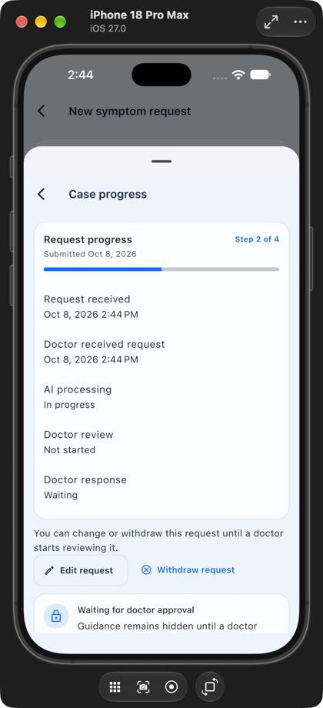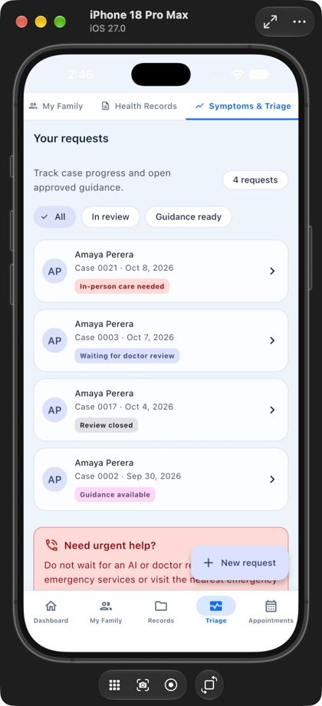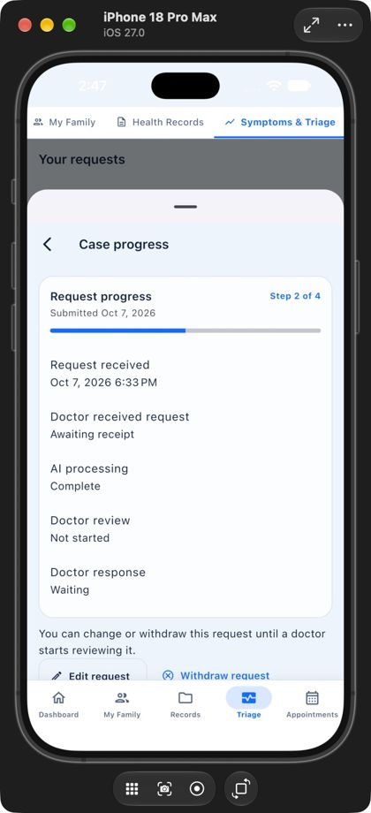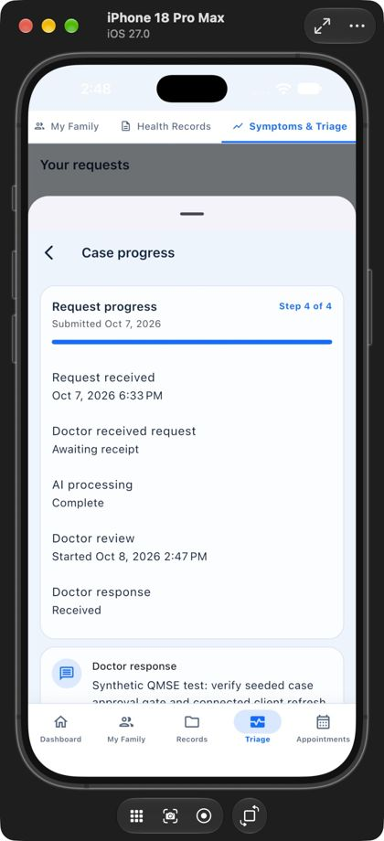
Figure 1 – Flutter iOS: case submitted; safe failure; seeded case before approval; approved case showing the internal-note defect before the fix.
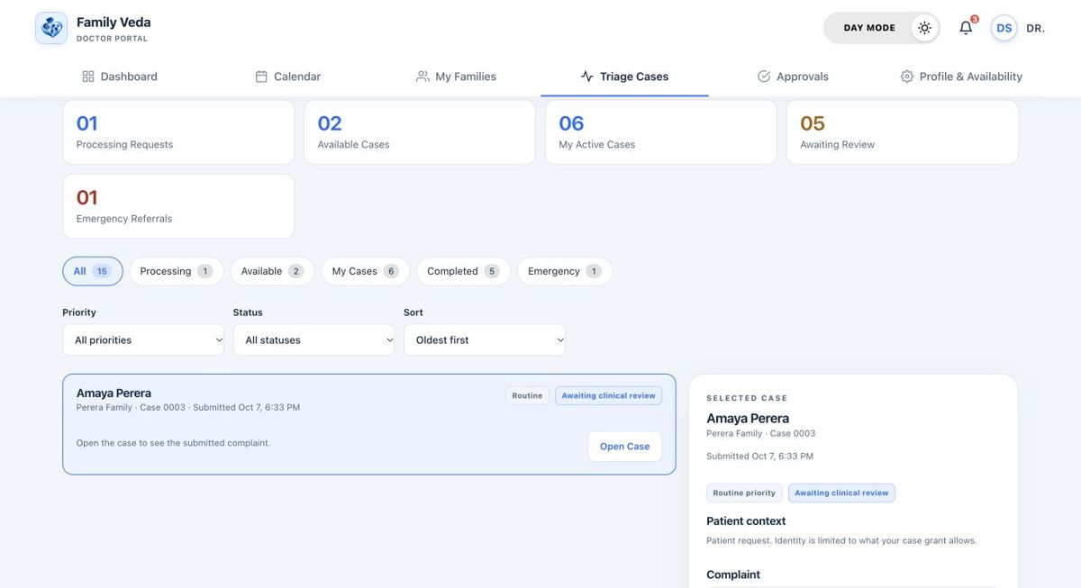
Figure 2 – React web: doctor approval desk reviewing seeded case 0003.
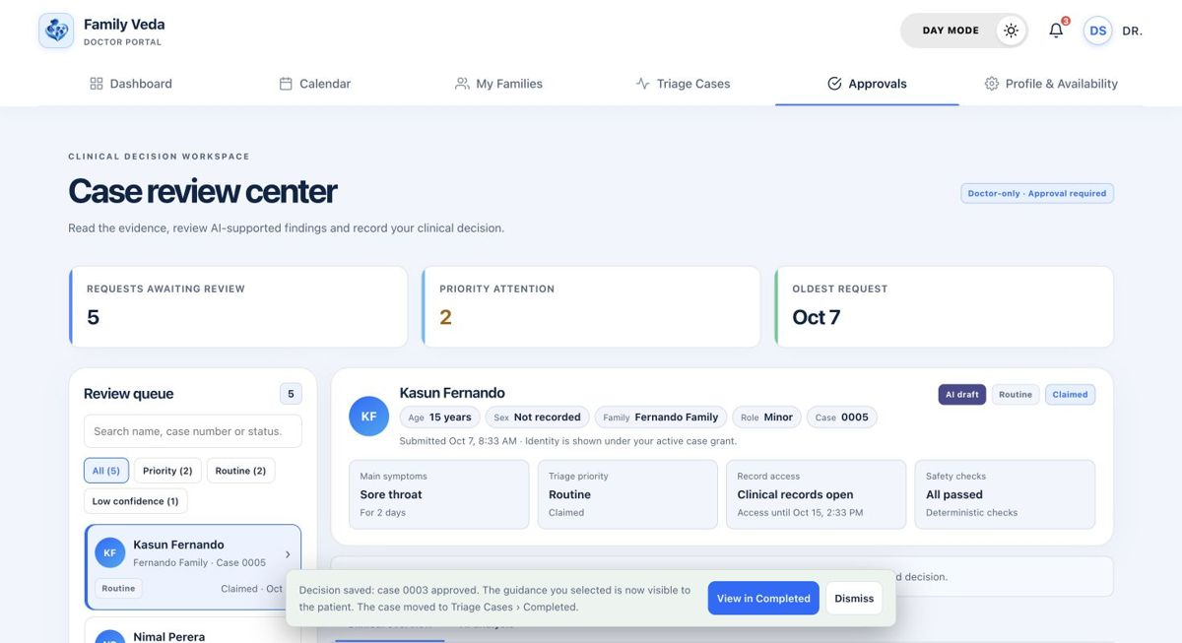
Figure 3 – React web: case 0003 after the doctor’s approval.
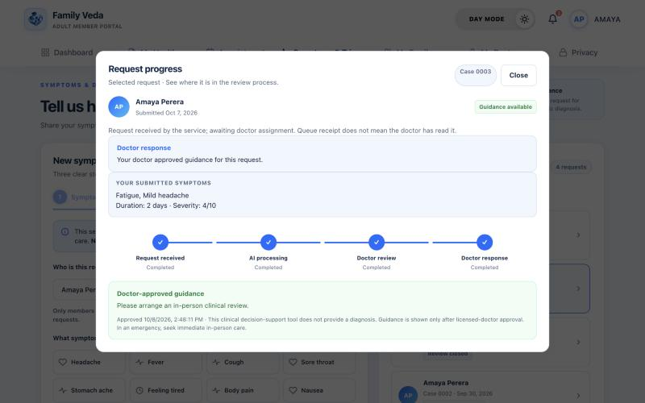
Figure 4 – React web after the fix: the patient view of approved case 0003 shows the doctor response and the approved guidance, with no internal note.
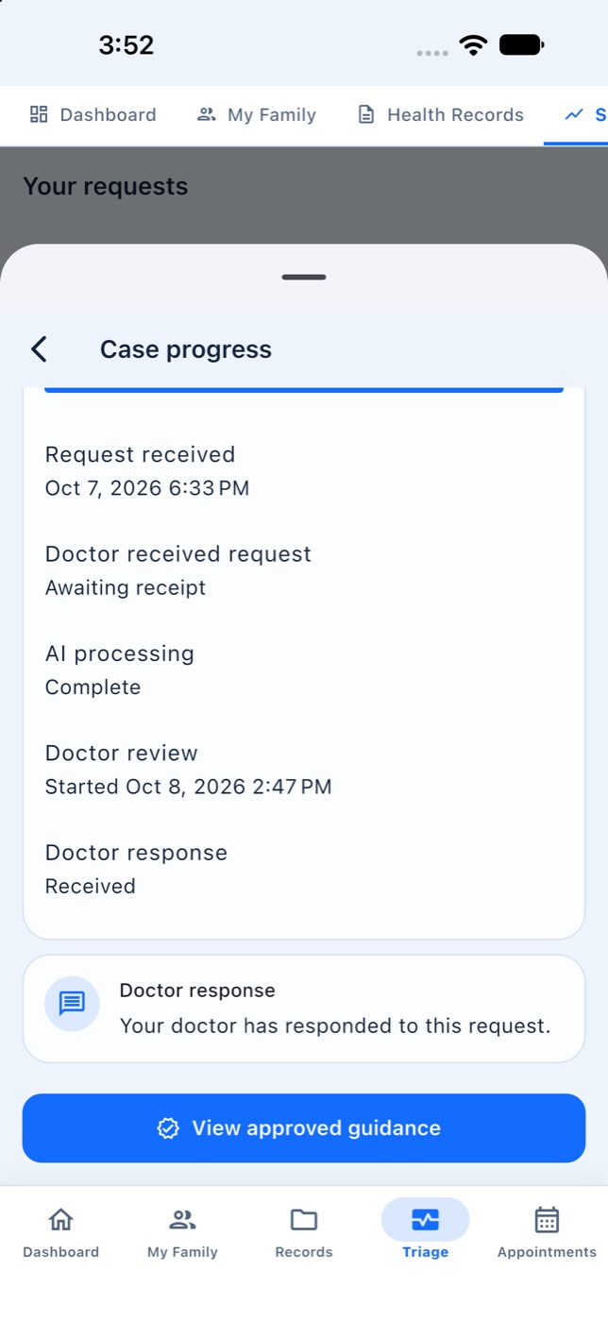
Figure 5 – Flutter iOS after the fix: the same case shows “View approved guidance” and no delay warning or internal note.
After the fix the local API was restarted on the fixed build, the Flutter app was rebuilt, and the same approved case 0003 was reopened as the synthetic patient on both clients (Figures 4 and 5; API assertion in after-fix-patient-case-assertion.json). Limitation: only this case was re-viewed; the whole two-client journey from a new submission was not repeated on screen after the fix, and that path is covered by the automated tests and the API journey below.

5.2 Hosted-agent golden journey (after the fix)
Because the fresh case above failed safe, the journey was repeated with provider keys loaded, using scripts/e2e/hosted_agent_golden_journey.py against a disposable database. The agents called the hosted Gemini model.
Table 5 – Hosted-agent journey
Variant | Pipeline outcome | Checks
Seeded member with recorded vitals and labs | PendingDoctorReview in 30.1 s; Context 0.90 and Analysis 0.88 confidence; draft advisory produced | 11 passed, 0 failed
Newly registered member with no health data | LowConfidence in 20.2 s; agents report NoData; no draft advisory | 10 passed, 0 failed

Checks in each run: guidance returns 404 before any decision; a family user gets 403 on the doctor-only review; every completed agent step is schema-valid and uses only allow-listed tools; guidance is still 404 after the agents finish; after the doctor approves, the family reads the approved guidance; the internal doctor note is absent from every patient response; no overdue-review marker remains.

5.3 Three-role API journey
scripts/e2e/synthetic_portal_journey.py signs in as a synthetic Family Head, Adult Member and Doctor and walks join-by-code, doctor acceptance, appointment booking, dashboards and notifications. Its first 8 October run stopped on a wrong expectation in the script itself (QMSE-20261008-04); after the script was corrected the full journey passed on a fresh database (07-after-fix-api-journey.txt).

6. Non-Functional Testing

6.1 Performance testing
scripts/e2e/local_load_profile.py signs in as a synthetic Family Head and Doctor, then drives ApacheBench with 1,000 requests at concurrency 25 against each of fourteen read endpoints (14,000 requests) on a disposable local API and PostgreSQL 16 database. The script refuses any non-local host and fails if any request fails or returns a non-2xx status.
Table 6 – Load profile, 8 October 2026
Endpoint | Done | Failed | Non-2xx | Req/s | Mean ms | p50 | p95 | p99 | Max
Health check (anonymous) | 1000 | 0 | 0 | 24,779 | 1.0 | 1 | 1 | 1 | 2
Family: own family | 1000 | 0 | 0 | 4,611 | 5.4 | 4 | 7 | 30 | 36
Family: dashboard | 1000 | 0 | 0 | 395 | 63.3 | 57 | 119 | 157 | 166
Family: notifications | 1000 | 0 | 0 | 2,307 | 10.8 | 10 | 17 | 22 | 32
Family: appointments | 1000 | 0 | 0 | 707 | 35.4 | 32 | 52 | 62 | 73
Family: health records | 1000 | 0 | 0 | 1,096 | 22.8 | 20 | 35 | 39 | 50
Family: vitals | 1000 | 0 | 0 | 2,313 | 10.8 | 10 | 17 | 19 | 22
Family: lab reports | 1000 | 0 | 0 | 749 | 33.4 | 25 | 62 | 231 | 250
Family: triage cases | 1000 | 0 | 0 | 278 | 90.0 | 66 | 220 | 331 | 347
Family: doctor directory | 1000 | 0 | 0 | 2,245 | 11.1 | 9 | 20 | 25 | 35
Doctor: dashboard | 1000 | 0 | 0 | 483 | 51.7 | 40 | 73 | 294 | 313
Doctor: my cases | 1000 | 0 | 0 | 790 | 31.7 | 29 | 43 | 48 | 73
Doctor: case pool | 1000 | 0 | 0 | 820 | 30.5 | 28 | 47 | 56 | 93
Doctor: appointments | 1000 | 0 | 0 | 1,335 | 18.7 | 17 | 29 | 34 | 37

Interpretation. All 14,000 requests completed with zero failed and zero non-2xx responses. The slowest endpoint is the family triage-case list (90 ms mean, 220 ms p95), followed by the two dashboards (63 ms and 52 ms mean); each aggregates several queries, so they are the first candidates for combining queries or brief caching. Simple list endpoints stay between 5 ms and 35 ms mean. Lab reports and the doctor dashboard show a long tail (p99 of 231 ms and 294 ms against medians of 25 ms and 40 ms), which points to occasional contention rather than a consistently slow query.
Table 7 – Write path and concurrency ramp (local_write_load_profile.py)
Test | Requests | Result | p50 | p95 | p99
Create symptom episode | 20 | 20 × HTTP 201 | 3.8 ms | 6.6 ms | —
Submit triage case | 20 | 20 × HTTP 202 | 10.9 ms | 16.4 ms | —
Ramp GET /dashboard/family, concurrency 10 | 2,000 | 371 req/s, 0 failed | 24 ms | 45 ms | 70 ms
Ramp, concurrency 25 | 2,000 | 432 req/s, 0 failed | 53 ms | 90 ms | 113 ms
Ramp, concurrency 50 | 2,000 | 447 req/s, 0 failed | 104 ms | 165 ms | 227 ms
Ramp, concurrency 100 | 2,000 | 437 req/s, 0 failed | 208 ms | 367 ms | 407 ms

Interpretation. Throughput levels off at about 430–450 requests per second from concurrency 25; beyond that, extra load only adds latency. At 100 concurrent connections a separate psql session was refused with “too many clients”, so the database connection limit is the first resource to saturate, while the API itself returned no errors. This identifies connection pooling as the first thing to tune before scaling.
Limits. One local machine, Debug build with SQL logging, small synthetic data set, no network latency. Agent latency is excluded: in the write run no provider keys were supplied, so the 20 submitted cases ended FailedSafe. The results say nothing about the hosted free-tier environment, which adds a cold-start delay.

6.2 Security testing
Table 8 – Security checks
ID | Check | Expected | Actual | Status
SEC-1 | Guidance requested before doctor approval (integration test) | Denied | HTTP 404 before approval; returned only after approval | Pass
SEC-2 | Action by a doctor whose verification is pending | Denied | Denied on every clinical route | Pass
SEC-3 | Refresh-token reuse | Usable once only | Single-use confirmed under concurrency | Pass
SEC-4 | Tool dispatch, case grants and consent (11 unit tests) | Unauthorised tool use, stale grants and revoked consent denied | 11 passed | Pass
SEC-5 | Unauthenticated GET to three protected routes | HTTP 401 | 401 on all three | Pass
SEC-6 | CORS preflight from an untrusted origin | No allow-origin header | HTTP 204 without Access-Control-Allow-Origin | Pass
SEC-7 | npm audit (web production dependencies) | No known vulnerabilities | found 0 vulnerabilities | Pass
SEC-8 | dotnet list package --vulnerable (API) | None | None reported | Pass
SEC-9 | OWASP ZAP API scan, three roles | No High or Medium alert | 0 High, 0 Medium for Head, Doctor and Admin | Pass
SEC-10 | Query string carrying a NUL character | HTTP 400 | HTTP 400 problem details | Pass
SEC-11 | X-Content-Type-Options on responses | nosniff | Present | Pass
SEC-12 | Doctor internal note in patient response | Never returned | Returned before fix; absent after fix | Pass (after retest)

Dynamic scan with OWASP ZAP 2.17.0. The API scan imports the OpenAPI definition from /swagger/v1/swagger.json, then passively inspects and actively attacks every documented endpoint using a bearer token. Each scan ran against its own disposable database and local API; the hosted service was deliberately not scanned.
Table 9 – ZAP results by role, 8 October
Role token | PASS | FAIL | WARN | High | Medium | Low | Informational
Family Head | 117 | 0 | 2 | 0 | 0 | 2 types / 4 instances | 3 types
Doctor | 117 | 0 | 2 | 0 | 0 | 2 types / 7 instances | 3 types
Clinic Admin | 117 | 0 | 2 | 0 | 0 | 2 types / 7 instances | 3 types

The first scan on 5 October raised four Low warnings. Two were real and were fixed: a server error on a NUL character in a query string (D-011) and a missing X-Content-Type-Options header (D-012). The rescan and all three 8 October scans no longer report them. Two Low warnings remain and are accepted:
- Cross-Origin-Resource-Policy header missing. The web client is served from a different site from the API, so a restrictive value risks blocking legitimate requests; the API returns JSON to authenticated callers, not embeddable resources.
- Unexpected content type on /swagger/. A false positive: the Swagger UI page is HTML by design.
Mapping to OWASP Top Ten 2021. A01 Broken Access Control: SEC-1, 2, 4, 5, 12. A02 / A07 Cryptographic and Authentication Failures: SEC-3. A03 Injection: SEC-9 (no injection alert) and SEC-10. A05 Security Misconfiguration: SEC-6, 9, 11. A06 Vulnerable Components: SEC-7, 8, with CodeQL and Dependabot for continuing coverage.
Limits. This is automated testing, not a penetration test. The scan covered the API only, not the web or mobile clients; unresolved path placeholders in the OpenAPI import produced client-error responses, so some parameterised routes were exercised only shallowly.

7. Agentic AI Testing and Evaluation
Most agent tests are deterministic: they replace the hosted model with a stub so the result does not depend on model behaviour, and they check the controls around the agents. Two hosted runs then confirm the same controls with the real model.
Table 10 – Agentic AI evaluation
Evaluation type | Test | Result
Structured-output validation | InvalidAgentSchema_FailsSafe_AndStopsRemainingAgents; SchemaViolation_RetriesOnce_ThenReturnsValidOutput | Invalid output fails safe; one retry then valid output — Pass
Tool selection and denial | DeniedTool_IsPersisted_AndThrowsHardError; FamilialRisk_ReadsOnlyBiologicalRelativesWithCurrentConsent | Out-of-list tool denied and logged; only consented relatives read — Pass
Business-rule compliance | Validate_WhenEmergencyRedFlagExists_HaltsBeforeLlmAndReturnsReferralOnly; Validate_WhenLabEvidenceContainsMedicationContent_StillBlocksContent; EmergencyGate_AlsoChecksFreeTextNotes_BeforeEveryLlmAgent | Emergency halts before any LLM call; prohibited content blocked — Pass
Approval enforcement | SyntheticGoldenCase_RequiresApprovalBeforeFamilyCanReadGuidance; hosted journey checks | Guidance 404 until a doctor approves — Pass
Failure recovery | RateLimitedTwice_FailsClosed; Recovery_ReturnsMoreThanChannelCapacity_WithoutBlockingStartup | Client fails closed; worker recovers queued cases — Pass
Safe failure | Connected run, case 0021 with provider unavailable | FailedSafe / AGENT_UNAVAILABLE; no guidance exposed — Pass
Task completion with hosted model | hosted_agent_golden_journey.py, two variants (Table 5) | 11 of 11 and 10 of 10 checks — Pass

Prompt injection. No separate adversarial prompt set (for example promptfoo) was run, so resistance to prompt injection is not claimed as tested. The mitigations are structural and are the ones tested above: agents hold no database credentials, tool access is limited to a per-agent allow-list enforced at dispatch, safety validation is deterministic code rather than a model judgement, OCR text is treated as untrusted input, and no output reaches a patient without doctor approval.

8. Defect Report and Retest Evidence

8.1 Defect log
Table 11 – Defect and retest log
ID | Description | Severity / priority | Steps to reproduce | Root cause | Fix and retest result | Status
D-001 | Doctor acceptance returned HTTP 500 | High / P1 | Run the API journey to doctor acceptance with a doctor already assigned | Duplicate assignment inserted for an already assigned doctor | Fixed; integration test returns HTTP 200, one assignment (A2-API-02) | Closed
D-002 | Flutter verification blocked | Blocker / P1 | flutter pub get on Flutter 3.41.2 / Dart 3.11 | camera ^0.12.1 requires Dart 3.12 | SDK upgraded to Flutter 3.47.5 / Dart 3.13.4; analyze clean, tests pass | Closed
D-003 | Doctor dashboard returned HTTP 500 | High / P1 | Confirm an appointment, then GET /api/v1/dashboard/doctor | Non-UTC DateTimeOffset day boundary passed to Npgsql | Boundary changed to UTC; integration check and repeat journey passed | Closed
D-004 | Android appointment time shown in UTC | Medium / P2 | Sri Lanka-time emulator: book 10:00 AM; list shows 4:30 AM | API instant displayed without conversion to device-local time | Parsed to local time; unit test and emulator retest show 10:00 AM | Closed
D-005 | Golden-case test returned HTTP 409 | Low / P3 (test defect) | Run the golden-case test, which called /claim on a case the primary doctor already held | Test used the shared-pool route for an already granted case | Test corrected to expect 409 and approve through the existing grant; 2 of 2 passed | Closed
D-006 | Hosted doctor dashboard rendered blank | High / P1 | Sign in as the synthetic verified doctor on the hosted web app; open /dashboard | API returns an integer count; client expected an array | Client contract corrected (PR #49), redeployed; regression test added | Closed
D-007 | Sample metrics shown above live doctor metrics | Medium / P2 | After D-006, open doctor /dashboard; hard-coded counts disagree with live counts | Static sample content rendered alongside the live panel | Route renders the live panel only; retested on a local build. Hosted sign-in retest not performed | Closed (local retest)
D-008 | Two vitals-panel web tests fail | Medium / P2 | npx vitest run src/pages/records/VitalsPanel.test.tsx at 613bf7e | Panel redesign removed the history table and filter; two tests still asserted them | Obsolete assertions removed; web suite passed in full | Closed
D-009 | Web lint and production build fail | High / P1 | npm run lint then npm run build at 613bf7e | Unused Link import in RecordsPage.tsx (no-unused-vars, TS6133) | Import removed; lint exit 0, build exit 0 | Closed
D-010 | Patient vital charts drew a hard-coded “normal” band | High / P1 (clinical safety) | Open Health Records → Vitals at 613bf7e; each chart shows a green reference band | Fixed limits written into the web client; one range cannot fit every member and it classifies a reading without a doctor | Limits removed (PR #160); guard test asserts no reference range is drawn; web suite 308 / 308 | Closed
D-011 | Server error on a NUL character in a query string | Medium / P2 | GET /api/v1/doctors/directory?search=%00 | Character reached PostgreSQL, which cannot store it in text; surfaced as HTTP 500. Found by OWASP ZAP | RequestHardeningMiddleware returns HTTP 400; integration test passed; ZAP rescan clean | Closed
D-012 | X-Content-Type-Options header missing | Low / P3 | Inspect response headers of any API route | Header never set. Found by OWASP ZAP | Middleware adds nosniff; integration test passed; ZAP rescan clean | Closed
QMSE-20261008-01 | Doctor-only internal note visible to the patient | High / P1 (privacy) | Doctor enters a marker in Internal Clinical Notes on seeded case 0003 and approves; patient opens the case in Flutter | TriageService mapped Approval.DoctorNotes to LatestDecisionReason in the patient DTO; both clients rendered it | Fixed in bed063f (PR #176): DTO no longer carries the note; clients stopped rendering the field. Before-fix test failed; after fix integration 31 / 31, React 12 / 12, Flutter 4 / 4 | Closed
QMSE-20261008-02 | Approved case kept the delayed-review state and hid the guidance button | High / P1 | Same case after approval: Flutter still shows the delay warning, no “View approved guidance” | failureCode DOCTOR_RESPONSE_DELAY was not cleared by the final decision | Fixed in bed063f (PR #176): a final decision clears the marker; Flutter ignores it once a decision exists. Same retests as above | Closed
QMSE-20261008-03 | Adult sees errors on Head-only family tabs | Medium / P2 | Synthetic Adult → My Family → Join Requests or Invitations: “Something went wrong” | Flutter Members screen showed Head-only tabs to every user and called Head-only endpoints | Tabs and providers limited to Family Head. New widget test failed before, 2 of 2 after; full suite 258 passed. Not re-run on a device | Closed
QMSE-20261008-04 | API journey script expected 404 for a private record list | Low / P3 (test defect) | Run synthetic_portal_journey.py; fails at the Head-lists-adult-records step | Script expectation was wrong: the tested contract is an empty list with 200 for lists, 404 for single-record reads. No private data was returned | Script asserts the empty list; full journey passed on a fresh database | Closed

Priority follows severity: P1 blocks a user journey, the build or a safety rule; P2 misleads without blocking; P3 affects only hardening or the test suite. Evidence files for each defect are listed in Section 12.

8.2 Retest evidence for the defects found on 8 October
Table 12 – Before and after evidence, PR #176 and related fixes
Step | Tool | Actual result | Evidence file (evidence/2026-10-08-defect-retest/)
Before fix | xUnit + Testcontainers, ApprovedCase_NeverReturnsInternalDoctorNotes_AndClearsStaleDelayMarker | Failed: patient response contained the marker note and failureCode DOCTOR_RESPONSE_DELAY | 01-before-fix-integration.txt
After fix, API | Full integration suite | 31 passed, 0 failed | 02-after-fix-integration.txt
After fix, React | Vitest + RTL, TriagePage.test.tsx | 12 passed, including “never renders internal doctor notes in the patient doctor-response card” | 03-after-fix-web.txt
After fix, Flutter | flutter_test, case_status_screen_test.dart | 4 passed, including the stale-delay and internal-note case | 04-after-fix-flutter.txt
Adult family tabs, before | flutter_test, new widget test | Failed | 05-before-fix-flutter-adult-family.txt
Adult family tabs, after | flutter_test, members_screen_test.dart; full suite | 2 passed; 258 passed; analyze clean | 06-after-fix-flutter-adult-family.txt
API journey after script fix | synthetic_portal_journey.py | Full journey passed | 07-after-fix-api-journey.txt

Consequence of the PR #176 fix: patients now see only the fixed decision label for Request-information and Reject decisions, not free text. This is an intended trade-off in favour of privacy.
Rerun: dotnet test backend/tests/IntegrationTests/FamilyVeda.IntegrationTests.csproj --filter "FullyQualifiedName~ApprovedCase_NeverReturnsInternalDoctorNotes"
All four defects were found during the 8 October test round run with the AI coding agent: QMSE-20261008-01 and -02 by the connected Flutter and web run, -03 while capturing the Adult screens on iOS, and -04 by the API journey script. The agent wrote the failing regression tests and the fixes under the repository account ImSahanS: commit bed063f (PR #176) for -01 and -02, commit 5dbf609 (PR #177) for -03, and the script correction in PR #177 for -04. The retests are the logs listed above. [ADD: the member who reviewed each fix and can explain and rerun its test in the viva.]

8.3 What the defects show
- D-003 was found only because integration tests run against real PostgreSQL: Npgsql rejects a non-UTC offset that an in-memory provider accepts.
- D-006 was a client–API contract mismatch that component tests with mocked data could not detect; a live sign-in found it and a regression test now guards it.
- D-011 and D-012 were found by the security scanner, not by functional tests.
- QMSE-20261008-01 and -02 were found only by the connected two-client run. Together these justify testing at several levels rather than relying on one.

9. Individual Contribution Evidence
The tables list test commits recorded in Git for each member (repository: https://github.com/sahansbandara/Family-Veda-SEF-Project). Git history shows recorded changes; the red fields must be completed by each member personally.

S1 — Samaranayaka S.G.V.S (IT23544154)
Commit / date | Recorded change | Test files | Tool
e678bf1 / 2026-09-23 | test(s1): cover the family, identity and consent providers and screens | mobile/test: main_test, active_member_provider_test, auth_provider_test, route_guard_test, login_screen_test, api_services_test, secure_storage_test | flutter_test
eadc2e5 / 2026-09-23 | test(s1): cover the family, identity and consent web screens | web/src: OnboardingPage.test.tsx, AppRouter.test.tsx, authSlice.test.ts | Vitest / RTL

Member-confirmed field | Value
Tests I personally ran (command, date, result) | [ADD: e.g. “cd mobile && flutter test test/screens/… on 8 Oct 2026 — N passed”. Only what you ran yourself.]
My role in a defect (found / fixed / retested) | [ADD: defect ID, what you did, commit or PR number.]
Test I will run, explain and modify in the viva | [ADD: test file and method; what you would change to add one more boundary or failure case.]
Why this tool and how it is configured | [ADD: 2–3 sentences in your own words.]

S2 — Fernando K.R.N (IT24101875)
Commit / date | Recorded change | Test files | Tool
43ca434 / 2026-09-22 | test(s2): cover the health records and extraction providers and screens | mobile/test/screens/records_screen_test.dart | flutter_test
2731780 / 2026-09-22 | test(s2): cover the health records and extraction web screens | web/src/pages/records/RecordsPage.test.tsx | Vitest / RTL
ef35ed8 / 2026-09-20 | test(s2): cover extraction agent, record sorting, and records UI | records_screen_test.dart; RecordsPage.test.tsx | Vitest / RTL, flutter_test

Member-confirmed field | Value
Tests I personally ran (command, date, result) | [ADD: e.g. “cd mobile && flutter test test/screens/… on 8 Oct 2026 — N passed”. Only what you ran yourself.]
My role in a defect (found / fixed / retested) | [ADD: defect ID, what you did, commit or PR number.]
Test I will run, explain and modify in the viva | [ADD: test file and method; what you would change to add one more boundary or failure case.]
Why this tool and how it is configured | [ADD: 2–3 sentences in your own words.]

S3 — Karunathilaka K.D.J.C (IT24100551)
Commit / date | Recorded change | Test files | Tool
3e137e7 / 2026-09-23 | test(s3): cover the triage and agent orchestration providers and screens | mobile/test: patient_providers_test, async_state_views_test, case_status_screen_test, home_screen_test | flutter_test
d09383e / 2026-09-23 | test(s3): cover the triage and agent orchestration web screens | web/src/components/shared/ViewState.test.tsx | Vitest / RTL

Member-confirmed field | Value
Tests I personally ran (command, date, result) | [ADD: e.g. “cd mobile && flutter test test/screens/… on 8 Oct 2026 — N passed”. Only what you ran yourself.]
My role in a defect (found / fixed / retested) | [ADD: defect ID, what you did, commit or PR number.]
Test I will run, explain and modify in the viva | [ADD: test file and method; what you would change to add one more boundary or failure case.]
Why this tool and how it is configured | [ADD: 2–3 sentences in your own words.]

S4 — Wasala W.M.S.S.B (IT24100559)
Commit / date | Recorded change | Test files | Tool
f002316 / 2026-10-04 | test(s4): cover the name-first case title and anonymous pool fallback (AI co-authored) | mobile/test/models/doctor_queue_case_reference_test.dart | flutter_test
e877454 / 2026-10-04 | test(s4): cover the doctor menu after a fresh sign-in through the real router (AI co-authored) | mobile/test/router/doctor_shell_after_login_test.dart | flutter_test
fa6c357 / 2026-09-22 | test(s4): cover the familial risk and clinical approval providers and screens | mobile/test: approved_guidance_test, guidance_provider_test, approved_guidance_screen_test, emergency_screen_test | flutter_test
977c822 / 2026-09-22 | test(s4): cover the familial risk and clinical approval web screens | web/src/pages/doctor/ApprovalsPage.test.tsx | Vitest / RTL

Member-confirmed field | Value
Tests I personally ran (command, date, result) | [ADD: e.g. “cd mobile && flutter test test/screens/… on 8 Oct 2026 — N passed”. Only what you ran yourself.]
My role in a defect (found / fixed / retested) | [ADD: defect ID, what you did, commit or PR number.]
Test I will run, explain and modify in the viva | [ADD: test file and method; what you would change to add one more boundary or failure case.]
Why this tool and how it is configured | [ADD: 2–3 sentences in your own words.]

Backend test commits recorded in the repository (git log -- backend/tests scripts/e2e): S1 — 8ca51ac, 23 Sep 2026, test(s1): cover the family, identity and consent service and policy layer. S2 — 2c1e458, 22 Sep 2026, test(s2): cover the health records and extraction service and policy layer. S3 — a3a0dbf, 23 Sep 2026, test(s3): cover the triage and agent orchestration service and policy layer. Account ImSahanS (listed under S4 above) — 4ccb643, 22 Sep 2026, test(s4): cover the familial risk and clinical approval service and policy layer; 4d0e7fa, 28 Sep 2026, test(s4): verify synthetic approval and safe-failure evidence; 7a90a77, 5 Oct 2026, request hardening tests with the ZAP fix; bed063f, 8 Oct 2026, regression test for the internal-note and stale-delay defects. The ZAP and load scripts and reports of 8 October were committed from the same account in PR #177.

10. Declaration of AI Usage
AI tools were used in this assignment, as the specification permits. The repository records this openly: some commits are authored or co-authored by AI coding agents (marked “AI co-authored” or carrying a co-author trailer), and the 8 October execution round, evidence capture and the connected-client observations were run with an AI coding agent on a group member’s machine.
Area | How AI was used | How the group checked it
Test-case ideas and test scripts | Drafting test cases and test code | [ADD: how you verified them against the real system, e.g. ran each test, read the assertions, removed unsupported claims]
Test execution and evidence capture | Running suites, scans and journeys; saving logs and screenshots | [ADD: who supervised the runs and re-ran which commands personally]
Defect fixing | Proposing and implementing fixes (e.g. PR #176) | [ADD: who reviewed and merged, and what you checked]
Documentation | Drafting and reconciling the testing documents and this report | [ADD: who reviewed the final text against the evidence]

[ADD: each member’s individual CLEAR declaration, using the module’s CLEAR template and written in the member’s own words (S1, S2, S3, S4). State the tools used (for example Claude, Codex, ChatGPT), what for, and what you can explain and reproduce in the viva.]

11. Limitations and Conclusion

11.1 Limitations
- After the PR #176 fix only the previously failing approved case was re-viewed on both clients; the whole two-client journey from a new submission was not repeated on screen. The fix is also verified by automated tests at three layers and by the API journey.
- Performance figures are local, on a Debug build with a small synthetic data set; they exclude hosted cold starts and LLM response time.
- Security testing is automated scanning and access-control tests, not a penetration test; two Low ZAP warnings are accepted with reasons.
- No tool-based usability or accessibility testing was done, and no adversarial prompt-injection set was run.
- Mobile testing used emulators and simulators only; A2-MOB-03 (hosted APK) did not cover the approved-guidance journey.
- D-007 was retested on a local build, not on the hosted site.

11.2 Conclusion
The system was tested at every level the specification lists: backend and API, database, React, Flutter, integration and end-to-end, performance, security and the agentic AI subsystem, each with a tool or framework. On 8 October 1,059 automated tests passed with none failing; 45 of 47 designed test cases pass and two are partial with the gap stated. Sixteen defects were recorded, fixed and retested, including two High privacy and workflow defects that only the connected-client run exposed. Performance testing showed zero failures across 14,000 requests and identified the database connection limit as the first bottleneck; security scanning with three roles found no High or Medium alert. The central safety property — no AI-generated guidance reaches a patient without a doctor’s approval — held in every test, including the hosted-model runs and the safe-failure case.

12. Evidence Index and How to Rerun
All evidence is in the repository under docs/QMSE/evidence/ and is submitted with this report. All evidence is in the repository under docs/QMSE/evidence/ and is submitted with this report as SE3090_SE016_Testing_Evidence.zip, a copy of that folder.
Evidence | Location under docs/QMSE/evidence/
Suite logs and TRX, 8 October | 2026-10-08-tests/ (backend-unit, backend-integration, web-tests, flutter-tests, lint, build, analyze, runtime-versions, git-test-history)
Coverage | 2026-10-08-coverage/ (web HTML report, mobile lcov.info, coverage-summary-calculated.json, and the two backend coverage.cobertura.xml files)
Performance | 2026-10-08-nonfunctional/ (performance-load-profile.txt, write-and-ramp-load-profile.txt, SUMMARY-write-ramp.md)
Security | 2026-10-08-zap/, 2026-10-08-zap-doctor/, 2026-10-08-zap-admin/ (HTML, JSON, Markdown reports, scan output, REPRODUCE.md); 2026-10-05/zap-first-run/ and zap-retest/
Connected E2E | 2026-10-08-connected-e2e/ (14 screenshots, assertion JSON files, API journey log)
Hosted-agent journey | 2026-10-08-hosted-golden/
Defect retests | 2026-10-08-defect-retest/ (01 to 08); 2026-10-05/ (web-tests, web-tests-retest, web-lint-build, web-lint-build-retest)
Screenshots | 2026-10-08-web/, 2026-10-08-web-all-tabs/, 2026-10-08-ios/, 2026-10-08-ios-all-tabs/; SCREENSHOT_GALLERY_2026-10-08.md
Earlier rounds | 2026-09-28/, 2026-10-05/

Table 13 – Commands to rerun
Purpose | Command
Backend unit tests | dotnet test backend/tests/UnitTests/FamilyVeda.UnitTests.csproj
PostgreSQL integration tests (Docker running) | dotnet test backend/tests/IntegrationTests/FamilyVeda.IntegrationTests.csproj
React tests / coverage | cd web && npx vitest run --maxWorkers=2 (add --coverage for coverage)
Flutter tests / coverage | cd mobile && flutter test (add --coverage for coverage)
Load profile | FV_TEST_API_BASE=http://127.0.0.1:5060/api/v1 FV_LOAD_REQUESTS=1000 FV_LOAD_CONCURRENCY=25 python3 scripts/e2e/local_load_profile.py
Write path and ramp | python3 scripts/e2e/local_write_load_profile.py
ZAP scan | See docs/QMSE/evidence/2026-10-08-zap/REPRODUCE.md
API journey | python3 scripts/e2e/synthetic_portal_journey.py
Hosted-agent journey | python3 scripts/e2e/hosted_agent_golden_journey.py (provider keys and Seed__Enabled=true on the API)
Test passwords and provider keys are supplied through environment variables and are never stored in the repository or the evidence.

