

AWS INSTANCE SUMMERY

ESBPII

IT 13 0673 66
CKB Wickramasinghe
Weekend
Github link :- https://github.com/KanishkaPicaros/ESBII_Lab

Lab1
Introduction
Web services, these are provided by use of cloud services. These cloud services provides various types of services through the internet. We can access these services and use them without installing them in to our personal computers. The web services can provide network, software services.
These services are all available to use even operating systems are available to use according to our requests.
Multiple users can access web services at the same time to get services. All authorized users get them through a cloud. Which has various security standards to ensure the secureness of the data that you use in the services.

Creating a web service
First you must have working web access to receive services.
Create a valid account and register in the Amazon web services.(Will take 24 hours to enable the account for use)

After completing the above steps use EC2 category to create instance then launch instance
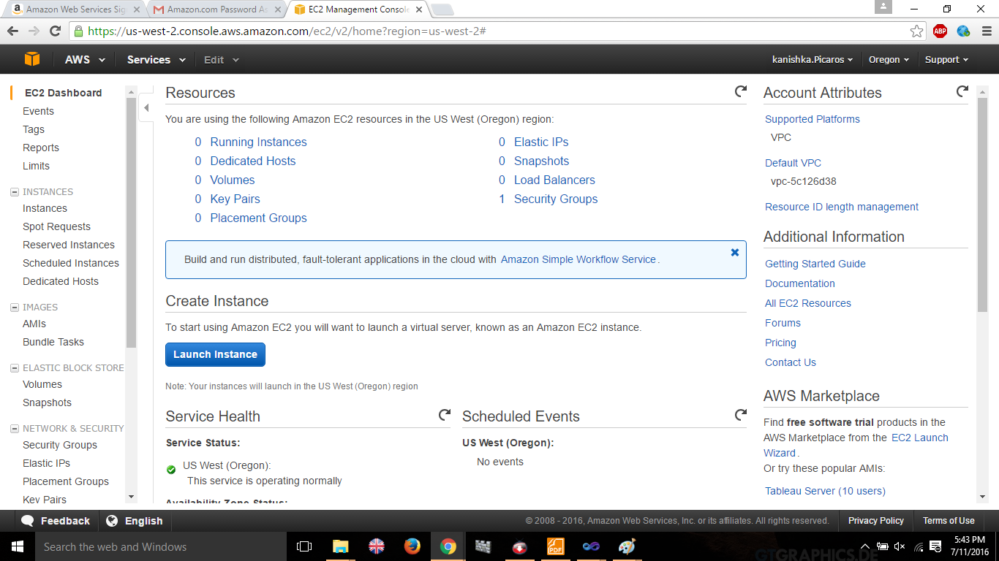
Select required service to create instance.
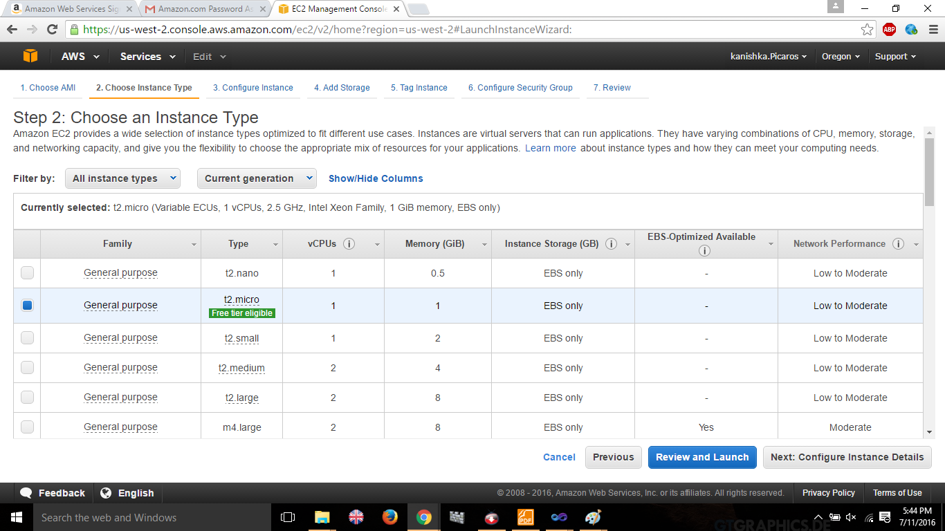

Complete the following requirements
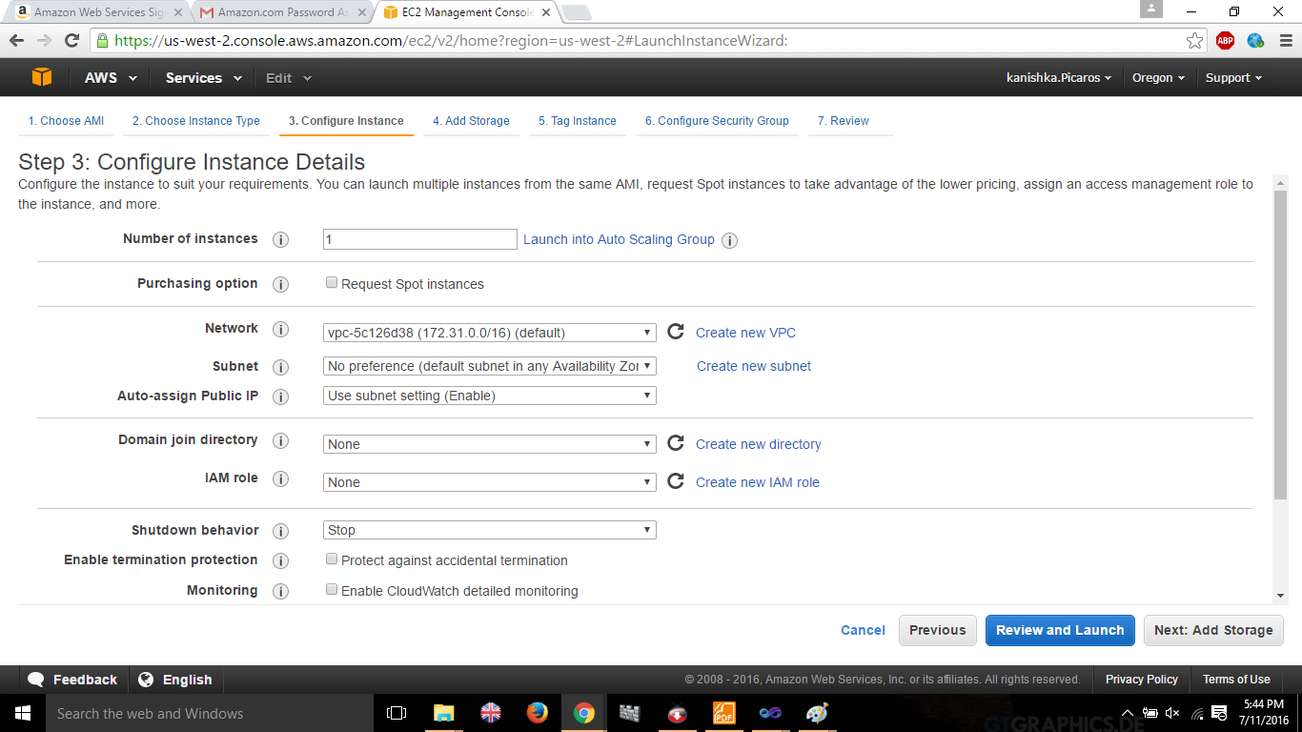

Add the storage details
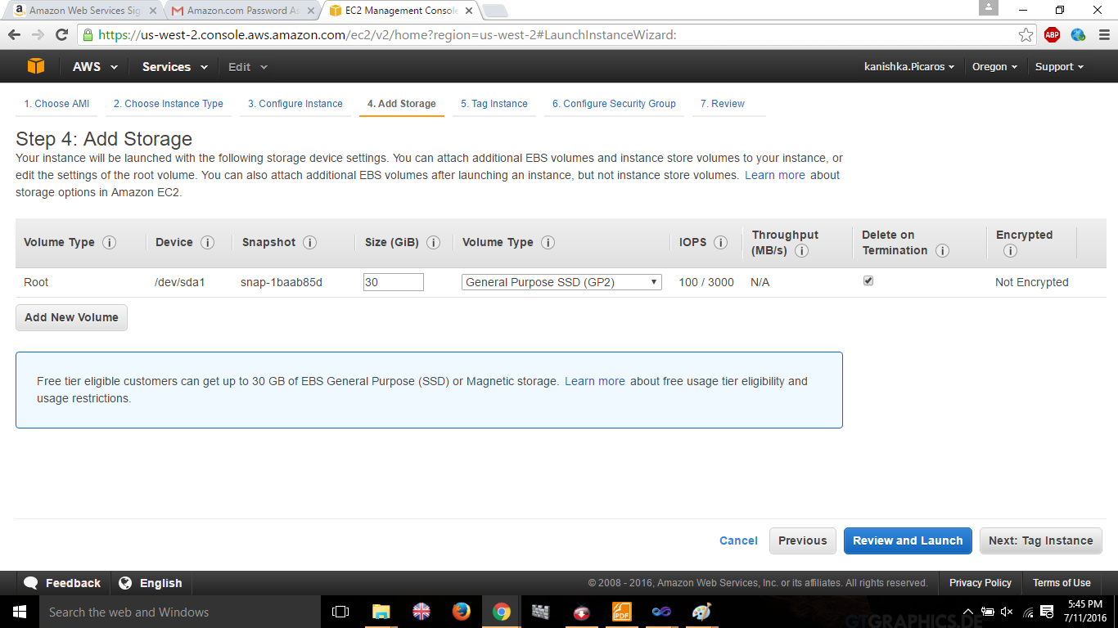

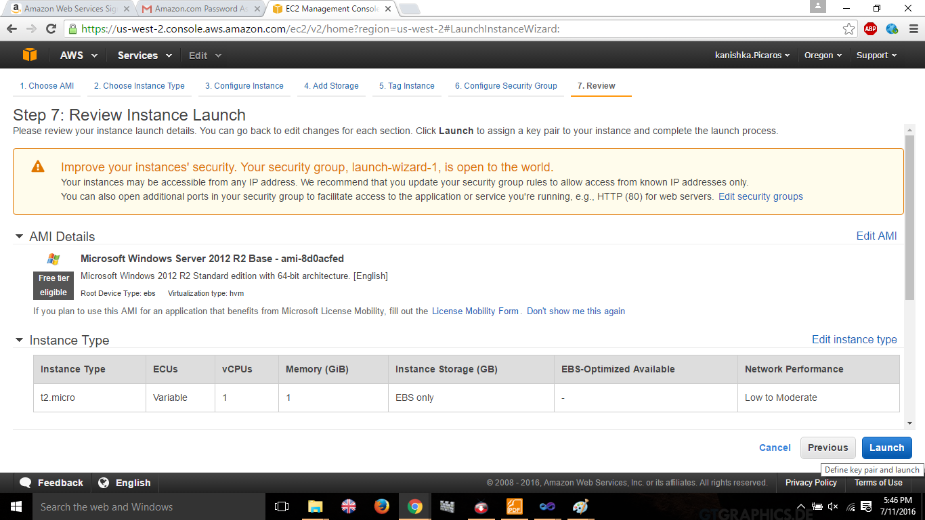

Download key in order to decrypt data that we use
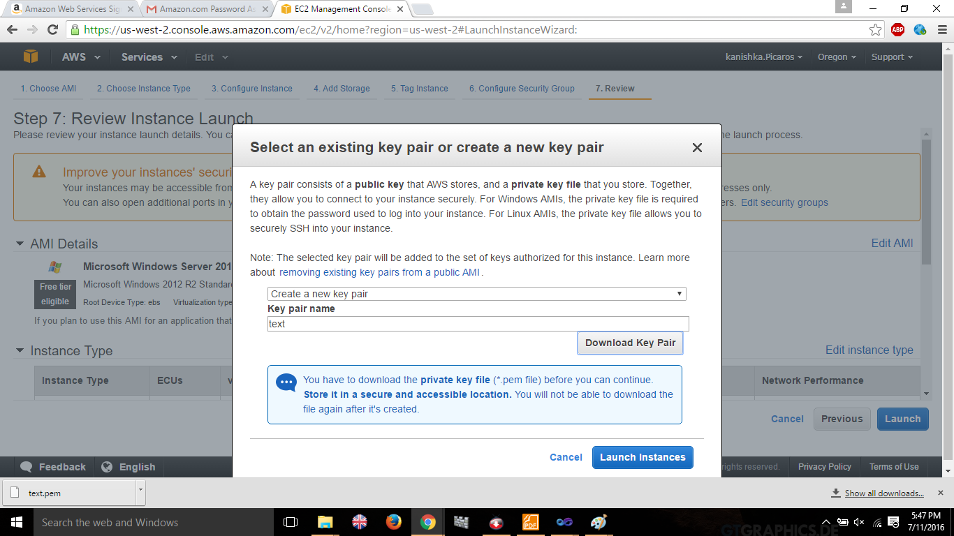

Launch instance
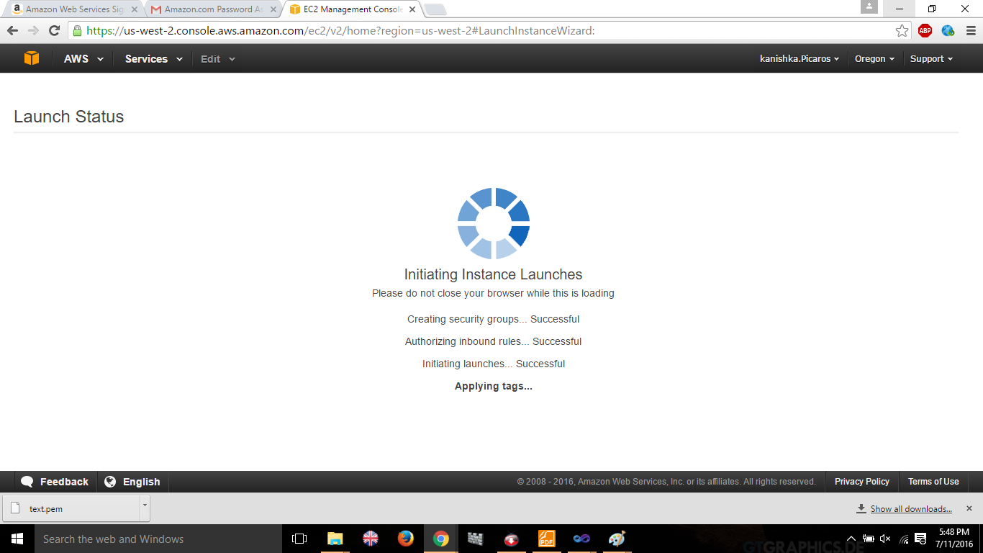

Choose the key in order to decrypt the data

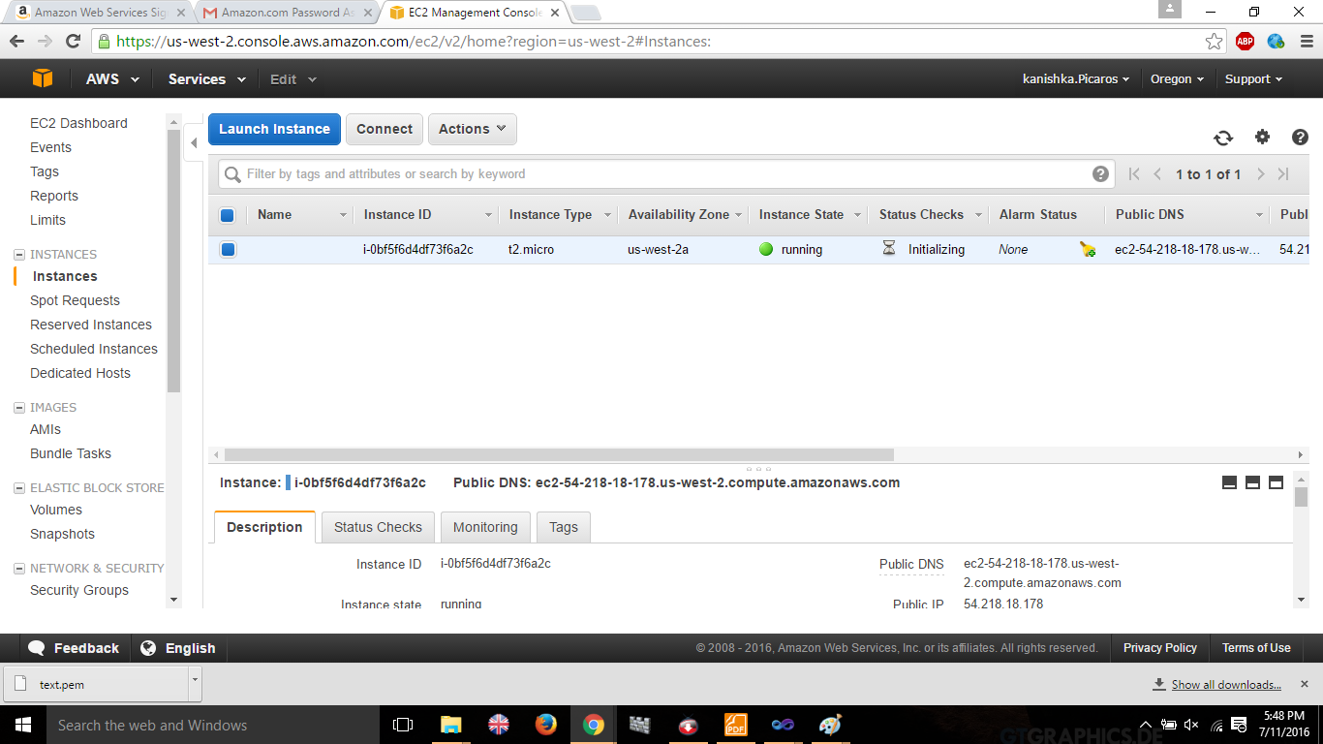

Decrypt the data using the key
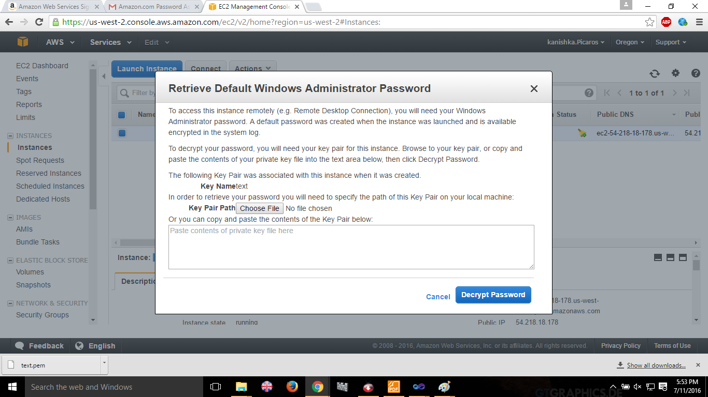
Launch the instance after entering the key
.

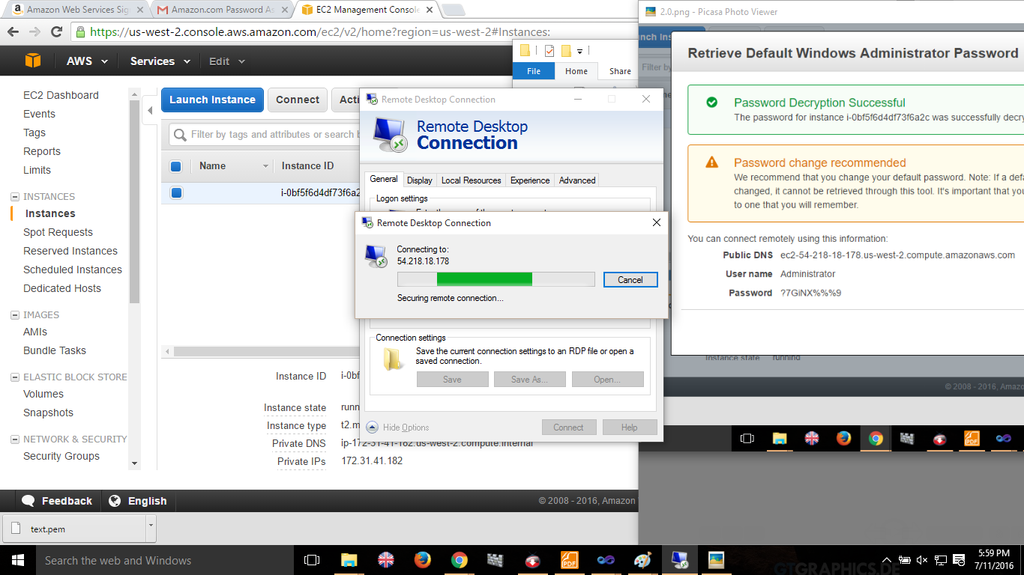

Lab2
Creating a Linux based AMI Service
Choose the linux free tire service.
Click launch instance
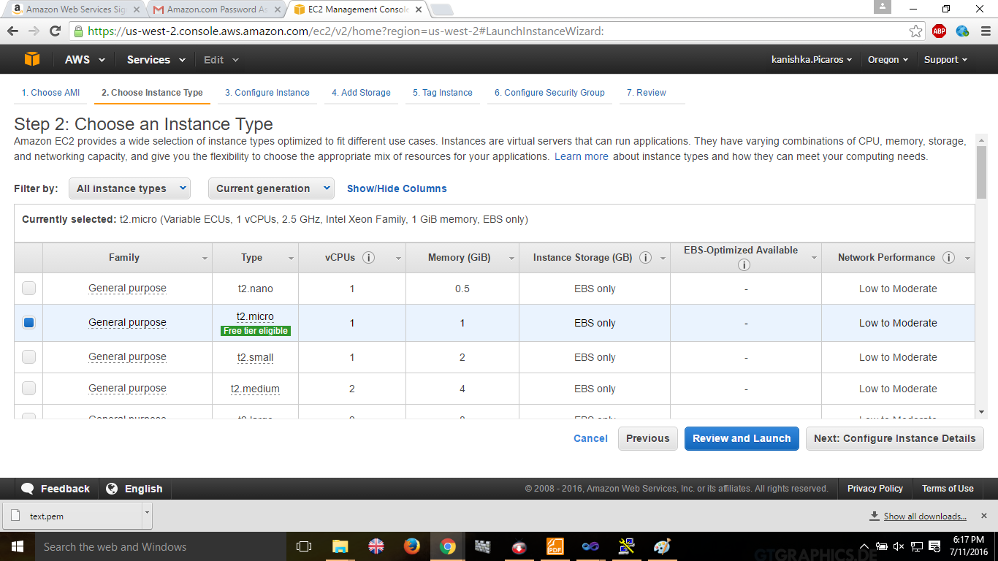

Use the default settings of linux instance to launch , and click on launch
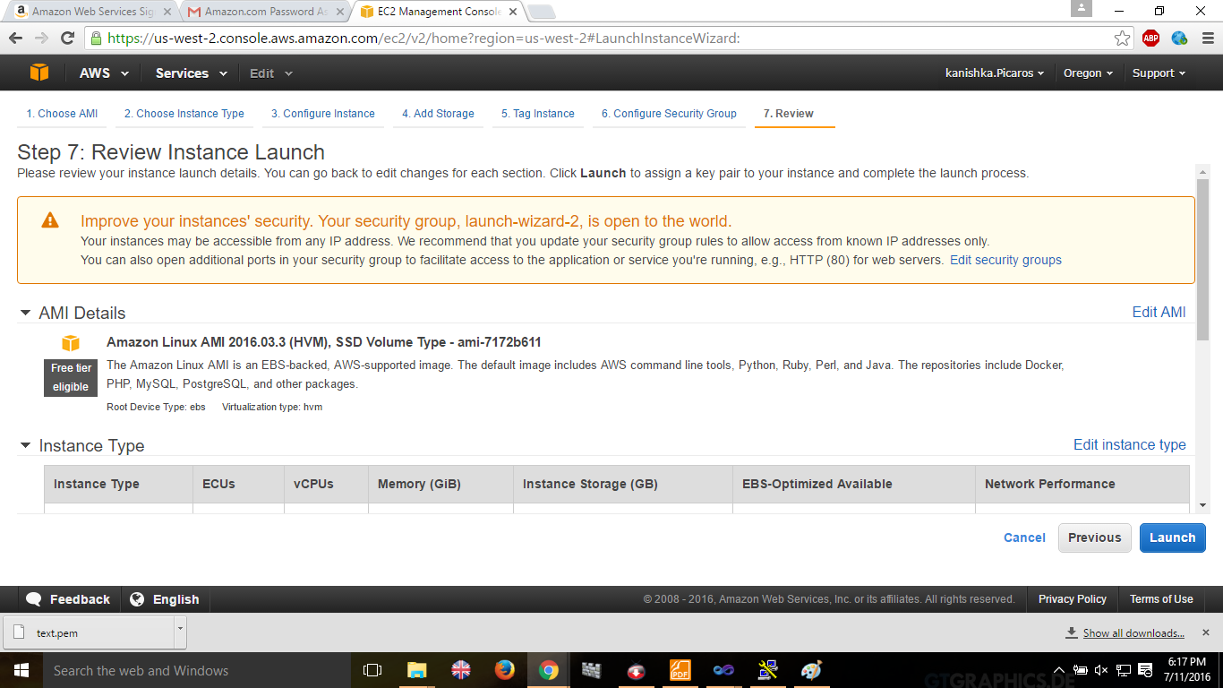

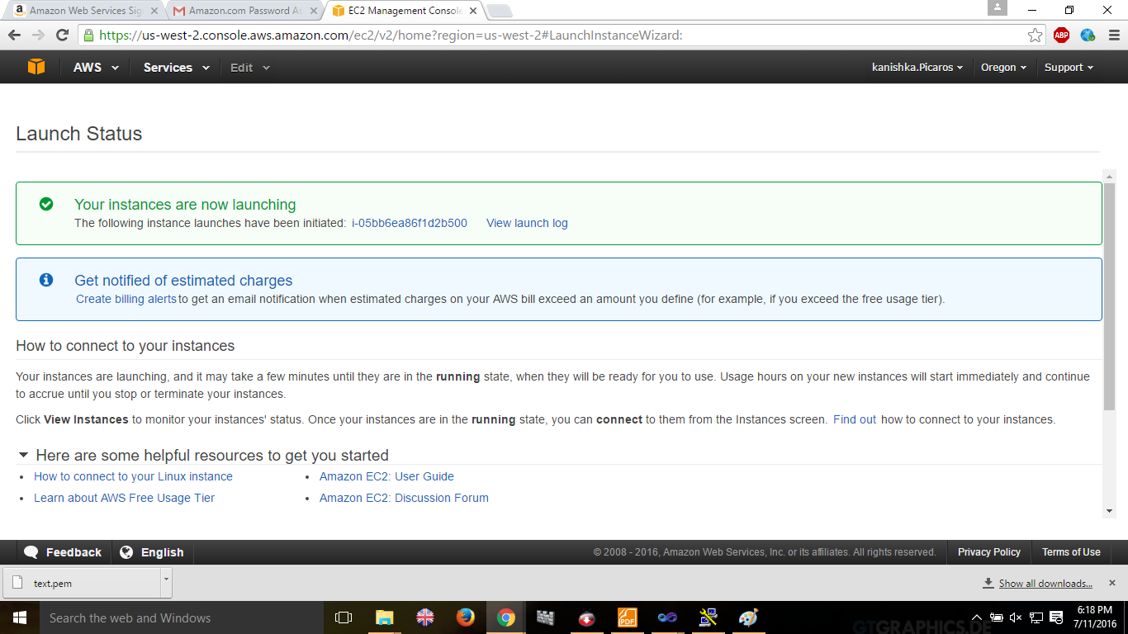

The instance is ready to use
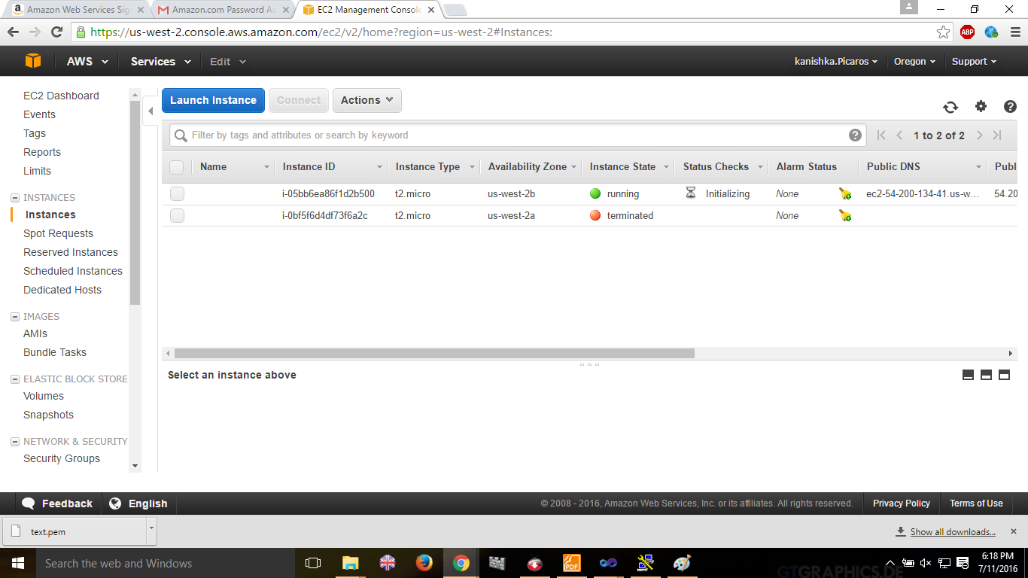

Launch putty gen to create a private key by importing the previously created key wen creating the Linux Instance.
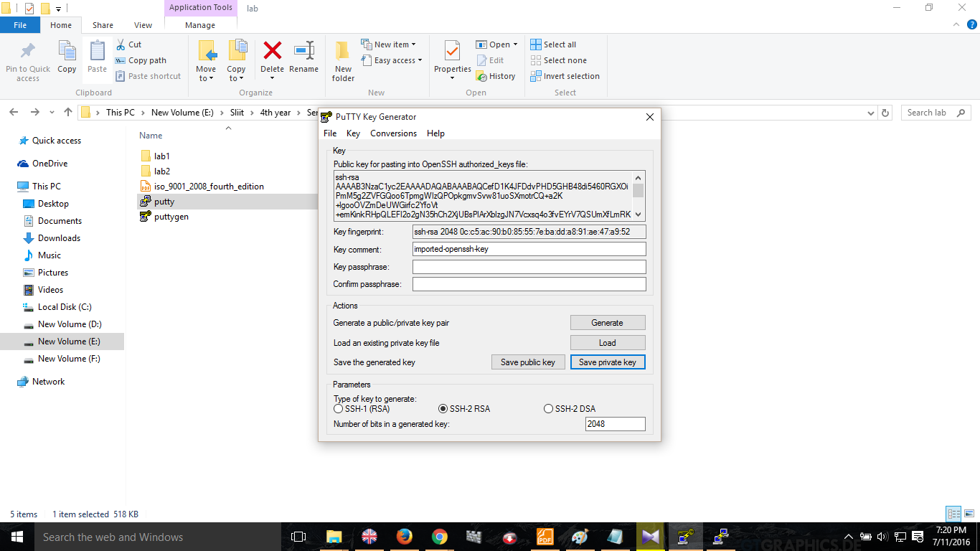

Use the private key when launching service.. And launch service successfully.
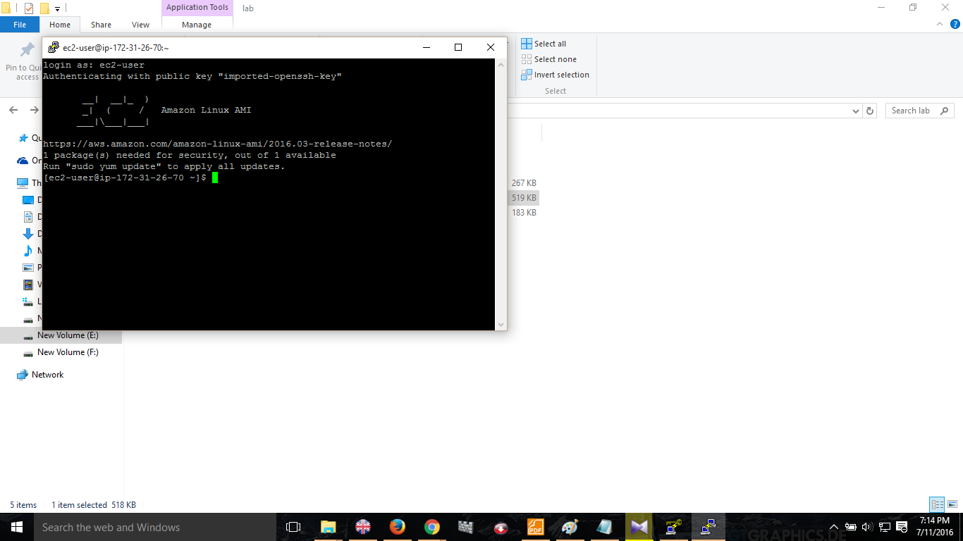

Lab 3-
Creating and launching an Amazon Rational Database Service

Select database service and click on get started now.
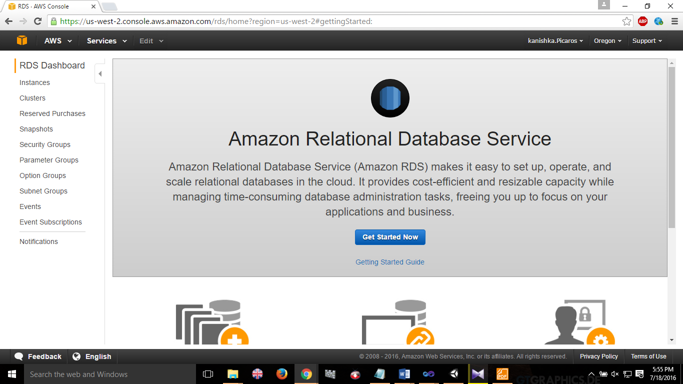

Select a database service type-(I used MySQL)
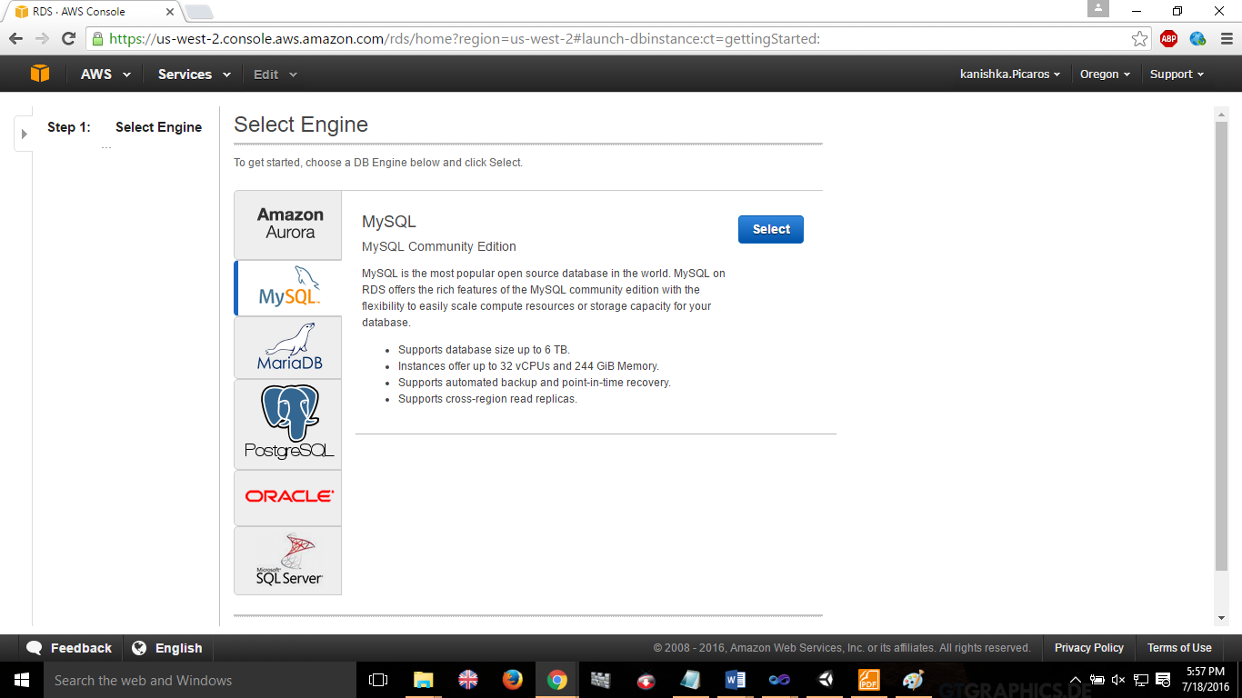

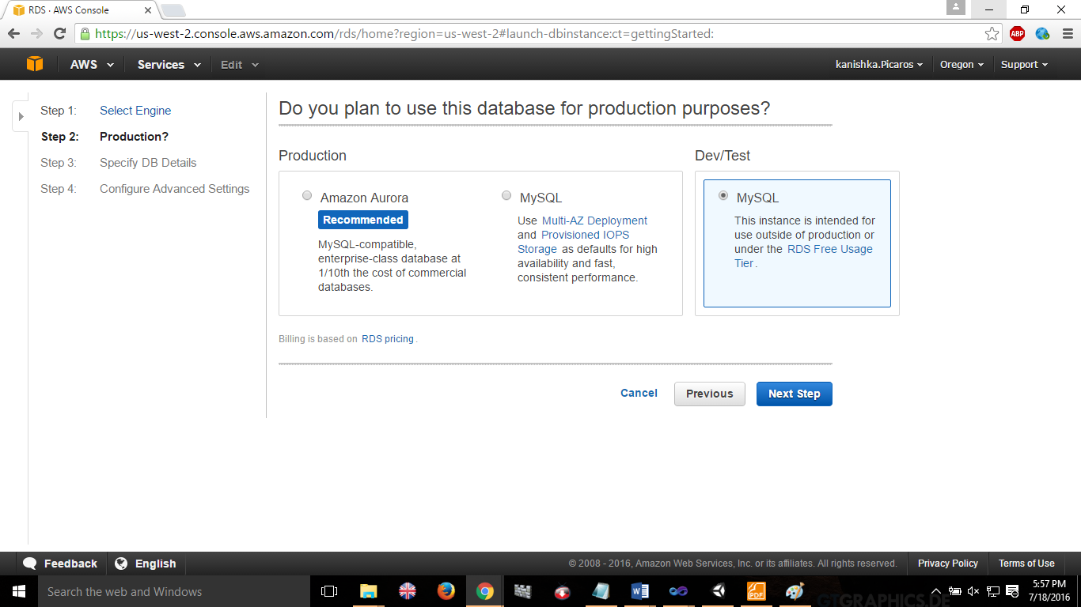

Fill in Database data.
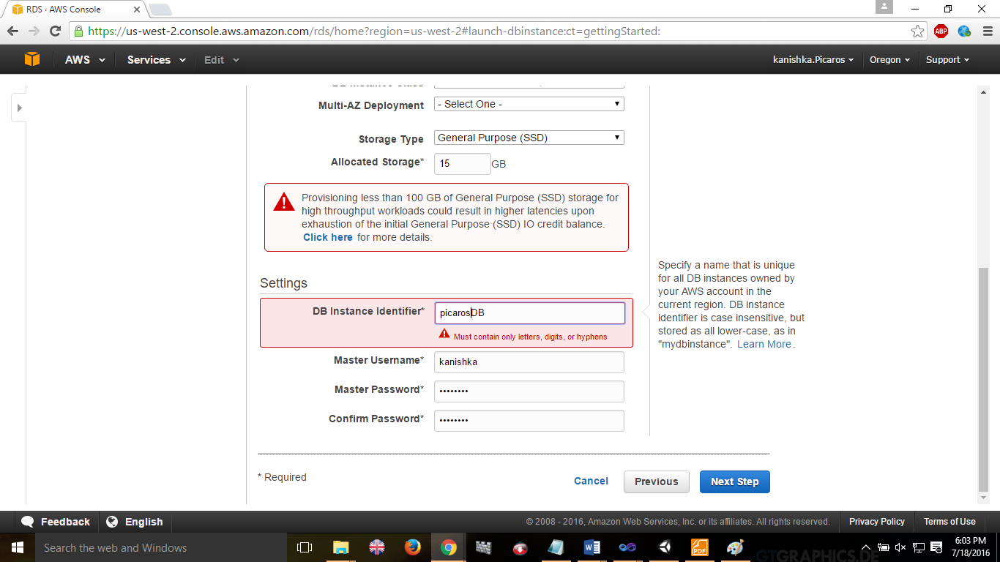

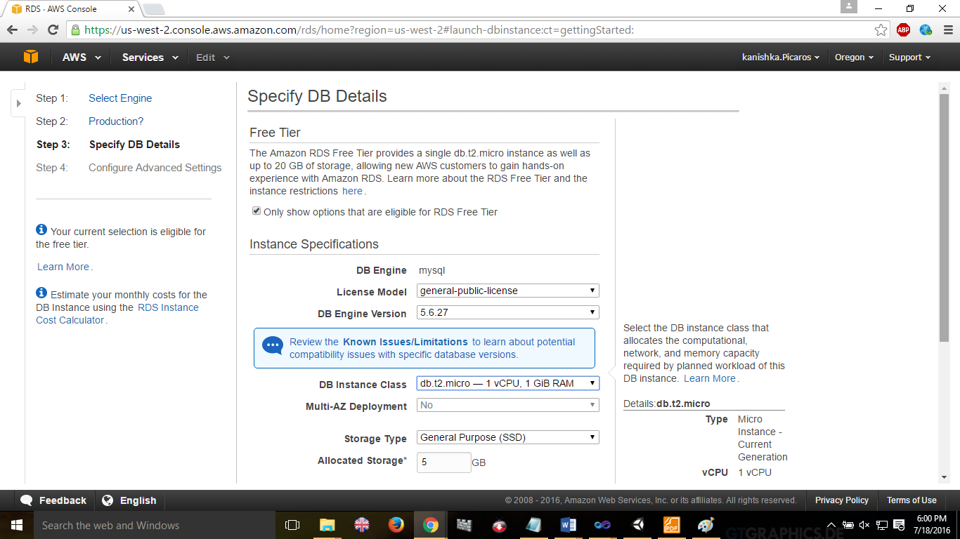

Fill in advance settings of configuration.
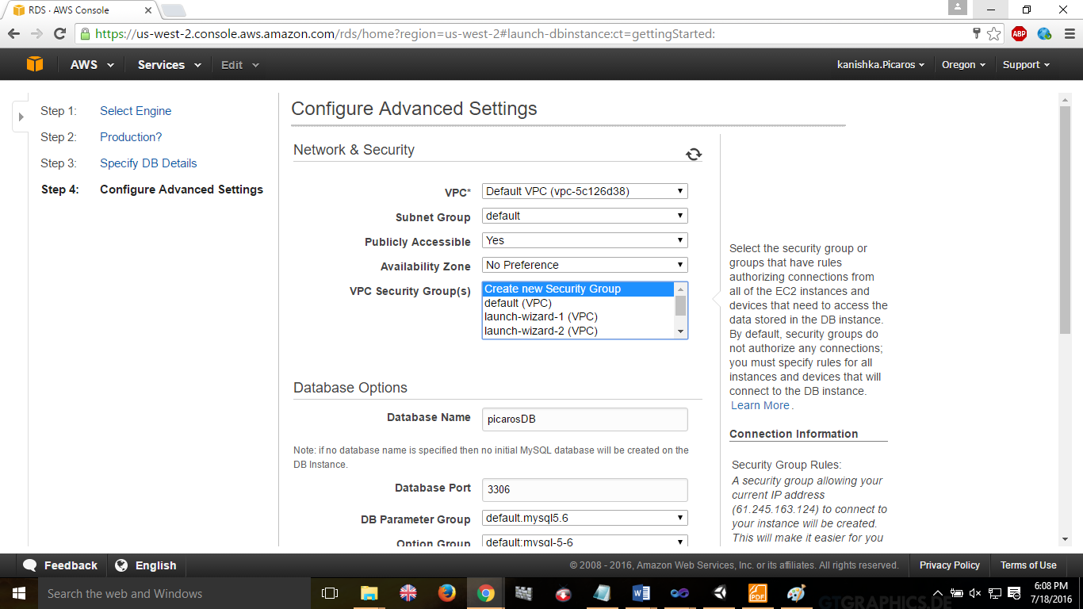

Successfully created database
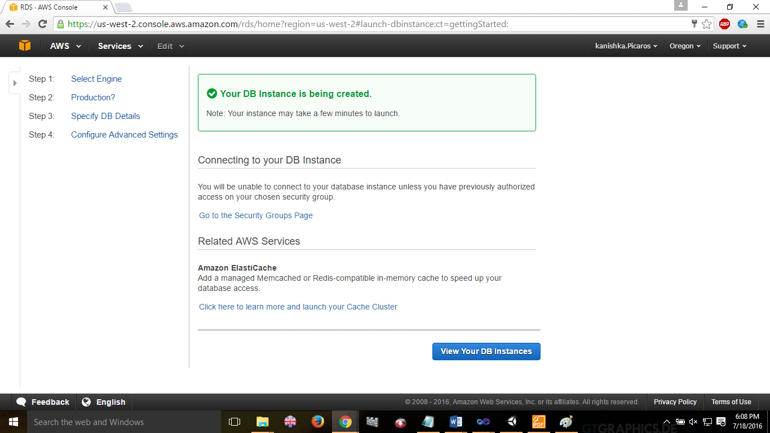

View instance
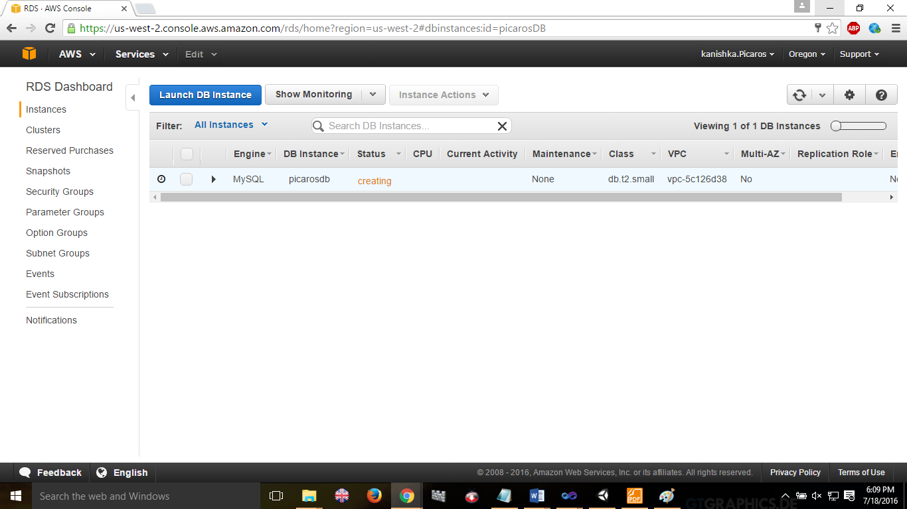

Install MySQL Workbench to use database service easily
Create connection by entering instance url
Then create
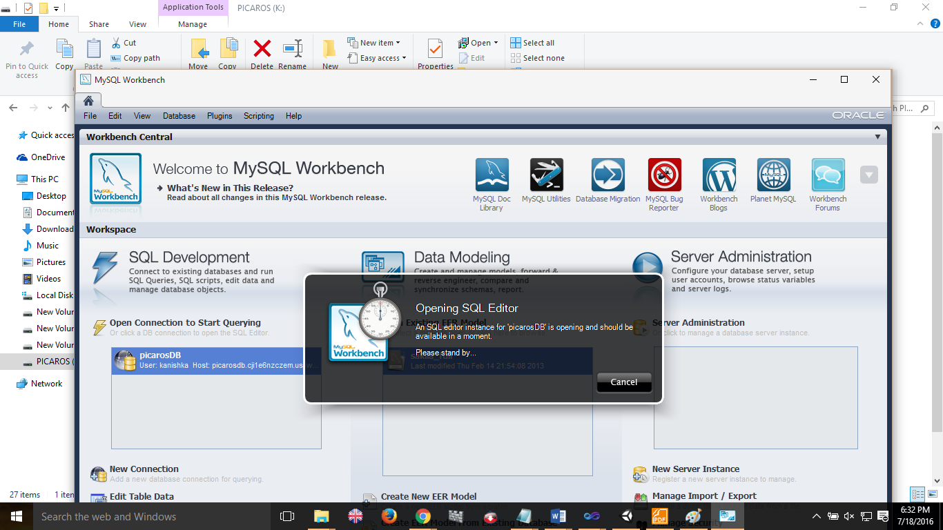

Successfully launce the database services.
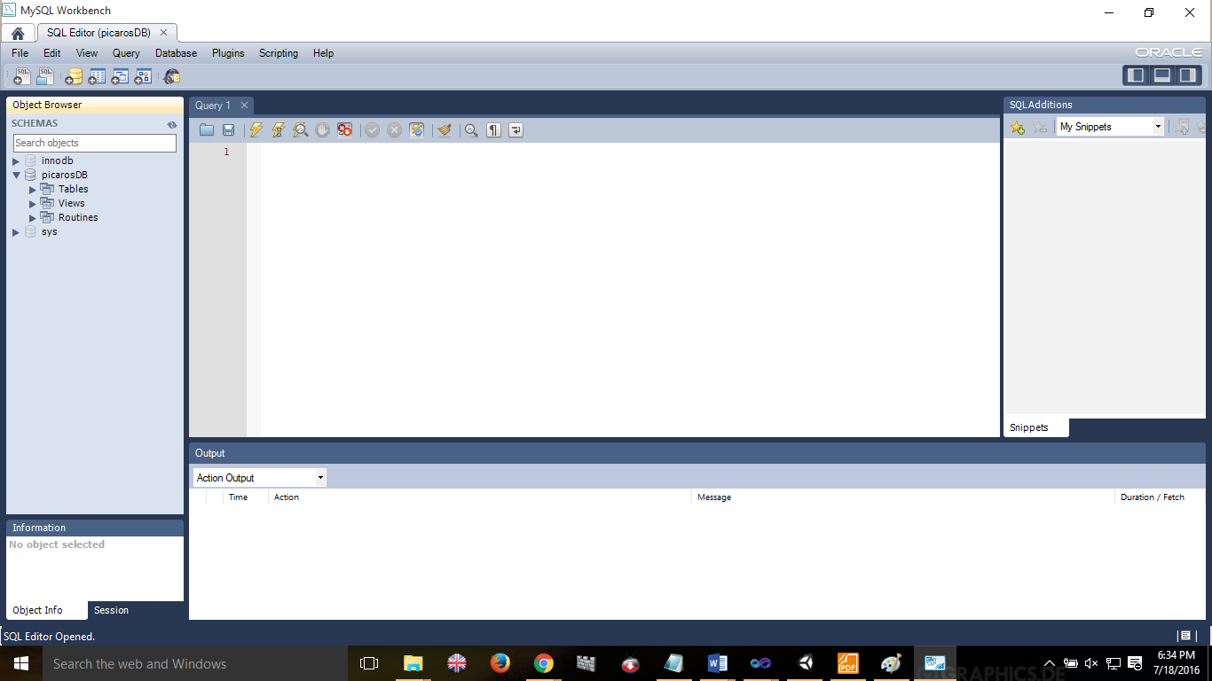

Execute db commands in commandline
