**SPACE IMPACT**

Space impact is the game that user controls the spaceship fight with monsters .To win this game user have to kills the boss of monster that come in the end of game. But if user had attack by monster and hp(health point) is 0 game will end and user is lose. The 5 highest score will be kept and shown.

**MENU**

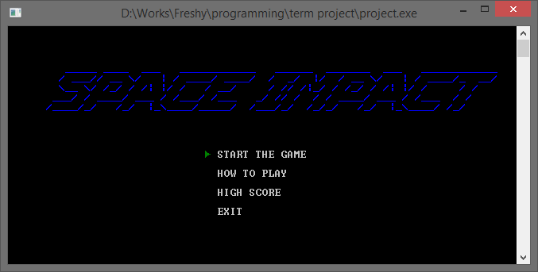

When enter the program there will have 4 choice for you.

1. START THE GAME to enter to play game.

2. HOW TO PLAY to see how to play this game.

3. HIGH SCORE to see 5 highest score that user can get.

4. EXIT to quit the program

**RULE & INSTRUCTION**  
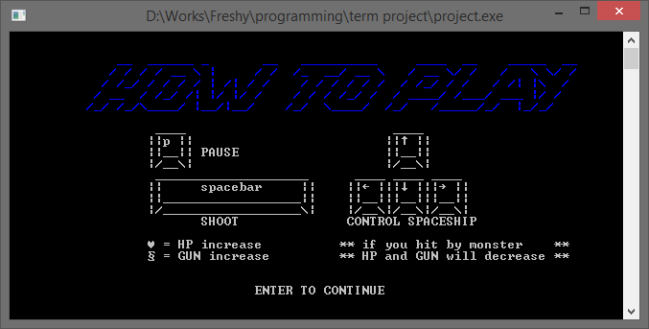

This game control by using the keyboard the program will keep the button that user key in change to movement in the game.

-Arrow pad = control spaceship.

-Space bar = shoot.

-P = pause the game.

You have to control the space ship avoid from monster and kill them. If you can kill the boss you will win the game but if you die you lose.

In the game there are items that help you win the game don’t forget to get it.

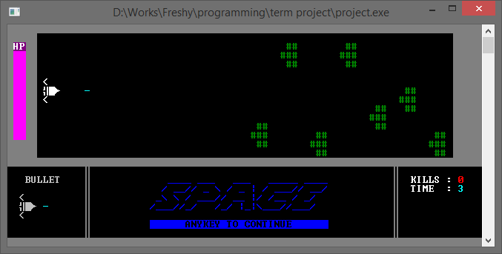**GAME PLAY**

When the game start there will be a lot of monster came to front of you. You have to kill or avoid them don’t let them attack you. When time past 40 sec. monster will come more units you have to focus to the game. When time past 70 sec the boss will come out if you can beat them you are the winner. If your score is higher than highest score you are new high score.

