HW5

Sahar Toulabi

2023-10-12

#import data and selected only Denver

homicides <- read_csv("/Users/sahartoulabi/Library/CloudStorage/OneDrive-Colostate/PostDoc/Classes/R ProgrammingForResearch_2022/Homework/HW5/homicide-data.csv")

## Rows: 52179 Columns: 12  
## ── Column specification ────────────────────────────────────────────────────────  
## Delimiter: ","  
## chr (9): uid, victim_last, victim_first, victim_race, victim_age, victim_sex...  
## dbl (3): reported_date, lat, lon  
##   
## ℹ Use `spec()` to retrieve the full column specification for this data.  
## ℹ Specify the column types or set `show_col_types = FALSE` to quiet this message.

# to make sure Denver is one of the cities  
homicides %>%   
 select(city) %>%   
 distinct() %>%   
 pull()

## [1] "Albuquerque" "Atlanta" "Baltimore" "Baton Rouge"   
## [5] "Birmingham" "Boston" "Buffalo" "Charlotte"   
## [9] "Chicago" "Cincinnati" "Columbus" "Dallas"   
## [13] "Denver" "Detroit" "Durham" "Fort Worth"   
## [17] "Fresno" "Houston" "Indianapolis" "Jacksonville"   
## [21] "Kansas City" "Las Vegas" "Long Beach" "Los Angeles"   
## [25] "Louisville" "Memphis" "Miami" "Milwaukee"   
## [29] "Minneapolis" "Nashville" "New Orleans" "New York"   
## [33] "Oakland" "Oklahoma City" "Omaha" "Philadelphia"   
## [37] "Phoenix" "Pittsburgh" "Richmond" "San Antonio"   
## [41] "Sacramento" "Savannah" "San Bernardino" "San Diego"   
## [45] "San Francisco" "St. Louis" "Stockton" "Tampa"   
## [49] "Tulsa" "Washington"

#Making Denver dataset   
denver_homicides <- homicides %>%   
 filter(city == "Denver")  
  
#group all unsolved homicides together in "unsolved" column  
denver_homicides <- denver_homicides %>%   
 mutate(unsolved_homicides = disposition == "Closed without arrest" |   
 disposition == "Open/No arrest")   
  
# mutate TRUE and FALSE in "unsolved" column to "Solved" and "Unsolved"  
denver_homicides <- denver_homicides %>%   
 mutate(unsolved_homicides = as_factor(x = unsolved_homicides),  
 unsolved_homicides = fct_recode(unsolved_homicides, Solved = "TRUE",   
 Unsolved = "FALSE"))  
# check towns  
denver_homicides %>%  
 mutate(victim_race = fct_lump(victim_race, n = 3)) %>%  
 count(victim_race)

## # A tibble: 4 × 2  
## victim_race n  
## <fct> <int>  
## 1 Black 113  
## 2 Hispanic 94  
## 3 White 95  
## 4 Other 10

#sf map of denver,colorado To download boundaries for some sub-city geography (e.g., tracts, block groups, county subdivisions)

counties <- counties(state = "CO", cb = TRUE, class = "sf",   
 progress_bar = FALSE)

## Retrieving data for the year 2020

blocks <- block_groups("CO", "Denver", progress_bar = FALSE)

## Retrieving data for the year 2020

ggplot() +  
 geom_sf(data = blocks, fill = "darkcyan", alpha = 0.5)

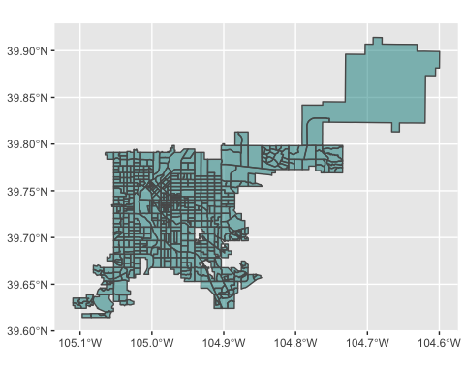 #adding the homicides  
to show as a layer underneath the points showing homicides. Use different facets for solved versus unsolved homicides and different colors to show the three race groups with the highest number of homicides

denver_homicides <- st_as_sf(denver_homicides, coords = c("lon", "lat")) %>%   
 st_set_crs(4269)  
  
denver_homicides <- st_transform(denver_homicides, st_crs(blocks))  
  
ggplot() +  
 geom_sf(data = blocks, fill = "darkcyan", alpha = 0.5) +  
 geom_sf(data = denver_homicides, aes(colour = city)) +   
 facet_wrap(~ unsolved_homicides)

