Peer Review Report

1. Manual Testing
Following the steps outlined in the ReadMe file, I completed the installation of the environment and configured the necessary conditions for operation. However, I encountered difficulties when attempting to start the server.
Initially, the remote server refused connections, with the terminal indicating that the introducer file could not be located. This confirmed that the introducer file was not being invoked. Consequently, I created three new terminals to establish connections between the server and the introducer port.

After the connection was established, I attempted to start the server.
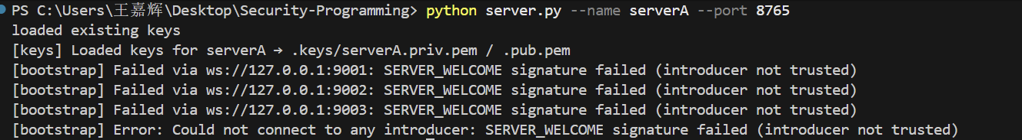
Meanwhile, the other three terminals displayed a message indicating that the remote server had refused the connection.
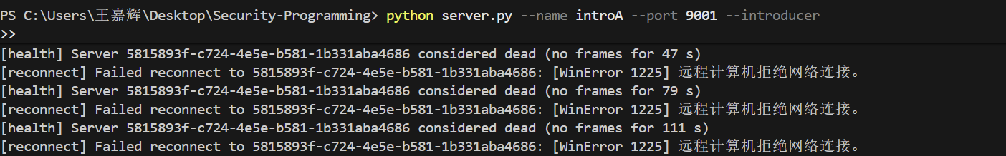
Taking into account the recommendations in the ReadMe file
I choose to follow and try again.
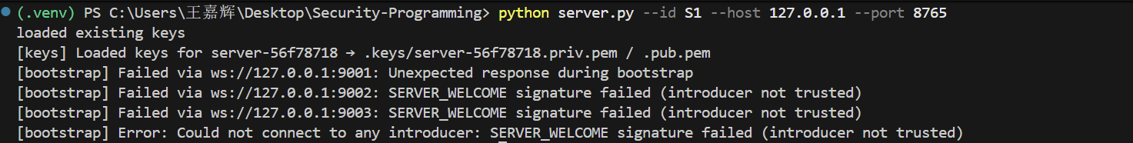
However, the outcome was evident: the connection request was still denied. Consequently, I had no choice but to resort to alternative methods for verifying the file.

Bandit Results Summary
Static analysis tool: Bandit (Python static security checker). Command：bandit -r .
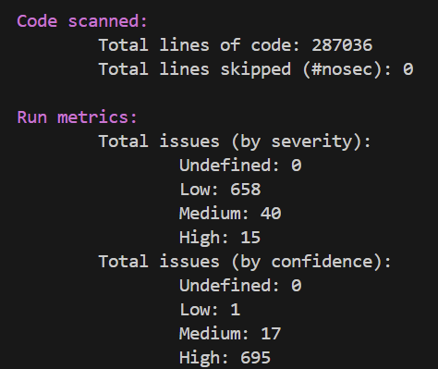
File | Issue ID | Description | Severity
client.py | B110 | try/except: pass (silent exception handling) | Low
TestingClient.py | B322 | Use of input() flagged (unsafe in py2 contexts) | High
server.py | B105 | Hardcoded password / default credential | High
datavault.py | B608 | SQL uses string formatting (possible injection) | Medium
quarantine/poc_weak_key_register.py | B505 | Weak RSA key generation (1024-bit) | High
multiple files | various | use of bare except, logging swallowed exceptions | Medium/Low
1.except: pass
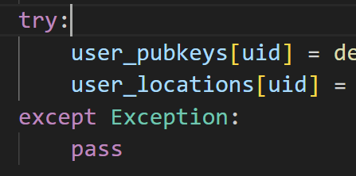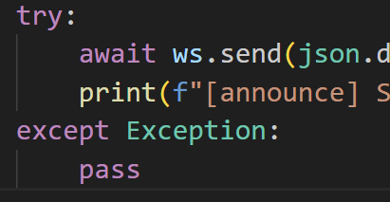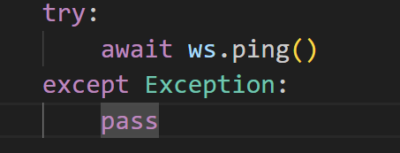
Location：Network/I/O processing branches appearing in server.py / client.py
Possible outcomes：Signature verification failures, database failures, connection anomalies, and similar issues are silently ignored, causing the programme to enter an inconsistent state; security events (such as BAD_USER_SIG) are not logged.
Recommendation:The `except: pass` clause may be modified to capture specific exceptions, with mandatory logging and alerting (or inclusion in monitoring) required for critical paths (signature verification, database writes).
2.Hardcoded password / default credential (B105)
Location:Placeholder fields for user registration/persistence in server.py
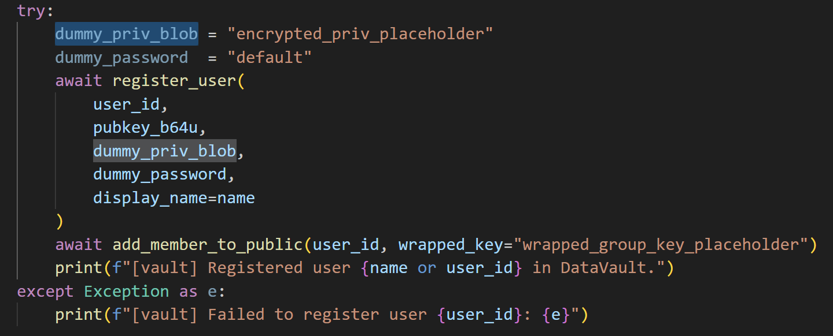
Possible outcomes:Should placeholder passwords or plaintext credentials be misused in production processes, this may result in arbitrary keys being decrypted or authentication being bypassed, thereby enabling attackers to recover private keys or impersonate users.
Recommendation:Hard-coded credentials may be removed; instead, store them using environment variables or secure keys (such as an encrypted secrets manager).
- SQL
Location:datavault.py / database operations: Use f‘SELECT * FROM {table}’
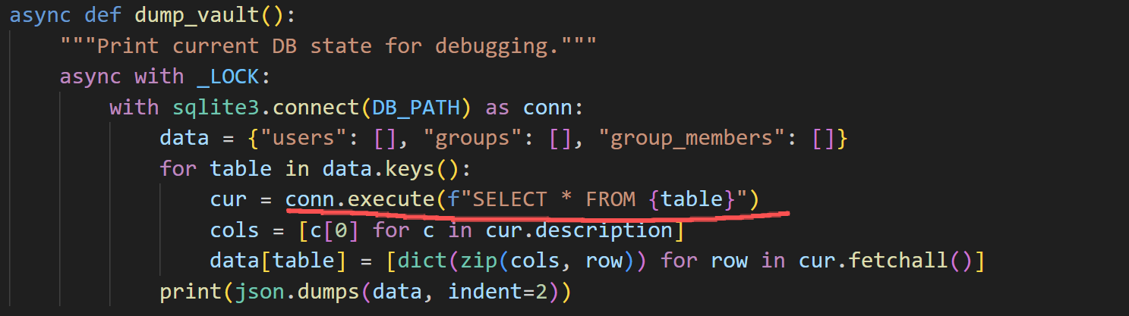
Possible outcomes:Should table/column names or other SQL fragments originate from controllable input, this may lead to SQL injection or unintended SQL execution.
Recommendation:Employ parametric queries (for values) or implement whitelist validation for identifiers (for lists)

3.BackDoor
BackDoor | Location | The outcome that will arise
Backdoor1 — Weak key acceptance | Within keys.py, there exists a conditional statement: if os.getenv(‘BACKDOOR_WEAK_KEYS’) == ‘1’: This then permits the generation or acceptance of key_size=1024, or directly bypasses the minimum key length check. | Forging signatures (impersonating users or servers)  Decrypting messages / file transfers that should remain confidential
Backdoor 2 — Unsigned gossip acceptance | Within the branch handling USER_ADVERTISE in server.py, when the BACKDOOR_TRUST_GOSSIP environment variable is set to true, the rsa_pss_verify(...) verification is bypassed or USER_ADVERTISE is accepted outright, even if the signature is missing or verification fails. | Injecting forged users and intercepting messages intended for them (identity hijacking / information theft);  Injecting forged server entries to influence routing / forwarding, enabling man-in-the-middle (MITM) attacks or message tampering;

4. Strengths
- Proper use of modern crypto primitives in core flows: RSA-OAEP for confidentiality and RSASSA-PSS for signatures.
- Maintain a standardised JSON signature to prevent format mismatches.
- A sound modular architecture (client/server/key/database) facilitates targeted fixes.

5.Recommendations
- Remove/disable PoCs from the main branch or place them behind CI flags; enforce minimum RSA key size checks.
- Fix hard-coded default credentials and ensure private keys are encrypted at rest.
- except: pass ,Replace exposed events with explicit error handling and logging.

Conclusion:
Static analysis (Bandit) combined with manual review has identified several high-priority security issues, primarily centred on key management, hard-coded credentials, and silent exception handling. These are recommended for prioritised remediation.

