* Use Postman to perform 5 different GET requests to retrieve 5 different Pokemon of your choice. Here is a link to the [Pokemon API DOCS](https://pokeapi.co/docs/v2" \t "_blank).

1. Get 🡪 <https://pokeapi.co/api/v2/pokemon/1> --> to get the pokemon with id =1

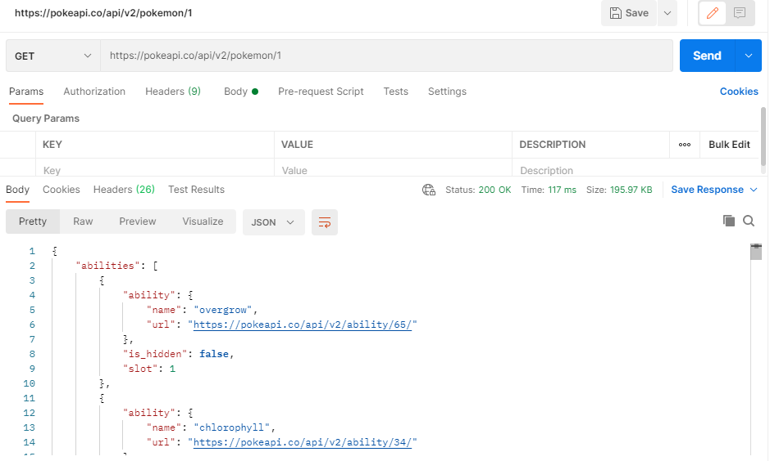

1. Get 🡪 <https://pokeapi.co/api/v2/pokemon/25-->> to get the pokemon with id=25

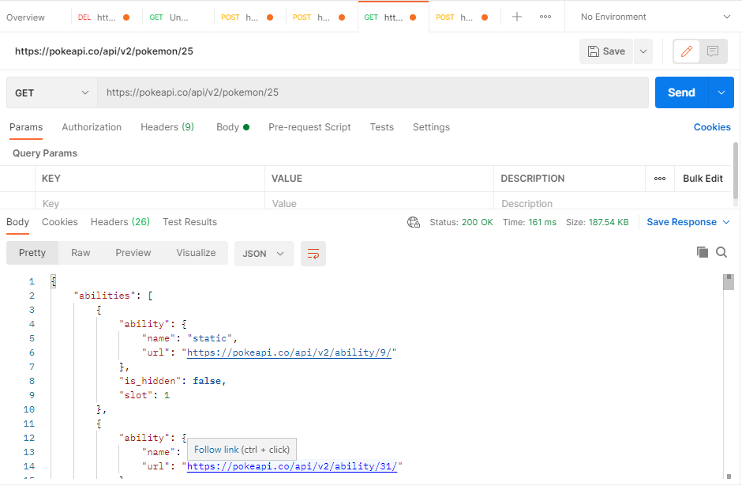

1. Get 🡪 <https://pokeapi.co/api/v2/pokemon/bulbasaur> 🡪 get the pokemon with name= bulbasaur

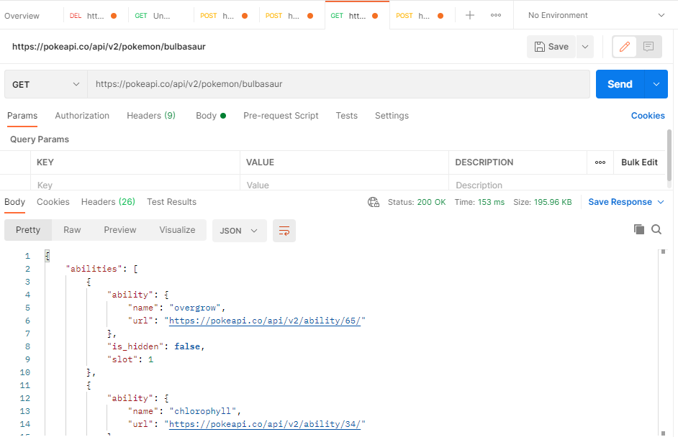

1. Get 🡪 <https://pokeapi.co/api/v2/pokemon/ditto> 🡪 get the okemon with name= ditto

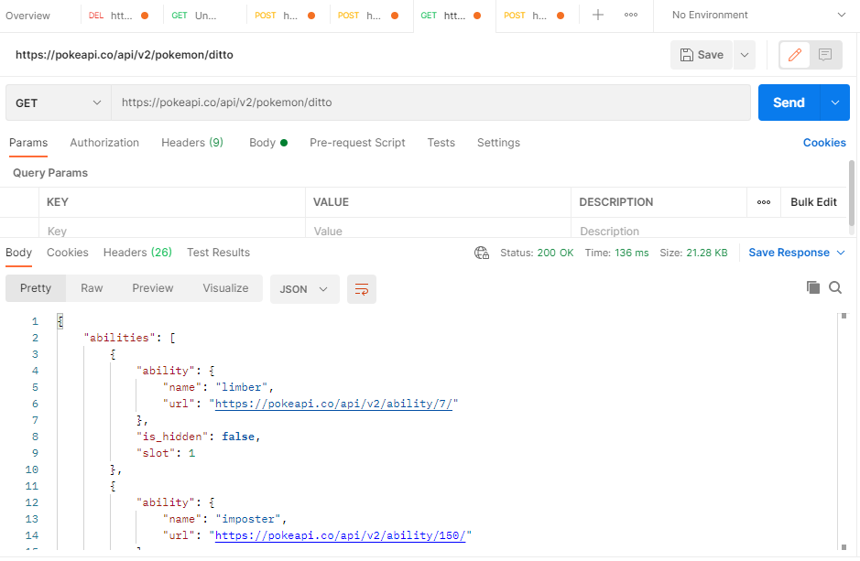

1. Get 🡪 <https://pokeapi.co/api/v2/pokemon/4> --> to get the pokemon with id=5

