Friendships table

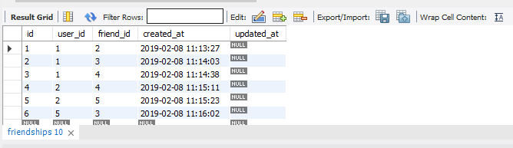

User2 and users table

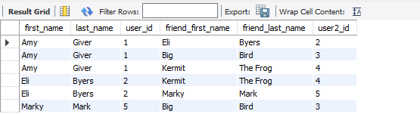

Users table

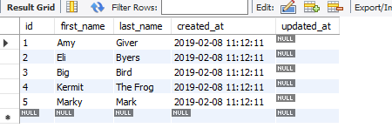

We joined friendships table with users table on the users_id as we know, and then we did rejoined for the users table again but as users2 and we joined it on the id since user2.id is equivalent to fiendships.fiend_id, and then we will get an output as the table provided in the question.