Introduction

Sahar Zalavi B01024509
Wireframe
Home page
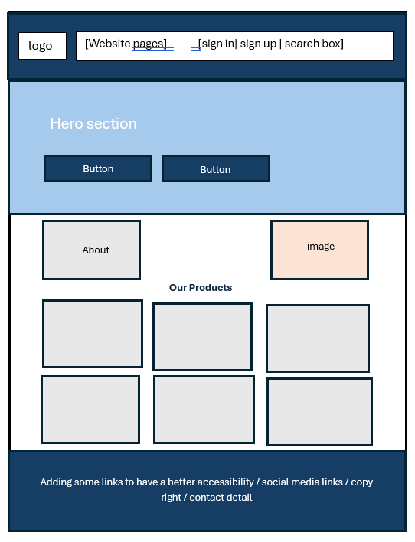

Our Product page
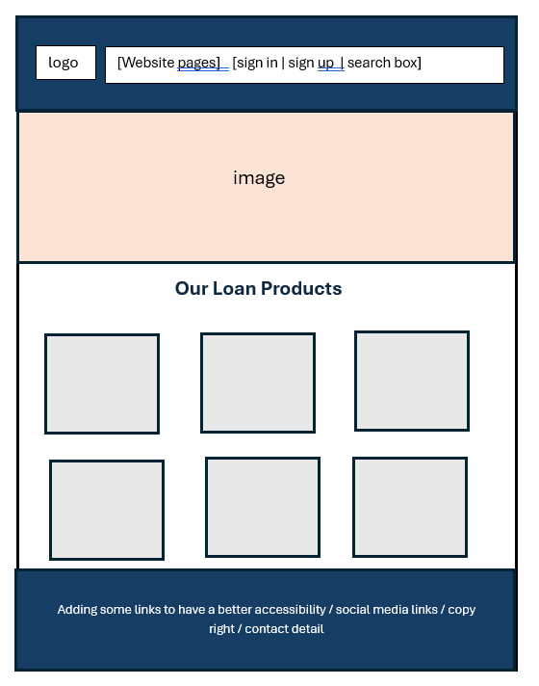
Telling browser that this document is written in HTML5. It ensures modern standards are applied
Specifying the language as English, it helps the browser and search engine to understand the content language

Setting the character encoding to UTF-8, it ensures that the page supports all characters
Controlling how the page looks on mobile devices. It matches the screen width and sets default zoom
Adding a small logo icon in the browser tab, it improves branding and makes the website look professional
Showing website’s name in browser tab and helps improve visibility on search engine through SEO
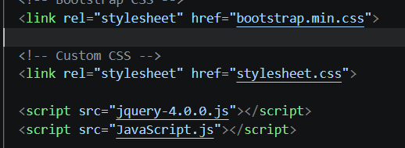
- Bootstrap provides predesigned style and layout tools to help create a responsive and visually consistent website
- Linking the external stylesheet and JavaScript file to HTML file, it makes the code easier to manage, update and reuse
- jQuery library simplifies JavaScript tasks

the header tag to have the nav bar with bootstrap class. The header is flexbox container to easily arrange items in a row or column
Creating clickable button to interact with navigation menu on smaller screens. Using a class to style the button using CSS and target it in JavaScript. Id is a specific identifier to easily access and control it by using JavaScript. The label provides text description for screen readers. It improves accessibility. This 6. &#9776; displays the menu button’s icon

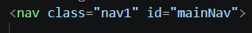
Creating navigation section to contain menu links and site navigation
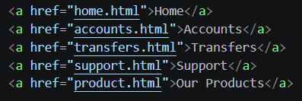
Anchor tag that makes a text clickable to takes the user to the other pages. The href= “” specifies the destination.
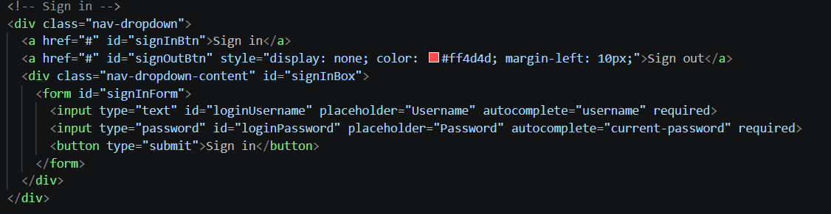
This section is creating a sign in link. The class is for having drop down container. Then I created a sign out link. It will appear in red colour after the user sign in to allow the user sign out. Then I created a form to allow the user sign in. Type attribute defines what kind of element it is and how it should behave. Autocomplete helps browser fill data. The placeholders show hint text. Both inputs are required it means it is mandatory.

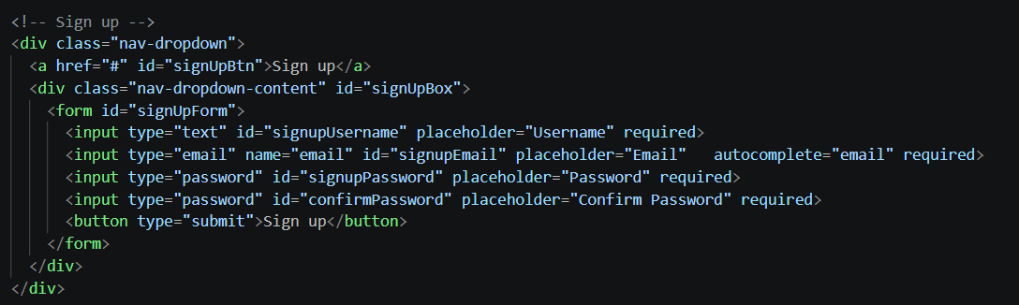
the type of email ensures the user enters a valid email format. Confirm password is to make sure the user type the same password twice basically it prevents mistakes when creating an account.
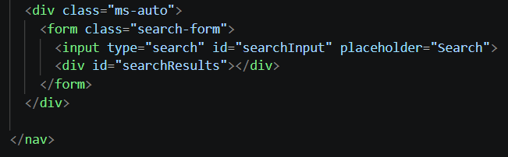
Div’s class is for pushing the whole section to the right side of navigation bar
Creating search form to group the search input for handling user’s input and submission
I created an empty container to display search results dynamically by using JavaScript
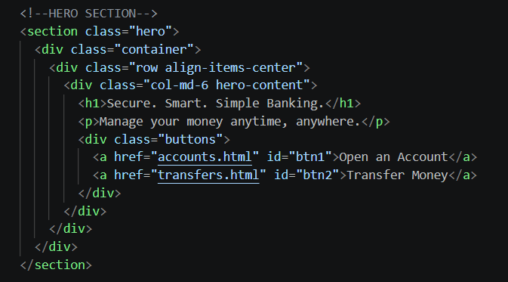
Section tag is to group the main introductory content together. First div class is to make the layout responsive and neatly structured. Second div class is to create a row and vertically centres content. The third div class is to create a column that takes half the width on medium screens. The button’s class is to group the buttons to style them easily.
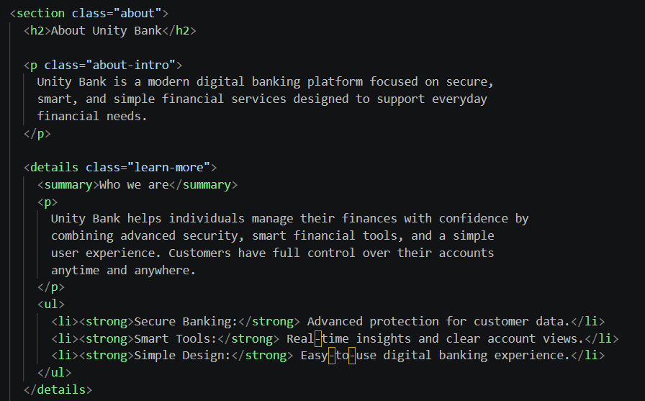
Section tag is to group all information together and style it. Details tags is to create a collapsible section that can be opened and closed. It hides extra information and keep the page clean. Summary tag is to make clickable title of dropdown that user can click to expand and see more details. <ul> tag is to make bullet points. <li> to make list items. <strong > to make the text bold
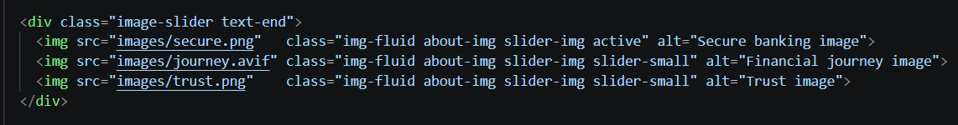
Div class image-slider used for styling or JavaScript, text-end is for aligning the images to the right side. Images tags img-fluid makes images responsive, active shows the current image, slider-small to include additional images that can be shown in the slider. alt attribute shows text u in case the image dose not load. It helps search engines understand the image content.
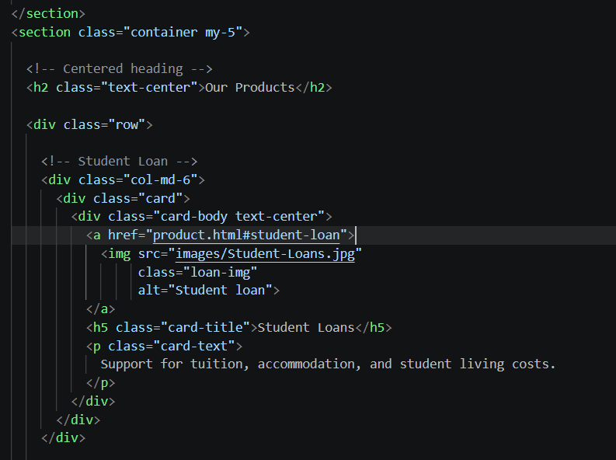
section tag class is to create a container, centres content, my-5 adds vertical spacing
Div class row creates bootstrap grid row to organize products in a structured layout. Div class card is to display content in a clean and structured box. The anchor tag direct the user to the specific section on the product page.
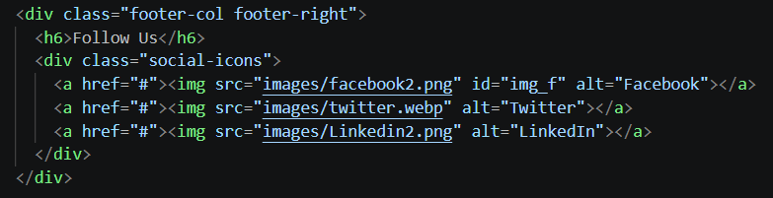
First div class footer-col is for general footer styling, footer-right is to align the anchor tags on the right side. Second div class to group all social medias tags together to style easily. I used # for the href section because there is no real social media for the website.
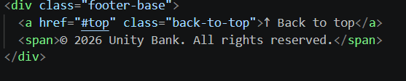
Div class creates a container for the bottom part of the footer. Anchor tag creates clickable link that allows the user to quickly return to the top of page href=#top refers to the body’s id. Between the span tags shows the ownership of the website.
JavaScript part
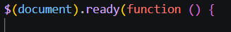
This line ensure that JavaScript code runs after the webpage has fully loaded, then all elements are ready to be used
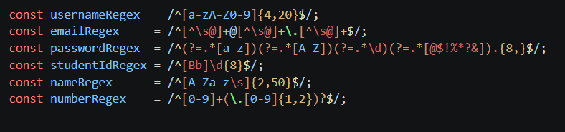
- Username: allows all letters and numbers (0-9) and it should be between 4 to 20 characters
- Email: ^ it makes sure the email starts correctly, [^\s@]+ the email has text before @ and has no space and no extra @, @ all emails should have @, [^\s@]+ make sure there is text after @, \. \ is used to because dot means any characters but with\ it means a real dot, $ end of string to make sure there is nothing extra after the email
- Password: it enforces strong and secure passwords, at least 1 lowercase letter, uppercase letter, 1 number, 1 special character, minimum 8 characters, ?=.* it’s pattern checks that makes sure the password contains required characters
- Studentid: /^ start with B or b, \d {8} contains 8 digits(0-9), $/ end. It forces specific id format
- Name: it allows letters, spaces and it can be between 2-50 characters
- Number: it can be 1 or more digit, \. Decimal point 1 or 2 digit after decimal, ? the whole decimal part is optional basically 10 or 10.9 is valid

