**Chapter 3: Design**

Design is the phase or stage after the analysis. It is also the plan or process in which the initial functions and structure of the software/system are describe. All the structural and logical planning of the software are developed in this phase. There are different phases in the design which are Structural modelling, Behavioural modelling, Database modelling and UI modelling. This phases are used to explain all the system functions which helps in system development.

**3.1 Structural modelling**

**3.1.1 Dataflow Diagram**

Dataflow diagram is way or method of representing the flow of data or the process in the system .It is also a graphical representation of the data flow in which the data are transfer from input to the file storage then generate a report. Provides information about the input and output of the system entities.

1. **Justification:**

DFd is used to show the flow of the data in my system. It is used to show the flow or process of how the information is used in the process. I have chosen the DFd among other structural modelling because; it describe the proper boundary of my system. Helps in communicating users with the current/ existing system. It is easy to recognize/understand.DFd can be easily understand by technical or nontechnical person. Shows the detail of systems component.

1. **Notation Used:**

|  |  |  |  |
| --- | --- | --- | --- |
| S.N | Symbols | Notation | Remark |
| 1 |  | Process | To represent the flow of the data. Indicates the internal data flow in the system. |
| 2 |  | Data store | Stores or collect the data used by the users, admin and the system. |
| 3 |  | External Entities | External entities can be consider as users and the admin. |
| 4 |  | Data flow | Used to show the flow of data from one to other |

1. **Diagram:**

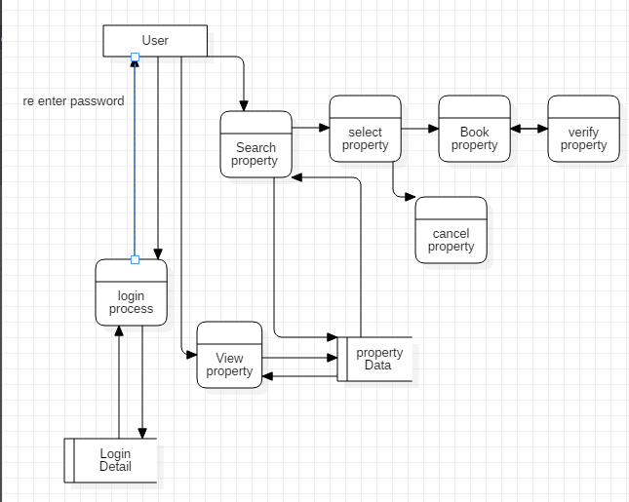

**Figure 1 User DFd**

As data flow diagram represents the flow of the data, process in the system. First diagram shows the users data flow diagram in which the users first login to the system by entering the username and then password. System validate the username and the password if the username and password is correct then system stores the data, if incorrect then ask for re validation. Login data are store in the database. Then users search and view for the property. The searching and viewing process is shown by the process diagram and their database is store in the data base which is represent by data store figure.

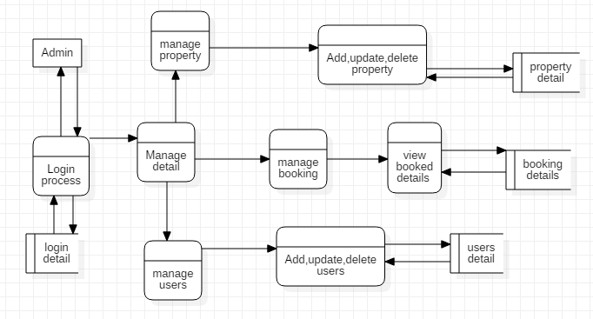

**Figure 2 Admin DFd**

Second figure shows the flow diagram in which the admin login the first login to the system and manage all the users’ details advertisement and property. In this figure admin has manage the property details, users and also manage the booking. Only the admin can add, update and delete the users and property.

**3.1.2 Class Diagram**

In software development class diagram is the structural representation of the system which shows the relation between the attributes, entity. A class diagram in the Unified Modeling Language (UML) is a sort of static structure diagram that describe the structure of a by showing classes, operations (or method ),attributes and the connections among object of the system.

**3.2 Behavioural Modelling**

**3.2.1 Activity diagram**

1. **Justification**

Activity Diagram is graphical and Behavioural modelling of the software which represent the work flow of the software. It is also the step wise activity or action which helps in describing the whole process of the system.

I have chosen the activity diagram for my system as, it helps to show real/actual work flow in the system. Helps in use case analyzing and describe the users and system action in clear way. Also describe the further action and their occurrence.

1. **Notation Used**

|  |  |  |  |
| --- | --- | --- | --- |
| **S.N** | **Symbol** | **Notation** | **Remark** |
| 1 |  | Actor | Represents the users of the system. |
| 2 |  | Initial state | Shows the initial or starting phase of the system |
| 3 |  | Control flow | Shows the flow of the work from one to another. |
| 4 |  | Decision node | Represents the decision made by the users and systems in binary format i.e. yes or no |
| 5 |  | Final node | Shows the last stage of the flow of the work in the system. |
| 6 |  | Send signal/message | Shows that the message is send to the receiver. |
| 7 |  | Receive message | Shows that the message is receive by the receiver which is send by the sender. |
| 8 |  | Swim lane | Used to show the process in sequential and step wise. Also helps to confirm the diagram with its participation in the process. |
| 9 |  | Fork | Shows that the one can do the different work in same system. |

1. **Diagram**

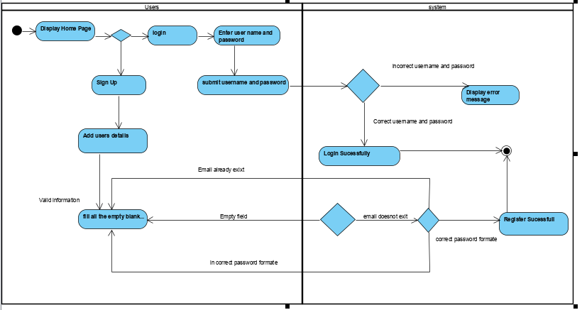

**Figure 3Activity Diagram1**

The above activity diagram shows the flow and activity perform by the users in the system this is the first activity perform by the users in the system. This activity shows that any/all users can use the system but they cannot booked the property. They have to login to the system to use the further system functions. The users have to register and have to enter their valid information. Users have to enter their valid username and password to login to the system. Users cannot control the property detail. They can only add their property details and update the property.

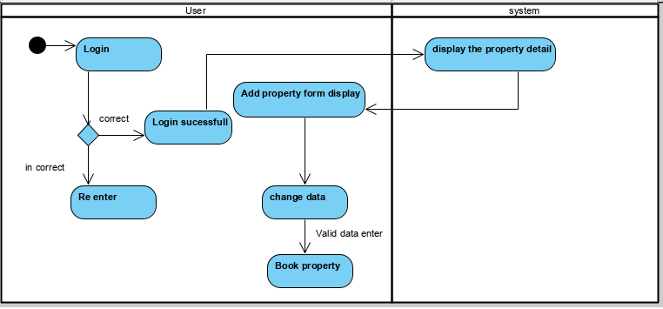

**Figure 4 Activity Diagram2**

The above activity diagram shows the activity between user and the system. Only the register users can use the functions of the system after login. Users can only book the property after login.

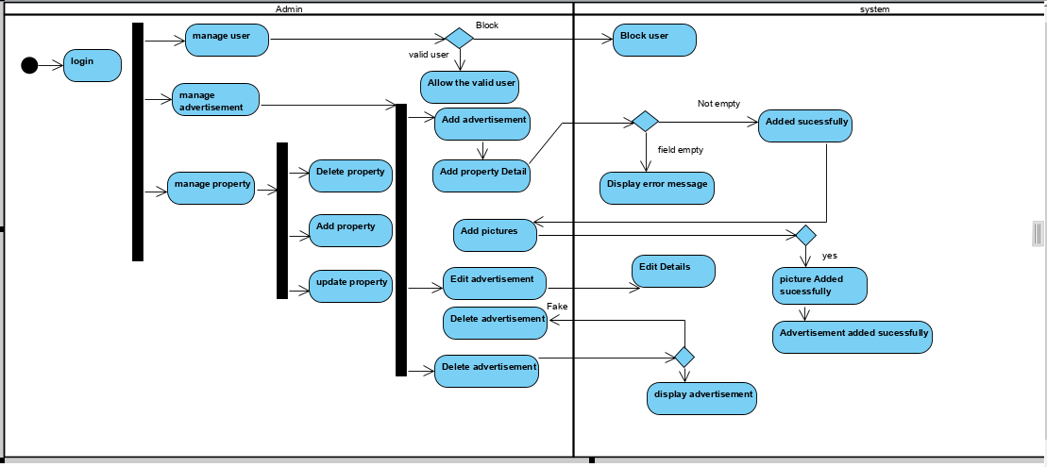

**Figure 5 Activity Diagram3**

Admin also should login to use the system. Admin can manage the users and advertisement. Admin has control of all the property in which admin can add, update and delete the property. Admin also manage the fake advertisement and the users.

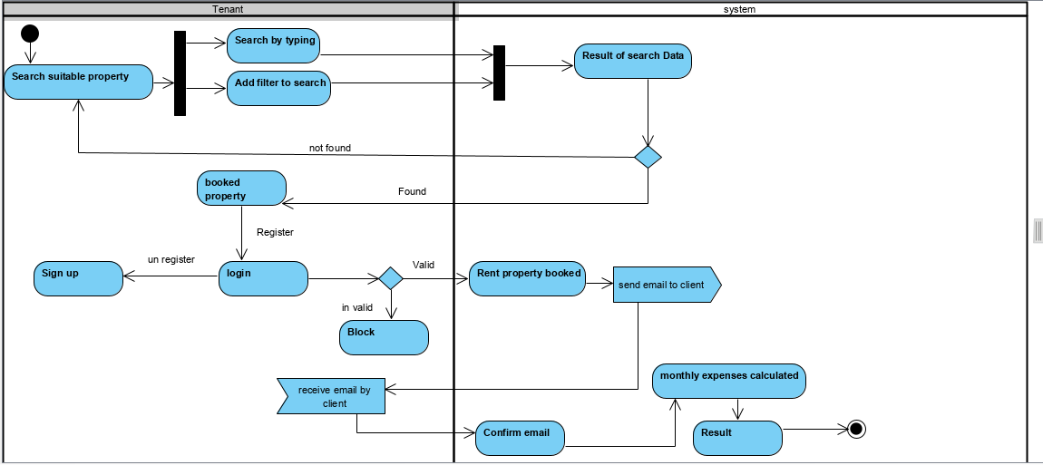

**Figure 6 Activity Diagram4**

Above diagram represent the work flow of the tenant. Tenant can also be consider as the guest users in which they have to sign up first in order to get login to the system. The system validates all the information provided by the users. User name and password should be unique. The guest users or tenant booked the property after login and confirm the email by the system.

**3.2.2 Sequence Diagram**

1. **Justification**

Sequence diagram is the diagrammatic representation of the system. It shows the object interaction and display as message. Sequence Diagrams are communication diagram that detail how activities are completed. They are time center and they shows the request for the interaction outwardly/visually by utilizing the vertical hub of the diagram to speak to time what messages are sent and when.

The following points represents why the sequence diagram is important to the system.

* + It helps to show the work flow of the system in diagrammatic way.
  + Architectural and logical problem are easily identified.
  + It helps to represent the dynamic view of the system which makes easier to view the system process.

1. **Notation used**

|  |  |  |  |
| --- | --- | --- | --- |
| **S.N** | **Symbol** | **Notation** | **Remark** |
| 1 |  | Actor and Life Line | Shows the users of the system and life time in using the system. |
| 2 |  | Message | Shows the message send by the users to the system. |
| 3 |  | Message Return | Return the message display by the system/users. |
| 4 |  | Activation | Activate the action in the system. |
| 5 |  | Self-message | Return or Repeat the same message |

1. **Diagram**

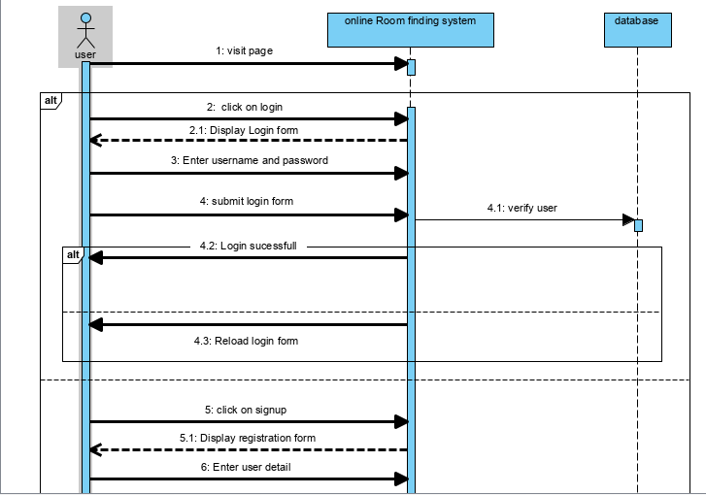

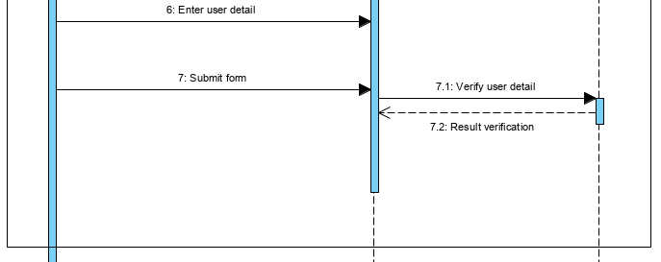

**Figure 7 Sequence Diagram 1**

First figure shows the works flow of the system in which the user login to the system and system verify the username and password which was save in database. If the users is unregister then the user can sign up the form and the register data is store in database.

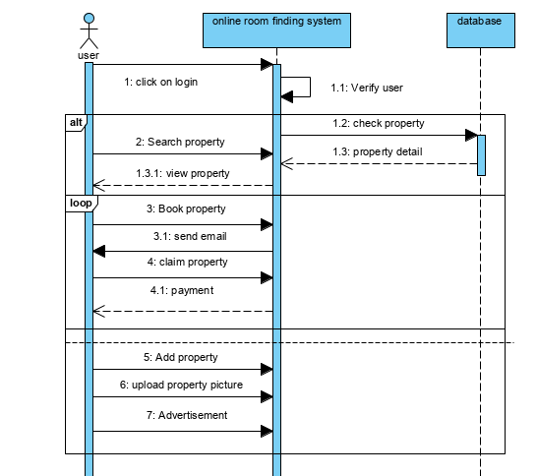

**Figure 8 Sequence diagram2**

This diagram shows that users should login to the system in order to booked property. First the system verify the users as, user data is already record in database. After login user can search, view and booked the property. Property details are already saved in the database. If the property is booked by the users then email is send to the users and email is confirm then property is claim or booked.

**3.3.1 Data Dictionary**

1. **Justification**

Data dictionary is define as the collection of the data, entity, attributes, name which are been used in database including their property.

Keeps the record of the document which contain database and metadata.

Keeps the record about the objects such as data relationship, data ownership etc.

Metadata of the Er diagram are created bellow in the table.

User Table

|  |  |  |  |  |
| --- | --- | --- | --- | --- |
| Field-Name | Data-Type | Length | Null | constraint |
| Id | Integer | 100 | Not null | Primary key |
| first name | Varchar | 100 | Not null | ……… |
| Last name | Varchar | 100 | Not null | …….. |
| Address | Varchar | 100 | Not null | …….. |
| Contact_number | Varchar | 20 | Not null | …….. |
| Email | Varchar | 50 | Not null | …….. |
| Password | Varchar | 50 | Not null | …….. |
| View property id | Integer | 10 | Not null | Foreign key |

Property Table

|  |  |  |  |  |
| --- | --- | --- | --- | --- |
| Field-Name | Data-Type | Length | Null | constraint |
| Id | integer | 10 | Not null | Foreign key |
| Cost | integer | 10 | Not null | ……. |
| Condition | varchar | 50 | Not null | …… |
| Property_Type id | integer | 10 | Not null | Primary key |
| Address | varchar | 100 | Not null | ……. |
| Image_id | integer | 10 | Not null | Primary key |
| Description | varchar | 255 | Not null | …… |
| Userid | integer | 10 | Not null | Foreign key |
| Property_Typeid2 | integer | 10 | Not null | Foreign key |
| Imageid | integer | 10 | Not null | Foreign key |

Address Table

|  |  |  |  |  |
| --- | --- | --- | --- | --- |
| Field-Name | Data-Type | Length | Null | constraint |
| Address_id | integer | 10 | Not null | …… |
| City | varchar | 45 | Not null | …… |
| House | integer | 10 | Not null | …… |
| property_Typeid | integer | 10 | Not null | Foreign key |
| Propertyimage_id | integer | 10 | Not null | Foreign key |

Booking Table

|  |  |  |  |  |
| --- | --- | --- | --- | --- |
| Field-Name | Data-Type | Length | Null | constraint |
| Booking_id | Integer | 10 | Not null | Primary key |
| In_date | Integer | 10 | Not null | …… |
| Out_date | Integer | 10 | Not null | …… |
| Propery_id | Integer | 10 | Not null | Primary key |
| Tenant_id | Integer | 10 | Not null | Primary key |
| Column | Integer | 10 | Not null | …… |
| Tenant_id | Integer | 10 | Not null | Foreign key |
| User_id | Integer | 10 | Not null | Foreign key |

Tenant Table

|  |  |  |  |  |
| --- | --- | --- | --- | --- |
| Field-Name | Data-Type | Length | Null | constraint |
| Tenant_id | Integer | 10 | Not null | Primary key |
| Full_name | Varchar | 255 | Not null | …… |
| contactnumber | Varchar | 20 | Not null | …… |
| Email | Varchar | 255 | Not null | ….. |
| Password | Varchar | 255 | Not null | ….. |

Payment Table

|  |  |  |  |  |
| --- | --- | --- | --- | --- |
| Field-Name | Data-Type | Length | Null | Constraint |
| Payment_id | Integer | 10 | Not null | Primary key |
| Tenant contact number | Integer | 15 | Not null |  |
| Firstname | Varchar | 10 | Not null |  |
| Lastname | Varchar | 10 | Not null |  |
| Amount due | Integer | 10 | Not null | Foreign key |
| Amount paid | Integer | 10 | Not null | Foreign key |
| Date paid | Integer | 10 | Not null | Foreign key |

View Property Table

|  |  |  |  |  |
| --- | --- | --- | --- | --- |
| Field-Name | Data-Type | Length | Null | Constraint |
| Id | Integer | 10 | Not null | Primary key |
| User_id | Integer | 10 | Not null | …… |
| Property_id | Integer | 10 | Not null | ….. |

Property_Type

|  |  |  |  |  |
| --- | --- | --- | --- | --- |
| Field-Name | Data-Type | Length | Null | Constraint |
| Id | Integer | 10 | Not null | Primary |
| Property_id | Varchar | 50 |  | …… |

Image

|  |  |  |  |  |
| --- | --- | --- | --- | --- |
| Field-Name | Data-Type | Length | Null | Constraint |
| Id | Integer | 10 | Not null | Primary |
| Imagename | Varchar | 20 | Not null | …… |

**3.3.2 Er Diagram**

Er diagram is the entity relationship diagram which shows the relationship between entities like object, conceptual related to each other and people with the system. Er diagram can also be defined as the conceptual diagram. ER diagram are related and identified with Data structure Design (DSDs), which spotlight /focus on the connections of components inside elements rather than connections between substances/entities themselves.

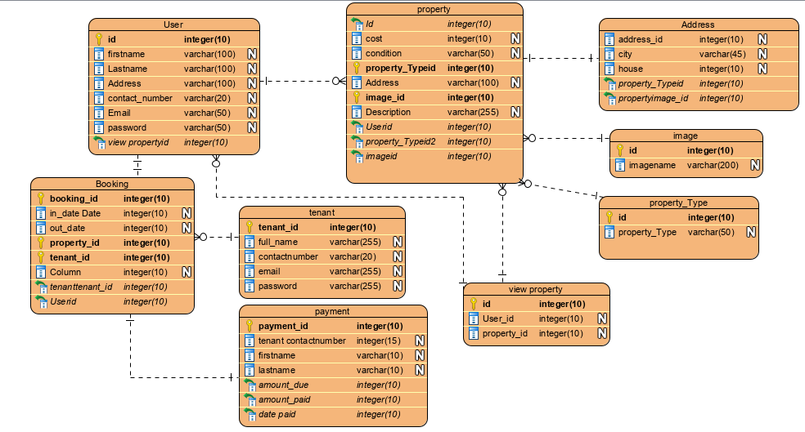

**Figure 9 Er Diagram for house rental management system**

**3.4.1 Prototyping**

Prototyping means the initial phase or stage from which the whole software is developed. A first full-scale and generally practical type of another kind or plan of a development. Also helps to minimize the occurrence of the error and it is easy to update.

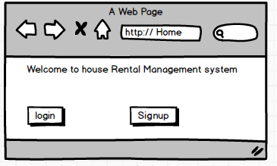

**Figure 10 Home page Form1**

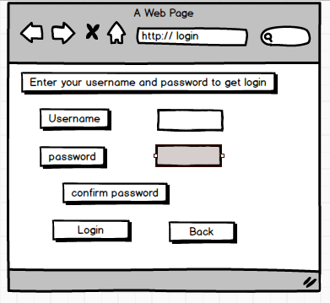

**Figure 11 Login form**

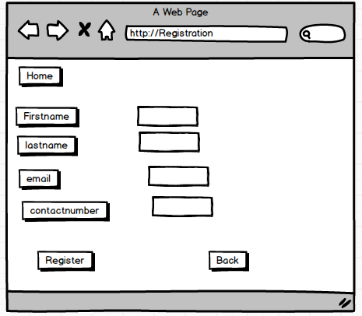

**Figure 12 Registration form**

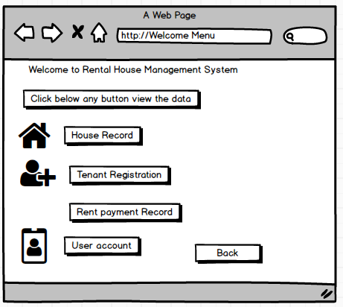

**Figure 13 Welcome form**

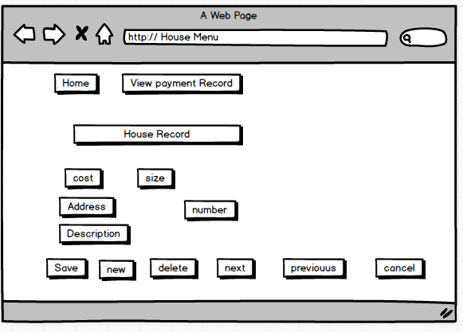

**Figure 14 Dashboard**

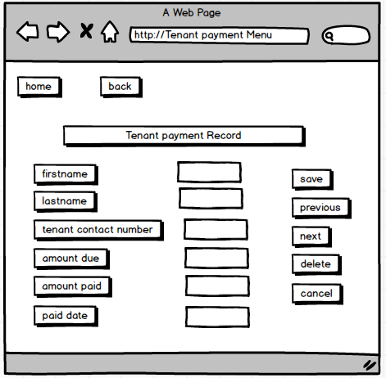

**Figure 15 Tenant payment Form**

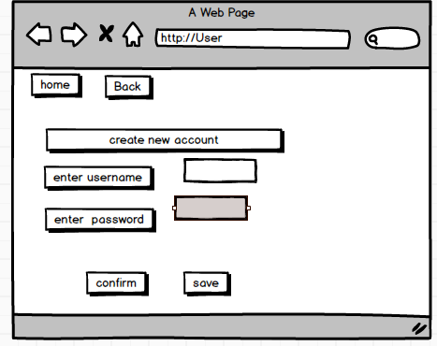

**Figure 16 users Form**

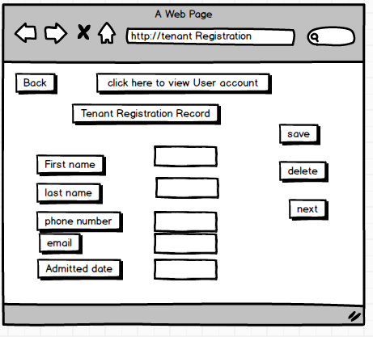

**Figure 17 Tenant Registration record form**