**5. Testing**

Testing is the stages after coding. For the effective presentation or performance of system testing is done. It is also done to ensure that any types of system ought not to result into any types of failures because it may cost high to compensate the error no time to recover and may be the final stage of the system where no any changes can be made. It helps to save the cost, future error are identified earlier, trustworthy product can be provided to the users, free vulnerability product can be deliver, assurance of the product quality can be made. So, testing is essential part of the software development which leads to the success of business. There are different types of methods used in testing.

I have used Unit testing and Black Box testing in order to test my system. Description of the Test that I have used during the system development are describe bellow.

**5.1 Black Box Testing**

It is also known as behavioural testing in which the functional and non-functional parts of the system are tested. Internal coding or structure of the system are not tested and consider only the input and output given by the system. This testing is based on software specification and requirements.

I have chosen the Black box testing to test my system because of the following points;

1. Easy to done because we don’t have to shows the internal working process.
2. Validation of the functional requirements are more focused.
3. Non-technical users can easily understand the testing process.

Some of the black Box Testing are shown with diagram bellow.

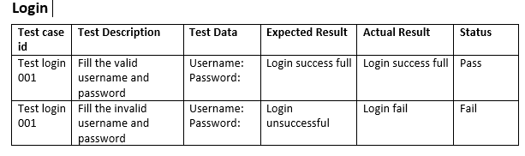



**Figure 1 Login Form for testing**

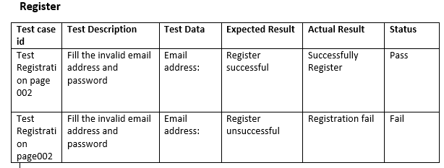

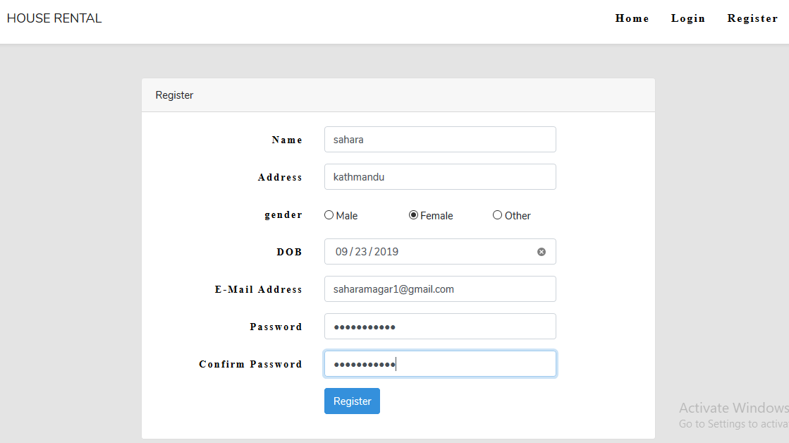

**Figure 2 Registration Form for Testing**

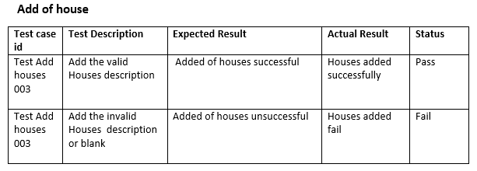

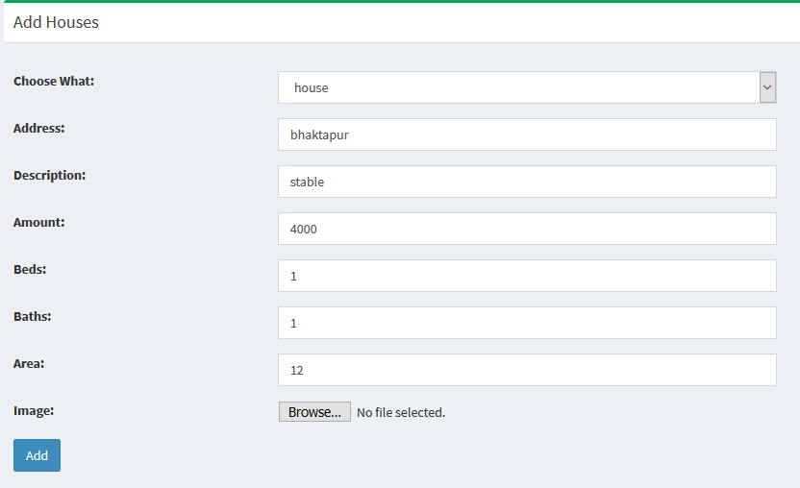

**Figure 3 Add House Form used for testing**

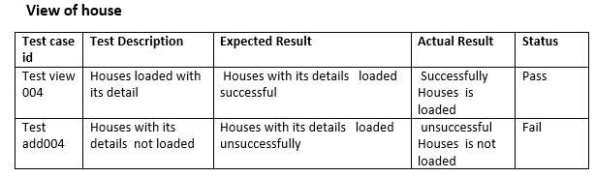

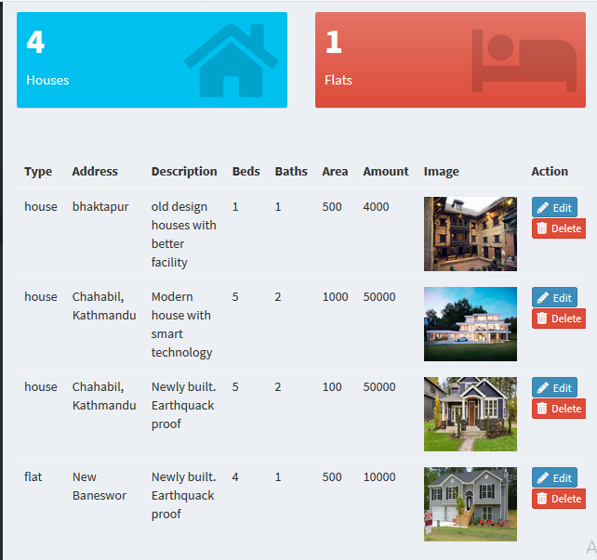

**Figure 4 View house form used for testing**

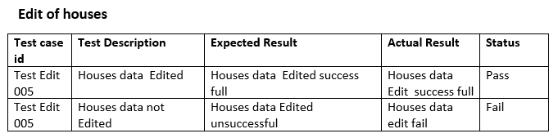

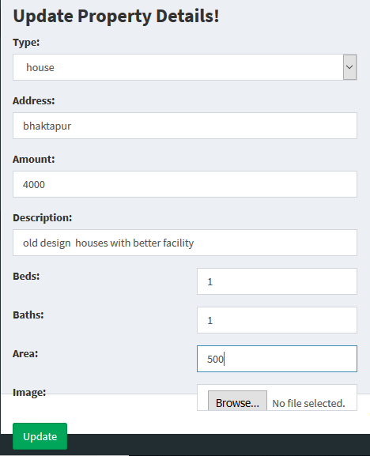

**5 Edit house form used in testing**

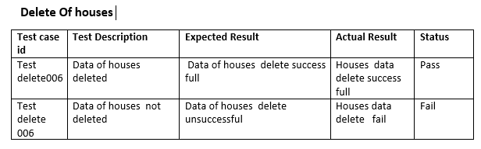

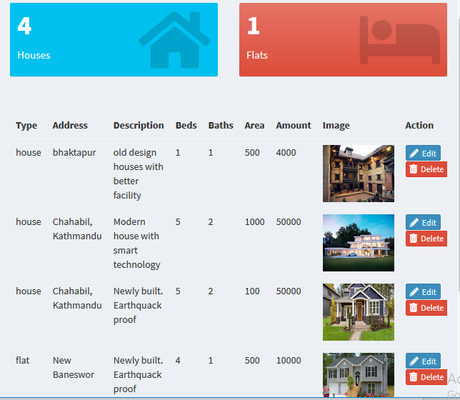

**Figure 6 Form before deleting the house**

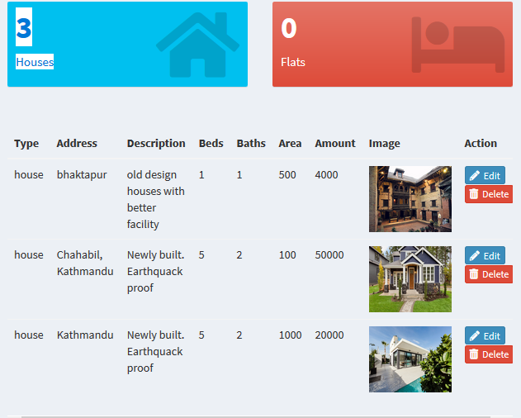

**Figure 7 Form After Delete of one House**

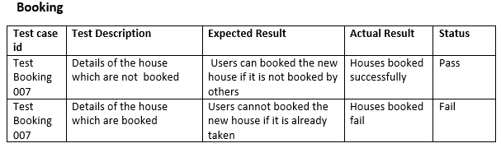



**Figure 8 Booking Form used in testing**

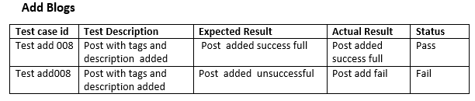

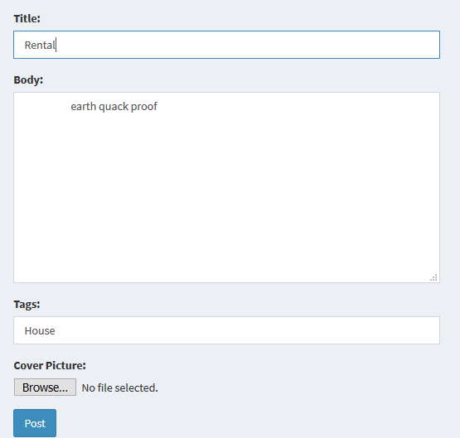

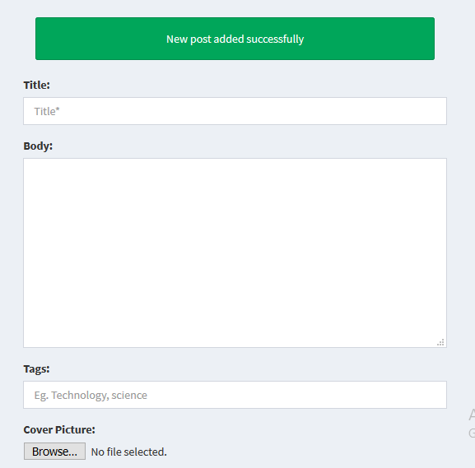

**Figure 9 Add Blog form used during testing**

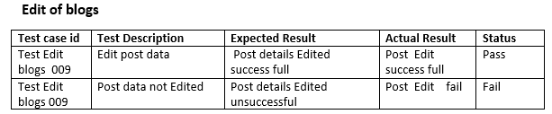

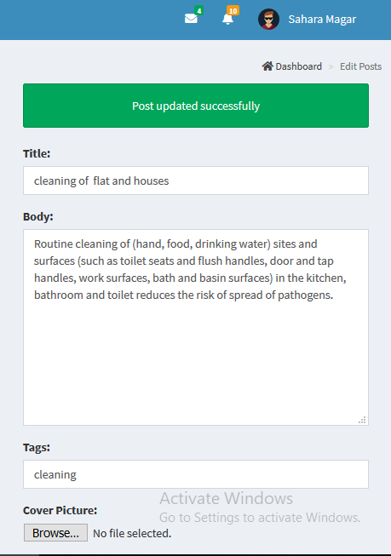

**Figure 10 Edit Bog form used during testing**

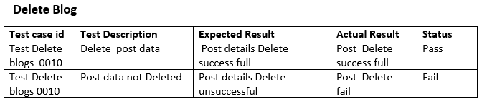

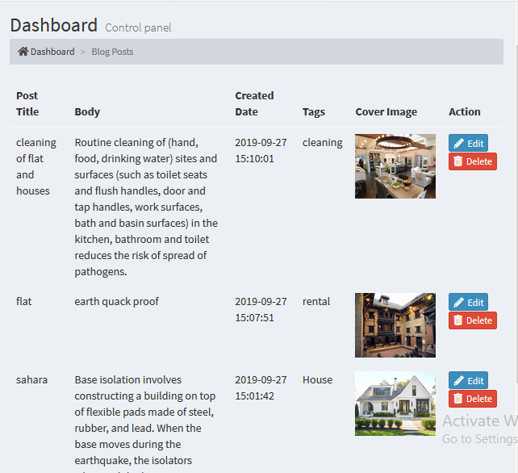

**Figure 11 Delete Blog Form**

**Unit Testing**

Unit Testing is the method of testing the system in which the individual component of the source code are tested whether if they are fit to use in the system or not. Results of this types of testing should be single and out- put must be single. This types of testing helps in detecting the error in early stage before starting the integration testing. Debugging process can be simplified with the help of this testing.