**-------------------------------------------------------------------------------------------------------------**

**Pandas-challenge Report**

**-------------------------------------------------------------------------------------------------------------**

1. **Introduction:**

This Assignment was about analyzing the data for the most recent fantasy game Heroes of Pymoliin in an independent gaming company. The company requested to a report that breaks down the game's purchasing data into meaningful insights.

First of all, the below is a brief overview of the provided data which includes “purchaser name (SN)”, “purchaser age (Age)”, “purchaser gender (Gender)”, “Item ID”, ”Item Name”, “Item price (Price)”, and “Purchase ID”. The total number of rows is 780 which means this dataset is the recorded data for 780 purchases.

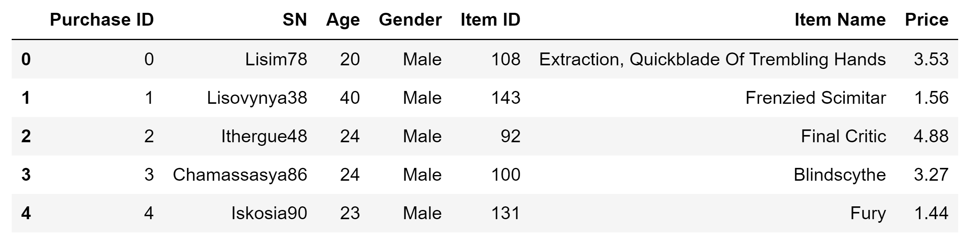

1. **Analysis Results:**

*Player Count*

Since some purchasers bought the products of the company more than once, the **total number of distinct players** was **576**.

*Purchasing Analysis (Total)*

Since one item was soled more than once **the total number of unique items** was **183**. **The average price** of all sold products was calculated as **$3.05.** The total **number of purchases** is **780** and the **total revenue** is **$2,379.77.** You can see the summary of results in the below table.

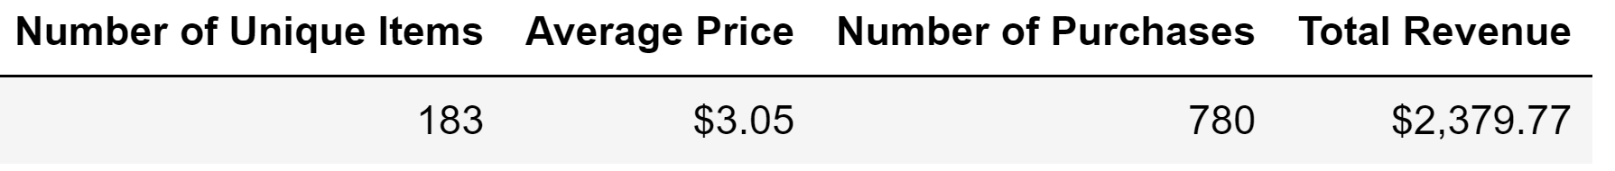

*Gender Demographics*

In the case of gender, the purchasers are female, male, or others. The below table shows the percentage and count of male players, percentage and count of female players, and percentage and count of other / non-disclosed players.

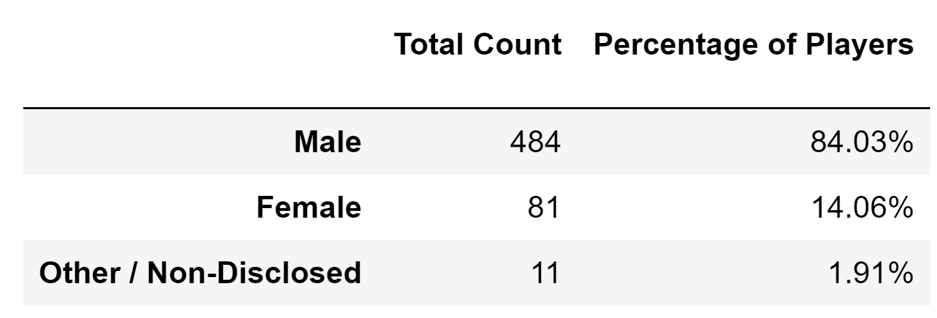

*Purchasing Analysis (Gender)*

The company needed to know how much the purchase count , average purchase price, total purchase value, and average purchase are per person for each gender differently. The below table summarizes this needed information.

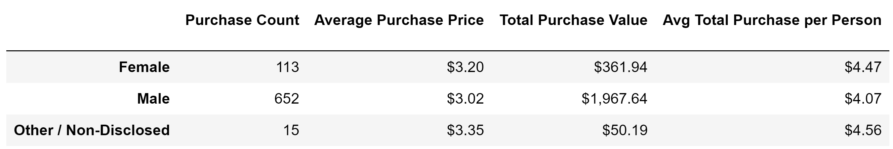

*Age Demographics*

The company asked for some information based on the different age ranges and specifically into bins of 4 years. Therefore, the purchaser ages were grouped by ['<10',"10-14","15-19","20-24","25-29","30-34","35-39","40+"]. The company needed to know the purchase count, average purchase price, total purchase value, and average purchase per person by age group. You can find all this information in the below table.

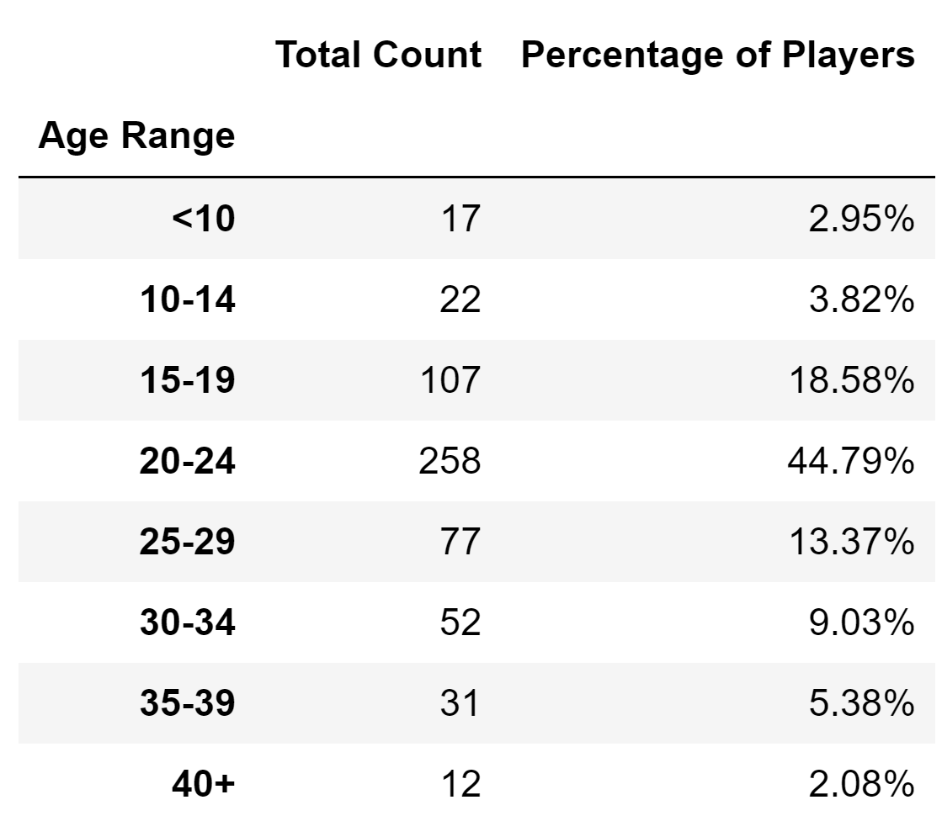

*Top Spenders*

In this section we present the top 5 spenders in the game by total purchase value, then list (in the below table): SN, Purchase Count, Average Purchase Price, Total Purchase Value

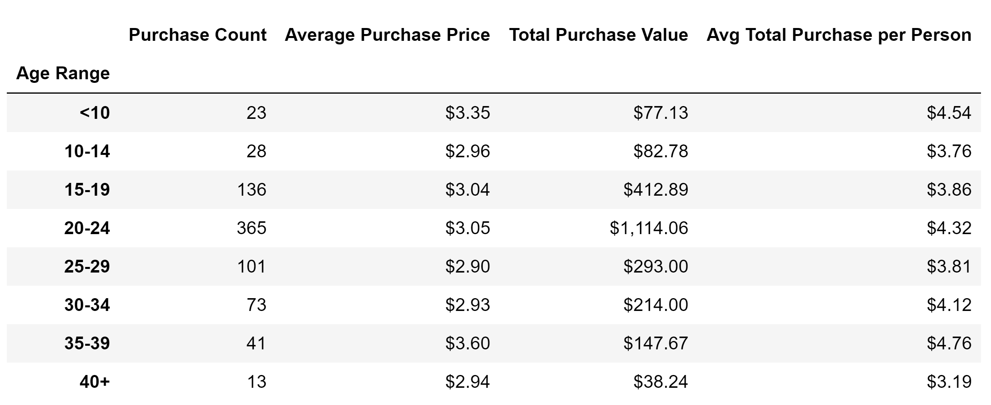

*Most Popular Items*

This section is dedicated to the representation of the 5 most popular items by purchase count, then list (in the below table table): Item ID, Item Name, Purchase Count, Item Price, Total Purchase Value

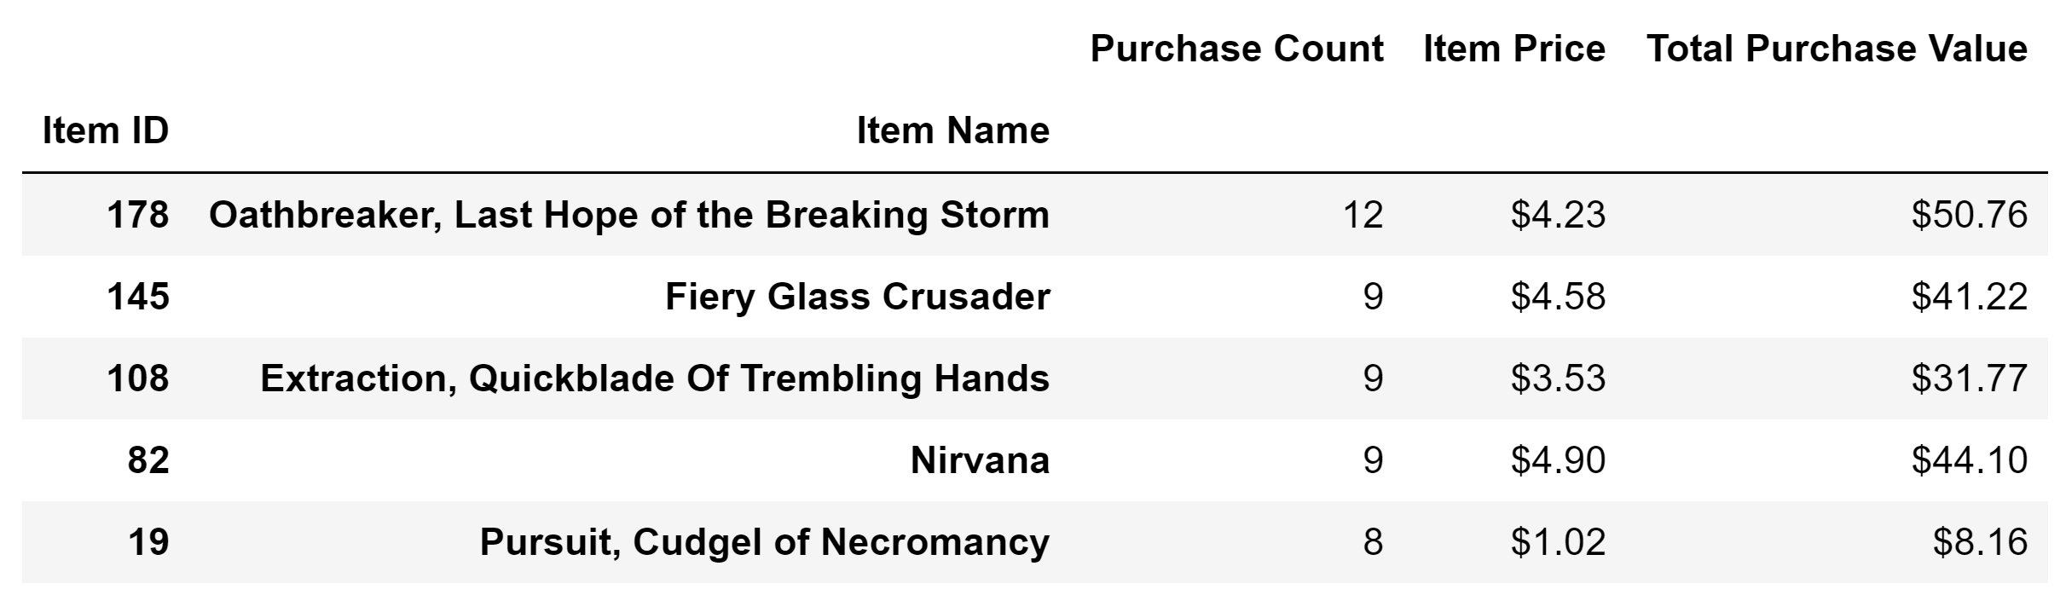

*Most Profitable Items*

In this section we show the 5 most profitable items by total purchase value, then list (in the following table): Item ID, Item Name, Purchase Count, Item Price, Total Purchase Value

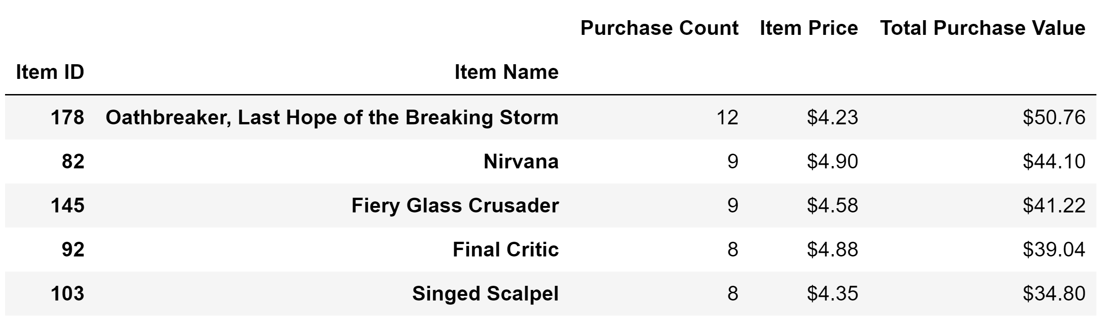

1. **Observable Trends:**

- The majority of the company customers are men (84%). It seems men show more interest in playing video games compared to the women and others.

-Although women bought less items in comparison to men, they have shown interest in more expensive products; because, the average purchase price of women group is $3.20; while, the number for men is $3.02

- The most customers of the company are young individuals in the age range of 20-24 years old (around 45%). However, since the average purchase price and the average purchase per person for the people in the group age of 35-39 are the highest numbers ($3.60 and $4.76, respectively), we can conclude that this group has bought the most expensive items.

- The client with the highest purchase value does not have the highest average purchase price.

-The most popular item which has been sold the most is “Oathbreaker, Last Hope of the Breaking Storm” with 12 purchase counts. Besides, since this item has the highest total purchase value ($50.76), is the most profitable product, as well.