Tracing Path Gain to Measure Signal Strength from Diffraction

Christopher Leong (cleong3@hawaii.edu) and Matthew Sahara (saharama@hawaii.edu)

Department of Electrical and Computer Engineering

University of Hawai`i at Mānoa, Honolulu, HI,, 96822, USA

*Abstract*—A basic electromagnetic propagation model is created to better understand the effects of diffraction and resulting path loss. MATLAB was used model a street intersection with set transmit and receive points at 1 GHz. Diffraction is made to only occur at two corner points, and path loss/gain is subsequently calculated and observed in two perpendicular directions. Several assumptions were made to simplify the model. The model only considers perpendicular polarization, does not consider reflection, and defines the diffraction interfaces to be perfect electrical conductors. This simplified model provides a solid foundation to understand path loss in a theoretical environment and to further build upon in more complex simulations with additional variables.

Keywords—wireless communications, path gain, diffraction

# Introduction

With the rapid rise in demand for faster, reliable wireless communication devices, there exists a greater need for the development of next-generation wireless communication networks and systems. The push towards 5G network integration, alongside the emerging popularity of Internet-of-Things devices, are just some of the changes propelling research in environmental factors and their respective effects on wireless communication range and resilience. Therefore, it is important for us to better understand the effects of these advanced systems when implemented in the dynamic, intricate world around us.

Much research on propagation modeling is largely focused environmental factors and their effects on mmWave wireless communications, as higher frequency devices fill the world around us. A study in [1] presents omnidirectional path loss models for 28 GHz and 73 GHz signals in a dense area in New York City. In another mmWave work [2], passive conductive reflectors were used to lower path losses outdoors, and effectively extend communication range at 28 GHz. In a simpler, lower-frequency case, path loss through walls was observed and characterized at 2.45 GHz.

In this work, we seek to better understand path loss in a simplified propagation environment. MATLAB was used to create the system model of path losses of a traffic intersection with set points of diffraction off of a PEC. Further assumptions are made to simply the problem, including limiting the analysis to perpendicular polarization and ignoring reflections.

While this project focuses on fundamental concepts of propagation and calculation in a basic environment, it lays a strong foundation to help in understanding and applying concepts to a real-life type of situation.

The paper will cover the formulation and model setup in Section 2, present results and discussion in Section 3, and conclude with Section 4.

# Formulation

## To investigate the path gain along a two-dimensional (2D) street cross-section, a model must be defined. This model will account for an intersection. Because only diffraction is accounted for, only the corners of the intersection are necessary in the model.

Fig. 1: Modeled street intersection with path gain taken

on red and blue lines.

An omnidirectional transmitter is placed at the origin in Fig. 1. For the sake of wireless systems, the path gain gives crucial insight to the necessary signal from the transmitter. A possible lossy scenario can diminish the signal heavily. To investigate the path gain on the street with respect to distance, a line 500 m in length is stretched in two perpendicular directions, each line parallel to the walls of the street. Line AB is 20 m north of the green wall and Line CD is 30 m west of the purple and green walls depicted in Fig. 1. The path gain is calculated every 0.05 m.

To determine the path gain, the received fields from three sources must be considered: the incident field and the diffracted fields from the two corners. The incident field is given as

*ei(r) = e-jβr/r* (1)

where *r* is the distance from the transmitter to the receiver. The *β* represents

*β= 2πf/c* (2)

as *f* is the frequency of the transmitted field and *c* is the speed of light.

The diffracted field received is dependent on the distance from the transmitter to the diffraction corner, the distance from the receiver to the diffraction corner, and the angles from a designated 0-face to the direct rays as seen in Fig. 2.

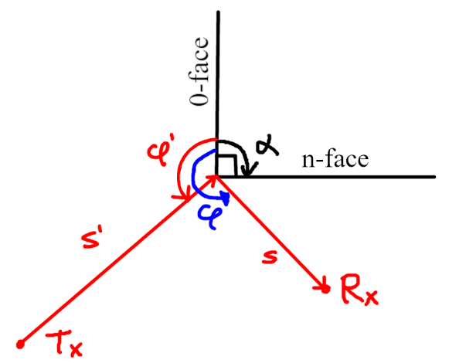

Fig. 2: Diffraction definitions.

The diffracted field is given by

$e^{d}\left(r\right)= \frac{\sqrt{λ}ds}{\sqrt{s's(s^{'}+s)}}e^{-jβ(s^{'}+s)}$ (3)

where *λ* is the wavelength given by *c/f*, *s’* and *s* are the magnitudes of the distance vectors in Fig. 2, and *ds* is the diffraction constant dependent on *L*, *φ*, and *φ’* seen in Fig. 2. The parameter *ds* is calculated through a script provided by Dr. Zhengqing Yun. Parameter *L* is calculated by

$L=\frac{1}{λ}\frac{s's}{s+s'}$ (4)

and input into the script with *φ, φ’, α = 90,* and *n = 1.5*.

The total field *e(r)* is the sum of the incident field and the diffraction fields from each of the two corners. The path gain is calculated with

$P_{G}={(\frac{λ}{4π})}^{2} {|e(r)|}^{2}$ (5)

and measuring the path gain in dB results in

$P_{G,dB}=20\log_{10}\left(\frac{λ}{4π}\right)+20\log_{10} |e\left(r\right)|$ (6)

MATLAB is used to model the system by calculating the path gain along the lines every 0.05 m. The frequency is taken at 1 GHz. The script used is in Appendix A.

# Results

The path gain along the defined lines in Fig. 1 was calculated and plotted in respect to the x-coordinate or y-coordinate for line AB and line CD, respectively. Line AB stretches from coordinates (0,70) to (500,70).

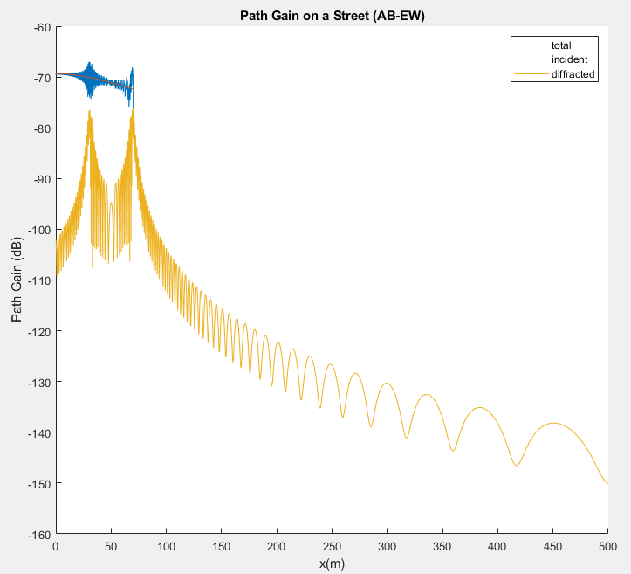

Fig. 3: Path gain along the line AB going east to west

Along the line AB from coordinates (0,70) to (70,70) as seen in Fig. 3, the frequency of the oscillations is high. Around *x* = 30, the amplitude of the oscillations stretches from -67 dB to -74 dB. From *x* = 70 on, the frequency of the oscillations and the magnitude of the signal begins to diminish exponentially, ending in the magnitude of -150 dB at *x* = 500.

Intrinsically this describes the signal to the receiver at its maximum from (0,70) to (70,70) near the intersection of the streets. As expected, the signal diminishes from a transmitter as distance increases from the intersection and the transmitter. Because the incident field is blocked by buildings from (70,70) onward, the signal at those points is attributed only by diffraction.

Line CD stretches from coordinates (20,0) to (20,500). Unlike line AB, it stretches with respect to the y-direction. The incident field from the transmitter is always in view with the points on this line.

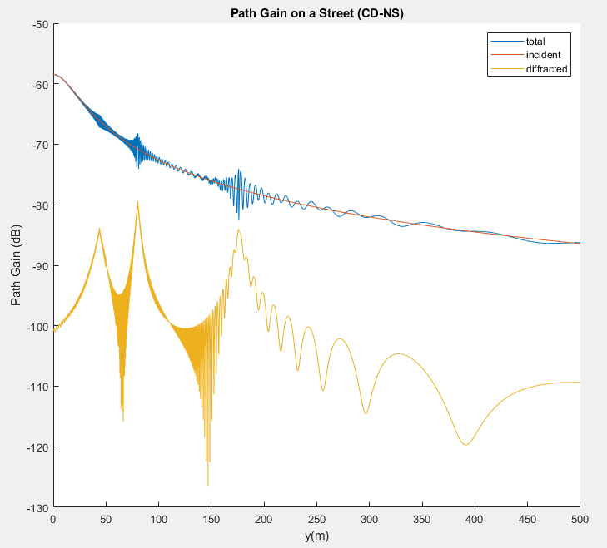

Fig. 4: Path gain along the line CD going north to south

Like the path gain on line AB, the signal experiences oscillations when moving from point C to point D and the oscillations’ frequency and magnitude diminish with the distance. The signal is at its maximum in the intersection of the two streets and diminishes with the distance from (20,0) to (20,500).

For both lines, the oscillations are largely attributed to diffraction from the two corners. In Fig. 3 and Fig. 4, the red incident field lines show that without diffracted fields, the resultant field would be exponential with no oscillations. Bringing diffracted fields into the equation adds oscillation to the incident signal. Higher peaks in the diffracted fields in Fig. 4 line up with higher amplitudes in the total field implying that diffraction is responsible for these larger amplitudes of the signal.

For comparison between the two lines, it is possible to check the methodology by referencing the intersecting point between the lines (20,70). The magnitude of the received signal at this point for line AB is -69.5980 dB while the magnitude for line CD is -69.6109, leaving a 0.0129 dB difference. This difference is minimal and may be attributed to errors in calculation.

# Conclusion

During this exercise, it is found that the signal diminishes with distance. Diffraction maintains a key part in

There are several complexities that can be made to this model to bring it closer to realism. One of these complexities is taking reflection into account, which would require the research of respective reflection coefficients for the properties of building materials. As only perpendicular polarization was considered, adding the third dimension is another significant improvement that can be made to this model.

##### Acknowledgment

This work was supported in part by Dr. Zhengqing Yun and the UH Mānoa EE671 class of Fall 2021.

##### References

1. M. K. Samimi, T. S. Rappaport and G. R. MacCartney, "Probabilistic Omnidirectional Path Loss Models for Millimeter-Wave Outdoor Communications," *IEEE Wireless Communications Lett.*, vol. 4, no. 4, pp. 357-360, Aug. 2015.
2. W. A. Gulzar Khawaja, O. Ozdemir, F. Erden, I. Guvenc, M. Ezuma and Y. Kakishima, "Effect of Passive Reflectors for Enhancing Coverage of 28 GHz mmWave Systems in an Outdoor Setting," in *IEEE Radio and Wireless Symp. (RWS)*, 2019, pp. 1-4.
3. T. Kang and J. Seo, "Practical Simplified Indoor Multiwall Path-Loss Model," in *Int. Conf. on Control, Automation and Systems (ICCAS)*, 2020, pp. 774-777.
4. Z. Yun. (2021, Fall). EE671 Project/Fall 2021 - Path loss/gain along streets. [Online]. Available: https://drive.google.com/file/d/10UNsyS_q-N3iPRc4LIYsqbLPwxaMKjxD/view?usp=sharing
5. Z. Yun

##### Appendix A. Matlab Script

close all; clear;

figure; hold on; grid on;

%plot street intersection

plot([0, 500], [70, 70], '-o')

plot([20, 20], [0, 500], '-o')

plot(0,0, 'o')

plot([50, 50, 600], [600, 110, 110], '-o')

plot([50, 50, 600], [-10, 50, 50], '-o')

xlabel('x(m)'); ylabel('y(m)');

title('Street');

%whole parameters

wavelength = 3*10^8/1000000000; %c/f

beta = 2*pi/wavelength;

Q1x = 50; Q1y = 50; Q2x = 50; Q2y = 110;

%AB direct field

ab = [0:.05:500;70*ones(1,10001)];

RAB = sqrt(ab(1,:).^2 + ab(2,:).^2);

incidAB = exp(-1i*beta.*RAB)./RAB;

incidAB(1401:end) = 0; %50/.05 = 1000

%diff1 AB- diffraction due to Q1

sp = sqrt(50^2 + 50^2); %calculate distance from transmitter to corner

s = sqrt((Q1x - ab(1,:)).^2+(Q1y - ab(2,:)).^2); %calculate distance from corner to receiver

L = 1/wavelength.*sp.*s./(s+sp); %calculate L

v1 = [zeros(1,10001);-1*ones(1,10001)]; phip = 45; %define wall unit vector, phi'

v2 = [ab(1,:) - 50; ab(2,:) - 50]./s; %calculate unit vectors from corner to receiver

phi = acos(dot(v1,v2))*180/pi; %find angle

phi(1001:end) = 360 - phi(1001:end); %change negative (=pos) cosines to positives

%take diffraction constant from function

for n = 1:1:length(phi)

[ds,dh] = wdc(L(n),phi(n),phip,90,1.5);

dsAB(n) = ds;

end

%calculate path gain based on summed matrix field

diff1AB = -sqrt(wavelength).*dsAB./sqrt(sp.*s.*(sp+s)).*exp(-1i*beta.*(sp+s));

%diff2 AB - diffraction due to Q2

sp = sqrt(50^2 + 110^2);

s = sqrt((Q2x - ab(1,:)).^2+(Q2y - ab(2,:)).^2);

L = 1/wavelength.*sp.*s./(s+sp);

v1 = [zeros(1,10001);ones(1,10001)];

v2 = [ab(1,:) - 50; ab(2,:) - 110]./s;

phip = acos(dot([50,110]/sqrt(110^2+50^2),[0,1]))*180/pi;

phi = acos(dot(v1,v2))*180/pi;

phi(1001:end) = 360 - phi(1001:end);

%take diffraction constant from function

for n = 1:1:length(phi)

[ds,dh] = wdc(L(n),phi(n),phip,90,1.5);

dsAB(n) = ds;

end

diff2AB = -sqrt(wavelength).*dsAB./sqrt(sp.*s.*(sp+s)).*exp(-1i*beta.*(sp+s));

PGAB = (wavelength/4/pi)^2 .* abs(incidAB + diff1AB + diff2AB).^2;

PGAB_d = (wavelength/4/pi)^2 .* abs(diff1AB + diff2AB).^2;

PGAB_i = (wavelength/4/pi)^2 .* abs(incidAB).^2;

%CD

cd = [20*ones(1,10001);0:.05:500];

%CD direct field

RCD = sqrt(cd(1,:).^2 + cd(2,:).^2);

incidCD = exp(-1i*beta.*RCD)./RCD;

%diff1 CD- diffraction due to Q1

sp = sqrt(50^2 + 50^2);

s = sqrt((Q1x - cd(1,:)).^2+(Q1y - cd(2,:)).^2);

L = 1/wavelength.*sp.*s./(s+sp);

v1 = [zeros(1,10001);-1*ones(1,10001)]; phip = 45;

v2 = [cd(1,:) - 50; cd(2,:) - 50]./s;

phi = acos(dot(v1,v2))*180/pi;

phi(1001:end) = 360 - phi(1001:end);

%take diffraction constant from function

for n = 1:1:length(phi)

[ds,dh] = wdc(L(n),phi(n),phip,90,1.5);

dsCD(n) = ds;

end

diff1CD = -sqrt(wavelength).*dsCD./sqrt(sp.*s.*(sp+s)).*exp(-1i*beta.*(sp+s));

%diff2 CD - diffraction due to Q2

sp = sqrt(50^2 + 110^2);

s = sqrt((Q2x - cd(1,:)).^2+(Q2y - cd(2,:)).^2);

L = 1/wavelength.*sp.*s./(s+sp);

v1 = [zeros(1,10001);ones(1,10001)];

v2 = [cd(1,:) - 50; cd(2,:) - 110]./s;

phip = acos(dot([50,110]/sqrt(110^2+50^2),[0,1]))*180/pi;

phi = acos(dot(v1,v2))*180/pi;

phi(1001:end) = 360 - phi(1001:end);

%take diffraction constant from function

for n = 1:1:length(phi)

[ds,dh] = wdc(L(n),phi(n),phip,90,1.5);

dsCD(n) = ds;

end

diff2CD = -sqrt(wavelength).*dsCD./sqrt(sp.*s.*(sp+s)).*exp(-1i*beta.*(sp+s));

%calculate path gain from summed matrices

PGCD = (wavelength/4/pi)^2 .* abs(incidCD + diff1CD + diff2CD).^2;

PGCD_i = (wavelength/4/pi)^2 .* abs(incidCD).^2;

PGCD_d = (wavelength/4/pi)^2 .* abs(diff1CD + diff2CD).^2;

%plot path gain from east to west

figure; hold on;

PGABdB = 10*log10(PGAB);

PGAB_idB = 10*log10(PGAB_i);

PGAB_ddB = 10*log10(PGAB_d);

plot(ab(1,:), PGABdB,'DisplayName','total');

plot(ab(1,:), PGAB_idB,'DisplayName','incident');

plot(ab(1,:), PGAB_ddB,'DisplayName','diffracted');

legend

title('Path Gain on a Street (AB-EW)')

xlabel('x(m)');

ylabel('Path Gain (dB)');

%plot path gain from north to south

figure; hold on;

PGCDdB = 10*log10(PGCD);

PGCD_idB = 10*log10(PGCD_i);

PGCD_ddB = 10*log10(PGCD_d);

plot(cd(2,:), PGCDdB,'DisplayName','total');

plot(cd(2,:), PGCD_idB,'DisplayName','incident');

plot(cd(2,:), PGCD_ddB,'DisplayName','diffracted');

legend

title('Path Gain on a Street (CD-NS)')

xlabel('y(m)');

ylabel('Path Gain (dB)');