**Introducing Abstract Argumentation with Many Lives**

**1. Background:**

Bonjour and Guten Morgan, Je m'appelle David with my pal Mr. Compiler (Sahar).

We shall introduce you a special case, the katsav's case, as an implementation of the abstract argumentation with many lives.

Moshe Katsav Served as the eighth President of the State of Israel. Prior to that, he served as the head of the Kiryat Malachi Council, as a member of the Knesset and as Minister of Government in Israel.

In July 2006, Katsav met with Attorney General Meni Mazuz and complained of an attempt to blackmail him by a former employee in his office, due to the threat of filing a sexual harassment complaint. The President soon became from a complainant to a suspected of sex offenses.

The verdict was in 2010, let's see the details of the case.

The convictions:

(**Back to the presentation**)

* 2 cases of rape and indecent assault of A. from the Ministry of Tourism
* An indecent act and sexual defamation of L. from the President's Residence
* Sexual harassment of H.** from the President's Residence
* Obstruction of justice

## A. from the Ministry of Tourism

* The first charge relates to the period of work of the Defendant as Minister of Tourism and to Complainant A, who served in a senior position in his office during the relevant period.
* In this charge, the accused**, accuses the defendant of committing a rape offense in A on two occasions: one in the defendant's office in Tel Aviv in April 1998 (hereinafter: "The event at Tel Aviv bureau"), and the second at the Plaza Hotel in Jerusalem on June 17, 1998 (hereinafter: "The event at the hotel").
* In addition, the defendant is charged with an offense of indecent assault, allegedly committed in the apartment of complainant A (hereinafter: "The incident in the apartment").

#### The incident in the apartment

After the defendant learned that she was living alone - he invited himself to her.  
She evaded with various excuses, but in the end the visit was carried out.  
When he arrived at the apartment, he committed an indecent act when he reached for her chest.  
I quote:** "He started to approach me and try to put his hand on my chest, in short ... I'm going back... until I got stuck in the closet... I had nowhere to run. I backed up to the closet and he clung to me and put his hand in my chest and then I pushed him away... I pushed him... no excess power, no kick, no kick... I just pushed... I pushed him with my hands."

🡪 I hope there are no children in the audience. There are other difficult descriptions here in the presentation. I shall skip some of them but you are invited to read.

#### The event at Tel Aviv bureau

This event took place, according to A, about three or four months after ** she started to work, after the end of a mass event held at the Exhibition Grounds or in some park.  
A. thinks that this was an event of the Iranian community, at the end of which the defendant told her that he "forgot something" in the Tel Aviv office and asked her to accompany him.  
When they entered the office, this occurred**: A. sat on one of the chairs, the defendant sat next to her and began to touch her.

(**I stop here. I jump to "A. testified…"**)

The two developed a struggle** as the defendant pulls her pants down and she pulls them up again.  
At one point, A. found herself sitting on the floor of the office, and immediately afterwards she reached a lying down state: "I kept fighting and saying that I did not want to, in small words, not shouting. Stop, I'm not interested. I do not want to. I tried to resist with my body and then he, I do not remember exactly at what stage... penetrated his penis into me."

A. testified that the incident in the office occurred no more than 10-15 minutes, and then** the rape was cut off.  
I quote:** "Either I pushed it out or I turned around, I do not remember exactly how it ended."

#### The event at the hotel

A. said that this incident occurred about two months after the rape in the office.  
It was one afternoon when the defendant worked at the Jerusalem bureau when he told her he wanted to rest in a hotel.  
A. ordered a room for him** in the Plaza Hotel in Jerusalem, and as planned, joined him after a while, in order to go over various documents and complete the work for that day.  
A. said that when she arrived at the hotel, the defendant phoned her and told her that he had not yet finished organizing and that he wanted her to go upstairs.  
When she thought it was for a few minutes, she did. A. went up to the right floor, knocked on the door, opened it, and entered the room and noticed that the defendant was wearing a long shirt, but without his pants.

(**I stop here. I add a sentence: (below)**)

🡪You can guess or read what's happened next. This was the second rape.

(**I jump to Supporting evidence**)

A, embarrassed by the occasion, sat down on the edge of the bed in the room and looked away from the defendant, thinking that he would immediately put on his pants and they would go out to the lobby.  
Instead, the defendant approaches her and clings her from the front, she tries to get away, and he continues to approach.  
A. fell on the bed, the defendant leaned over her and pulled off her pants and managed to remove them, spread her legs and penetrated her.  
Here, too, the defendant did not arrive at a sexual release, since A. succeeded in pushing him away.

#### Supporting evidence

The testimonies regarding A.'s statements,** regarding the violation of her by the defendant, in real time, deny the claim of the plot raised by the defendant.  
In this context we note the testimony of Shaul Halali, who spoke with the defendant, at the request of A., before her dismissal, in order to try to improve the atmosphere that prevailed in the office.  
According to him, A. told him that she was "very upset" because the defendant "sends long hands".  
Not only did he meet the defendant in his office, but the defendant even phoned him the day after the meeting in order to ascertain his impression.  
When the defendant's response to his testimony had been** requested, he denied, with** ostentatious contempt, his meeting with Halali, as well as his conversation with him, even though his defense counsel had to admit afterwards that the meeting was held, since it was mentioned in the letter of dismissal, Written by the defendant's himself.  
We shall** also mention the testimony of Shmuel Tzurel**, who served at the relevant times in a senior position in the Ministry of Tourism, who told the court that A. told him when she was working under the charge of the defendant that he was sexually harassing her and said, "I will say that he sexually harassed me".  
When Tzurel** appealed to the director-general of the ministry, even without mentioning the content of A.'s complaint regarding the sexual harassment of the defendant, so the director-general** would talk to A., he was reprimanded by the defendant who saw his interference with great severity.  
A special importance was attributed to the testimony of Attorney Ben-Tovim.** A. applied the attorney the day after her dismissal by the defendant, who told the court that A. told him that: "The Minister... harassed her sexually and that she felt that because she did not agree to him, then** her work came to an end".  
Attorney Ben-Tovim confirmed that he had "blocked his ears"** from hearing about the sexual issue, even though he understood that it was more than sexual harassment, but he wrote a copy of A.'s statement, which he kept in a safe and presented to the court at the testimony.  
Other statements by A. regarding her sexual harassment by the Defendant long before the affair broke out were heard by Dror Nissan, Yaron Armoza, Dr. Michal Sela, Ilana Dayan and others.  
All of the above statements, which came from A's mouth at the time of the events, contradict the defendant's contention that this is a later invention in order to get revenge.

🡪Before moving on to H. You know - in our first talk with Dov, he started talking to us about sex offenders. We asked him what it had to do with logic. He replied that it was possible to look at it in the form of an abstract argument. From there the subject rolled up to here.

(**Go to the blackboard**)

And here we are. So back to the theory: we propose to view argumentation networks (of the form (S, R)) as

representing a survival game. The players are the elements of S and

the relation R is the attack relation.

Who are the players in our case? Someone knows?

-Right. The main participates of our case. A, H, L and Katsav.

Does anyone know who's in the attack relation?

-Right. The complainants are the set of departure and the offenders are the set of destination.

So, in the meantime we have one element in the attack relation. Let's draw it.

(**I draw the nodes and connect them with an arrow. Your turn Sahar**)

## H. from the President's Residence

* On three frontal hugs that the defendant hugged H. in 2003, when he served as president, the second charge was brought against him, **and for that the accused attributes the offense of sexual harassment to the accused, while exploiting authority**.
* It was claimed that during the hugs the defendant pressed H.'s body to his body, and even after she told the defendant on two occasions that the hugs were not wanted and asked him to stop, the defendant continued to hug her. In her testimony to the court, H. added that the defendant had called her on her cell phone one night and presented himself as "Moshe", without any reason.
* H. claimed all along, both in her statements to the police and in her testimony in court, that the defendant had embraced her for three hugs ,**certainty, and that a fourth hug might have occurred. In her version, these are hugs of an intimate nature, in which the defendant pressed her against his chest, as she is frozen with her hands beside her. H. insisted that she told the defendant after the first hug and during the second embrace that the embraces were not in her favor and asked him to stop this, but the defendant continued and hugged her again for the third time.
* **H. testified fluently, consistently and decisively. Her testimony was consistent with her statements to the police and the State Attorney's Office, and was noted for her minority, caution and precision, as well as the fact that she did not want to complain against the defendant, and was dragged into **this case, that she did not wish for.

#### Supporting evidence

* Further reinforcement of the existence of embraces of sexual significance was found, **in testimonies of "similar acts" which came from the words of L., N.A. and N.R. who also had a similar experience of hug, while they worked for the defendant. These testimonies serve to reinforce the defendant's intentions and reject the following argument from his mouth about a random and innocent hug.
* Various victims described a man who was close to Katsav,** helping him to terrorize the victims and lead them into his arms.

🡪 You go to the blackboard, add (H, Katsav) to the relation and H to the Set, and draw the nodes, connect them with an arrow

(**My turn**)

## L. from the President's Residence

* In the third charge we are dealing with the embraces that the defendant embraced L., who was 25 when she worked in the President's Residence and was subordinate to his authority, as well as statements of sexual content he had told her. In respect of these, the defendant is charged with offenses of indecent assault, as well as sexual harassment offenses while exploiting authority and labor relations.
* The indictment alleges that during the working meetings held by the Defendant with L., while the two were in solitary confinement, the Defendant used to make personal remarks to her. So he** told her that she is "cute" because she has "beautiful eyes" that she "looks beautiful today" because she is "dressed beautifully today" and so on.
* The main point of the indictment relates to December 25, 2005, the date on which the defendant's 60th birthday party was held. L., who assisted in its organization, entered the defendant's office for the purpose of coordinating the final details. At the end of the meeting, she wished him a happy birthday. The defendant got up, told her that she deserved a hug, approached her and held her for a long time, pressing her body against his body, even tilting his face to her neck, ** to smell her, for sexual arousal. L., who was surprised by the defendant's act, left the office when she was upset and crying (this hug was called by us "birthday hug").

🡪 The extension is in the next presentation but let 's jump to "Supporting evidence"

(**I jump to Supporting evidence**)

* In her testimony to the court, she also recounted another statement by the defendant who told her that she had "sensual lips."
* In court L. told that on the afternoon of the day the defendant was attending his birthday party, she entered his office to give him a final update, when the defendant asked her if he did not deserve a hug for his birthday. He went to her and hugged her. L. demonstrated the manner of the hug, showing that the defendant had embraced her face to face with his hands behind her back and he was holding her close to him. She also testified that she felt the defendant sniff her neck as she, on her part, froze in her place with her hands to the sides. L. left the office upset and burst into tears.
* It was further claimed that on another occasion, whose timing is not known precisely, a similar incident took place in which the defendant hugged L. in the front. In her testimony, L. got over her reluctance to tell about the extra hug, and said: "I remember that there was one more hug for sure".

#### Supporting evidence

* We can learn from N.R.'s, N.A.'s and H. testimonies of the defendant's practice of embracing the young women who are subject to him in unusual embraces. From N.A. We heard that he had hugged her on his birthday. After refusing to give him a kiss, he even asked her what she would do if he reached her room in the hotel, because of the question ** she canceled her participation in the conference she was about to take part in. The witness N.R. was also under the authority of the defendant, and told the court about two hugs that the defendant had embraced her**. One hug by **side, by the window and another, this time in front of her**, when he returned from abroad. The defendant even called her ** in the evening and introduced himself as "Moshe" and offered to come visit her.
* Various victims who did not know about each other described a pattern of repetitive harassment, whereby the initiation of "courtship" and an attempt to get close to the victims would begin in the offender's library and then continue in other places.

🡪 I go to the blackboard, add (L, Katsav) to the relation and L to the Set, and draw the nodes, connect them with an arrow

(**Your turn**)

🡪Let's show you the key of the argument:

## Modeling the argument

* Who VS who - The three complainants (A., H. and L.) against Moshe Katsav.
* Goal - To convict Katsav of significant offenses with actual imprisonment.
* Thanks to our article, we can now present the argument using a network of signs.
* S - The participants in the case.
* R - Who VS who, that is, the accusers against the accused.
* M - Life, the more life a participant has, the harder it is to "kill" him.
* K - The power of the attack.
* βm - A bonus of 1 attack power, when there are more than m accusers, we assign m=1 (we will get to it later on).
* The full formula:

(**While you read I add the details and the formula on the blackboard. You read also the details of the next presentation("The plea bargain") then - My turn**)

**2.Background**

Let's go back in time until 2007. Then in the plea bargain there were only two complainants.

I shall explain to you later the different values in the model, but first let's ask ourselves why when we reduced from Moshe's life - the sum of strengths of the attack it's not equals 2.

## Explanation:

* Katsav, who was working as the president at that time was a very powerful person, so we shall** give him a high amount of life: 10.
* Back in 2007 **due to problems in the schedule of A.'s testimony and expectations of difficulties in finding a proof required for proving rape, the prosecution decided it would be better to go for a plea bargain.
* The plea bargain was very lenient for Katsav, in which he was not received a prison sentence but only two years'** probation. Katsav was charged by A. only for indecent assault (see above) and by L. for sexual harassment.
* It is seen from the deal that Katsav was not far from getting an active prison sentence, and that if Katsav had not been the president of the state, he would have actually been arrested.
* If we wanted to define our purpose in another way, for example only to convict him, we would place a lower value on the life of Katsav.
* Due to the severity of A.'s accusation against Katsav and the allegations of two rapes that were not part of the plea bargain, we defined the power of A.'s attack against Katsav as 5.
* In the plea bargain L. accused Katsav of sexual harassment, that was considered lesser offenses than indecent assaults and rape suspicions, so we defined the power of L.'s attack on Katsav about one-third of Katsav's life.
* Since there are similar charges from 2 complainants we assume that the total attack strength will be slightly greater so we add 1 more to the overall attack strength: 5 + 3 + 1 = 9.

(**I continue to read the definition 2.2. and then your turn**)

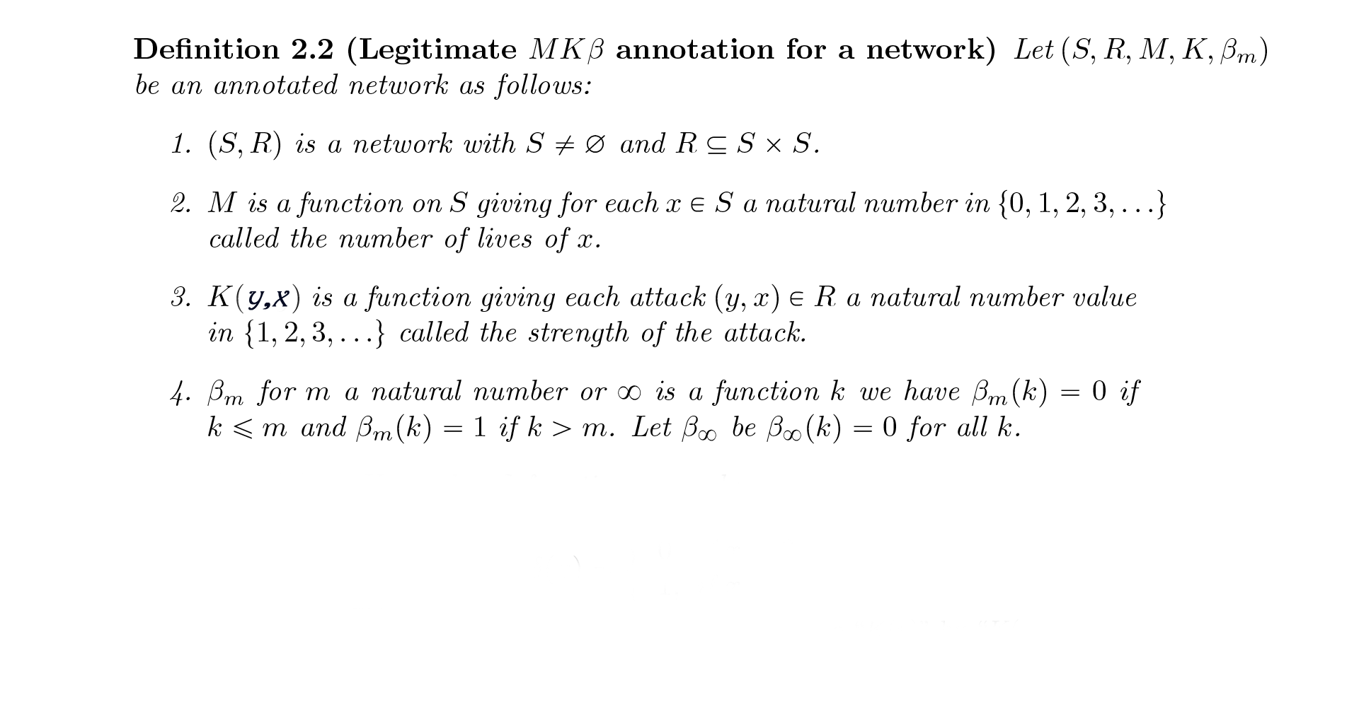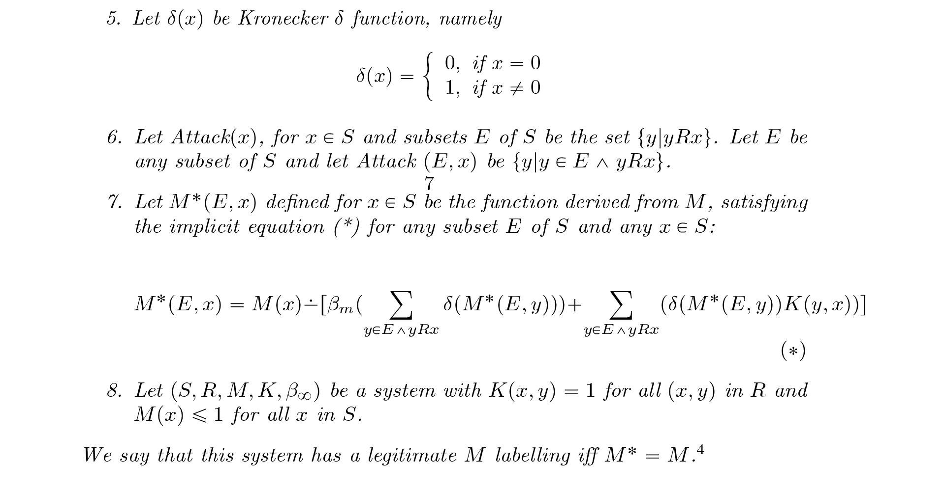(**Your turn**)

## Conclusion

* Katsav's Life: Starting life (10) minus* [Addition of β (1) if there's more than 1 accuser (m=1) + delta of kroncker (1) multiplied by the attack power of L. on Katsav (3) + delta of kroncker (1) multiplied by the attack power of A. on Katsav (5)] = 1. *What's inside the brackets must be less than or equal to the starting life of the accused.
* No one attacks the complainants, the complainants have already given their testimonies, so the delta of each one is 1.
* From here we showed that Katsav is still "alive", meaning that the charges were not strong enough to put him in jail.
* At the opening of his trial on April 8, 2008, in which Katsav had to admit the suspicions** attributed to him, his lawyers announced that Katsav had retracted the plea bargain.
* Katsav made a very easy plea bargain, but one of the victims announced that she intended to speak out in front of the court and asked to describe her horrors (it was not an interrogation, but she wanted to take advantage of her right to speak). Apparently, Katsav was very concerned about this, and especially that standing before judges and a full description of his crimes, which would apparently have reached the media, would have further stigmatized his name, and perhaps even his supporters would have avoided him. Therefore, it is believed that this was one of the reasons for Katsav's decision to reject the plea bargain.

(**You read also the details of the next presentation("The sentence") then - My turn**)

## Explanation:

* Each sentence or plea bargain is essentially a rearrangement of all the factors. Therefore, we will use a new network** in which Katsav's life remains 10. Moreover, more and more new supporting evidence has been added as well as the accuser H.
* In 2010, Katsav was convicted by the Tel Aviv court of two rape offenses and an indecent assault of A. from the Tourism Ministry, A sexual harassment of A. from the President's Residence, For offenses of indecent assault and sexual harassment of L. from the President's Residence and for the offense of obstructing court proceedings when he tried to coordinate versions with L. from the President's Residence.
* Would Katsav be in prison only from A.'s indictment? The indictment of two cases of rape and the commission of an indecent act is a very serious charge, but we speak of former President Moshe Katsav and there was no such precedent before in the State of Israel. It is doubtful that only A's attack on Katsav would be enough. For example, people would ask themselves - why would the former head of the council, a minister in the Israeli government and president of the state innocent so far, decide to rape Mrs. A.? From here we define A's attack on Katsav as 9, a tiny amount** less of Katsav's life.
* H. accused Katsav of sexual harassment. A slight offense relative to the rest. Let's define the power of the attack at 2**.
* L. accuses Katsav of committing an indecent act, sexual harassment and obstruction of justice. Although the offenses are difficult but relative to the indictment of A. These are lighter offenses but their power(H🡪Katsav) is greater than the charge of H.,** Therefore: We define the attack power of L. as 5, between the strength of A. and H' attack**.
* Since there are similar charges from 3 complainants, we assume that the total attack strength will be slightly greater so we add another 1 to the total attack strength: 9 + 2** + 5 + 1 = 17** > the life of Katsav. Therefore,** the intensity of the attack = 10.

## Conclusion:

* The life of Katsav after the attack: Starting life (10) minus* [Addition of β (1) if there is more than one accuser (m = 1) + Kroncker Delta (1) multiplied by the attack power of L. on Katsav (5) + Kroncker Delta (1) multiplied by the attack power of H. on Katsav (2)** + Kroncker Delta (1) multiplied by the attack power of A. on Katsav (9)] = 0. *What's inside the brackets must be less than or equal to the life of the attacked.
* No one attacks the complainants, the complainants have already given their testimonies, so the delta of each one is 1.
* From here we saw that Katsav was "dead", meaning that the charges were strong enough to put him in jail and indeed he received seven years in prison.
* Epilogue: The judges noted that Katsav's alibi was refuted and his testimony was "laced with lies". As a result, he was the only president of the State of Israel convicted in the trial. On March 22, 2011, the District Court sentenced Katsav to seven years in prison, two years' probation and 125,000 NIS refund for the complainants.
* Katsav appealed his conviction to the Supreme Court, but his appeal was rejected. On December 7, 2011, Katsav began to serve his sentence in the religious wing of Maasiyahu Prison. His request for an additional hearing was rejected. In October 2013, Katsav submitted a request for a retrial to Supreme Court President Asher Grunis,** saying that there was a miscarriage of justice in his conviction. His application was rejected in May 2014 stating that he had not been deformed.
* On December 18, 2016, the release committee decided to release him early, but at the request of the State Attorney's Office, his release was delayed, in order to be able to appeal that decision. In the end, Katsav was released from prison on December 21, 2016, with various restrictions imposed on him.

(**Your turn. You describe the Java app's graphics' code**)

(**In the end .My turn. I describe the calculator and the logic code with JavaScript's code**)