CV Gap Recommendation System
Full Project Documentation
Core CV Analysis & Recommendations • RAG Knowledge Retrieval

System Architecture Overview
The diagram below summarizes the user workflow, Streamlit frontend, FastAPI backend, core CV analysis, RAG retrieval pipeline, external discovery providers, and local configuration.
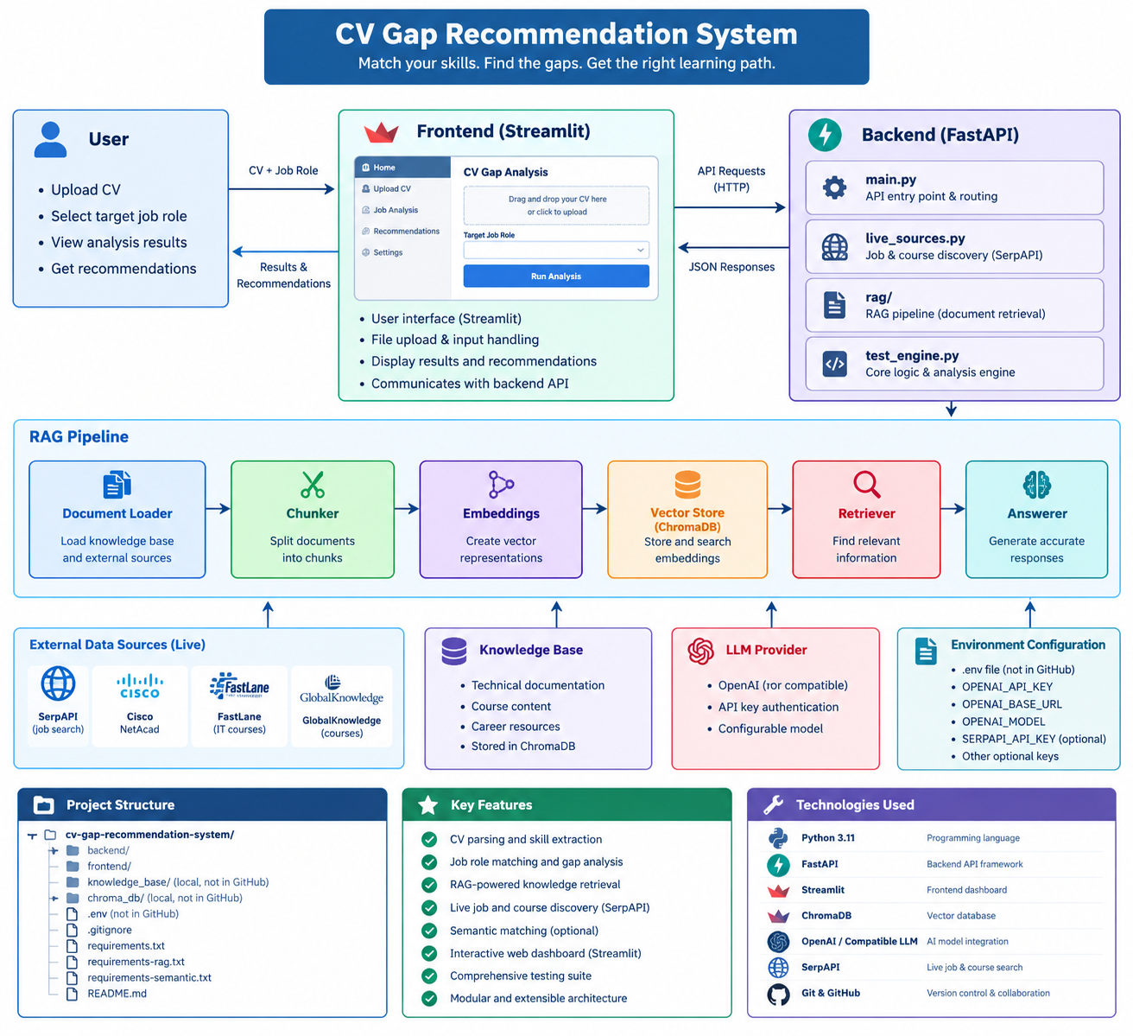
Figure 1. High-level architecture illustration. Verify exact module names, endpoints, and runtime connections against the current repository before treating the figure as a formal implementation specification.
This document covers both major parts of the project: (1) CV analysis, skill-gap detection, scoring and recommendations; and (2) retrieval-augmented generation (RAG) over indexed documents. It reflects details confirmed during development. Where exact implementation details have not been re-inspected from the current repository, they are described functionally and should be verified before production.

1. Executive Summary
The system analyzes a CV against a target role, extracts skills, compares them with role requirements, calculates a match score, identifies missing or underrepresented skills, and recommends learning resources and a roadmap. It uses a Python FastAPI backend and Streamlit frontend. PDF CV text extraction uses pdfplumber. Skill extraction combines deterministic rules with an optional schema-validated LLM path and deterministic fallback. Optional local sentence embeddings can support semantic matching. Live job/course discovery is separate from the persistent RAG knowledge base.
The RAG subsystem ingests supported documents, chunks text, creates embeddings, stores vectors and metadata in persistent ChromaDB, retrieves relevant chunks for a question, and supplies context to the answer layer for grounded responses and source citations. RAG should remain separate from the CV scoring formula.

2. Components and Responsibilities
Component | Responsibility | Output
CV analysis | Parse CV and extract skills against a target role. | Detected skills and evidence.
Scoring and gap analysis | Normalize skill names/aliases and apply role weights. | Match score, matched skills, missing skills and priorities.
Recommendations | Map gaps to a curated resource catalog and roadmap. | Learning recommendations and next steps.
Optional semantic matching | Use local sentence embeddings when enabled. | Potential additional skill matches.
Live discovery | Search configured providers for jobs and learning resources. | External results, not automatically part of RAG.
RAG ingestion | Load documents, chunk text, embed and persist records. | Searchable ChromaDB collection.
RAG retrieval and answers | Retrieve relevant chunks and provide context for answering. | Answer with source references where supported.
FastAPI / Streamlit | Expose API endpoints and browser-based workflows. | JSON API and interactive UI.

3. Technology Stack
Technology | Use
Python 3.11.9 | Runtime used by the project virtual environment.
FastAPI / Uvicorn | Backend API and local development server.
Streamlit | Frontend UI.
pdfplumber | PDF CV text extraction.
ChromaDB | Persistent RAG vector store.
Sentence Transformers | Optional local semantic matching and RAG embeddings.
Pydantic/schema validation | Validate API requests and structured LLM extraction.
OpenAI-compatible LLM configuration | Optional extraction and answer generation, depending on current settings.
SerpAPI / Adzuna configuration | External learning-resource and job discovery, where configured.
pytest | Automated tests.

4. Setup and Running the Application
Known project root:
D:\cv_gap_recommendation_system\cv_gap_recommendation_system

4.1 Start the backend
.\.venv\Scripts\python.exe -m uvicorn backend.main:app --reload
API: http://127.0.0.1:8000 | Swagger: http://127.0.0.1:8000/docs | OpenAPI: http://127.0.0.1:8000/openapi.json

4.2 Start the frontend
.\.venv\Scripts\python.exe -m streamlit run .\frontend\app.py
Run the frontend from a second PowerShell window while the backend remains running.

4.3 Environment and secrets
- The root .env is used for optional integrations. Known configuration families include OpenAI-compatible/Groq settings, LLM timeout, ENABLE_EMBEDDING_MATCHING, SERPAPI_API_KEY and ADZUNA_COUNTRY.
- Never commit .env, API keys, private CVs or confidential documents to GitHub.
- Keep deterministic extraction available when an external LLM is unavailable.
- When external LLMs are enabled, CV text may be transmitted to the provider. Provide suitable privacy notice/consent.
- Optional semantic matching was discussed with all-MiniLM-L6-v2; thresholds should be validated against representative CV/role pairs.

5. Part A — Core CV Analysis and Recommendations

5.1 Workflow
- The user uploads a CV and selects or enters a target role.
- The backend extracts CV text; PDF extraction uses pdfplumber.
- Skills are extracted using deterministic rules and, when configured, a schema-validated LLM path.
- If LLM extraction fails or is unavailable, deterministic fallback logic is used.
- Skill names are normalized through aliases/catalog mappings.
- The scoring layer compares detected skills with target-role requirements and weights.
- The result identifies match percentage, detected/matched skills, missing skills and gap priorities.
- The recommendation engine maps gaps to curated learning resources and builds a suggested roadmap.
- Optional semantic matching and live discovery may enrich results, but external availability and relevance are not guaranteed.

5.2 Scoring and explainability
Scoring is core business logic. Do not alter the formula, weights, thresholds or score interpretation without explicit approval and regression tests. Keep extraction separate from scoring. Make the detected skills, matched skills and gaps visible so users can understand why a score was produced. Use a fixed set of CVs and target roles as a regression baseline.
Historical MVP example: a Systems Administrator CV produced a 61.4% match with 7 detected skills and a list of matched/missing skills plus recommendations and a roadmap. This is an example from an earlier test, not a guaranteed result.

5.3 Extraction, semantic matching and recommendations
- Rule-based extraction provides predictable behavior and a fallback when network-based services fail.
- Validate LLM output against a schema; handle authentication failures, rate limits, timeouts and malformed responses.
- Local embeddings can improve matching of related terms but can also create false positives. Keep the feature configurable.
- Map each gap to relevant resources; where possible include title, provider, URL, resource type and matched skill.
- Distinguish direct courses from training portals and informational articles. A search result is not necessarily a course.
- Keep live job/course discovery separate from curated catalog recommendations and RAG.
The catalog was previously reported as having 26 items, including Windows Server, Backup & Recovery and Virtualization resources. Verify the current catalog before publishing this as a live count.

5.4 Core API
Endpoint | Purpose
/health | Health/status check.
/roles | Available target roles.
/debug/roles | Development/debug view of role configuration.
/analyze | Analyze an uploaded CV against a target role.
/discover/jobs | Discover job results using configured provider logic.
/discover/courses | Discover learning resources using configured search/provider logic.
Confirm exact HTTP methods and request/response schemas from the current /openapi.json or /docs before treating this table as a formal API contract.

6. Part B — RAG Knowledge Retrieval

6.1 Purpose and data flow
- Discover supported documents recursively from the configured knowledge-base directory.
- Extract text from PDF, DOCX, TXT and Markdown files.
- Split extracted text into chunks with overlap.
- Generate embeddings for each chunk.
- Store chunk text, vectors and metadata in persistent ChromaDB.
- Retrieve relevant chunks for a question; filename-aware retrieval is used when the question explicitly mentions an indexed filename.
- Pass retrieved context to the answer layer for a grounded response and source citations where supported.

6.2 Confirmed implementation details
Setting / behavior | Current known value
Default knowledge base | data/knowledge_base; overridable with RAG_DOCUMENTS_DIR.
Default vector-store path | data/chroma_db; overridable with RAG_CHROMA_PATH.
Collection name | cv_knowledge by default.
Supported file types | PDF, DOCX, TXT, Markdown.
Discovery | Recursive.
Chunk size / overlap | 1,000 characters / 150 characters by default.
Chunk ID | SHA-256 derived from source, chunk index and chunk text.
Storage operation | ChromaDB upsert by ID.
Stored metadata | source, file_type, chunk_index.
Distance space | Cosine.
Confirmed source modules include backend/rag/pipeline.py, backend/rag/document_loader.py and backend/rag/vector_store.py. Directory ingestion reports documents_processed, chunks_added_or_updated, per-document results and errors.

6.3 RAG API endpoints
Endpoint | Method | Purpose
/rag/ingest | POST | Index supported documents from the configured knowledge-base directory.
/rag/stats | GET | Return collection name, chunk count, persistence path and knowledge-base path.
/rag/ask | POST | Answer a question using retrieved documents; request includes question and top_k.
Use http://127.0.0.1:8000/docs to inspect exact request schemas and run these endpoints.

6.4 Knowledge-base organization
data/knowledge_base/
CVs/ # Preserve existing CV documents
Courses/ # Future course resources
Certifications/ # Future exam objectives and certification guides
Technical_Guides/ # Future technical documentation
Career_Resources/ # Future career-development resources
These subfolders are an organizational proposal. The current metadata is source, file_type and chunk_index; the code has not yet been confirmed to store folder names as formal categories. Do not move or delete existing CVs as part of adding resources.
- Copy supported documents into the appropriate subfolder.
- Run POST /rag/ingest through Swagger.
- Review documents_processed, chunks_added_or_updated and errors.
- Run GET /rag/stats to check the indexed chunk count.
- Test POST /rag/ask with questions whose answers are in the new documents.

6.5 Known RAG limitations
- Unchanged documents generally upsert the same chunk IDs rather than create duplicate IDs.
- Because IDs include chunk text, changed content creates new IDs. The current pipeline does not automatically remove obsolete chunks from an earlier version.
- Deleting a file from the folder does not automatically remove its already-indexed chunks.
- Add per-source reconciliation before relying on document updates/deletion: compare current source chunk IDs with indexed IDs and remove stale IDs only for that source.
- Do not delete or rebuild data/chroma_db as a routine fix; doing so may remove the existing persistent index.
- There is no confirmed formal category field yet. Folder names alone do not guarantee category-aware retrieval.
- Mentioning a filename can trigger source-specific retrieval; otherwise semantic search uses top_k. Verify source references for answers.
Historical ingestion result: 295 documents and 2,161 chunks were reported in an earlier run. Current totals may differ.

7. Live Discovery vs. RAG
Aspect | Live discovery | RAG
Source | External search/provider at request time. | Files already indexed locally.
Freshness | Depends on provider and search results. | Depends on the last successful ingestion.
Persistence | Usually transient unless separately saved. | Stored in ChromaDB.
Purpose | Find current job/course URLs. | Answer from available document content.
Risk | Snippets can be incomplete or misclassified. | Chunks can be stale or irrelevant.
A URL discovered by live search is not automatically indexed by RAG unless an import/download workflow is implemented.

8. Testing and Quality Assurance
Run the full suite:
.\.venv\Scripts\python.exe -m pytest -v
Run RAG tests:
.\.venv\Scripts\python.exe -m pytest .\tests\test_rag.py -v
Historical result: 29 full-suite tests passed with 2 warnings; RAG-focused tests passed 5/5. Rerun tests on the current checkout before release.

Regression checklist
- Analyze a known CV/role pair and compare scores and skill gaps to a baseline.
- Test rule-based extraction with LLM unavailable.
- Test empty, invalid and supported CV uploads.
- Test semantic matching both disabled and enabled.
- Test empty knowledge base, supported files and unsupported extensions.
- Ingest the same document twice and verify no duplicate chunk IDs.
- After source reconciliation is implemented, test document update and deletion.
- Ask questions answered by known sources and verify citations.
- Test missing provider keys, timeouts, rate limits and empty discovery results.

9. Security and Privacy
- CVs contain personal data; restrict access to uploads, logs, indexes and backups.
- Do not commit secrets, private CVs or confidential documents.
- Disclose external LLM processing and obtain suitable consent when CV text is sent to a provider.
- Validate uploaded file types and sizes; do not accept arbitrary executable content.
- For production, add authentication/authorization, rate limits, structured logging, monitoring and retention/deletion policies.
- Check licensing and download permissions before importing third-party course materials; prefer provider-authorized PDFs and public documentation.

10. Troubleshooting
Symptom | Checks
Backend does not start | Check project root, .venv Python 3.11.9, dependencies and terminal traceback.
UI cannot reach API | Confirm Uvicorn is running on 127.0.0.1:8000 and verify frontend API configuration.
LLM extraction fails | Check configuration names, network, timeout and provider rate limits; verify fallback.
Semantic matching unavailable | Check dependency/model availability and ENABLE_EMBEDDING_MATCHING.
No RAG chunks indexed | Check RAG_DOCUMENTS_DIR, file extensions, ingestion response and errors.
RAG returns unrelated chunks | Review source documents, question specificity, top_k and mixed CV/technical content.
Old text appears after an update | Stale chunks may remain until per-source reconciliation is implemented.
Course discovery returns articles | Search results may be informational pages; refine classification separately.

11. Recommended Roadmap
- Freeze current CV scoring behavior with regression tests.
- Add formal RAG category metadata without altering existing CV records.
- Implement safe per-source reconciliation to remove stale chunks after updates.
- Implement explicit document deletion and an indexed-document inventory.
- Add Streamlit document upload, category selection, ingestion status, errors and index statistics.
- Add category-aware retrieval so course questions prioritize course/certification content.
- Improve discovery classification for direct courses, portals and informational articles.
- Add production access controls, privacy/retention rules, upload limits and monitoring.

12. Verified Details and Items to Recheck
Status | Details
Confirmed in development sessions/source excerpts | Python 3.11.9; FastAPI; Streamlit; pdfplumber; rules plus optional schema-validated LLM extraction; optional local embeddings; curated recommendations; RAG endpoints; recursive loader; supported formats; chunk defaults; ChromaDB persistence; stable chunk ID strategy.
Historical results | 29 full-suite tests passed; 5 RAG tests passed; 295 documents/2,161 chunks in an earlier ingestion; 61.4% earlier Systems Administrator example.
Verify against current repository | Exact API schemas/methods; current catalog count; actual UI flows; current environment variable defaults; answer-generation model/prompt; current test result; deployment and security settings.

Appendix A — Quick Start
- Open PowerShell at the project root.
- Start backend with .\.venv\Scripts\python.exe -m uvicorn backend.main:app --reload
- Open http://127.0.0.1:8000/docs.
- Start frontend in a second terminal with .\.venv\Scripts\python.exe -m streamlit run .\frontend\app.py
- Run .\.venv\Scripts\python.exe -m pytest -v after changes.

Appendix B — Important Paths
Path | Purpose
backend/main.py | FastAPI route definitions.
backend/rag/pipeline.py | Ingestion orchestration, chunking and retrieval facade.
backend/rag/document_loader.py | Recursive discovery and document text extraction.
backend/rag/vector_store.py | ChromaDB persistence, IDs, metadata and query behavior.
data/knowledge_base/ | Source files to ingest.
data/chroma_db/ | Persistent ChromaDB store by default.
frontend/app.py | Streamlit entry point.
tests/test_rag.py | RAG tests.
.env | Local configuration/secrets; keep private.

