Coronavirus Visualization

Sahar Saber

3/30/2020

## Introduction

Today, I found a dataset about coronavirus updated daily and because there is so much interest in this topic, I thought I would create some data visualizations using ggplot2!

ggplot2 is a library in R used to create interactive and dynamic data visualizations.

*Note: All images were created by myself using ggplot2.*

## Load Required Data

As mentioned above, I used a dataset about coronavirus found at [ourworldindata](https://ourworldindata.org/coronavirus-source-data)

head(march_29)

## # A tibble: 6 x 3  
## location total_cases total_deaths  
## <chr> <dbl> <dbl>  
## 1 World 657140 30451  
## 2 United States 124665 2191  
## 3 Italy 92472 10023  
## 4 China 82342 3306  
## 5 Spain 72248 5690  
## 6 Germany 52547 389

Also, a dataframe contains the information required to create Choropleth Maps.

world <- map_data("world")  
head(world)

## long lat group order region subregion  
## 1 -69.89912 12.45200 1 1 Aruba <NA>  
## 2 -69.89571 12.42300 1 2 Aruba <NA>  
## 3 -69.94219 12.43853 1 3 Aruba <NA>  
## 4 -70.00415 12.50049 1 4 Aruba <NA>  
## 5 -70.06612 12.54697 1 5 Aruba <NA>  
## 6 -70.05088 12.59707 1 6 Aruba <NA>

## Data Manipulation

* A left join was made

world_corona <- world %>% left_join(march_29_countries, by = c("region" = "location")) %>% arrange(desc(total_cases))

* Changing the continuous variables *total_cases* and *total_deaths* into discrete variables

world_corona_tidied <- world_corona_tidied %>% mutate(total_cases_discrete = cut(world_corona_tidied$total_cases,   
 breaks=c(-Inf,0,500, 1000, 10000,100000, Inf),   
 labels=c("0","<500", "<1000","<10,000","<100,000", ">100,000")))  
  
world_corona_tidied <- world_corona_tidied %>% mutate(total_deaths_discrete = cut(world_corona_tidied$total_deaths,   
 breaks=c(-Inf,0,500, 1000, 2000,3000, Inf),   
 labels=c("0","<500", "<1000","<2000","<3000", ">3000")))

### Choropleth Maps

And Finally, Choropleth Maps shows the spread of the Coronavirus Globally.

ggplot(world_corona_tidied, aes(x = long, y = lat, group = group, fill =total_cases_discrete )) +  
 geom_polygon(col = "#000000") +  
 scale_fill_brewer(palette = "Reds")+  
 theme_void()

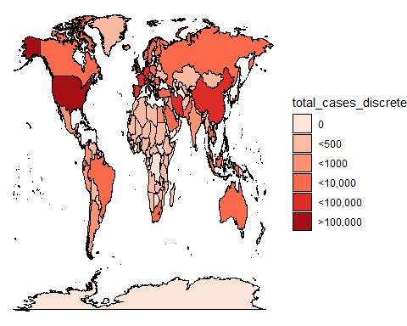

ggplot(world_corona_tidied, aes(x = long, y = lat, group = group, fill =total_deaths_discrete )) +  
 geom_polygon(col = "#000000") +  
 scale_fill_brewer(palette = "Reds")+  
 theme_void()

