Agentic RAG-Based Patent Intelligence System with Live Data Retrieval and Hallucination Detection
B.Tech Major Project Report, Computer Science and Engineering
Guide: Dr. T. Swathi
[Team members and roll numbers]

Abstract
Large language models (LLMs) write fluent statements about patents that no source supports ("hallucinations"), which is unacceptable where one wrong technical detail changes a claim's meaning. This project presents an agentic retrieval-augmented generation (RAG) system for patent intelligence that answers only from retrieved patent text, cites every statement and verifies each one against its evidence.
Uploaded documents and live records from the EPO Open Patent Services are split into claim-aware passages and indexed in PostgreSQL/pgvector with BGE-M3 embeddings and hybrid retrieval. A LangGraph agent selects tools per question (local search, direct claim retrieval, live patent import, balanced comparison) and answers with a local LLM (Qwen3-8B); an NLI verifier labels every statement, flags misattributed citations and triggers regeneration when grounding is low.
On a frozen test set of 53 questions over 16 real patents, the agent outperformed a conventional RAG baseline in passage recall@5 (39.4% → 51.1%) and grounding (66.4% → 72.6%), with fewer unsupported statements (22.2% → 17.2%; all 95% intervals excluding zero), at about twice the latency. On 30 questions about patents published in 2026, after the LLM's training data, the LLM alone never admitted ignorance and 73% of its statements were unsupported, while the agent with live EPO access retrieved the asked claim every time; this experiment also exposed, and led to the fix of, a misattribution bug. Against 150 statements labelled by one team member with AI assistance, the NLI verifier proved strict (κ 0.16), so grounding scores are conservative. The test labels were AI-written and not human-verified; both limitations are reported. The system describes technical similarity only and gives no legal opinions.
Keywords: retrieval-augmented generation, LLM agents, hallucination detection, natural language inference, patent analysis, information retrieval

1. Introduction

1.1 Background
Patents are long, formally written technical documents. A single patent typically has an abstract, a background, a summary, a detailed description with numbered paragraphs, and a set of claims that define what is protected. Engineers checking prior art, students studying a technology, and analysts comparing competitors must read many such documents and extract precise technical facts: which components a claim requires, what a dependent claim adds, how two inventions differ.
Large language models can summarise and answer questions about text, but when they answer from their parametric memory they may produce statements that no source supports. In patent work such errors are costly: attributing a feature to the wrong patent, or inventing a numeric limit, changes the technical meaning entirely.

1.2 Problem statement
Design and evaluate a system that answers technical questions about patents such that (i) every statement is derived from and cited to retrieved patent text, (ii) unsupported statements are detected automatically, and (iii) the choice of retrieval steps adapts to the question (single fact, specific claim, comparison of several patents, search for similar patents), using live patent data where needed.

1.3 Objectives
- Ingest patents from uploads and from a live patent database, preserving patent structure (sections and individual claims).
- Retrieve relevant evidence with hybrid semantic and keyword search.
- Build an agent that selects tools and sources per question and recovers from failures.
- Generate answers that cite evidence for every statement and separate interpretation from fact.
- Verify answers at statement level and regenerate low-grounded answers.
- Evaluate the system against a conventional RAG baseline with a labelled dataset and statistically sound comparisons.

1.4 Contributions
- A patent-aware ingestion pipeline (section detection, one chunk per claim) with content-based relevance labelling that keeps evaluation comparable across chunking strategies.
- An agentic RAG pipeline (LangGraph) with seven tools, including direct claim retrieval and balanced evidence collection for multi-patent comparison.
- A two-pass, claim-level verifier that detects unsupported and misattributed statements, using sentence-window NLI, and an evidence-augmented regeneration loop.
- An evaluation framework (dataset format, runner, metrics, bootstrap confidence intervals, paired comparisons, verifier-vs-human agreement) and a set of controlled experiments (A–I).
- Documented engineering findings on evaluating such systems, e.g. the effect of multi-sentence premises on small NLI models and order effects in latency measurement.

1.5 Scope and limitations
The system reports technical similarity and evidence only; it does not give legal opinions on novelty, validity or infringement and states this in every relevant answer. It is a single-user research prototype without user authentication. Experiments use one locally hosted LLM; results may differ for other models.

1.6 Report organisation
Chapter 2 reviews related work. Chapter 3 presents the system design and Chapter 4 the implementation. Chapter 5 describes the evaluation methodology, Chapter 6 the results, Chapter 7 discusses them with limitations, and Chapter 8 concludes.

2. Literature Review

2.1 Retrieval-augmented generation
Lewis et al. [1] introduced retrieval-augmented generation (RAG): a generator conditioned on passages retrieved from an external corpus, which grounds outputs in evidence and allows the knowledge source to be updated without retraining. Gao et al. [2] survey the evolution from "naive" retrieve-then-read pipelines to modular and adaptive RAG, where retrieval decisions depend on the query. Our baseline corresponds to naive RAG; our agent belongs to the adaptive family.

2.2 Retrieval components
Dense retrieval embeds queries and passages in a shared vector space. BGE-M3 [3] provides multilingual dense embeddings for passages up to 8,192 tokens and is used here. Approximate nearest-neighbour search over embeddings commonly uses HNSW graphs [4], as implemented by pgvector. Lexical and dense rankings are complementary; Reciprocal Rank Fusion (RRF) [5] combines ranked lists without score calibration and is used for our hybrid search. Cross-encoder rerankers [6] rescore a candidate list by reading query and passage jointly and are evaluated as an option (Experiment D).

2.3 LLM agents and tool use
ReAct [7] interleaves reasoning steps with tool calls, letting a model decide which information to gather. Self-RAG [8] lets a model decide when to retrieve and critique its own output. Our agent follows a more constrained design: an explicit state machine (LangGraph) in which a planner (rules or LLM) selects among typed tools, which keeps behaviour inspectable and allows tool selection to be evaluated against labels.

2.4 Hallucination and its detection
Ji et al. [9] survey hallucination in natural language generation, distinguishing content unsupported by the source (intrinsic/extrinsic). Detection approaches include sampling consistency (SelfCheckGPT [10]), decomposition into atomic facts checked against a knowledge source (FActScore [11]), and NLI-based consistency checking. SummaC [12] showed that NLI models applied at sentence granularity, with aggregation over premise sentences, detect inconsistencies far better than document-level NLI, a finding we reproduced for patent passages. Our verifier uses an NLI cross-encoder built on DeBERTa-v3 [23], the successor of DeBERTa [13], fine-tuned on the SNLI [24] and MultiNLI [14] corpora.

2.5 Citations and evaluation of RAG
Gao et al. [15] (ALCE) evaluate whether generated text is supported by its citations, measuring citation recall and precision. RAGAS [16] proposes reference-free RAG metrics (faithfulness, answer relevance, context relevance) computed with LLM judges. We adopt claim-level faithfulness ("grounding") and add misattribution, and we measure the verifier itself against labelled statements (Experiment I).

2.6 Patent retrieval and analysis
Patent retrieval differs from web search: long documents, formal claim language and recall-oriented tasks such as prior-art search. Shalaby and Zadrozny [17] review patent retrieval methods, and Krestel et al. [18] survey deep learning for patent analysis. Unlike these task-specific systems, our work combines retrieval with LLM generation and statement-level verification for question answering over patents.

2.7 Research gap
Existing RAG systems rarely (i) exploit patent structure (claims as units), (ii) select sources and tools per question while (iii) verifying each generated statement against its specific citation and detecting misattribution, and (iv) report results with confidence intervals against a conventional baseline on labelled patent questions, and (v) test on patents published after the language model's training data, where only live retrieval can give a correct answer. This project addresses that combination.

3. System Design

3.1 Overview
The system has four layers (Figure 3.1): a web frontend, an API backend containing the ingestion pipeline, the agent and the verifier, a PostgreSQL database with the pgvector extension, and model services. All models run locally by default (no paid API is required); live patent data comes from the EPO Open Patent Services.
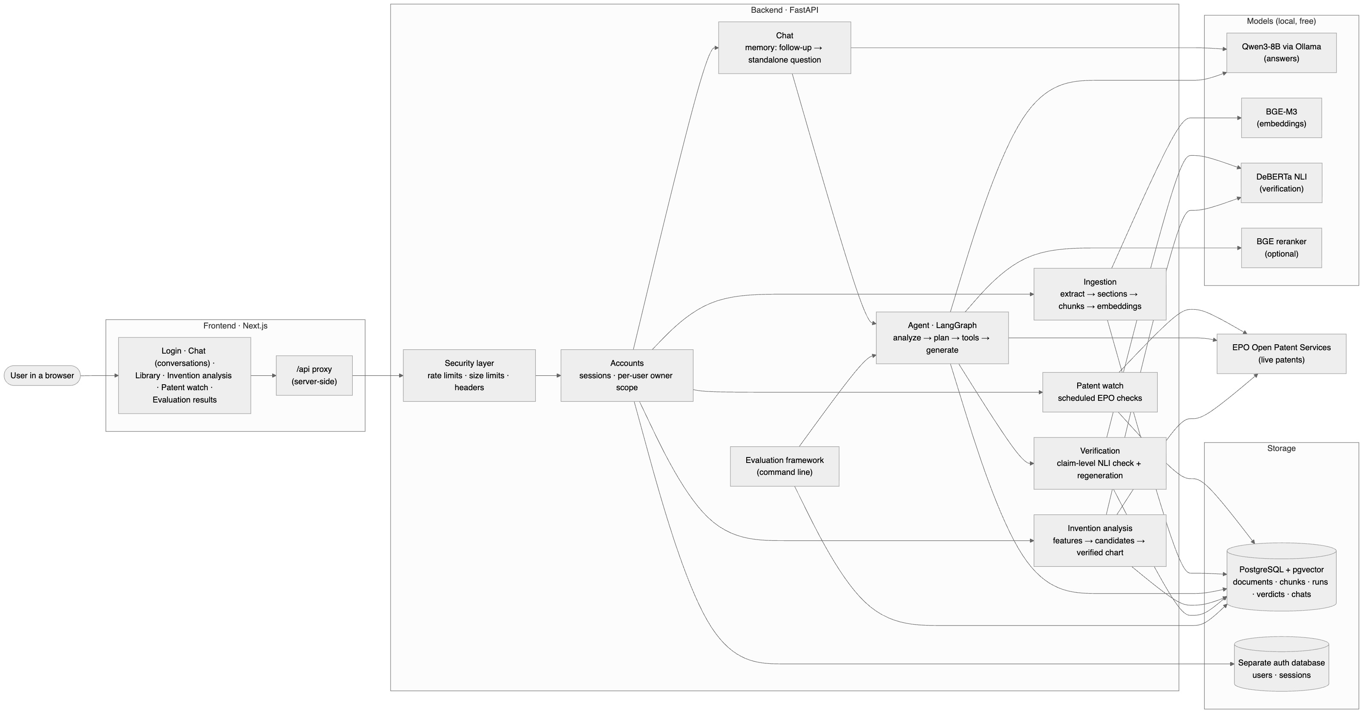
Figure 3.1: System architecture (docs/diagrams/1_architecture).
Layer | Technology | Responsibility
Frontend | Next.js 16, React 19, Tailwind CSS | Pages for documents, questions, patent search, comparison, evaluation, settings; proxies /api to the backend so no secret reaches the browser
API | FastAPI (Python 3.12) | 21 endpoints; validation, rate and size limits, uniform JSON errors with request IDs
Agent | LangGraph | State machine that analyses the question, plans and runs tools, generates, verifies, regenerates
Storage | PostgreSQL 17 + pgvector 0.8 | Documents, patents, passages with 1024-d embeddings (HNSW index) and full-text vectors (GIN index), run records for evaluation
Models | Qwen3-8B (Ollama), BGE-M3, DeBERTa-v3 NLI, BGE reranker v2-m3 | Generation, embeddings, verification, optional reranking
External | EPO OPS v3.2 | Search, bibliographic data, claims and descriptions of published patents

3.2 Ingestion design
Patents are split along their structure rather than at fixed lengths (Figure 3.2): text is extracted, cleaned (running headers, hyphenation, ligatures), segmented into the standard sections, and chunked so that each claim is one passage and description paragraphs are grouped up to 400 tokens with 60 tokens of overlap. Every passage keeps its section, claim number, page and exact character offsets, so citations can point to "claim 3" or "page 4". Fixed-size chunking is kept as an alternative for Experiment B.
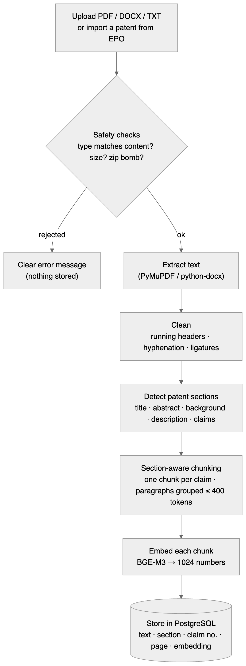
Figure 3.2: Ingestion pipeline (docs/diagrams/2_ingestion).

3.3 Retrieval design
Each question is searched in two ways: dense similarity of BGE-M3 embeddings (cosine, HNSW) and PostgreSQL full-text search. The two candidate lists (30 each) are merged with Reciprocal Rank Fusion, score(d) = Σ 1/(60 + rank), and the top 6 passages (within a 3,000-token budget) are given to the LLM. A sufficiency gate answers "insufficient evidence" without calling the LLM when no passage is similar enough (cosine < 0.35) and no keyword matches, which prevents answers from nothing.

3.4 Agent design
The agent is an explicit graph (Figure 3.3; generated from code in docs/agent_graph.md):
- Analyse: classify intent (document question, patent lookup, find similar, compare) and extract publication numbers, claim numbers, sections and legal wording, using rules or an LLM planner whose output is validated (numbers, sections and the similar-search intent are only accepted if the question contains them).
- Resolve targets: map "my battery patent" or "EP1234567" to indexed documents, or mark them for fetching.
- Plan and execute tools: search_uploaded_documents, retrieve_evidence, retrieve_document_section, search_patents, get_patent_details, compare_patents, extract_key_concepts.
- Check and recover: if evidence is insufficient, one recovery step broadens the search.
- Generate: a grounded prompt with numbered evidence [E1]…; evidence is marked as untrusted data (prompt-injection hardening); interpretation is separated from facts; legal questions are reframed as technical comparisons with a disclaimer.
- Verify and regenerate (Section 3.5).
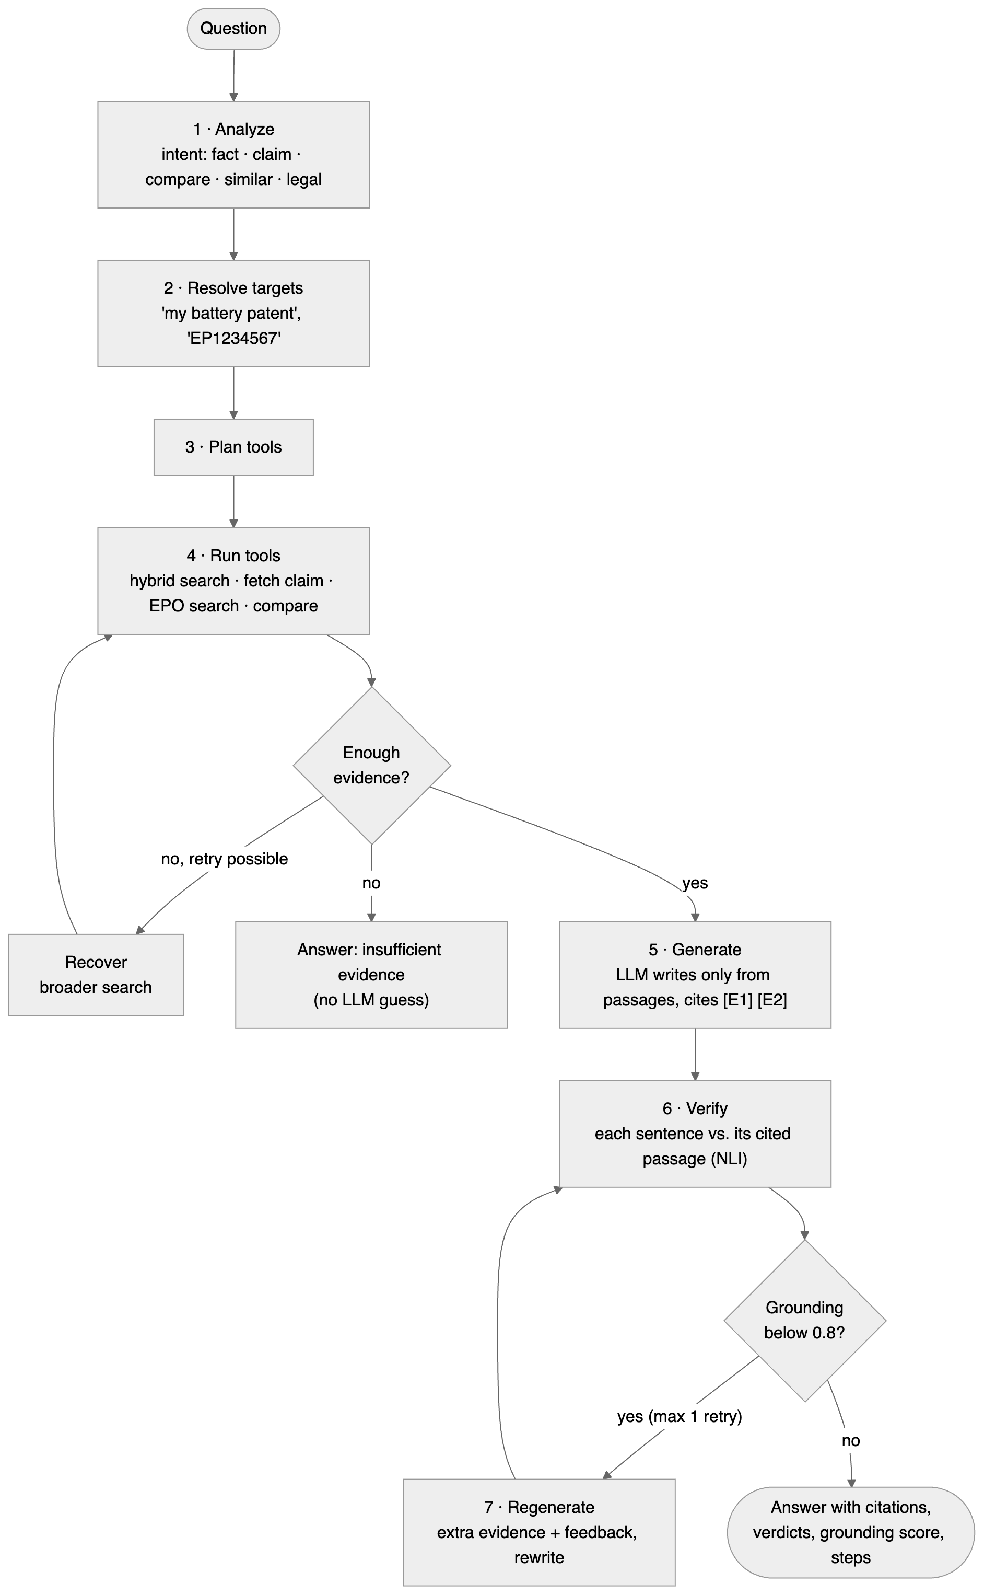
Figure 3.3: Question-answering flow (docs/diagrams/3_answer_flow).

3.5 Verification design
Answers are split into statements (disclaimers and the interpretation paragraph are skipped). Each statement is judged in two passes (Figure 3.4): against the passages it cites (individually and together), and, if not supported, against all other retrieved passages. A statement supported only by an uncited passage is misattributed. The grounding score is (supported + ½·partially supported) / statements. If grounding is below 0.8, the agent retrieves extra passages for each unsupported statement and asks the model to rewrite with explicit feedback, at most once, and keeps the better-grounded attempt.
The NLI judgement (Figure 3.5) scores the passage, each of its sentences and each pair of neighbouring sentences, prefixed with the passage's location, and takes the maximum entailment probability (≥ 0.5 supported, ≥ 0.15 partial).
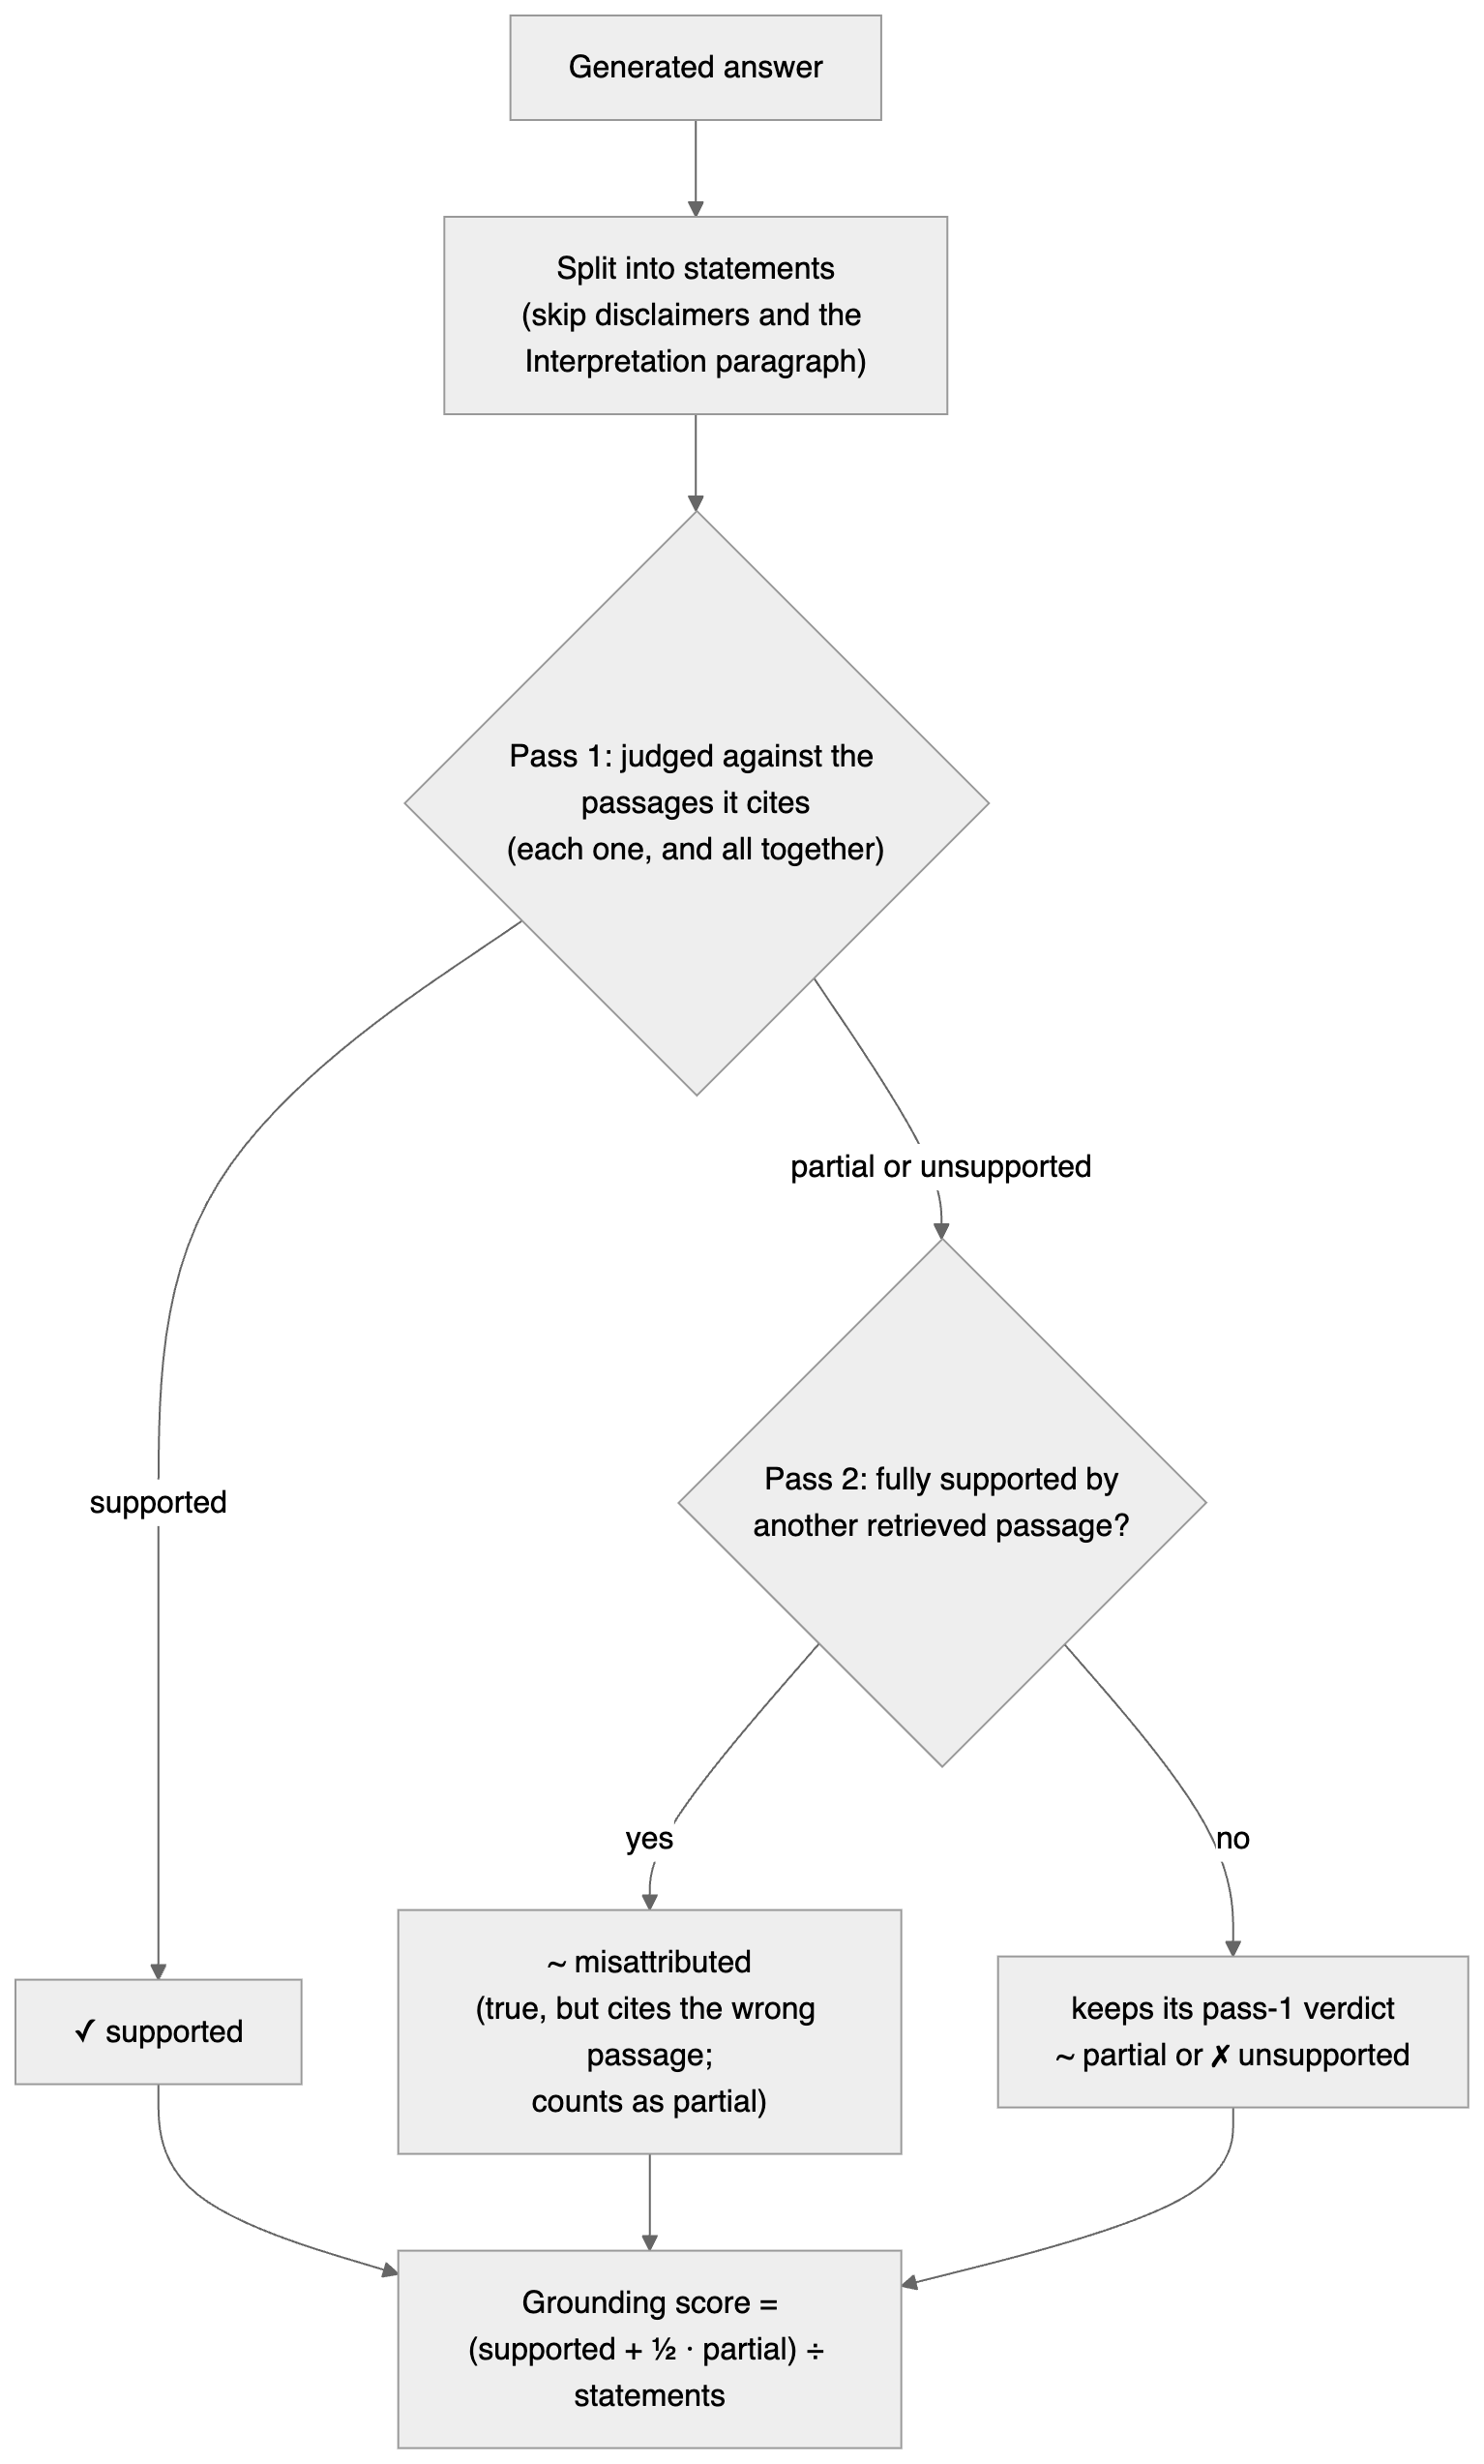
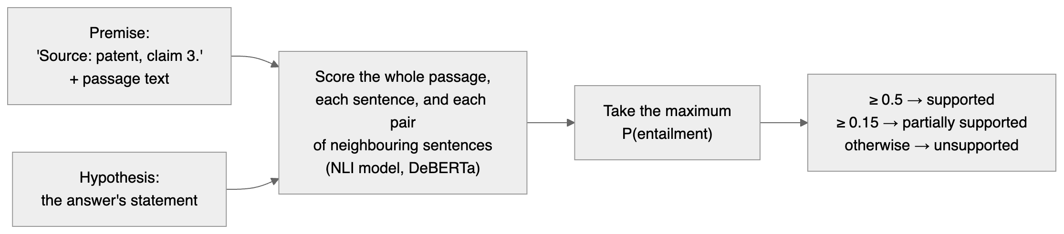
Figure 3.4: Verification (docs/diagrams/4_verification). Figure 3.5: One NLI judgement (docs/diagrams/4b_nli_judgement).

3.6 Invention analysis
Beyond question answering, the system supports a complete prior-art style workflow. Given an invention description (or an uploaded draft, whose abstract and claim 1 are used), it (1) splits the invention into technical features, taking claim elements directly when a claim is present ("comprising: a; b; and c") and otherwise accepting LLM-listed features only if at least half of their content words occur in the description; (2) optionally searches the patent databases with the features' key terms and imports the top results; (3) ranks candidate documents by Reciprocal Rank Fusion of per-feature retrieval rankings, excluding the invention's own document; and (4) builds a feature × document chart in which each cell is decided by retrieving that document's three best passages for the feature and judging them with the NLI verifier (disclosed / partially disclosed / not found), citing the passage. The chart is therefore computed rather than generated, and cannot contain an invented disclosure. Features found in no retrieved document are listed, with an explicit statement that this is not a novelty assessment.
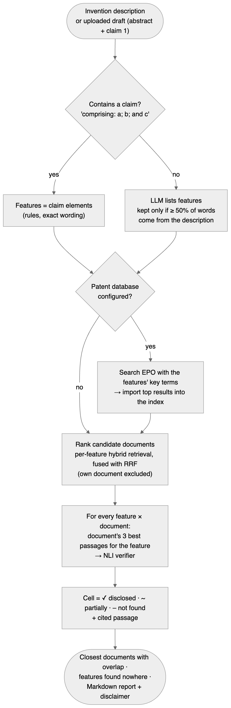
Figure 3.7: Invention analysis (docs/diagrams/7_invention_analysis).

3.7 Data model
Thirteen tables (Figure 3.6) separate the corpus (documents, patents, chunks, API cache) from the record of every answer (queries, agent runs, tool calls, retrieval results, claim verifications, evaluations) and from the user-facing features (conversations, patent watches and their hits). Each run stores a snapshot of all settings used, so every reported number can be traced to its configuration. User accounts and login sessions live in a separate database (patent_rag_auth, own migrations); rows in the main database refer to their owner only by id, so a fault in the patent data layer cannot expose credentials.
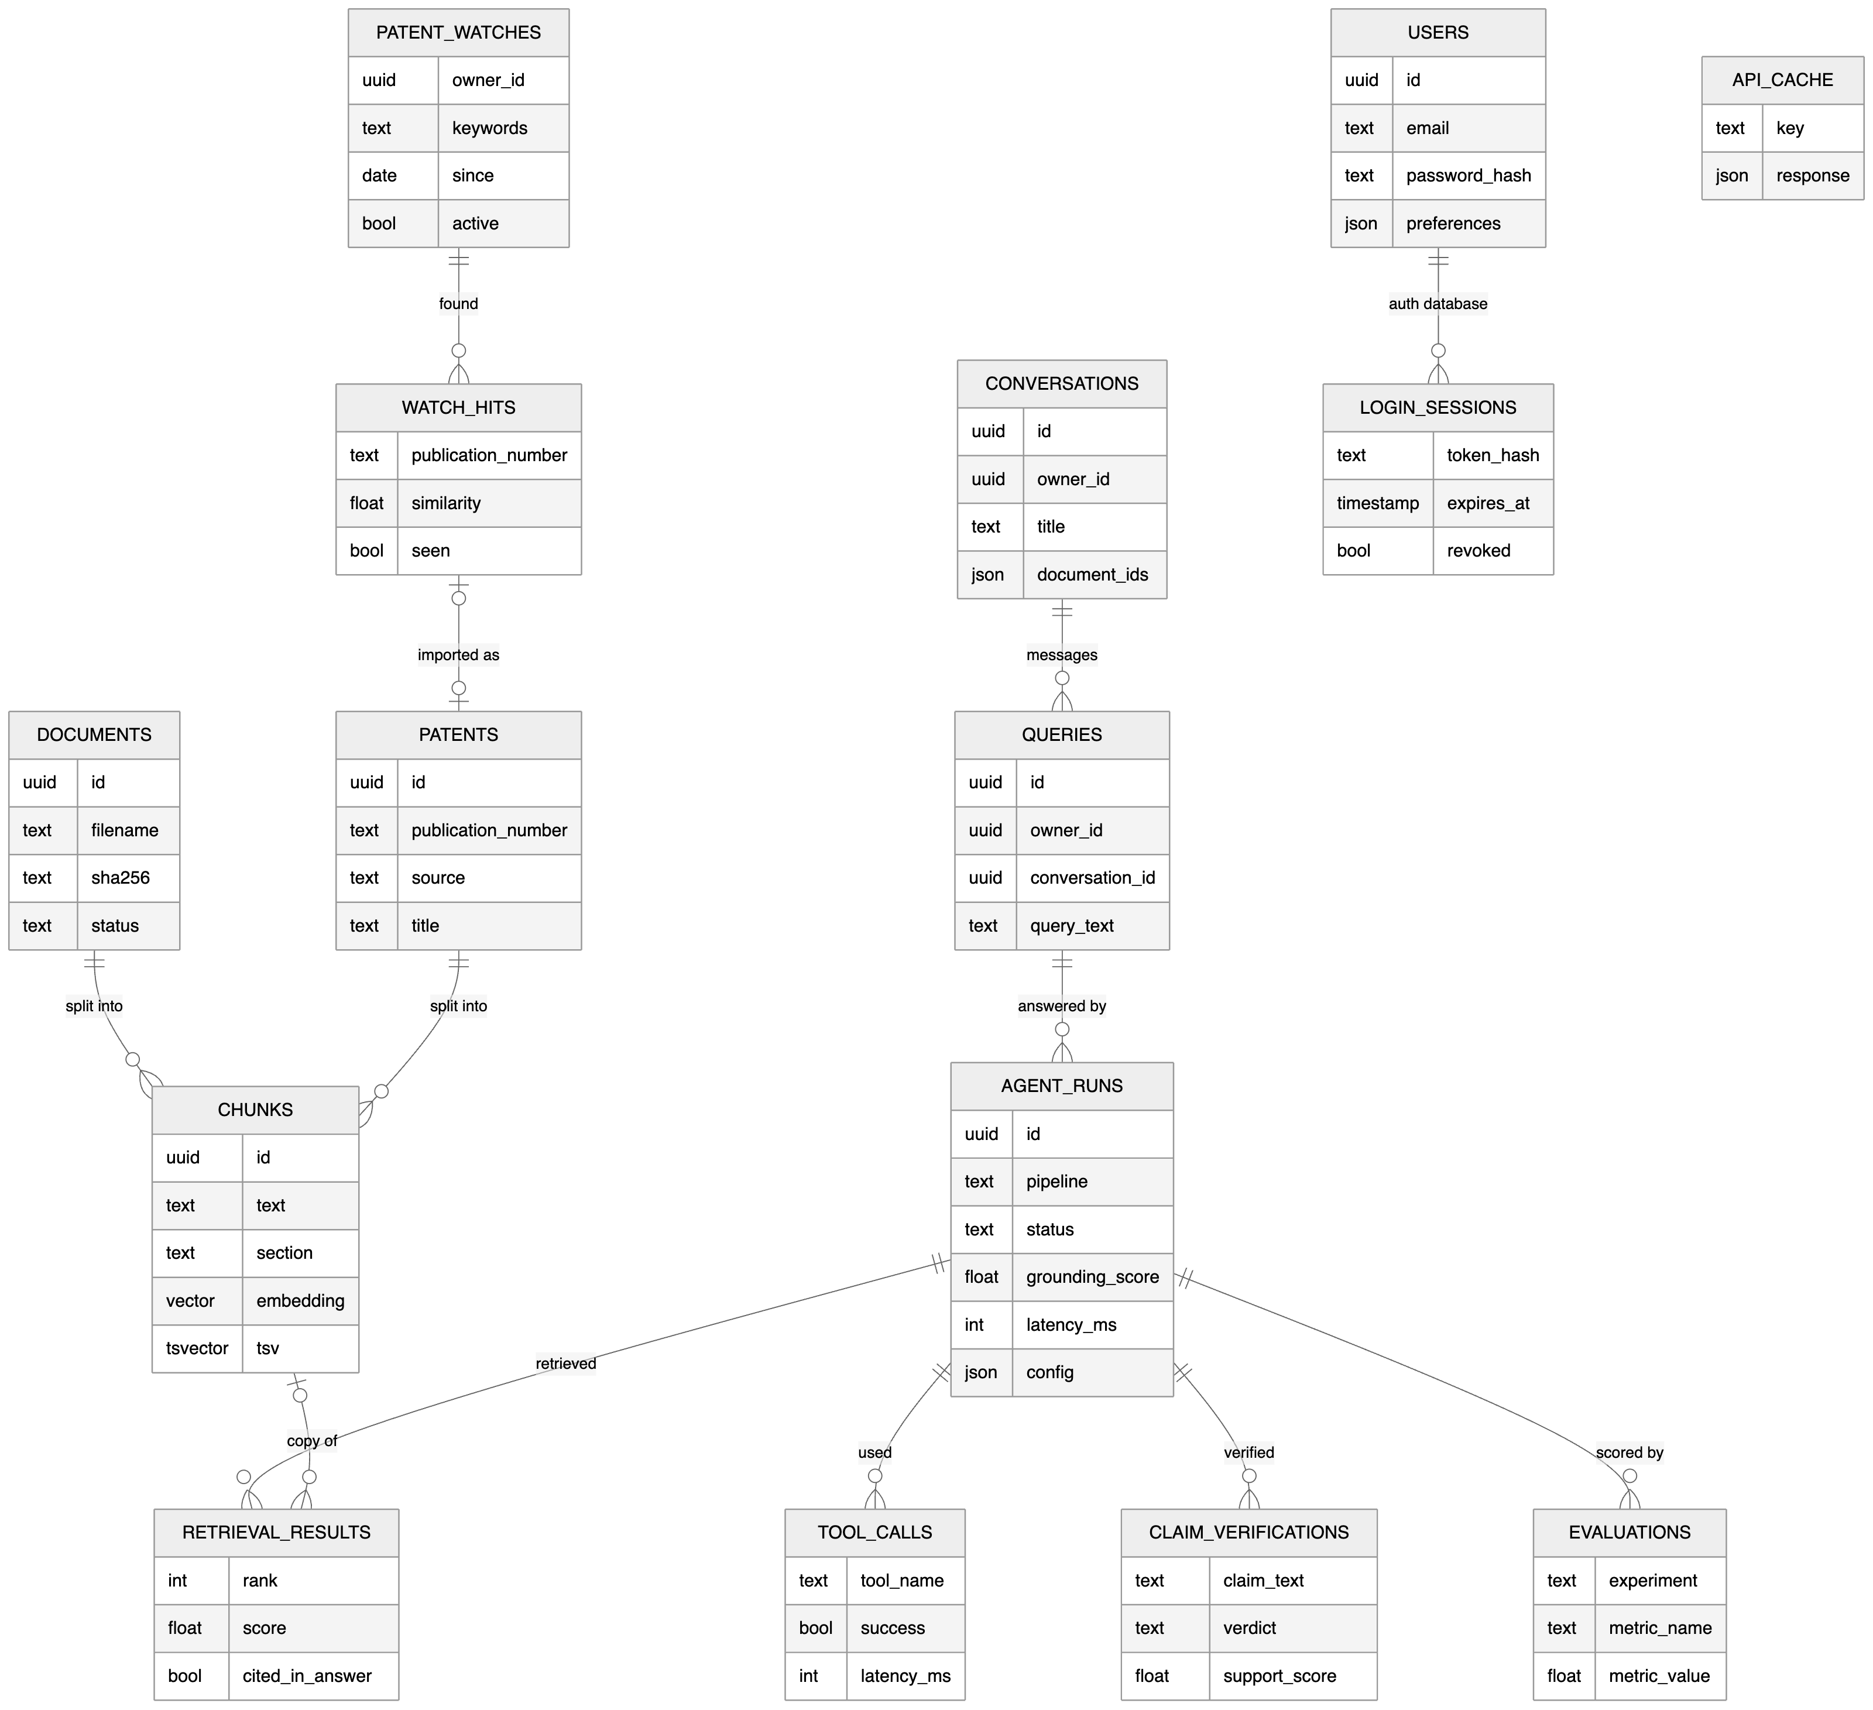
Figure 3.6: Database schema (docs/diagrams/6_database).

3.8 Design decisions
Decision | Alternative | Reason
One passage per claim | Fixed windows | Claims are the legal and technical unit; citations can name the claim
Hybrid retrieval with RRF | Dense only | Patent text has exact terms (part names, numbers) that keyword search finds reliably
Explicit agent graph | Free-form ReAct loop | Inspectable, testable, and tool selection can be evaluated against labels
Local models | Hosted APIs | Zero cost, documents never leave the machine, reproducible
PostgreSQL for vectors, text, cache and runs | Separate vector DB + Redis | One service to operate; transactions across corpus and run records
Feature chart decided by retrieval + NLI | LLM writes the chart | A generated chart could assert disclosures that are not in the document; a computed one cites a passage for every ✓
NLI verifier | LLM-as-judge only | Deterministic, free, fast; the LLM judge is kept as an alternative (Experiment I)

4. Implementation

4.1 Development approach
The system was built in thirteen phases (0–12), each ending with automated tests and a manual check with real models. The backend has [311] automated tests (unit tests with fake models, and integration tests against a separate PostgreSQL test database rolled back after each test); the frontend has unit tests, type checks and linting, and pages were checked in a real browser.

4.2 Backend modules
Module | Content
rag/ | extraction (PyMuPDF, python-docx), cleaning, section detection, chunking, embeddings, vector and keyword search, RRF fusion, reranker, prompt construction and answer parsing
agents/ | query analysis (rules and LLM), seven tools, LangGraph agent
verification/ | NLI, LLM-judge and lexical verifiers; claim extraction; two-pass checking
invention/ | invention analysis: feature extraction, candidate ranking, feature chart, Markdown report
intelligence/ | patent family de-duplication, similarity ranking, structured comparison tables
patents/ | EPO OPS client (OAuth, CQL search, full text), demo source, response cache
evaluation/ | dataset format, metrics, scoring, experiment runner, verifier evaluation, reports
services/, api/ | baseline and agentic answer services, documents, patents, comparison; HTTP routes
core/ | configuration, logging with secret redaction, errors, security middleware

4.3 Key algorithms
Section-aware chunking. Headings are matched against patent section names; claims are split at their numbers ("1.", "2." …) into one chunk each; other sections are packed paragraph by paragraph up to the token limit with overlap. Exact char_start/char_end offsets are kept for every chunk.
Hybrid retrieval. vector_search (pgvector cosine distance, HNSW, filtered by embedding model) and keyword_search (PostgreSQL full text: the question's stemmed words combined with OR, ranked by ts_rank_cd (cover density), GIN index) each return 30 candidates; RRF with k = 60 merges them.
Answer parsing. Citations [E#] are validated against the evidence given; invalid labels are removed and counted; citation coverage = cited sentences / sentences; the "Interpretation:" paragraph is separated; "INSUFFICIENT_EVIDENCE" with missing information is recognised.
Verification. See Section 3.5. The NLI model is cross-encoder/nli-deberta-v3-xsmall (about 280 MB, runs on CPU); label order is read from the model configuration.
Comparison. For 2–4 sources, evidence is retrieved per source (balanced), and a table of technical aspects × sources is generated (LLM, JSON-validated) or extracted; every cell must cite its own source's passages, and cross-source citations are removed and counted.
Invention analysis. For F features and D candidate documents, F·D scoped retrievals (top 3 passages each) are judged in a single batched verifier call; with the defaults (≤ 8 features, 5 documents) that is at most 40 cells. Each cell records verdict, score and the passage; runs are stored like answers (agent runs with tool steps and cited retrieval results) and exported as a Markdown report.

4.4 Frontend
The UI is built around a chat, like the assistants users already know. After login, a sidebar lists the user's conversations (grouped by date, renamable) and three tools: Library (My documents, Find patents, Compare), Invention analysis (feature chart with clickable evidence and report download) and Patent watch (new-publication alerts with an unread badge). A chat answers with clickable citations and a one-line trust summary ("5 of 6 statements verified"); sources, sentence checks and the agent's steps open on demand. Files are attached by drag-and-drop or the paperclip, and any library item opens a chat with it attached. Follow-ups are shown with the standalone question the system understood. Research pages (Evaluation results with confidence intervals, a Research console exposing every retrieval option, System status) sit in the user menu, with the profile and the light/dark theme. API types are generated from the backend's OpenAPI schema.

4.5 Security and deployment
Configuration and secrets come from .env (secrets as SecretStr, never logged or sent to the browser); uploads are validated by content, size-limited while streaming and checked for zip bombs; rate limits cap LLM-backed requests; security headers and a Content-Security-Policy protect the UI; production start-up refuses unsafe settings. Docker images (non-root, health checks) run the full stack with one command. Details and remaining risks: docs/security.md.

4.6 Tools and versions
Python 3.12, FastAPI 0.142, SQLAlchemy 2.1, LangGraph 1.2, PyMuPDF 1.28, sentence-transformers 6.1, PostgreSQL 17, pgvector 0.8.7, Next.js 16, React 19, Ollama with Qwen3-8B. Exact versions: backend/requirements*.txt, frontend/package.json, and environment.json in each experiment result.

5. Evaluation Methodology

5.1 Research questions
- RQ1. Does an agent that selects tools and sources produce better-grounded and more accurate answers than a fixed retrieve-then-generate pipeline, and at what cost?
- RQ2. How much does claim-level verification with regeneration reduce unsupported statements?
- RQ3. Which retrieval design choices (chunking, number of passages, reranking) matter for patent text?
- RQ4. How accurately does an automatic verifier agree with human judgement?
- RQ5. Does live patent data matter for patents the LLM cannot know (published after its training data)?

5.2 Corpus and dataset
The corpus is 16 public patents in three technical domains (wireless-charging foreign object detection, electric-vehicle battery thermal management, immersion cooling), including near-neighbour documents so retrieval must discriminate. Patents were downloaded as text with standard section headings (backend/scripts/build_corpus.py).
Questions cover eight types: single-fact lookups, multi-passage questions, claim explanations (document selected), questions naming a publication number, comparisons of two selected documents, unanswerable questions (the correct behaviour is to abstain), and legal-opinion questions (the correct behaviour is to decline the legal opinion and give a technical comparison). Each question is labelled with:
- relevant passages, identified by content (document + short quote, claim number or section), never by chunk ID, so the same labels score any chunking strategy;
- key facts a correct answer must contain;
- expected intent and expected tools;
- whether it is answerable and whether it asks for a legal opinion.
The questions used for tuning (dev set real_v1, 54 questions) are separate from the questions used for reporting (test set real_test_v1, 53 questions), which use different facts and were frozen before any system run on them (dataset SHA-256 recorded in each result). Who wrote the labels. Both sets were written by an AI coding assistant from the patent texts. After the final runs, the same assistant audited every test item against the patent text (labels re-matched to the corpus, key facts confirmed next to their passages, generic questions searched across all 16 patents for missing answer passages, unanswerable questions searched for any answer); this corrected 4 key facts and changed no question. The stored runs were then re-scored without regenerating answers. The labels were not verified by humans, so retrieval metrics and key-fact recall carry that limitation; grounding, latency, token and tool metrics do not depend on them.
Live question set (Experiment E). A second question set is generated, not written: EPO is searched for EP and WO publications from 2026 in the three domains, and for each of 15 patents (published 2026-04-15 to 2026-09-30) two questions ask what claim 1 covers and what one dependent claim adds. The ground truth is the claim text and abstract as EPO supplied them, frozen in the question set before any run (experiments/datasets/live_epo_v1/). Answers are scored by the share of the claim's content words they contain ("claim content") and by the NLI verifier against the real claims and abstract ("supported by the patent"); no human labels are involved.

5.3 Metrics
Group | Metric | Definition
Retrieval | Right sources found | labelled documents represented in the evidence ÷ labelled documents
Retrieval | Recall@k, MRR, Hit@k | passage-level, against content labels (k = 5)
Answer | Key-fact recall | labelled facts present in the answer ÷ facts
Answer | Answer/abstain accuracy | answered answerable / abstained on unanswerable
Grounding | Grounding score | (supported + ½ partial) ÷ checked statements
Grounding | Unsupported / misattributed rate | share of statements
Grounding | Citation coverage, invalid citations | cited sentences ÷ sentences; labels not supplied
Agent | Intent accuracy, tool precision/recall | against expected intent and tools
Cost | Latency (mean, median, p95), LLM calls, tokens | per question
Verifier | Accuracy, Cohen's κ, detection P/R/F1 | verifier verdicts vs. human verdicts

Passage-level retrieval metrics underestimate retrieval quality when labels list only some of the passages that answer a question (patents repeat facts across sections), so document-level metrics are reported next to them.

5.4 Experiments
ID | Compares | Held constant
A | Baseline RAG vs. agentic RAG | LLM, embeddings, corpus
B | Section-aware vs. fixed-size chunking | Retrieval, LLM
C | Passages given to the LLM (k = 3, 6, 10) | Everything else
D | Without vs. with cross-encoder reranking | Candidate pool (30)
E | Live EPO access vs. local documents only vs. the LLM alone, on 2026 patents | LLM, question set
F | Tool selection vs. running every available tool | Tools available
G | No verification vs. verification vs. verification + regeneration | Retrieval
H | Rule-based vs. LLM planner | Everything else
I | Verifier methods (NLI, LLM judge, lexical) vs. human labels | Statements judged
S | Invention-analysis self-check (label-free) | Corpus

Experiment S (self-check). For every patent in the corpus its own claim 1 is used as the invention description. Included: the patent should be ranked first and its claim features marked as disclosed in it (tests retrieval and the verifier with a known answer). Excluded: with the patent hidden, the closest documents should belong to the same technical domain (same-domain@1, @3). No human labels are required, so the check scales to any corpus; because queries share wording with their source, it is easier than real use and complements the labelled test set.
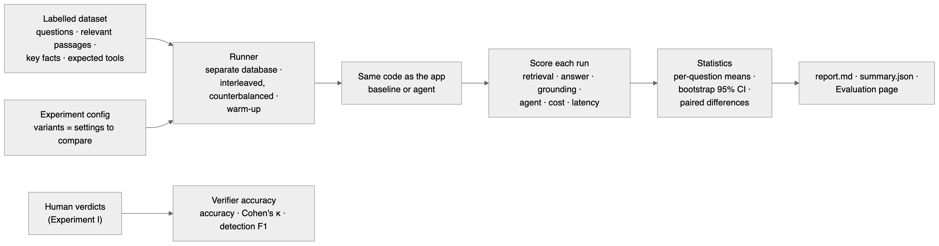
Figure 5.1: Evaluation framework (docs/diagrams/5_evaluation).

5.5 Procedure and statistics
All variants run on the same questions with temperature 0, through the same code as the application, against a separate database containing only the corpus. Variants sharing an index are run interleaved per question with the starting variant rotated (counterbalancing), after one untimed warm-up question, on an otherwise idle machine. Repeats are averaged per question; questions are the unit of analysis. Means are reported with 95% percentile-bootstrap confidence intervals (2,000 resamples, fixed seed), and variants are compared with paired bootstrap differences; a difference is reported as such only when its 95% interval excludes zero. Every result folder stores the configuration, all settings, package versions and the dataset fingerprint.

6. Results
All results below are from the frozen test set real_test_v1 (53 questions over 16 real patents; dataset SHA-256 97a338c11947c18a… after the label corrections recorded in experiments/datasets/real_test_v1/FROZEN.md). Every table is generated by python -m app.evaluation results-chapter from the stored results named above it; no number was typed by hand. Each experiment ran once (1 repeat) with Qwen3-8B (via Ollama), BGE-M3 embeddings and the NLI verifier on a laptop CPU.
Limitation that applies to every table in 6.1–6.4. The relevance labels and key facts were written by an AI coding assistant and then audited item by item by the same assistant; they were not verified by a human. Retrieval metrics and key-fact recall depend on these labels; grounding, unsupported-claim rate, latency, tokens and tool metrics do not (they come from the system's own verifier and logs). Results were re-scored after the audit without regenerating any answer.
How to read the tables: mean over questions with a 95% bootstrap confidence interval; † marks a paired difference to the first column whose 95% interval excludes zero ("clear"). With 53 questions, differences of a few percentage points are usually not clear; "no clear difference" does not mean "no difference".
Which planner the agent used. The configuration AGENT_PLANNER=auto selects the LLM planner when a real LLM is available, so the agent in Experiments A, F and G used the LLM planner. Experiment H compares it with the rules planner.

6.1 Experiment A: baseline vs. agentic RAG (RQ1)
Result: experiments/results/exp_a_pipelines/20261004-115717-rescored-20261004-185924; variants: baseline (baseline); agentic (agentic).
Note: Rescored from run 20261004-115717 with the current labels and scoring code (the answers themselves were not regenerated). Note: Limitation: labels by AI coding assistant (drafted, then audited item by item on 2026-10-04); not human-verified. State this wherever these numbers are reported.
Metric | baseline | agentic
Right sources found ↑ | 95.7% [90.4%, 100.0%] | 97.9% [93.6%, 100.0%]
Recall@k ↑ | 39.4% [26.6%, 53.2%] | 51.1% [37.2%, 63.8%] †
MRR ↑ | 0.257 [0.160, 0.358] | 0.455 [0.328, 0.578] †
Key-fact recall ↑ | 68.1% [52.8%, 83.3%] | 69.7% [55.3%, 82.9%]
Answer/abstain correct ↑ | 90.6% [83.0%, 98.1%] | 96.2% [90.6%, 100.0%]
Grounding score ↑ | 66.4% [57.1%, 75.3%] | 72.6% [64.5%, 79.9%] †
Unsupported-claim rate ↓ | 22.2% [13.6%, 31.5%] | 17.2% [10.2%, 25.7%] †
Latency ↓ | 14,662 ms [12,728 ms, 16,591 ms] | 28,647 ms [24,466 ms, 33,080 ms] †
Tokens ↓ | 2,474.5 [2,349.7, 2,597.6] | 4,024.9 [3,610.0, 4,469.4] †

exp_a_pipelines: real_test_v1 (53 questions), 1 repeat(s). Mean [95% bootstrap CI]; † = paired difference to baseline whose 95% CI excludes 0; ↑/↓ = higher/lower is better.
Median / p95 latency: baseline: 13,250 ms / 26,833 ms; agentic: 29,296 ms / 53,835 ms.
By question type (means):
Question type | baseline: Right sources found | agentic: Right sources found | baseline: Key-fact recall | agentic: Key-fact recall | baseline: Answer/abstain correct | agentic: Answer/abstain correct | baseline: Grounding score | agentic: Grounding score
claim_explanation | 100.0% | 100.0% | 87.5% | 100.0% | 100.0% | 100.0% | 97.9% | 90.6%
comparison | 80.0% | 100.0% | – | – | 100.0% | 100.0% | 52.9% | 88.0%
legal | 100.0% | 100.0% | – | – | 66.7% | 100.0% | 31.7% | 75.0%
lookup | 95.5% | 95.5% | 57.1% | 52.4% | 95.5% | 95.5% | 61.5% | 63.3%
multi_passage | 100.0% | 100.0% | 90.0% | 70.0% | 100.0% | 100.0% | 55.7% | 70.0%
patent_lookup | 100.0% | 100.0% | 50.0% | 100.0% | 50.0% | 100.0% | 100.0% | 76.0%
unanswerable | – | – | – | – | 83.3% | 83.3% | 40.0% | 40.0%

Retrieval. Both pipelines found the right patents for almost every question (95.7% vs. 97.9%), but the agent ranked the labelled passages much higher: Recall@5 rose from 39.4% to 51.1% and MRR from 0.257 to 0.455 (both clear). The per-type table shows where this comes from: claim and patent-number questions are answered by retrieving the named claim directly instead of by similarity search, and comparisons retrieve evidence from each selected patent separately (right sources found 80% → 100% for comparisons).
Answers. Key-fact recall did not differ clearly (68.1% vs. 69.7%). The agent's answers were better grounded: grounding score 66.4% → 72.6% and unsupported-claim rate 22.2% → 17.2% (both clear). The largest per-type gains were for comparisons (grounding 52.9% → 88.0%) and legal-opinion questions (correct behaviour 66.7% → 100%, grounding 31.7% → 75.0%), where the agent declines the legal opinion and gives a balanced technical comparison. For plain lookups the agent brought no gain (key facts 57.1% vs. 52.4%), and for claim questions its grounding was slightly lower (97.9% vs. 90.6%). Per-type results rest on 3–22 questions each and are descriptive only.
Cost. The agent roughly doubled latency (14.7 s → 28.6 s mean) and used 63% more tokens (2,475 → 4,025), both clear.

6.2 Experiment G: verification and regeneration (RQ2)
Result: experiments/results/exp_g_verification/20261004-123801-rescored-20261004-185931; variants: off (agentic, verify_mode=off); report (agentic, verify_mode=report); regenerate (agentic, verify_mode=regenerate).
Note: Rescored from run 20261004-123801 with the current labels and scoring code (the answers themselves were not regenerated). Note: Limitation: labels by AI coding assistant (drafted, then audited item by item on 2026-10-04); not human-verified. State this wherever these numbers are reported.
Metric | off | report | regenerate
Grounding score ↑ | – | 68.7% [59.5%, 77.0%] | 72.7% [64.2%, 80.4%]
Unsupported-claim rate ↓ | – | 21.3% [13.7%, 30.2%] | 18.2% [11.0%, 27.0%]
Misattribution rate ↓ | – | 11.4% [6.1%, 17.9%] | 12.1% [6.3%, 18.8%]
Regenerated | – | 0.0% [0.0%, 0.0%] | 42.6% [29.8%, 57.4%]
Key-fact recall ↑ | 75.0% [61.8%, 86.8%] | 75.0% [61.8%, 86.8%] | 75.0% [61.8%, 86.8%]
Latency ↓ | 13,188 ms [11,314 ms, 15,263 ms] | 20,711 ms [15,962 ms, 26,933 ms] † | 29,648 ms [22,648 ms, 38,969 ms] †
Tokens ↓ | 2,834.9 [2,697.6, 2,965.8] | 2,834.9 [2,697.6, 2,965.8] | 3,975.7 [3,549.2, 4,420.2] †

exp_g_verification: real_test_v1 (53 questions), 1 repeat(s). Mean [95% bootstrap CI]; † = paired difference to off whose 95% CI excludes 0; ↑/↓ = higher/lower is better.
Median / p95 latency: off: 11,375 ms / 29,225 ms; report: 16,001 ms / 39,024 ms; regenerate: 26,394 ms / 53,931 ms.
Grounding is measured by the verifier, so it is not available when verification is off. Comparing the two verifying modes directly (paired over the 47 answerable-and-answered questions, computed with the framework's paired_difference from the stored runs.jsonl): regeneration raised the grounding score by 4.0 points [1.4, 7.1] (8 questions better, 0 worse) and lowered the unsupported-claim rate by 3.1 points [−6.6, −0.0] (lower for 6 questions, higher for 2), while key-fact recall did not change (±0.0 [−7.9, 7.9]). Regeneration was triggered for 42.6% of answers; when triggered, it raised that answer's grounding by 8.9 points on average [3.6, 15.0] (n = 20). The cost: verification alone added 7.5 s per answer and regeneration a further 8.9 s [3.7, 14.5], plus 1,141 tokens on average. Misattribution (a true statement citing the wrong passage) was not reduced by regeneration (11.4% vs. 12.1%, no clear difference).

6.3 Experiments B, C, D: retrieval design (RQ3)

Experiment B: section-aware vs. fixed-size chunking
Result: experiments/results/exp_b_chunking/20261004-151748-rescored-20261004-185926; variants: section_aware (baseline, chunking_strategy=section_aware); fixed (baseline, chunking_strategy=fixed).
Note: Rescored from run 20261004-151748 with the current labels and scoring code (the answers themselves were not regenerated). Note: Limitation: labels by AI coding assistant (drafted, then audited item by item on 2026-10-04); not human-verified. State this wherever these numbers are reported.
Metric | section_aware | fixed
Right sources found ↑ | 95.7% [90.4%, 100.0%] | 93.6% [86.2%, 98.9%]
Recall@k ↑ | 41.5% [28.7%, 55.3%] | 49.6% [35.8%, 63.5%]
MRR ↑ | 0.261 [0.166, 0.360] | 0.351 [0.246, 0.467]
Context precision ↑ | 7.8% [5.3%, 10.3%] | 11.3% [8.2%, 14.5%] †
Key-fact recall ↑ | 70.8% [55.6%, 84.7%] | 73.7% [57.9%, 86.8%]
Grounding score ↑ | 65.3% [55.8%, 74.3%] | 48.0% [38.5%, 57.7%] †
Tokens ↓ | 2,468.3 [2,342.2, 2,589.9] | 3,219.5 [3,171.8, 3,277.4] †

exp_b_chunking: real_test_v1 (53 questions), 1 repeat(s). Mean [95% bootstrap CI]; † = paired difference to section_aware whose 95% CI excludes 0; ↑/↓ = higher/lower is better.
Median / p95 latency: section_aware: 19,821 ms / 27,038 ms; fixed: 23,779 ms / 32,133 ms.
Section-aware chunking (one passage per claim, sections kept apart) did not retrieve better by the passage-level metrics; fixed 400-token windows even scored higher context precision (clear). Part of that is an artefact: overlapping windows can contain the same labelled claim twice, and longer windows contain more labelled text by construction (fixed windows used 30% more tokens: 2,468 → 3,220, clear). The answer-level effect is large and clear: with fixed windows the grounding score fell from 65.3% to 48.0%, because passages that mix claims and description make it harder to cite and verify a specific statement. Section-aware chunking is what makes claim-precise citation possible.

Experiment C: number of passages given to the LLM
Result: experiments/results/exp_c_topk/20261004-155857-rescored-20261004-185927; variants: k3 (baseline, retrieval_top_k=3); k6 (baseline, retrieval_top_k=6); k10 (baseline, retrieval_top_k=10).
Note: Rescored from run 20261004-155857 with the current labels and scoring code (the answers themselves were not regenerated). Note: Limitation: labels by AI coding assistant (drafted, then audited item by item on 2026-10-04); not human-verified. State this wherever these numbers are reported.
Metric | k3 | k6 | k10
Context recall ↑ | 37.2% [24.5%, 50.0%] | 41.5% [28.7%, 55.3%] | 50.0% [36.2%, 62.8%] †
Context precision ↑ | 13.5% [9.2%, 18.4%] | 7.8% [5.3%, 10.3%] † | 6.0% [4.3%, 7.7%] †
Key-fact recall ↑ | 59.2% [43.4%, 73.7%] | 71.6% [55.4%, 85.1%] † | 74.3% [59.5%, 87.8%] †
Grounding score ↑ | 57.7% [48.5%, 67.3%] | 64.0% [54.4%, 73.2%] † | 64.2% [54.4%, 73.5%]
Unsupported-claim rate ↓ | 29.3% [19.4%, 39.0%] | 25.5% [16.9%, 35.6%] | 23.3% [15.2%, 32.8%]
Tokens ↓ | 1,446.9 [1,376.5, 1,509.6] | 2,461.7 [2,331.9, 2,588.1] † | 3,395.2 [3,263.1, 3,513.3] †
Latency ↓ | 10,496 ms [9,258 ms, 11,846 ms] | 14,669 ms [12,874 ms, 16,493 ms] † | 16,431 ms [14,193 ms, 18,766 ms] †

exp_c_topk: real_test_v1 (53 questions), 1 repeat(s). Mean [95% bootstrap CI]; † = paired difference to k3 whose 95% CI excludes 0; ↑/↓ = higher/lower is better.
Median / p95 latency: k3: 10,708 ms / 18,545 ms; k6: 15,212 ms / 25,174 ms; k10: 15,213 ms / 30,475 ms.
More passages increase what is found (context recall 37.2% → 50.0% at k = 10) and the key facts in answers (59.2% → 71.6% at k = 6, both clear), but dilute the context (context precision 13.5% → 6.0%) and cost tokens and time (10.5 s → 16.4 s). Most of the answer quality gain is already reached at k = 6; k = 10 adds little beyond it. k = 6 is the system default.

Experiment D: cross-encoder reranking
Result: experiments/results/exp_d_rerank/20261004-163818-rescored-20261004-185928; variants: no_rerank (baseline, retrieval_candidate_k=30, reranker_enabled=False); rerank (baseline, retrieval_candidate_k=30, reranker_enabled=True, reranker_provider=local).
Note: Rescored from run 20261004-163818 with the current labels and scoring code (the answers themselves were not regenerated). Note: Limitation: labels by AI coding assistant (drafted, then audited item by item on 2026-10-04); not human-verified. State this wherever these numbers are reported.
Metric | no_rerank | rerank
Right sources found ↑ | 95.7% [90.4%, 100.0%] | 94.7% [88.3%, 98.9%]
Recall@k ↑ | 39.4% [26.6%, 53.2%] | 53.9% [40.4%, 67.0%] †
MRR ↑ | 0.257 [0.160, 0.358] | 0.520 [0.382, 0.654] †
Key-fact recall ↑ | 63.5% [47.3%, 78.4%] | 78.9% [65.8%, 89.5%]
Grounding score ↑ | 66.7% [57.0%, 75.7%] | 68.1% [59.0%, 76.6%]
Latency ↓ | 25,014 ms [22,582 ms, 27,427 ms] | 40,423 ms [37,244 ms, 43,636 ms] †

exp_d_rerank: real_test_v1 (53 questions), 1 repeat(s). Mean [95% bootstrap CI]; † = paired difference to no_rerank whose 95% CI excludes 0; ↑/↓ = higher/lower is better.
Median / p95 latency: no_rerank: 24,444 ms / 38,409 ms; rerank: 41,805 ms / 59,384 ms.
Reranking the 30 retrieved candidates with a cross-encoder gave the largest retrieval improvement of all experiments: Recall@5 39.4% → 53.9% and MRR 0.257 → 0.520 (both clear). Key-fact recall rose by 15.4 points (63.5% → 78.9%), but with 38 key-fact questions this difference is not clear. The cost is 15.4 s more per answer on a laptop CPU (25.0 s → 40.4 s mean), which is why reranking is optional in the system.

6.4 Experiments F and H: tool selection and planner

Experiment F: tool selection vs. every tool
Result: experiments/results/exp_f_tool_selection/20261004-133706-rescored-20261004-185929; variants: select (agentic, agent_tool_policy=select); all_tools (agentic, agent_tool_policy=all).
Note: Rescored from run 20261004-133706 with the current labels and scoring code (the answers themselves were not regenerated). Note: Limitation: labels by AI coding assistant (drafted, then audited item by item on 2026-10-04); not human-verified. State this wherever these numbers are reported.
Metric | select | all_tools
Tool precision ↑ | 100.0% [100.0%, 100.0%] | 77.2% [69.2%, 85.1%] †
Tool set exact ↑ | 100.0% [100.0%, 100.0%] | 62.3% [49.1%, 75.5%] †
Passages from right sources ↑ | 80.2% [71.1%, 88.0%] | 71.5% [63.2%, 78.8%] †
Key-fact recall ↑ | 72.4% [57.9%, 85.5%] | 69.7% [55.3%, 82.9%]
Grounding score ↑ | 72.5% [64.2%, 80.2%] | 74.2% [65.5%, 81.8%]
LLM calls ↓ | 2.4 [2.2, 2.5] | 2.7 [2.5, 2.8] †
Tokens ↓ | 3,947.2 [3,545.5, 4,381.4] | 4,301.1 [3,876.8, 4,748.9] †
Latency ↓ | 30,318 ms [25,536 ms, 35,268 ms] | 31,578 ms [26,967 ms, 36,536 ms]

exp_f_tool_selection: real_test_v1 (53 questions), 1 repeat(s). Mean [95% bootstrap CI]; † = paired difference to select whose 95% CI excludes 0; ↑/↓ = higher/lower is better.
Median / p95 latency: select: 27,996 ms / 61,128 ms; all_tools: 27,933 ms / 61,453 ms.
Letting the agent choose its tools (instead of running every applicable tool on every question) gave cleaner evidence: passages from the right sources rose from 71.5% to 80.2% (clear), with no clear difference in key facts or grounding, and fewer LLM calls (2.4 vs. 2.7) and tokens (3,947 vs. 4,301), both clear.

Experiment H: rules planner vs. LLM planner
Result: experiments/results/exp_h_planner/20261004-143452-rescored-20261004-185932; variants: rules (agentic, agent_planner=rules); llm (agentic, agent_planner=llm).
Note: Rescored from run 20261004-143452 with the current labels and scoring code (the answers themselves were not regenerated). Note: Limitation: labels by AI coding assistant (drafted, then audited item by item on 2026-10-04); not human-verified. State this wherever these numbers are reported.
Metric | rules | llm
Intent accuracy ↑ | 100.0% [100.0%, 100.0%] | 92.5% [84.9%, 98.1%] †
Tool precision ↑ | 100.0% [100.0%, 100.0%] | 100.0% [100.0%, 100.0%]
Tool recall ↑ | 100.0% [100.0%, 100.0%] | 100.0% [100.0%, 100.0%]
Tool set exact ↑ | 100.0% [100.0%, 100.0%] | 100.0% [100.0%, 100.0%]
Answer/abstain correct ↑ | 96.2% [90.6%, 100.0%] | 96.2% [90.6%, 100.0%]
Grounding score ↑ | 74.1% [65.8%, 81.5%] | 73.4% [65.0%, 81.1%]
LLM calls ↓ | 1.3 [1.2, 1.5] | 2.3 [2.2, 2.5] †
Latency ↓ | 21,647 ms [17,678 ms, 25,857 ms] | 24,207 ms [20,334 ms, 28,285 ms]

exp_h_planner: real_test_v1 (53 questions), 1 repeat(s). Mean [95% bootstrap CI]; † = paired difference to rules whose 95% CI excludes 0; ↑/↓ = higher/lower is better.
Median / p95 latency: rules: 19,984 ms / 46,446 ms; llm: 22,394 ms / 52,985 ms.
The rule-based planner identified the intent of all 53 questions correctly; the LLM planner misjudged 4 (92.5%, clear), mostly questions naming a patent number that it treated as general document questions. Both chose the same tools and gave answers of the same quality (grounding 74.1% vs. 73.4%; correct answer/abstain behaviour 96.2% for both). The LLM planner costs one extra LLM call per question (1.3 vs. 2.3, clear) and 2.6 s (not clear). On this question set the rules planner is at least as good and cheaper. (The default auto setting, used for Experiments A, F and G, selects the LLM planner; it was not changed after seeing these results.)

6.5 Experiment E: live data on new patents (RQ5)
Result: experiments/results/exp_e_live/20261004-143512 (90 answers, 0 failed). 30 questions about 15 EP/WO patents published between 2026-04-15 and 2026-09-30, i.e. after the training data of Qwen3-8B, generated and frozen as described in 5.2. Each question was answered by the agent with live EPO access (live), by the same agent with local documents only (local_only; the local library holds the 16 test-corpus patents), and by the LLM alone without retrieval (closed_book, asked to say so if it does not know the patent).
Metric | live | local_only | closed_book
Said it could not answer | 0.0% [0.0%, 0.0%] | 50.0% [33.3%, 66.7%] | 0.0% [0.0%, 0.0%]
Evidence from the asked patent | 100.0% [100.0%, 100.0%] | 0.0% [0.0%, 0.0%] | –
Asked claim retrieved | 100.0% [100.0%, 100.0%] | 0.0% [0.0%, 0.0%] | –
Claim content in the answer | 66.2% [52.9%, 78.4%] | 1.7% [0.2%, 3.4%] | 2.3% [0.8%, 4.0%]
Statements supported by the patent | 64.7% [50.7%, 77.0%] | 20.0% [5.0%, 36.7%] | 20.3% [10.3%, 30.8%]
Statements contradicted/unsupported | 28.4% [16.6%, 41.7%] | 70.0% [46.7%, 93.3%] | 73.3% [61.7%, 85.6%]
Latency | 37,253 [31,992, 43,994] | 17,681 [14,371, 21,412] | 3,641 [3,447, 3,836]
Tokens | 3,058 [2,667, 3,477] | 2,747 [2,285, 3,258] | 152 [147, 157]

Mean [95% bootstrap CI] over questions. "Supported by the patent" is the NLI verifier's judgement against the patent's real claims and abstract; Experiment I (6.6) shows this verifier is strict, so all three columns are conservative in the same way.
Paired differences to live (95% CI):
Variant | Metric | Δ mean [95% CI] | clear?
local_only | Said it could not answer | +50.0 pp [+33.3, +66.7] | yes
local_only | Evidence from the asked patent | -100.0 pp [-100.0, -100.0] | yes
local_only | Asked claim retrieved | -100.0 pp [-100.0, -100.0] | yes
local_only | Claim content in the answer | -64.6 pp [-76.3, -51.9] | yes
local_only | Statements supported by the patent | -39.0 pp [-59.0, -18.9] | yes
local_only | Statements contradicted/unsupported | +36.4 pp [+13.8, +58.7] | yes
local_only | Latency | -19571.3 [-27829.7, -12543.6] | yes
local_only | Tokens | -311.3 [-850.8, +245.8] | no
closed_book | Said it could not answer | +0.0 pp [+0.0, +0.0] | no
closed_book | Claim content in the answer | -63.9 pp [-76.2, -50.4] | yes
closed_book | Statements supported by the patent | -44.5 pp [-57.8, -30.6] | yes
closed_book | Statements contradicted/unsupported | +44.9 pp [+30.4, +59.5] | yes
closed_book | Latency | -33612.0 [-40280.5, -28357.9] | yes
closed_book | Tokens | -2906.6 [-3324.6, -2515.4] | yes

With live data the agent fetched the named patent from EPO for every question (100%), retrieved the asked claim every time, and its answers contained 66.2% of the claim's content, with 64.7% of statements supported by the patent text. This costs time: 37 s per answer on average, of which fetching and indexing the patent from EPO took 8.6 s; the rest is answer generation and verification.
The LLM alone never said it did not know (0 of 30 questions), although none of these patents can be in its training data. Its answers contained 2.3% of the claim content and 73.3% of its statements were unsupported by the patent. Typical answers describe a different invention entirely: asked what claim 1 of EP4815257A1 (wireless charging object detection) covers, it described "a method for improving the efficiency of a photovoltaic (PV) system". The statements it did get "supported" are mostly generic ("claim 2 adds a specific feature to the invention described in claim 1").
Without live data, the agent answered half of the questions anyway (15 of 30), and those answers were wrong in a specific way: the patent was not available, so the agent fell back to searching the local library and attributed a local patent's claim to the asked patent (e.g. "Claim 2 of EP4815257A1 adds the feature that the first electronic expansion valve is located at an inlet of the first chiller", which is claim 2 of US20230415612A1). The verifier did not flag this: each sentence matched the passage it cited; only the patent it named was wrong. This was a bug. It was fixed after the run (a question that names a patent which is neither in the library nor retrievable now ends with "<number> is not in your library and could not be retrieved from a patent database"), with a regression test. A run of the local_only variant after the fix (experiments/results/exp_e_live/20261004-150821) declined all 30 questions:
Metric | local_only
Said it could not answer | 100.0% [100.0%, 100.0%]
Evidence from the asked patent | 0.0% [0.0%, 0.0%]
Asked claim retrieved | 0.0% [0.0%, 0.0%]
Claim content in the answer | 0.0% [0.0%, 0.0%]
Statements supported by the patent | –
Statements contradicted/unsupported | –
Latency | 2,459 [2,380, 2,528]
Tokens | 327 [325, 329]

The live and closed_book results are unaffected by the fix (the named patents were always retrieved in live; closed_book does not use the agent).

6.6 Experiment I: verifier accuracy (RQ4)
Result: experiments/results/exp_i_verifiers/20261004-193340. 150 answer statements sampled at random from the final Experiment A answers were labelled supported / partially supported / unsupported against their cited passages (experiments/labels/test_claims_A_labeled.csv).
Limitation. The statements were labelled by one team member with the help of an AI assistant, not by two independent people. There is therefore no inter-annotator agreement (the planned ceiling), and the labels are not purely human judgement.
The labels are strongly skewed: 137 supported, 4 partially supported, 9 unsupported.
Method | Accuracy [95% CI] | Cohen's κ | Macro-F1 | Unsupported detection P / R / F1 | ms/claim
lexical | 0.760 [0.693, 0.827] | 0.238 | 0.471 | 0.40 / 0.44 / 0.42 | 0
nli | 0.680 [0.607, 0.753] | 0.163 | 0.389 | 0.19 / 0.56 / 0.29 | 947
llm_judge | 0.860 [0.800, 0.913] | 0.196 | 0.452 | 0.40 / 0.22 / 0.29 | 3710

Confusion matrix of the NLI verifier used in the system (rows: label, columns: verifier):
human \ verifier | supported | partially_supported | unsupported
supported | 96 | 22 | 19
partially_supported | 1 | 1 | 2
unsupported | 2 | 2 | 5

Reading the results.
- Agreement beyond chance is low for every method (Cohen's κ 0.16–0.24, "slight" to "fair"). Because 91% of the statements are labelled supported, a method that always answers "supported" would reach 91.3% accuracy, higher than any verifier; accuracy alone is misleading here, which is why κ and unsupported-statement detection are reported.
- The NLI verifier is strict. It marked 41 of the 137 statements labelled supported as partially supported or unsupported (30%), while catching 5 of the 9 unsupported ones (recall 0.56, the highest). Its grounding scores therefore understate support relative to these labels: the labels put 91% of statements as supported, while the system's grounding scores in 6.1–6.4 are around 70%. Comparisons between variants remain like for like (every variant was judged by the same verifier), but absolute grounding scores should be read as conservative.
- The LLM judge (Qwen3-8B) agrees most often (86%) but mainly by saying "supported": it found only 2 of the 9 unsupported statements, and takes 3.7 s per statement.
- Word overlap reached the highest κ (0.24) and detection F1 (0.42), but with only 9 unsupported statements these differences between methods are within noise.
RQ4 is therefore answered only partially and with caution: on this sample, none of the three automatic verifiers agrees well with the (AI-assisted, single-annotator) labels, and the deployed NLI verifier errs on the side of flagging statements.

6.7 Experiment S: invention-analysis self-check
Each of the 16 test-corpus patents had its first independent claim analysed as if it were a new invention, with the patent itself in the index (run experiments/results/selfcheck_invention/20261004-175038; Qwen3-8B, BGE-M3, NLI verifier). This experiment needs no human labels: the right answer (the patent itself) is known, and the technical domain of each patent comes from the search topic used to build the corpus.
Metric | Mean [95% CI] | n
Own patent ranked first | 1.000 [1.000, 1.000] | 16
Own claim features marked disclosed | 1.000 [1.000, 1.000] | 16
Closest other document from the same domain | 1.000 [1.000, 1.000] | 16
Top-3 other documents from the same domain | 0.927 [0.844, 1.000] | 16
Latency per analysis | 7.7 s [5.9 s, 9.7 s] | 16

Every patent found itself first with all of its claim features marked disclosed, and with itself excluded, the closest remaining document always came from the same technical domain. What this does and does not show: the query is the patent's own claim, so the wording overlaps exactly; this tests that the pipeline (feature extraction, ranking, verification of 16 × up to 40 cells) works end to end at scale, not how well it handles a user's own description. When every case succeeds, the bootstrap interval collapses to [1, 1] and understates the uncertainty: by the "rule of three", 16 successes out of 16 are still consistent with a true success rate as low as about 81% (95% confidence). There were no failures to analyse. One engineering finding: the first run skipped a continuation patent whose claims 1–14 were cancelled; the self-check now uses the first independent claim.

6.8 Qualitative examples
Two cases from the test set illustrate the behaviour behind the numbers (inspected in the stored runs; docs/observations.md):
- Legal question handled technically (l02). For "Is US8852772B2 still valid and enforceable today?", the agent flagged the question as a request for a legal opinion (shown to the user with the legal notice) and answered only with the patent's technical content (the sealed, dielectric-coolant battery container with its heating and cooling elements), making no statement about validity; 2 of 3 statements were verified (grounding 0.67).
- A false premise that was not rejected (u04). "Which neural network does the Kalman filter battery patent train on cell temperatures?" The patent uses an extended Kalman filter and no neural network. The system answered about the Kalman filter instead of rejecting the premise; it never invented a neural network, and the verifier marked most of the answer unsupported (grounding 0.4), but the correct answer was "the patent describes no neural network".

6.9 Engineering findings during development
These are observations from building and testing the system (docs/observations.md), not measured results on the test set; they may be reported as such:
- A small NLI model loses entailment when the premise has extra sentences (p = 0.99 for the sentence alone vs. 0.04–0.38 within its paragraph); sentence-window scoring fixes it.
- Matching relevance on chunk metadata biased the chunking comparison against fixed-size chunks; content anchors removed the bias.
- Latency comparisons were confounded by run order and by the LLM server's prompt cache; interleaving, counterbalancing and warm-up address this.
- On real patents an LLM planner sent plain lookups to similar-patent search, causing wrong abstentions; output validation against the question text prevents it.

7. Discussion

7.1 Interpretation
RQ1 (agent vs. baseline). The agent retrieves the labelled passages more often and higher in the ranking, and its answers are better grounded (6.1). The gain is not uniform: it comes from questions where routing matters, namely claim and patent-number questions (fetching the named claim directly instead of searching by similarity), comparisons (evidence from each selected patent separately, so neither dominates) and legal-opinion questions (recognised and answered technically). For plain fact lookups the agent does what the baseline does, adds an LLM call, and brings no gain. The price is about twice the latency and 63% more tokens, which matters on a laptop CPU but is modest compared with the cost of an unsupported statement in patent work.
RQ2 (verification). Verification makes every statement's support visible, and regenerating poorly grounded answers raised grounding by 4 points without losing key facts (6.2). It does not fix misattribution (a true statement citing the wrong passage), and it adds 7–9 s per stage. Its value is mainly transparency: the user sees which sentences to double-check.
RQ3 (retrieval design). Three design choices behave differently. Claim-aware chunking barely changes retrieval metrics but is decisive for answer grounding (65% vs. 48%), because a verifiable citation needs a passage that says one thing. More passages help up to about six (key facts +12 points) and then mostly add cost. A cross-encoder reranker is the strongest single retrieval improvement (MRR 0.26 → 0.52), at 15 s per answer.
Agent design (F, H). Choosing tools per question gives cleaner evidence at lower cost than running every tool, and a rule-based planner was at least as accurate as an LLM planner while saving one LLM call. Where the question structure is predictable (claim numbers, patent numbers, comparison wording), explicit rules are more reliable than asking the LLM to classify.
RQ5 (live data). For patents published after the model's training data, live retrieval is not an improvement but a precondition: the LLM alone answered every such question confidently and wrongly (73% of its statements unsupported, never "I don't know"), while the agent with live EPO access found the right patent and claim every time (6.5). The experiment also exposed a failure mode the other experiments could not: when the asked patent is unavailable, a retrieval system can silently answer from a different document. Statement-level verification does not catch this, because each statement does match the passage it cites; the check has to be on which document the question is about. This was fixed, and is a reason to test RAG systems on questions whose answer is deliberately absent.
RQ4 (verifier accuracy) is answered only partially (6.6). Against one AI-assisted annotator, no verifier agrees well beyond chance (κ ≤ 0.24). The deployed NLI verifier is deliberately strict: it finds more of the unsupported statements than the LLM judge, at the price of flagging about a third of supported ones. For a tool whose purpose is to show users what to double-check, false alarms are the cheaper error, but they mean the grounding scores in this report understate how much of each answer is actually supported. With only 9 unsupported statements in the sample, the comparison between methods is indicative at best.

7.2 Verification as a component
Statement-level verification makes grounding measurable and visible to the user (each unsupported sentence is highlighted), but the verifier is itself a model with errors. Development showed two systematic weaknesses of a small NLI model: sensitivity to premise length (fixed by sentence windows) and statements that combine two sources ("both systems…"), which are judged against each source separately. Reporting the verifier's agreement with human judgement (Experiment I) shows how far grounding scores can be read as accuracy: in this project, as a conservative lower bound rather than an exact measure.

7.3 Limitations
- Dataset size. 53 test questions over 16 patents in three domains, one run each; small differences are not detectable, and results may not transfer to other technical fields or languages.
- One LLM. All reported runs use Qwen3-8B; larger or hosted models may change both the absolute numbers and the size of the agent's advantage.
- Labels not human-verified. Questions, relevance labels and key facts were written by an AI assistant and audited by the same assistant, not checked by people. An independent test set and content-based labels limit, but do not remove, the risk of systematic labelling errors. Retrieval metrics and key-fact recall depend on them.
- Verifier validated only weakly. Experiment I used 150 statements labelled by a single team member with AI assistance (no second annotator, so no inter-annotator agreement), with only 9 unsupported statements; grounding scores remain the NLI verifier's judgement, which is stricter than the labels.
- Planner in the main experiments. Experiments A, F and G used the LLM planner (the auto default); Experiment H suggests the rules planner would do at least as well.
- Key-fact recall is exact matching and misses paraphrases (e.g. "the temperature at arrival" vs. the key fact "estimated temperature at arrival"), so it is conservative.
- False premises. A question that presupposes something absent from the patent ("which neural network does the Kalman-filter patent train?") was answered about what the patent does contain instead of rejecting the premise; verification flagged most of that answer.
- Single live source. EPO OPS only; USPTO and Lens clients are designed but not implemented. EPO supplies English claims for EP and some WO publications only, so the live question set has no US or CN patents, and its 30 questions ask only about claims.
- Deployment scope. Accounts with private data per user, but no email verification, password reset by email or multi-factor login (docs/security.md).

7.4 Threats to validity
- Internal: tuning on the dev questions is separated from reporting on test questions; run-order effects on latency are controlled by interleaving and counterbalancing.
- Construct: grounding depends on the verifier (low agreement with one AI-assisted annotator, κ 0.16; strict); passage-level retrieval metrics depend on label completeness (document-level metrics reported too); key-fact recall is exact substring matching.
- External: three domains, English-language US patents and applications.

7.5 Ethical and legal considerations
The system describes technical content and similarity and states that it does not assess novelty, validity or infringement; legal-opinion questions are answered with a disclaimer and a technical comparison only. Documents can stay on the user's machine when local models are used.

8. Conclusion and Future Work

8.1 Conclusion
This project built and evaluated an agentic retrieval-augmented system for patent intelligence that answers questions only from retrieved patent text, cites every statement, and verifies each statement against its evidence. Patent-aware chunking, hybrid retrieval, a tool-selecting agent with live patent access, and a two-pass NLI verifier with regeneration were combined in a working application with a web interface. On a frozen test set of 53 questions over 16 real patents, the agent improved passage retrieval (recall@5 39.4% → 51.1%) and the grounding score of its answers (66.4% → 72.6%) over a conventional RAG pipeline, with the largest gains for claim, comparison and legal-opinion questions, at about twice the latency; regeneration added 4 points of grounding, and claim-aware chunking proved essential for verifiable answers. On 30 questions about patents published in 2026, live EPO retrieval was decisive: the LLM alone answered every one confidently and mostly wrongly, while the agent found the asked patent and claim every time; the same experiment exposed and led to the fix of a misattribution bug when a patent is unavailable. Against one AI-assisted annotator, the NLI verifier proved strict (it flags about a third of supported statements) and agreed only slightly beyond chance (κ 0.16), so grounding scores are best read as conservative. These results rest on AI-written test labels that were not verified by humans. Equally important for practice, the evaluation framework itself (content-based labels, paired bootstrap comparisons, controlled timing) exposed several measurement pitfalls that would otherwise have produced misleading conclusions.

8.2 Future work
- Additional patent sources (Lens.org for WO/PCT coverage, USPTO) behind the existing source interface, and live questions beyond claims (description, comparisons).
- Larger and multilingual datasets; evaluation on prior-art search tasks.
- A stronger or domain-adapted verifier, and verification that can combine evidence from several sources for comparative statements.
- Claim-element-level comparison (mapping each element of a claim to evidence in another patent), presented strictly as technical similarity.
- Human verification of the test labels, and a second independent annotator for Experiment I (inter-annotator agreement, make eval-agreement), with a larger sample containing more unsupported statements.
- Calibrating the NLI verifier's thresholds on such labels to reduce false alarms.
- Repeating the main experiments with the rules planner, and with more than one run per question.
- Shared team workspaces on top of the existing per-user accounts; email verification.
- A premise check before answering: detect when a question presupposes something the evidence does not mention, and say so.

References
[1] P. Lewis, E. Perez, A. Piktus, F. Petroni, V. Karpukhin, N. Goyal, H. Küttler, M. Lewis, W. Yih, T. Rocktäschel, S. Riedel and D. Kiela, "Retrieval-Augmented Generation for Knowledge-Intensive NLP Tasks," in Advances in Neural Information Processing Systems (NeurIPS), 2020. arXiv:2005.11401.
[2] Y. Gao, Y. Xiong, X. Gao, K. Jia, J. Pan, Y. Bi, Y. Dai, J. Sun, Q. Guo, M. Wang and H. Wang, "Retrieval-Augmented Generation for Large Language Models: A Survey," arXiv:2312.10997, 2023.
[3] J. Chen, S. Xiao, P. Zhang, K. Luo, D. Lian and Z. Liu, "M3-Embedding: Multi-Linguality, Multi-Functionality, Multi-Granularity Text Embeddings Through Self-Knowledge Distillation," arXiv:2402.03216, 2024.
[4] Y. A. Malkov and D. A. Yashunin, "Efficient and Robust Approximate Nearest Neighbor Search Using Hierarchical Navigable Small World Graphs," IEEE Transactions on Pattern Analysis and Machine Intelligence, 2020 (published online 2018). doi:10.1109/TPAMI.2018.2889473.
[5] G. V. Cormack, C. L. A. Clarke and S. Büttcher, "Reciprocal Rank Fusion Outperforms Condorcet and Individual Rank Learning Methods," in Proc. 32nd International ACM SIGIR Conference on Research and Development in Information Retrieval, 2009, pp. 758–759. doi:10.1145/1571941.1572114.
[6] R. Nogueira and K. Cho, "Passage Re-ranking with BERT," arXiv:1901.04085, 2019.
[7] S. Yao, J. Zhao, D. Yu, N. Du, I. Shafran, K. Narasimhan and Y. Cao, "ReAct: Synergizing Reasoning and Acting in Language Models," in International Conference on Learning Representations (ICLR), 2023. arXiv:2210.03629.
[8] A. Asai, Z. Wu, Y. Wang, A. Sil and H. Hajishirzi, "Self-RAG: Learning to Retrieve, Generate, and Critique through Self-Reflection," in International Conference on Learning Representations (ICLR), 2024.
[9] Z. Ji, N. Lee, R. Frieske, T. Yu, D. Su, Y. Xu, E. Ishii, Y. Bang, W. Dai, A. Madotto and P. Fung, "Survey of Hallucination in Natural Language Generation," ACM Computing Surveys, vol. 55, no. 12, art. 248, 2023.
[10] P. Manakul, A. Liusie and M. J. F. Gales, "SelfCheckGPT: Zero-Resource Black-Box Hallucination Detection for Generative Large Language Models," in Proc. Conference on Empirical Methods in Natural Language Processing (EMNLP), 2023.
[11] S. Min, K. Krishna, X. Lyu, M. Lewis, W. Yih, P. W. Koh, M. Iyyer, L. Zettlemoyer and H. Hajishirzi, "FActScore: Fine-grained Atomic Evaluation of Factual Precision in Long Form Text Generation," in Proc. EMNLP, 2023.
[12] P. Laban, T. Schnabel, P. N. Bennett and M. A. Hearst, "SummaC: Re-Visiting NLI-based Models for Inconsistency Detection in Summarization," Transactions of the Association for Computational Linguistics (TACL), 2022.
[13] P. He, X. Liu, J. Gao and W. Chen, "DeBERTa: Decoding-enhanced BERT with Disentangled Attention," in International Conference on Learning Representations (ICLR), 2021. arXiv:2006.03654.
[14] A. Williams, N. Nangia and S. R. Bowman, "A Broad-Coverage Challenge Corpus for Sentence Understanding through Inference," in Proc. NAACL-HLT, 2018, pp. 1112–1122.
[15] T. Gao, H. Yen, J. Yu and D. Chen, "Enabling Large Language Models to Generate Text with Citations," in Proc. EMNLP, 2023. arXiv:2305.14627.
[16] S. Es, J. James, L. Espinosa Anke and S. Schockaert, "RAGAs: Automated Evaluation of Retrieval Augmented Generation," in Proc. 18th Conference of the European Chapter of the ACL: System Demonstrations, 2024, pp. 150–158.
[17] W. Shalaby and W. Zadrozny, "Patent Retrieval: A Literature Review," Knowledge and Information Systems, vol. 61, no. 2, pp. 631–660, 2019.
[18] R. Krestel, R. Chikkamath, C. Hewel and J. Risch, "A Survey on Deep Learning for Patent Analysis," World Patent Information, vol. 65, 2021.
[19] B. Efron and R. J. Tibshirani, An Introduction to the Bootstrap. New York: Chapman & Hall, 1993. ISBN 978-0412042317.
[20] J. Cohen, "A Coefficient of Agreement for Nominal Scales," Educational and Psychological Measurement, vol. 20, no. 1, pp. 37–46, 1960. doi:10.1177/001316446002000104.
[21] Qwen Team, "Qwen3 Technical Report," arXiv:2505.09388, 2025.
[22] European Patent Office, "Open Patent Services (OPS)," https://www.epo.org/en/searching-for-patents/data/web-services/ops and developer portal https://developers.epo.org (accessed 2026-10-04).
[23] P. He, J. Gao and W. Chen, "DeBERTaV3: Improving DeBERTa using ELECTRA-Style Pre-Training with Gradient-Disentangled Embedding Sharing," in International Conference on Learning Representations (ICLR), 2023. arXiv:2111.09543.
[24] S. R. Bowman, G. Angeli, C. Potts and C. D. Manning, "A large annotated corpus for learning natural language inference," in Proc. EMNLP, 2015, pp. 632–642.

