REAL-TIME IDENTIFICATION OF
STUDENT LEARNING DIFFICULTIES
USING FACIAL EXPRESSION ANALYSIS

CHAPTER 1

INTRODUCTION
Artificial Intelligence (AI) is transforming modern education by enabling intelligent and adaptive learning environments. One of the major challenges faced by educators is identifying students who experience learning difficulties during lectures. In traditional classroom settings, instructors cannot continuously monitor each student’s level of understanding, especially in large or online classrooms.
Facial expressions play a crucial role in conveying human emotions such as confusion, engagement, boredom, and frustration. However, these subtle visual cues are often overlooked due to time constraints and classroom limitations. This results in delayed intervention, accumulation of learning gaps, and reduced academic performance.
Facial Expression Recognition (FER), a subfield of computer vision and deep learning, enables automated detection of human emotions from facial images. With the advancement of Convolutional Neural Networks (CNNs), it has become possible to extract meaningful features from facial data and classify emotional states with high accuracy.
This project proposes a real-time system for detecting student learning difficulties using facial expression analysis. The system integrates CNN-based emotion classification, OpenCV-based face detection, and Streamlit-based web deployment to provide real-time feedback on student engagement.

1.1 OBJECTIVE

The primary objective of this project is to develop an intelligent AI-based system that detects student confusion using facial expression recognition.
The objectives include:

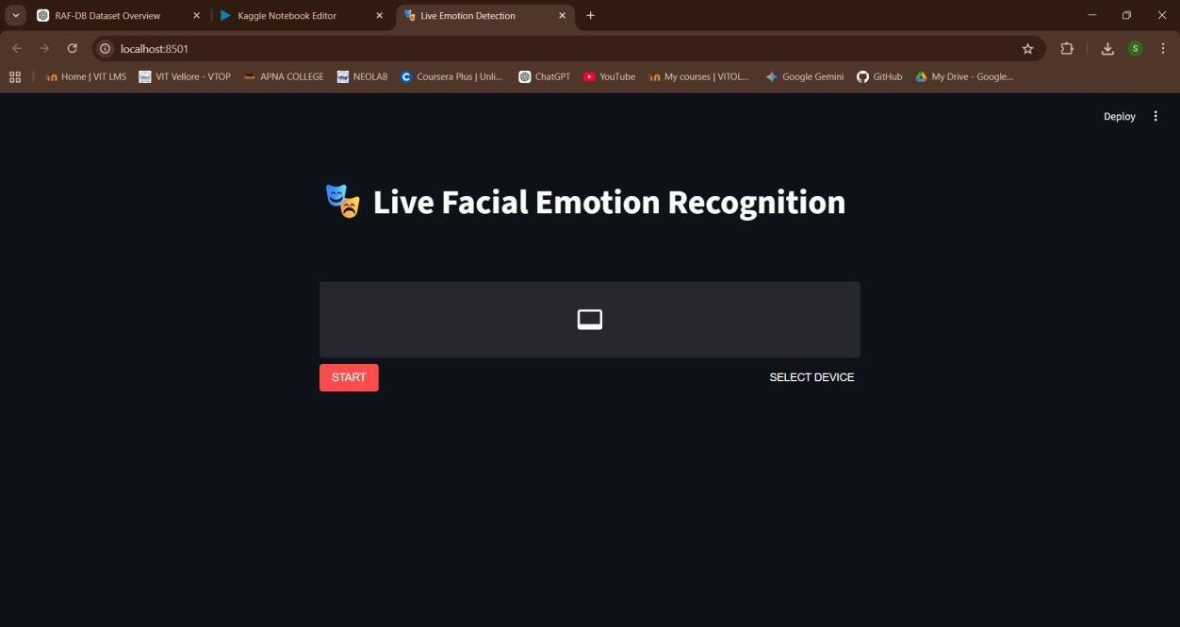
- To design and develop a CNN-based facial expression recognition model using the RAF-DB dataset.
- To identify emotional states associated with confusion and disengagement.
- To implement real-time face detection using OpenCV.
- To deploy a web-based system using Streamlit for live emotion prediction.
- To enable early intervention by identifying students who require academic support.

1.2 MOTIVATION

In modern classrooms, especially in online learning environments, it is difficult for instructors to assess student understanding in real time. Traditional evaluation methods such as quizzes or verbal questioning are reactive and fail to provide continuous feedback.
An AI-based system that monitors student emotions can significantly improve teaching effectiveness. By detecting confusion early, educators can adjust their teaching strategies, clarify concepts, and provide personalized support. This leads to improved engagement, better learning outcomes, and the development of intelligent classroom systems.

1.3 PROBLEM STATEMENT
In modern educational environments, especially in large classrooms and online learning systems, it is difficult for instructors to continuously monitor the learning state of every student. Traditional teaching methods rely heavily on manual observation, which is subjective and limited in scope.
Students often experience confusion, boredom, or disengagement during lectures but may not actively communicate their difficulties. This results in:
- Delayed identification of learning gaps
- Reduced academic performance
- Decreased student engagement
Existing systems either depend on periodic assessments or self-reported feedback, which are reactive rather than proactive.
Therefore, there is a strong need for an automated system that can:
- Detect student emotions in real time
- Identify learning difficulties early
- Assist instructors in adapting teaching strategies

1.4 SCOPE OF THE PROJECT

The scope of this project includes the development of an AI-based system that can analyze facial expressions to detect student emotions in real time.
The system is designed to:
- Operate using standard webcam input
- Process facial data using deep learning models
- Provide live feedback on student engagement This project can be extended to:
- Integration with online learning platforms
- Multi-student monitoring systems
- Advanced behavioral analytics
However, the current implementation is limited to:
- Single-user detection
- Controlled lighting conditions
- Basic emotion classification

1.5 APPLICATIONS

The proposed system has wide applications in various domains:
- Smart Classrooms
Enables teachers to monitor student engagement automatically.
- Online Learning Platforms
Helps instructors understand student reactions during virtual classes.
- Corporate Training
Assists trainers in evaluating participant engagement.
- Special Education
Helps identify emotional responses of students with learning disabilities.
- Research in Human Behavior
Useful for analyzing emotional patterns in learning environments.

CHAPTER 2

LITERATURE SURVEY
Several research works have explored facial expression recognition and its application in education.
Facial Expression Recognition using CNN has shown that deep learning models such as VGG, ResNet, and DenseNet outperform traditional machine learning models in image classification tasks.
Emotion Detection in E-Learning Systems highlights that emotional states influence cognitive processing and knowledge retention. However, most systems rely on self-reported data instead of automated detection.
Classroom Engagement Monitoring techniques use wearable sensors and gaze tracking, but these methods are intrusive and not scalable for large classrooms.
Real-Time Emotion Recognition Applications combine OpenCV and deep learning for live emotion detection, but they are mainly used in domains like security and healthcare rather than education.
Despite these advancements, very few systems focus on real-time detection of student confusion in classroom environments.

2.1 INTRODUCTION TO FACIAL EXPRESSION RECOGNITION

Facial Expression Recognition (FER) is a technique used to identify human emotions based on facial features. It plays a significant role in human-computer interaction, psychology, and artificial intelligence.
FER systems typically follow these steps:
- Face detection
- Feature extraction
- Emotion classification
With the advancement of deep learning, FER systems have become more accurate and efficient.

2.2 TRADITIONAL METHODS
Earlier approaches used machine learning techniques such as:
- Support Vector Machines (SVM)
- K-Nearest Neighbors (KNN)
- Decision Trees
These methods required manual feature extraction using techniques like:
- Histogram of Oriented Gradients (HOG)
- Local Binary Patterns (LBP) Limitations:
- Time-consuming
- Less accurate
- Dependent on handcrafted features

2.3 DEEP LEARNING APPROACHES

Deep learning methods automatically extract features from images. The most commonly used architecture is the Convolutional Neural Network (CNN).
Advantages:
- Automatic feature extraction
- High accuracy
- Robust to variations in lighting and pose Popular models:
- VGGNet
- ResNet
- DenseNet

2.4 LIMITATIONS OF EXISTING SYSTEMS

Despite advancements, current systems face several challenges:
- Lack of real-time processing
- High computational cost
- Dataset bias
- Privacy concerns
Most systems focus on general emotion detection rather than identifying learning difficulties.

2.5 COMPARATIVE STUDY OF TECHNIQUES
Various techniques have been used for emotion detection, each with its advantages and limitations.
- Machine Learning Approaches
Require manual feature extraction and are less accurate
- Deep Learning Approaches
Automatically learn features and provide higher accuracy

• Hybrid Approaches
Combine multiple techniques but increase complexity
Deep learning methods, particularly CNNs, have shown superior performance in handling complex image data.

2.6 SUMMARY OF LITERATURE REVIEW
From the literature survey, it is evident that:
- CNN-based models outperform traditional methods
- Real-time emotion detection is still an emerging area
- Most systems are not tailored for educational purposes
This motivates the development of a system specifically designed for detecting student learning difficulties.

CHAPTER

RESEARCH GAP AND OBJECTIVES
3.1 RESEARCH GAP
From the literature survey, the following gaps are identified:
- Existing systems focus on general emotion detection rather than learning difficulty detection.
- Most systems operate offline and lack real-time capabilities.
- Current monitoring systems are intrusive or impractical.
- Limited integration with classroom-friendly platforms.

The proposed system integrates the following components:
- CNN-based emotion classification
- RAF-DB dataset
- OpenCV Haar Cascade for face detection
- Streamlit-based web interface
This system provides real-time monitoring and enables early intervention.

3.3 OBJECTIVES OF THE PROPOSED SYSTEM

The proposed system aims to achieve the following:
- Develop a real-time facial expression recognition system
- Detect emotions associated with learning difficulties
- Provide immediate feedback to instructors
- Improve student engagement and understanding

3.4 ADVANTAGES OF THE PROPOSED SYSTEM

- Real-time monitoring
- Non-intrusive approach
- Scalable solution
- Easy deployment using web interface

3.5 NEED FOR THE PROPOSED SYSTEMa
The need for the proposed system arises from the limitations of existing approaches. Current systems fail to provide real-time insights into student behavior and are not optimized for classroom environments.
The proposed system addresses these issues by:
- Providing continuous monitoring
- Reducing dependency on manual observation
- Enabling timely intervention

CHAPTER 4

SYSTEM ARCHITECTURE
The system consists of five modules:
Image Acquisition
Webcam captures real-time video using Streamlit WebRTC.
Face Detection
OpenCV Haar Cascade detects facial regions.
Preprocessing
Images are resized to 100×100 pixels and normalized.
Emotion Classification
CNN model classifies facial expressions.
Visualization
Emotion labels and bounding boxes are displayed in real time.

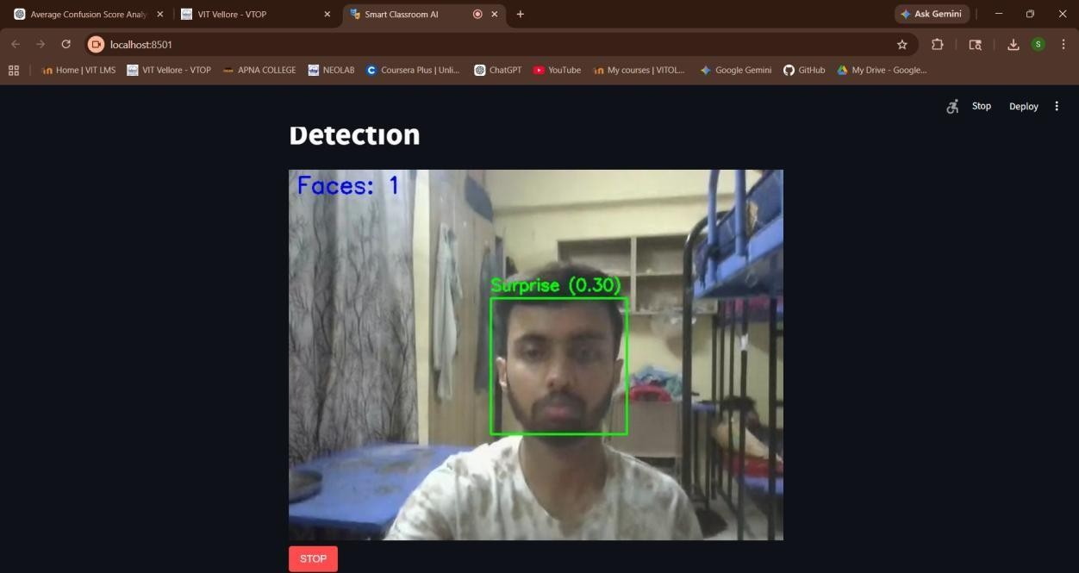

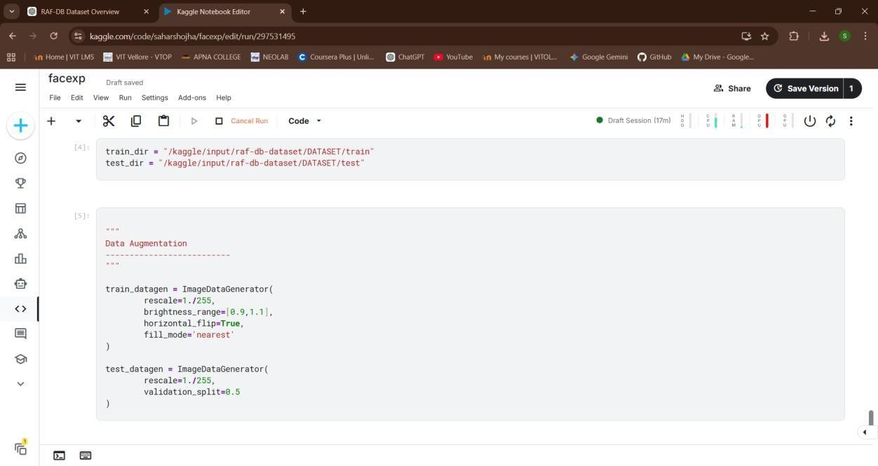

4.1 DETAILED SYSTEM ARCHITECTURE

The system architecture consists of multiple stages that work together to achieve realtime emotion detection.

1. Image Acquisition

The system captures real-time video using a webcam. The video is divided into frames for processing.

2. Face Detection

Face detection is performed using the Haar Cascade classifier. It identifies the region of interest (ROI) in each frame.

3. Preprocessing

The detected face is:
- Resized to 100×100 pixels
- Converted to grayscale
- Normalized for better performance

4. Emotion Classification

The preprocessed image is passed to a CNN model which classifies it into different emotion categories.

5. Visualization

The output is displayed using Streamlit, showing:
- Bounding box around face
- Predicted emotion label

4.2 WORKING PRINCIPLE
The working principle of the system involves capturing video frames, detecting faces, and analyzing facial expressions using a trained CNN model.
Steps involved:
- Capture video stream from webcam
- Detect face using OpenCV
- Preprocess the image
- Predict emotion using CNN
- Display results in real time

4.3 SYSTEM FLOW
The system follows a sequential flow:
Input → Face Detection → Preprocessing → Emotion Classification → Output Display
This flow ensures efficient processing and real-time performance.

CHAPTER 5

DATASET
The RAF-DB dataset is used for training and evaluation.
Dataset Overview
- 30,000 facial images
- Diverse backgrounds and lighting conditions
- Includes multiple ethnicities and age groups
Emotion Classes
- Angry
- Disgust
- Fear
- Happy

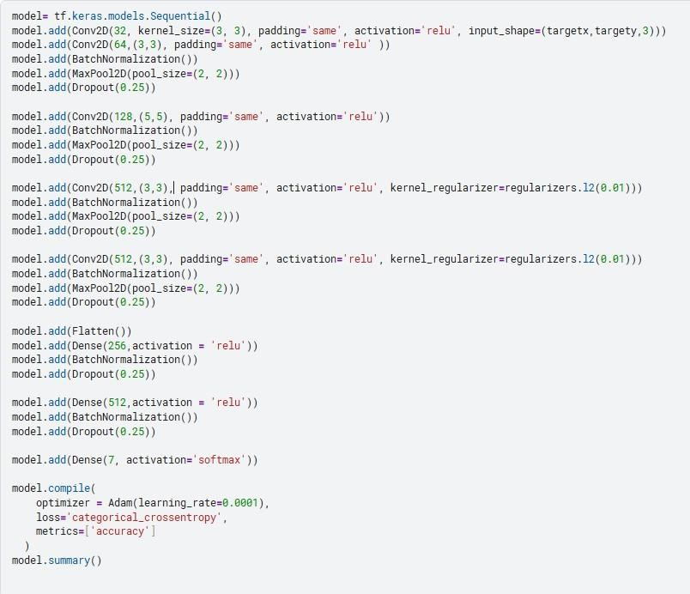

- Neutral
- Sad
- Surprise
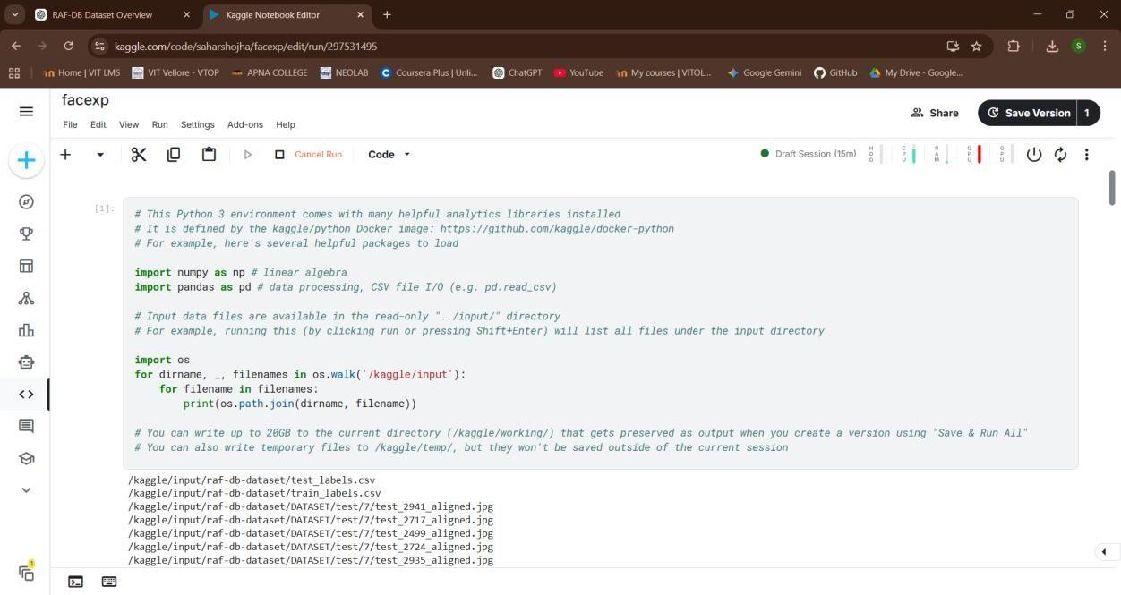

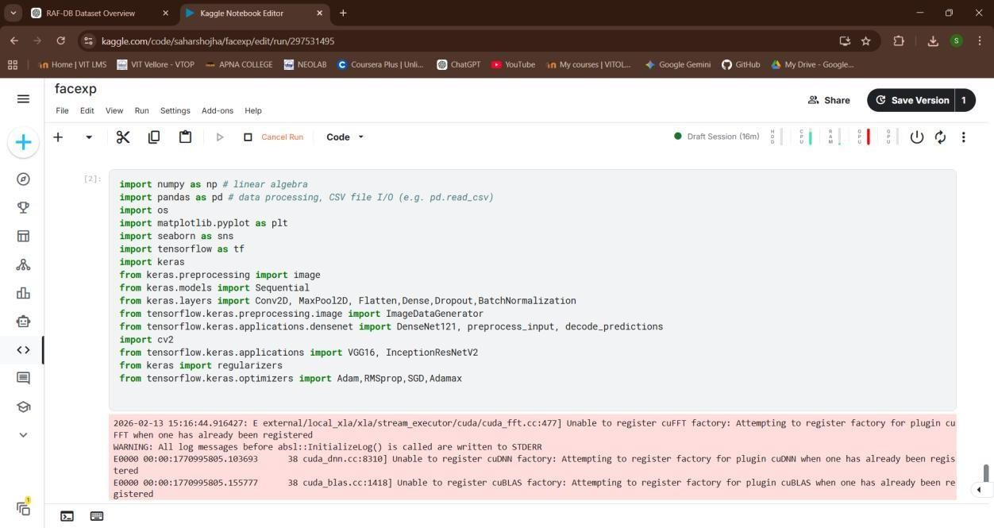

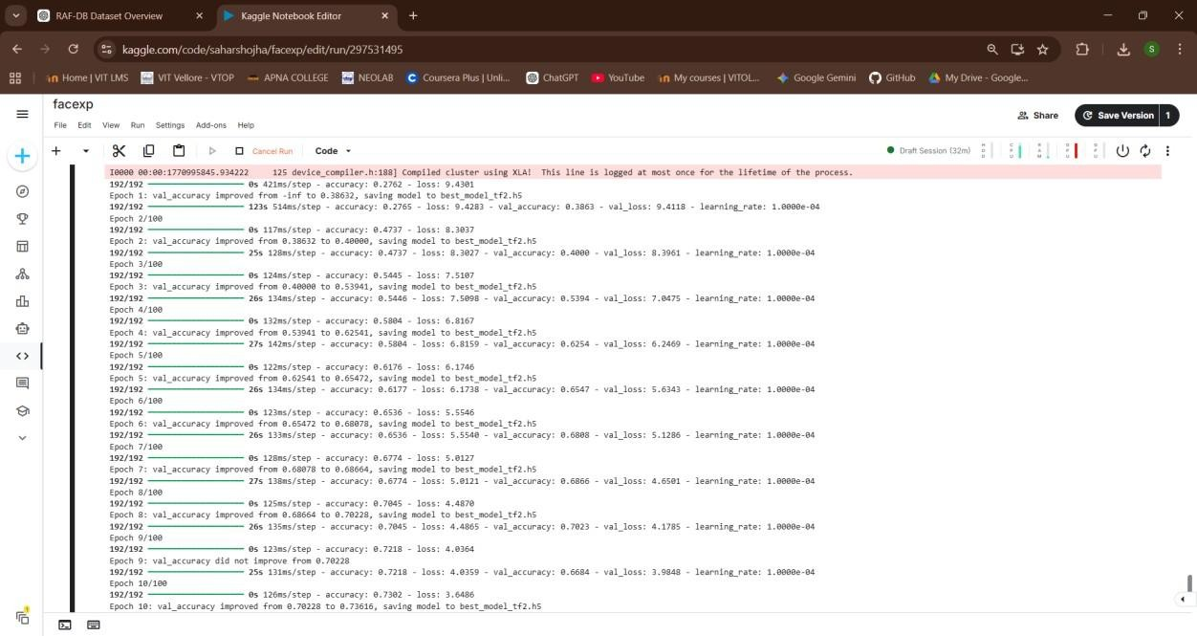

5.1 DATA PREPROCESSING

Before training the model, the dataset undergoes preprocessing:
- Image resizing
- Noise removal
- Normalization
- Data augmentation (rotation, flipping)
•

5.2 DATA SPLITTING

The dataset is divided into:
- Training set (70%)
- Validation set (15%)
- Testing set (15%)

5.3 DATASET CHALLENGES
Working with real-world datasets presents several challenges:
- Variations in lighting conditions
- Differences in facial expressions
- Occlusions such as glasses or masks
- Imbalanced class distribution
These challenges affect the performance of the model and require preprocessing techniques to handle them.

5.4 DATA AUGMENTATION
To improve model performance, data augmentation techniques are applied:
- Rotation
- Flipping
- Zooming
- Cropping
These techniques increase dataset diversity and reduce overfitting.

CHAPTER 6

METHODOLOGY
CNN is used due to its advantages:
- Preserves spatial information
- Automatic feature extraction
- Reduced parameters through weight sharing
- Translation invariance
- High accuracy in image classification

6.1 CNN ARCHITECTURE DETAILS

The CNN model consists of:
- Convolutional Layers
Extract features using filters
- Activation Function (ReLU)
Introduces non-linearity
- Pooling Layers
Reduces dimensionality
- Dropout Layer
Prevents overfitting

5. Fully Connected Layers
Perform classification

6.2 TRAINING PROCESS

- Loss Function: Categorical Crossentropy
- Optimizer: Adam
- Epochs: 20–50
- Batch Size: 32

CHAPTER 7

IMPLEMENTATION
The system is implemented using:
- Python
- TensorFlow and Keras
- OpenCV
- Streamlit
The CNN model consists of convolutional layers, pooling layers, dropout, and dense layers.
Real-time detection is achieved using webcam input and Streamlit interface.








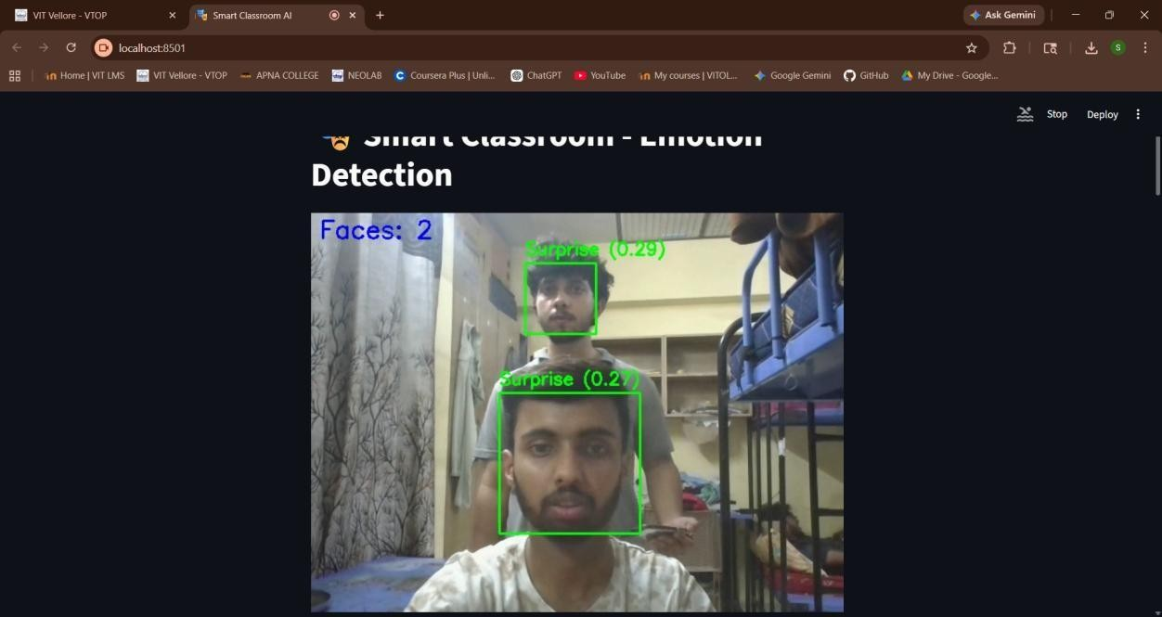

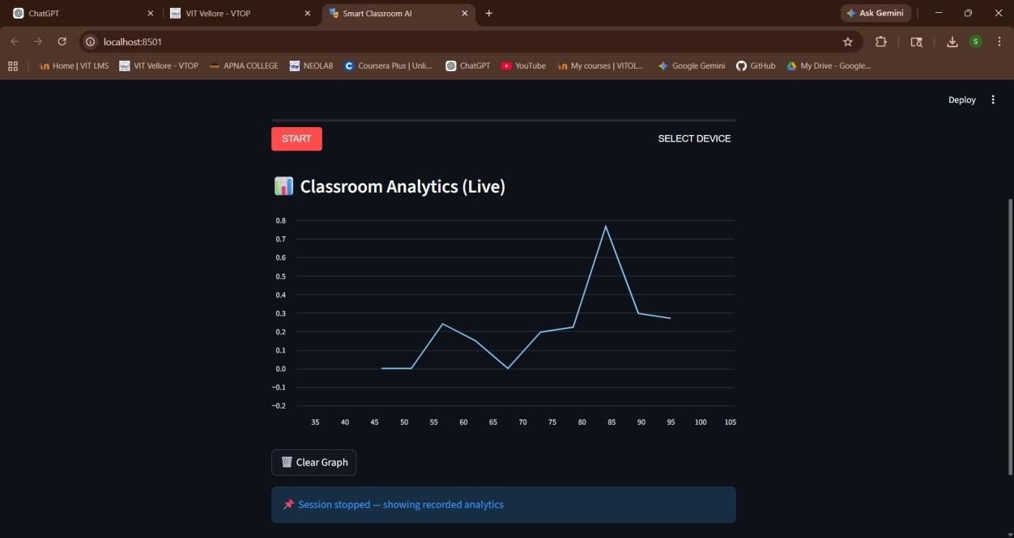

7.1 SOFTWARE REQUIREMENTS
- Python 3.x
- TensorFlow
- Keras
- OpenCV
- Streamlit

7.2 HARDWARE REQUIREMENTS

- Minimum 8GB RAM
- Webcam
- GPU (optional for faster training)

7.3 IMPLEMENTATION STEPS

- Load dataset
- Preprocess images
- Train CNN model
- Save trained model
- Integrate with OpenCV
- Deploy using Streamlit

CHAPTER 8

CONCLUSION

This system enhances teaching and learning by providing real-time feedback on student emotions. It enables educators to identify confusion early and adjust teaching strategies accordingly.
The proposed solution supports adaptive learning, improves student engagement, and contributes to the development of smart classroom environments.

8.1 FUTURE ENHANCEMENTS
- Multi-face detection
- Integration with LMS
- Emotion trend analysis
- Voice-based emotion detection
- Mobile application deployment

8.2 LIMITATIONS
- Sensitive to lighting conditions
- Accuracy depends on dataset quality
- Privacy concerns

.2 PROPOSED SYSTEM

