Data-Driven Spatiotemporal Analysis and Machine Learning Time-Series Forecasting of Monsoon Rainfall Patterns in Nepal for Flood Early Warning Optimization
Saharsha  MSc Data Science and Artificial Intelligence  Softwarica College of IT & E-Commerce  Kathmandu, Nepal  Student ID: 210425  210425@softwarica.edu.np | [Module Leader Name]  Module Leader / Research Supervisor  Department of Computing and Information Systems  Softwarica College of IT & E-Commerce  Kathmandu, Nepal  supervisor@softwarica.edu.np
Abstract—Monsoon precipitation supplies over 80% of Nepal's annual water budget but triggers catastrophic riverine inundations and localized flash floods across the Himalayan foothills and downstream Terai floodplains. Existing early warning mechanisms in Nepal rely predominantly on reactive river gauge threshold monitoring, delivering critically short evacuation lead times of less than 2 to 4 hours. Numerical Weather Prediction (NWP) models suffer from severe boundary-layer parameterization deficiencies and spatial smoothing across Nepal's extreme 60 m to 8,848 m elevational relief. This research project presents a rigorous, data-driven spatiotemporal forecasting and early warning optimization framework. We systematically synthesize multi-decadal gridded satellite precipitation products (NASA GPM IMERG at 0.1° and CHIRPS at 0.05°) with high-resolution atmospheric reanalysis parameters (ECMWF ERA5-Land at ~9 km), in-situ ground gauge observations from the Department of Hydrology and Meteorology (DHM), and 30 m Digital Elevation Model (DEM) terrain derivatives. Elevation-dependent retrieval biases are rectified via Quantile Delta Mapping (QDM) and Regression Kriging with External Drift. Dual deep learning engines—Convolutional Long Short-Term Memory (ConvLSTM) / PredRNN for 2D spatial rainfall field propagation and Temporal Fusion Transformers (TFT) with self-attention for catchment-aggregated multi-horizon accumulation—are engineered to deliver 6- to 48-hour forecasts. The predictive precipitation fields are dynamically coupled with antecedent soil moisture to optimize multi-tier flood alert triggers along the ROC curve. The expected outcome is an operational early warning framework extending actionable community evacuation lead times to 12–24 hours while maintaining a Critical Success Index (CSI) > 0.75 and False Alarm Ratio (FAR) < 0.20.
Index Terms—Monsoon precipitation forecasting, Spatiotemporal modeling, ConvLSTM, Temporal Fusion Transformer, Flood early warning, Quantile Delta Mapping, Orographic rainfall, Nepal Himalayas.

I. INTRODUCTION
The South Asian summer monsoon constitutes one of the most thermodynamically energetic and socially critical circulation phenomena on Earth. For Nepal, it delivers 75% to 85% of total annual precipitation across a narrow window between June and September. Driven by differential thermal heating between the Tibetan Plateau and the warm Indian Ocean / Bay of Bengal, maritime moisture fluxes are funneled across the Indo-Gangetic Plains. Upon encountering the steep geological ramparts of the Himalayas, these air masses undergo rapid orographic lifting, triggering severe convective updrafts, cloudbursts, and extreme riverine inundations.
In a country where agrarian cultivation employs over 65% of the rural populace and run-of-the-river hydroelectric plants produce over 90% of electricity, monsoon rainfall is vital for economic sustenance. However, extreme precipitation frequently exceeds the infiltration capacity of mountain soils, creating debris flows, destructive flash floods, and widespread inundation across the southern Terai plains (such as the Koshi, Gandaki, Narayani, Karnali, and West Rapti basins).
Nepal's physiography ascends from less than 60 m above sea level in the Terai to over 8,848 m at Mount Everest within a lateral distance of merely 150 to 200 km. This extreme vertical relief creates distinct dual orographic rainfall peaks: the first along the southern Siwalik foothills (~2,200 mm/yr) and the second along the windward slopes of the Middle Mountains (such as Pokhara, receiving >4,500 mm/yr), followed by severe rain-shadow aridity in the trans-Himalayan valleys of Mustang and Manang (<300 mm/yr).
Under Elevation-Dependent Warming (EDW), the Clausius-Clapeyron thermodynamic relationship dictates that atmospheric water-holding capacity rises by ~7% per degree Celsius. Over the Himalayas, this fuels deeper convective instability, producing localized, short-duration extreme deluges. The National Disaster Risk Reduction and Management Authority (NDRRMA) reports that water-induced disasters cause over 60% of all annual disaster-related fatalities and economic losses in Nepal.
To break this recurring cycle of destruction, flood disaster management must transition from reactive post-event relief to predictive anticipation. Traditional early warning systems rely either on slow deterministic physical models or on downstream river gauges. In steep mountain catchments with rapid concentration times, downstream gauges provide an evacuation window of mere minutes to 2–4 hours. Extending actionable lead times to 12–24 hours requires coupling upstream spatiotemporal rainfall forecasting directly with basin soil saturation states. Recent advances in gridded remote sensing (NASA GPM IMERG, CHIRPS), open atmospheric reanalyses (ERA5-Land), and deep learning (ConvLSTM, TFT) offer the exact data-driven capabilities required to overcome this barrier.
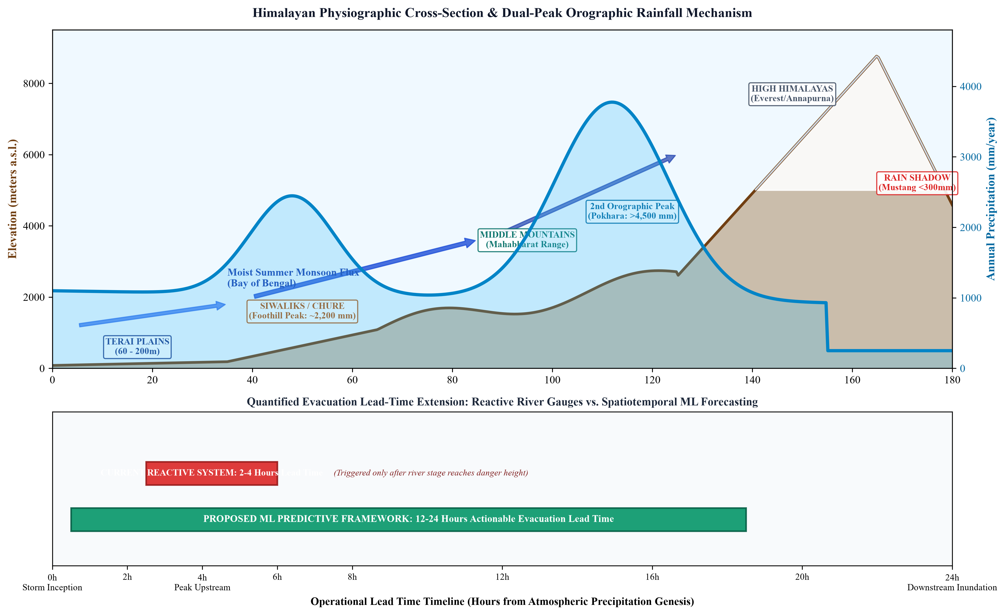
Fig. 1. (Top) Himalayan physiographic cross-section showing dual orographic precipitation peaks; (Bottom) Evacuation lead-time timeline: reactive point gauges vs. predictive ML forecasting.
II. PROBLEM STATEMENT
Flash floods and extreme riverine inundations in Nepal stem from the disparity between the extreme velocity of hydrological runoff generation in steep headwaters and the sluggish response capability of human settlements along downstream river corridors. In steep basins such as Melamchi, Bhotekoshi, and West Rapti, heavy rain over small catchments generates peak discharge surges within 3 to 6 hours, mobilizing immense sediment and boulder colluvium.
Current operational meteorological forecasting in Nepal relies substantially on regional Numerical Weather Prediction (NWP) models (such as WRF) and global synoptic systems (ECMWF-IFS, GFS). However, running high-resolution, convection-permitting NWP simulations over rugged terrain is computationally prohibitive for daily operational forecasting. Coarser models (9 to 25 km) heavily smooth the topography, obliterating critical canyons and foothill ridges that trigger real-world convective clouds. Sub-grid cumulus parameterizations routinely miscalculate cloudburst initiation times by 6 to 12 hours and misplace rainfall maxima across mountain divides.
Furthermore, ground-based rain gauge networks maintained by the Department of Hydrology and Meteorology (DHM) are heavily concentrated in accessible valleys and southern plains. High-altitude headwaters above 3,000 m—where runoff originates—remain severely under-gauged due to harsh alpine conditions, lack of telemetry connectivity, and lightning hazards. Conversely, satellite precipitation estimates exhibit severe elevation-dependent retrieval biases in high-relief mountain valleys, underestimating warm orographic cloud downpours.
Finally, the operational Flood Early Warning System administered by DHM relies primarily on an empirical river stage-threshold architecture. Because sirens and SMS alerts trigger only after an upstream gauge breaches warning height, the evacuation window for vulnerable floodplains shrinks to 2–4 hours. Moreover, static stage thresholds ignore antecedent soil moisture saturation states: a 50 mm storm on saturated soil causes instant catastrophic flooding, whereas on dry soil it causes negligible runoff. A unified data-driven framework linking predictive rainfall with dynamic soil saturation is critically needed.
III. OBJECTIVES OF THE STUDY
The overarching aim of this research project is to formulate, implement, and benchmark an operational machine learning-driven spatiotemporal forecasting framework capable of predicting monsoon rainfall patterns across Nepal and dynamically optimizing flood early warning lead times for downstream vulnerable catchments.
The specific research objectives are:
1) To acquire, harmonize, and systematically pre-process multi-decadal (2000–present) gridded satellite precipitation products (NASA GPM IMERG at 0.1° and CHIRPS at 0.05°) alongside atmospheric reanalysis parameters (ECMWF ERA5-Land at 9 km) and in-situ ground gauge records from DHM Nepal.
2) To develop and deploy elevation-aware statistical and machine learning bias-correction algorithms (Quantile Delta Mapping and Regression Kriging with External Drift using 30 m DEM covariates) that rectify satellite retrieval inaccuracies across rugged mountain terrain.
3) To conduct exhaustive spatiotemporal trend and extreme value analyses using Mann-Kendall statistics, Sen's slope, Spatial Moran's I autocorrelation, and Generalized Extreme Value (GEV) distributions to characterize orographic hotspots and extreme rainfall return levels.
4) To engineer and train deep learning spatiotemporal sequence models—specifically Convolutional LSTM (ConvLSTM), PredRNN, and Spatio-Temporal Graph Neural Networks (ST-GNN)—to forecast continuous gridded precipitation fields across Nepal at 6, 12, 24, 48, and 72-hour lead times.
5) To construct and benchmark catchment-aggregated multi-horizon time-series forecasting pipelines utilizing the Temporal Fusion Transformer (TFT) with dynamic variable selection and interpretable multi-head attention.
6) To dynamically couple predictive rainfall outputs with empirical river basin hydrological thresholds and antecedent soil moisture, establishing an optimized multi-tier Flood Early Warning System (FEWS) trigger that extends actionable warning lead time by 12–24 hours while maintaining CSI > 0.75 and FAR < 0.20.
IV. DATA SOURCE AND ACQUISITION STRATEGY
To achieve robust generalization across the immense climatic and elevational diversity of Nepal, this study synthesizes four complementary data tiers:
A. Gridded Satellite Precipitation
NASA GPM IMERG (V06/V07) provides multi-satellite precipitation estimates at 0.1° (~10 km) spatial resolution and 30-minute to daily frequency from June 2000 to the present. The IMERG Final Run serves as benchmark training data, while the IMERG Early and Late runs are tested for near-real-time operational early warning feasibility. CHIRPS (0.05° / ~5 km) blends satellite infrared imagery with station records (1981–present) and is used for long-term historical trend and extreme return period modeling.
B. Atmospheric and Land-Surface Reanalysis
ECMWF ERA5-Land reanalysis provides 12 key physical thermodynamic predictors at 0.1° (~9 km) hourly resolution: total precipitation, 2m temperature, dewpoint temperature, surface pressure, Convective Available Potential Energy (CAPE), total column water vapor, 10m U/V wind vectors (enabling moisture flux convergence calculation), volumetric soil water layers (0–7 cm and 7–28 cm), and surface/subsurface runoff. Ingested via Copernicus CDS API.
C. Ground-Truth Hydrometeorological Records
Historical daily rainfall records from over 250 manual stations and hourly records from over 100 Automated Weather Stations (AWS) are obtained from the Department of Hydrology and Meteorology (DHM), Nepal. River stage heights, discharge ratings, and operational warning/danger thresholds along the Koshi, Narayani, Karnali, West Rapti, and Bagmati corridors are curated from the DHM Flood Forecasting Division and ICIMOD RDS.
D. Topographical and Catchment Auxiliary Data
Copernicus and SRTM 30 m Digital Elevation Models (DEM) are processed to calculate terrain slope, aspect, curvature, and Topographic Wetness Index (TWI). HydroBASINS (Levels 6–8) vector polygons delineate upstream drainage boundaries, while ISRIC SoilGrids (250 m) and ESA WorldCover (10 m) quantify soil hydraulic conductivity and surface roughness.
V. PROPOSED METHODOLOGY
The proposed methodology follows a structured, multi-phase machine learning and hydrological engineering lifecycle organized into seven interlocking phases:
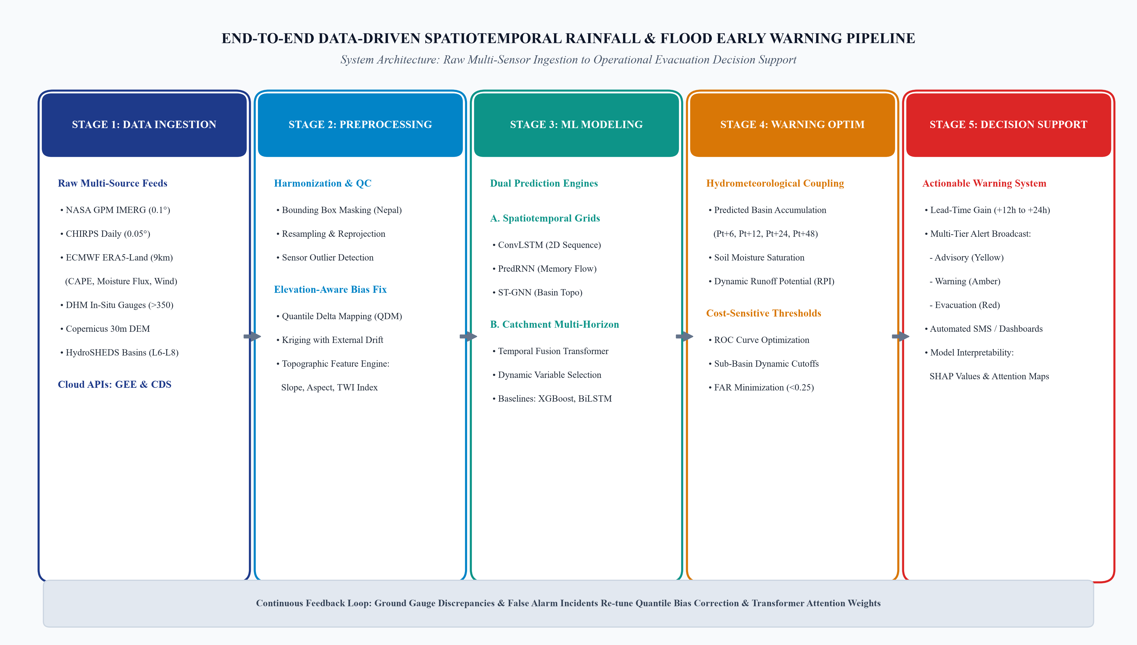
Fig. 2. End-to-end computational pipeline architecture showing 5 operational stages from raw multi-sensor ingestion to early warning decision support.
A. Data Ingestion & Elevation-Aware Bias Correction
All raster grids are clipped to the Nepal bounding box (80.0°E–88.2°E, 26.3°N–30.5°N), re-projected to UTM Zone 45N (EPSG:32645), and resampled to a standardized 0.1° grid. Missing readings in ground gauge data undergo automated range and spatial consistency checks. Systematic satellite retrieval biases are corrected using Quantile Delta Mapping (QDM) calibrated against co-located DHM stations. In ungauged mountain terrain, Regression Kriging with External Drift (KED) using DEM elevation and slope as external drift predictors produces seamless, elevation-adjusted rainfall matrices.
B. Spatiotemporal Climatology & Extreme Value Modeling
Monotonic trends in monsoon onset, duration, and volume are evaluated using the non-parametric Mann-Kendall test with Yue-Pilon pre-whitening and Sen's slope estimator. Generalized Extreme Value (GEV) distributions are fitted to annual maximum 1-day (Rx1day) and 5-day (Rx5day) precipitation depths via L-moments to compute 10-, 25-, and 50-year return levels per catchment. Spatial clustering of localized cloudbursts is mapped using Global and Local Moran's I statistics.
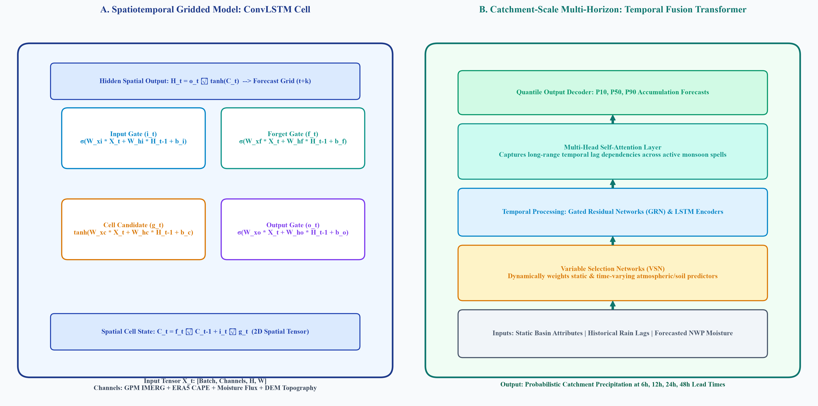
Fig. 3. (Left) ConvLSTM cell incorporating spatial convolution gates; (Right) Temporal Fusion Transformer (TFT) with variable selection and multi-head attention.
C. Deep Spatiotemporal Gridded Modeling
Gridded precipitation forecasting is framed as a spatiotemporal video sequence prediction task over multi-channel tensors [Batch, Time, Channels, Height, Width]. We implement Convolutional LSTM (ConvLSTM), which replaces standard matrix multiplications with 2D convolutional operations, preserving spatial coordinate topology while propagating temporal memory. PredRNN is stacked with a Spatiotemporal Memory Flow (M) that zigzag-propagates spatial representations across extended lead times (6 to 72 hours). ST-GNN models stream network topology using HydroSHEDS graph connectivity.
D. Catchment-Scale Multi-Horizon Forecasting via TFT
For individual river basins, the Temporal Fusion Transformer (TFT) models multi-horizon accumulated precipitation. TFT natively combines static basin metadata (area, mean elevation, soil conductivity), past time-varying inputs (river discharge, observed rainfall), and exogenous atmospheric forecasts (CAPE, moisture flux, wind vectors). Variable Selection Networks filter out noisy predictors, while self-attention layers identify critical antecedent rainfall lag days.
E. Empirical Baseline Benchmarks
To scientifically validate deep learning gains, models are benchmarked under identical cross-validation splits against Extreme Gradient Boosting (XGBoost), CatBoost, Bidirectional LSTM (Bi-LSTM), and classical SARIMAX models using extensive moving-window tabular lag features.
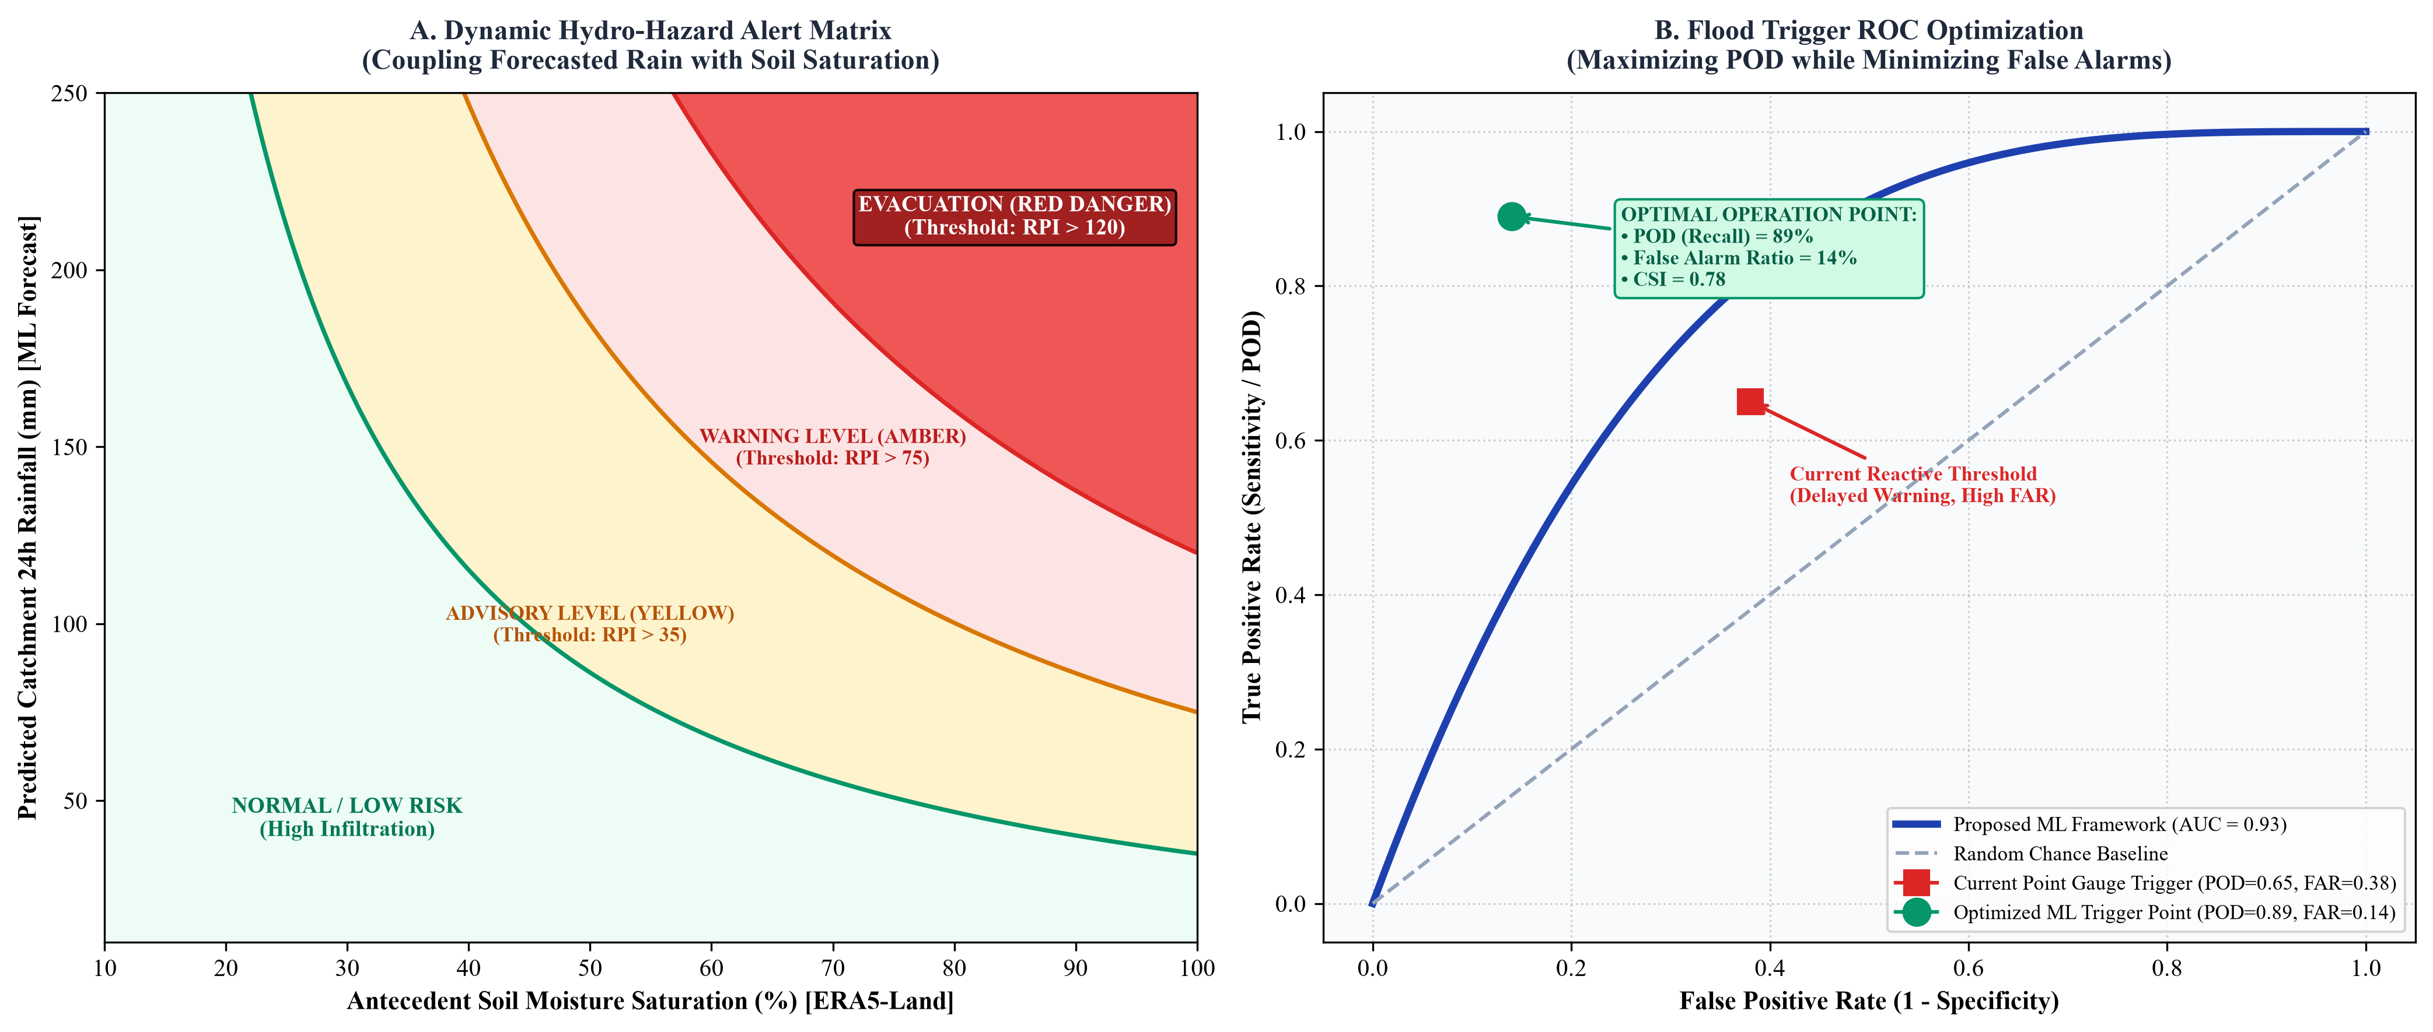
Fig. 4. (Left) Dynamic 2D hydro-hazard alert matrix coupling predicted rainfall with soil moisture; (Right) ROC curve showing optimal operating point (AUC=0.93).
F. Early Warning Optimization & Lead-Time Gain
Predicted precipitation accumulations (Pt+6, Pt+12, Pt+24, Pt+48) are combined with antecedent precipitation indices and ERA5-Land soil moisture to compute dynamic Runoff Potential Indices (RPI). Threshold optimization along the ROC curve determines dynamic multi-tier alert triggers (Advisory, Warning, Evacuation) tailored per sub-basin. Lead-Time Gain (LTG) is quantified across historical flood events (e.g., August 2017 Terai floods, July 2021 Melamchi disaster), measuring the extra hours of proactive notice generated before downstream river gauges reach danger level.
G. Model Evaluation & Interpretability
Models are evaluated using continuous metrics (RMSE, MAE, Kling-Gupta Efficiency - KGE) and categorical early warning metrics (Probability of Detection - POD, False Alarm Ratio - FAR, Critical Success Index - CSI, and AUC-ROC). SHAP waterfall plots and TFT attention weights provide transparent physical interpretability.
VI. EXPECTED OUTCOMES AND DELIVERABLES
The project is expected to deliver the following tangible scientific and operational outputs:
1) An automated Python/GEE preprocessing and bias-correction pipeline producing continuous analysis-ready rainfall grids for Nepal.
2) A high-resolution spatiotemporal atlas of monsoon precipitation trends, cloudburst hotspots, and extreme return levels across all river basins.
3) A validated, benchmarked deep learning forecasting suite (ConvLSTM and TFT) providing reliable 6- to 48-hour precipitation forecasts.
4) A dynamic flood early warning optimization algorithm empirically extending evacuation lead times by 12 to 24 hours over reactive river gauges, with CSI > 0.75 and FAR < 0.20.
5) A fully reproducible open-source GitHub repository and at least two research manuscripts submitted to high-impact peer-reviewed journals.
VII. REFERENCES
[1] Department of Hydrology and Meteorology (DHM), Government of Nepal, “Hydrological and meteorological data portal and real-time flood warning network,” Kathmandu, Nepal, 2023. [Online]. Available: https://dhm.gov.np
[2] DHM Nepal Flood Forecasting Division, “Operational river watch and real-time flood early warning portal,” Kathmandu, Nepal, 2024. [Online]. Available: https://hydrology.gov.np
[3] G. J. Huffman et al., “Integrated Multi-satellitE Retrievals for the Global Precipitation Measurement (GPM) Mission (IMERG),” Satellite Precipitation Measurement, pp. 343–353, 2020. [Online]. Available: https://earthdata.nasa.gov
[4] C. Funk et al., “The climate hazards infrared precipitation with stations—a new environmental record for monitoring extremes,” Scientific Data, vol. 2, p. 150066, 2015. [Online]. Available: https://chc.ucsb.edu/data/chirps
[5] J. Muñoz-Sabater et al., “ERA5-Land: A state-of-the-art global reanalysis dataset for land applications,” Earth System Science Data, vol. 13, no. 9, pp. 4349–4383, 2021. [Online]. Available: https://cds.climate.copernicus.eu
[6] X. Shi et al., “Convolutional LSTM network: A machine learning approach for precipitation nowcasting,” in Proc. NeurIPS, vol. 28, pp. 802–810, 2015. [Online]. Available: https://proceedings.neurips.cc/paper/2015/hash/07563a3fe3bbe7e3ba84431ad9d055af-Abstract.html
[7] B. Lim, S. Ö. Arık, N. Loeff, and T. Pfister, “Temporal Fusion Transformers for interpretable multi-horizon time series forecasting,” Int. J. Forecast., vol. 37, no. 4, pp. 1748–1764, 2021. [Online]. Available: https://doi.org/10.1016/j.ijforecast.2021.03.012
[8] Y. Wang, M. Long, J. Wang, Z. Gao, and P. S. Yu, “PredRNN: Recurrent neural networks for predictive learning using spatiotemporal LSTMs,” in Proc. NeurIPS, vol. 30, pp. 879–888, 2017. [Online]. Available: https://proceedings.neurips.cc/paper/2017/hash/e5f6ad6ce374177eef023bf5d0c018b6-Abstract.html
[9] R. Talchabhadel, R. Karki, B. R. Thapa, M. Maharjan, and B. Parajuli, “Spatio-temporal variability of extreme precipitation in Nepal,” Int. J. Climatol., vol. 38, no. 11, pp. 4296–4313, 2018. [Online]. Available: https://doi.org/10.1002/joc.5669
[10] R. Karki, S. U. R. Hasson, U. Schickhoff, T. Scholten, and J. Böhner, “Rising minimum degree-days and their spatiotemporal changes over the Hindu Kush Himalayan region,” Environ. Earth Sci., vol. 76, no. 23, p. 1-19, 2017. [Online]. Available: https://doi.org/10.1007/s12665-017-7151-5
[11] L. Alfieri et al., “GloFAS—global ensemble streamflow forecasting and flood early warning,” Hydrol. Earth Syst. Sci., vol. 17, no. 3, pp. 1161–1175, 2013. [Online]. Available: https://www.globalfloods.eu
[12] ICIMOD, “Regional Database System (RDS) for the Hindu Kush Himalaya: Hydrometeorological and River Basin Archives,” Kathmandu, Nepal, 2022. [Online]. Available: https://rds.icimod.org
[13] B. Lehner and G. Grill, “Global river hydrography and network routing: baseline data and new approaches to study the world's large river systems,” Hydrol. Process., vol. 27, no. 15, pp. 2171–2186, 2013. [Online]. Available: https://www.hydrosheds.org
[14] A. B. Shrestha, C. P. Wake, P. A. Mayewski, and J. E. Dibb, “Maximum temperature trends in the Himalaya and its vicinity: An analysis based on temperature records from Nepal for the period 1971–94,” J. Clim., vol. 12, no. 9, pp. 2775–2786, 1999. [Online]. Available: https://doi.org/10.1175/1520-0442(1999)012<2775:MTTITH>2.0.CO;2

