23CSE202 DATABASE MANAGEMENT SYSTEMS
S3 B.Tech CSE
Department of Computer Science and Engineering
Amrita School of Computing, Amritapuri Campus

PROJECT REPORT

Group No :
Team Members :
Roll No | Student Name
AM.SC.U4CSE25245 | Saharsh Baiju
AM.SC.U4CSE25244 | Rishik Raj P
AM.SC.U4CSE25212 | Dev Narayan U
AM.SC.U4CSE25227 | Kashyap S

Project Title : O(1): An ICPC Practice Tracker for College Teams

CONTENTS
Sl. No | Chapter | Page No
1 | Abstract | 3
2 | Introduction | 4
3 | Requirements (Functional & Non-functional) | 5
4 | UI Design | 6
5 | Database Design | 7
6 | Database Selection & Justification | 10
7 | Implementation | 11
8 | Testing & Validation | 14
9 | Results & Screenshots | 16
10 | Challenges Faced & Solutions | 20
11 | Conclusion & Future Enhancements | 21
 | References | 22

1. Abstract
ICPC teams in our college practise on Codeforces and track their progress in a shared spreadsheet. The spreadsheet repeats the same student and problem details on every row, so it is hard to update and often goes wrong. We built O(1), a web app backed by a PostgreSQL database of nine tables. Students sign up, link their Codeforces handle and import all their submissions with one click. They can form teams of up to three, make shared practice sheets, and compare each other on a leaderboard and a team analytics page. We designed the tables using functional dependencies, closures, minimal cover and normalisation up to BCNF, and checked that the split is lossless and dependency preserving. The database uses keys, foreign keys, CHECK constraints, a trigger, views, an index and transactions. Every number shown in the app comes from a SQL query, so it always matches the stored data.

2. Introduction

2.1 Background
ICPC is a contest where teams of three solve programming problems. Teams prepare on Codeforces, which has thousands of problems with topics (DP, graphs, greedy, ...) and ratings from 800 to 3500. A team needs to know what each member has solved, practise the same problems together, and find its weak topics.

2.2 Existing system and its problems
• Codeforces shows one person at a time. There is no team or college view.
• The spreadsheet repeats data. Changing a team name means editing many rows (update anomaly). A problem cannot be added until someone tries it (insertion anomaly). Deleting a student's only attempt also deletes the problem (deletion anomaly).
• Everything is typed by hand, so it is slow and full of mistakes.
• No rules. Nothing stops a fourth team member or the same college being typed two different ways.

2.3 Our solution
O(1) keeps the same data in a normalised database and builds every page from SQL queries. Submissions are imported from Codeforces, so nobody types them. Teams, colleges and sheets are stored only in our database, because Codeforces has no such data. Counts and ranks are calculated by views, not stored, so they are always correct. Rules like "at most 3 members" are enforced by the database itself.

2.4 Objectives
1. Design a schema in BCNF from the old spreadsheet using FDs, closures and a minimal cover.
2. Prove the design is lossless and dependency preserving.
3. Build it in PostgreSQL with constraints, a trigger, views and an index.
4. Build a web app (React + Flask) where every feature uses SQL.
5. Give teams shared sheets and side-by-side analytics.

3. Requirements (Functional & Non-functional)

3.1 Functional requirements
Table 1: Functional requirements
ID | Requirement | SQL used
FR1 | Sign up with name, e-mail, password, college and Codeforces handle. Suggest an existing college while typing. | INSERT, fuzzy search
FR2 | Log in and log out. | SELECT
FR3 | Edit profile and change password. | UPDATE
FR4 | Import all submissions from Codeforces. Importing again adds no duplicates. | INSERT ... ON CONFLICT
FR5 | Search problems by code, title, topic and difficulty. | JOIN, GROUP BY, view
FR6 | See submission history for me, my team or everyone. | JOIN, WHERE
FR7 | Create, join and leave a team (max 3 members). | INSERT, UPDATE, trigger
FR8 | Create and delete team practice sheets from any Codeforces problem. | INSERT, DELETE CASCADE
FR9 | Track each member's progress on each sheet. | view, NOT EXISTS
FR10 | Leaderboard, filter by college. | view, rank() OVER
FR11 | Team analytics: rating, solved, streaks, topics. | CTE, window functions
FR12 | Database page showing live tables (for the viva). | SELECT *

3.2 Non-functional requirements
• Integrity: all rules are in the schema, so they hold even if the app has a bug.
• Security: passwords are stored as scrypt hashes; all values are passed as SQL parameters, so SQL injection is not possible.
• Reliability: each request is one transaction, so it fully happens or not at all.
• Performance: pages use a few indexed queries; Codeforces is called only when syncing.
• Usability: simple black-and-white design that works on phones and laptops.
• Software: PostgreSQL 14+, Python 3.10+ with Flask and psycopg2, Node.js with React, any browser.

4. UI Design
The app has a sidebar with all pages and a top bar with problem search. Every data page has an SQL button that shows the query behind it. The flow is:
Landing -> Sign up / Log in -> Dashboard
Dashboard : my numbers, next problems, sheet progress, recent submissions
Leaderboard : students ranked by problems solved
Problems : search and filter, open on Codeforces
Submissions : history for me / team / everyone
Sheets : team practice lists, "New sheet" dialog
My team : create / join / leave, analytics, sync team
Database : live tables, views and DDL
Profile : edit details, change password

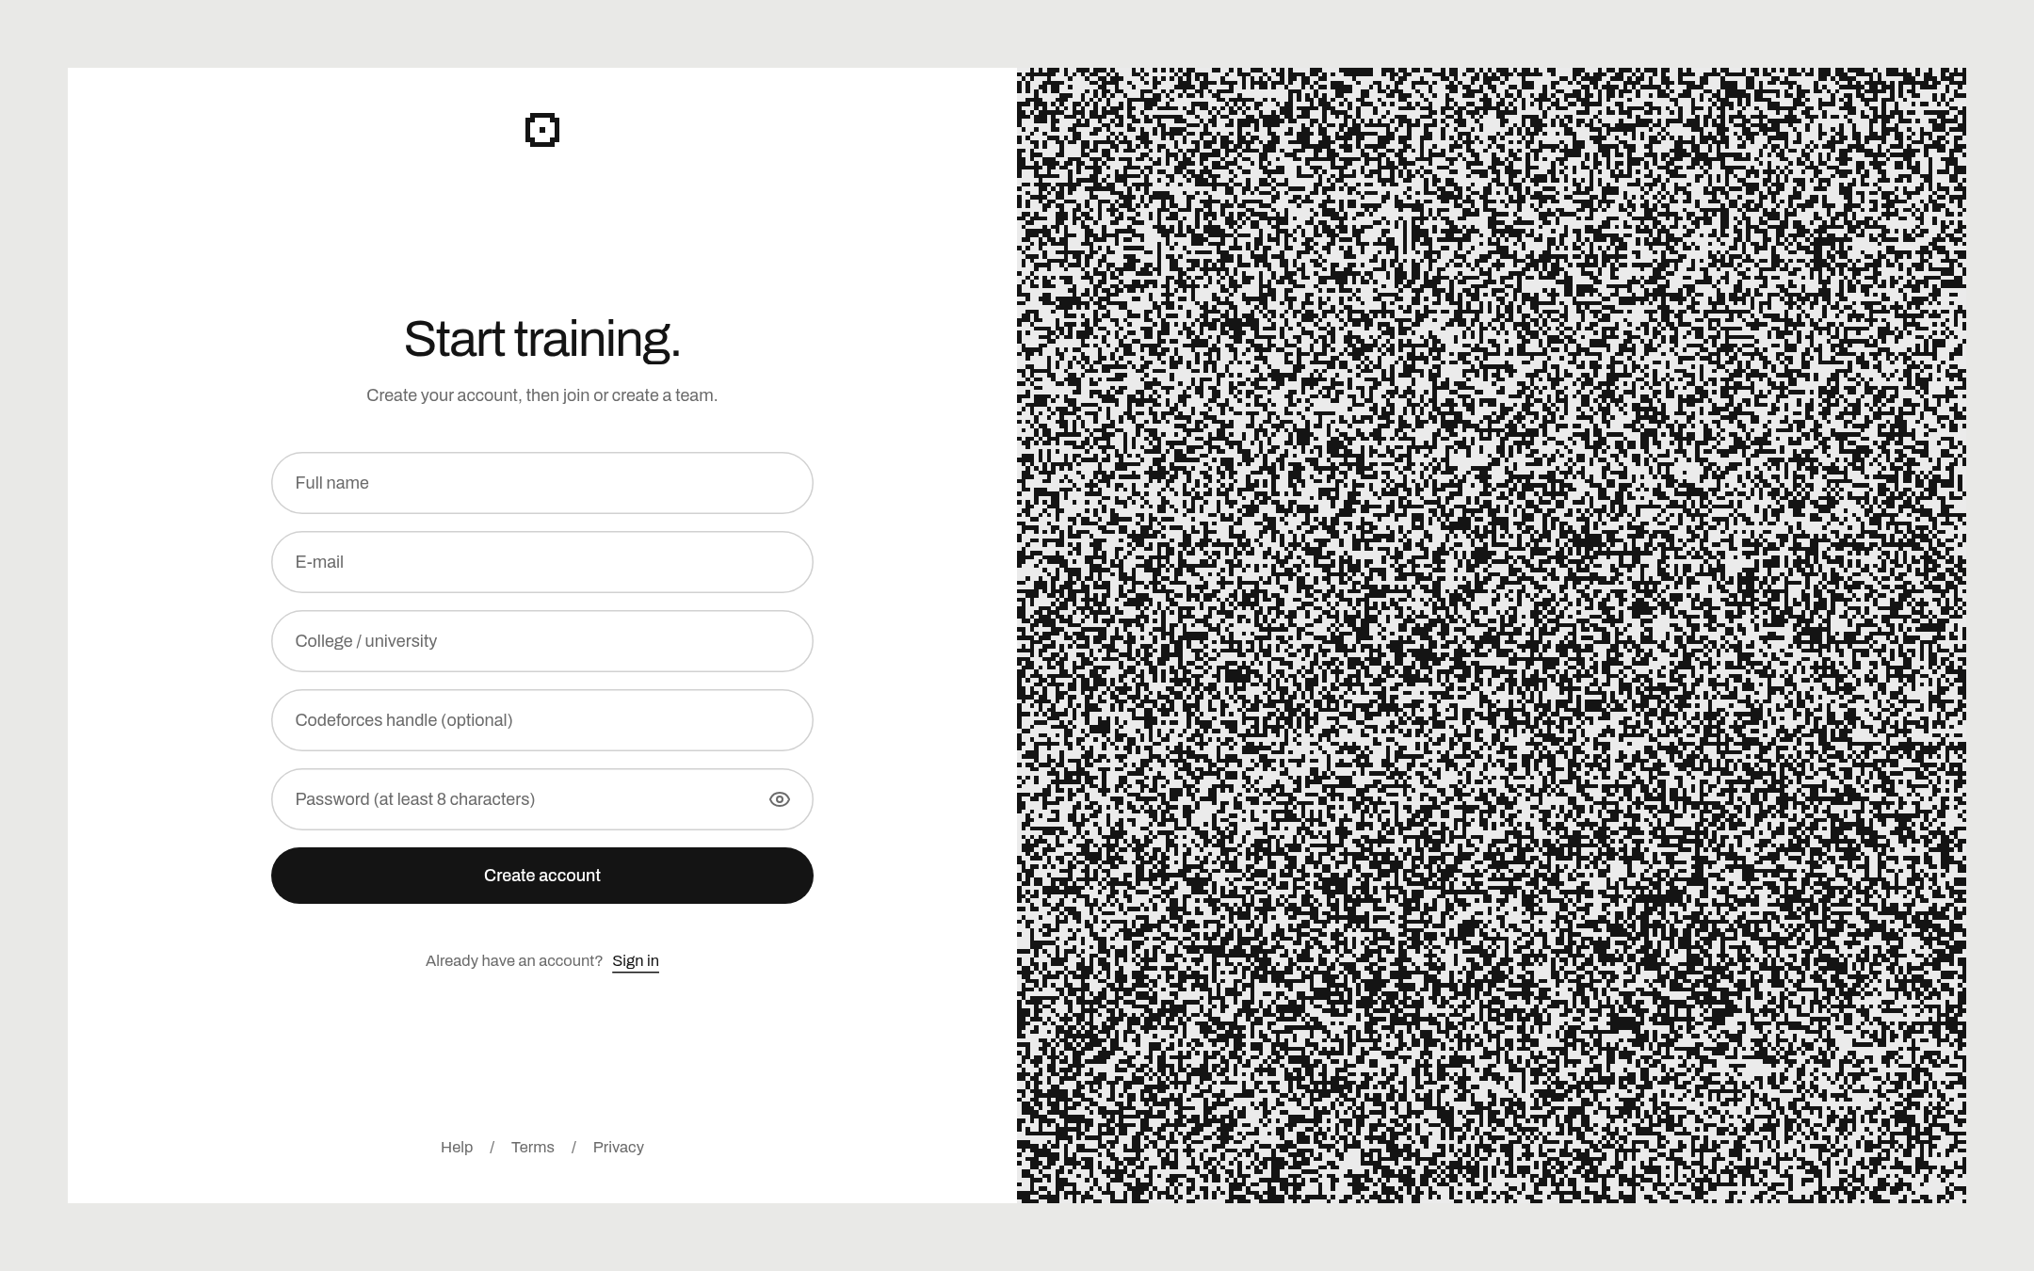
Figure 1: Sign-up page. The college box suggests colleges already in the database.
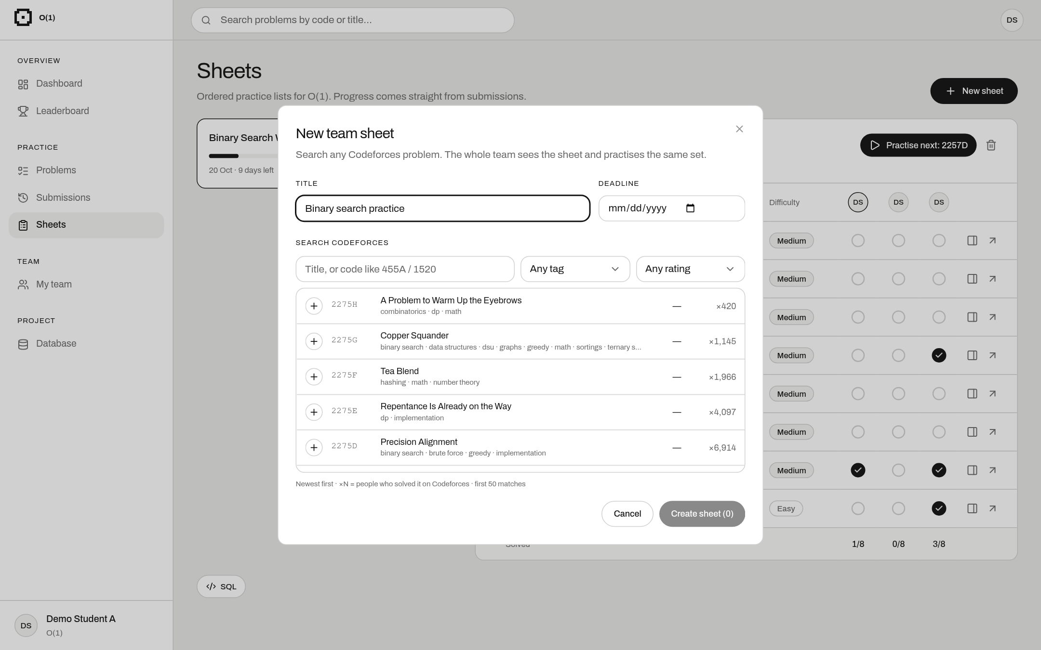
Figure 2: New sheet dialog. It searches all Codeforces problems; picked problems become rows of sheet_problem.

5. Database Design

5.1 ER diagram
Submission is a weak entity: it is identified by the user, the problem and the time. Difficulty is a derived attribute, so it is not stored.
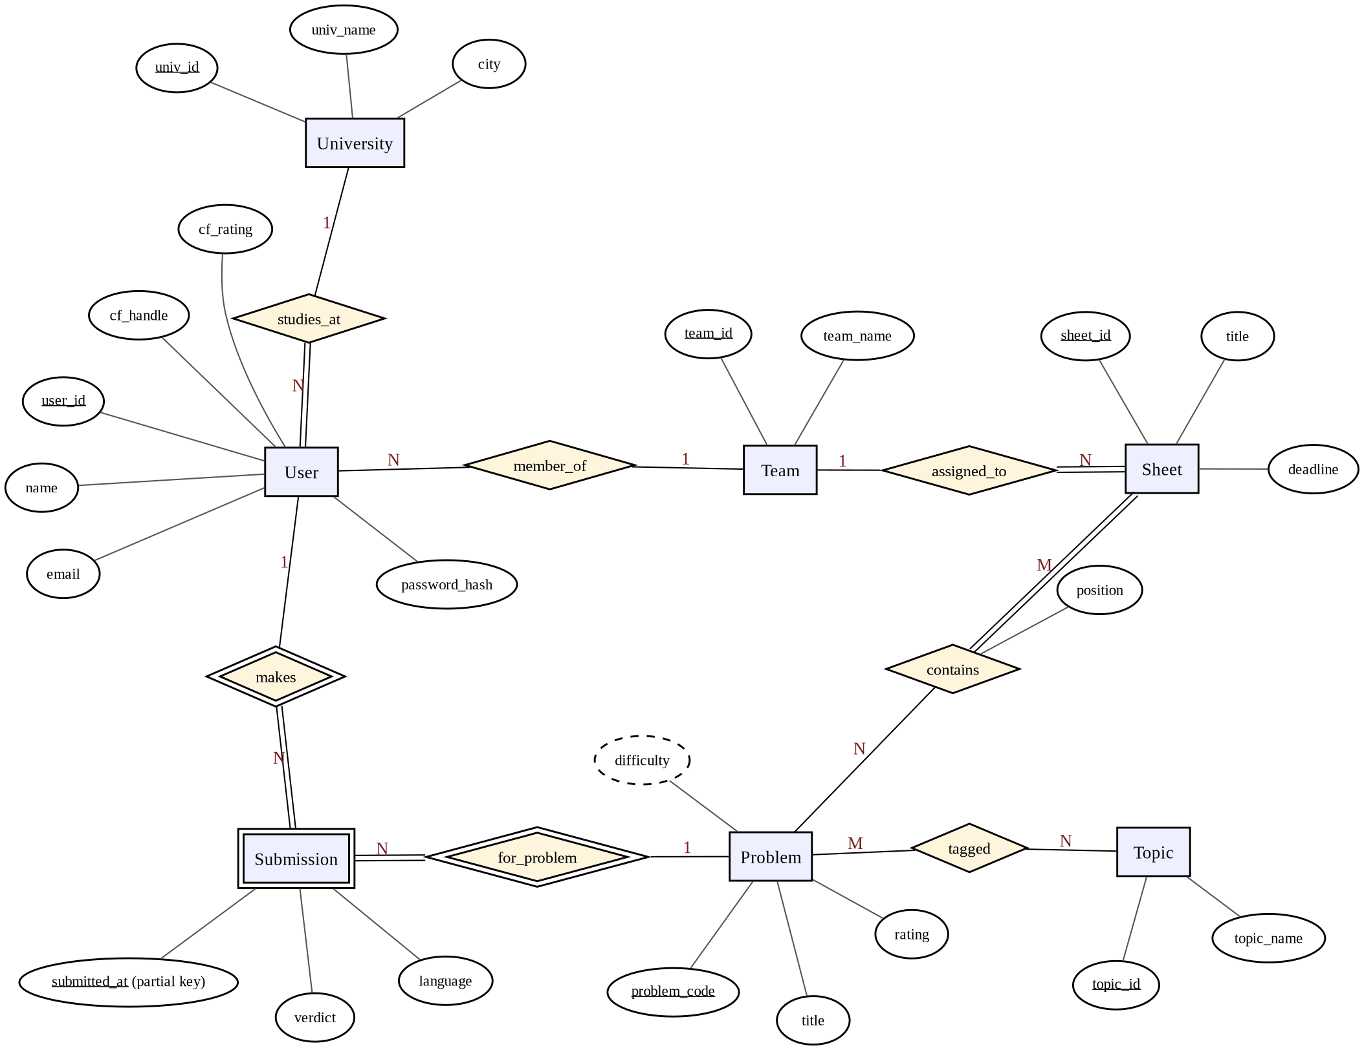
Figure 3: ER diagram of O(1).
Table 2: Relationships
Relationship | Entities | Cardinality | Note
studies_at | User – University | N : 1 | every user has a college
member_of | User – Team | N : 1 | optional, max 3 per team
assigned_to | Sheet – Team | N : 1
contains | Sheet – Problem | M : N | with position
tagged | Problem – Topic | M : N
makes / for_problem | User / Problem – Submission | 1 : N | identifying (weak entity)

5.2 ER to tables
Each entity became a table. 1:N relationships became foreign keys on the N side (team_id is nullable because a user may have no team). M:N relationships became junction tables (problem_topic, sheet_problem). The weak entity Submission got the key (user_id, problem_code, submitted_at).
university (univ_id PK, univ_name UNIQUE, city)
team (team_id PK, team_name UNIQUE)
app_user (user_id PK, name, email UNIQUE, password_hash, cf_handle UNIQUE,
cf_rating, cf_max_rating, univ_id FK, team_id FK NULL)
topic (topic_id PK, topic_name UNIQUE)
problem (problem_code PK, title, rating CHECK 800-3500)
problem_topic (problem_code FK, topic_id FK) PK = both
submission (user_id FK, problem_code FK, submitted_at, verdict CHECK, language)
PK = first three
sheet (sheet_id PK, title, team_id FK, deadline)
sheet_problem (sheet_id FK, problem_code FK, position CHECK > 0)
PK = (sheet_id, problem_code), UNIQUE (sheet_id, position)

Constraints: NOT NULL and primary keys on every table; UNIQUE on e-mail, handle and names; CHECK on rating, verdict and position; ON DELETE CASCADE for owned rows (a user's submissions, a sheet's problems); ON DELETE SET NULL so deleting a team keeps its members; a trigger for the 3-member limit; a GIN trigram index for college search.

5.3 Normalisation
We started from our old spreadsheet, which had one row per submission and a list of topics in one cell. To keep the working short we name each column with a letter:
U user_id N name M email I univ_id J univ_name G team_id K team_name
P problem_code T title R rating S submitted_at V verdict L language

1NF: the topics cell had many values, so we moved topics to Problem_Topic (one row per problem and topic) and a Topic table. Now every cell has one value.
Functional dependencies (F): U → NMIG, M → U, I → J, G → K, P → TR, UPS → VL, plus three extra ones the team wrote down: UM → N, U → J, UPS → T.
Closure and keys: {U,P,S}⁺ gives all 13 columns (U adds N,M,I,G; then J and K; P adds T,R; UPS adds V,L). {M,P,S}⁺ also gives all columns because M → U. No smaller set works, since P and S are never on the right side of any FD. So the candidate keys are {U,P,S} and {M,P,S}.
F⁺ and membership: using Armstrong's axioms we get, for example, U → J (U → I, I → J) and M → K (M → U → G → K). To test X → Y we check if Y is in X⁺: M → K is in F⁺, but I → U is not, since {I}⁺ = {I, J}.
Minimal cover: split right sides; UM → N reduces to U → N and UPS → T reduces to P → T (already there); U → J is redundant because U → I → J. Result:
Fc = { U → NMIG, M → U, I → J, G → K, P → TR, UPS → VL }

2NF: U → NMIG and P → TR depend on only part of the key {U,P,S}. We split them out:
USER_INFO(U,N,M,I,J,G,K) PROBLEM(P,T,R) SUBMISSION(U,P,S,V,L)

3NF: in USER_INFO, I → J and G → K are transitive (U → I → J). We split again:
USER(U,N,M,I,G) UNIVERSITY(I,J) TEAM(G,K)

BCNF: now the left side of every FD is a key in its table, so every table is in BCNF. The other tables (topic, problem_topic, sheet, sheet_problem) also have only keys as determinants.
Lossless join: each split shares a column that is a key of one side (U, P, I, G), so joining back gives exactly the original rows. The chase test ends with the SUBMISSION row all 'a', which confirms it. If we had split SUBMISSION into (U,P) and (P,S,V,L), joining on P would create fake submissions.
Dependency preservation: every FD in Fc fits inside one table (I → J in UNIVERSITY, P → TR in PROBLEM, and so on), so each rule can be checked without joins.
Derived values: difficulty depends on rating (rating → difficulty), so storing it would break 3NF. We calculate it in the view v_problem_difficulty instead. Solved counts and sheet progress are also views.

6. Database Selection & Justification
We used PostgreSQL 18. Our data is connected (users, teams, problems, sheets), and our features need joins and grouping across many users, so a relational database fits best. We chose PostgreSQL because:
• It supports everything we needed: CTEs, window functions, the FILTER clause, views, CHECK constraints and INTERSECT.
• PL/pgSQL triggers let us enforce the 3-member rule.
• The pg_trgm extension gives fuzzy search for college names.
• INSERT ... ON CONFLICT makes the Codeforces import safe to repeat.
• It is free, open source, reliable (ACID transactions) and works well with Python (psycopg2).
Table 3: Comparison of databases
Feature | PostgreSQL | MySQL | SQLite | MongoDB
Window functions, CTEs | Yes | Yes | Yes | Partly
Triggers | Yes | Yes | Limited | No
Fuzzy text search | pg_trgm | No | No | Paid add-on
FILTER clause | Yes | No | Yes | No
Multi-user server | Yes | Yes | No | Yes
Cost | Free | Free | Free | Free

7. Implementation

7.1 How it works
The React front end calls our Flask back end (for example /api/sheets). Flask runs plain SQL on PostgreSQL using psycopg2 and sends back JSON. We did not use an ORM, so every query is easy to read. The schema is in schema-lite.sql and is created with one command: python init_db.py.

7.2 Tables, trigger and view
CREATE TABLE submission (
user_id INT REFERENCES app_user(user_id) ON DELETE CASCADE,
problem_code VARCHAR(12) REFERENCES problem(problem_code),
submitted_at TIMESTAMP NOT NULL,
verdict VARCHAR(25) NOT NULL CHECK (verdict IN ('OK', 'WRONG_ANSWER', ...)),
language VARCHAR(50) NOT NULL,
PRIMARY KEY (user_id, problem_code, submitted_at)
);

CREATE FUNCTION check_team_size() RETURNS trigger AS $$
BEGIN
IF NEW.team_id IS NOT NULL AND
(SELECT count(*) FROM app_user
WHERE team_id = NEW.team_id AND user_id <> NEW.user_id) >= 3 THEN
RAISE EXCEPTION 'team % already has 3 members', NEW.team_id;
END IF;
RETURN NEW;
END $$ LANGUAGE plpgsql;

CREATE TRIGGER team_size_check BEFORE INSERT OR UPDATE OF team_id ON app_user
FOR EACH ROW EXECUTE FUNCTION check_team_size();

CREATE VIEW v_problem_difficulty AS
SELECT problem_code, title, rating,
CASE WHEN rating IS NULL THEN NULL WHEN rating < 1400 THEN 'Easy'
WHEN rating < 2000 THEN 'Medium' ELSE 'Hard' END AS difficulty
FROM problem;

7.3 Sample data
The app has no built-in data; it comes from sign-up and the Codeforces sync. For testing we made four demo accounts linked to public Codeforces handles. After one sync the database had 26,944 submissions, 9,591 problems, 21,535 problem–topic rows and 37 topics. The import uses ON CONFLICT DO NOTHING, so syncing again adds nothing twice:
INSERT INTO submission (user_id, problem_code, submitted_at, verdict, language)
VALUES (%s, %s, %s, %s, %s)
ON CONFLICT (user_id, problem_code, submitted_at) DO NOTHING;

7.4 CRUD operations
Table 4: CRUD examples
Operation | Feature | SQL
Create | Sign up | INSERT INTO app_user (...) VALUES (...) RETURNING user_id
Read | Leaderboard | SELECT rank() OVER (ORDER BY solved DESC), ... FROM v_leaderboard
Update | Join team | UPDATE app_user SET team_id = %s WHERE user_id = %s
Delete | Delete sheet | DELETE FROM sheet WHERE sheet_id = %s (its problems are deleted by CASCADE)

Values are always passed as %s parameters, never joined into the SQL text, which stops SQL injection. Each request is one transaction: if any statement fails, everything is rolled back.

7.5 Queries with output
All outputs below are from our demo data. The full list of queries is in the separate SQL document.

Q1. Join of three tables: latest accepted submissions
SELECT u.name, p.problem_code, p.title, s.submitted_at
FROM submission s
JOIN app_user u ON u.user_id = s.user_id
JOIN problem p ON p.problem_code = s.problem_code
WHERE s.verdict = 'OK'
ORDER BY s.submitted_at DESC
LIMIT 5;

name | problem_code | title | submitted_at
Demo Student A | 2271H1 | Personal Issues (Easy Version) | 2026-10-10 18:38
Demo Student A | 2271F | Beautiful Pillers | 2026-10-10 17:21
Demo Student B | 2271H1 | Personal Issues (Easy Version) | 2026-10-10 16:50
Demo Student B | 2271F | Beautiful Pillers | 2026-10-10 16:19

(4 of 5 rows shown)

Q2. GROUP BY with HAVING: students with 2,000+ solved
SELECT u.name, count(DISTINCT s.problem_code) AS solved
FROM app_user u JOIN submission s ON s.user_id = u.user_id
WHERE s.verdict = 'OK'
GROUP BY u.name
HAVING count(DISTINCT s.problem_code) >= 2000;

name | solved
Demo Student B | 4596
Demo Student C | 3956
Demo Student D | 3049

Q3. NOT EXISTS: sheet problems student 2 has not solved
SELECT sp.position, sp.problem_code
FROM sheet_problem sp
WHERE sp.sheet_id = 1
AND NOT EXISTS (SELECT 1 FROM submission s
WHERE s.user_id = 2 AND s.problem_code = sp.problem_code
AND s.verdict = 'OK')
ORDER BY sp.position;

position | problem_code
1 | 2257D
2 | 2254E
3 | 2232C2
4 | 2229D

(4 of 8 rows shown)

Q5. Window function on a view: leaderboard
SELECT rank() OVER (ORDER BY solved DESC) AS rank, name, univ_name, solved
FROM v_leaderboard;

rank | name | univ_name | solved
1 | Demo Student B | Amrita Vishwa Vidyapeetham | 4596
2 | Demo Student C | Amrita Vishwa Vidyapeetham | 3956
3 | Demo Student D | NIT Calicut | 3049
4 | Demo Student A | Amrita Vishwa Vidyapeetham | 1542

Q10. INTERSECT: problems solved by both student 1 and 2
SELECT p.problem_code, p.title
FROM problem p
WHERE p.problem_code IN (
SELECT problem_code FROM submission WHERE user_id = 1 AND verdict = 'OK'
INTERSECT
SELECT problem_code FROM submission WHERE user_id = 2 AND verdict = 'OK')
ORDER BY p.rating DESC NULLS LAST
LIMIT 5;

problem_code | title
1523F | Favorite Game
1782G | Diverse Coloring
1446F | Line Distance
1349D | Slime and Biscuits

(4 of 5 rows shown)

Q6. Team analytics (CTE + window function)
For streaks we number each member's active days with row_number(). For days in a row, day − row_number() stays the same, so grouping by it gives each streak. Part of the output:
name | rating | solved | solved_30d | longest_streak | acceptance | unique
Demo Student A | 2624 | 1542 | 7 | 7 | 50 | 676
Demo Student B | 3353 | 4596 | 15 | 7 | 64 | 2849
Demo Student C | 3676 | 3956 | 7 | 20 | 56 | 2396

8. Testing & Validation
We tested the database rules directly in SQL, and the app through its API. Database tests were rolled back after running.

8.1 Database tests
Table 5: Database tests
ID | Input | Expected | Actual output | Result
T1 | Insert user with an e-mail that exists | Error: UNIQUE(email) | Rejected: duplicate key "app_user_email_key" | Pass
T2 | Insert user with a handle that exists | Error: UNIQUE(cf_handle) | Rejected: duplicate key "app_user_cf_handle_key" | Pass
T3 | Insert user with univ_id = 999 | Error: foreign key | Rejected: "app_user" breaks foreign key constraint "app_user_univ_id_fkey" | Pass
T4 | Insert user without a name | Error: NOT NULL | Rejected: null value in column "name" of relation "app_user" breaks not-null con | Pass
T5 | Insert problem with rating 500 | Error: CHECK rating 800–3500 | Rejected: "problem" breaks check constraint "problem_rating_check" | Pass
T6 | Insert submission with verdict 'ACCEPTED' | Error: CHECK verdict | Rejected: "submission" breaks check constraint "submission_verdict_check" | Pass
T7 | Insert the same submission twice | Error: composite primary key | Rejected: duplicate key "submission_pkey" | Pass
T8 | Submission for problem 99999Z | Error: foreign key | Rejected: "submission" breaks foreign key constraint "submission_problem_code_f | Pass
T9 | 4th member joins team 1 | Rejected by trigger team_size_check | Rejected: team 1 already has 3 members | Pass
T10 | Same problem twice in a sheet | Error: primary key (sheet_id, problem_code) | Rejected: duplicate key "sheet_problem_pkey" | Pass
T11 | Two problems at position 1 | Error: UNIQUE(sheet_id, position) | Rejected: duplicate key "sheet_problem_sheet_id_position_key" | Pass
T13 | Team name 'O(1)' again | Error: UNIQUE(team_name) | Rejected: duplicate key "team_team_name_key" | Pass
T14 | DELETE a sheet | Works; 0 sheet_problem rows left | Accepted; sheet_problem_rows = 0 | Pass
T15 | DELETE a team | Works; users remain with team_id = NULL | Accepted; users_left = 4, users_with_team = 0 | Pass
T17 | Problem with NULL rating | Works; difficulty NULL | Accepted; difficulty = NULL | Pass

8.2 Application tests
Table 6: Application tests
ID | Input | Expected | Actual | Result
A1 | Log in with the wrong password | 401, "Wrong password" | 401, "Wrong password" | Pass
A3 | Sign up with a 5-character password | 400, password too short | 400, "Password must be at least 8 characters" | Pass
A4 | Sign up at a new college without its city | 400, asks for the city | 400, "This is a new college: please enter its city" | Pass
A5 | Sign up with an e-mail already registered | 409, e-mail already registered | 409, "That e-mail is already registered" | Pass
A6 | Open the dashboard without signing in | 401, "Please sign in" | 401, "Please sign in" | Pass
A7 | Create a sheet with a code that is not on Codeforces | 400, not a Codeforces problem | 400, "99999Z is not a Codeforces problem" | Pass
A8 | Create a sheet with no problems | 400, needs at least one problem | 400, "A sheet needs a title and at least one problem" | Pass
A9 | Create a second team while already in one | 400, leave current team first | 400, "Leave your current team first" | Pass

All 15 database tests and 8 application tests passed. We also checked every page on a laptop and a phone screen, and made sure buttons cannot be double-clicked to send two requests.

9. Results & Screenshots
Screenshots of the working app with our demo data:
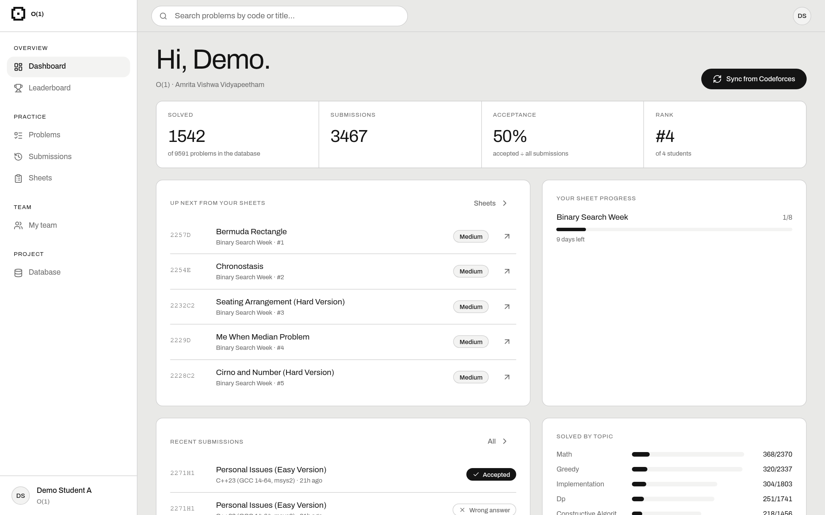
Figure 4: Dashboard: solved count, acceptance and rank come from one query; "Up next" uses NOT EXISTS.
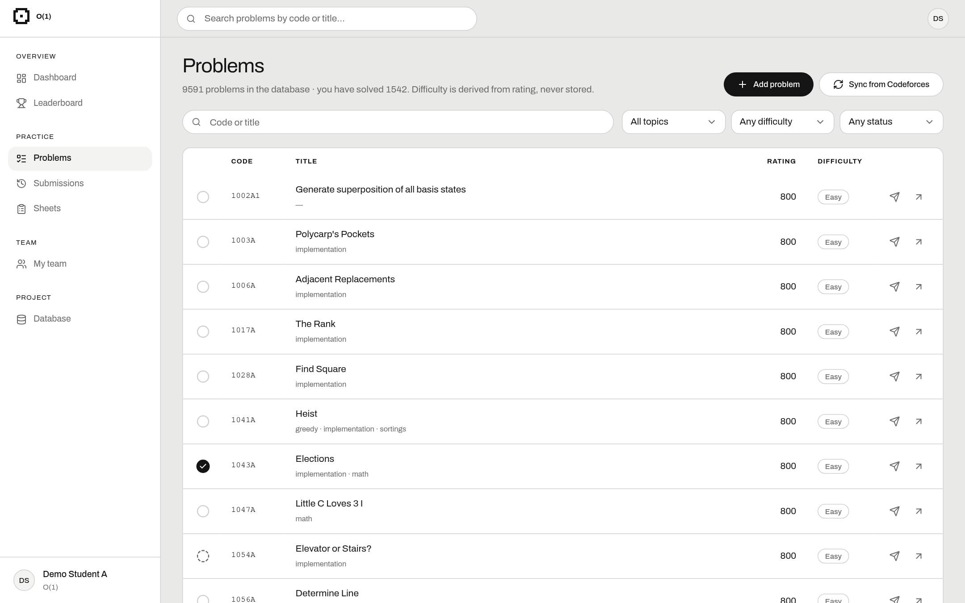
Figure 5: Problems: every stored problem with its topics, difficulty (from the view) and my status.
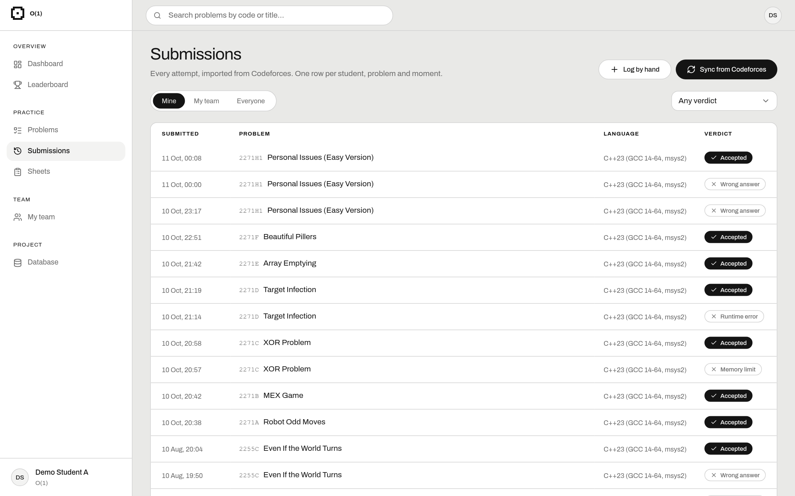
Figure 6: Submissions: a join of submission, app_user and problem, filtered by verdict.
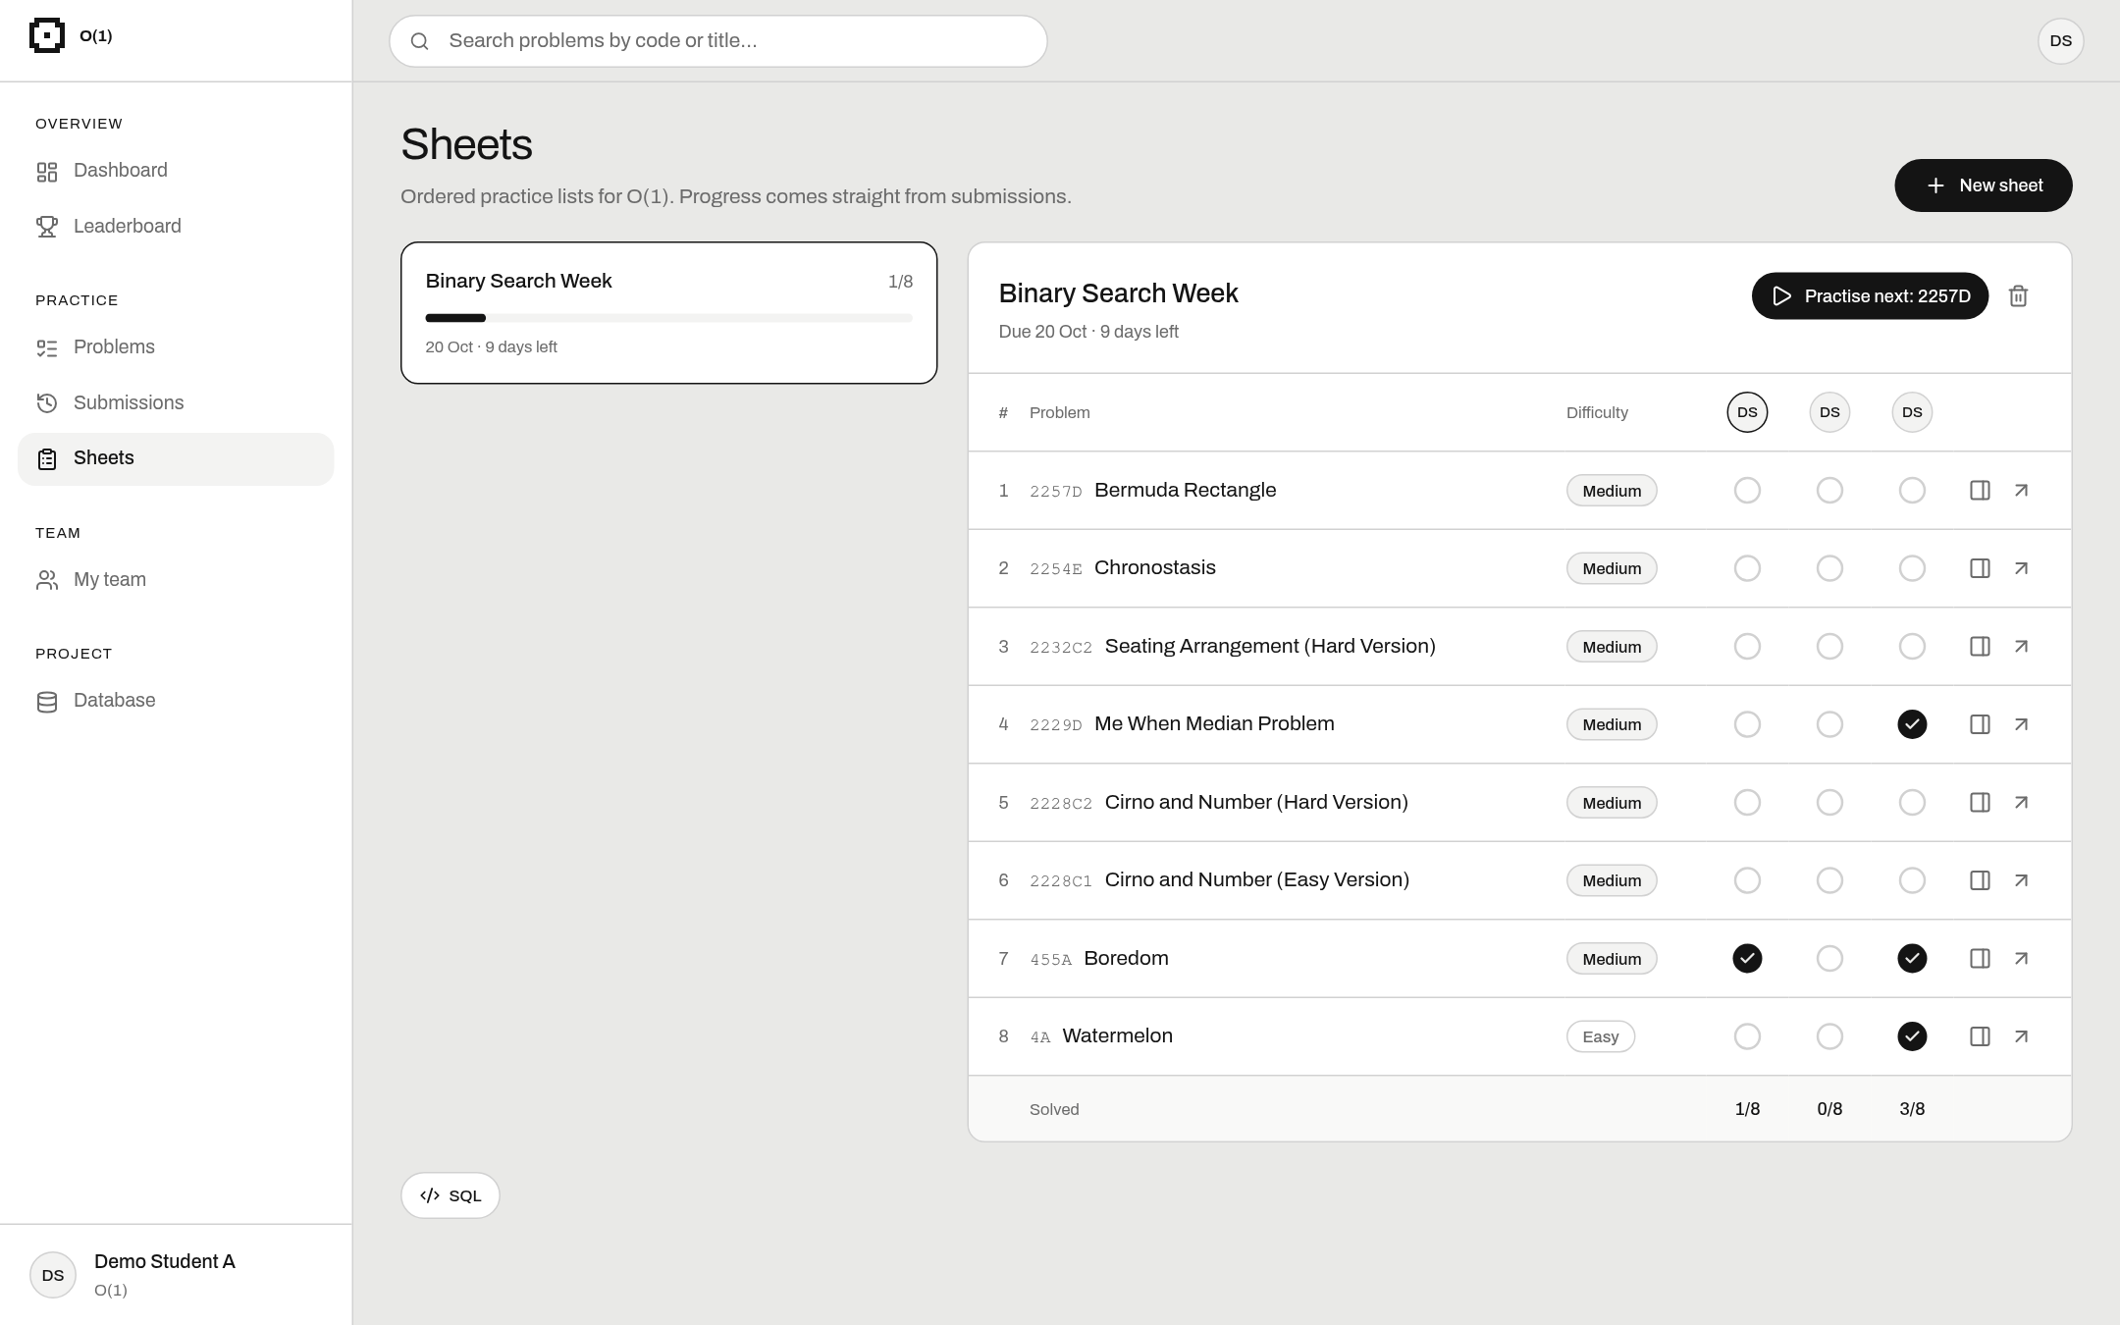
Figure 7: Team sheet: ticks show who solved each problem; progress comes from the v_sheet_progress view.
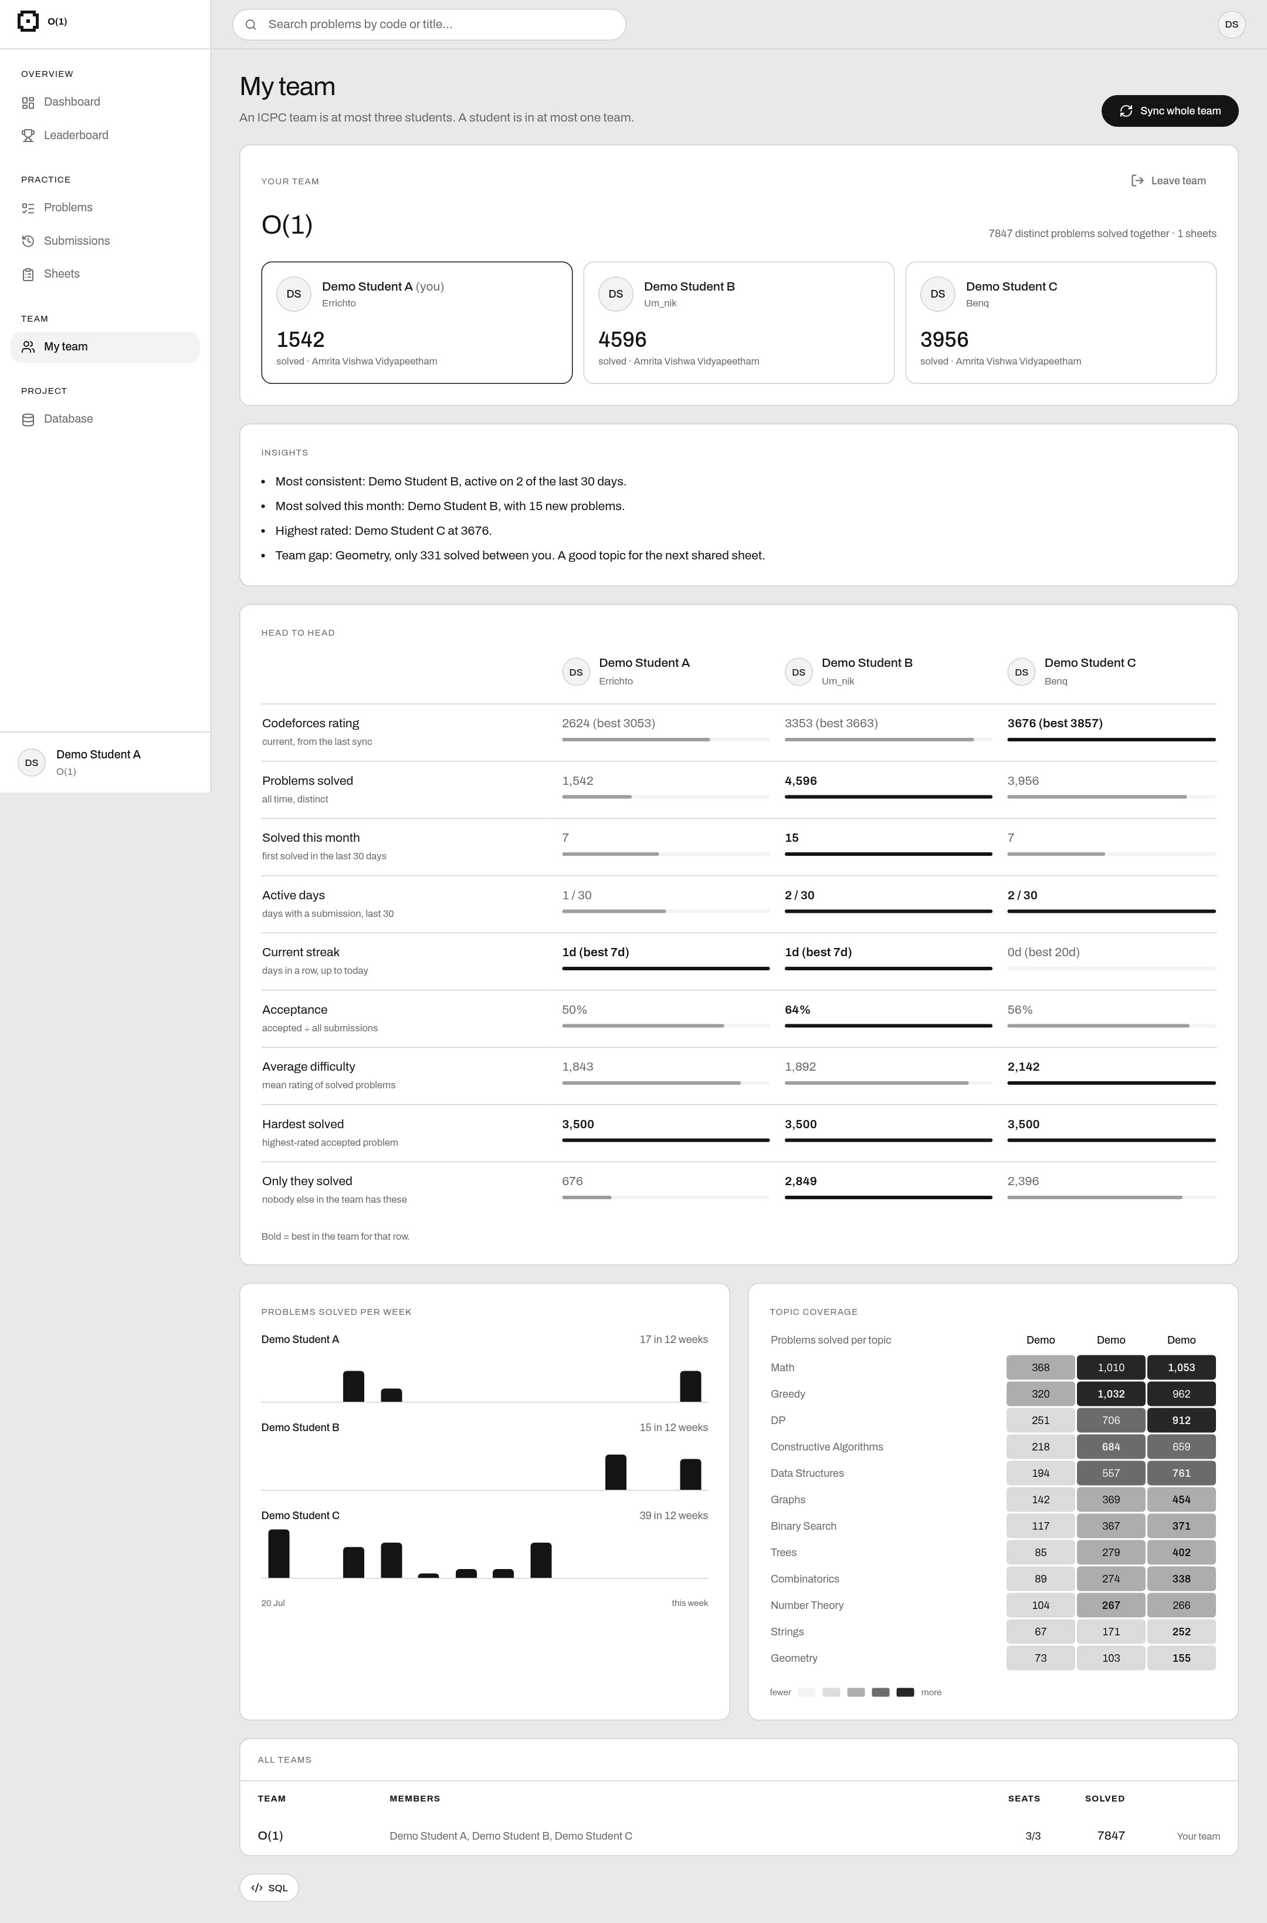
Figure 8: Team analytics: side-by-side numbers, weekly activity and topic heatmap.
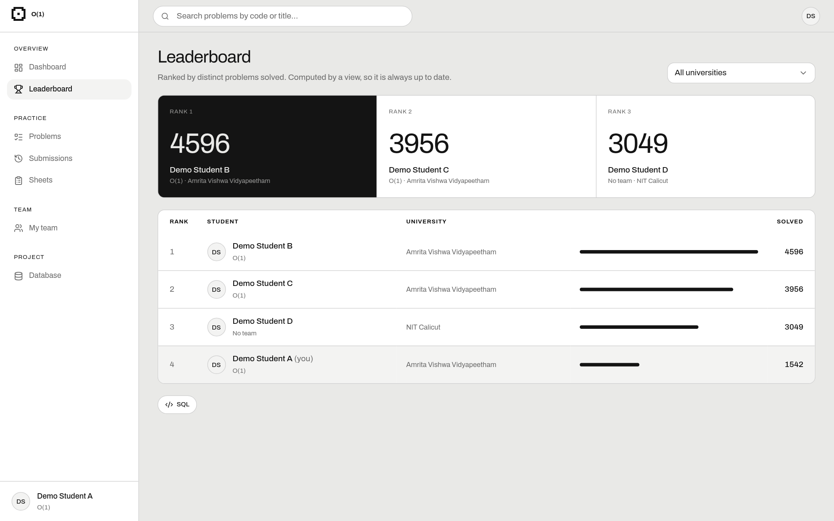
Figure 9: Leaderboard: v_leaderboard ranked with rank() OVER.
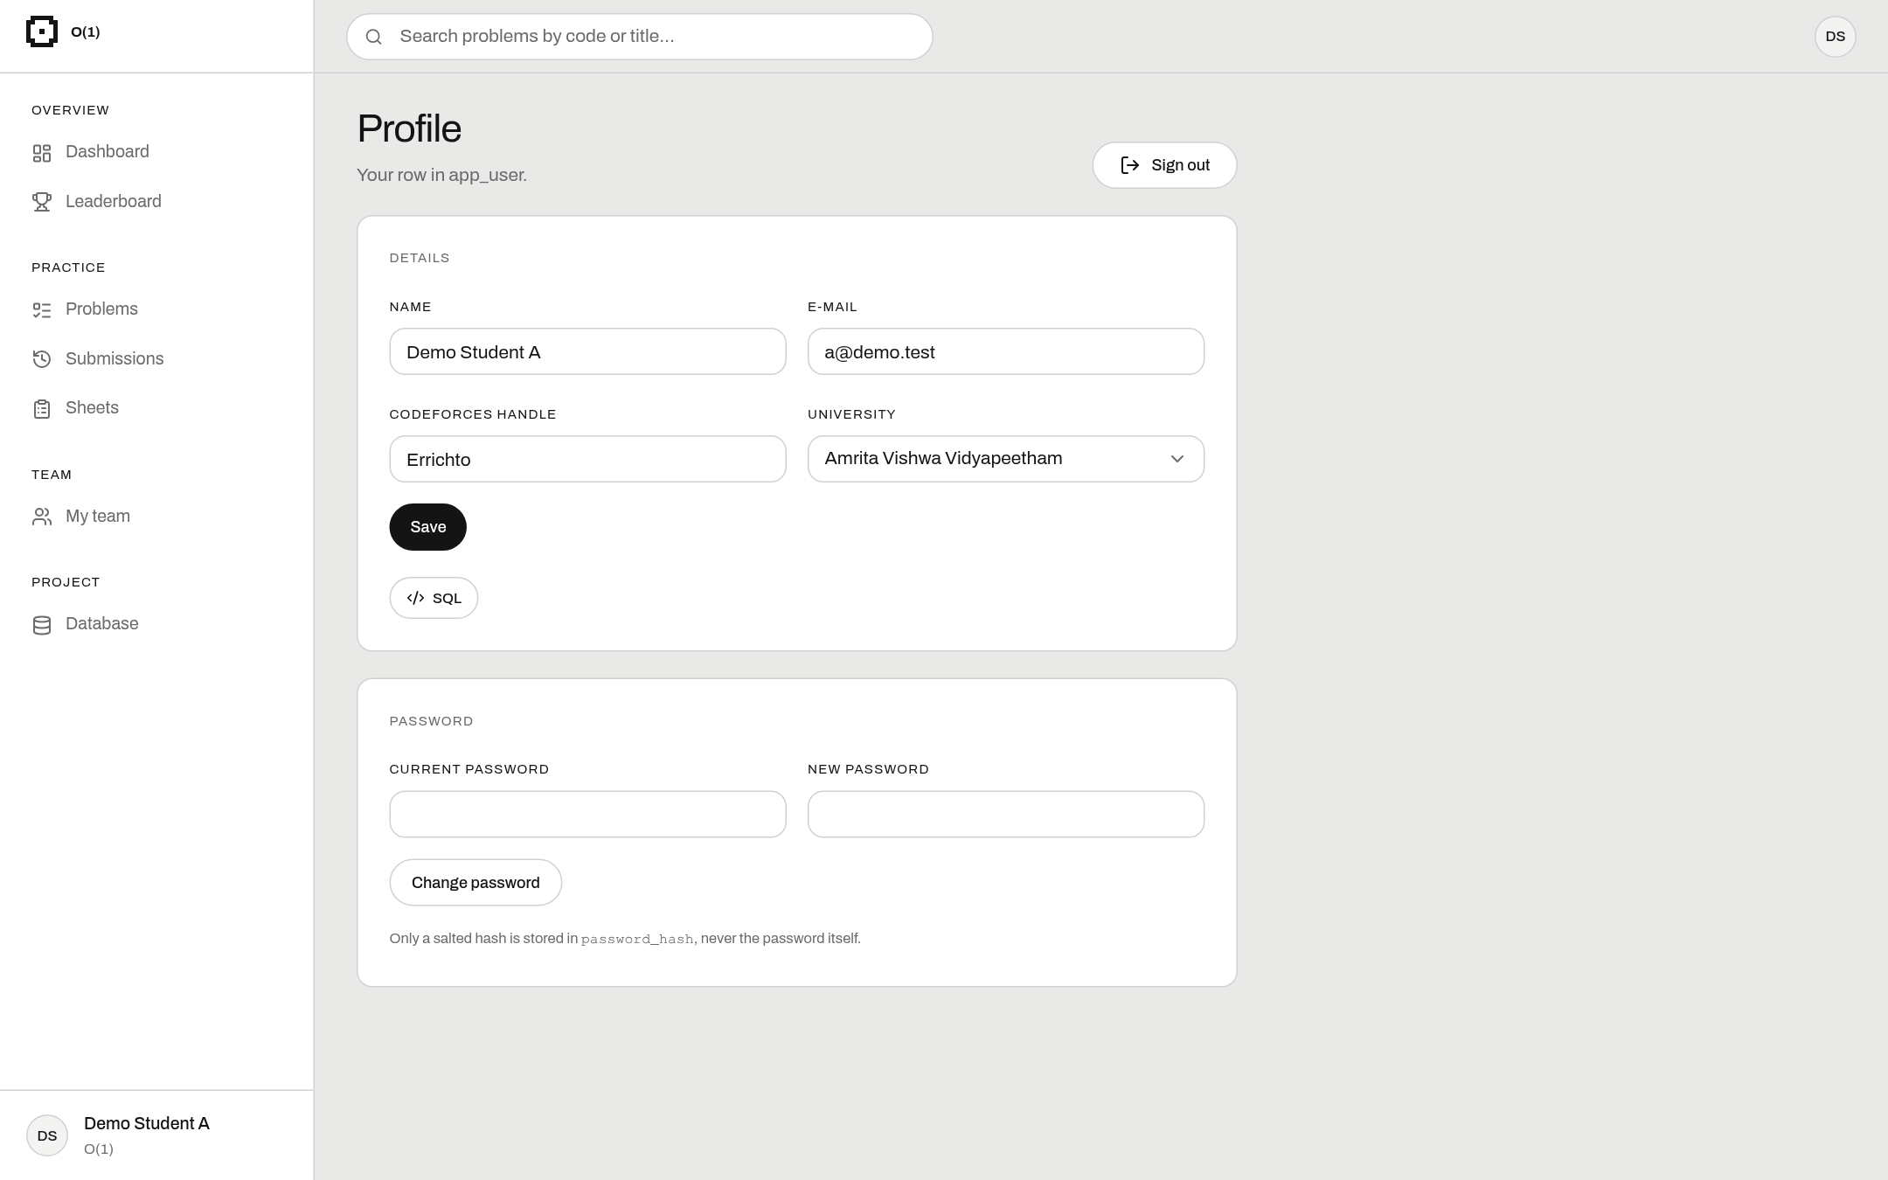
Figure 10: Profile: updates app_user; the database rejects an e-mail or handle that is already used.
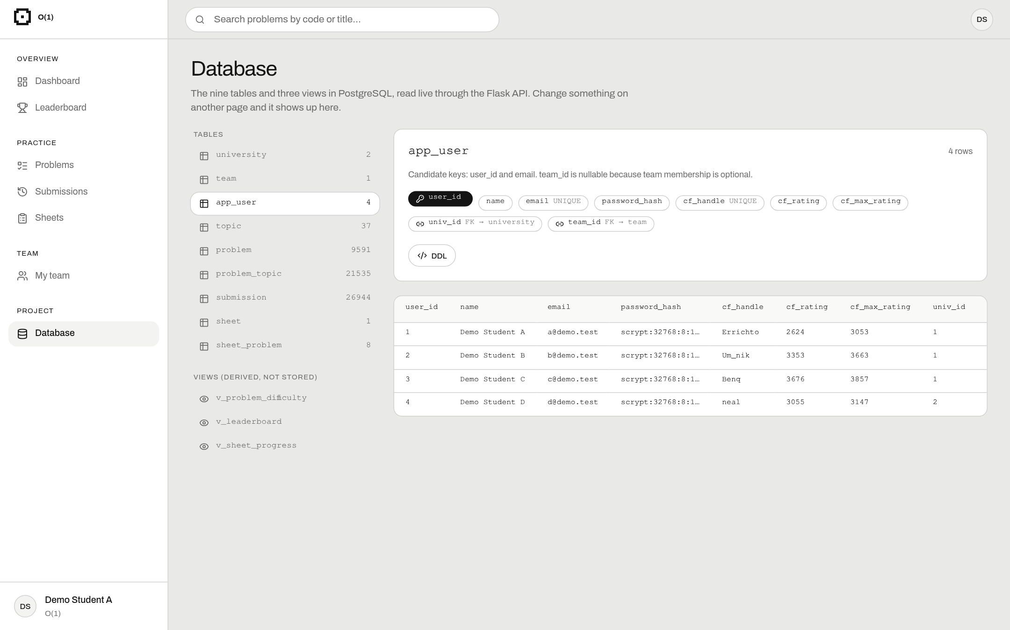
Figure 11: Database page: live tables with keys, DDL and rows.

10. Challenges Faced & Solutions
Table 7: Challenges and solutions
Challenge | How we solved it
Our first design had 20 tables and was too hard to explain. | We cut it to 9 tables and kept only the core features.
A problem has many topics, which broke 1NF. | Made a Topic table and the problem_topic junction table.
Stored counts and difficulty could go out of date. | We calculate them with views instead of storing them.
"Max 3 members" cannot be a CHECK constraint. | Wrote a trigger that counts members before insert or update.
Students typed the same college in different ways. | Used pg_trgm fuzzy search to suggest the existing name.
Syncing twice made duplicates; Codeforces limits API calls. | Composite primary key with ON CONFLICT DO NOTHING; calls are spaced 2 seconds apart.
Password hashes were too long for VARCHAR(100). | Changed the column to VARCHAR(255).
Creating a team takes two statements. | One transaction per request, so both happen or neither does.
Calculating streaks in SQL. | Used the "gaps and islands" trick with row_number().
Codeforces cannot be shown inside our app. | Problems open in a new tab instead.

11. Conclusion & Future Enhancements
We replaced a messy spreadsheet with a nine-table PostgreSQL database in BCNF. We designed it step by step using FDs, closures, a minimal cover and normalisation, and showed it is lossless and dependency preserving. The database itself enforces the rules with keys, constraints and a trigger, and views keep calculated values correct. On top of it we built a working web app with Codeforces import, teams, shared sheets, a leaderboard and team analytics. All our objectives were met and all tests passed.
Future work: contests and rating history, a coach role, more judges (AtCoder, CodeChef), automatic daily sync, password reset by e-mail, and hosting the app online.

References
1. Silberschatz, Korth and Sudarshan, Database System Concepts, 7th ed., McGraw-Hill, 2019.
2. Elmasri and Navathe, Fundamentals of Database Systems, 7th ed., Pearson, 2016.
3. PostgreSQL 18 Documentation (including pg_trgm), https://www.postgresql.org/docs/
4. Codeforces API, https://codeforces.com/apiHelp
5. Flask documentation, https://flask.palletsprojects.com/ and Psycopg 2, https://www.psycopg.org/docs/
6. React documentation, https://react.dev/

