How Many Radiologists Define the Truth? Inter-observer Variability in the Detection of Interval Change on Longitudinal Chest Radiographs
[Author list]
[School of Computer Science and Engineering, The Hebrew University of Jerusalem; Department of Radiology, Hadassah Hebrew University Medical Center, Jerusalem, Israel]
Corresponding author: Prof. Leo Joskowicz — josko@cs.huji.ac.il
Placeholder color key: TO ADD — real data/values required before submission SUGGESTION — optional analysis/addition to consider DECISION — confirm wording / choice

Abstract
Purpose: Comparison of a current chest radiograph with a prior study to identify interval change is one of the most frequent tasks in thoracic imaging, yet the reliability of this judgment across readers is poorly quantified. We aimed to quantify the inter-observer agreement and variability of radiologists in detecting and characterizing interval change on longitudinal chest radiograph (CXR) pairs, and to determine how many readers are required before the reference standard stabilizes.
Materials and Methods: Five [board-certified] radiologists independently reviewed 100 longitudinal CXR pairs (a prior and a current image from the same patient) [ICU/inpatient cohort; retrospective; IRB approval and waiver of consent obtained]. Readers marked every region of interval change and classified it as appearance (new), disappearance (resolved), or persistence with a change in size and/or intensity; findings were grouped into positive (new/worsening) and negative (resolved/improving) change. A region marked by at least k readers was assigned consensus level k. Agreement was quantified with a Pairwise Agreement Index (PAI) at the detection and pair levels and with per-reader leave-one-out sensitivity by consensus level. To determine the number of readers required, we measured, for every subgroup of 1–5 readers, the fraction of the full five-reader reference findings the subgroup recovered (coverage), averaged over all subgroups of each size.
Results: Readers marked a mean of 1.68 change findings per pair (range 1.45–1.97). The mean pairwise agreement between two readers was 0.55 at the detection level (range 0.46–0.64) and 0.62 at the pair level (range 0.52–0.70); agreement was higher for positive than for negative change. Of 185 positive change findings, 45% were reported by a single reader and only 15% by all five (negative: 40% solo, 9% unanimous). Per-reader leave-one-out sensitivity rose with consensus, from 0.46 at level 1 to 0.89 at level 4 for positive change. A single reader recovered a mean of 49% of the full five-reader reference; two readers 69%, three 81%, and four 92%. The marginal gain per added reader fell from +19% (2nd reader) to +13% (3rd), +10% (4th), and +9% (5th).
Conclusions: Radiologist agreement on interval change on chest radiographs is moderate and graded, and nearly half of all findings are seen by a single reader. One radiologist captures only about half of the changes a five-reader panel would identify; three radiologists recover roughly four-fifths, with diminishing returns thereafter. Two or three readers are insufficient to capture the full range of reported change, but three readers offer a practical operating point for a stable reference standard.
Key Points
- Inter-observer agreement for interval change on chest radiographs is moderate (mean pairwise detection agreement 0.55) and highest for new/worsening findings.
- Nearly half of all change findings (45% positive, 40% negative) were reported by only one of five readers.
- A single radiologist recovers ~49% of the five-reader reference; three recover ~81%. Two or three readers are insufficient to capture the full range, but three provide a practical, largely stabilized reference.

1. Introduction
Serial comparison of chest radiographs is among the highest-volume interpretive tasks in radiology, particularly in intensive-care and inpatient settings, where daily films are used to track lines and tubes, effusions, consolidation, edema, and pneumothorax. Clinical decisions frequently turn on whether a finding is new, resolved, larger, or smaller relative to the prior study.
Despite the ubiquity of this task, the reliability of interval-change judgments across radiologists has received far less attention than single-image detection or quantitative measurement. Prior inter-observer studies in CT have shown that variability is large and that two or three observers may not capture its full range [Joskowicz 2019 Eur Radiol; Olesinski 2026 J Thorac Imaging]. Whether the same holds for the comparative, detection-level task of interval change on radiographs is unknown, yet it directly determines what should count as ground truth and how many readers are needed to define it.
In this study we quantify the inter-observer agreement and variability of five radiologists detecting interval change on 100 longitudinal CXR pairs, and we introduce a subgroup analysis that measures how completely groups of one to five readers reproduce the full-panel reference—directly answering how many radiologists are needed before the read stabilizes.

2. Materials and Methods

2.1 Study population
[Retrospective] analysis of 100 longitudinal chest radiograph pairs from [N patients] imaged at [institution] between [dates]. Each pair comprised a prior and a current [AP/portable] radiograph from the same patient [selection criteria: consecutive ICU studies with an interpretable prior within X days]. [IRB approval number; informed consent waived.] Patient demographics are summarized in [Table S1].

2.2 Readers and reading protocol
Five radiologists ([R1–R5]; [years of experience]) independently reviewed all 100 pairs on a dedicated annotation workstation, blinded to one another and to clinical information beyond the two images. For each pair, a reader delineated every region of interval change with an elliptical marker and labeled it Appearance (new), Disappearance (resolved), or Persistence (present on both, with an annotated change in size and intensity). Each region was reduced to a signed change: positive (appearance, or persistence with increased size/intensity) or negative (disappearance, or persistence with decreased size/intensity). Persistence without change was excluded.

2.3 Reference standard and consensus levels
Annotations were rasterized to the current-image space and grouped into connected components (findings). Each finding was assigned a consensus level equal to the number of readers (1–5) who independently marked an overlapping region. Consensus level 1 is the union of all reader findings; consensus level 5 comprises only unanimous findings.

2.4 Agreement, variability, and subgroup metrics
- Pairwise Agreement Index (PAI): for two readers, the per-detection PAI is 2M/(2M + U), where M is the number of matched (overlapping) findings and U the number of unmatched findings; the per-pair PAI averages agreement over the 100 image pairs.
- Human-Matched Detection Rate (HMDR): the fraction of a reader's findings overlapping a finding of at least one other reader; Unmatched Detections Per Pair (UDPP): the mean number of a reader's solo findings per pair.
- Sensitivity at consensus level (leave-one-out): for each reader, the fraction of the other four readers' consensus findings, at each consensus level, that the reader also marked.
- Reader-subgroup coverage: for every subgroup of size m (1–5), the fraction of the full five-reader reference findings recovered by the subgroup (a finding is recovered if any subgroup member marked it), averaged over all C(5, m) subgroups. Coverage is 1.0 by construction at m = 5; its rise with m quantifies how many readers are needed to stabilize the reference.

2.5 Statistical analysis
Agreement metrics are reported as means with ranges across reader pairs; subgroup coverage as the mean with the min–max envelope across subgroups of each size. [Bootstrap 95% confidence intervals over image pairs to be added.] Analyses were performed in Python [3.x] with NumPy, SciPy, and scikit-image.

3. Results

3.1 Finding burden
Across 100 pairs the five readers marked a mean of 1.68 change findings per pair, with per-reader totals of 145–197 (mean 1.45–1.97 per pair; maximum 4–6 on a single pair)—a 1.36-fold difference in reporting rate between the least and most prolific reader (Table 1).
Table 1. Change-finding burden per reader (100 pairs).
Reader | Total findings | Mean per pair | SD | Max per pair
R1 | 148 | 1.48 | 0.77 | 4
R2 | 185 | 1.85 | 1.04 | 6
R3 | 145 | 1.45 | 0.8 | 4
R4 | 166 | 1.66 | 0.95 | 5
R5 | 197 | 1.97 | 0.84 | 4

3.2 Pairwise agreement
The mean per-detection PAI between two readers was 0.55 (range 0.46–0.64); the mean per-pair PAI was 0.62 (range 0.52–0.70). The highest-agreeing reader pair concurred on only ~64% of individual detections, and the lowest on ~46% (Table 2, Figure 1). Agreement was higher for positive change (mean per-detection PAI 0.57) than for negative change (0.51), indicating that new or worsening findings are marked more reproducibly than resolving ones.
Table 2. Pairwise Agreement Index (per detection, all change).
 | R1 | R2 | R3 | R4 | R5
R1 | — | 0.47 | 0.59 | 0.51 | 0.59
R2 | 0.47 | — | 0.5 | 0.46 | 0.5
R3 | 0.59 | 0.5 | — | 0.57 | 0.63
R4 | 0.51 | 0.46 | 0.57 | — | 0.64
R5 | 0.59 | 0.5 | 0.63 | 0.64 | —
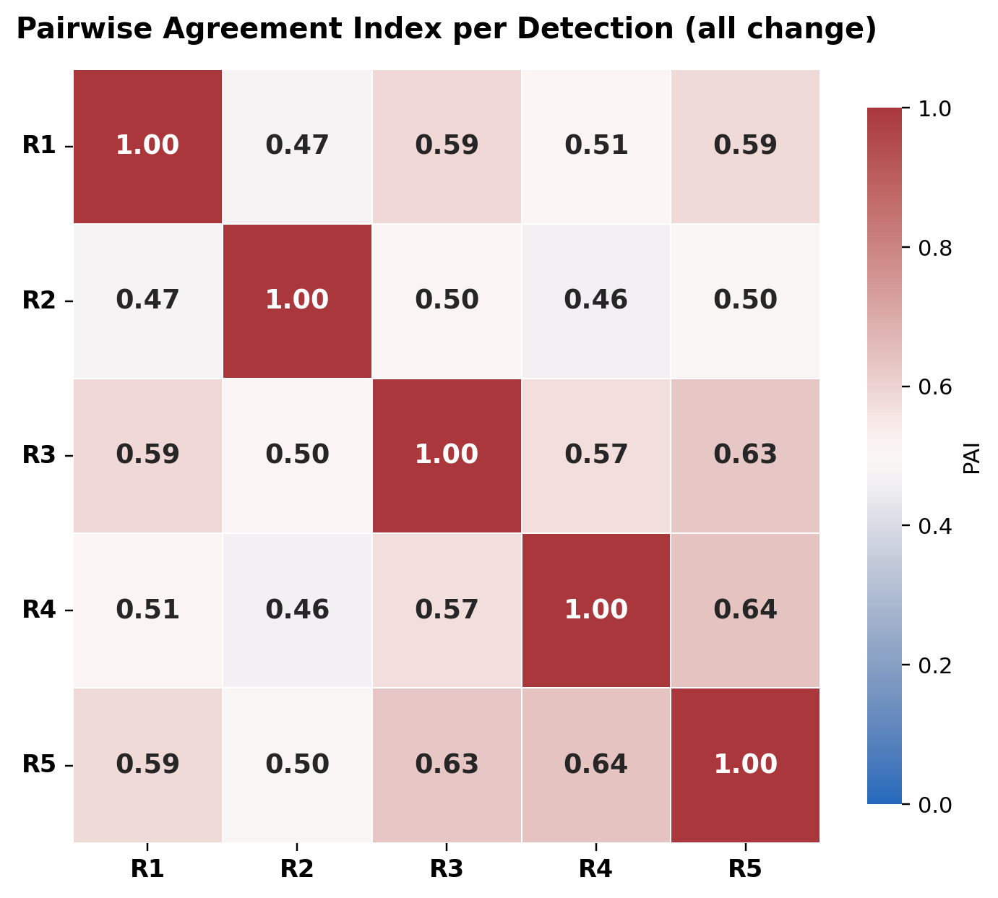
Figure 1a. Pairwise Agreement Index per detection (all change), five radiologists.
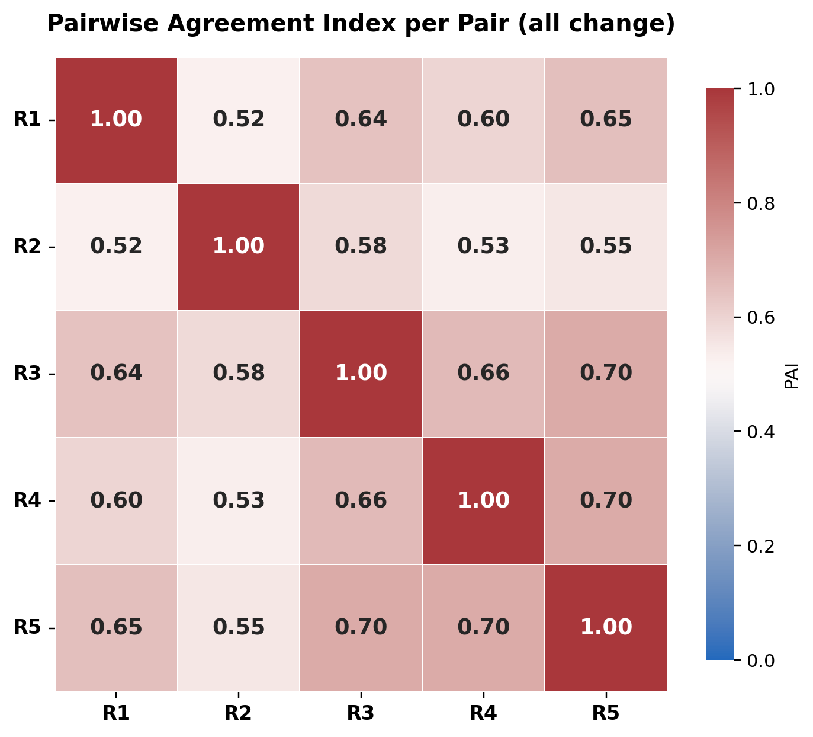
Figure 1b. Pairwise Agreement Index per pair (all change), five radiologists.

3.3 Consensus structure and disagreement
Disagreement was dominated by low-consensus findings. Of 185 positive change findings, 101 (55%) reached consensus level 2, 76 (41%) level 3, 52 (28%) level 4, and only 27 (15%) were unanimous; 45% (83/185) were solo findings marked by a single reader. Negative change followed the same pattern: of 139 findings, 84 (60%) reached level 2 and only 13 (9%) were unanimous, with 40% (55/139) solo (Figure 2). Between 3% and 28% of each reader's findings were unmatched by any peer (HMDR 0.72–0.97; Table 4).
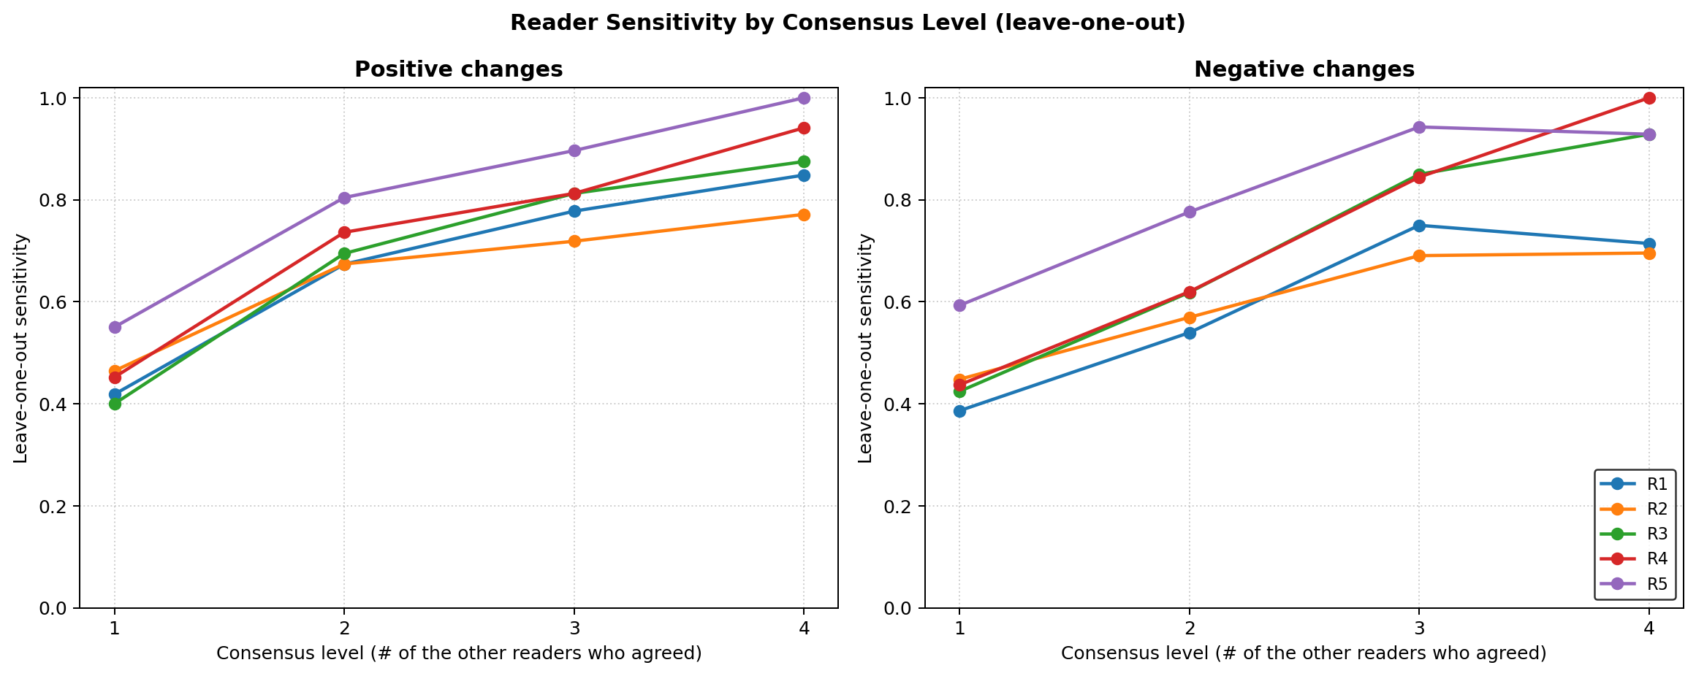
Figure 2. Per-reader leave-one-out sensitivity as a function of consensus level, for positive (left) and negative (right) change. Sensitivity rises steeply as more readers agree.
Table 4. Corroboration of each reader's findings.
Reader | HMDR (pos) | HMDR (neg) | UDPP (pos) | UDPP (neg)
R1 | 0.83 | 0.85 | 0.15 | 0.09
R2 | 0.72 | 0.78 | 0.3 | 0.17
R3 | 0.97 | 0.88 | 0.02 | 0.08
R4 | 0.89 | 0.88 | 0.11 | 0.08
R5 | 0.77 | 0.83 | 0.26 | 0.15

3.4 Agreement rises with consensus
Per-reader leave-one-out sensitivity increased monotonically with consensus level (Figure 2, Table 3). Averaged across readers, sensitivity for positive change rose from 0.46 at consensus level 1 to 0.72, 0.80, and 0.89 at levels 2–4; for negative change from 0.46 to 0.62, 0.82, and 0.85. When only one other reader had seen a finding, a given radiologist reproduced it less than half the time; when all four others agreed, ~85–90% of the time.

Table 3. Mean per-reader leave-one-out sensitivity by consensus level.
Consensus level | Positive | Negative
≥1 | 0.46 | 0.46
≥2 | 0.72 | 0.62
≥3 | 0.8 | 0.82
≥4 | 0.89 | 0.85

3.5 How many radiologists stabilize the read?
A single radiologist recovered a mean of 49% (range 42–60%) of the findings identified by the full five-reader panel. Coverage rose to 69% with two readers, 81% with three, and 91% with four (Figure 3, Table 5). The marginal gain from each added reader declined steadily—from +19% for the second reader to +13%, +10%, and +9% for the third, fourth, and fifth—so that no single additional reader after the third changed the reference by more than about a tenth. Because nearly half of all findings were solo, complete coverage was reached only with all five readers; however, three readers already recovered roughly four-fifths of the reference with a narrow between-subgroup spread (range 71–91%). Positive and negative change behaved almost identically (Figure 3).
Table 5. Reader-subgroup coverage of the full five-reader reference (all change).
# readers | Coverage (mean) | Range (min–max) | Marginal gain
1 | 0.49 | 0.42–0.60 | —
2 | 0.69 | 0.59–0.82 | +19%
3 | 0.81 | 0.71–0.91 | +13%
4 | 0.91 | 0.85–0.97 | +10%
5 | 1.00 | — | +9%
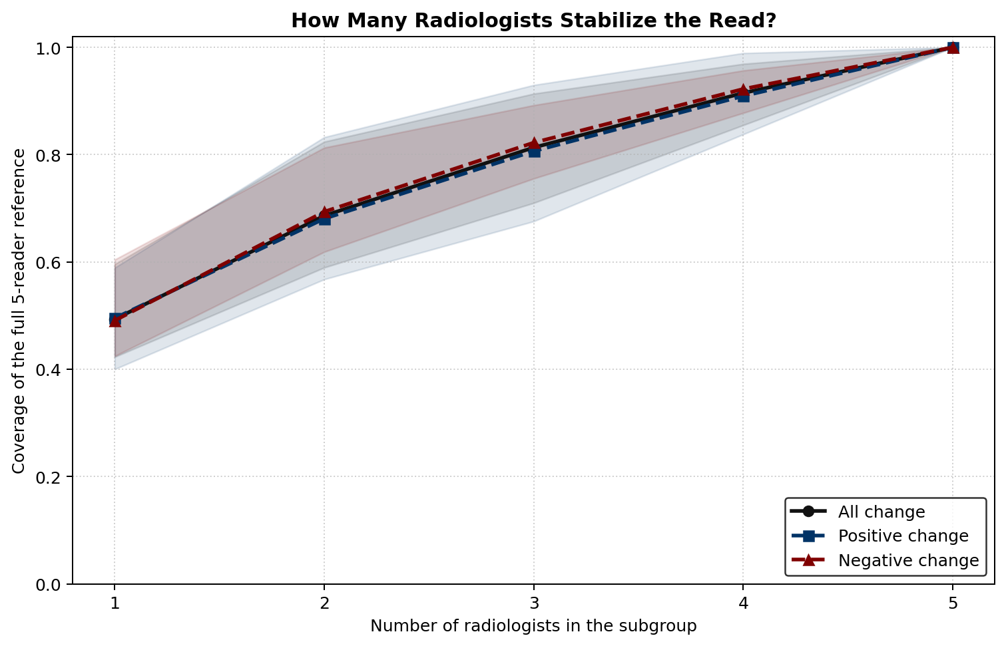
Figure 3. Coverage of the full five-reader reference as a function of subgroup size, for all, positive, and negative change. Points are means over all subgroups of each size; shaded bands show the min–max envelope. Coverage rises with diminishing returns and, by construction, reaches 1.0 only with all five readers.

4. Discussion
In a multi-reader study of interval change on 100 longitudinal chest radiographs, radiologist agreement was moderate and dominated by low-consensus findings: nearly half of all changes were reported by a single reader, and fewer than one in six were unanimous. Agreement climbed steeply with consensus, and the completeness of the reference standard depended strongly on the number of readers.
The subgroup analysis makes the practical trade-off explicit. One radiologist reproduces only about half of the changes a five-reader panel would identify—an important caveat for routine single-reader practice. Adding a second and third reader yields the largest gains (to ~69% and ~81%), after which each additional reader contributes under about a tenth. Because ~45% of findings are solo, no finite panel short of all five reaches full coverage; but the diminishing returns identify three readers as a practical operating point that recovers roughly four-fifths of the reference with limited between-group variability. This extends to the detection-level task of interval change the central message of prior CT studies—that two or three observers may not capture the full range of inter-observer variability [Joskowicz 2019]—while quantifying where the returns to additional readers taper.
These findings have two implications. For reader practice and quality assurance, the predominance of solo findings suggests that a substantial share of reported interval change is not reproducibly perceived, and that double or triple reading materially changes the reported picture. For the construction of reference standards—including those used to train and evaluate automated longitudinal tools—a single-reader ground truth is inadequate; a three-reader consensus, reported by consensus level, offers a defensible and largely stabilized standard. [A companion analysis evaluates an automated change-detection method against this consensus.]
Limitations. This was a [single-center, retrospective] study of 100 pairs read by five radiologists. Reader experience was [not stratified]; annotations used elliptical region markers rather than pixel-wise contours, which may merge or split adjacent findings. The cohort was enriched for [ICU studies], which may over-represent devices and rapidly evolving findings and limit generalizability. Finally, the reference is defined by the readers themselves; consensus level and subgroup coverage are pragmatic surrogates for truth, not an independent gold standard, and coverage necessarily reaches 1.0 only at the full panel size.

5. Conclusions
Radiologist agreement on interval change on chest radiographs is moderate and graded, and nearly half of all identified changes are seen by a single reader. One radiologist recovers only about half of the changes a five-reader panel identifies; three radiologists recover roughly four-fifths, with each further reader adding less than a tenth. Two or three readers are insufficient to capture the full range of reported change, but three readers provide a practical, largely stabilized reference standard for interval change and for the evaluation of automated change-detection tools.

Supplementary figures
Per-reader sensitivity-at-consensus curves and the positive/negative PAI heatmaps:
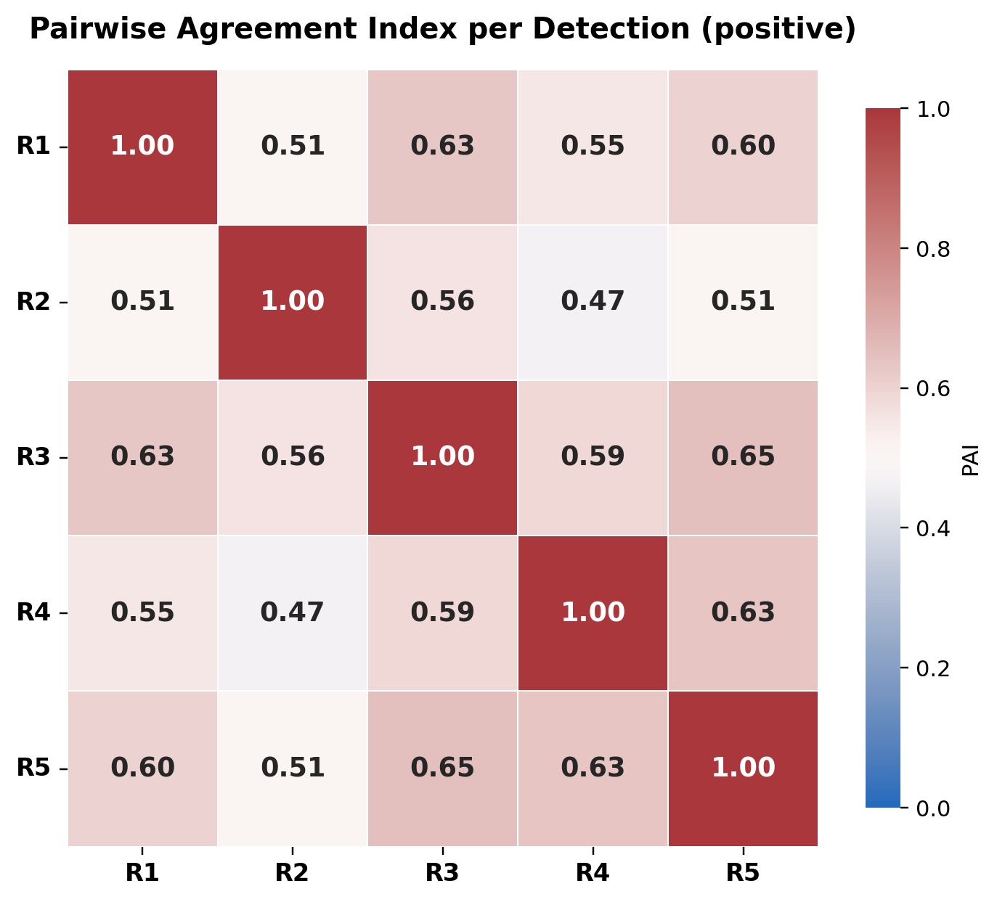
Supplementary Figure S1. PAI per detection (positive change).
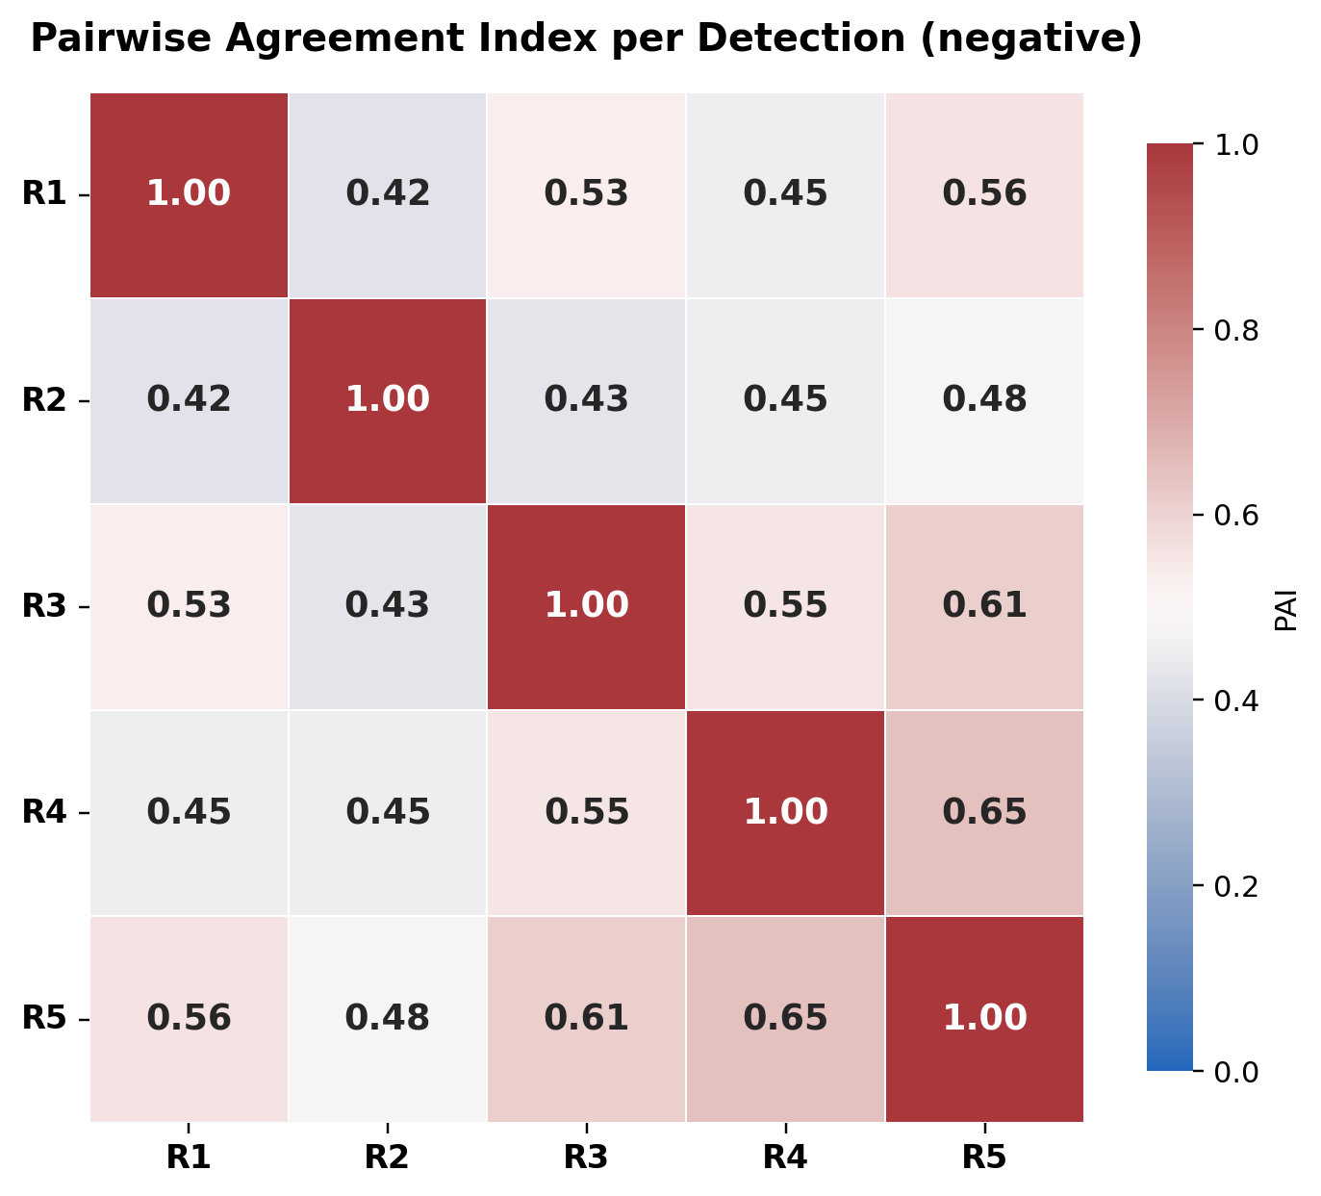
Supplementary Figure S2. PAI per detection (negative change).
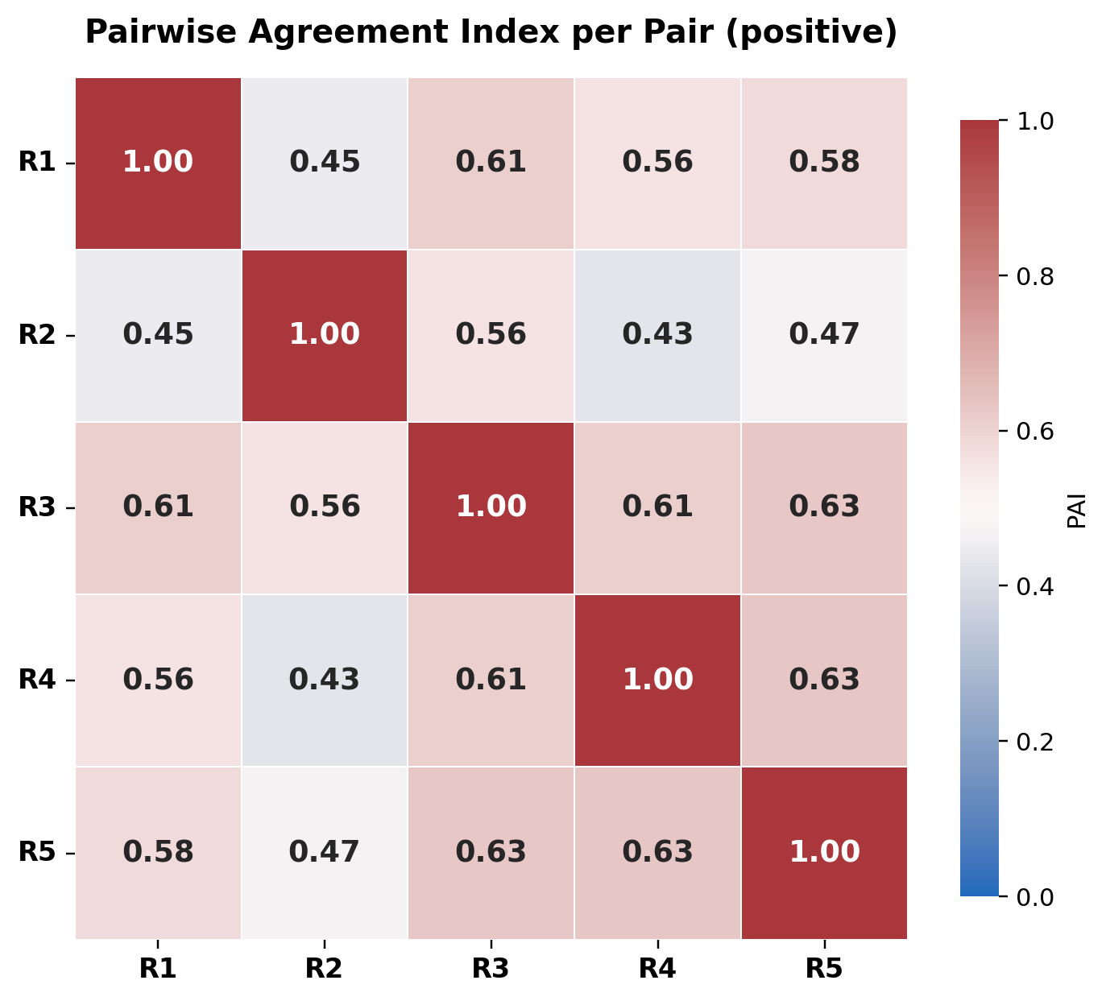
Supplementary Figure S3. PAI per pair (positive change).
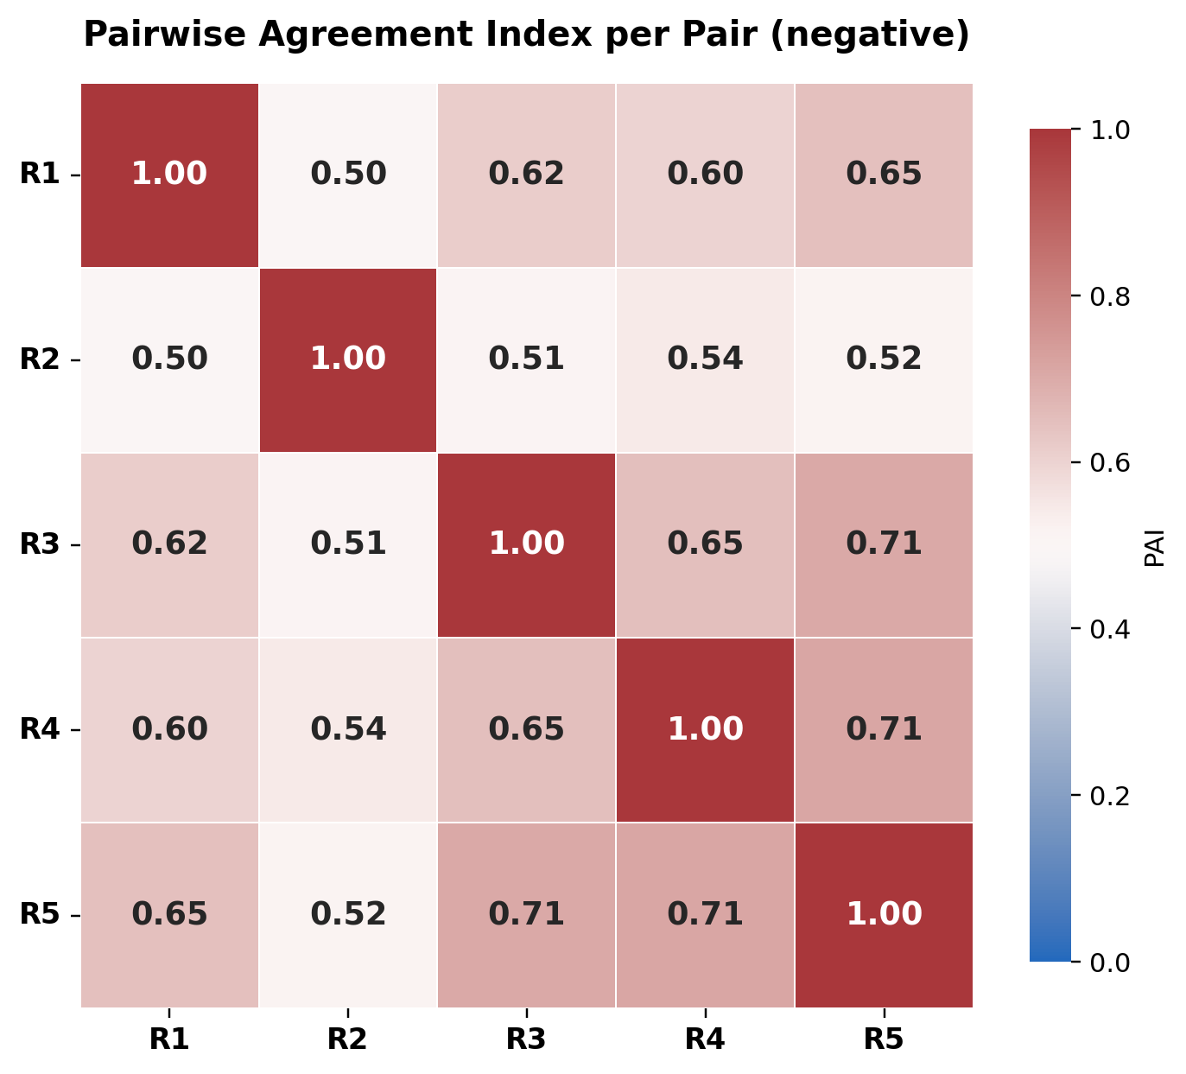
Supplementary Figure S4. PAI per pair (negative change).
Draft v2 (human readers only). Reader labels R1–R5 are anonymized. Source metrics: ov_results_human_only/human_ov_metrics.json.

