**AI ENABLED INTEGRATED APPLICATION FOR LUGGAGE CAREER SYSTEM**

**A System Requirement Specification**

Submitted in Partial Fulfilment of the Requirements for the Degree of

**Bachelor of Technology in**

**Computer Science and Engineering**

by

Atish Gorka (2000270110026)

Gaurav Singh (2000270110040)

Kartikey Tyagi (2100270119005)

Sahastranshu Mishra (2000270310134)

Under the Supervision of

Ms. Akansha Shukla



**AJAY KUMAR GARG ENGINEERING COLLEGE, GHAZIABAD**

**DR. A.P.J ABDUL KALAM TECHNICAL UNIVERSITY, LUCKNOW**

October 13, 2023

## DECLARATION

We hereby declare that the work presented in this report entitled “AI ENABLED INTEGRATED APPLICATION FOR LUGGAGE CAREER SYSTEM”, was carried out by us. We have not submitted the matter embodied in this report for the award of any other degree or diploma of any other University or Institute. I have given due credit to the original authors / sources for all the words, ideas, diagrams, graphics, computer programs, experiments, results, that are not my original contribution. I have used quotation marks to identify verbatim sentences and given credit to the original authors / sources.

I affirm that no portion of my work is plagiarized, and the experiments and results reported in the report are not manipulated. In the event of a complaint of plagiarism and the manipulation of the experiments and results, I shall be fully responsible and answerable.

Name : Atish Gorka

Roll No. : 2000270110026

Name : Gaurav Singh

Roll No. : 2000270110040

Name : Kartikey Tyagi

Roll No. : 2100270119005

Name : Sahastranshu Mishra

Roll No. : 2000270310134

## 

## CERTIFICATE

Certified that **Atish Gorka** (2000270110026), **Gaurav Singh** (2000270110040), **Kartikey Tyagi** (2100270119005), **Sahastranshu Mishra** (2000270310134) has carried out the Project / Research entitled **“AI ENABLED INTEGRATED APPLICATION FOR LUGGAGE CAREER SYSTEM”** for the award of **Bachelor Of Technology** from DR.APJ ABDUL KALAM TECHNICAL UNIVERSITY LUCKNOW under my supervision. The project / research embodies results of original work, and studies are carried out by the students himself and the contents of the work do not form the basis for the award of any other degree to the candidate or to anybody else from this or any other University/Institution.

**(Ms. Akansha Shukla)**

(Associate Professor)

(CSE Department, AKGEC Ghaziabad)

Date : 15/10/2023

**Contents**

**Declaration** i

**Certificate** ii

**1 Introduction** 1

1.1 Background 1

1.2 Identification of the Problem 3

1.3 Significance of the Problem 4

1.4 Research / Project Questions and Objectives 4

**2 System Overview** 6

2.1 Scope 6

2.2 Key Features 7

**3 Functional Requirements** 8

3.1 User Requirements 8

3.2 System Requirements 10

3.3 Functional Specification 10

**4 Non-Functional Requirements** 11

4.1 Performance Requirements 11

4.2 Security Requirements 11

**5. Use Case 13**

**6 System Architecture** 15

6.1 Overall Architecture 15

**7 Data Flow Diagrams** 19

7.1 Level 0 DFD 19

7.2 Level 1 DFDs 19

**8 Database and Schema** 21

8.1 Database Design 21

8.1.1 Tables and Fields 21

**9 Test Cases** 24

9.1 Test Case 24

**10 Glossary** 27

**References** 29

**List of Tables**

7.1 User Details . . . . . . . . . . . . . . . . . . . . . . 21

7.2 Admin Details . . . . . . . . . . . . . . . . . . . . . . 21

7.3 Branch Details . . . . . . . . . . . . . . . . . . . . . . 22

7.4 City Details . . . . . . . . . . . . . . . . . . . . . . 22

7.5 Parcel Details . . . . . . . . . . . . . . . . . . . . . . 23

**List of Figures**

5.1 Use case diagram : luggage management. . . . . . . . . . . . . . . . . . . 13

5.2 Use case diagram : automation services . . . . . . . . . . . . . 14

6.1 System architecture . . . . . . . . . . 18

7.1 Level 0 DFD diagram . . . . . . . . . . . . . . . . . . . . . 19

7.2 Level 1 DFD Diagram . . . . . . . . . . . . . . . . . . . . . 20

**Chapter 1**

# Introduction

## Background

The AI-enabled integrated application for a luggage carrier system represents a cutting-edge solution poised to revolutionize the efficiency, security, and overall experience within the logistics and transportation industry. By seamlessly merging artificial intelligence with sophisticated logistics management, this innovative application promises to optimize every facet of the luggage transit process.

From automated route optimization based on real-time data to predictive maintenance leveraging advanced algorithms, the system ensures a streamlined and reliable service. Incorporating technologies such as GPS, RFID, and encryption based security, the application not only tracks the real-time location of luggage but also prioritizes security through advanced authentication measures.With features like image recognition for sorting, environmental impact analysis, and comprehensive data analytics for business intelligence, this AI-enabled application represents a holistic approach to modernize and enhance the luggage carrier ecosystem.

**Overview of the System**

An AI-enabled luggage carrier management system is a sophisticated application of artificial intelligence in the domain of logistics and transportation. The primary goal of such a system is to efficiently manage the movement and handling of luggage in various contexts, such as airports, hotels, and other transportation hubs. Here's an overview of key components and features typically associated with an AI-enabled luggage carrier management system:

Automated Routing and Navigation:

AI algorithms are employed to determine optimal routes for luggage carriers within a facility or transportation hub.

Real-time data, including the current status of pathways, traffic, and other obstacles, is considered for dynamic route planning.

Computer Vision and Sensor Integration:

Cameras and sensors are deployed to track the location and movement of luggage carriers.

Computer vision technology may be used for object recognition, ensuring the system can identify and differentiate between different

luggage items.

Predictive Analytics:

AI algorithms analyze historical data to predict and optimize luggage traffic patterns.

Predictive analytics can be used to anticipate peak times, enabling proactive adjustments to resources and staffing.

Resource Optimization:

AI helps in optimizing the allocation of resources, such as luggage carts and personnel, based on demand forecasts and real-time data.

This ensures efficient operations and reduces bottlenecks in the luggage handling process.

Customer Service Integration:

AI interfaces may be integrated to provide customers with real-time information on the location and status of their luggage.

Chatbots or virtual assistants can handle customer queries and provide assistance.

Security Enhancement:

AI can contribute to enhanced security by monitoring and flagging any unusual or suspicious behavior in the luggage handling process.

Facial recognition or biometric technologies may be incorporated for secure identification.

Energy Efficiency:

AI can help optimize the energy consumption of automated systems, ensuring sustainability and cost-effectiveness.

Scalability and Adaptability:

The system should be designed to scale seamlessly with growing demands and adapt to changes in the infrastructure or operational requirements. Implementing an AI-enabled luggage carrier management system requires collaboration between experts in AI, logistics, and system integration. The integration of these technologies can lead to more efficient and streamlined luggage handling processes, improving customer satisfaction and overall operational efficiency in transportation hubs.

## Identification of the Problem

Identifying the problems that an AI-enabled luggage carrier management system aims to address is crucial for its successful implementation. Here are some common challenges and issues that such a system may seek to solve:

Inefficiency in Luggage Handling:

Traditional luggage handling systems may suffer from inefficiencies, leading to delays, lost luggage, or suboptimal use of resources.

Traffic Congestion:

High traffic areas, such as airports, may experience congestion and bottlenecks in luggage movement, especially during peak times.

Lack of Real-Time Visibility:

Limited visibility into the real-time location and status of luggage can lead to challenges in tracking, potentially causing delays and inconvenience for passengers.

Resource Allocation Challenges:

Manual resource allocation, such as the deployment of luggage carts and personnel, can be suboptimal, leading to resource shortages or overallocation.

Security Concerns:

Traditional luggage handling systems may face security challenges, including the risk of lost or mishandled luggage, or unauthorized access to luggage storage areas.

Ineffective Route Planning:

Without dynamic and intelligent route planning, luggage carriers may follow suboptimal paths, contributing to congestion and inefficiency.

Customer Frustration:

Delays, lost luggage, or lack of communication regarding the status of luggage can result in customer frustration and a negative overall experience.

Manual Tracking and Handling:

Reliance on manual tracking and handling processes can be error-prone and may not scale well in environments with high volumes of luggage.

Environmental Impact:

Inefficient operations can contribute to unnecessary energy consumption and environmental impact, especially in large transportation hubs.

Lack of Adaptability to Changes:

Traditional systems may struggle to adapt to changing conditions, such as variations in passenger traffic, infrastructure updates, or changes in operational procedures.

Integration of Emerging Technologies:

The integration of new technologies, such as AI, autonomous vehicles, and IoT devices, may present integration challenges with existing systems.

Communication Gaps:

Lack of effective communication channels between the luggage management system and passengers may lead to misunderstandings and dissatisfaction.

Identifying these problems serves as a foundation for designing an AI-enabled luggage carrier management system that addresses specific pain points, enhances operational efficiency, and improves the overall customer experience in transportation and logistics settings.

## Significance of the Problem

The significance of addressing these problems lies in the holistic improvement of transportation and logistics operations, resulting in better customer experiences, cost savings, and a more sustainable and competitive industry. The successful implementation of an AI-enabled luggage carrier management system can have a far-reaching impact on the efficiency and effectiveness of transportation services.

## 1.4 Research / Project Questions and Objectives

**Question**: What are the key technological components required for an effective AI-enabled luggage carrier management system?

Answer: An effective AI-enabled luggage carrier management system requires the integration of technologies such as computer vision, IoT devices, real-time data processing, autonomous vehicles, and adaptive routing algorithms. These components work in tandem to optimize route planning, enhance security, and improve resource allocation.

**Question**: How does the integration of AI and IoT technologies improve real-time tracking and visibility in luggage handling processes?

Answer: The integration of AI and IoT technologies allows for the deployment of sensors, RFID tags, and other tracking devices on luggage. AI algorithms process data from these devices in real-time, providing enhanced visibility into the location and status of each piece of luggage. This improves overall tracking accuracy and reduces the likelihood of lost or misplaced items.

**Question**: What impact does AI-enabled route optimization have on the efficiency of luggage transport within transportation hubs?

Answer: AI-enabled route optimization significantly improves the efficiency of luggage transport by dynamically analyzing traffic patterns, congestion levels, and the real-time status of pathways. This optimization minimizes delays, reduces bottlenecks, and enhances the overall flow of luggage through transportation hubs.

**Question**: How can AI contribute to enhancing security in luggage handling processes, and what are the potential challenges associated with this integration?

Answer: AI can enhance security through the implementation of facial recognition, anomaly detection, and risk assessment algorithms. Challenges may include privacy concerns, ethical considerations, and the need for robust cybersecurity measures to prevent unauthorized access to sensitive data.

**Question**: What role does customer feedback play in the continuous improvement of AI-enabled luggage carrier management systems?

Answer: Customer feedback is crucial for the continuous improvement of AI-enabled systems. Analyzing passenger experiences and perceptions helps identify areas for improvement, refine algorithms, and implement features that enhance customer satisfaction, ultimately contributing to the success of the system.

**Question**: How can AI-enabled luggage carrier management systems be designed to adapt to changing environmental conditions and evolving transportation infrastructures?

Answer: Designing AI systems with adaptive algorithms and machine learning models allows them to learn from and adapt to changing environmental conditions. Continuous monitoring and integration with real-time data enable these systems to evolve alongside infrastructure updates and operational changes within transportation hubs.

**Chapter 2**

# System Overview

## 2.1 Scope

The scope of an AI-enabled luggage carrier management system is broad and encompasses various aspects within the domain of transportation and logistics. Here's an overview of the key elements that define the scope of such a system:

Transportation Hubs:

Airports: The primary focus is often on airports, where large volumes of luggage need to be efficiently managed due to the constant influx and departure of flights.

Train Stations, Bus Terminals, and Seaports: The system can extend to other transportation hubs, optimizing luggage handling in diverse settings.

Luggage Tracking and Visibility:

Real-time tracking of luggage within the transportation hub to provide visibility to both operators and passengers.

Route Optimization:

AI-driven algorithms for optimizing the routes of luggage carriers, minimizing congestion, and ensuring timely delivery to designated locations.

Resource Allocation:

Efficient allocation of resources such as luggage carts, personnel, and other assets based on real-time demand and historical data.

Security Enhancement:

Integration of AI technologies to enhance security through features like facial recognition, anomaly detection, and monitoring for suspicious activities.

Customer Interaction:

Providing passengers with real-time information about the location and status of their luggage, as well as interactive interfaces for queries and assistance.

Integration with Emerging Technologies:

Incorporating and integrating technologies such as IoT, autonomous vehicles, and robotics for seamless luggage handling.

Adaptability to Changing Conditions:

Designing the system to adapt to fluctuations in passenger numbers, changes in infrastructure, and variations in operational procedures.

Data Analytics and Predictive Modeling:

Utilizing data analytics and predictive modeling to analyze historical data, forecast demand, and optimize operations for future scenarios.

Environmental Sustainability:

Incorporating features that contribute to energy efficiency, reduced environmental impact, and adherence to sustainability goals.

Scalability:

Ensuring that the system can scale efficiently to handle varying levels of demand in both small and large transportation hubs.

Regulatory Compliance:

Complying with relevant regulations and standards related to luggage handling, security, and data privacy.

Interoperability:

Designing the system to be compatible with existing infrastructure and capable of interoperability with other systems within the transportation ecosystem.

Continuous Improvement:

Establishing mechanisms for gathering and analyzing feedback from both operators and passengers to drive continuous improvement in the system's performance.

Cost Efficiency:

Striving for cost-effective operations by optimizing resource usage, reducing delays, and minimizing the need for manual interventions.

The scope of an AI-enabled luggage carrier management system is dynamic, evolving with advancements in technology and the changing landscape of transportation. It is not limited to a single technology or methodology but involves a holistic approach to enhance the efficiency, security, and overall passenger experience in luggage handling across various transportation hubs.

## 2.2 Key Features

## User Authentication

## AI Vision based image reading

## Encryption based security

## AI based distance, travel supports

## Real time tracking

* User friendly GUI

**Chapter 3**

# Functional Requirements

## 3.1 User Requirements

User requirements for an AI-enabled luggage carrier management system can vary based on the stakeholders involved, such as airport operators, transportation authorities, service providers, and passengers. Here are some common user requirements across different user categories:

Airport Operators and Transportation Authorities:

Real-time Monitoring: Ability to monitor and manage the movement of luggage in real-time within the transportation hub.

Resource Optimization: Tools to optimize the allocation of luggage carts, personnel, and other resources based on demand.

Security Features: Integration of AI-driven security features like facial recognition, anomaly detection, and monitoring for unauthorized access.

Data Analytics: Tools for analyzing historical data to identify patterns, forecast demand, and optimize operations.

Scalability: System scalability to handle fluctuations in passenger numbers and accommodate the growth of the transportation hub.

Service Providers and Operators:

Efficient Operations: Features that enhance the overall efficiency of luggage handling, reducing delays and bottlenecks.

Automation: Integration of autonomous vehicles, robotics, and other automated technologies to streamline operations.

Maintenance and Support: Access to maintenance tools and support services to ensure the continuous and reliable operation of the system.

Interoperability: Compatibility with existing infrastructure and interoperability with other systems used by service providers.

Passengers:

Real-time Tracking: Access to real-time information about the location and status of their luggage.

Communication Channels: Interactive interfaces for communicating with the system, making inquiries, and receiving updates.

Security and Privacy: Assurance of the security and privacy of personal information and luggage details.

Customer Support: Access to customer support services in case of issues, lost luggage, or other concerns.

Ease of Use: Intuitive interfaces and user-friendly features that make it easy for passengers to interact with the system.

Regulatory Authorities:

Compliance: Assurance that the system complies with relevant regulations and standards related to luggage handling, security, and data privacy.

Auditability: Features that enable auditing and reporting to demonstrate compliance with regulatory requirements.

Environmental and Sustainability Committees:

Energy Efficiency: Features that contribute to energy efficiency and sustainability goals.

Reduced Environmental Impact: Measures to minimize the environmental impact of luggage handling operations.

IT and Technical Support Teams:

Integration Capabilities: Tools and documentation to facilitate the integration of the system with other IT infrastructure.

Technical Support: Access to technical support services, including troubleshooting and issue resolution.

Understanding and addressing these user requirements is essential for the successful design, implementation, and adoption of an AI-enabled luggage carrier management system. Regular feedback and collaboration with stakeholders are critical to ensuring that the system meets their needs and contributes to the overall goals of improved efficiency, security, and customer satisfaction.

## 3.2 System Requirements

**Hardware Requirements**

* Intel(R) Core(TM) i5-7300U CPU @ 2.60GHz 2.71 GHz
* 4GB RAM
* 15MB Hard drive storage

**Software Requirements**

* Anaconda Distribution
* GPS
* Vscode
* Xampp Server

## 3.3 Functional Specification

## The functional requirements are as listed below,

* Real-time Luggage Tracking
* Route Optimization
* Resource Allocation
* Security Features
* Real Time Tracking
* GPS services
* Data Analytics and Predictive Modelling
* User Authentication and authorization

**Chapter 4**

# Non-Functional Requirements

## 4.1 Performance Requirements

The performance requirements of the AI enabled luggage career system give as,

* The response time on each request should be specified time frame
* The system should handle a certain number of transactions or requests per unit of time.
* The system should be designed to scale horizontally or vertically to handle increased user load. The system should be able to handle multiple concurrent users without a significant decrease in performance.
* Database queries for luggage information and user data should be executed within a defined time frame.

## 4.2 Security Requirements

* Users must authenticate securely before accessing the system
* All sensitive data, including user information and transaction details, must be encrypted during transmission.
* Ensure that APIs are secure and protected against unauthorized access.
* Users should have control over their privacy settings.

These security requirements are essential for safeguarding user data, ensuring the integrity of transactions, and maintaining the trust of users in the AI enabled luggage career system. Regular security assessments and updates are crucial to adapt to evolving security threats.

## 4.3 Usability Requirements

* The user interface should be intuitive and easy to navigate.
* Maintain a consistent design throughout the system.
* Provide a smooth onboarding process for new users.
* Implement a robust search feature.
* Ensure that the system is responsive and works well on different devices and screen sizes.
* Provide filtering options for refining search results.
* Offer personalized recommendations based on user preferences.
* Minimize loading times for pages and content.

By incorporating these usability requirements, you can enhance the overall user experience and increase user satisfaction with the AI enabled luggage carrier system. Regular usability testing and feedback collection are essential to identify areas for improvement and ensure ongoing user satisfaction.

**Chapter 5**

# Use Cases

Some of the main use cases of the AI enabled luggage career system is listed below,

1. User registration and login

2. User role configuration

3. Luggage data management

4. Monitoring and report generation

5. AI based travel route help

6. Parcel Authenticity and Verification

The figure 5.1and the figure 5.2 explains about the overall use case of the project.

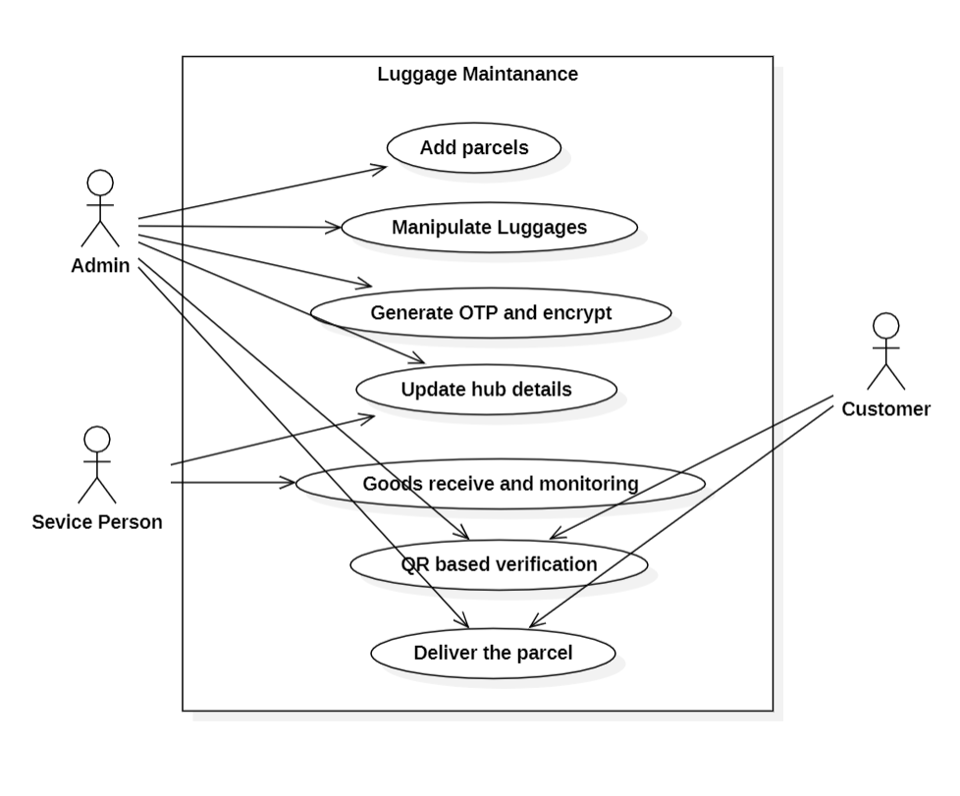

Figure 5.1 : Use case Diagram of luggage management

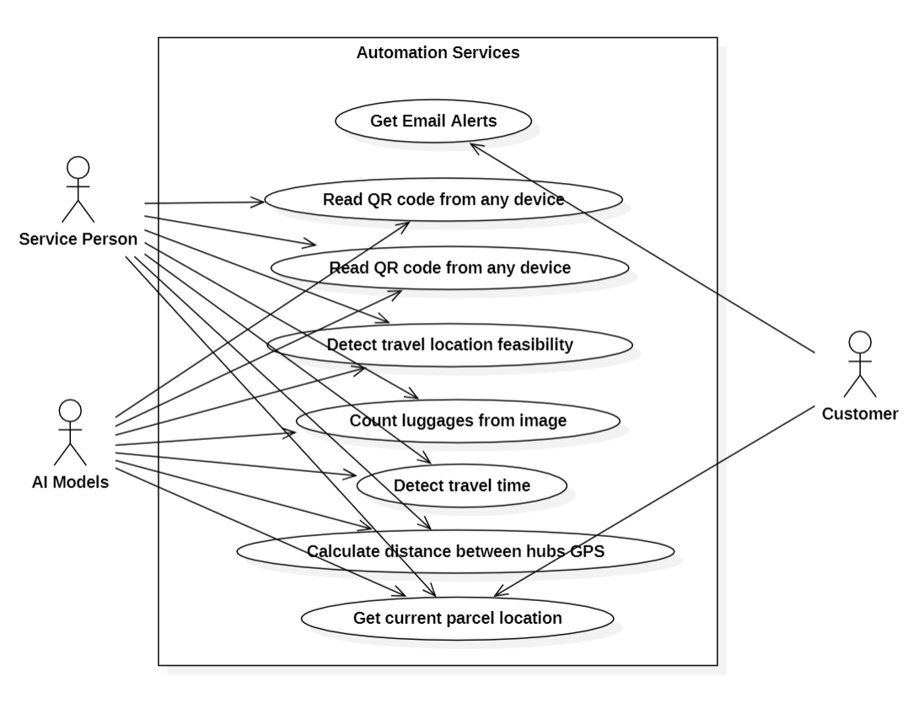

Figure 5.2 : Use case Diagram of automation services

**Chapter 6**

# System Architecture

## 6.1 Overall Architecture

The overall architecture of the proposed AI enabled integrated application for luggage career system is given in the figure 6.1.

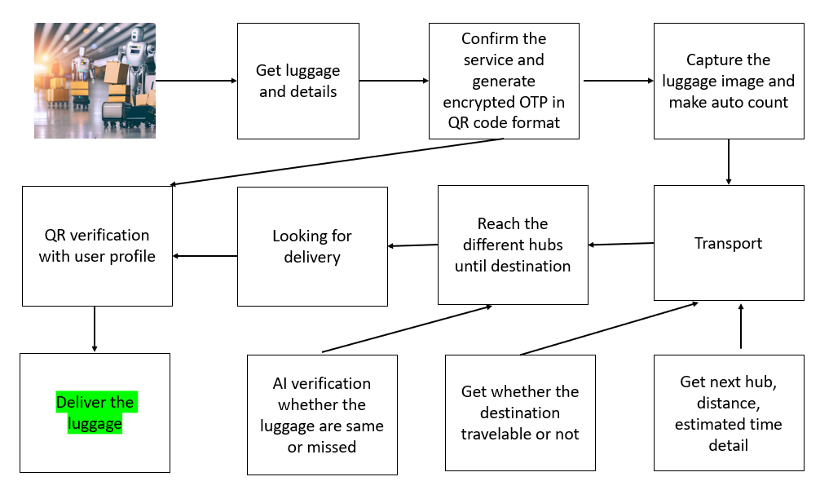

Figure 6.1 : System Architecture

Designing the architecture of a AI enabled integrated application for luggage career system involves structuring the components, interactions, and data flow to meet the functional and non-functional requirements of the system.

**Components**

**User Interface (UI):**

Description: The user interface provides interactive platforms for different users, such as operators, passengers, and administrators, to interact with the system.

Functionality: Displays real-time luggage tracking information, allows for system configuration, and provides communication channels.

**Luggage Tracking System:**

Description: Incorporates technologies like RFID, GPS, or sensors to track the real-time location and status of luggage.

Functionality: Collects and processes data from tracking devices, providing accurate and up-to-date information about luggage movement.

**Route Optimization Module:**

Description: Uses AI algorithms to optimize routes for luggage carriers within the transportation hub.

Functionality: Analyzes real-time data, predicts traffic patterns, and dynamically adjusts routes to minimize delays and congestion.

**Resource Allocation Module:**

Description: Manages the allocation of resources such as luggage carts, autonomous vehicles, and personnel based on real-time demand and historical data.

Functionality: Optimizes the utilization of resources to ensure efficient luggage handling operations.

**Security and Authentication System:**

Description: Implements security features such as facial recognition, anomaly detection, and user authentication to enhance the security of luggage handling.

Functionality: Monitors for unauthorized access, ensures the privacy of sensitive data, and maintains secure user access to the system.

**Communication Channels:**

Description: Establishes communication channels between the system and users for notifications, alerts, and assistance.

Functionality: Facilitates real-time communication between the system and passengers, operators, and other stakeholders.

**Data Processing and Analytics Engine:**

Description: Processes real-time data from tracking devices, sensors, and other sources to derive meaningful insights.

Functionality: Utilizes data analytics and predictive modeling to optimize operations, forecast demand, and improve overall system performance.

**Integration Middleware:**

Description: Enables interoperability by integrating the luggage carrier management system with existing infrastructure and other systems within the transportation ecosystem.

Functionality: Facilitates seamless data exchange and communication between different components and external systems.

**Autonomous Vehicles and Robotics Integration:**

Description: Integrates autonomous vehicles, robotics, or other automated technologies for the physical movement and handling of luggage.

Functionality: Coordinates the activities of autonomous devices, ensuring they follow optimized routes and contribute to efficient luggage transport.

**Database Management System:**

Description: Manages the storage and retrieval of data related to luggage tracking, resource allocation, and system configurations.

Functionality: Supports efficient data storage, retrieval, and management for various components of the system.

**Monitoring and Control Dashboard:**

Description: Provides operators and administrators with a centralized dashboard to monitor system performance, receive alerts, and control system configurations.

Functionality: Allows for real-time oversight, system diagnostics, and the ability to intervene if issues arise.

**Customer Support Integration:**

Description: Integrates customer support features to assist passengers in case of issues, lost luggage, or other concerns.

Functionality: Provides a channel for passengers to seek assistance, report problems, and receive timely support.

**Chapter 7**

# Data Flow Diagrams

A Data Flow Diagram (DFD) is a graphical representation of the flow of data within a system. It is a visual tool that illustrates how data moves between processes, data stores, and external entities. Below is a simplified representation of a Data Flow Diagram for a AI enabled luggage career system.

## 7.1 Level 0 DFD

The 0th level data flow diagram provide a end to end process of the proposed system which is given in the figure 7.1.

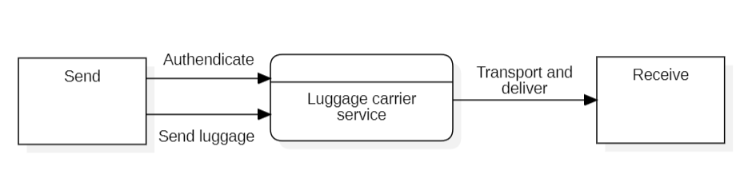

Figure 7.1 : Level 0 DFD

## 7.2 Level 1 DFDs

This Level 1 DFD provides a more detailed view of specific interactions and processes within the AI enabled luggage career system. It helps visualize how data flows between different components and how users interact with the system at various stages.

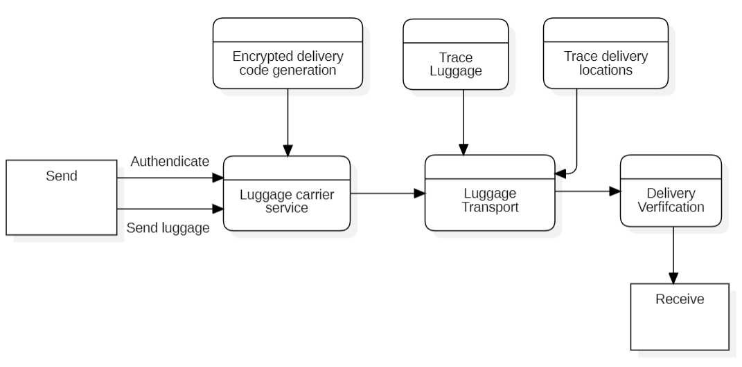

Figure 7.2 : Level 1 DFD

**Chapter 8**

# Database and Schema

## 8.1 Database Design

Designing the database for a AI enabled luggage career system involves defining the structure of the database, including tables, relationships, and constraints.

### 8.1.1 Tables and Fields

**1. User Data**

Table Name: user_details

|  |  |  |
| --- | --- | --- |
| **Column** | **Data Type** | **Description** |
| user_id | int(11) | Unique ID |
| user_name | varchar | Name of the user |
| phone | varchar | Phonr |
| email | varchar | Email |
| password | varchar | Password |
| created_at | varchar | Register date |

Table 7.1 : User Details

**2. Admin Data**

Table Name: admin_details

|  |  |  |
| --- | --- | --- |
| **Column** | **Data Type** | **Description** |
| admin_id | int(11) | Unique ID |
| admin_name | varchar | Name of the admin |
| phone | varchar | Phone |
| email | varchar | Email |
| password | varchar | Password |
| created_at | varchar | Created date |

Table 7.2 : Admin Details

**3. Branch Data**

Table Name: branch_details

|  |  |  |
| --- | --- | --- |
| **Column** | **Data Type** | **Description** |
| branch_id | int(11) | Unique ID |
| branch_name | varchar | Branch name |
| phone | varchar | Phone |
| email | varchar | Email |
| address1 | varchar | Address1 |
| address2 | varchar | Address2 |
| district | varchar | District |
| state | varchar | State |
| zip | varchar | Zip |

Table 7.3 : Branch Details

**4. Cities Data**

Table Name:Indian_cities_database

|  |  |  |
| --- | --- | --- |
| **Column** | **Data Type** | **Description** |
| city_id | int(11) | Unique ID |
| city | varchar | city |
| latitude | varchar | Latitude |
| longitude | varchar | Longitude |
| country | varchar | country |
| state | varchar | State |

Table 7.4 : City Details

**5. Parcel Data**

Table Name : parcel_details

|  |  |  |
| --- | --- | --- |
| **Column** | **Data Type** | **Description** |
| parcel_id | int(11) | Unique ID |
| luggage_id | varchar | Luggage_id |
| serviceman_id | varchar | Serviceman_id |
| user_id | varchar | User_id |
| from_branch | varchar | From_branch |
| to_branch | varchar | To_branch |
| pay_amount | varchar | Pay_amount |
| present_hub | varchar | Present_hub |
| sentotp | varchar | Sentotp |
| courier_image | varchar | Courier_image |
| status | varchar | Status |
| created_at | varchar | Created_at |

Table 7.5 : Parcel Details

**Chapter 9**

# Test Cases

Test Case 1: Login Functionality

Steps: Enter valid credentials and attempt to log in.

Expected Result: The user should be successfully logged in and directed to the appropriate dashboard.

Test Case 2: Real-time Tracking Display

Steps: Access the tracking interface and verify if real-time luggage locations are accurately displayed.

Expected Result: Luggage locations should be displayed accurately, and the information should update in real-time.

Test Case 3: Tracking Accuracy

Steps: Attach tracking devices to luggage and track their movement.

Expected Result: The tracked location of luggage should match its actual location with minimal deviation.

Test Case 4: Dynamic Route Adjustment

Steps: Introduce changes in real-time traffic conditions and monitor the system's response to dynamically adjust luggage routes.

Expected Result: The system should adapt routes promptly based on changing traffic patterns.

Test Case 5: Resource Utilization

Steps: Simulate varying passenger loads and monitor the system's allocation of resources such as luggage carts and personnel.

Expected Result: Resources should be allocated efficiently based on demand.

Test Case 6: Facial Recognition

Steps: Enrol a user for facial recognition and attempt unauthorized access.

Expected Result: Authorized users should be granted access, and unauthorized attempts should be denied.

Test Case 7: Notification System

Steps: Trigger notifications for passengers based on changes in their luggage status.

Expected Result: Passengers should receive timely and accurate notifications about their luggage.

Test Case 8: Predictive Analytics

Steps: Input historical data, and observe the system's predictions for future luggage demand.

Expected Result: The system should accurately predict demand patterns based on historical data.

Test Case 9: Interoperability

Steps: Integrate the luggage carrier management system with an external system and ensure seamless data exchange.

Expected Result: Data should be exchanged successfully without errors or data loss.

Test Case 10: Data Retrieval

Steps: Retrieve data related to luggage tracking and resource allocation.

Expected Result: Data should be retrieved accurately, reflecting the current state of the system.

Test Case 11: System Alerts

Steps: Simulate system anomalies and check if alerts are generated on the monitoring dashboard.

Expected Result: Alerts should be generated for abnormal conditions, enabling operators to take corrective action.

Test Case 12: Customer Query Handling

Steps: Submit a query through the customer support interface and verify the system's response.

Expected Result: The system should acknowledge the query and provide relevant information or assistance.

**Chapter 10**

# Glossary

**AI (Artificial Intelligence):**

Definition: The simulation of human intelligence processes by machines, especially computer systems, to perform tasks that typically require human intelligence.

**GPS (Global Positioning System):**

Definition: A satellite-based navigation system that provides real-time location and time information anywhere on Earth.

**Computer Vision:**

Definition: A field of AI that enables computers to interpret and make decisions based on visual data, often involving image and video analysis.

**Predictive Analytics:**

Definition: The use of data, statistical algorithms, and machine learning techniques to identify the likelihood of future outcomes based on historical data.

**Route Optimization:**

Definition: The process of determining the most efficient path or route from a starting point to a destination, often using algorithms to minimize time, cost, or resource usage.

Resource Allocation:

Definition: The process of assigning and distributing resources, such as personnel, vehicles, or equipment, to maximize efficiency and meet operational goals.

Anomaly Detection:

Definition: The identification of patterns in data that do not conform to expected behaviour, often used for detecting unusual events or potential security threats.

**Interoperability:**

Definition: The ability of different systems or components to communicate and exchange data seamlessly, often involving standardization of protocols.

**Facial Recognition:**

Definition: A biometric technology that uses facial features to identify and authenticate individuals.

**Data Analytics:**

Definition: The process of examining, cleaning, transforming, and modeling data to discover useful information, draw conclusions, and support decision-making.

**Sustainability:**

Definition: The practice of using resources in a way that meets current needs without compromising the ability of future generations to meet their needs.

**Scalability:**

Definition: The capability of a system to handle increased loads or demand by adding resources without sacrificing performance.

**Customer Satisfaction:**

Definition: The measure of how products and services meet or surpass customer expectations, often measured through feedback and surveys.

**Environmental Impact:**

Definition: The effect that human activities have on the environment, including factors such as energy consumption, pollution, and resource depletion.

# References

[1] Kalliopi Tsolaki, Thanasis Vafeiadis, Alexandros Nizamis, Dimosthenis Ioannidis and Dimitrios Tzovaras, Utilizing machine learning on freight transportation and logistics applications: A review, ICT Express 9, Elsevier, Volume 9, Issue 3, June 2023, https://doi.org/10.1016/j.icte.2022.02.001

[2] Terence, E. and Reddy, Siva and Reddy, K. Madhu and Reddy, T. Veera, Smart Luggage Carrier System, Proceedings of the International Conference on Innovative Computing & Communication (ICICC), May 27, 2022. Available at SSRN: https://ssrn.com/abstract=4121060 or http://dx.doi.org/10.2139/ssrn.4121060

[3] Tetsuya Manabe, Kazuo Mizuno, Keisuke Hatano and Masahiko Kaneko, "Ultraviolet sterilization information provision system of baggage carts and arriving baggage for airports", IATSS Research, December 2022. DOI:10.1016/j.iatssr.2022.12.004

[4] P. L. S. Krishnan, R. Valli, R. Priya and V. Pravinkumar, Smart Luggage Carrier system with Theft Prevention and Real Time TrackingUsing Nano Arduino structure, 2020 International Conference on System, Computation, Automation and Networking (ICSCAN), Pondicherry, India, 2020, pp. 1-5, doi: 10.1109/ICSCAN49426.2020.9262445.

[5] Afrin Khan, Bandini Nalwade, Neha Kharshinge3, Sonali Kamble, SMART LUGGAGE SYSTEM, International Research Journal of Engineering and Technology (IRJET), Volume: 06 Issue: 11, Nov 2019, https://www.irjet.net/archives/V6/i11/IRJET-V6I1130.pdf.

[6] Senthil, Sudha & Krishnamurthy, Brindha & R, Charanya. LUGGAGE TRACKING SYSTEM USING IOT. International Journal of Pure and Applied Mathematics. 117. 49-54. September2017.

[7] Deepti Mishra and Alok Mishra, "Improving Baggage Tracking, Security and Customer Services with RFID in the Airline Industry", Improving Baggage Tracking, Security and Customer Services with RFID in the Airline Industry, Vol. 7, No. 2, 2010.

[8] DeVries, Peter. The state of RFID for effective baggage tracking in the airline industry. IJMC. Volume6. 151-164. January 2008. 10.1504/IJMC.2008.016574.