**AI ENABLED INTEGRATED APPLICATION FOR LUGGAGE**

**CAREER SYSTEM**

|  |  |  |  |
| --- | --- | --- | --- |
| Atish Gorka  *Department of IT*  Ajay Kumar Garg Engineering College  Ghaziabad, India | Gaurav Singh  *Department of IT*  Ajay Kumar Garg Engineering College  Ghaziabad, India | Kartikey Tyagi *Department of IT*  Ajay Kumar Garg Engineering College  Ghaziabad, India | Sahastranshu Mishra *Department of IT*  Ajay Kumar Garg Engineering College  Ghaziabad, India |

**Abstract**

The importance of a luggage carrier system in today's era lies in its ability to address the challenges posed by increased travel, globalization, security concerns, and technological advancements. By providing efficient, secure, and data-driven solutions, these systems play a crucial role in shaping the future of the transportation and logistics industry. This project implements, AI integrated services into the logistic management application to enables the tasks such as parcel similarity detection, travel time detection, upcoming hubs tracking and the destination suitability prediction for safe travel of the upcoming hubs. If there is a lack of possibility found then the good route will be suggested to reach the next hub. Also integrated GPS services in order to identify the present location and routes. The luggage’s location will be traced when transporting one hub to another and if the luggage’s location getting changed more than a particular range then the notification will be sent to the previous and oncoming hub managers and the map will be created for the luggage present location. Upon the luggage reaching the next hub, the system will generate goods receiving notes. Subsequently, a comparison between the source image and the received parcel image will take place. If there is any missing luggage detected, a notification alert will be sent to the hub managers via email. OTP authentication is one of the major practices in the industries. But there are lot of fraudulent activities are arrived with OTP based authentication. To overcome this, the project introduces OTP encoded QR code-based authentication mechanism for authenticate the receiver. Also the sentimental analysis is implemented in order to analyse the customer feedbacks and queries to further improvement of the system.

This project reduces the man power in the process of parcel verification, routing and tracking. The location-based transport zone comfortability detection reduces the complexity of traveling in inauspicious areas. The QR based authentication reduces the risk of unaffiliated threads using OTP to commit fraud.

**Keywords:** Artificial Intelligence, Hash encryption, Luggage transport management, GPS, Travel zone tracking, Routing, Logistics.

1. **INTRODUCTION**

The AI-enabled integrated application for a luggage carrier system represents a cutting-edge solution poised to revolutionize the efficiency, security, and overall experience within the logistics and transportation industry. By seamlessly merging artificial intelligence with sophisticated logistics management, this innovative application promises to optimize every facet of the luggage transit process. From automated route optimization based on real-time data to predictive maintenance leveraging advanced algorithms, the system ensures a streamlined and reliable service. Incorporating technologies such as GPS, and encryption-based security, the application not only tracks the real-time location of luggage but also prioritizes security through advanced authentication measures. With features like image recognition for sorting, environmental impact analysis, and comprehensive data analytics for business intelligence, this AI-enabled application represents a holistic approach to modernize and enhance the luggage carrier ecosystem. Identifying the problems that an AI-enabled luggage carrier management system aims to address is crucial for its successful implementation.

Striving for cost-effective operations by optimizing resource usage, reducing delays, and minimizing the need for manual interventions. The scope of an AI-enabled luggage carrier management system is dynamic, evolving with advancements in technology and the changing landscape of transportation. It is not limited to a single technology or methodology but involves a holistic approach to enhance the efficiency, security, and overall passenger experience in luggage handling across various transportation hubs.

The use case domain for the AI-enabled luggage carrier management system spans across various sectors within the transportation and logistics industry. The system is designed to address the complexities and challenges associated with the management of luggage, ensuring efficiency, security, and an enhanced user experience. Below is a detailed. The primary users of the system include transportation companies, airlines, shipping companies, and other logistics providers involved in the movement of goods and luggage. These entities deploy the AI-enabled system to optimize their operations and enhance the overall efficiency of luggage transportation. Airports and major travel hubs play a pivotal role in the use case domain. The luggage carrier system integrates with airport infrastructure to streamline the handling and tracking of luggage from check-in to final destination, ensuring a seamless travel

Luggage carriers, whether automated systems or human handlers, utilize the AI-enabled features for real-time tracking, route optimization, and efficient resource allocation. The system assists carriers in delivering luggage with precision and minimizing delays. End users, such as travellers and customers, are integral to the use case domain. The system provides a user-friendly interface for travellers to track the location of their luggage in real time, enhancing their overall experience and providing peace of mind during their journey. With the rise of e-commerce, the system extends its utility to the management of goods purchased online. Retailers and e-commerce platforms integrate the luggage carrier system to ensure efficient and secure delivery of purchased items to customers

In the rapidly evolving landscape of luggage management, our proposed AI-enabled luggage carrier system stands out as a transformative solution, surpassing conventional systems through a comprehensive set of features designed to revolutionize the industry. Embracing cutting-edge artificial intelligence (AI) technologies, our system introduces a paradigm shift in the way luggage is handled, offering a superior level of efficiency, security, and user experience. Unlike traditional systems, our AI-enabled solution boasts real-time luggage tracking capabilities, allowing both carriers and users to monitor the precise location and status of luggage throughout its entire journey. This feature enhances transparency, minimizes the risk of loss, and ensures an unparalleled level of customer satisfaction. The figure 1 describes about the architectures of the proposed system.

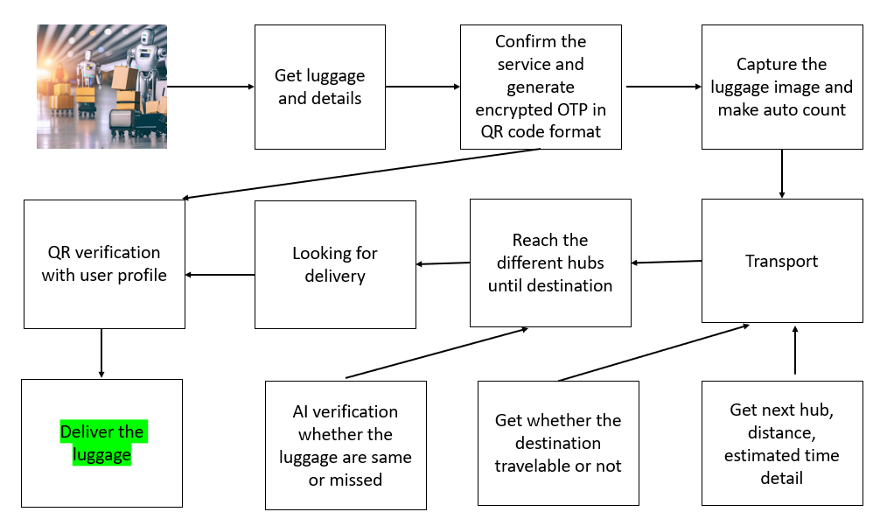

Fig 1. Architecture Diagram

The system's route optimization and resource allocation algorithms represent a departure from outdated methods. By leveraging AI, we empower carriers to streamline operations, minimizing travel time and maximizing resource efficiency. This not only enhances overall system productivity but also contributes to cost savings—an advantage that sets our proposed model apart from its predecessors. Security is a paramount concern, and our system addresses it comprehensively. Through robust security features, unauthorized access, theft, and potential breaches are mitigated, ensuring the safety of luggage and instilling confidence in both carriers and passengers.

This is a significant advancement compared to traditional systems that may lack such robust protective measures. The integration of real-time tracking, GPS services, and data analytics sets our system apart in terms of responsiveness and adaptability. Users can access up-to-the-minute information about their luggage, and carriers benefit from data analytics and predictive modelling to proactively address challenges and optimize operations. This forward-looking approach ensures that our system is not only responsive to current needs but also anticipates future demands. User authentication and authorization mechanisms provide an additional layer of security and personalization. Unlike previous systems that may lack stringent user controls, our proposed model ensures that sensitive information is accessed only by authorized individuals, safeguarding against potential breaches and misuse. In essence, our AI-enabled luggage carrier management system represents a leap forward in the industry, offering a holistic solution that transcends the limitations of traditional models. The integration of real-time tracking, route optimization, resource allocation, security features, GPS services, and advanced analytics positions our system as a comprehensive and forward-thinking answer to the evolving needs of modern luggage management.

1. **LITERATURE SURVEY**

Examining the Role of Machine Learning in Freight Transportation and Logistics Applications: A Survey by Kalliopi et al. 2023: This comprehensive review delves into the present advancements in the application domains of freight transportation, supply chain, and logistics. The focus areas include arrival time prediction, demand forecasting, optimization of industrial processes, traffic flow and location prediction, vehicle routing problems, and anomaly detection in transportation data. The article categorizes relevant studies based on machine learning methodologies, providing a chronological overview of the methods' progression over time, their combinations, and their integration into various applications within the specified domains. Consequently, readers gain effortless insights into the current state-of-the-art in machine learning within the realm of freight transportation and its associated application areas

Smart Luggage Carrier System by Terance et. al 2022: The main idea of this project, Smart Luggage Carrier System (SLCS) Using IoT, is to develop a user-friendly luggage carrier. The act of dragging luggage all over the place has been a practice since the golden age. The motivation behind the project has been the concept of a luggage system that conveys its weight, tracks its location, and follows a designated path. This motivation has guided the project to be user-friendly and operable. In this project, an effort was made to address the problem of 'Back-Ache, Spinal Cord Bends, Muscle Strain, etc.' that arises due to the burden of carrying heavy luggage on the back. An IR sensor, connected to an Arduino Nano interfaced with an L293d motor driver, is utilized for the movement of the luggage carrier along different predefined paths through the assistance of DC motors. Obstacle detection is facilitated by an ultrasonic sensor; if any obstacle is present in front of the luggage, an alert will be sounded through the buzzer. The location of the luggage carrier is tracked using GPS and GPRS modules. In the event of a loss of the luggage carrier, a message can be received on a smartphone through the GPS module.

Tetsuya et. al 2022 proposed an UV (Ultra Violet Rays) based sterilization information system providing baggage cart and arrival baggage for airports. In this study, a system has been developed to enhance border quarantine measures at airports, focusing on the sterilization of both baggage carts and arriving passenger baggage, hereafter referred to as arrival baggage. The system integrates ultraviolet (UV) sterilization and information communication technology to ensure a thorough sterilization process and efficient information dissemination. Through UV irradiation, the system sterilizes both arrival baggage and baggage carts, prioritizing passenger safety, as well as the well-being of airport, airline, and customs staff who may have direct contact with the sterilized items. The system employs radio frequency identification technology to allow passengers easy access to sterilization information. This information, readily available to passengers, enhances the overall safety and security measures within the airport environment. Furthermore, the system offers passengers the convenience of tracking their baggage in real-time, providing details such as the current location and estimated delivery time. This not only improves passenger experience but also facilitates social distancing at baggage claim areas, serving as an effective infection prevention measure. To validate the practicality and effectiveness of the developed system, a proof-of-concept demonstration was conducted at Central Japan International Airport. The demonstration aimed to verify the feasibility of the system and identify any potential challenges that need to be addressed for its successful.

An Intelligent Luggage Carrier System with Anti-Theft Features and Real-Time Tracking Utilizing Nano Arduino Architecture presented by Krishnan et al. in 2020: This paper presents a Smart Luggage Carrier System with integrated theft prevention and real-time tracking capabilities, utilizing a Nano Arduino structure. The system addresses the growing need for advanced solutions in luggage management. By employing Nano Arduino technology, the system aims to enhance the security and tracking functionalities of luggage carriers. The proposed system incorporates theft prevention measures, ensuring the safety of luggage during transit. Additionally, real-time tracking features provide users with up-to-date information on the location of their belongings

Smart Luggage System by Afrin Khan et. al 2019: This work explores the realm of smart luggage systems, aiming to address common challenges encountered by travellers during the carriage of their belongings. By delving into the advancements of technology in luggage design, the paper discusses innovations that contribute to the ongoing improvement of the travel experience. The focus is on leveraging smart technologies to overcome the difficulties associated with conventional luggage, presenting a forward-looking perspective on the intersection of travel and technology.

Luggage tracking system using IOT by Sudha et. al 2019: The luggage tracking system is designed to track the luggage and bags which gets lost or theft from public and other areas. As people travel, there is always a risk of theft of the luggage and bags which is where the proposed system comes into account. The Andriano board and GPS based alarm is set up in this project for notify when theft found. The alarm will be ring if the luggage is not on the rage. Moreover, a map is generated to monitor the bag's location in real-time by dropping markers, providing a visual representation of the bag's movement away from the owner. This involves the utilization of IoT components, including an Arduino Board and a GPS Module, for bag tracking. Additionally, a frontend or mobile application has been developed to facilitate monitoring of the bag's location.

Improving Baggage Tracking, Security and Customer Services with RFID in the Airline Industry by Deepty et. al 2010: This work discussed that the Radio Frequency Identification (RFID) stands out as a significant technological advancement in the 21st century, earning recognition among the top ten contributory technologies. The market for RFID technology is rapidly expanding, with enterprises across various industries adopting RFID to enhance operational efficiency and gain a competitive edge. This paper explores the widespread adoption of RFID technology in the aviation industry, particularly within major airports and airlines. The focus is on the application of RFID in baggage handling, a domain where the technology has showcased superior accuracy and performance compared to traditional bar codes. The paper delves into the planning, architecture, and implementation of RFID technology at a major airline, emphasizing its impact on services related to baggage handling, airport/airline security, and frequent flier programs. The integration of RFID technology with networking and database technologies is highlighted as a key enabler for achieving enhanced services. The findings and insights from this study contribute to a better understanding of the role of RFID in transforming operational processes and improving overall services within the aviation industry.

The state of RFID for effective baggage tracking in the airline industry by Devries 2008: This article examines the state of Radio Frequency Identification (RFID) as a solution to the issue of luggage tracking in aviation sectors. In this research work the merits and demerits of the RFID is discussed. The works states that the installation and maintenance cost of RFID is the major barrier till now. However, this technology can be very much useful to the customers and service providers. This work address that there is challenge in building the RFID based infrastructure in aviation sector is a cooperation. Benefits must be analysed over cross-functional processes owned by different departments and organisations.

**PROPOSED SYSTEM**

In the rapidly evolving landscape of luggage management, our proposed AI-enabled luggage carrier system stands out as a transformative solution, surpassing conventional systems through a comprehensive set of features designed to revolutionize the industry. Embracing cutting-edge artificial intelligence (AI) technologies, our system introduces a paradigm shift in the way luggage is handled, offering a superior level of efficiency, security, and user experience. Unlike traditional systems, our AI-enabled solution PROVIDES real-time luggage tracking capabilities, allowing both carriers and users to monitor the precise location and status of luggage throughout its entire journey. This feature enhances transparency, minimizes the risk of loss, and ensures an unparalleled level of customer satisfaction.

The system's route optimization, GPS based route tracking, notification alerts, luggage verification and authorized delivery represent a departure from outdated methods. By leveraging AI, we empower carriers to streamline operations, minimizing travel time and maximizing resource efficiency. This not only enhances overall system productivity but also contributes to cost savings an advantage that sets our proposed model apart from its predecessors.

1. **METHODOLOGY**

The proposed project adapts different machine learning methodologies for do the different tasks. This project is developed as a collection of different modules. The modules are listed below.

1. Distance and Travel time detection
2. Hub route optimization
3. Destination Suitability Prediction for Safe Transport
4. Location based luggage tracking
5. Parcel verification
6. Encrypted OTP QR Verification
7. Customer sentiment analysis.

**Distance and Travel Time Detection**

The distance and the average travel time to one hub to another hub is calculated based on the latitude and the longitude. The hub’s geo coordinates are stored in the database and once the source and destination are given the distance will be calculated as follows.

dlong = longitude2 – longitude1

dlat = latitude2 - latitude1

a = sin(dlat / 2)**2 + cos(lat1) * cos(lat2) * sin(dlong / 2)**2 ……….. (1)

c = 2 * asin(sqrt(a))

r = 6371

distance = c * r

Where,

dlong – distance between the source and destination longitudes

dlat - distance between the source and destination latitudes

r – it is a constant value, radius of earth

The based on the transport vehicle speed the various time to reach the upcoming hub will be listed.

**Hub Route Optimization**

Route optimization refers to the process of finding the most efficient or cost-effective path for a given set of destinations.Once the source and destination given, the Haversine formula (eq. 1) is used to calculate the distance in between all the possible routes and the lowest distance route will be sorted and suggested for the transportation.

**Destination Suitability Prediction for Safe Transport**

One significant barrier in transportation is adverse weather conditions, which can pose risks and lead to potential injuries. The Europe open source accident severity dataset is used to develop the model. This project leverages the Gradient Boosting algorithm to construct a model capable of classifying the suitability of a transport location based on weather data. The model undergoes training and evaluation using weather data, and once extracted, it is deployed for practical use. To detect the travel suitability, an API request is sent to the Weather Stack API service, providing geographic coordinates. The API responds by furnishing the current weather data for the specified locations. Utilizing this information, the model makes predictions, aiding in the assessment of whether the transport location is deemed favourable or not.

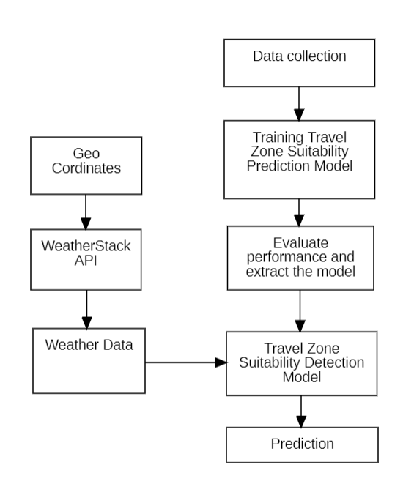

Fig 2. Destination Suitability Prediction for Safe Transport

The process of travel zone suitability detection is described in the figure 2. The detection will be made for all the hubs in between the source and destination.

**Location Based Luggage Tracking**

The source to destination path will be drawn based on the optimized routes. The location of the vehicle will be traced. If the luggage is not under the range the mail notification will be send to the hub managers and the geo coordinates of the luggage will be traced and drawn as a map for tracking the luggage.

**Parcel Verification**

Once the luggage received in hub, the parcels will be verified against the list of parcels that are send from the source hub. A OpenCV based image processing is employed for scanning the image and compare with the actual image taken from source station. If the image analyser detects that there is a mis match of parcels then the mail notification will be sent to the respective hub managers immediately. The figure 3 describes about the parcel verification process.

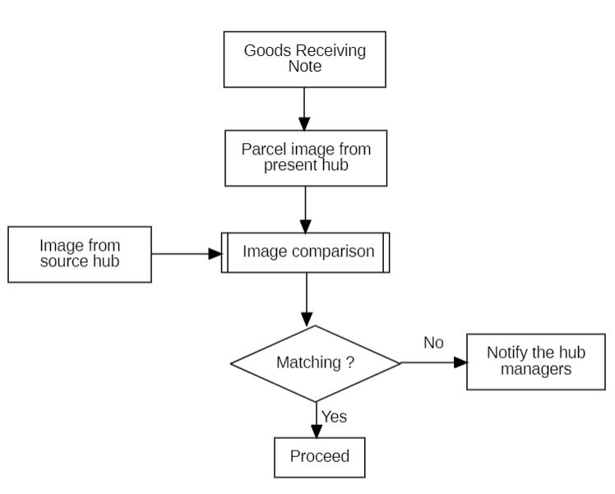

Fig 3. Parcel Verification

**Encrypted OTP QR Verification**

OTP Encrypted QR Verification is a security mechanism that involves the use of a one-time password (OTP) and encryption within a QR code for authentication purposes. This process typically includes generating a unique OTP, encrypting it, and embedding it into a QR code. Users can then scan the QR code to receive the encrypted OTP, which is decrypted for verification against the original OTP. This method enhances security by combining one-time password generation, encryption, and QR code technology to ensure a secure and reliable verification process.

When the parcel received from the source hub, an OTP will be generated and encrypted using the MD5 cryptographic algorithm. The encrypted value will be converted into a QR code image stored with the name of the parcel code. For the receiving end the QR code will be accessible any time via their login. When the parcel requires delivery, on the receiving end the QR code is scanned through a open CV and read the QR code.

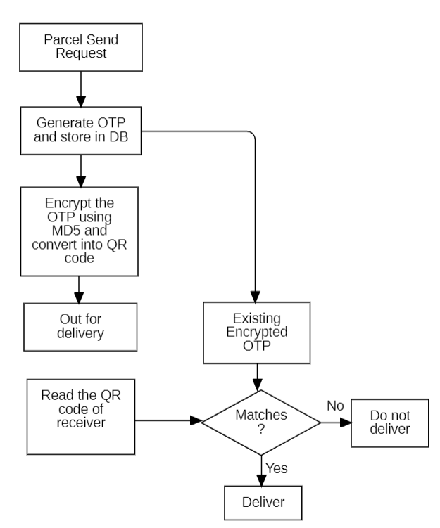

Fig 4. Encrypted OTP QR Verification

Authentication for delivery is confirmed when the encrypted OTP value associated with the user matches the QR code value. If there's a match, the user is authenticated for the delivery; otherwise, the person will not be authorized to deliver the luggage.

**Customer Sentiment Analysis**

Sentiment analysis plays a crucial role in logistics systems, contributing to the enhancement of user experience. By analysing customer queries and feedback, valuable insights can be gained to improve various aspects of the system. Feedback data enables tasks such as scheduling, prioritizing, and more to be efficiently executed, ultimately leading to improved overall system performance and customer satisfaction. In order to build the sentiment analysis model, the customer review dataset is taken from the Kaggle data portal. In this project a sentiment analysis model developed by using the Support vector machine (SVM) classification algorithm. The admin has an authority to check the kind of sentiments for the user provided queries and feedbacks. The process of building the sentiment analysis model is given in the below figure 5.

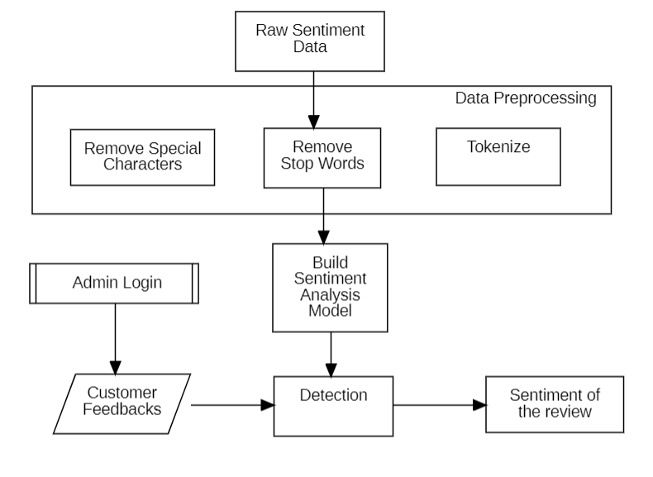

Fig 5. Customer Sentiment Analysis

1. **RESULTS AND DISCUSSION**

This project has implemented in the windows environment with the 8 GB RAM specification. The machine learning models are trained using the Jupyter notebook and the Flask based backend implemented using the Spyder IDE. In order to achieve the different task various tech stacks used in this proposed project and that are listed below.

The MySQL database used for the data storing and retrieving mechanism. Open CV is a python library which plays the major role in the image processing. In this project Open CV used for QR code scanning and image similarity detection. In order to achieve the OTP encryption tasks, the MD5 algorithm utilized from the hashlib python library. The Multipurpose Internet Mail Extension (MIME) used for the mail notification services. GPS service us used for the geo coordinates. Weather stack open-source API service is utilized for get the weather data.

There are two machine learning models were utilized in this project. For the destination suitability prediction for safe transport, the gradient boosting algorithm were utilized. The Gradient boosting algorithm provided 90% of classification accuracy. For the customer feedback sentiment analysis, the Support Vector Machine (SVM) given 91% classification accuracy on predicting the type of sentiments. The both machine learning models are extracted as a pickle file and integrated within the system for the respective tasks. The system has strong login functionality for user authorization process and also there is a admin control to monitor the activities takes place in the application. The users are verified using the Email based OTP verification while joining. The system has tested with various test cases and different test data with the real time scenarios.

1. **CONCLUSION**

In summary, the importance of a luggage carrier system today lies in its ability to overcome challenges related to increased travel, globalization, security issues, and technological advancements. This project takes a comprehensive approach by integrating AI services into logistics management applications, addressing tasks like detecting similar parcels, estimating travel times, tracking upcoming hubs, and predicting destination suitability for safe travel. With GPS services, the system precisely identifies the luggage's location during transit, triggering alerts for any deviations.

To enhance security and counteract fraudulent activities, the project introduces an OTP-encoded QR code authentication mechanism, which improves upon traditional OTP methods. Additionally, incorporating sentiment analysis provides valuable insights from customer feedback and queries for ongoing system improvement. The project reduces manpower in parcel verification, routing, and tracking, while location-based transport zone comfortability detection simplifies travel in challenging areas. In conclusion, this project represents a significant step towards optimizing logistics processes, improving security measures, and adopting innovative technologies to create a more efficient and resilient luggage carrier system for the future.

**REFERENCES**

[1] Kalliopi Tsolaki, Thanasis Vafeiadis, Alexandros Nizamis, Dimosthenis Ioannidis and Dimitrios Tzovaras, Utilizing machine learning on freight transportation and logistics applications: A review, ICT Express 9, Elsevier, Volume 9, Issue 3, June 2023, https://doi.org/10.1016/j.icte.2022.02.001

[2] Terence, E. and Reddy, Siva and Reddy, K. Madhu and Reddy, T. Veera, Smart Luggage Carrier System, Proceedings of the International Conference on Innovative Computing & Communication (ICICC), May 27, 2022. Available at SSRN: https://ssrn.com/abstract=4121060 or http://dx.doi.org/10.2139/ssrn.4121060

[3] Tetsuya Manabe, Kazuo Mizuno, Keisuke Hatano and Masahiko Kaneko, "Ultraviolet sterilization information provision system of baggage carts and arriving baggage for airports", IATSS Research, December 2022. DOI:10.1016/j.iatssr.2022.12.004

[4] P. L. S. Krishnan, R. Valli, R. Priya and V. Pravinkumar, Smart Luggage Carrier system with Theft Prevention and Real Time TrackingUsing Nano Arduino structure, 2020 International Conference on System, Computation, Automation and Networking (ICSCAN), Pondicherry, India, 2020, pp. 1-5, doi: 10.1109/ICSCAN49426.2020.9262445.

[5] Afrin Khan, Bandini Nalwade, Neha Kharshinge3, Sonali Kamble, SMART LUGGAGE SYSTEM, International Research Journal of Engineering and Technology (IRJET), Volume: 06 Issue: 11, Nov 2019, https://www.irjet.net/archives/V6/i11/IRJET-V6I1130.pdf.

[6] Senthil, Sudha & Krishnamurthy, Brindha & R, Charanya. LUGGAGE TRACKING SYSTEM USING IOT. International Journal of Pure and Applied Mathematics. 117. 49-54. September2017.

[7] Deepti Mishra and Alok Mishra, "Improving Baggage Tracking, Security and Customer Services with RFID in the Airline Industry", Improving Baggage Tracking, Security and Customer Services with RFID in the Airline Industry, Vol. 7, No. 2, 2010.

[8] DeVries, Peter. The state of RFID for effective baggage tracking in the airline industry. IJMC. Volume6. 151-164. January 2008. 10.1504/IJMC.2008.016574.

[9] Valery Lukinskiy, Natalia Pletneva, Victor Gorshkov, Pyotr Druzhinin, "Application of the Logistics “Just in Time” Concept to Improve the Road Safety", Transportation Research Procedia, Volume 20, 2017, Pages 418-424

[10] Liu Y, Tao X, Li X, Colombo A and Hu S. Artificial Intelligence in Smart Logistics Cyber-Physical Systems: State-of-The-Arts and Potential Applications. IEEE Transactions on Industrial Cyber-Physical Systems. 10.1109/TICPS.2023.3283230.