
TRIBHUVAN UNIVERSITY
INSTITUTE OF ENGINEERING, PULCHOWK CAMPUS
A Report on

Lab 6

Submitted by:
Alex Shrestha (080BCT012)

Submitted to::
Department of Electronics and Computer Engineering
Pulchowk Campus, Lalitpur

Simple CRUD Application
SmartShop (Django Rest Framework + React JS)
A functional Full-Stack CRUD (Create, Read, Update, Delete) application .
Project Overview
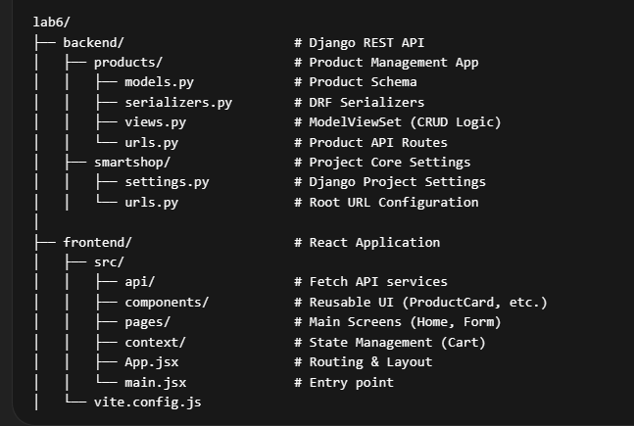

Step 1: Backend Implementation (Django REST Framework)
The backend provides the API infrastructure to handle data persistence.
- Model Definition: Created a Product model in products/models.py with fields for name, description, price , stock, and image_url.
- Serialization: Used serializers.ModelSerializer to automatically convert Django model instances into JSON format.
- API Views: Implemented viewsets.ModelViewSet, which provides the following logic out-of-the-box:
GET /api/products/ (List all products)
POST /api/products/ (Create a new product)
GET /api/products/{id}/ (Retrieve a single product)
PUT /api/products/{id}/ (Update a product)
DELETE /api/products/{id}/ (Remove a product)

Step 2: Frontend Implementation (React JS)
The frontend consumes the API and provides an interactive user interface.
API Service Layer: Created src/api/products.js using the Native Fetch API to centralize all network requests to the Django backend.
State Management:
- Local State: Used useState and useEffect hooks in components to fetch and store product data.
- Global State: Implemented React Context API (CartContext) to manage a persistent shopping cart across different views.
Routing: Utilized react-router to handle navigation between the Product List (Home) and the Product Form (Add/Edit) pages.

UI Components:
HomePage: Handles Read (listing products) and Delete actions.
ProductFormPage: Handles both Create and Update actions using a dynamic form

Output:
