**A project report on**

QUIZ MANAGEMENT SYSTEM

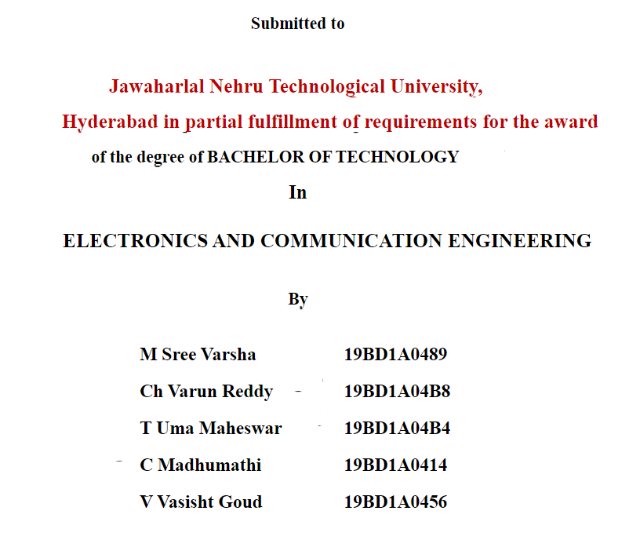



**Sir**

**Sir**

**Sir**

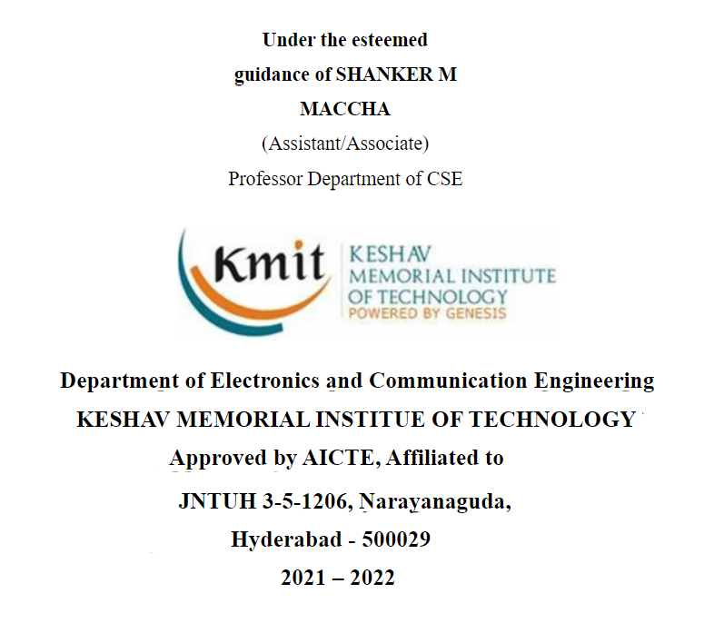

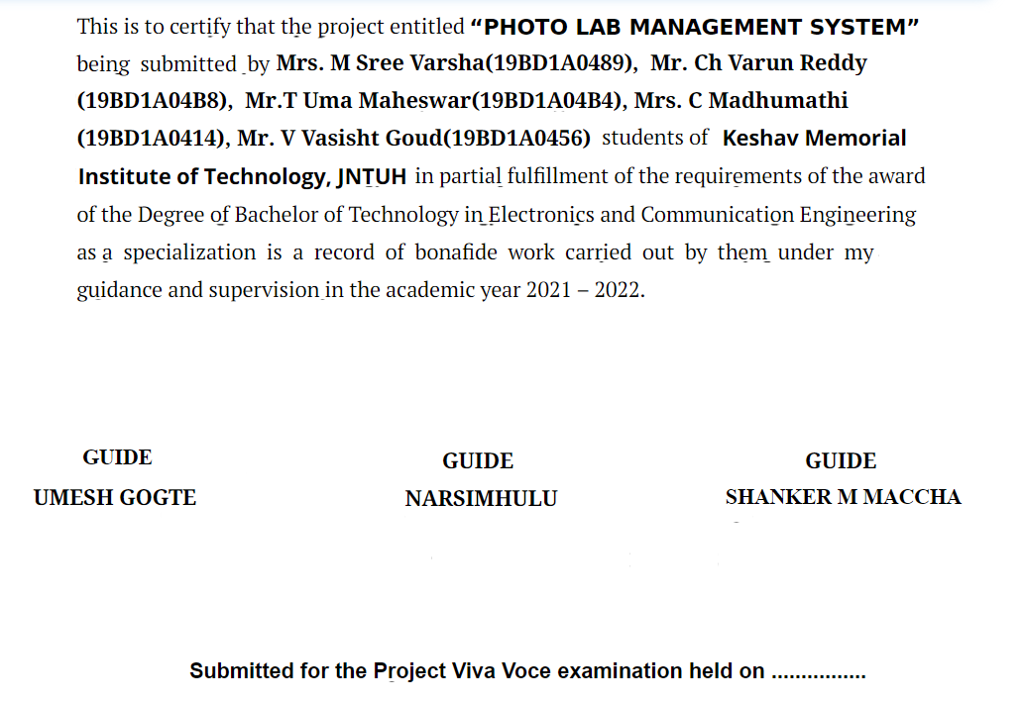

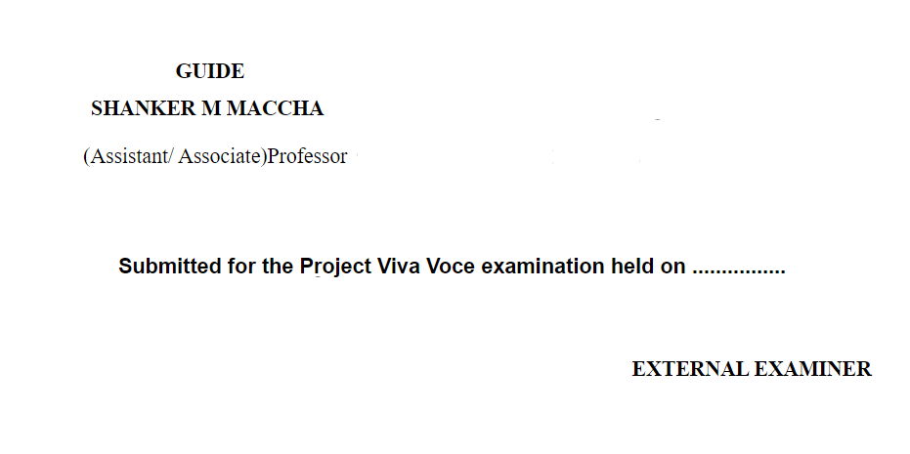

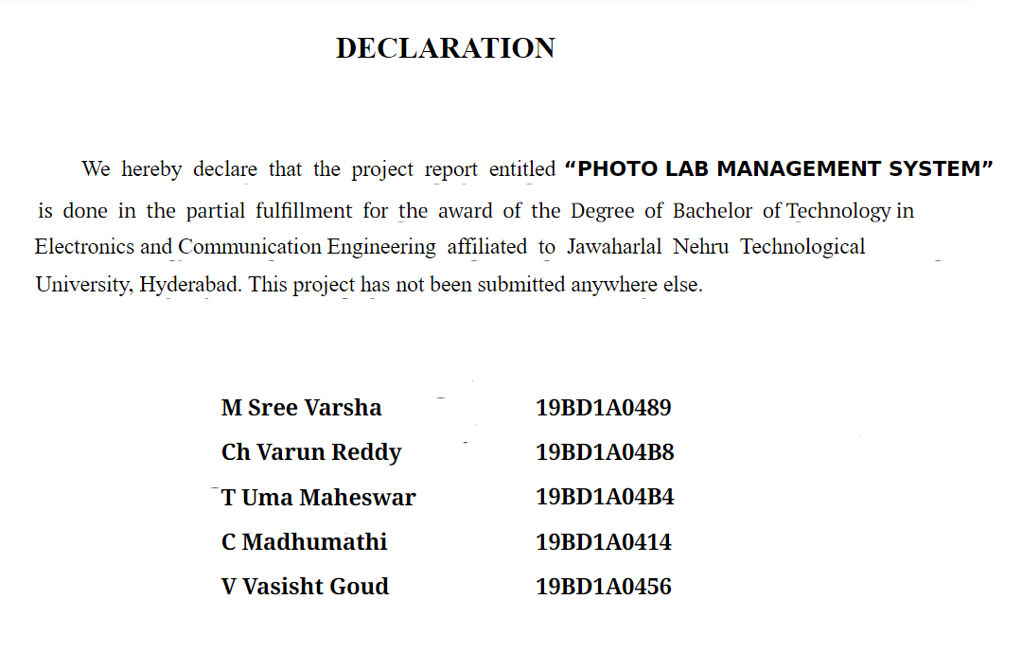

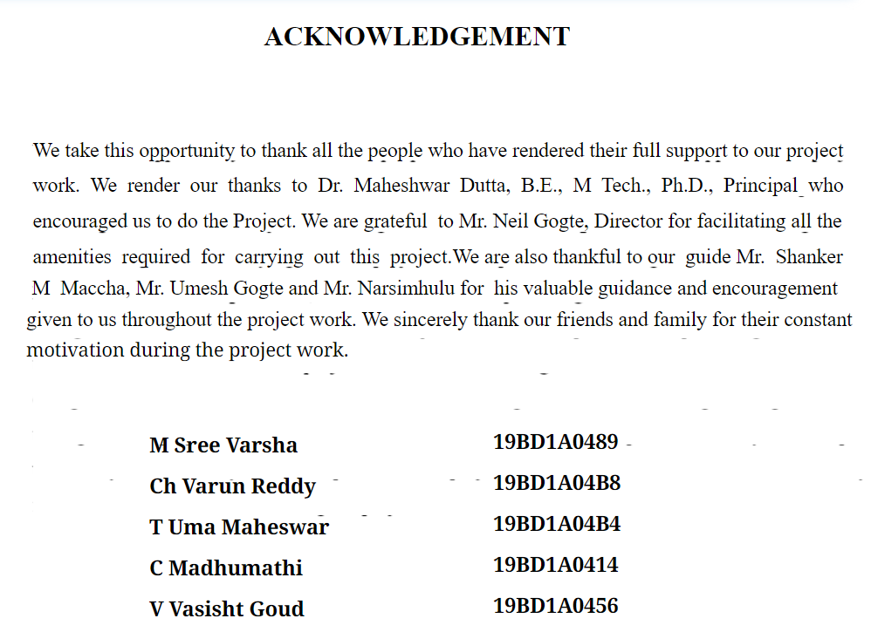

**Team Members:**

1. M Sree Varsha 19BD1A0489 ECE - B
2. Ch. Varun Reddy 19BD1A04B8 ECE – B
3. T Uma Maheswar 19BD1A04B4 ECE – B
4. C Madhumathi 19BD1A0414 ECE - B
5. V Vasisht Goud 19BD1A0456 ECE – B

**Under the esteemed guidance of**

* Umesh Gogte Sir
* Narsimhulu Sir
* Shanker Sir

# CONTENTS

**DESCRIPTION PAGE No**

ABSTRACT 1

1. INTRODUCTION
   1. Purpose of the Project 2
   2. How it works? 3
2. SOFTWARE REQUIREMENTS SPECIFICATIONS
   1. What is SRS? 4
   2. Role of SRS? 4
   3. Requirement Specification Document 5
   4. Functional Requirements 6
   5. Non-Functional Requirements 8
   6. Software Requirements 9
   7. Hardware Requirements 9
3. LITERATURE SURVEY
   1. Software Development Life Cycle (SDLC) 10
   2. Technologies Used 12
4. SYSTEM DESIGN
   1. Introduction to UML 15
   2. Use Case diagram 16
   3. Sequence diagram 18
   4. Class diagram 22
5. IMPLEMENTATION
   1. Implementation steps 24
   2. Code Snippets 25
6. Conclusion 32
7. References 33

# ABSTRACT

The traditional method of conducting quiz is most difficult task to implement. The judge of the game should manually calculate the total marks of all teams and eliminate the lowest average team. This takes much time and effort. Instead of conducting the quiz game among the teams manually, we have devised a project on C which decreases the efforts of the judges. There are two end users mainly Admin and the user. The application that consists a range of questions on different topics, fields and subjects. A user can play the mock test to know the environment of the game. A multiple users can play the quiz at a time. Here, admin can manage quiz (includes update, add, deletion, display) questions from one side and another side user can select any topic questions. To make it more interesting the team’s score will be allocated -1 for every wrong answer and +5 for every correct answer. After eliminating n-1 teams, we are not going the declare last team as winner, the team should score minimum 10 to qualify as winner of the game.

# 1.INTRODUCTION

We have designed this project to decrease the usage of pen and paper. This project is designed with the purpose of allowing students to give quiz and view their results. Students are provided the flexibility to choose among different types of questions.

The student can access the quiz at any time and at any place and of any interesting topic.

Our project is mainly divided into two modules:

1.Admin module

2.User module

**Main functions of admin module:**

1.Manage questions

🡪Add question

🡪 Update question

🡪 Display question

🡪 Delete question

2.Update admin

3.Delete admin

**Main functions of User module:**

1.signup

2.signin

3.Select the topic of his/her interest.

4. Create number of teams required.

5.Access the test

6.Update user details

7.Delete the user

**DATA STRUCTURES USED:**

🡪SIGNIN/SIGNUP ;- LINKED LISTS, FILES

🡪 MANAGE QUESTIONS :- HASHTABLES, LINKEDLIST, FILES, QUEUES

🡪UPDATION OF QUESTIONS :- LINKEDLIST,FILES

🡪DELETION /DELETION OF QUESTIONS:- LINKEDLIST,FILES

🡪 UPDATE DETAILS OF USER/ ADMIN—LINKEDLISTS , FILES, QUEUES

🡪CREATE NUMBER OF TEAMS –CIRCULAR LINKED LISTS

🡪ACCESS THE TEST—LINKED LIST,FILES,QUEUES

**PROBLEM STATEMENT:**

This C-based application proposes to create an platform that will consist of a wide range of questions on different topics, fields, and subjects. By creating a user-friendly environment, this application is a resourceful tool for individuals who wish to practice mock quizzes and tests. In this project, you will build a comprehensive online platform for managing both quiz competitions and the participants in the different teams. This application can be used by academic institutions and any organization willing to find suitable candidates through the process of quizzing. The application permits multiple admins, each having their unique user id and password. While admins can create an "n" number of participating teams for a quiz, they can also set an "n" number of rounds for the quiz. All the participants will automatically receive the questions. In case a team is unable to answer a question or gives the wrong answer, they'll receive negative marking. The teams having the lowest average score will be eliminated, and the remaining teams will continue to compete in the next level. This will continue until the winner is declared.

**EXISTING SYSTEM:**

Existing system is a manual one where the admins should maintain the data of users like id no , name etc

And they should maintain historical data of the users. And admins should be constantly asking the questions to the users and calculate the marks manually after each round and eliminate the team with least average score.

**TECHNICAL FEASIBILITY:-**

Technical feasibility study is an excellent tool for long term planning. Quiz management system is technical feasible due to following reasons :-

It will be developed with c programming language as it is relevant, stable and also established.

**OPERATIONAL FEASIBILITY:-**

Operational feasibility is a measure of how well a proposed system solves the problems. QUIZ MANAGEMENT IS OPERATIONALLY FEASIBLE DUE TO **FOLLOWING REASONS:-**

Because the application will operate after it is developed and will be operative once it is installed.

Admin can modify the required things very easily and nothing is complex from the side of user too.

**ECONOMIC FEASIBILITY:-**

It details the costs that will be incurred by the organization adopting the new system; considers development costs and running costs.

**Software Requirements**

Platform : C platform

Database : Text file

Workbench Operation System : Windows XP, Windows 7, Windows 8or 10

**Hardware Requirements**

Processor : Intel Core Duo 2.0 GHz or more

RAM : 2 GB or More

Hard disk : 80GB or more

Monitor : 15” CRT, or LCD monitor

Keyboard : Normal or Multimedia

Mouse : Compatible mouse

**Software:**

Text Files DETAILS:

C CODE

**FUTURE SCOPE:**

🡪In future, if user wants to add the new topics, he can easily add.

🡪 The admin can add a new feature like time limit for each question which makes the games interesting

🡪 We can use webdev technology for this project to make it very attractive and interactive

* We can add a new platforms where the students can discuss answers among themselves
* The explanation can be displayed after each question

**CONCLUSION**

Quiz management System is a C based project. The key concept is to minimize the amount of paper and convert all forms of documentation to digital form. It can observe that the information required can be obtained with ease and accuracy in the computerized system. The user with minimum knowledge about computer can be able operate the system easily. The system also produces brief required by the management.