1)We group the case and control population into 3 weight groups (<1kg,1kg-1.25kg,1.25kg-1.5kg) and find their distributions.

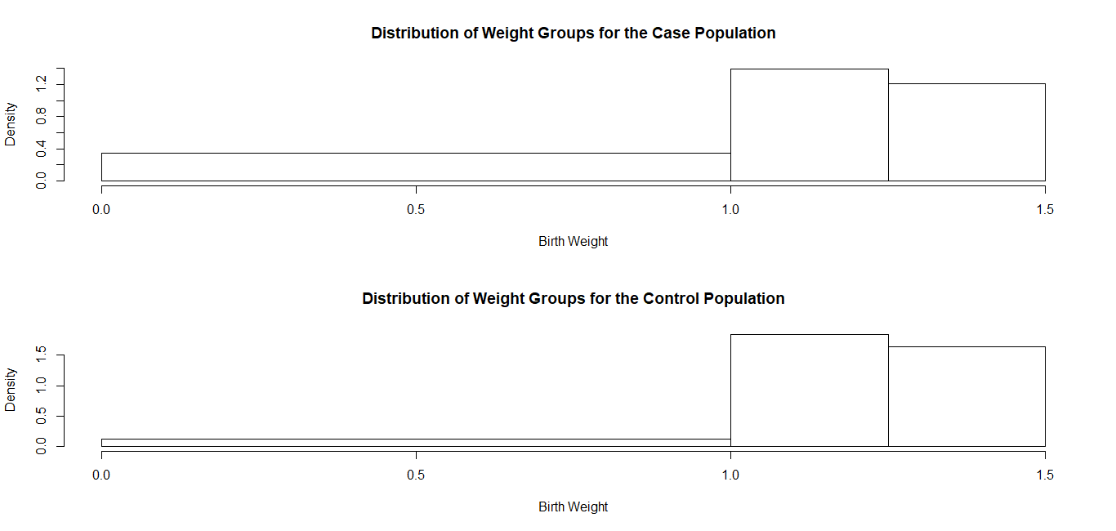

Observations:-

We see that the weight groups are identically distributed for both the case and control populations.

2)We group the gestational age groups as (<30weeks,30-34 weeks, 34-38 weeks) and check their distribution for both the case and control population.

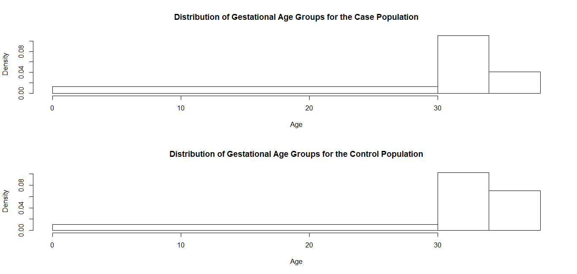

OBSERVATIONS:-

We see that the distributions are identical for both the case and control populations.

TABLE SHOWING THE MEANS AND THE P-VALUES

|  |  |  |  |  |
| --- | --- | --- | --- | --- |
| Side Effects | Case | Control | P-value | 95% Confidence Interval |
| TSB | 3.767317 | 3.907500 | 0.7775 | (-1.1267471, 0.8463812) |
| DB | 0.535122 | 0.648750 | 0.02852 | (  -0.21488122, -0.01237488) |
| SGOT | 42.07317 | 43.59375 | 0.3658 | (-4.868498, 1.827339) |
| SGPT | 47.21951 | 48.06250 | 0.6141 | (-4.173105, 2.487129) |
| PY-MS-TH | 0.007703 | 1.807187 | 0.007703 | (  -0.46478031, -0.07544835) |
| PY DIA | 9.548780 | 9.859375 | 0.3284 | (-0.9413551, 0.3201661) |

Here we check whether there is any significant differences in the side effects in the case and the control population. We proceed with the comparison by testing whether the means of each of the effect are same for the case and the control population. Assuming Normality of the data we use Welsh T-test for this purpose.

Observations:-

We observe that the p-values for the side effects TSB,SGOT,SGPT are greater then 0.05 whereas the p-value for DB is less than 0.05.Hence we conclude that at 5% level of significance the means of the side effect TSB,SGOT,SGPT are equal and DB is unequal for the case and the control population.

COMPARISON OF OUTCOMES

|  |  |  |  |
| --- | --- | --- | --- |
| Fate | Case | Control | P-value |
| Survived | 0.9534884 | 0.8205128 | 0.1164 |
| Expired | 0.04651163 | 0.17948718 | 0.1164 |
| (NEC+Sepsis) | 0.04651163 | 0.28205128 | 0.008958 |

To compare the outcomes for the case and the control population we use the tests of proportion. We do this procedure for comparison of the number of people who expired, survived and has symptoms (NEC & SEPSIS) for each of the case and control population.

TABLE SHOWING THE PROPORTIONS AND THE P-VALUES

Observations:-

We see that the p-value for the people who survived and expired is greater than 0.05. So we conclude that the proportion of the people who survived and expired are same for the case and the control populations. Similarly we see that the proportion of people having (NEC+Sepsis) are unequal for the case and control populations.

PRIMARY FINDINGS

|  |  |  |  |
| --- | --- | --- | --- |
| Birth Weight | Case(Frequency) | Control(Frequency) | P-value |
| <1kg | 12 | 4 | 0.08271 |
| 1-1.25kg | 17 | 18 | 0.7027 |
| 1.25-1.5kg | 14 | 17 | 0.4232 |

Observations:-

We carry out a comparison for children with birth-weight (<1kg, 1-1.25kg, 1.25-1.5kg). This is done by a test of proportion. We see all the p-values are greater than 0.05 and conclude that the proportion of children in each of the categories are same for both the case and control populations.

|  |  |  |  |
| --- | --- | --- | --- |
| Gestational Age | Case(Frequency) | Control(Frequency) | P-value |
| <30 weeks | 11 | 8 | 0.7785 |
| 30-34 weeks | 21 | 11 | 0.09178 |
| 34-38 weeks | 11 | 20 | 0.03009 |

Observations:-

The p-values are greater than 0.05 for the first two and less than 0.05 for the last one. So we can conclude that the proportion of children are different for the gestational age group (34-38 weeks) for the case and control populations and same for the other two age-groups.

FOR AGE GROUP<30 weeks

|  |  |  |  |
| --- | --- | --- | --- |
| Variable | Case | Control | P-value |
| ¼ Feed | 12.54545 | 20.33333 | 0.005183 |
| ½ Feed | 14.7 | 26.5 | 0.001206 |
| ¾ Feed | 17.10000 | 32.83333 | 0.0001148 |
| Full Feed | 19.44444 | 39.33333 | 6.533e-05 |
| Weight at Discharge | 1342.222 | 1330.833 | 0.3085 |

FOR AGE GROUP (30-34 weeks)

|  |  |  |  |
| --- | --- | --- | --- |
| Variable | Case | Control | P-value |
| ¼ Feed | 6.714286 | 10.642857 | 0.06009 |
| ½ Feed | 8.761905 | 14.642857 | 0.02563 |
| ¾ Feed | 10.47619 | 18.00000 | 0.01618 |
| Full Feed | 12.80952 | 21.50000 | 0.01264 |
| Weight at Discharge | 1373.381 | 1368.357 | 0.7949 |

FOR AGE GROUP (34-38 weeks)

|  |  |  |  |
| --- | --- | --- | --- |
| Variable | Case | Control | P-value |
| ¼ Feed | 5.636364 | 9.750000 | 0.02352 |
| ½ Feed | 6.727273 | 14.375000 | 0.001921 |
| ¾ Feed | 7.818182 | 17.500000 | 0.002029 |
| Full Feed | 9.363636 | 21.000000 | 0.002642 |
| Weight at Discharge | 1404.273 | 1330.875 | 0.003634 |