NAME: SAHASRA V
REG NO:192424234
COURSE: CSA1209 Computer Architecture

EXPERMENT-1

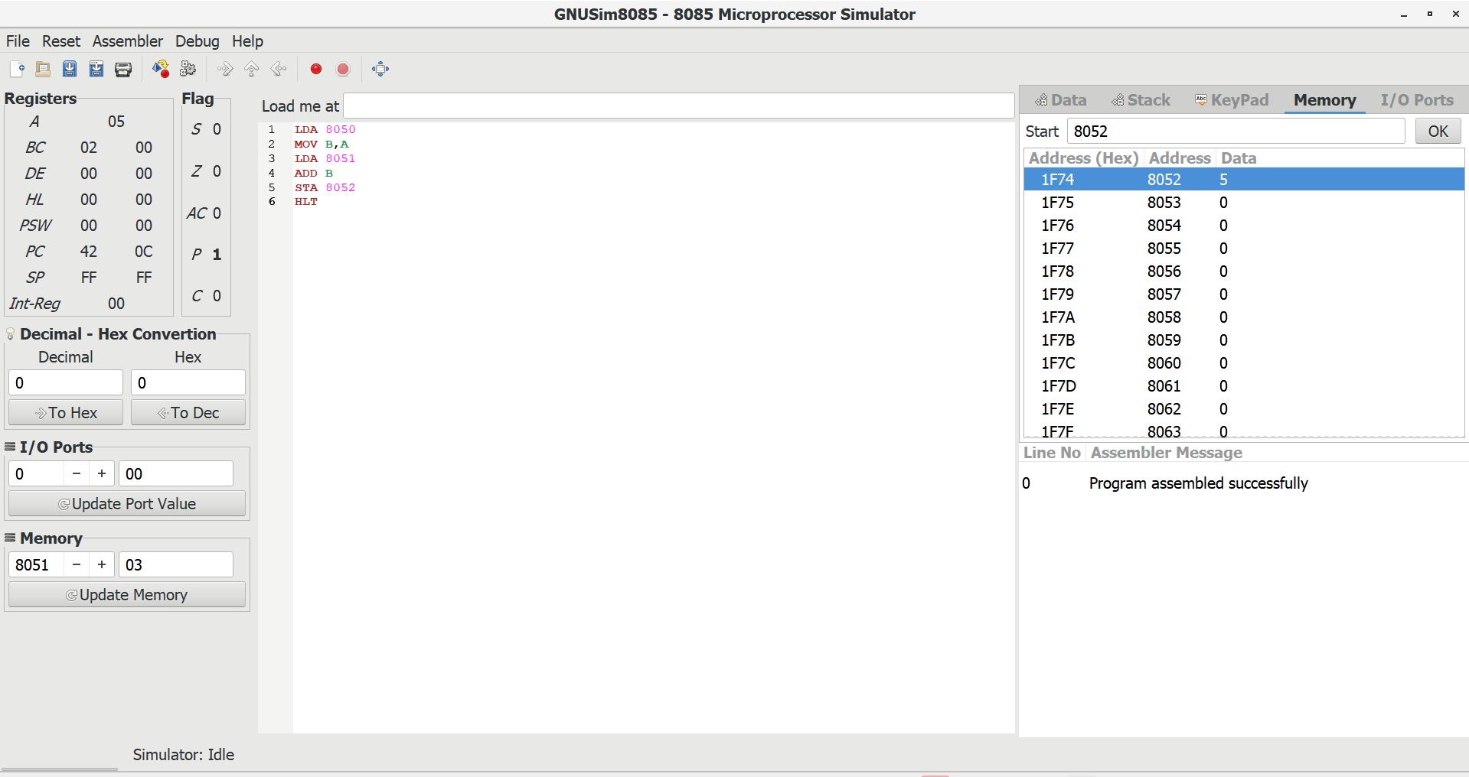

EXPERIMENT-2

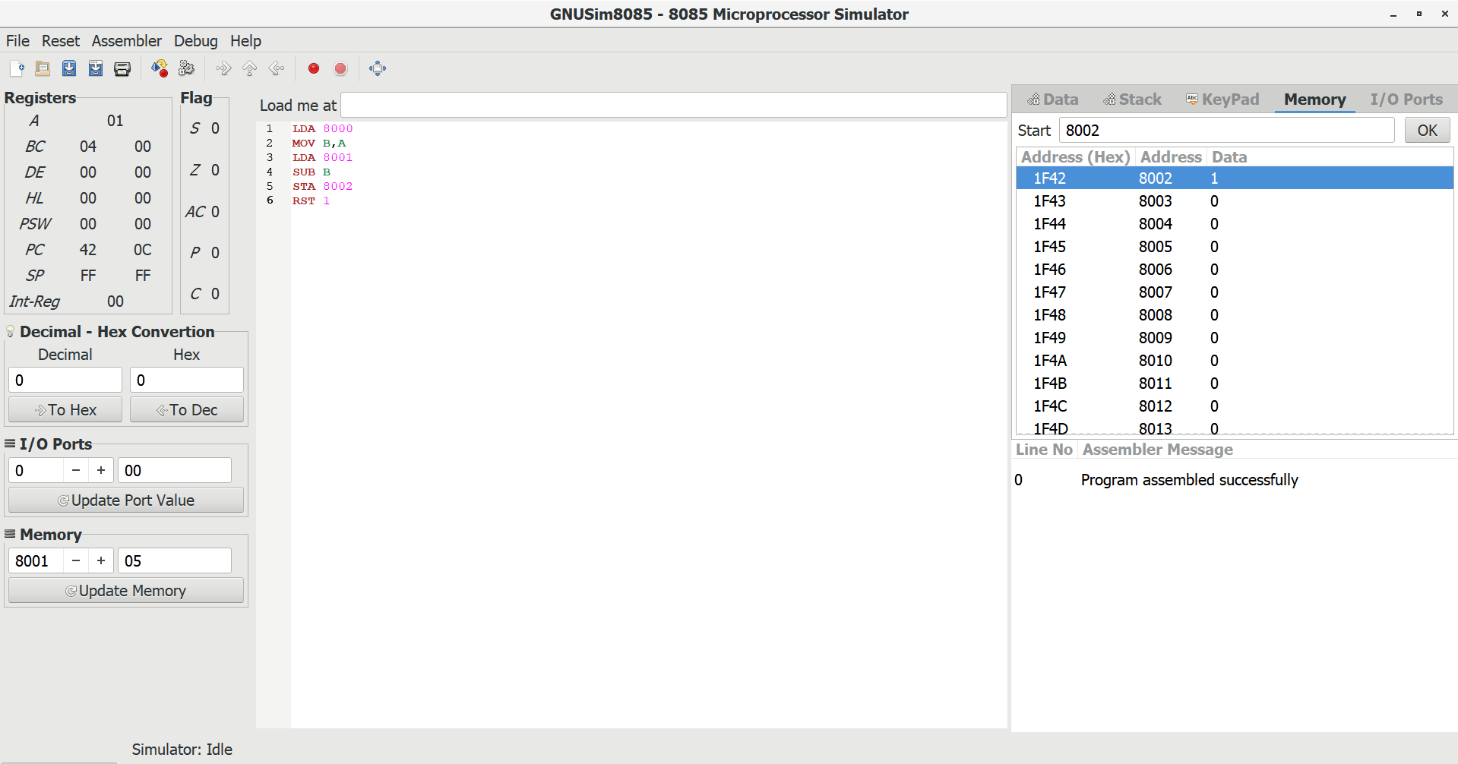

EXPERIMENT-3

