DSA0504-Query processing for Data Science Name: Sahasra V
Reg no:192424234

- Write a python program to display barchart of popularity of subjects
CODE:
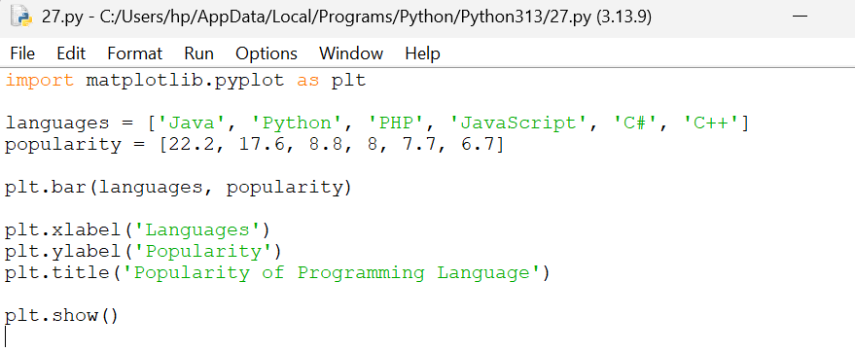

OUTPUT:
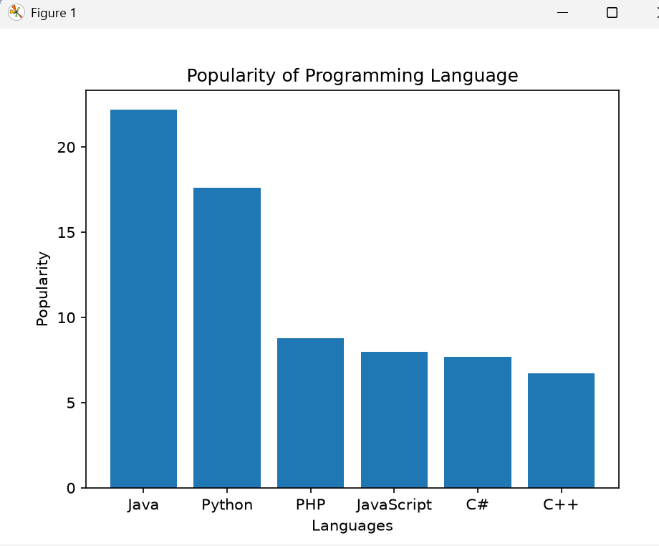

- Write a python program to display horizontal barchart of programming languages
CODE:
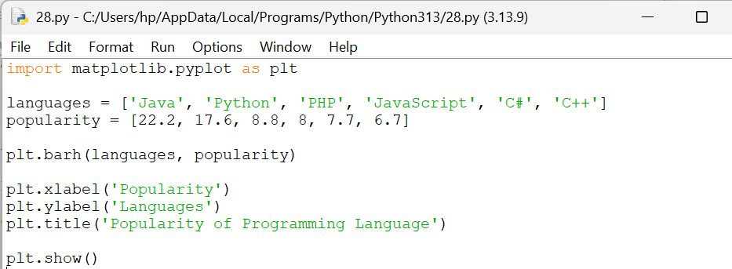
OUTPUT:

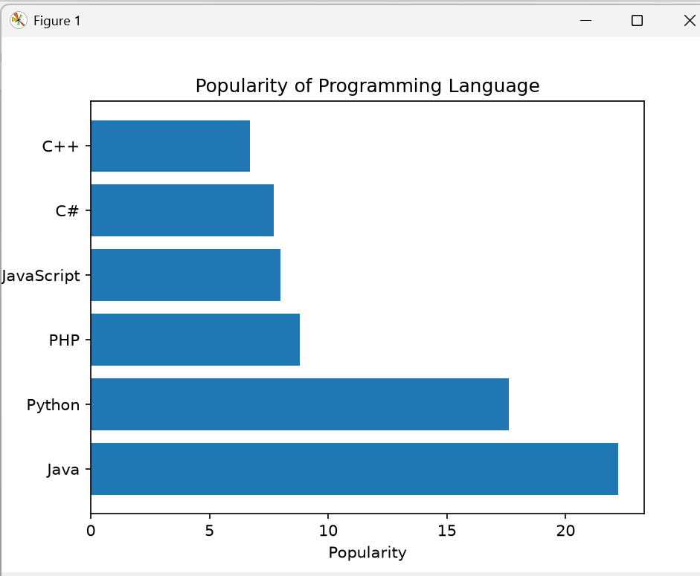

- Write a python program to display barchart of popularity of programming languages using different colours

