SIMATS ENGINEERING
QUERY - LAB PROGRAMS
EXP – 33,34,35
NAME : Sahasra V
REG NO : 192424234

CODE WITH OUTPUT:
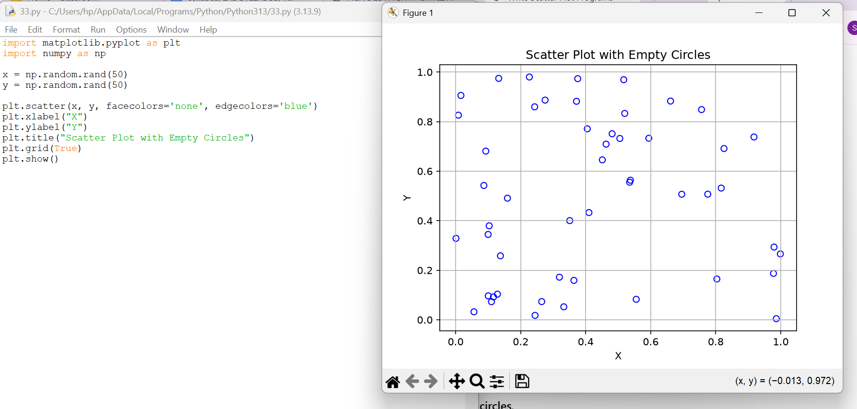

CODE WITH OUTPUT
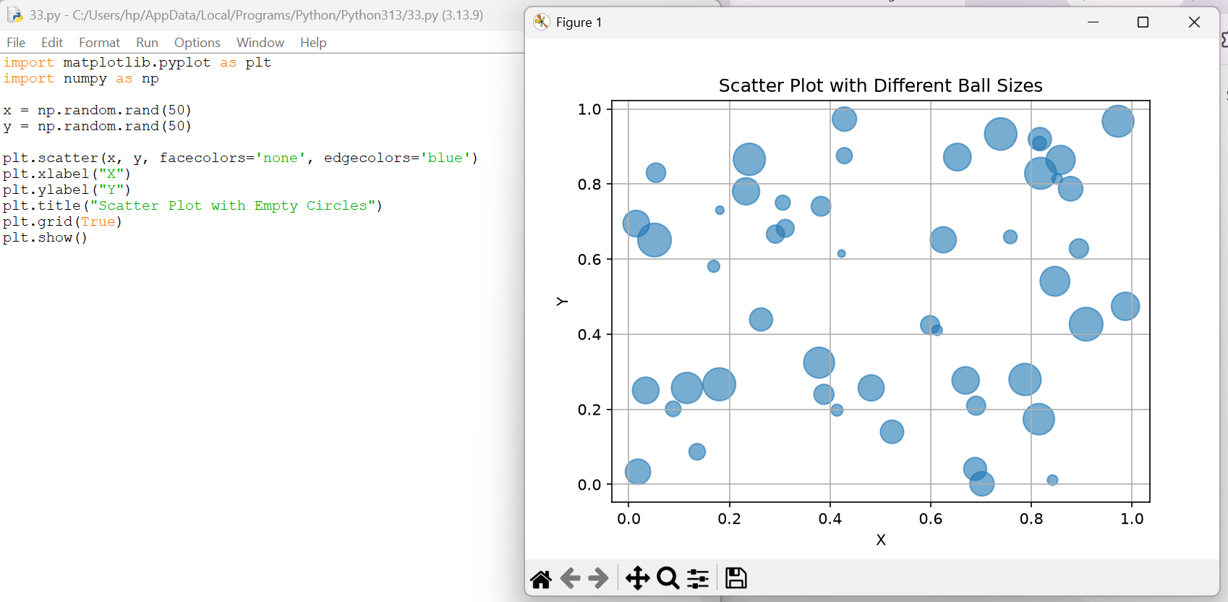

CODE WITH OUTPUT
