DSA0504-Query processing for Data Science Name: Sahasra V
Reg no:192424234

CORRELATION AND OUTLIERS

Correlation Analysis

Aim
To analyze the relationship between numerical variables in a dataset using correlation analysis and visualize the correlation matrix.

Objective
- To calculate the correlation coefficient between numerical features.
- To identify positive, negative, and weak correlations.
- To visualize the relationships using a heatmap.
- To understand feature dependencies for data analysis and machine learning.

Description
Correlation analysis is a statistical technique used to measure the strength and direction of the relationship between two numerical variables. The correlation coefficient ranges from -1 to +1:
- +1 indicates a perfect positive correlation.
- -1 indicates a perfect negative correlation.
- 0 indicates no correlation.
A correlation matrix helps identify highly related variables, which is useful in feature selection, predictive modeling, and exploratory data analysis.
CODE:
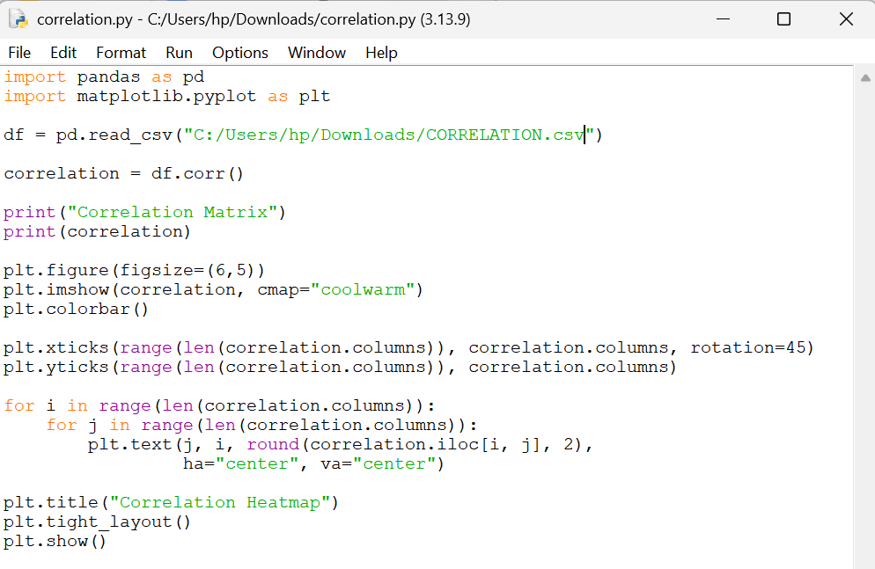
OUTPUT:

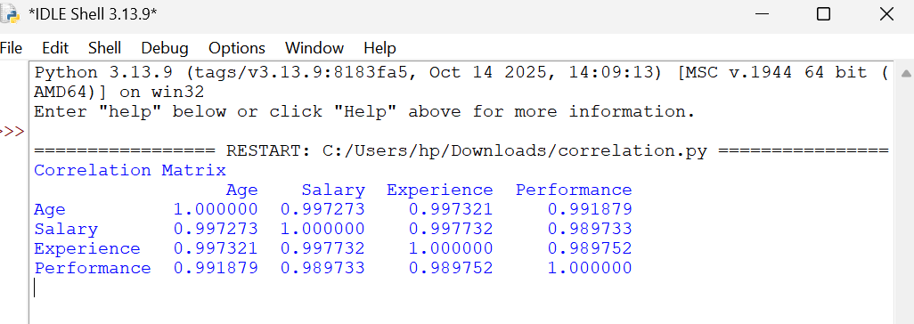

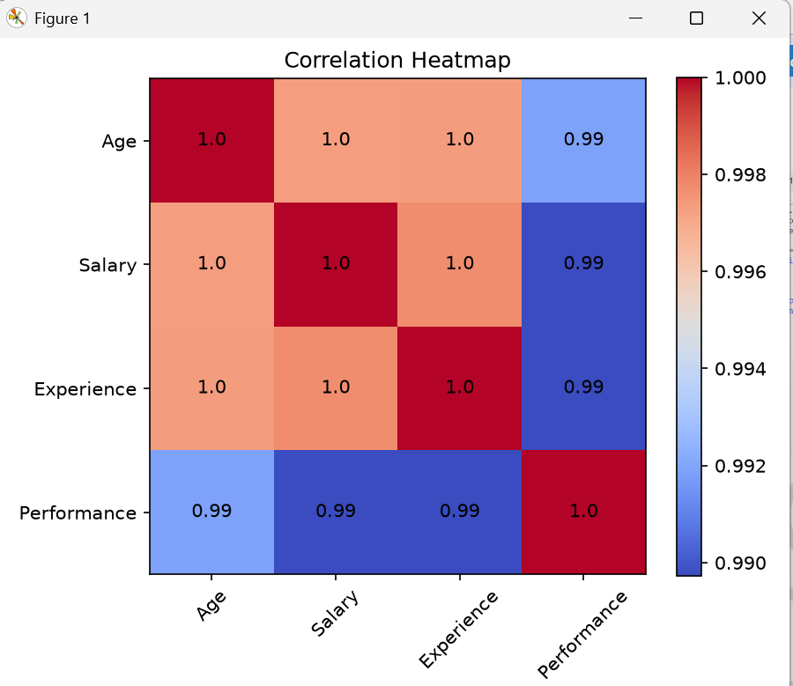

Outlier Detection

Aim
To detect outliers in a dataset using the Interquartile Range (IQR) method and visualize them using a box plot.

Objective
- To identify abnormal values in numerical data.
- To calculate Q1, Q3, and IQR.
- To detect lower and upper outliers.
- To visualize outliers using a box plot.

Description
Outliers are data points that differ significantly from other observations. They may occur due to measurement errors, data entry mistakes, or genuine extreme values.
The Interquartile Range (IQR) method detects outliers using:

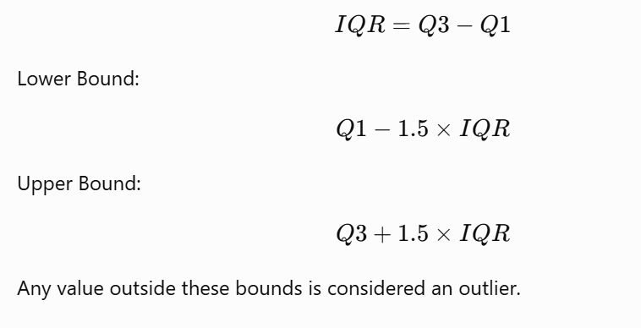

CODE”

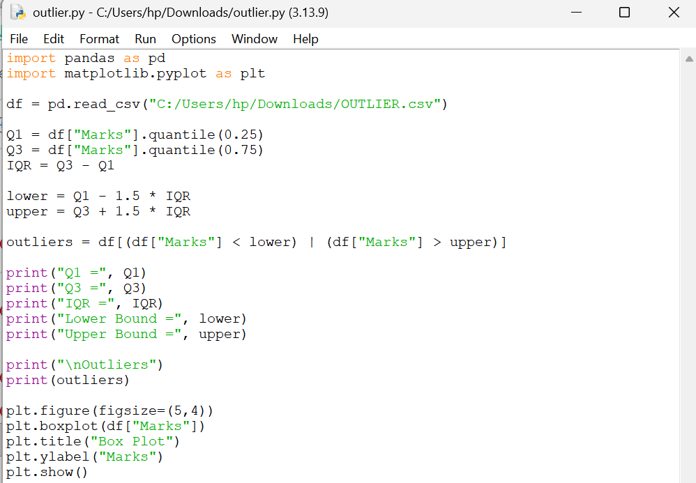

OUTPUT:

