DSA0504-Query processing for Data Science Name: Sahasra V
Reg no:192424234

Question 8: Create a Pivot Table and Find the Item-wise Unit Sold

Aim
To create a pivot table and calculate the total units sold for each item using Pandas.

Algorithm
- Import the Pandas library.
- Create the sales dataset.
- Create a pivot table with Item as the index.
- Sum the Units sold for each item.
- Display the pivot table.
CODE:
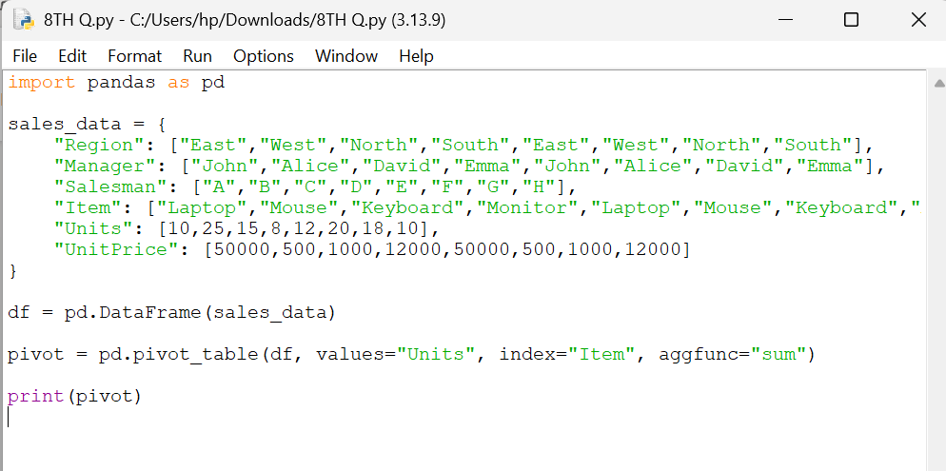
OUPUT:
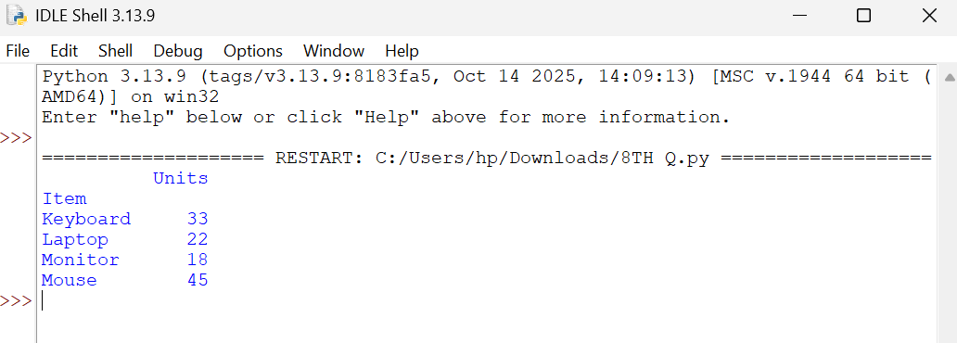

Result
The pivot table was successfully created, showing the total units sold for each item.

Question 9: Create a Pivot Table and Find the Total Sale Amount Region-wise, Manager-wise, and Salesman-wise

Aim
To create a pivot table and calculate the total sale amount based on region, manager, and salesman using Pandas.

Algorithm
- Import the Pandas library.
- Create the sales dataset.
- Calculate the sale value (Units × Unit Price).
- Create a pivot table using Region, Manager, and Salesman as the index.
- Display the total sale amount.
CODE:
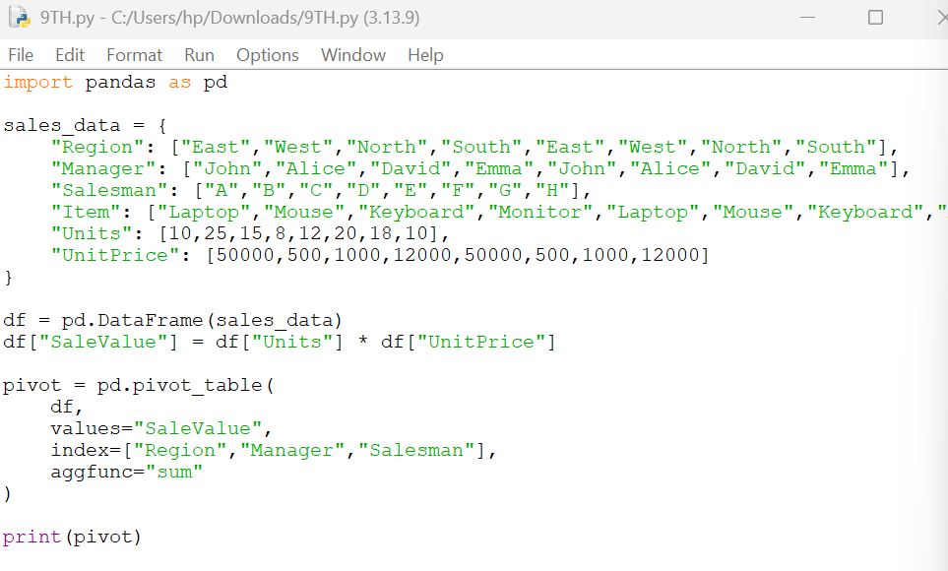
OUTPUT
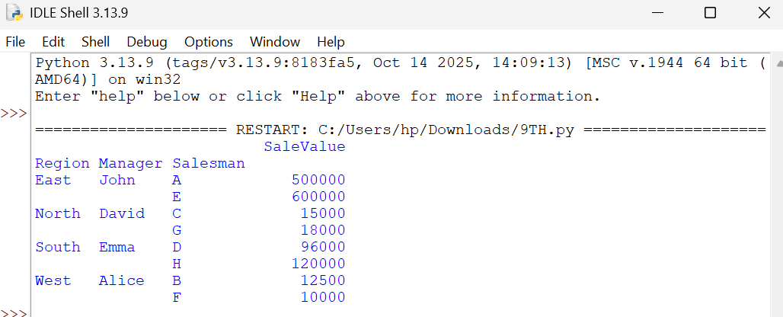

Result
The pivot table was successfully created, showing the total sale amount region-wise, manager-wise, and salesman-wise.

