DSA0504-Query processing for Data Science Name: Sahasra V
Reg no:192424234

18. Write a Pandas program to split the following DataFrame into groups based on school code and class.
CODE:
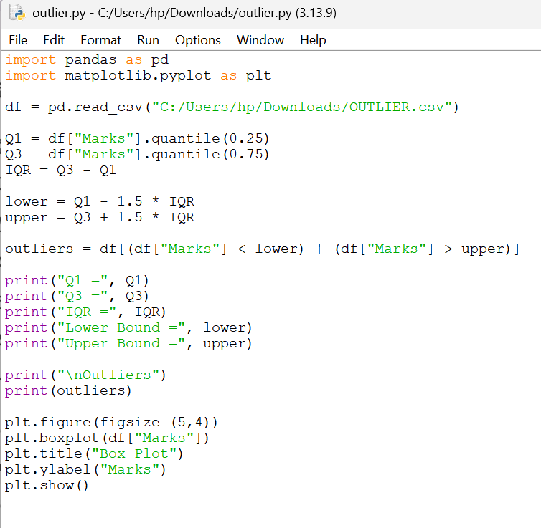

OUTPUT:
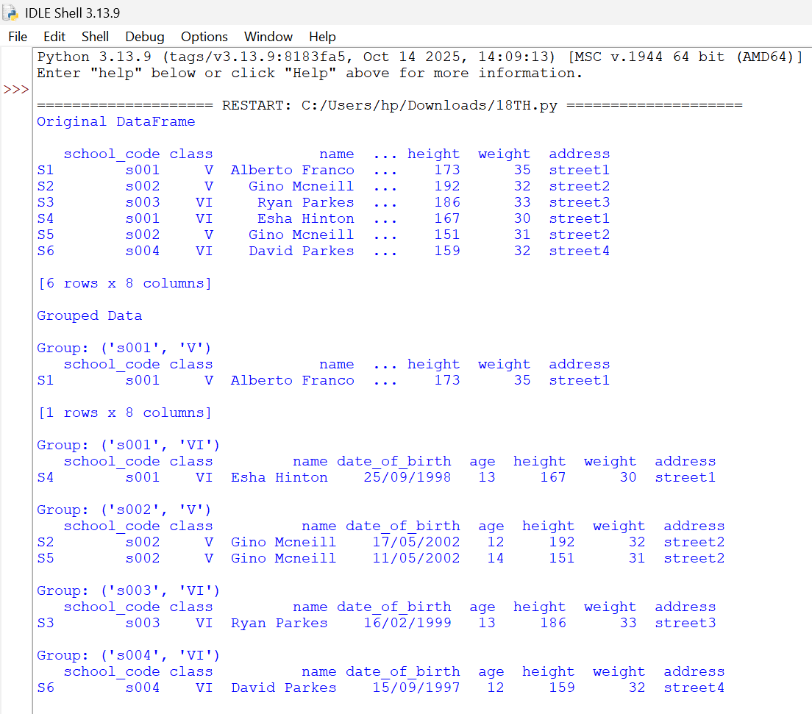

- Write a Pandas program to display the dimensions (shape) of the World Alcohol Consumption dataset. Also extract the column names from the dataset.

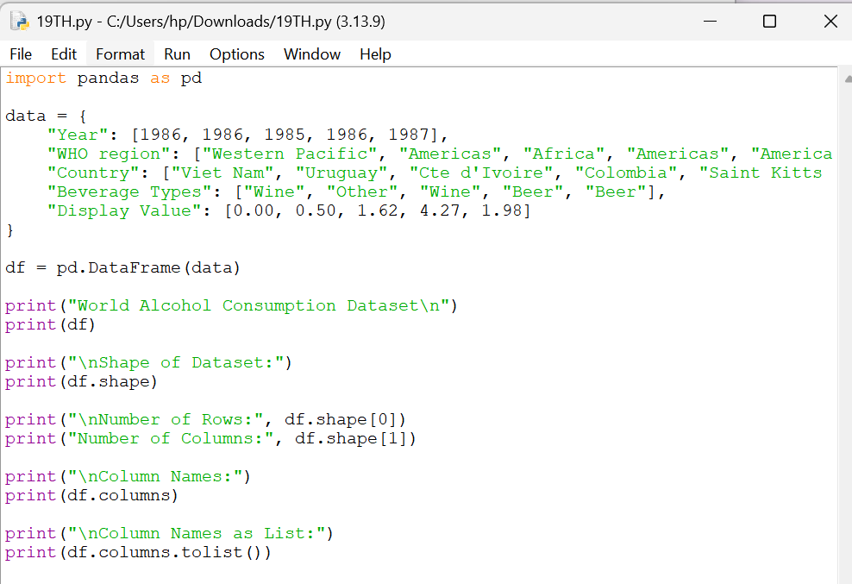

OUTPUT:

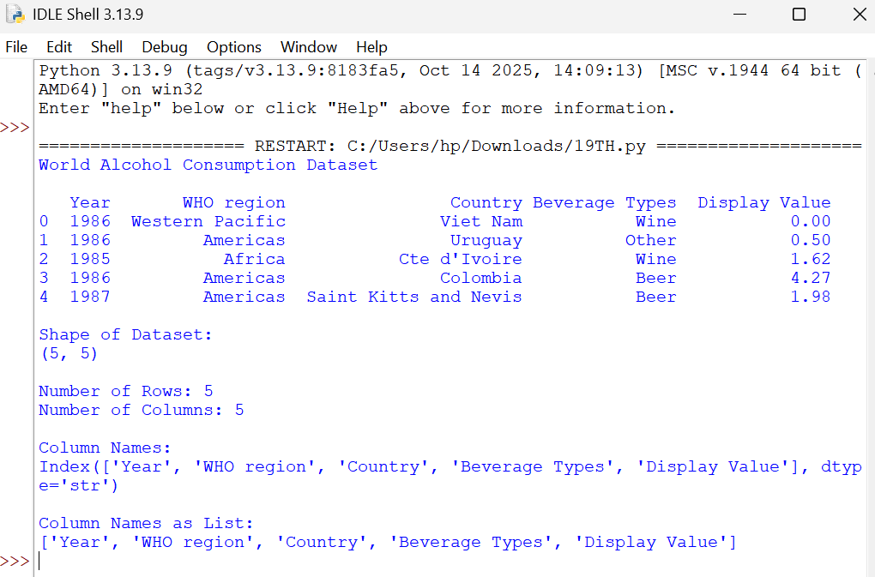

- Write a Pandas program to find the index of a given substring of a DataFrame column.

