Name: Sahasra V
Reg no: 192424234

13th

Write a pandas program to detect missing values of given dataframe

Aim
To write a Pandas program that detects missing values in a DataFrame and displays the result as True (missing value) or False (no missing value).

Procedure
- Import the Pandas library and read the CSV file into a DataFrame.
- Display the original DataFrame to view the available data.
- Use the isnull() function to check each cell for missing values.
- Display the resulting DataFrame containing True and False values, where True indicates a missing value and False indicates a valid value.
- Verify the output and terminate the program.
窗体顶端
CODE:
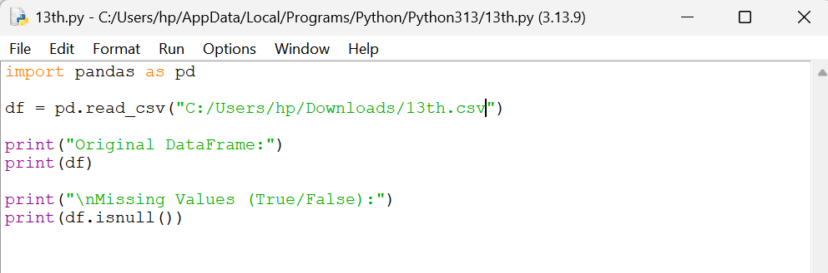

OUTPUT:
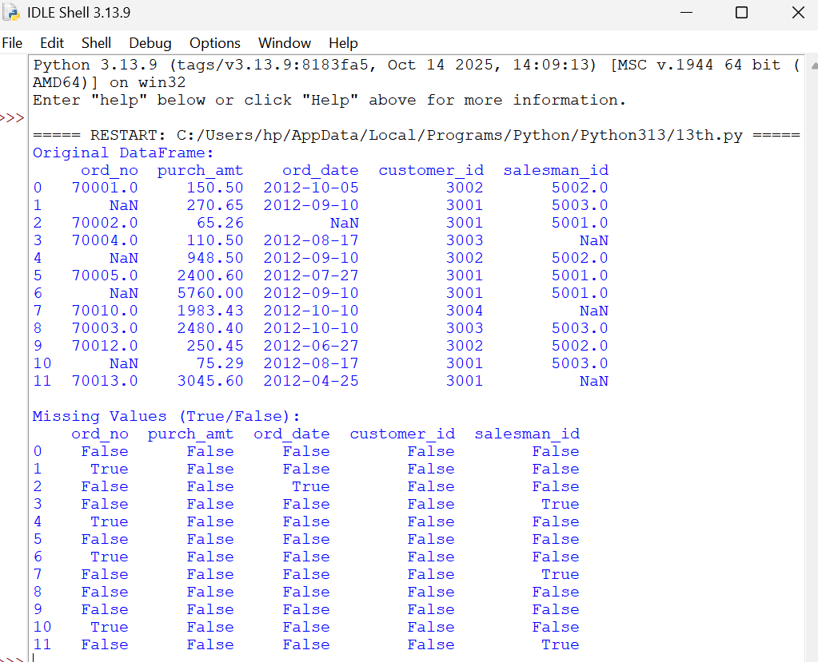

14th

Aim
To write a Pandas program to identify and replace missing values in a DataFrame with appropriate values so that the dataset contains complete and meaningful information.

Procedure
- Import the Pandas library and read the CSV file into a DataFrame.
- Display the original DataFrame containing missing values.
- Replace invalid or missing entries such as ?, --, and blank values with NaN.
- Fill the missing values using a suitable replacement value such as "Not Available".
- Display the updated DataFrame after replacing the missing values.
CODE:
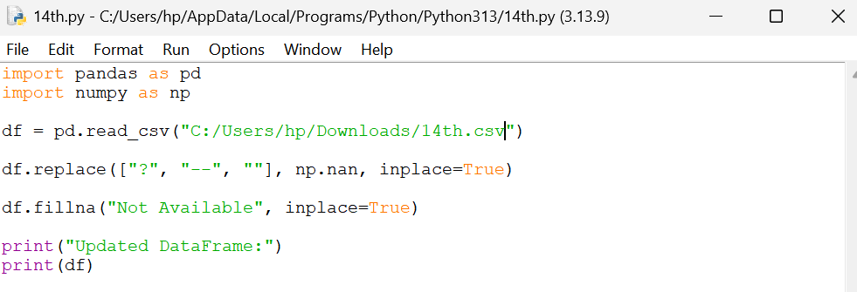

OUTPUT:

