ITA-0601- MACHINE LEARNING

PROGRAMS

16. Compare Different Classification Algorithms and Evaluate Their Performance

CODE WITH OUTPUT:

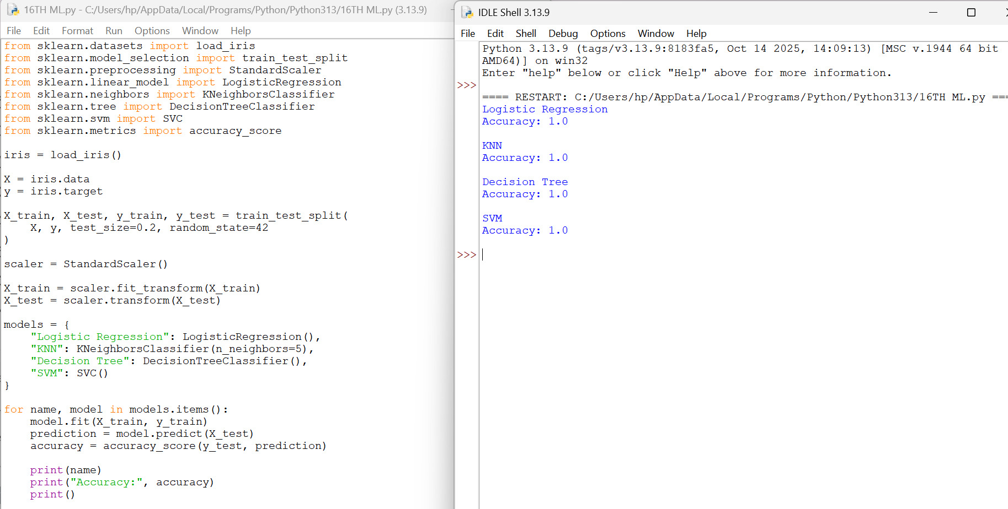

- Implement Mobile Price Prediction Using Machine Learning

CODE WITH OUTPUT

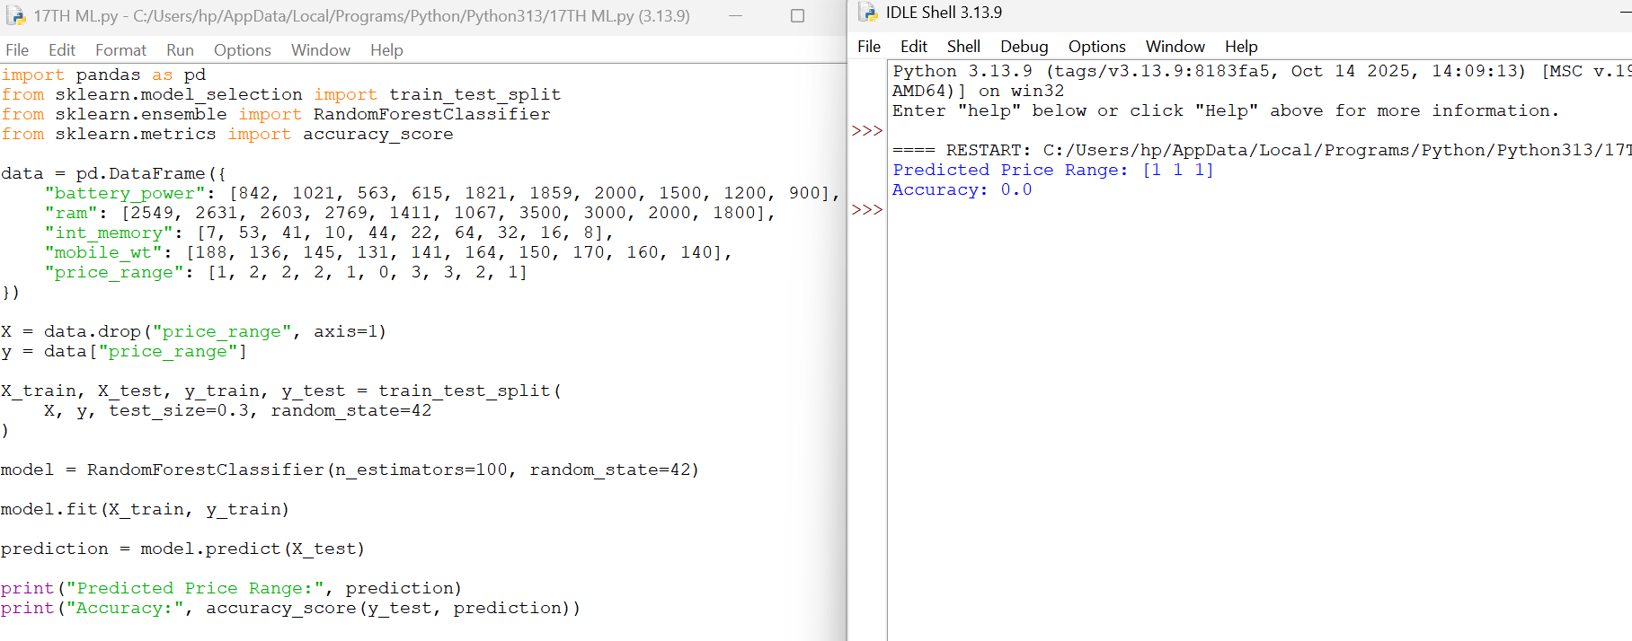

- Implement Perceptron-Based IRIS Classification

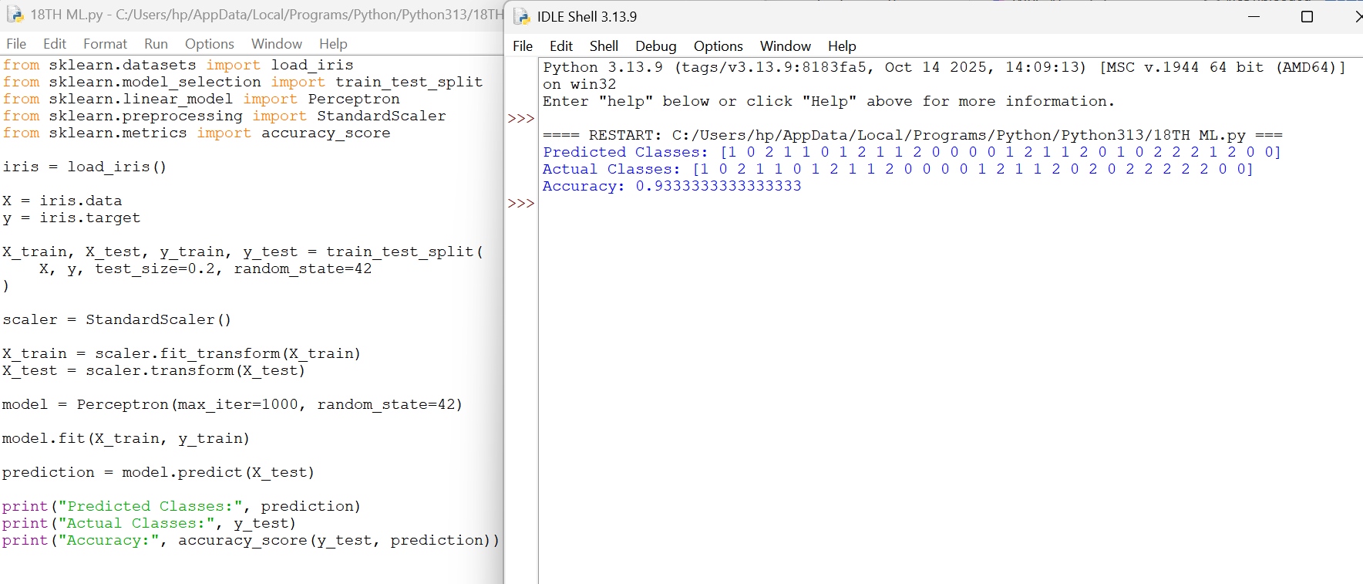

- Implementation of Naive Bayes Classification for Bank Loan Prediction

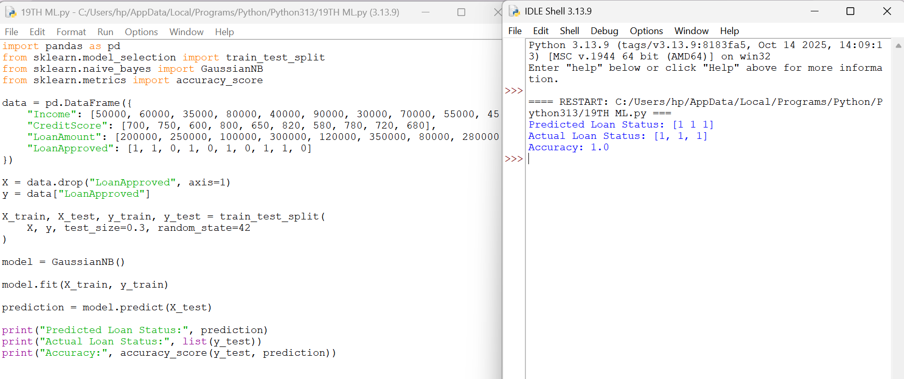

- Implement Future Sales Prediction Using Machine Learning

