ITA-0601- MACHINE LEARNING

PROGRAMS

- Write a program to implement Logistic Regression (LR) algorithm in python

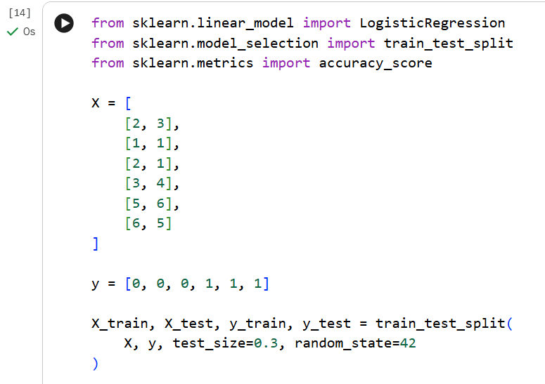

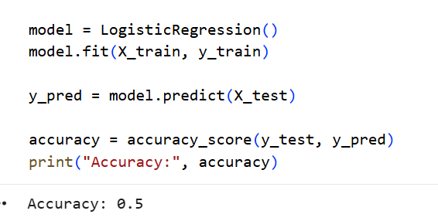

- Write a program to implement Linear Regression (LR) algorithm in python

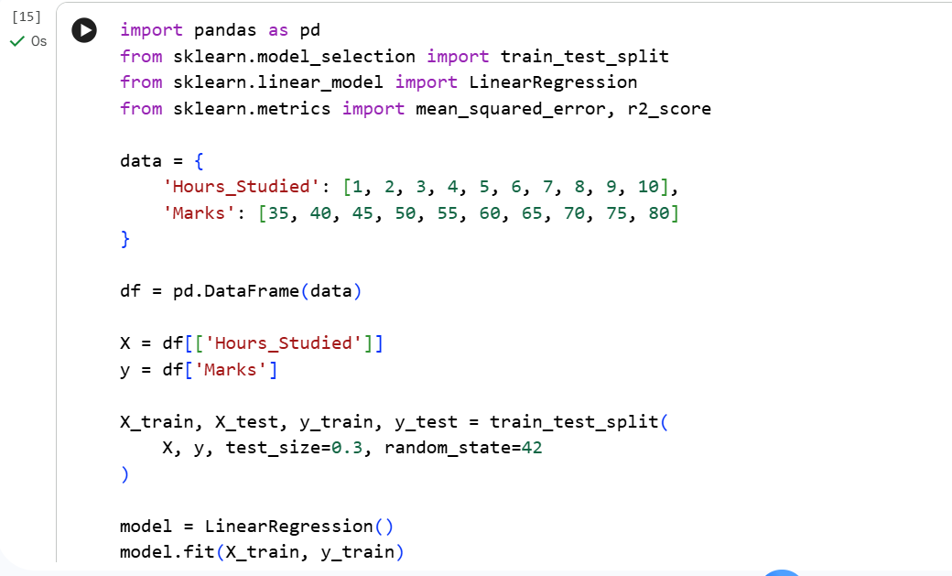

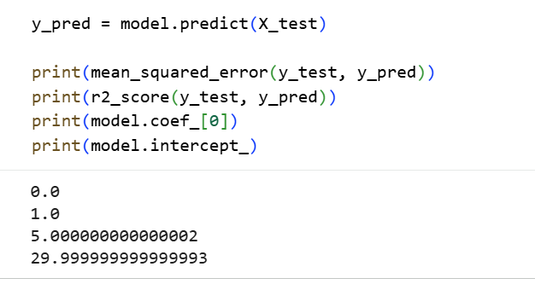

- IMPLEMENT NAIVE’S BAYES ALGORITHM

