NAME: SAHASRA V
REG NO: 192424234
COURSE: ITA-0601 MACHINE LEARNING

- Artificial Neural network by backpropagation algorithm

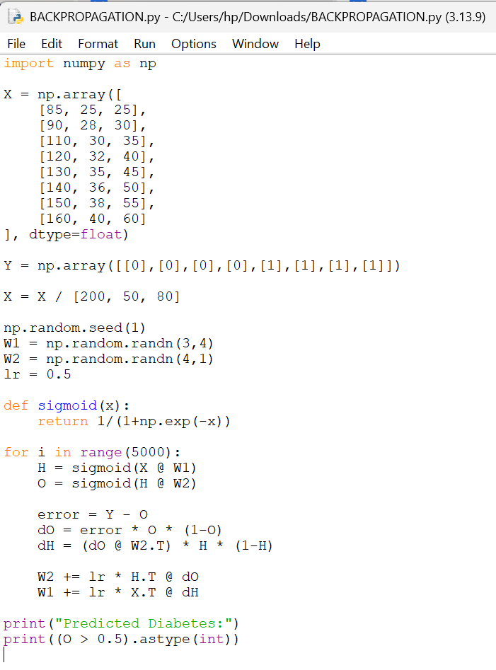

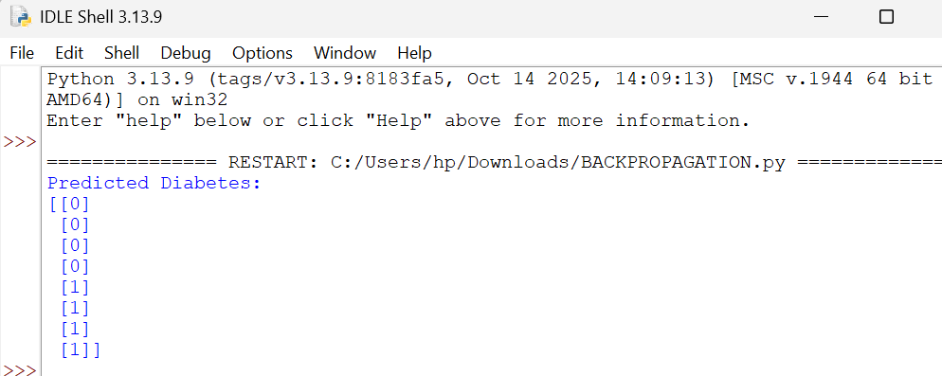

- KNN Algorithm

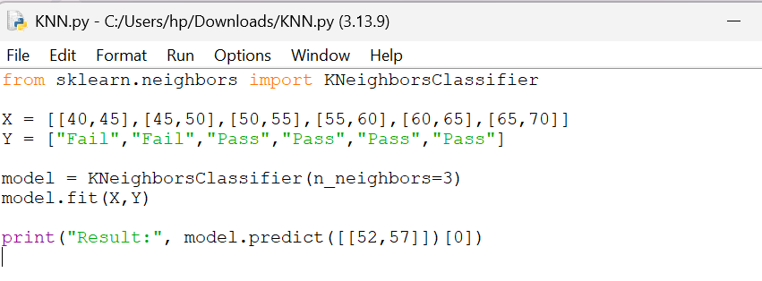

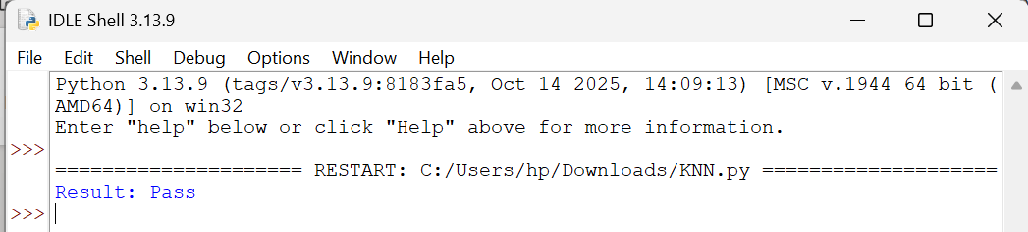

- COMPARE LINEAR AND POLYNOMIAL REGRESSION

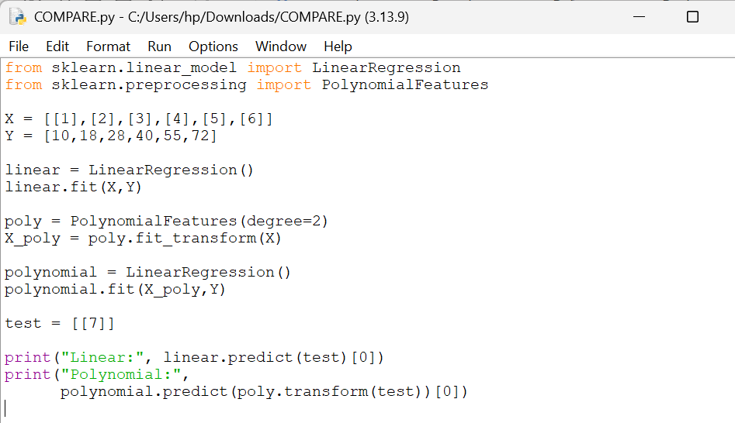

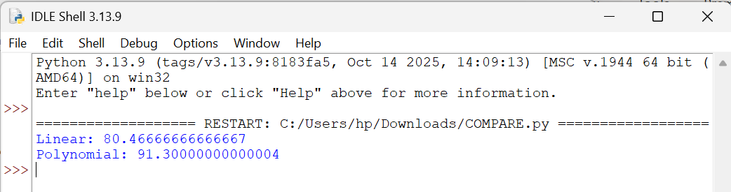

- EXPECTATION AND MAXIMIZATION ALGORITHM

