NAME: SAHASRA V
REG NO: 192424234
COURSE: ITA-0601 MACHINE LEARNING

- Program for task for credit score classification

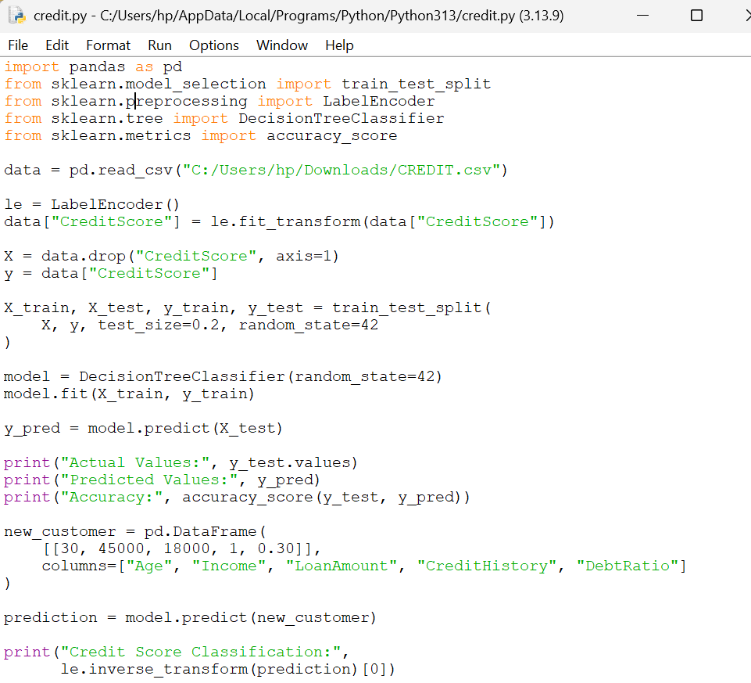

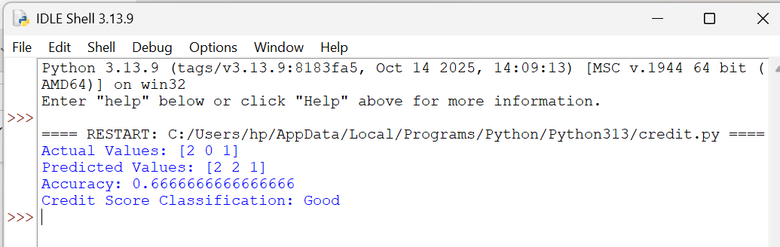

- Implement Iris flower classification using KNN

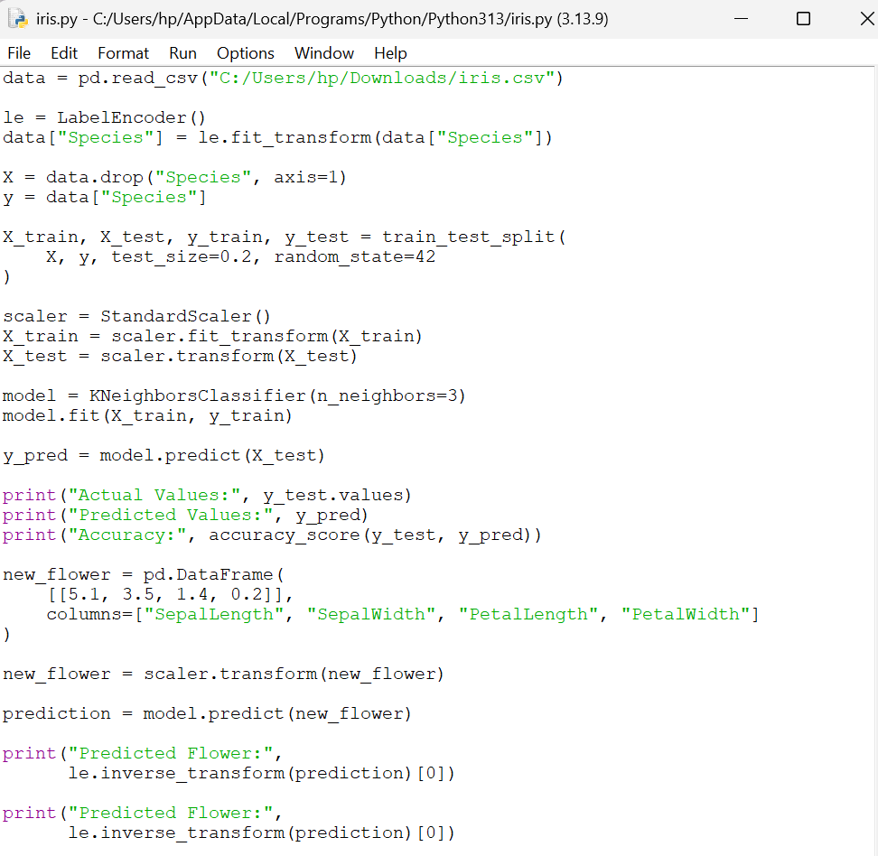

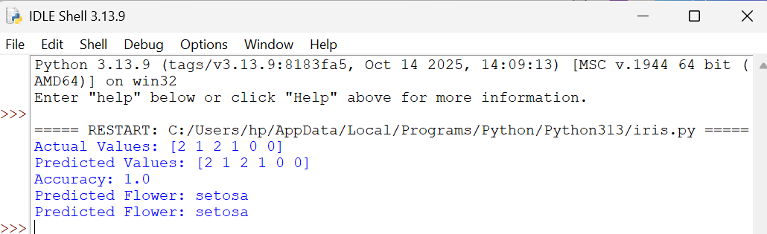

- Car prediction

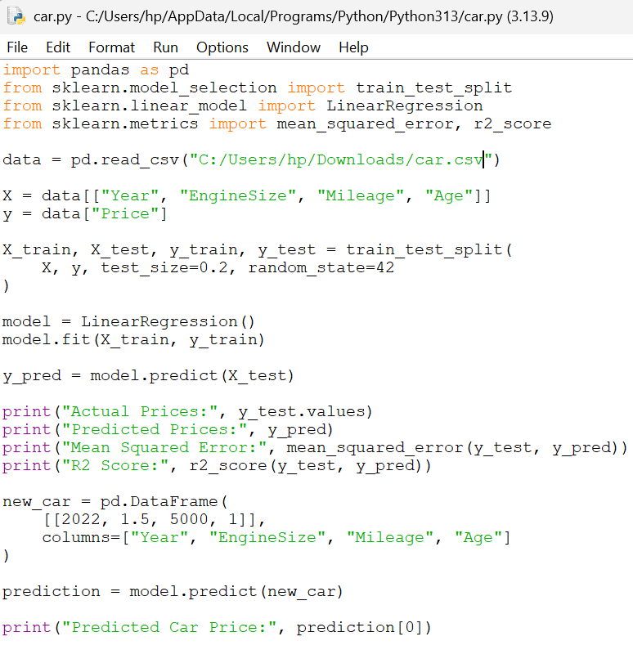

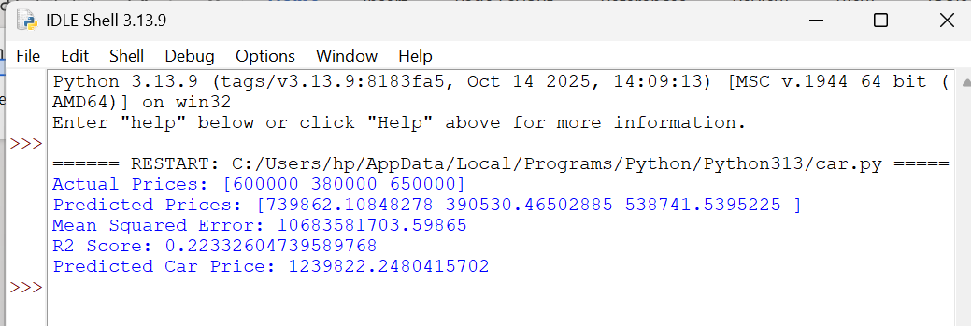

- House price prediction

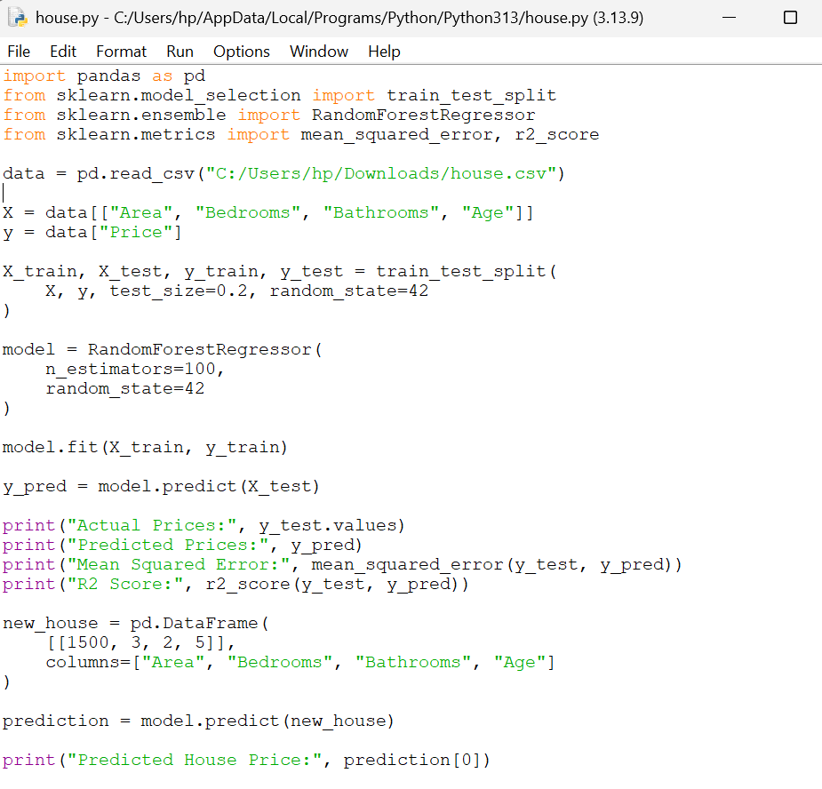

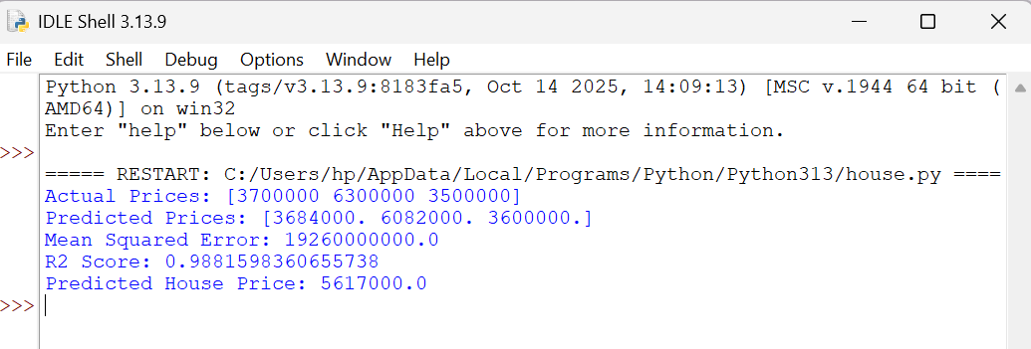

- Flower classification- Naive Bayes classifier

