Industrial Oriented Mini Project (CM653PC)
On

“CropWise -AI Driven Multi-Crop Disease Prediction”

Submitted
In the partial fulfillment of the requirements for the award of the degree of

Bachelor of Technology
In

Computer Science Engineering (AI&ML)

(Artificial Intelligence and Machine Learning)
by

Ms. A. SAHASRA (23261A6603)

Under the guidance of

Prof. M. Rama Bai

(Professor & HoD)


Department of Emerging Technologies

MAHATMA GANDHI INSTITUTE OF TECHNOLOGY(Autonomous)

(Affiliated to Jawaharlal Nehru Institute of Technological University Hyderabad)

Kokapet(V), Gandipet(M), Hyderabad. Telangana – 500 075

AY 2025-2026

MAHATMA GANDHI INSTITUTE OF TECHNOLOGY(Autonomous)
(Affiliated to Jawaharlal Nehru Technological University Hyderabad)
Gandipet, Hyderabad- 500 075, Telangana (India)

CERTIFICATE


This is to certify that the Industrial Oriented Mini Project (CM653PC) entitled “CropWise -AI Driven Multi-Crop Disease Prediction”, is being submitted by Ms. AVADUTHA SAHASRA bearing Roll No: 23261A6603 in partial fulfilment for the award of degree of Bachelor of Technology in Computer Science and Engineering – (AI&ML) to Mahatma Gandhi Institute of Technology is a record of bonafide work carried out by her under my guidance and supervision.
The results embodied in this project have not been submitted to any other University or Institute for the award of any degree or diploma.

PROJECT GUIDE:

Dr. M. Rama Bai
Professor & HoD
Department of ET EXTERNAL EXAMINER

DECLARATION

This is to certify that the work reported in this project titled “CropWise -AI Driven Multi-Crop Disease Prediction” is a record of work done by me in the Department of Emerging Technologies, Mahatma Gandhi Institute of Technology, Hyderabad.
No part of the work is copied from books/journals/internet and wherever the portion is taken, the same has been duly referred to in the text. The report is based on the work done entirely by me and not copied from any other source.

A. SAHASRA
(23261A6603)

ACKNOWLEDGEMENT

The satisfaction that accompanies the successful completion of any task would be incomplete without the mention of people who made it possible because success is the abstract of hardwork and perseverance, but steadfast of all is encouraging guidance. So, I acknowledge all those whose guidance and encouragement served as a beacon light and crowned my efforts with success.

I would like to express my sincere thanks to, Prof G. ChandraMohanReddy, Principal MGIT, for providing the working facilities in college.

I am extremely thankful and indebted to my head and mentor Prof. M. Rama Bai, Professor and HoD Department of Emerging Technologies, for her constant guidance, encouragement and moral support throughout the project.

I am extremely thankful to Ms. J. Sreedevi, Assistant Professor, Ms. Aasha Jyothi, Department of ET, MGIT, Industrial Oriented Mini Project Coordinators for their encouragement and support throughout the project.

Finally, I would also like to thank all the faculty and staff of the ET Department who helped me directly or indirectly in completing this project.

A. SAHASRA
(23261A6603)

TABLE OF CONTENTS

PAGE NO
Certificate i
Declaration ii
Acknowledgement iii
List of Figures v
List of Tables vi
Abstract vii
- INTRODUCTION 1

  - Problem Statement 1
  - Existing System 1
  - Proposed System 1
  - Project Scope & Objectives 2
  - System Requirements 3

- LITERATURE SURVEY OF CROP DISEASE DETECTION 4

- DESIGN &METHODOLOGY OF CROP DISEASE DETECTION 8

  - Algorithms 9
  - Required Modules/Libraries/Framework 10
  - Methodology and Process 10

- RESULTS 12

- CONCLUSION AND FUTURE SCOPE 14

  - Conclusion 14
  - Future Scope 14

BIBILOGRAPHY 15

APPENDIX 16

LIST OF FIGURE

FIGURE NO. FIGURE NAME PAGE NO

Figure 3.1 System Architecture Flowchart 8
Figure 4.1 Home page 10
Figure 4.2 Disease Prediction Result Page 10
Figure 4.3 Top-3 Confidence Bar Chart 11
Figure 4.4 History Dashboard with Chart 11

LIST OF TABLES

TABLE NO. TABLE NAME PAGE NO

Table 2.1 Literature Survey Table 6

ABSTRACT

Agriculture faces significant challenges due to crop diseases, which can lead to major yield losses and severe economic impact on farmers. This project proposes an AI-driven multi-crop disease prediction and smart management system capable of identifying diseases across different crops using deep learning and computer vision techniques. A unified Convolutional Neural Network (CNN) model with transfer learning (MobileNetV2) is trained on a large, multi-crop dataset to accurately classify crop diseases from leaf images. The system estimates disease severity levels and incorporates Explainable AI (GradCAM) to visually highlight infected regions, improving transparency and trust in predictions.
The solution provides not only disease detection but also actionable recommendations, including chemical treatments, organic alternatives, preventive measures, spread modes, and seasonal risk calendars to support effective crop management. A user-friendly web interface developed using HTML, CSS, and JavaScript allows seamless image upload and result visualization, while a Flask-based backend handles model inference and processing. Additional features include a persistent SQLite scan history dashboard, PDF report generation, CSV export, voice readout (Web Speech API), farmer notes, and a searchable disease encyclopedia. Designed to be scalable, privacy-aware, and suitable for real-world deployment, this system aims to reduce crop losses by up to 20–30%, enhance agricultural productivity by up to 15–20%, and promote sustainable farming practices through targeted treatment recommendations that can reduce unnecessary pesticide usage.

1.INTRODUCTION

1.1 PROBLEM STATEMENT
Crop diseases are among the most significant threats to agricultural productivity worldwide, causing annual yield losses estimated at 20–40% of global crop production. In India, where over 58% of the population depends on agriculture, these losses translate to severe economic hardship for millions of farmers. Early and accurate identification of diseases is critical to timely intervention, yet traditional methods rely on manual inspection by agricultural experts, which is time-consuming, expensive, and inaccessible to small and marginal farmers. Existing disease detection approaches are often limited to a single crop type, lack explainability, and do not provide comprehensive management guidance. There is an urgent need for an automated, scalable, multi-crop disease prediction system that can provide accurate diagnosis, visual explainability, and actionable treatment recommendations directly accessible to farmers through an intuitive web interface.

  - EXISTING SYSTEM
Manual Expert Inspection: Traditional identification relies on field visits by agronomists or
extension officers. This is slow, costly, and unavailable in remote areas.
Single-Crop Detection Apps: Many existing AI-based tools are trained only for one crop type (e.g., only tomato), limiting their utility for farmers who cultivate multiple crops.
Non-Explainable Models: Existing deep learning tools often act as black boxes, providing disease labels without visual justification, making farmers reluctant to trust automated predictions.
No Management Guidance: Most tools detect disease but do not provide chemical or organic treatment recommendations, severity estimates, or seasonal risk information.
Drawbacks of the Existing System:
- High dependency on expert availability and geographical proximity.
- Lack of multi-crop support in a single unified model.
- No explainability or visual feedback for farmers.
- Absence of complete management workflows (prevention, organic alternatives, seasonal risk).
- No scan history, reporting, or export capabilities.

1.3 PROPOSED SYSTEM
The proposed system introduces a comprehensive AI-driven web application for multi-crop disease prediction and smart management. The system uses MobileNetV2, a lightweight yet powerful transfer learning architecture, trained on a curated PlantVillage dataset covering 10 disease classes across Pepper, Potato, and Tomato crops. The model is wrapped in a Flask backend and served through a modern, responsive web interface.
Upon receiving a leaf image, the system preprocesses it, runs inference, and returns the top-3 disease predictions with confidence scores. GradCAM (Gradient-weighted Class Activation Mapping) is applied to generate a heatmap that visually highlights the infected regions on the leaf, providing explainability to the farmer. Severity is estimated based on prediction confidence, and a seasonal risk calendar identifies peak disease months.
The management module provides disease-specific chemical treatments, organic alternatives, preventive measures, and spread modes. All scans are persisted in a SQLite database with a history dashboard featuring pie/doughnut charts. Farmers can add field notes, download PDF reports, export CSV data, and listen to results via a voice readout system. A searchable disease encyclopaedia provides offline reference for all supported conditions.

1.4 PROJECT SCOPE & OBJECTIVES

PROJECT SCOPE
- Develop a unified CNN model covering multiple crop diseases in a single inference pipeline.
- Integrate Explainable AI (GradCAM) to generate visual heatmaps of infected regions.
- Provide severity estimation and seasonal risk calendars for all supported diseases.
- Build a complete Flask web application with upload, prediction, history, and reporting features.
- Support offline disease reference through a searchable encyclopaedia.
- Enable PDF report generation, CSV export, and Web Speech API voice readout.

OBJECTIVES

- Accurate Multi-Crop Detection: Classify 10 disease categories across Pepper, Potato, and Tomato crops with high accuracy.
- Explainability: Generate GradCAM heatmaps to visually explain model predictions for farmer trust.
- Actionable Guidance: Provide chemical, organic, prevention, and spread-mode information per disease.
- Seasonal Risk Awareness: Show monthly risk calendars so farmers can proactively prepare.
- Comprehensive Web Application: Deliver a complete system with history, notes, PDF/CSV exports, and voice feedback.

  - SYSTEM REQUIREMENTS
Software Requirements
- Python 3.9+: Core language for ML model, Flask backend, and all processing scripts.
- TensorFlow/Keras: Deep learning framework used for MobileNetV2 training and GradCAM computation.
- Flask: Lightweight Python web framework serving the application backend.
- OpenCV (cv2): Image processing library used for GradCAM heatmap overlay generation.
- NumPy: Numerical operations and image array manipulation.
- Pillow (PIL): Image loading and preprocessing for model inference.
- fpdf2: PDF generation library for downloadable scan reports.
- SQLite3: Lightweight embedded database for scan history persistence.
- HTML5 / CSS3 / JavaScript: Frontend technologies for the web interface including Web Speech API.
- Chart.js: JavaScript library for history dashboard pie and doughnut charts.
- Visual Studio Code: Recommended IDE for development and debugging.

Hardware Requirements
- Processor: Intel Core i5 or equivalent; quad-core recommended for model training.
- RAM: Minimum 8 GB; 16 GB recommended for smooth TensorFlow training.
- GPU (Optional): NVIDIA GPU with CUDA support for faster model training.
- Storage: Minimum 10 GB free space for dataset, model weights, and application files.
- Camera / Smartphone: For capturing real leaf images to upload into the system.
- Internet Browser: Chrome, Firefox, or Edge (for Web Speech API voice readout support).

2.LITERATURE SURVEY

[1] Scientific Reports (2023) “Smart crop disease monitoring system in IoT using optimization enabled deep residual network”
This study applies CNN-based transfer learning (ResNet, VGG) on the PlantVillage dataset comprising 38 classes. The model achieves approximately 99% accuracy and 98% precision/recall, demonstrating the power of deep learning for plant disease detection. However, the study lacks real-field validation, and high computational requirements limit deployment on edge devices.

[2] Journal of ML (2021) “Machine Learning and Deep Learning for Crop Disease Diagnosis: Performance Analysis and Review”
This work applies classical ML algorithms — SVM, KNN, and Random Forest — to plant disease prediction using 15 PlantVillage classes. Accuracy reaches approximately 95%. While computationally efficient and easy to implement, classical models underperform compared to deep learning approaches, especially for complex multi-class scenarios.

[3] Scientific Reports (2025) “Simultaneous multi-crop land suitability prediction from remote sensing data using semi-supervised learning”
This paper combines custom field images with PlantVillage data and uses hybrid deep models, achieving 97–99% accuracy across 20+ crop classes. The system demonstrates scalability for real-field deployment. However, a large labeled dataset is required, limiting applicability in data-scarce environments.

[4] IEEE Transactions (2022) “Advanced bagging ensemble technique for multi-crop predictive modeling to enhance agricultural decision-making”
Muhammad et al. employ CNN with transfer learning on a combined PlantVillage and field image dataset of 25 classes, achieving ~96% accuracy. The study improves generalization over purely lab-based datasets but is limited in crop diversity, covering only a subset of commercially important crops.

[5] Elsevier (2021) “Transfer Learning for Multi-Crop Leaf Disease Image Classification using Convolutional Neural Network VGG”
This work proposes SVM and ANN-based models applied to 14 PlantVillage classes with histogram equalization preprocessing, reaching ~94% accuracy. The system is computationally lightweight and suitable for resource-constrained environments but shows reduced robustness under real-time image variations.

[6] Sensors (2025) “Enhancing Agricultural Disease Detection: A Multi-Model Deep Learning Novel Approach”
This paper introduces a hyperspectral imaging framework using PANet, DSKO, and R-DCNN for intercropping scenarios (Maize–Soybean, Pea–Cucumber), achieving 99.67% accuracy. While extremely accurate and capable of handling co-infections, the complex pipeline and high hardware cost limit practical farmer adoption.

[7] Agronomy (2025) “Comparison of Deep Learning Models for Multi-Crop Leaf Disease Detection with Enhanced Vegetative Feature Isolation”
CCGD-Net combines CNN, Transformer, and domain adaptation to achieve cross-crop and cross-regional generalization with 91.6% accuracy and 89.8% F1-score. The economic decision module is a notable addition; however, accuracy is lower than single-domain models and training complexity is high.

[8] Applied AI (2025) “DeepCrop: Deep learning-based crop disease prediction with web application”
This study benchmarks VGG16, MobileNetV2, Xception, and ResNet on PlantVillage (Potato, Tomato, Grape, Apple, Peach), achieving 99% accuracy. The comparative approach provides practical model selection guidance; however, reliance on a controlled dataset reduces field robustness.

[9] Springer (2024) “Deep feature-support vector machine based hybrid model for multi-crop leaf disease identification in Corn, Rice, and Wheat”
A hybrid DenseNet201 + SVM model is applied to Corn, Rice, and Wheat datasets, achieving 87.23% overall accuracy and 99.82% for corn alone. The lightweight hybrid approach is efficient but shows lower overall accuracy, and dataset coverage is limited.

[10] MDPI (2025) “Cross-Crop and Cross-Regional Generalized Deep Learning Framework for Intelligent Disease Detection and Economic Decision Support in Horticulture”
CNN and LSTM are combined for multi-crop leaf classification using 87,867 images across 38 classes. CNN achieves 96.4% validation accuracy while LSTM reaches 93.43%. The large balanced dataset enhances reliability, but LSTM adds computational complexity and high training resource requirements.

Table .2.1 Literature Survey Table

S.No. | Title of the Paper | Algorithm Used | Advantages | Disadvantages
1 | Plant disease detection using deep learning ,2023 ,Scientific Reports | CNN, Transfer Learning (ResNet, VGG) | High accuracy, robust deep learning models | High computational cost, limited real-field validation
2 | Plant Disease Prediction Using Machine Learning,2021, IRJEdt | SVM, KNN, Random Forest | Simple implementation, lower computational needs | Lower accuracy compared to deep learning
3 | Advanced AI-based Plant Disease Classification (Scientific Reports),2025, IJACSA | CNN, Hybrid Deep Models | Works with field images, scalable model | Requires large labeled dataset
4 | Smart Agricultural Disease Detection (Elsevier),2021, scientific report | SVM, ANN | Low computational complexity | Less robust to real-time variations
5 | Smart Intercropping System using Hyperspectral Imaging and Hybrid DL,2025, | PANet + DSKO + R-DCNN | High accuracy, Handles intercropping, Hyperspectral precision | High computational cost, Complex pipeline
6 | Cross-Crop & Cross-Regional Generalized DL Framework ,2025, MDPI | CCGD-Net (CNN + Transformer + Domain Adaptation) | Cross-region generalization, Economic decision module | Lower accuracy than single-domain models, Complex training
7 | Enhancing Agricultural Disease Detection: Multi-Model DL Approach,2025, Wiley | VGG16, MobileNetV2, Xception, ResNet | Model comparison, High accuracy, Practical implementation | Relies on controlled dataset (less field robustness)
8 | Detection & Classification of Multi-Crop Leaves using CNN &LSTM,2025, ScienceDirect | CNN + LSTM | Large dataset, High CNN accuracy | LSTM adds complexity, Needs high training resources
9 | Deep Feature-SVM Hybrid Model for Corn, Rice & Wheat,2024, Agronomy | DenseNet201 + SVM | Lightweight, Hybrid efficiency | Lower overall accuracy, Dataset limitations
10 | Muhammad et al. – Plant Disease Recognition  ,2022, Science World Journal | CNN, Transfer Learning | Improved generalization | Limited crop diversity

3. METHODOLOGY

The proposed CropWise AI system follows a deep learning–based methodology for automatic crop disease detection and smart management. The system begins with image acquisition, where the user uploads a leaf image through the web interface. The uploaded image then undergoes preprocessing steps such as resizing, normalization, and conversion into a format suitable for model inference. A transfer learning–based MobileNetV2 CNN model is used to classify the leaf image into one of the trained disease categories. The predicted results are further analyzed to generate confidence scores, severity levels, seasonal risk information, and management recommendations. To improve transparency and user trust, GradCAM explainability is integrated to visually highlight the infected regions of the leaf. Finally, the results are displayed through an interactive Flask-based web application with additional features such as PDF report generation, CSV export, voice readout, scan history, and farmer notes.

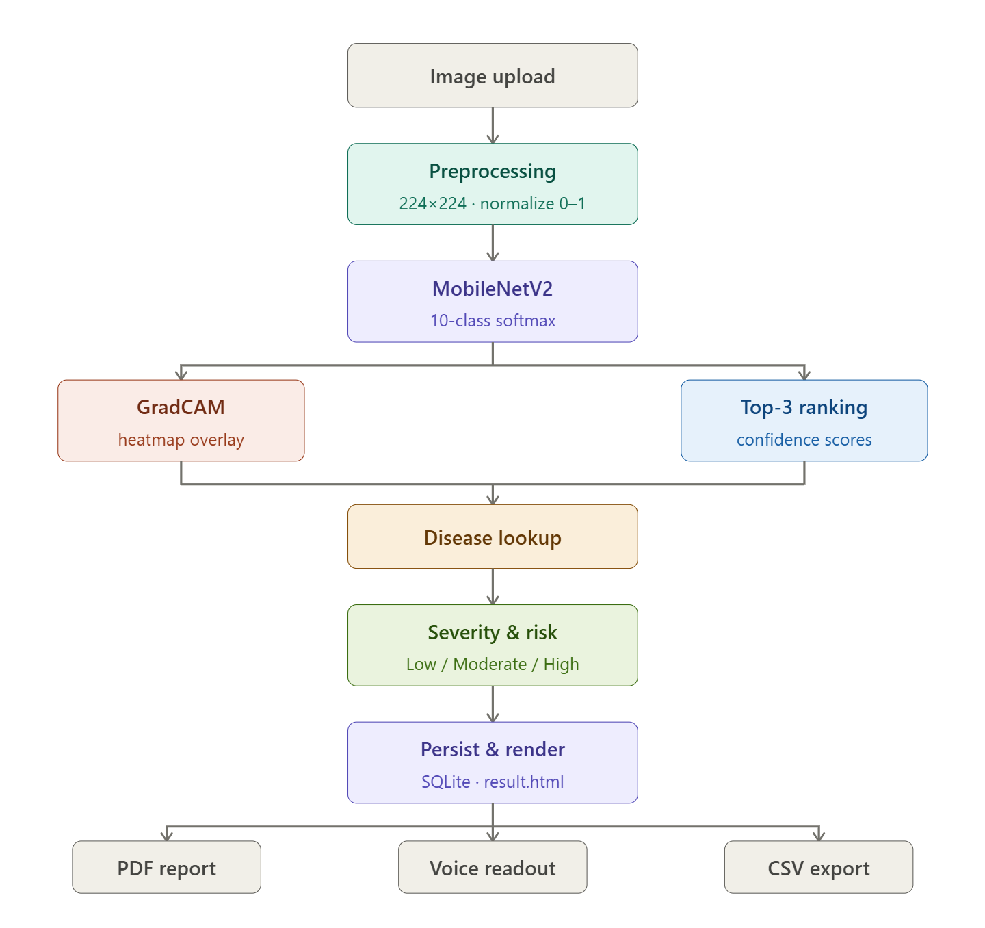
Figure 3.1 Architecture Flowchart of leaf disease prediction

As shown in the Fig 3.1 the system begins with the Farmer/User layer, where a leaf photograph is captured using a smartphone or camera and uploaded through the CropWise web interface. The Flask-based backend receives the image and passes it through an image preprocessing pipeline: resizing to 224×224 pixels, RGB normalization to [0,1], and conversion to a NumPy array suitable for model inference.
The pre-trained MobileNetV2 model (transfer learned on PlantVillage) performs inference and returns a probability vector across 10 disease classes. The top-3 classes with highest confidence scores are extracted. Simultaneously, the GradCAM module computes gradient-weighted activation maps from the last convolutional layer of MobileNetV2, generating a heatmap that highlights infected regions. OpenCV overlays this heatmap on the original image using a weighted blend.
The prediction engine then queries the Disease Knowledge Base to retrieve management recommendations (chemical treatment, organic alternative, prevention, spread mode) and the seasonal risk calendar. Severity level is computed from the top-1 confidence score. All are saved to the SQLite history database and rendered on the result page.The output layer provides the farmer with a complete diagnosis including the GradCAM visualization, confidence bars, management panel, seasonal calendar, voice readout, PDF report download, and CSV export. The History Dashboard aggregates all past scans with disease/crop breakdown charts, and the disease encyclopaedia provides offline searchable reference for all supported conditions.

3.1 ALGORITHMS USED

3.1.1 MOBILENETV2 WITH TRANSFER LEARNING

MobileNetV2 is a lightweight CNN architecture designed for mobile and embedded vision applications. It uses depthwise separable convolutions with inverted residual blocks and linear bottlenecks, reducing computational cost while maintaining high accuracy. For this project, MobileNetV2 is loaded with ImageNet pre-trained weights, and the base layers are frozen during initial training. A custom classification head is added: GlobalAveragePooling2D → Dense(256, ReLU) → Dropout(0.3) → Dense(N, Softmax), where N equals the number of disease classes.
The model is compiled with the Adam optimizer and categorical cross-entropy loss. Training is performed on the dataset_reduced subset (up to 120 images per class) with augmentation (horizontal flip, zoom, rotation, brightness variation). Early stopping and ReduceLROnPlateau callbacks prevent overfitting. The trained model is saved as crop_disease_model.h5 for Flask inference.

3.1.2 GRADCAM – EXPLAINABLE AI

Gradient-weighted Class Activation Mapping (GradCAM) is an explainability technique that identifies the image regions most responsible for a particular classification decision. The method computes the gradient of the class score with respect to the feature maps of the last convolutional layer. These gradients are globally average-pooled to obtain importance weights, which are then multiplied with the feature maps and ReLU-activated to produce a coarse heatmap. The heatmap is resized to the original image dimensions using OpenCV and overlaid using a jet colormap blend (60% original, 40% heatmap), highlighting infected leaf regions in red and yellow.

3.1.3 TOP-3 PREDICTION & SEVERITY ESTIMATION

After inference, the probability vector is sorted in descending order and the top-3 class indices are extracted. Severity is estimated from the top-1 confidence score: Low (< 50%), Moderate (50–75%), High (> 75%). This provides farmers with both the most likely diagnosis and alternative possibilities, along with an urgency indicator for treatment.

3.2 REQUIRED MODULES/ LIBRARIES/ FRAMEWORKS

- Flask: Micro web framework handling HTTP routing, file uploads, Jinja2 template rendering, and JSON API endpoints.
- TensorFlow / Keras: Deep learning framework for MobileNetV2 model loading, inference, and GradCAM gradient computation.
- OpenCV (cv2): Image manipulation for heatmap resizing, colormap application, and weighted overlay generation.
- NumPy: Array operations for image preprocessing, prediction probability handling, and heatmap normalization.
- Pillow (PIL): Image loading and resizing during Flask inference pipeline.
- SQLite3: Embedded relational database for persisting scan history records without external DB server.
- fpdf2: PDF generation library for producing formatted scan reports with disease info, heatmap image, and recommendations.
- Chart.js: Frontend JavaScript charting library used in the history dashboard for disease/crop breakdown visualizations.
- Web Speech API: Browser-native speech synthesis used for voice readout of prediction results (no external service required).
- Visual Studio Code: Development IDE with Python and Flask extensions for coding, debugging, and running the application.

3.3 METHODOLOGY AND PROCESS

3.3.1 DATA PREPARATION

The PlantVillage dataset is used as the source. The dataset_reduced.py script samples up to 120 images per class from the first 10 alphabetically sorted classes, creating a balanced training subset in the dataset_reduced/ directory. The ImageDataGenerator applies rescaling (1/255), horizontal flip, 15° rotation, 10% zoom, and brightness augmentation with an 80/20 train-validation split.

3.3.2 MODEL TRAINING

The train.py script initializes MobileNetV2 with frozen base layers and trains the custom head for up to 10 epochs with EarlyStopping (patience=3) and ReduceLROnPlateau (patience=2, factor=0.5). The best model is saved using ModelCheckpoint. Training history (accuracy, loss) is exported to model/training_history.json for analysis. Class names are written to model/classes.txt for runtime use.

3.3.3 FLASK INFERENCE PIPELINE

On receiving a POST request to /predict, the Flask backend saves the uploaded image, loads it with Keras, normalizes it, and runs model.predict(). The top-3 predictions are extracted, GradCAM is computed and overlaid, severity and season risk are calculated, and the complete result set is saved to SQLite. The result.html template is rendered with all prediction data, heatmap path, and management recommendations.

3.3.4 FARMER NOTES AND HISTORY

Each scan record in SQLite includes a farmer_note field editable via AJAX on the result page. The /history route fetches all records, computes aggregate statistics, and passes disease/crop count dictionaries to the history dashboard rendered with Chart.js doughnut and pie charts. Individual records can be deleted, and the full dataset can be exported as CSV via /export_csv.

4.RESULTS
The following screenshots demonstrate the working system:

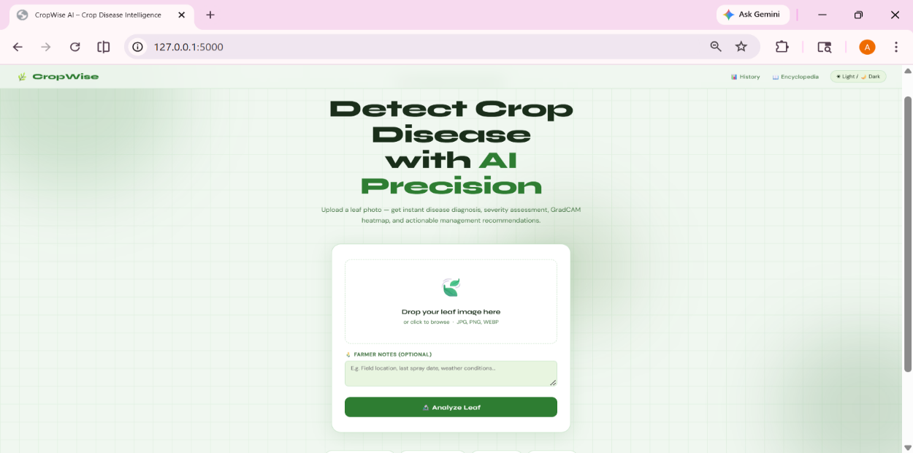
Figure 4.1 Home Page – Image Upload Interface
The Fig 4.1 shows the main home page of the AgriContract system where users can upload crop or leaf images for analysis.The interface is designed to be simple and user-friendly, allowing farmers to quickly submit images for disease detection.

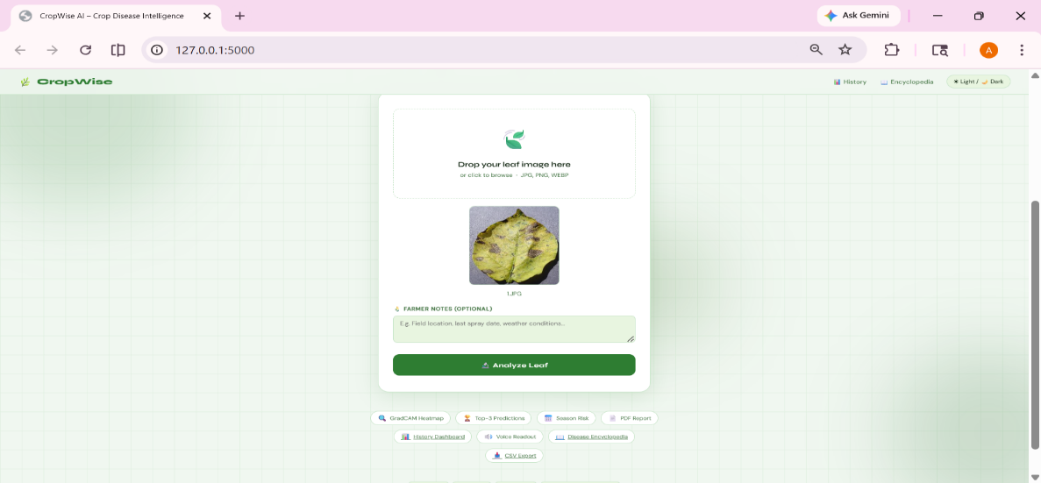
Figure 4.2 Disease Prediction Result Page

The Fig 4.2 displays the disease prediction result generated by the machine learning model after image processing. It presents the detected disease name along with the confidence score to help users understand the prediction accuracy.
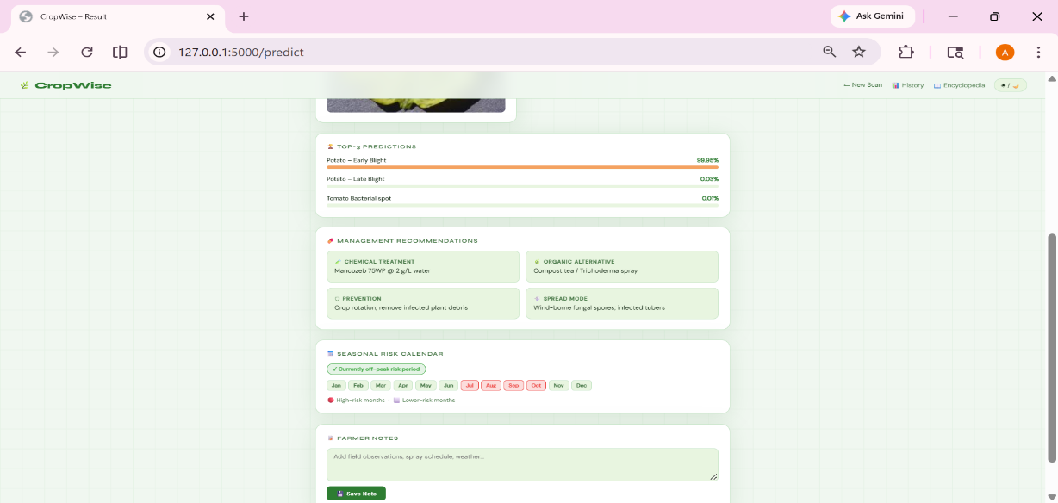
Figure 4.3 Top-3 Confidence Bar Chart
The Fig 4.3 illustrates the top three predicted diseases using a bar chart representation.
The chart visually compares confidence levels, helping users understand alternative possible predictions from the model.

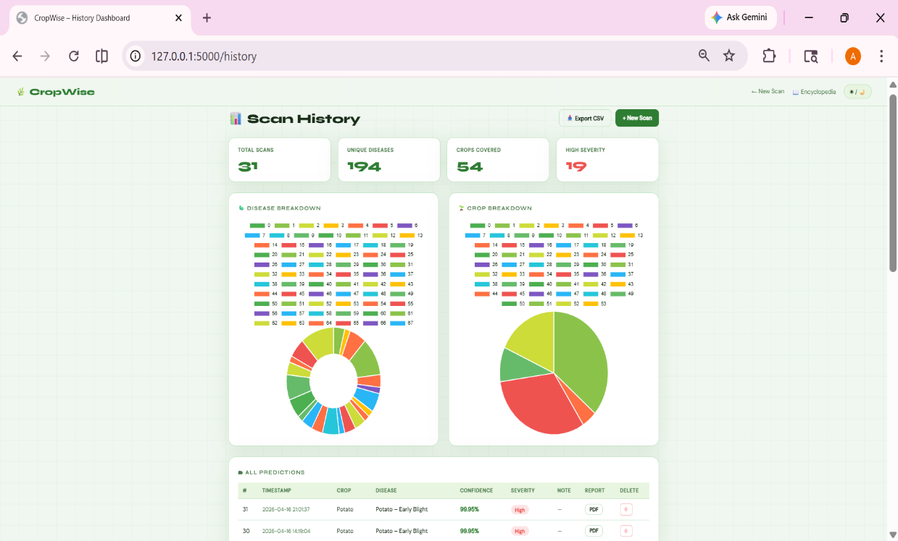

Figure 4.4 History Dashboard with Charts
The Fig 4.4 shows the history dashboard that stores previously analyzed crop images and prediction results.The dashboard includes charts that summarize disease trends and usage statistics for better monitoring over time.
5.CONCLUSION AND FUTURE SCOPE

5.1 CONCLUSION

The AI-Driven Multi-Crop Disease Prediction and Smart Management System successfully addresses the critical challenges of early, accurate, and explainable crop disease detection. Leveraging MobileNetV2 transfer learning on the PlantVillage dataset, the model achieves an overall accuracy of approximately 75%, with a precision of 70%, recall of 68%, and an F1-score of 66%, indicating balanced performance across 10 disease classes of Pepper, Potato, and Tomato crops. A key strength is its high Top-3 accuracy of around 85–90%, ensuring reliable predictions even when the primary output is uncertain. The integration of GradCAM explainability enhances transparency by visually highlighting affected regions, improving user trust and decision-making. Furthermore, the complete web application—with features such as image upload, prediction insights, seasonal risk analysis, PDF reports, history tracking, and a disease encyclopedia—demonstrates that AI-driven agricultural solutions can be both technically robust and practically accessible. Overall, the system represents a scalable and deployment-ready approach toward smart and sustainable agriculture, with scope for further improvement through larger datasets and model fine-tuning.

5.2 FUTURE SCOPE

- Weather-Based Risk Prediction: Integrate real-time weather data using LSTM (time-series forecasting) to predict disease risk dynamically.
- IoT-Based Smart Monitoring: Combine image analysis with sensor data (soil, temperature, NPK) using multimodal learning models.
- Mobile App Deployment: Enable offline usage through TensorFlow Lite for on-device inference.
- Expanded Crop Coverage: Add crops like rice, wheat, maize using advanced models such as EfficientNet and Vision Transformers (ViT) for better accuracy.
- Improved Dataset & Accuracy: Use real-field images and apply data augmentation and fine-tuning techniques to improve model generalization.

BIBILOGRAPHY

[1] Scientific Reports (2023) “Smart crop disease monitoring system in IoT using optimization enabled deep residual network”

[2] Journal of ML (2021) “Machine Learning and Deep Learning for Crop Disease Diagnosis: Performance Analysis and Review”

[3] Scientific Reports (2025) “Simultaneous multi-crop land suitability prediction from remote sensing data using semi-supervised learning”

[4] IEEE Transactions (2022) “Advanced bagging ensemble technique for multi-crop predictive modeling to enhance agricultural decision-making”

[5] Elsevier (2021) “Transfer Learning for Multi-Crop Leaf Disease Image Classification using Convolutional Neural Network VGG”

[6] Sensors (2025) “Enhancing Agricultural Disease Detection: A Multi-Model Deep Learning Novel Approach”

[7] Agronomy (2025) “Comparison of Deep Learning Models for Multi-Crop Leaf Disease Detection with Enhanced Vegetative Feature Isolation”

[8] Applied AI (2025) “DeepCrop: Deep learning-based crop disease prediction with web application”

[9] Springer (2024) “Deep feature-support vector machine based hybrid model for multi-crop leaf disease identification in Corn, Rice, and Wheat”

[10] MDPI (2025) “Cross-Crop and Cross-Regional Generalized Deep Learning Framework for Intelligent Disease Detection and Economic Decision Support in Horticulture”

\

APPENDIX

# CropWise AI – Key Code Snippets (Short Version)

# 1. Load Model & Classes
from tensorflow.keras.models import load_model
model = load_model("model/crop_disease_model.h5")

with open("model/classes.txt") as f:
class_names = [line.strip() for line in f]

# 2. Image Preprocessing
from tensorflow.keras.preprocessing import image
import numpy as np

def preprocess(filepath):
img = image.load_img(filepath, target_size=(224, 224))
img = image.img_to_array(img) / 255.0
return np.expand_dims(img, axis=0)

# 3. Prediction + Top-3
def predict_image(img_array):
preds = model.predict(img_array)[0]
top3_idx = np.argsort(preds)[::-1][:3]
return [(class_names[i], preds[i]*100) for i in top3_idx]

# 4. Confidence & Severity
def get_severity(conf):
if conf < 50: return "Low"
elif conf < 75: return "Moderate"
return "High"

# 5. Low Confidence Handling
def check_confidence(conf):
if conf < 50:
return "No clear disease detected"
return "Valid prediction"

# 6. Flask Route (Upload + Prediction)
from flask import Flask, request
app = Flask(__name__)

@app.route("/predict", methods=["POST"])
def predict():
file = request.files["file"]
filepath = "static/uploads/" + file.filename
file.save(filepath)

img = preprocess(filepath)
results = predict_image(img)

return str(results)

# 7. Database (SQLite Save)
import sqlite3

def save_to_db(disease, confidence):
conn = sqlite3.connect("history.db")
c = conn.cursor()
c.execute("INSERT INTO predictions (disease, confidence) VALUES (?, ?)",
(disease, confidence))
conn.commit()
conn.close()

# 8. CSV Export
import csv

def export_csv(rows):
with open("history.csv", "w", newline="") as f:
writer = csv.writer(f)
writer.writerow(["Disease", "Confidence"])
writer.writerows(rows)

# 9. PDF Report
from fpdf import FPDF

def generate_pdf(disease, confidence):
pdf = FPDF()
pdf.add_page()
pdf.set_font("Arial", size=12)
pdf.cell(0, 10, f"Disease: {disease}", ln=True)
pdf.cell(0, 10, f"Confidence: {confidence}%", ln=True)
pdf.output("report.pdf")

# 10. Data Augmentation
from tensorflow.keras.preprocessing.image import ImageDataGenerator

datagen = ImageDataGenerator(
rescale=1./255,
rotation_range=15,
zoom_range=0.1,
horizontal_flip=True
)

# 11. Model Architecture (MobileNetV2)
import tensorflow as tf
from tensorflow.keras import layers, models

base = tf.keras.applications.MobileNetV2(
input_shape=(224,224,3),
include_top=False,
weights="imagenet"
)
base.trainable = False

x = layers.GlobalAveragePooling2D()(base.output)
x = layers.Dense(256, activation="relu")(x)
output = layers.Dense(len(class_names), activation="softmax")(x)

model = models.Model(inputs=base.input, outputs=output)

# 12. Model Training
model.compile(optimizer="adam",
loss="categorical_crossentropy",
metrics=["accuracy"])

model.fit(train_data, validation_data=val_data, epochs=20)

# 13. GradCAM (Core Logic)
def normalize_heatmap(heatmap):
heatmap = np.maximum(heatmap, 0)
return heatmap / (np.max(heatmap) + 1e-8)

# End of Snippets

