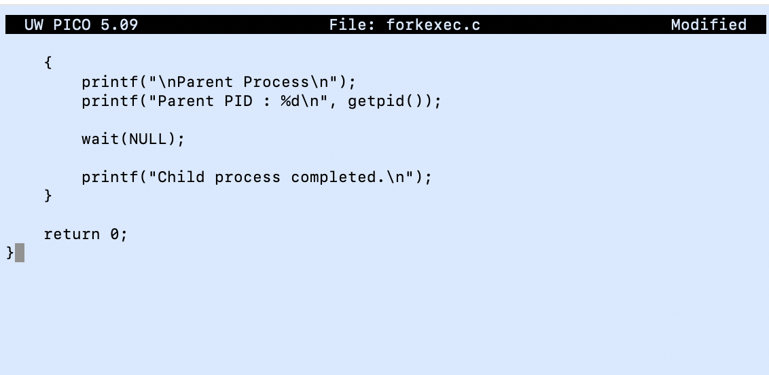

OSSP (Operating Systems And Systems Programming) - 25CS2104E

TASK1:

1A). Develop a C program that demonstrates how a Linux operating system
executes a command entered by a user that
1. Accept a Linux command as input.
2. Create a child process using fork).
3. Execute the command in the child process using an appropriate exec() system call.
4. Allow the parent process to wait for the child using wait ().
5. Display the Process ID (PID) of both parent and child processes.

1B). Using Linux terminal commands (uname, Iscpu, Isblk, ps, top), investigate the
relationship between hardware resources and operating system services. Prepare
a report explaining how the OS abstracts CPU, memory, storage, and I/O devices.
Part 1: C Program using fork(), exec(), and wait()
Step 1: Create a C file and write the code.
Step 2: Save the file
By pressing Ctrl+O —> Enter —> Ctrl+X
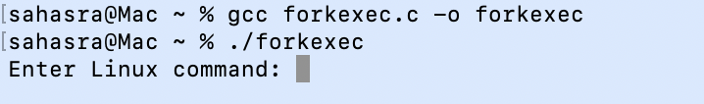
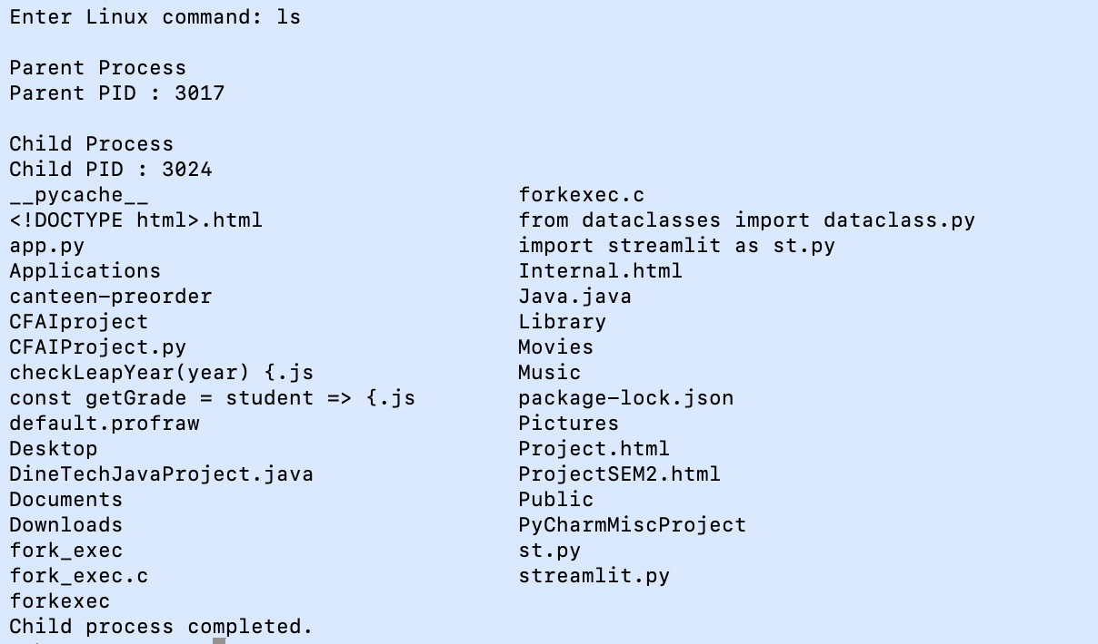
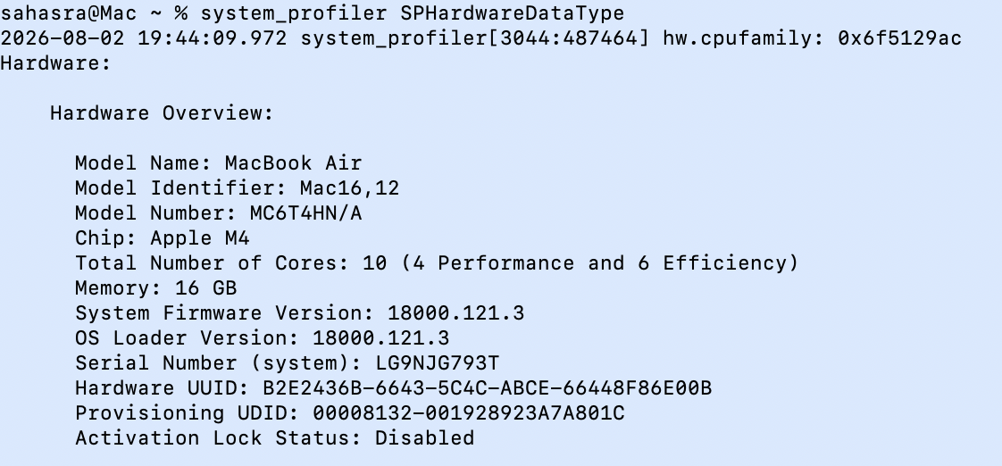
Step 3: Compile the program and Run the program
Part 2: Operating System Commands
1. Display Operating System Information
2. Display CPU Information
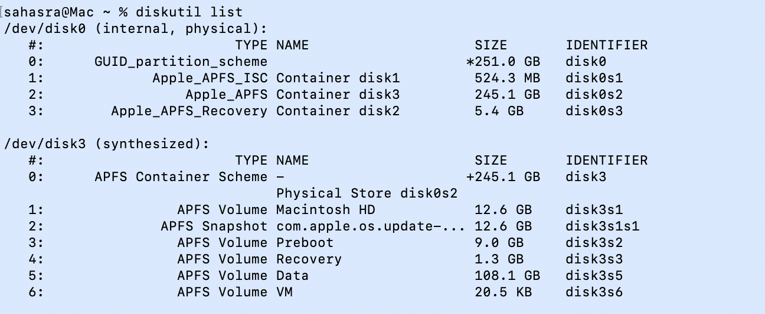
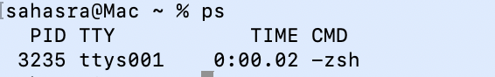

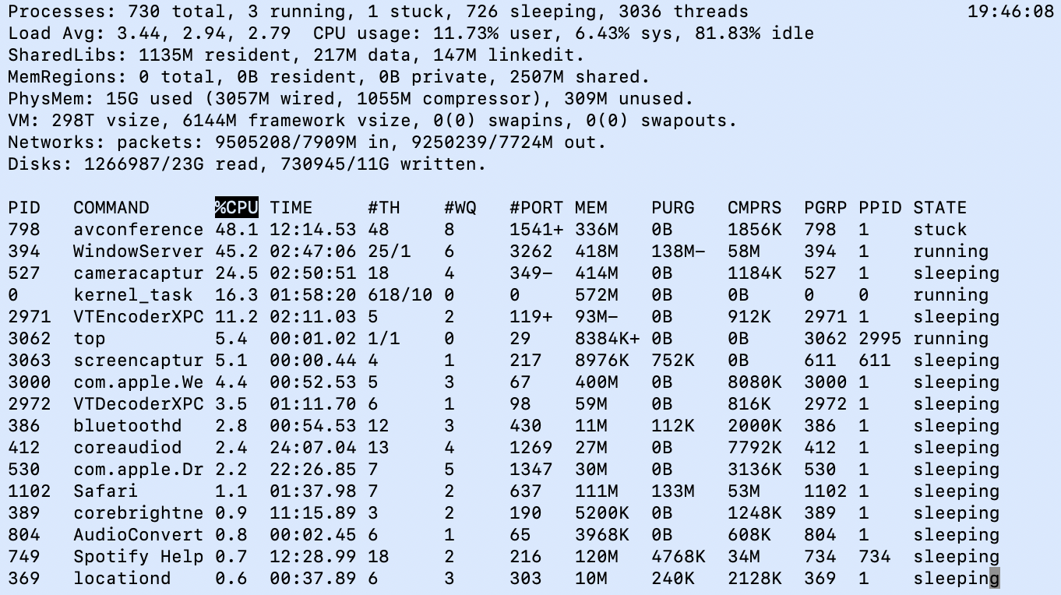
3. Display Storage Information
4. Display Running Processes
5. Display Live System Usage

