Practical Session 1

Task 1
Develop a C program that demonstrates how a Linux operating system executes a command entered by a user that:
- Accept a Linux command as input.
- Create a child process using fork().
- Execute the command in the child process using an appropriate exec() system call.
- Allow the parent process to wait for the child using wait().
- Display the Process ID (PID) of both parent and child processes.
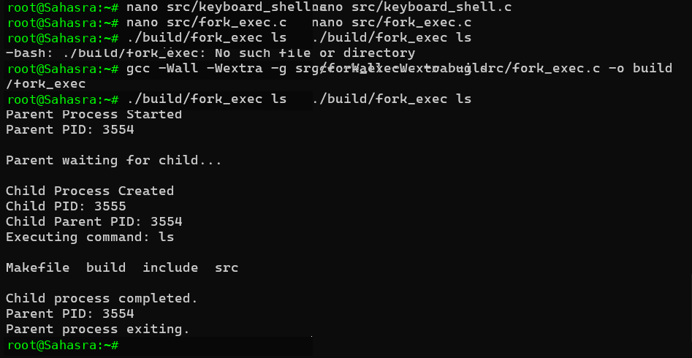
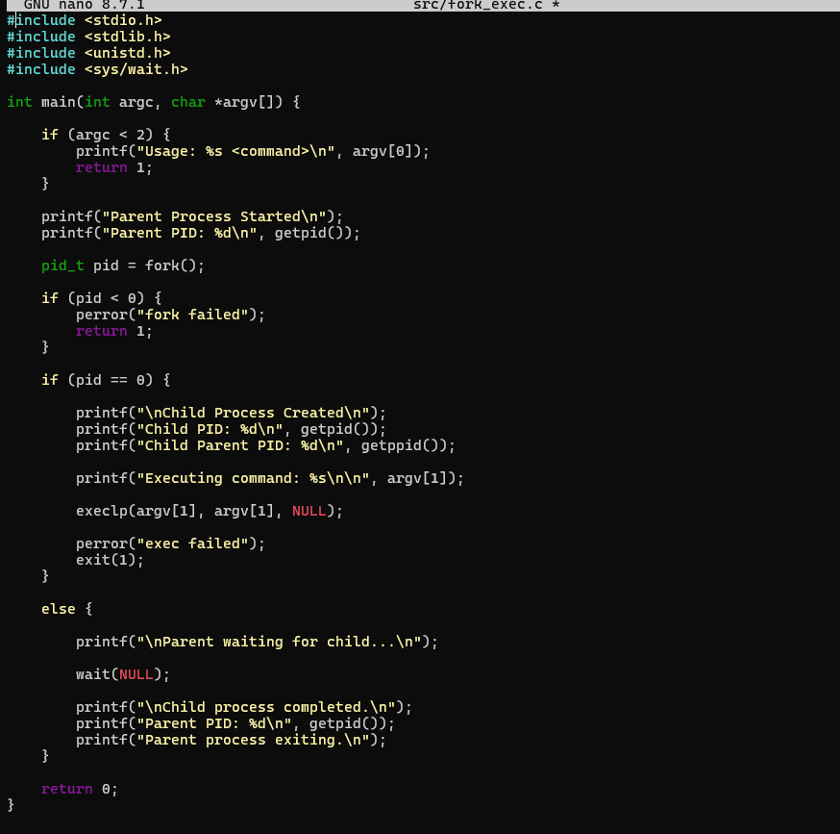

Task 2
Using Linux terminal commands (uname, lscpu, lsblk, ps, top), investigate the relationship between hardware resources and operating system services. Prepare a report explaining how the OS abstracts CPU, memory, storage, and I/O devices.
