A Project Report on
PPO-BASED SEMANTIC AND AGE-OF-INFORMATION-AWARE SCHEDULING FOR MASSIVE IOT NETWORKS
submitted in partial fulfilment of the requirements for the course

MACHINE LEARNING
25SC2107E
in
A.Y.: 2026-27
by

L. Sahasra Roll No. 2520040087
M. Honeysha Roll No. 252004085
Nimisha Sri Roll No. 2520029127

Under the Esteemed guidance of
Venu Bajaji Vinnakota
Assistant Professor,
Department of ECE





DEPARTMENT OF ELECTRONICS & COMMUNICATION ENGINEERING

Abstract:

Massive Internet of Things (IoT) networks contain many connected devices that periodically report status updates, while a network may provide only one transmission opportunity at a time. A scheduler must therefore decide which device should transmit next. Prioritizing only the oldest information can overlook the meaning of an update, while selecting only the most important information can allow other devices to become stale. This project investigates a Proximal Policy Optimization (PPO) scheduler that learns a trade-off between information freshness and semantic importance. A Python simulation models ten virtual IoT devices and one permitted transmission per time slot. The observation contains twenty values: the normalized Age of Information (AoI) for each device and a synthetic importance score between zero and one. PPO chooses one of ten actions, the selected device's AoI is reset to zero, and the remaining devices age subject to a cap of 50. Each episode lasts 200 time slots.

PPO is implemented with Stable-Baselines3 and an MLP policy; the recorded training monitor contains 757 completed episodes (151,400 time steps, close to the configured 150,000-step budget). The evaluation compares PPO with Random, Highest-AoI, and Highest-Semantic policies over 50 matched-seed episodes per policy. The repository's results.csv reports mean and standard deviation across those 50 episodes. PPO achieved the highest cumulative reward (52.490 ± 7.716) and semantic utility of 0.699 ± 0.092, with average AoI of 8.682 ± 1.434 and peak AoI of 35.160 ± 6.166. Highest-AoI achieved the best freshness results, while Highest-Semantic achieved the highest semantic utility. The recorded training curve shows a noisy but generally improving reward trend. These findings demonstrate the trade-off in this controlled simulation; they do not establish that PPO is best on every metric or that the result transfers directly to real hardware. Semantic scores are synthetic, and channel errors, queues, energy, and physical devices are outside the current model.
Signature of the Supervisor Course Instructor

INDEX
Abstract 2
1. Introduction 4
1.1 Background and Motivation 5
1.2 Current Work and Challenges 5
1.3 Problem Statement 6
1.4 Objectives and Contributions 6
2. System Model and Problem Formulation 7
2.1 Network and State Model 7
2.2 Action Space 7
2.3 State Transition 7
2.4 Reward Function 8
3. Proposed PPO Scheduling Method 9
3.1 Reinforcement Learning Formulation 9
3.2 Proximal Policy Optimization 9
3.3 Training Configuration 9
3.4 Baseline Scheduling Policies 9
3.5 High-Level Algorithm 10
4. Experimental Setup and Results 11
4.1 Experimental Setup 11
4.2 Evaluation Metrics 11
4.3 PPO Training Reward Curve 11
4.4 Numerical Results 12
4.5 Discussion of Results 14
4.6 Main Finding 15
4.7 Practical Usefulness and Interpretation 16
5. Conclusion and Future Scope 17
References 19

- Introduction

The Internet of Things (IoT) connects sensors, machines, appliances, and other devices that continuously produce status updates. In many networks, devices compete for limited communication opportunities. When only one device can transmit in a time slot, the scheduler must select which update should be delivered next.
Age of Information (AoI) measures how old the latest information is at the receiver. Lower AoI generally indicates fresher information. However, freshness alone does not capture whether a message is useful. A routine sensor reading may be old, while a safety-related update may be highly important. A useful scheduler should therefore consider both information freshness and semantic importance.
This project formulates the choice of a transmitting device as a reinforcement-learning problem. A Proximal Policy Optimization (PPO) agent observes the current AoI and importance values, chooses one of ten devices, receives a reward, and learns from repeated interactions with a simulated environment. The learned policy is compared with simple rules that provide interpretable reference points.
1.1 Background and Motivation
Rule-based scheduling is easy to understand, but each fixed rule emphasizes only one objective. Random scheduling provides a neutral reference. Highest-AoI prioritizes the device with the stalest information, while Highest-Semantic prioritizes the device whose update has the largest importance score. The first rule tends to keep information fresh, whereas the second can repeatedly serve important devices while allowing others to become stale. This project studies whether PPO can learn a useful balance from a reward that includes both terms.
1.2 Current Work and Challenges
Earlier work has studied freshness-aware scheduling and semantic-aware scheduling from different angles. Research on classified wireless body-area networks considers age penalties that reflect the value of health-monitoring information [1]. Deep reinforcement-learning research has also investigated AoI scheduling in wireless powered sensor networks, where energy availability and wireless conditions influence transmission decisions [2]. These studies motivate the use of application importance and learning-based scheduling, but their network assumptions differ from the simplified model used here.
The central challenge is that freshness and importance can conflict. If the scheduler always selects the highest-AoI device, it may deliver routine data while missing a highly important event. If it always selects the highest-importance device, some other devices may remain stale for a long time. A further challenge is evaluation: average AoI, worst-case AoI, semantic utility, and reward measure different properties, so one metric alone cannot show the complete behavior. This project isolates the trade-off in a reproducible simulation before introducing channel failures, energy limits, queues, or real sensor data.
The central challenge is that freshness and importance can conflict. If the scheduler always selects the highest-AoI device, it may deliver routine data while missing a highly important event. If it always selects the highest-importance device, some other devices may remain stale for a long time. A further challenge is evaluation: average AoI, worst-case AoI, semantic utility, and reward measure different properties, so one metric alone cannot show the complete behavior. This project isolates the trade-off in a reproducible simulation before introducing channel failures, energy limits, queues, or real sensor data.
1.3 Problem Statement
Given ten virtual IoT devices, one transmission opportunity per time slot, the AoI of each device, and a semantic-importance score for each device, select one device at every time step to balance information freshness and semantic utility. The policy is assessed against transparent baselines using the same environment and matched initial conditions.
1.4 Objectives and Contributions
The objectives are to: (1) develop a Python simulation of a constrained IoT scheduling environment; (2) represent each device using AoI and semantic-importance information; (3) train a PPO policy to select one device per time slot; (4) compare PPO with Random, Highest-AoI, and Highest-Semantic baselines; (5) evaluate average AoI, peak AoI, semantic utility, and cumulative reward over 50 episodes; and (6) explain the observed trade-offs and limitations. The contribution is an implemented and reproducible comparison framework, not a claim of a new PPO algorithm.
2. SYSTEM MODEL AND PROBLEM FORMULATION
The project models a small IoT network in which ten virtual devices compete for one transmission opportunity in every discrete time slot. This is a controlled simulation rather than a physical hardware implementation. Each device has an Age of Information value and a semantic-importance value between zero and one. The semantic values in the current version are synthetic.
2.1 Network and State Model
The repository environment normalizes each AoI by the maximum AoI of 50 before adding it to the observation. This produces ten normalized AoI values and ten semantic-importance values in a 20-dimensional state.

Equation (1). State representation supplied to PPO; N = 10 and A_max = 50.
The state interleaves the normalized age and importance of each device. Normalization keeps AoI inputs within the same 0-to-1 range as the importance values, helping the neural policy work with consistently scaled inputs.
2.2 Action Space
The action space is discrete with ten actions. Action 0 selects Device 1, action 1 selects Device 2, and so on, through action 9 for Device 10. Only one device can be selected in each time slot.
2.3 State Transition
At each step, all device AoI values increase by one, subject to the maximum value of 50. The selected device’s AoI is then reset to zero because its information has been transmitted. The episode length is fixed at 200 time slots. This transition captures the freshness effect of serving one device while the remaining devices become older.
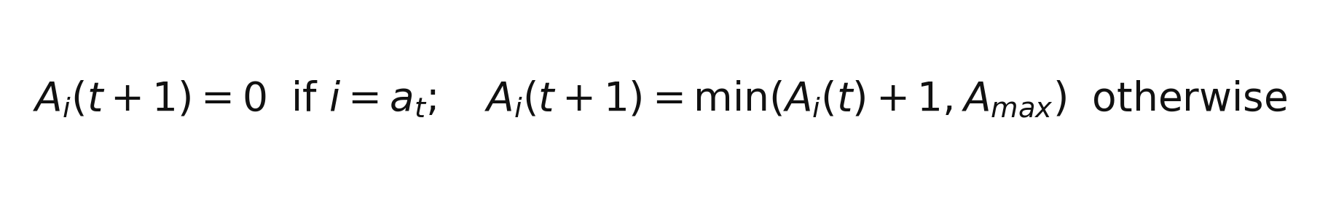
Equation (2). AoI transition after scheduling action a_t.
In plain language, the chosen device becomes fresh immediately after service, while every other device becomes one time slot older. No device can exceed the cap of 50. This rule isolates scheduling decisions from channel effects because a selected transmission is always assumed to succeed.
2.4 Reward Function
The repository implementation calculates the reward after updating all devices' AoI values and resetting the selected device's AoI to zero. The reward has two terms: a positive semantic benefit for the selected device and a negative penalty based on the mean AoI of the updated network. The implemented formula is shown below.

Equation (3). Implemented reward function, evaluated using AoI after the state update.
Here, I_(a_t) is the importance of the selected device, A_i(t+1) is the updated AoI of device i, N is the number of devices, and A_max = 50. Both terms have equal weights of 0.5. The semantic term rewards selecting an important update; the AoI term penalizes a network whose information is old on average. This is a simplified weighted objective, not a claim that one weighting is universally optimal.

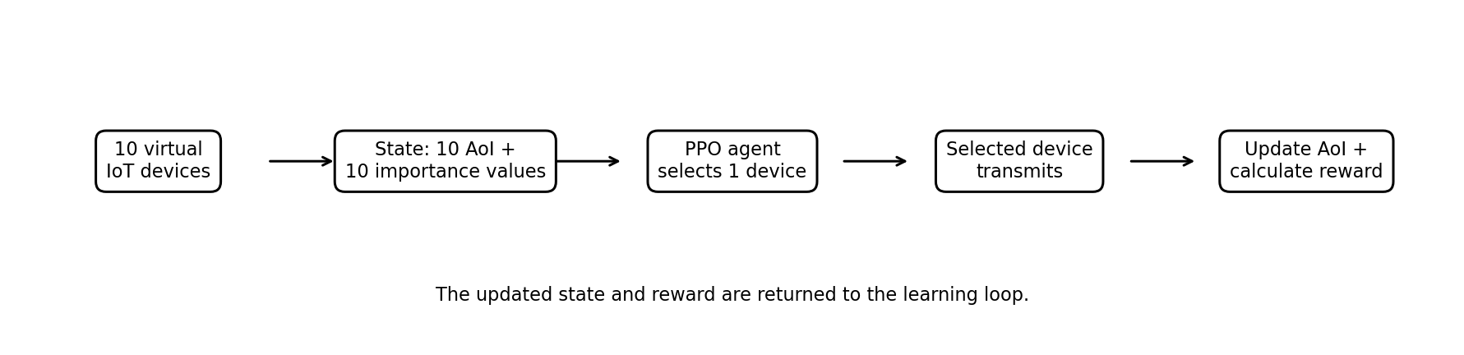Figure 1. Overall simulation and PPO scheduling loop.

3. PROPOSED PPO SCHEDULING METHOD
3.1 Reinforcement Learning Formulation
The scheduling environment is modeled as a Markov decision process. At every time step, the agent receives the state, selects an action, the environment updates the AoI values, and a scalar reward is returned. Repeated interaction supplies experience for policy improvement.
3.2 Proximal Policy Optimization
Proximal Policy Optimization (PPO) is a policy-gradient reinforcement learning method. It updates a policy while limiting how much the new policy can differ from the previous policy in a single update. This helps make policy learning more stable than unrestricted large policy updates. The project uses Stable-Baselines3 and an MLP (multilayer perceptron) policy.

Equation (4). Clipped PPO objective, shown in its standard simplified form.
The probability ratio compares how likely the new policy is to select an action relative to the previous policy. The advantage estimate measures whether an action performed better than expected. Clipping limits the effect of very large policy changes during an update, which helps training remain stable. This optimization objective is part of PPO; it is separate from the environment reward in Equation (3).
3.3 Training Configuration
The repository configuration sets a 150,000-step training budget, an episode length of 200 time slots, a fixed seed of 42, and CPU training. Because the last episode can finish after the requested threshold is crossed, the monitor file contains 757 completed episodes or 151,400 recorded time steps. PPO uses an MLP policy with hidden layers [64, 64], learning rate 3 × 10^-4, rollout length 2,048, batch size 64, 10 optimization epochs, discount factor 0.99, GAE lambda 0.95, clipping range 0.2, and entropy coefficient 0.01. These settings were used as configured and were not reported as hyperparameter-tuned.
3.4 Baseline Scheduling Policies
Random: chooses a device at random and provides a simple reference for performance.
Highest-AoI: selects the device with the greatest AoI. This rule focuses on reducing the age of the stalest information.
Highest-Semantic: selects the device with the greatest semantic-importance score. This rule prioritizes important information even when other devices become stale.
PPO: selects a device using the policy learned from the state and reward signal. Its performance is compared with the three fixed decision rules.
3.5 High-Level Algorithm
1. Initialize the ten-device environment and reset the AoI state.
2. Construct the observation from the ten AoI values and ten importance values.
3. Select a device using the policy being evaluated.
4. Transmit the selected device’s update.
5. Increase AoI for all devices and reset the selected device’s AoI according to the environment transition.
6. Calculate the reward and record the evaluation metrics.
7. During PPO training, use collected experience to update the policy.
8. Repeat until the episode ends; evaluate each policy over 50 episodes.
Algorithm 1: PPO-Based IoT Device Scheduling
Input: AoI vector, semantic-importance vector, trained PPO policy
Output: selected device for the current time slot
1. Observe the current 20-dimensional state.
2. Use PPO to select one of the ten device actions.
3. Allow the selected device to transmit.
4. Update the AoI values and calculate the reward.
5. Return the next state and reward to the learning loop.
The training loop repeats this interaction and stores completed episode returns in training.monitor.csv. During evaluation, each policy is run for 50 episodes. Episode k uses the same reset seed for every policy, so methods start from matched initial AoI and importance values. PPO uses deterministic action selection during evaluation. This makes the comparison more controlled than evaluating each method from unrelated starting states.

4. EXPERIMENTAL SETUP AND RESULTS
4.1 Experimental Setup
The repository evaluation script evaluates each scheduling method over 50 episodes. For a fair comparison, episode k uses the same reset seed for every method, and PPO selects actions deterministically during evaluation.
4.2 Evaluation Metrics
Average AoI: the mean information age over the evaluated devices and time. Lower values indicate fresher information overall.
Peak AoI: the maximum observed information age. Lower values indicate that the oldest information was less stale.
Semantic Utility: the average semantic importance of selected or successfully served devices, as defined in the implementation. Higher values indicate that more important information was served.
Cumulative Reward: the sum of rewards over an episode or evaluation run. Higher values indicate better performance under the implemented reward function. The cumulative reward should be interpreted alongside AoI and semantic utility, because it reflects the project’s chosen reward rather than every possible network objective.

Equation (5). Summary expressions for average AoI, semantic utility, and cumulative reward.
Peak AoI is computed separately as the maximum AoI reached by any device in any slot of an episode. For each method, the repository evaluates 50 episodes and reports the mean and standard deviation. Error bars in the comparison charts represent one standard deviation, showing the variation between episodes rather than a confidence interval.
4.3 PPO Training Reward Curve
Figure 2 shows episode reward from the repository training monitor. For readability, the blue episode-reward trace is sampled every five completed episodes, while the red line is the corresponding 20-episode moving average calculated from the full monitor log. The log contains 757 completed episodes (151,400 time steps). The average reward across all recorded episodes is 47.87; the mean of the first 20 episodes is 31.97, compared with 50.95 for the last 20 episodes. This increase suggests the agent learned a more rewarding scheduling pattern, although individual episode rewards remain noisy because initial ages and importance values are resampled.
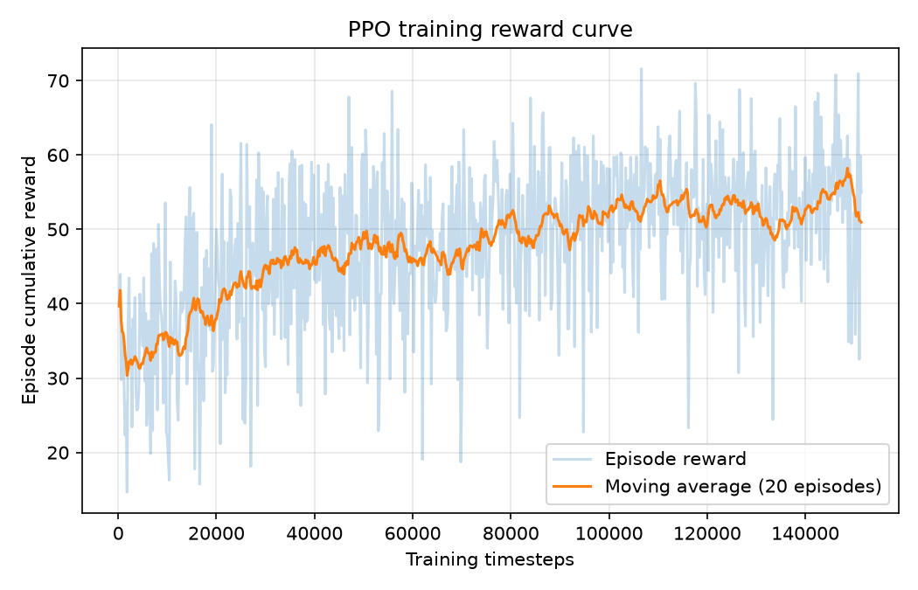
Figure 2. PPO training reward curve generated from training.monitor.csv; 20-episode moving average.
How to read the graph: the blue trace represents the total reward collected during an individual 200-slot episode, so it naturally rises and falls. The red moving-average line smooths these short-term changes. It begins near the low-to-mid 30s in early training and is generally around the low-to-mid 50s toward the end. The line does not need to rise at every point for learning to occur. A higher return means the policy obtained a better combined score under the chosen reward formula; it does not by itself prove that average AoI or peak AoI is the lowest.
4.4 Numerical Results
Table 1 presents the mean ± standard deviation values from the repository's results.csv, which aggregates 50 evaluation episodes per scheduling method. These repository results are used as the primary numerical source because they include the episode-level evaluation summary. The charts show the means with one-standard-deviation error bars.
Scheduling method | Average AoI ↓ | Peak AoI ↓ | Semantic utility ↑ | Cumulative reward ↑
Random | 8.740 ± 0.607 | 47.520 ± 4.072 | 0.477 ± 0.079 | 30.223 ± 8.044
Highest-AoI | 4.509 ± 0.024 | 10.660 ± 1.206 | 0.478 ± 0.074 | 38.809 ± 7.427
Highest-Semantic | 40.486 ± 0.221 | 50.000 ± 0.000 | 0.906 ± 0.093 | 9.599 ± 9.444
PPO | 8.682 ± 1.434 | 35.160 ± 6.166 | 0.699 ± 0.092 | 52.490 ± 7.716
Table 1. Mean ± standard deviation across 50 evaluation episodes from repository results.csv.
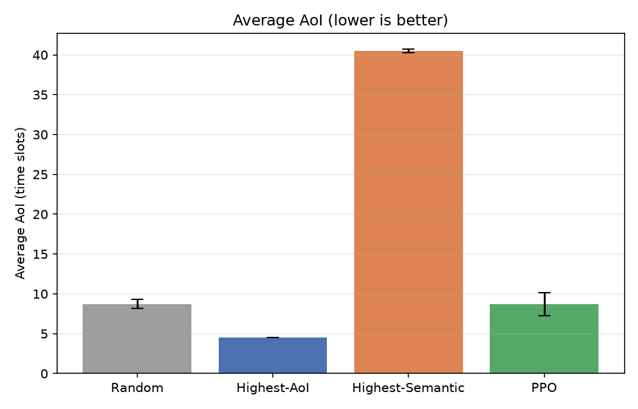
Figure 3. Average AoI comparison across scheduling policies.
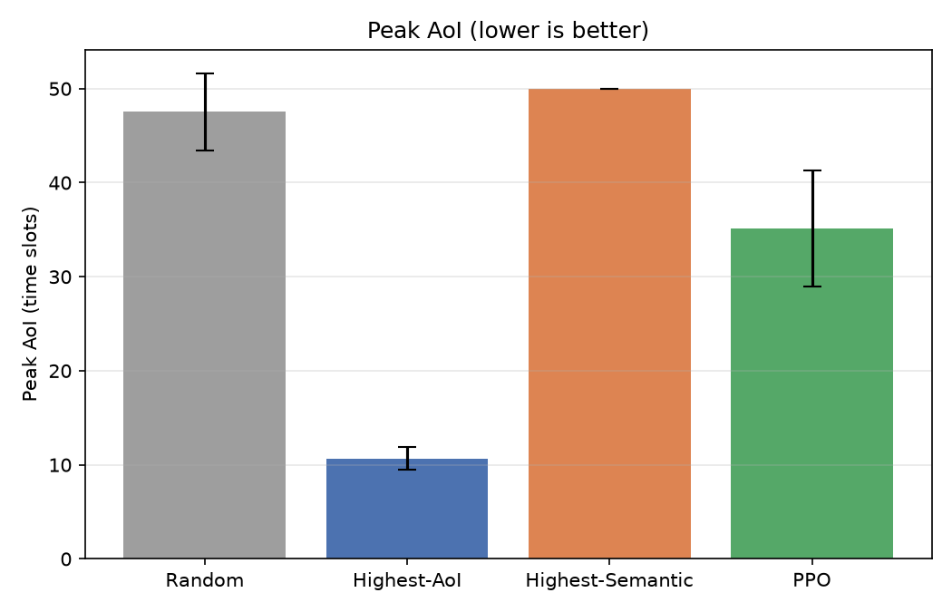
Figure 4. Peak AoI comparison across scheduling policies.
Figure 5. Semantic utility comparison across scheduling policies.
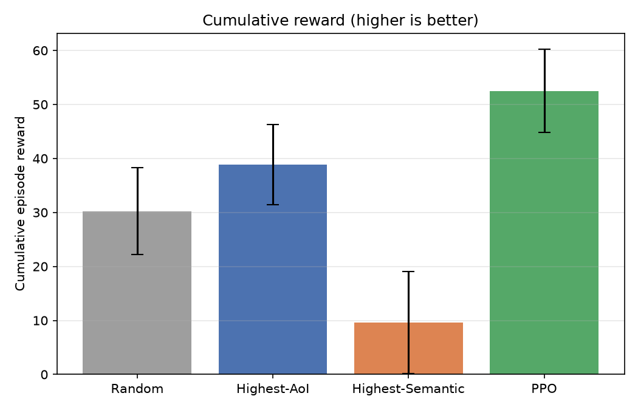
Figure 6. Cumulative reward comparison across scheduling policies.
4.5 Discussion of Results
Average AoI: Highest-AoI achieved the lowest average AoI at 4.509 slots. PPO achieved 8.682 slots, close to Random at 8.740 slots, while Highest-Semantic reached 40.486 slots. The result is consistent with the expected trade-off: choosing the stalest device directly targets freshness, whereas choosing only by semantic importance can leave less-important devices waiting for long periods.
Peak AoI: Highest-AoI recorded the lowest peak AoI at 10.660 slots. PPO recorded 35.160 slots, compared with 47.520 for Random and 50.000 for Highest-Semantic. The reported result suggests that the Highest-AoI rule is strongest for the freshness metrics in this experiment.
Semantic Utility: Highest-Semantic achieved the highest utility at 0.906. PPO reached 0.699, exceeding Random (0.477) and Highest-AoI (0.478). PPO therefore served semantically important updates more effectively than the two baselines that do not explicitly optimize semantic importance, while not reaching the utility of the importance-only rule.
Cumulative Reward: PPO achieved the highest cumulative reward at 52.490, followed by Highest-AoI at 38.809, Random at 30.223, and Highest-Semantic at 9.599. Under the implemented reward function, PPO provides the strongest overall reward. This should not be interpreted as PPO being best on every individual metric: Highest-AoI leads on freshness, and Highest-Semantic leads on semantic utility.
4.6 Main Finding
The results demonstrate a multi-objective trade-off rather than a single policy dominating all metrics. PPO’s main result is the highest cumulative reward with intermediate freshness and semantic utility. The two rule-based strategies provide useful extremes: Highest-AoI favors freshness, while Highest-Semantic favors importance. The conclusion is limited to the current synthetic, ten-device simulation and the specific reward definition used.
The average-AoI chart shows why the freshness-only rule performs well on age: Highest-AoI repeatedly serves the stalest device, producing the lowest average AoI (4.509). PPO averages 8.682, while Random is 8.740. The difference between PPO and Random is small for average AoI in this run, so the main advantage of PPO should not be described as winning every freshness metric.
The peak-AoI chart reveals a similar pattern. Highest-AoI limits the worst observed staleness to 10.660 on average, whereas PPO reaches 35.160 and Random reaches 47.520. Highest-Semantic reaches the cap of 50.000 because the same high-importance devices may be selected repeatedly, leaving other devices waiting. The semantic-only policy therefore illustrates how an application can receive important messages while still maintaining stale information elsewhere in the network.
The semantic-utility chart shows the opposite side of the trade-off. Highest-Semantic reaches 0.906 because it always selects the device with the largest importance score. PPO reaches 0.699, well above Random (0.477) and Highest-AoI (0.478), showing that it can select valuable updates more often than policies that do not explicitly balance semantic value. It does not match the semantic-only strategy because it also pays attention to freshness through the reward penalty.
The cumulative-reward chart is the metric directly optimized during training. PPO records the highest mean reward (52.490), followed by Highest-AoI (38.809), Random (30.223), and Highest-Semantic (9.599). The low reward for Highest-Semantic is consistent with its very high mean AoI, which creates a large negative freshness term. Read together, the four charts show that PPO provides the best reward under the current 0.5/0.5 weighting, but Highest-AoI remains best for freshness and Highest-Semantic remains best for semantic utility.
4.7 Practical Usefulness and Interpretation
The main practical value of this project is its comparison framework. In a real monitoring network, a scheduler may have to choose between an old routine measurement and a newer but more informative event. By recording freshness, semantic utility, and reward separately, the simulation makes this conflict measurable instead of hiding it in one final score. The same framework can later be adapted to healthcare sensors, industrial monitoring, environmental sensors, or smart-city devices, provided that importance scores are defined from an appropriate application and the model is extended to reflect the network conditions.
The current result should be interpreted as a prototype and not as a deployment-ready scheduler. The synthetic importance scores are useful for testing the logic, but they do not demonstrate how semantic importance would be estimated from actual sensor messages. The simulation also assumes successful transmission and does not charge the scheduler for energy, latency, or congestion. These limitations are important because they can change which policy is best in a real network.

5. CONCLUSION AND FUTURE SCOPE
5.1 Conclusion
This project implemented a simulation-based framework for semantic- and Age-of-Information-aware scheduling in a constrained IoT network. Ten virtual devices share one transmission opportunity per time slot. The environment represents each device using AoI and a synthetic semantic-importance score, and the PPO agent learns to select one device using state, action, and reward feedback. Random, Highest-AoI, and Highest-Semantic baselines were used to contextualize the learned policy.
Across the reported 50-episode evaluation, PPO achieved the highest cumulative reward of 52.490 and semantic utility of 0.699, with average AoI of 8.682 and peak AoI of 35.160. Highest-AoI achieved the lowest average and peak AoI, while Highest-Semantic achieved the highest semantic utility. These findings support the project’s central observation that freshness and semantic importance can conflict, and that the chosen reward function determines the balance encouraged by learning.
5.2 Limitations
• Semantic-importance scores are synthetic rather than derived from real sensor data or a trained semantic feature extractor.
• Channel quality, packet failures, queues, throughput, delay, and energy consumption are not modeled in the current version.
• The aggregate results.csv reports means and standard deviations over 50 evaluation episodes, but the experiment uses one configured training seed and does not report confidence intervals across independent training runs.
• PPO hyperparameters and the 0.5/0.5 reward weights were not tuned systematically. A different reward weighting or network model may change the policy ranking.
5.3 Future Scope
• Use real or application-grounded data to define semantic importance.
• Model channel conditions, packet failures, queues, and variable transmission success.
• Include throughput, delay, fairness, and energy-consumption metrics.
• Run multiple random seeds and report variability, confidence intervals, and statistical comparisons.
• Study sensitivity to the number of devices, episode length, reward weights, and AoI cap.
• Save raw evaluation outputs and generate training and evaluation plots directly from CSV logs for reproducibility.
REFERENCES
[1] G. Xin, F. Hu, Z. Ling, S. Na, and C. L. Jin, “Dynamic Scheduling for Minimizing Age Penalty in Resource-Constrained Classified WBANs With Energy Harvesting,” IEEE Sensors Journal, vol. 23, pp. 23638–23652, Oct. 2023. doi: 10.1109/JSEN.2023.3285248.
[2] W. Jin, J. Sun, K. Chi, and S. Zhang, “Deep Reinforcement Learning Based Scheduling for Minimizing Age of Information in Wireless Powered Sensor Networks,” Computer Communications, vol. 191, pp. 1–10, 2022. doi: 10.1016/j.comcom.2022.04.007.
[3] J. Schulman, F. Wolski, P. Dhariwal, A. Radford, and O. Klimov, “Proximal Policy Optimization Algorithms,” arXiv:1707.06347, 2017.
[4] Stable-Baselines3 Contributors, “Stable-Baselines3: Reliable Reinforcement Learning Implementations,” project documentation, https://stable-baselines3.readthedocs.io/ (accessed 15 October 2026).
[5] Project team, “PPO-Based Semantic and Age-of-Information-Aware Scheduling for Massive IoT Networks,” project review presentation and evaluation-results slides, 2026.
[6] Project team, “PPO IoT Scheduling,” source repository, including environment.py, train_ppo.py, evaluate.py, results.csv, and training.monitor.csv, 2026. https://github.com/sahasralaggani123-bit/PPO-Based-Analysis-using-Semantic-and-AOI-Information--ML

