NEAR-DUPLICATE DOCUMENT DETECTION
A Project Based Learning Report
Submitted in partial fulfilment of the requirements for the award of the degree
of
BACHELOR OF TECHNOLOGY
Department of Computer Science and Engineering
Course: Data Structures and Algorithms

SUBMITTED BY
2510030377 — Sahasra
2510030402 — Ashwini
2510030255 — Manisha

UNDER THE GUIDANCE OF
Mr. Aftab Yaseen

Department of Electronics and Communication Engineering
Koneru Lakshmaiah Education Foundation
Aziz Nagar, Hyderabad – 500075
October 2026

ABSTRACT
Near-duplicate document detection identifies documents that are highly similar in content but are not necessarily identical character by character. This project presents a web-based application that accepts TXT, PDF and DOCX files, preprocesses their text, and compares documents using several complementary techniques. Shingling creates overlapping word sequences; Jaccard similarity measures exact overlap between shingle sets; MinHash estimates shingle-set similarity; SimHash creates compact content fingerprints; Hamming distance compares fingerprint bits; and TF-IDF cosine similarity compares weighted word vectors. The system uses a React frontend and a FastAPI backend, with SQLite storing comparison history such as filenames, scores and labels. In the example shown in the project presentation, eight of 62 shingles were shared, Jaccard similarity was 12.9%, MinHash estimated 16.4%, SimHash similarity was 78.1%, and TF-IDF cosine similarity was 52.2%. These values demonstrate why multiple metrics should be interpreted together rather than relying on a single score. The application is intended to support review and investigation; a similarity score alone is not proof of plagiarism or copying.

Keywords
Near-duplicate detection, shingling, Jaccard similarity, MinHash, SimHash, Hamming distance, TF-IDF, cosine similarity.

LIST OF FIGURES
Figure 1. System architecture of the near-duplicate document detection application.

LIST OF TABLES
Table 1. Algorithms used and their roles.
Table 2. Example comparison results reported in the project presentation.

TABLE OF CONTENTS
1. Introduction
2. Methodology
2.1 System Design and Architecture
2.2 Preprocessing and Shingling
2.3 Similarity Algorithms
3. Experiments
4. Results and Discussion
5. Conclusion and Future Work
References

NEAR-DUPLICATE DOCUMENT DETECTION
A framework for comparing documents using shingles, fingerprints and similarity scores.

1. INTRODUCTION
Digital documents are created, edited and shared at a large scale. In academic settings, digital libraries, content management systems and document archives, it is common to encounter documents that contain repeated or lightly modified text. Exact file matching is insufficient for these cases because formatting changes, punctuation edits, reordered wording or small revisions can make two files differ even when much of their content is shared. Near-duplicate detection therefore aims to estimate how closely two documents resemble one another while tolerating some changes.
A practical detector should distinguish several kinds of similarity. Exact overlap of word sequences can be measured with shingle sets, while vector-based methods can capture shared vocabulary even when exact sequences differ. Hash-based fingerprints provide compact representations that are useful when many documents must be compared. Broder described resemblance and containment measures for documents using shingling and set overlap [1]. Charikar introduced similarity-estimation techniques based on rounding algorithms, which are relevant to compact fingerprinting approaches such as SimHash [2]. TF-IDF weighting and cosine similarity are established techniques for comparing text documents by their term distributions [3].
This project combines these complementary methods in one application rather than presenting a single score as a definitive answer. Users upload two or more TXT, PDF or DOCX documents, select comparison settings, and receive similarity metrics and a category based on the configured Jaccard threshold. The user interface also provides comparison history and CSV export. The presentation reports that the example pair shared 8 of 62 shingles, yet its SimHash similarity was much higher than its Jaccard score. This difference illustrates that each metric measures a different property of the text.
The main objectives are: (i) accept common document formats; (ii) normalize extracted text consistently; (iii) implement exact and approximate similarity measures; (iv) display results in an understandable interface; and (v) preserve useful comparison metadata without storing the uploaded document contents. The intended use is as a screening aid. Results should be reviewed alongside the documents themselves, because high similarity may arise from quotations, templates or common terminology, and a low score does not guarantee that two documents are unrelated.

2. METHODOLOGY

2.1 System Design and Architecture
The application follows a frontend–backend design. The React interface, built with Vite and Tailwind, handles file selection, settings and result display. A FastAPI service provides endpoints and validates incoming requests. The backend extracts text, preprocesses it, creates shingles and fingerprints, computes similarity metrics, and returns a structured result. SQLite stores local history containing filenames, scores and labels. According to the project design, uploaded files are parsed in memory and are not stored in the history database.
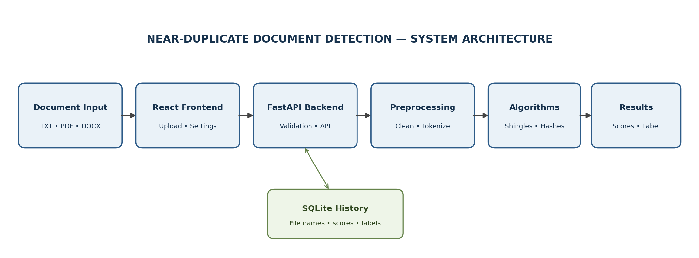
Figure 1. System architecture of the near-duplicate document detection application.

2.2 Preprocessing and Shingling
The application accepts TXT, PDF and DOCX files. Extracted text is converted to lowercase, punctuation and symbols are removed, words are tokenized, stop words are filtered, and extra whitespace is collapsed. These operations reduce superficial differences that do not necessarily indicate a meaningful content change. After preprocessing, a sliding window creates overlapping k-word shingles. For example, with k = 3, the sentence “documents can be compared effectively” produces “documents can be”, “can be compared” and “be compared effectively”. The shingle size is a configurable parameter.

2.3 Similarity Algorithms
Method | Representation / calculation | Role in the system
Shingling | Overlapping k-word sequences | Converts text into comparable units
Jaccard similarity | |A ∩ B| / |A ∪ B| × 100% | Exact overlap between shingle sets
MinHash | Signature generated with multiple hash functions | Estimates Jaccard similarity efficiently
SimHash | 64-bit weighted word fingerprint | Captures content similarity in compact form
Hamming distance | Number of differing fingerprint bits | Measures distance between SimHash fingerprints
TF-IDF cosine | Cosine of the angle between weighted term vectors | Measures similarity in word-weight distributions

The final category in the presented application is driven by the configured Jaccard threshold. A score at or above the threshold is categorized as highly similar; a score between half the threshold and the threshold is moderately similar; and a score below half the threshold is low similarity. MinHash, SimHash and cosine values are shown as complementary signals, not substituted for the Jaccard-based label.

3. EXPERIMENTS

3.1 Input Data and Experimental Procedure
The example reported in the presentation compares the files named “doc1_original” and “doc1_near_dup”. The workflow is: select the documents, extract and normalize text, create shingles, generate the required fingerprints and vectors, calculate the similarity metrics, and present the scores. The interface supports TXT, PDF and DOCX input and provides controls for shingle size, MinHash function count and the detection threshold.

3.2 Evaluation Scope
The results in this report are the example values displayed in the project presentation. They are not a claim of benchmark accuracy across a large dataset. A more comprehensive evaluation would require a labelled collection containing exact duplicates, lightly edited documents, documents on the same topic with different wording, and unrelated documents. Thresholds could then be evaluated using precision, recall, F1-score and false-positive/false-negative counts. Those dataset-wide measurements were not provided in the supplied presentation.

4. RESULTS AND DISCUSSION
Metric | Reported result | Interpretation
Shared shingles | 8 of 62 | Only a limited portion of the shingle set overlaps
Jaccard similarity | 12.9% | Exact overlap of the shingle sets
MinHash estimate | 16.4% | Approximate estimate of shingle overlap
SimHash similarity | 78.1% | Fingerprint-based similarity derived from bit differences
Hamming distance | 14 / 64 bits | Fourteen fingerprint bits differ
TF-IDF cosine similarity | 52.2% | Moderate similarity in weighted word-vector space
Exact match | No | The example pair is not an exact duplicate

4.1 Interpretation of the Example
The reported Jaccard value is 12.9%, reflecting the limited exact overlap among shingles. MinHash gives an estimate of 16.4%, which is reasonably close but not identical; estimation differences are expected from a finite signature. SimHash reports 78.1% similarity with a Hamming distance of 14 out of 64 bits, while TF-IDF cosine similarity is 52.2%. These values are not contradictory: shingle overlap, fingerprint distance and vector similarity represent different aspects of textual resemblance.
The presentation also shows an exact-duplicate pair with Jaccard and cosine similarity of 100%, labelled highly similar. The near-duplicate example is labelled low similarity under the displayed Jaccard threshold. Lowering the threshold may change the category, so the threshold should be selected based on the intended use and tested against representative examples. A label should guide further review rather than serve as an automatic judgement of misconduct.

4.2 Implementation and User Interface
The technology stack shown in the presentation includes React, Vite, Tailwind and Recharts on the frontend; Python and FastAPI on the backend; NumPy and scikit-learn for numerical and vector operations; PyMuPDF and python-docx for document parsing; and SQLite for local history. The interface groups document selection, similarity summaries, searchable history, deletion and CSV export into one workflow.

5. CONCLUSION AND FUTURE WORK

5.1 Conclusion
This project presents a near-duplicate document detection workflow that combines text normalization, shingling, Jaccard similarity, MinHash, SimHash, Hamming distance and TF-IDF cosine similarity. Its web interface accepts common document formats and reports several scores so users can understand more than one dimension of similarity. The example output demonstrates that scores may differ substantially because each algorithm measures a different signal. The application therefore supports document screening and comparison, while leaving final interpretation to the user.

5.2 Future Work
The next development priorities identified in the presentation are interactive learning pages for the algorithms, side-by-side original and preprocessed text panels, matching-passage highlighting, a downloadable PDF report, threshold tuning on low/medium/high similarity examples, and scalability improvements for large document collections. Local SQLite history could be replaced with PostgreSQL if multi-user persistence is required. Future evaluation should also use labelled test pairs and report precision, recall and F1-score before making claims about detection accuracy.

REFERENCES
[1] Broder, Andrei Z. “On the Resemblance and Containment of Documents.” Compression and Complexity of Sequences 1997, IEEE, 1997, pp. 21–29.
[2] Charikar, Moses S. “Similarity Estimation Techniques from Rounding Algorithms.” Proceedings of the Thirty-Fourth Annual ACM Symposium on Theory of Computing, ACM, 2002, pp. 380–388.
[3] Salton, Gerard, and Christopher Buckley. “Term-Weighting Approaches in Automatic Text Retrieval.” Information Processing & Management, vol. 24, no. 5, 1988, pp. 513–523.
[4] Leskovec, Jure, Anand Rajaraman, and Jeffrey D. Ullman. Mining of Massive Datasets. 3rd ed., Cambridge University Press, 2020.

