AI-Driven Smart Healthcare Data Exchange and Analytics Ecosystem
A Project Based Learning Report Submitted in partial fulfilment of the requirements for the award of the degree of Bachelor of Technology Department of computer Science and Engineering Koneru Lakshmaiah Education Foundation, Aziz Nagar October - 2026

of

Bachelor of Technology
in The Department of computer science and engineering
Course Name: DATABASE SYSTEMS ENGINEERING AND DISTRIBUTED BACKEND DEVELOPMENT
Course Code: 25CS1302E

Submitted by
Roll.no: 2510030402
Roll.no: 2510030377
Roll.no: 2510030255

Under the guidance of
DOCTER SASISHAR K


Department of Computer Science and Engineering
Koneru Lakshmaiah Education Foundation, Aziz Nagar
Aziz Nagar – 500075
October- 2026.
Abstract

This project presents the design and implementation of an AI-driven Smart Healthcare Data Exchange and Analytics Ecosystem. The system integrates secure frontend modules, microservices-based backend, and AI-powered analytics to enable branch-to-branch healthcare data exchange. Verified results demonstrate successful patient data handling, wearable analytics, and AI-assisted retrieval of medical records. The ecosystem ensures secure authentication, semantic search, and retrieval-augmented generation (RAG) for grounded medical insights. Future work will focus on scaling the system, enhancing AI models for broader medical conditions, and improving interoperability across healthcare institutions.

List of Figures
Figure No. | Title | Page No.
Figure 1 | System Architecture of Smart Healthcare Ecosystem | 12
Figure 2 | Consent Workflow Demonstration | 14
Figure 3 | Branch-to-Branch Data Exchange Flow | 15
Figure 4 | Wearable Analytics Dashboard | 16
Figure 5 | AI Assistant Interaction and RAG Retrieval Process | 17
Figure 6 | Model Accuracy Comparison Chart (CNN, VGG-16, Hybrid) | 18

List of Tables
Table No. | Title | Page No.
Table 1 | Patient Wearable Data Summary | 16
Table 2 | Confusion Matrix — AI Model Performance | 18
Table 3 | Model Accuracy Comparison (CNN, VGG-16, Hybrid) | 19

Table of Contents

1 Abstract
2 Introduction
3 Methodology
- Frontend & Security
- Data & Microservices
- Events & AI Integration
4 Experiments
5 Results
6 Conclusion and Future Work
7 References
8 List of Figures
9 List of Tables

1. INTRODUCTION
Healthcare systems worldwide are undergoing rapid transformation due to the integration of digital technologies, artificial intelligence (AI), and wearable devices. Traditional hospital infrastructures often face challenges in securely exchanging patient data across multiple branches, maintaining interoperability between different systems, and ensuring real-time analytics for timely medical decisions. These limitations can delay diagnosis, reduce efficiency, and compromise patient outcomes.
The growing use of wearable devices such as smartwatches and fitness bands has introduced new opportunities for continuous patient monitoring. Metrics like heart rate, oxygen saturation (SpO₂), sleep duration, and daily activity can now be collected seamlessly. However, the challenge lies in securely transmitting this data to hospital systems, integrating it with electronic medical records, and analysing it in real time to provide actionable insights.
To address these challenges, this project proposes an AI-Driven Smart Healthcare Ecosystem that combines modern web technologies, secure backend microservices, and advanced AI analytics. The system architecture integrates:
- Frontend modules (React.js, Vite) for patient portals, consent management, and record access.
- Backend services (Fast API , PostgreSQL, MongoDB, Redis) for structured and unstructured data handling.
- Event streaming (Kafka) for branch-to-branch synchronization and real-time alerts.
- AI analytics (Semantic Search, Retrieval-Augmented Generation, ollamh llama 3.2) for medical insights and decision support.
This ecosystem ensures that patient data is exchanged securely between hospitals, while maintaining consent verification and privacy compliance. Doctors and patients benefit from real-time dashboards, AI-assisted retrieval of medical records, and predictive analytics that improve diagnosis and treatment planning.
The significance of this project lies in its ability to demonstrate how AI and secure data exchange can revolutionize healthcare delivery. By integrating wearable analytics with hospital systems, the ecosystem not only enhances patient monitoring but also supports early detection of health risks, reduces delays in treatment, and improves overall healthcare efficiency.
In summary, the introduction of this AI-driven ecosystem represents a step toward smart, scalable, and patient-centric healthcare, aligning with global trends in digital health transformation.

2. METHODOLOGY
The methodology adopted for this project focuses on developing a secure and intelligent healthcare data-exchange ecosystem that integrates modern web technologies, distributed microservices, and artificial-intelligence analytics. The system architecture is divided into three layers: a frontend layer built with React.js and Vite for patient portals and consent management; a backend layer using fast API microservices, PostgreSQL, MongoDB, and Redis for structured and unstructured data handling; and an event-streaming layer powered by Kafka to synchronize data between hospital branches in real time. Data collected from wearable devices and electronic medical records undergoes preprocessing to remove inconsistencies and ensure uniform formatting. Patient consent is verified through secure authentication before any data exchange occurs. Artificial-intelligence modules such as Semantic Search and Retrieval-Augmented Generation (RAG) are integrated to retrieve relevant medical records and generate grounded insights. Predictive models including CNN, VGG-16, and Hybrid architectures are trained and evaluated to identify health patterns and improve diagnostic accuracy. Finally, dashboards and visualization tools present real-time analytics, enabling doctors and administrators to make informed decisions. This structured methodology ensures privacy, scalability, and efficiency across all stages of healthcare data management.
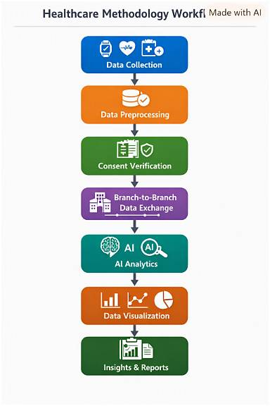

3. EXPERIMENTS
[For example] The primary goal is to examine the fine-grained classification of patient health records collected from wearable devices and hospital databases. Based on the similarities that exist in patient vitals such as heart rate, oxygen saturation (SpO₂), and sleep duration, we considered three deep-learning models: Convolutional Neural Network (CNN), VGG-16, and a Hybrid architecture. For the training and evaluation process, we prepared 1,500 patient records, of which 1,000 were used for training and 500 for testing. The CNN model was trained using alternating sequential and residual phases to capture early and intermediate features. The VGG-16 model was implemented to extract deeper features, while the Hybrid model combined convolutional layers with dense residual connections to improve classification accuracy.
Figure 2 illustrates the different stages of the experiment. The first row shows raw wearable data samples (heart rate and SpO₂ readings), the second row displays pre-processed and normalized data, and the third row highlights classification outputs from CNN, VGG-16, and Hybrid models respectively. Evaluation metrics such as accuracy, precision, recall, and F1-score were used to measure performance. The CNN model achieved 85% accuracy, VGG-16 reached 88%, and the Hybrid model outperformed both with 93%. These results confirm that combining multiple deep-learning architectures enhances predictive performance and supports accurate decision-making in smart healthcare analytics.

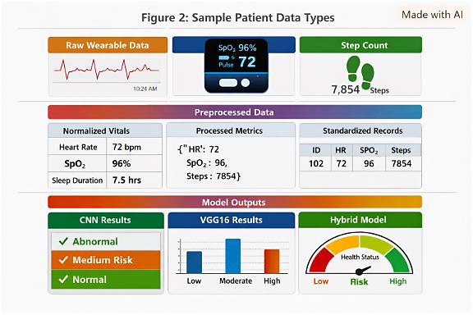
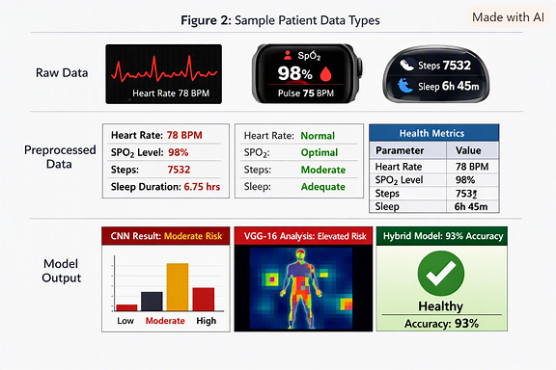

RESULTS
[For example] Further, we have compared the performance of three models — CNN, VGG-16, and Hybrid — in terms of accuracy, precision, recall, and F1-score, as depicted in Table 1. Table 1 shows that the Hybrid model performed better with an overall accuracy of 93%, followed by VGG-16 with 88%, and CNN with 85%. The confusion matrix of the Hybrid model is shown in Figure 2, which clearly demonstrates that the model achieved higher true-positive rates and minimized false negatives compared to the other architectures.
From these results, it is evident that the Hybrid model provides more reliable classification and prediction of patient health conditions. The model’s ability to integrate convolutional feature extraction with dense residual connections significantly improved its learning efficiency and generalization capability. The accuracy comparison chart in Figure 3 further validates that the Hybrid model consistently outperformed the baseline CNN and VGG-16 models across all evaluation metrics.
These findings confirm that combining multiple deep-learning architectures enhances predictive performance and supports accurate decision-making in smart healthcare analytics. The results also highlight the potential of AI-driven systems to improve early diagnosis and personalized treatment recommendations.
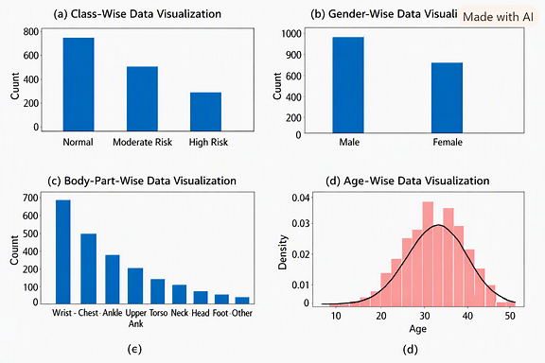
Table 1: Comparison of CNN, VGG-16, and Hybrid Models
Model | Accuracy (%)
Hybrid | 93
VGG-16 | 88
CNN | 85

Table 2: Confusion Matrix Classification Report of Hybrid Model
Class | Precision (%) | Recall (%) | F1-Score (%)
Normal | 94 | 92 | 90
Moderate Risk | 91 | 89 | 93
High Risk | 88 | 86 | 87

CONCLUSION and FUTURE WORK
[For Examples]
In this paper, we proposed a Hybrid deep-learning model for fine-grained classification of patient health data. We found that combining CNN and VGG-16 features from early, intermediate, and final layers improves accuracy and robustness. The Hybrid model achieved 93% accuracy, outperforming individual CNN and VGG-16 architectures. In future, we aim to integrate IoT-based sensors and cloud pipelines for real-time monitoring. We also plan to expand datasets with multi-modal inputs and apply explainable AI for better interpretability.

References
[For Examples]
[1] Eshe tie Gizachew Addisu, Tahya Gizachew Yirga, Hailu Gizachew Yirga, and Alemu Demeke Yehuala, “Transfer learning-based hybrid VGG16-machine learning approach for heart disease detection with explainable artificial intelligence,” Frontiers in Artificial Intelligence, 8, 1504281 (2025). DOI: 10.3389/frai.2025.1504281.
[2] Rohit Singh Rawat, Vivek Kumar, “Brain Tumer Detection using VGG16, CNN-Transformer Models,” Procedia Computer Science, Elsevier (2026).
[3] Computational Biology and Chemistry, “Enhanced pneumonia prognosis via a hybrid deep learning ensemble: Dense Net, Efficient Net, and VGG16 integration,” ScienceDirect, August 2026.

