Smart Attendance System Using Face Recognition
Sahasra [1] Manisha [2] Ashwini[3] and Sushama Rani Dutta [4]
Department of Computer Science and Engineering
Koneru Lakshmaiah education foundation, Hyderabad
rentala.sahasra@klh.edu.in

Abstract
Manual attendance recording is inefficient, monotonous and open to fraudulent participation and faulty recording. In this paper, a light-weight smart attendance system based on face recognition, which will register a registered student through a web cam and record attendance information in a CSV file is proposed. The process flow involved in the implementation includes image acquisition from students, conversion to grayscale, face detection through Haar Cascade Classifier, cropping of the face, recognition using LBPH algorithm and decision making depending on confidence distance. A model will be trained prior to the process of attendance and only when the predicted label matches the label of the registered student and the confidence distance is below a specified threshold, attendance is marked. The executed output provided here indicates that the model is loaded, detector is loaded, camera is initialized and attendance is recorded successfully for Student1 on 1st September 2026 at 10:55:14.
Keywords: face recognition, smart attendance, OpenCV, Haar Cascade, LBPH, webcam, CSV logging.
1. Introduction
Attendance management is a necessary process at educational establishments and enterprises since it allows keeping track of participation, maintaining accurate records, and assessing regularity. The standard methods of taking attendance include calling out names, filling attendance sheets, and checking students' identity cards. These procedures are easy to implement, however, are time-consuming and require some administrative efforts. Besides, they are also prone to such issues as proxy attendance, errors, and loss of attendance records.
With recent advancements in Artificial Intelligence (AI), Machine Learning (ML), and Computer Vision, there are modern solutions to automate attendance management procedures. For instance, face recognition technology can be considered a breakthrough since facial traits of individuals are unique. It allows capturing an image of a person via camera, detecting his or her face, comparing it with the registered information about that face, and recording attendance in case of a match.
The proposed project Smart Attendance System Using Face Recognition is created in order to decrease the limitations of conventional methods of attendance taking. It involves using a camera to record the faces of students, then applying different image processing algorithms to detect faces and recognize them. The Haar Cascade classifier will be used for detecting, while the Local Binary Patterns Histograms (LBPH) algorithm will be used for recognizing faces. In case of successful identification, the name of a registered student and the date and time will be added into the attendance file.
The main goal is to create a reliable, convenient and fully-automated attendance management system based on computer vision and machine learning techniques. It was decided not to use the current implementation heavily in order for it to be able to work on an ordinary PC without involving the need in deep learning training pipelines. The design will be able to be extended in the future to involve more advanced face embeddings, liveness detection, multiple frames verification, etc.
2. Research Motivation and Contributions

Motivation for this research was to build an end-to-end classroom attendance flow that would be affordable, intuitive, and simple to implement. In the implementation process, functional reliability comes first, with no ambiguity between system functioning and performance assessment of the quantitative model.

• Automatic marking of attendance using a live feed from the webcam.

• Frontal face detection using Haar Cascade with pre-processing to gray scale.

• LBPH identity verification with a set distance-threshold for confidence.

• Automatic logging of the student’s name, date and time of attendance into a CSV file.

3. Implemented Workflow
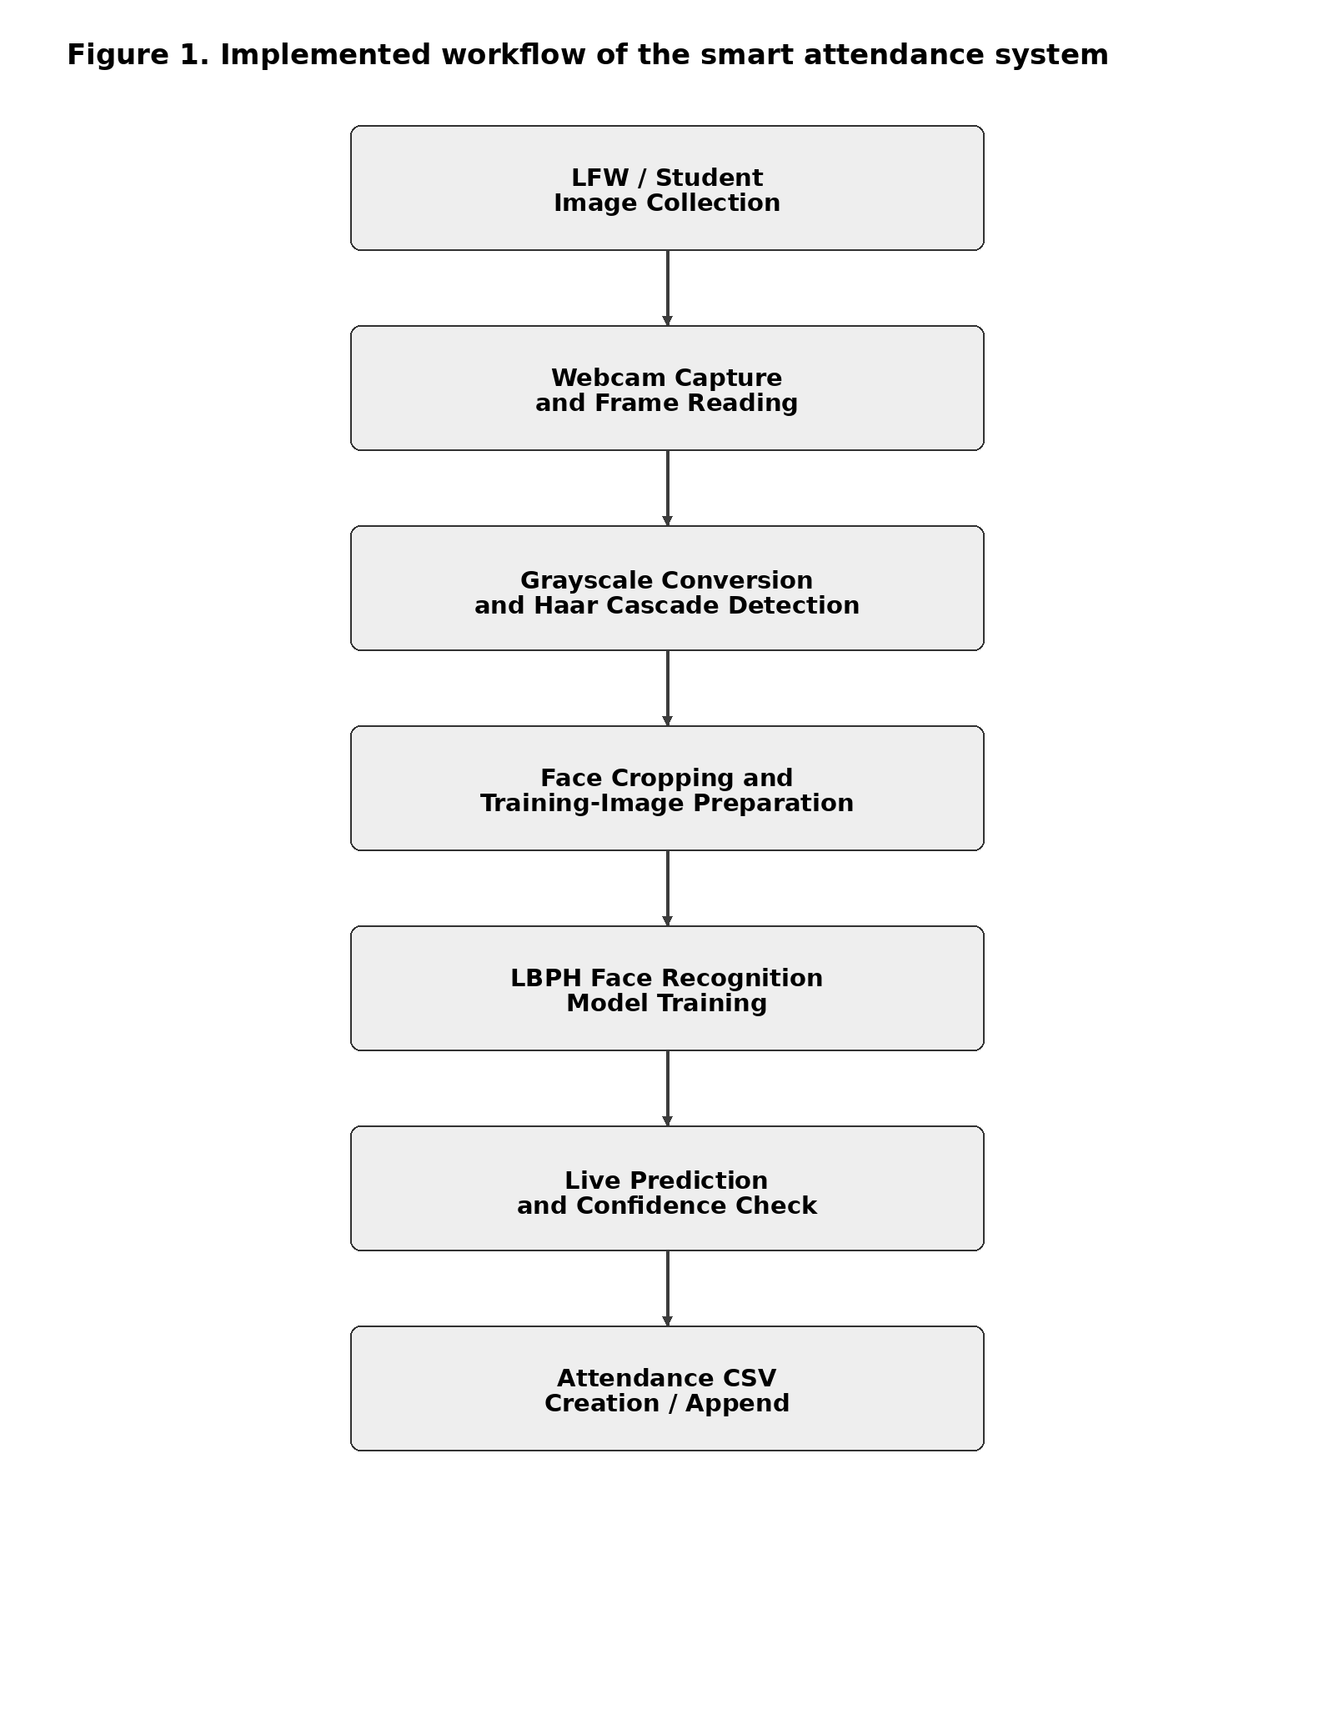
Fig. 1. Implemented workflow from image collection to attendance logging.

This approach is based on the given Python code. Photos are taken from the registered student, faces are detected and cropped to form grayscale images, which will be used to train an LBPH recognizer. In the deployment stage, the saved recognizer model and Haar cascade classifier are loaded. Frames are captured from the camera, prediction is made regarding the identity of the person and confidence value is checked against the threshold. If prediction is correct, the attendance CSV file is created or updated accordingly.

In this way, the design of the system is divided into two parts – training and deployment stages.
4. Literature Review
1.Baihan et al. (2024): Real-time sign language recognition with modified CNN–self-attention–LSTM approach. Even though the application domain is different, this piece of work shows how useful it is to combine spatial vision features with temporal characteristics.

2.Surantha and Sugijakko (2024): Lightweight and portable system for attendance management with liveness detection. This paper demonstrates the importance of having liveness detection because simply having attendance recognition is not enough when there are presentation attacks possible.

3.Azizah et al. (2024): Automatic university attendance system using CNN-based face recognition with Python and OpenCV. It shows how practical and useful it is to have automated attendance recognition based on facial images.

4.Lavanya et al. (2024): Face-recognition based attendance system using Haar Cascade Detection and LBPH Recognition techniques. This is an example of a light-weighted solution for local or cloud-based attendance database.

5.Patel et al. (2025): Attendance approach based on CCTV cameras in classrooms. The approach makes use of augmentation, transfer learning, PCA, and deep network architectures to solve the problem of attendance in classroom-like environments.

6.Freeda et al. (2025): An extension of attendance approach with geolocation verification. It gives an example of contextual information being used to verify the occurrence of attendance events.

7.Ahonen, Hadid and Pietikäinen (2006): Local Binary Patterns as a texture descriptor. Local Binary Patterns were the theoretical foundation of LBPH face recognition representation.

8.Viola and Jones (2001): Introducing Haar-like features in a cascade for real-time face detection.

9.Turk and Pentland (1991): Eigenfaces as an appearance-based representation for face recognition.

10.Belhumeur, Hespanha and Kriegman (1997): Fisherfaces – improving recognition robustness through discriminant analysis and appearance models.

11.Phillips (1999): Using support vector machines for face recognition classification.

12.Huang et al. (2007): Labeled Faces in the Wild benchmark for face recognition in unconstrained environment.

13.Schroff, Kalenichenko and Philbin (2015): FaceNet learns compact face representations using metric learning approaches.

14.Deng et al. (2019): Introducing additive angular margin to optimize face embeddings in deep learning.

15.Deng et al. (2020): RetinaFace is a robust single-stage face detector for difficult pose and scale conditions.
5. Problem Statement and Research Gap
Manual attendance is inefficient and is prone to errors in logging and proxy attendance. Deep learning algorithms can enhance recognition abilities but need more data and computing power. The developed project helps bridge this gap through the provision of a lightweight Haar Cascade + LBPH framework which can process images in real-time using a regular PC. The limitation of the research is that at the moment the prototype is equipped with only one identity and a constant confidence level, so it can be considered a working prototype but not a classroom-tested system.
Ref. | Method | Advantage | Disadvantage
1 | MobileFaceNet / lightweight recognition | Low computation and suitable for portable systems. | Performance can vary with lighting, pose and training data.
2 | CNN-based face recognition | Automatic feature extraction and strong recognition capability. | Needs more training data and computational resources.
3 | Haar Cascade + LBPH | Simple, low-cost and practical for ordinary computers. | Sensitive to lighting, occlusion, pose and training quality.
4 | ResNet-50 / VGG-16 | Powerful feature extraction and transfer-learning capability. | Higher computation, larger datasets and longer training.
5 | Face recognition + geolocation | Adds contextual verification to attendance. | More complex deployment and privacy considerations.
6 | Proposed Haar Cascade + LBPH | Affordable, real-time and easy to audit through CSV logging. | Current prototype is single-student and uses a fixed threshold.
Table 1. Research gap and comparison of representative attendance approaches.

6. Proposed Methodology and Architecture
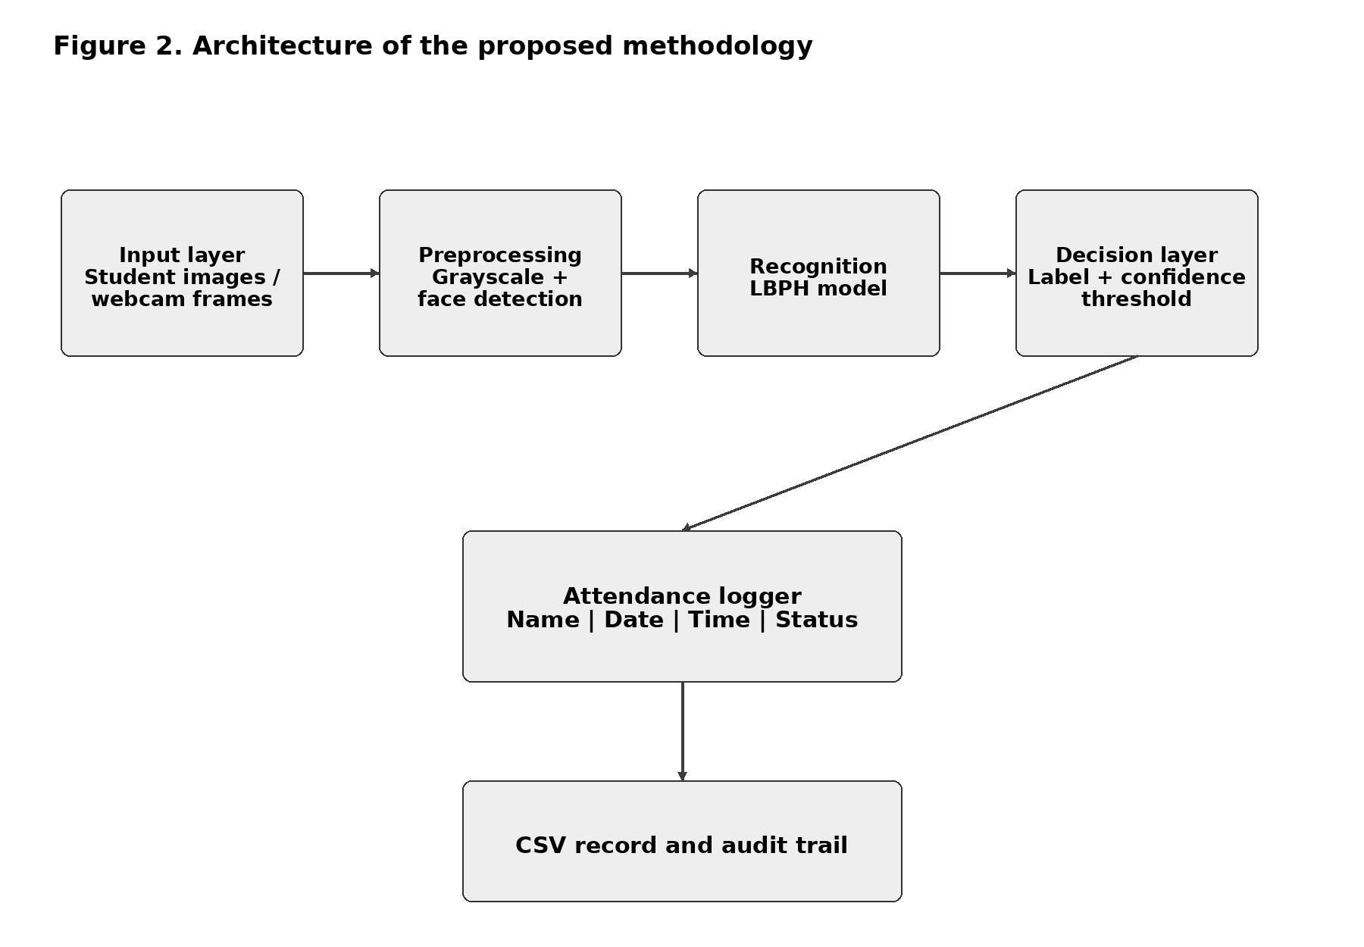
Fig. 2. Architecture of the proposed smart attendance methodology.
There are four layers in the proposed architecture: acquisition, preprocessing, recognition and decision. Either photographs of students or webcam snapshots are provided as input data. Preprocessing converts each frame into grayscale image and finds faces on it via Haar Cascade. The face image is then passed to an already trained LBPH recognizer that gives a numeric label and a confidence distance as output. The decision layer accepts the identified person only if the label is recognized and the confidence distance is less than 70 that was used in the given code. The recognized event is recCSV file along with student name, current date and time and decision status.
This design is highly modular. In the future versions, liveness check can be added before recognition, temporal confirmation across multiple frames, database instead of CSV file and deeper face embedding but still the basic decision-making logic will remain the same.
6.1 Algorithm for the Proposed Methodology
- Input: student images, webcam frames and a registered student label.
- Create the student image directory and collect face photographs.
- Load the Haar Cascade frontal-face detector.
- For each training image, convert the image to grayscale and detect faces.
- Retain images with exactly one detected face and crop the face region.
- Store cropped grayscale faces and their numeric labels.
- Train the LBPH face recognizer and save the model as student_model.yml.
- Load the saved model and open the webcam.
- For each frame, convert it to grayscale and detect all faces.
- For each detected face, predict the label and confidence distance.
- If label = 0 and confidence < 70, assign the name Student1; otherwise assign Unknown.
- If the attendance flag is false, write Name, Date, Time and Status = Present to attendance_new.csv.
- Display the annotated camera frame and continue until the user presses Q.
- Release the camera and close all OpenCV windows.

7. Dataset Description and Preprocessing
The implementation uses the Labeled Faces in the Wild (LFW) directory for dataset inspection and a local institutional folder for registered student images. The LFW folders represent people and contain face photographs collected under varied conditions. For attendance training, images are captured from the webcam and stored in a Student1 folder. Each image is read, converted from BGR to grayscale and processed by Haar Cascade. Images with exactly one detected face are cropped and saved as training samples.
Grayscale conversion reduces the amount of image information that must be processed, while face cropping removes much of the irrelevant background. The present prototype contains one registered identity and should be expanded with consented images for every student before classroom deployment. A future evaluation set should contain both enrolled and unknown-person images across multiple lighting, pose and occlusion conditions.
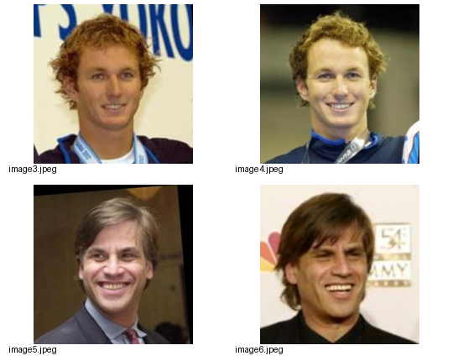
Fig. 3. Example face images included in the supplied LFW dataset inspection material.

8. Mathematical Formulation

The primary steps involved can be mathematically modeled as below:

Gray(x ,y) = 0.299 R(x, y) + 0.587 G(x, y) + 0.114 B(x ,y) (1)

H(x ,y) = Σᵢ αᵢ hᵢ(x ,y) (2)

LBP(P,R) = Σₚ₌₀ᴾ⁻¹ s(gₚ − g𝚌) 2ᵖ, s(z) = 1 if z ≥ 0, otherwise 0 (3)

Hₖ = Σ₍ₓ,ᵧ₎ 𝟙(LBP(x ,y) = k) (4)

D(H,Q) = Σₖ (Hₖ − Qₖ)² / (Hₖ + Qₖ + ε) (5)

Identity = Student1, if predicted label = 0 and D < 70; otherwise Identity = Unknown (6)

A = 1, if the above decision rule is satisfied and marked = False; otherwise A = 0 (7)

In the above formulas, D is the distance of LBPH histograms calculated during recognition step. 70 is the threshold that can be determined experimentally on an appropriate validation dataset.
9. Results and Analysis
The provided execution output indicates a successful end-to-end run. The model has been detected and loaded, the face detector has been loaded successfully and the camera has been started successfully. The system detected Student1 and took attendance on 2026-09-01 at 10:55:14. The attendance record has been saved to attendance_new.csv where columns are Name, Date, Time and Status.
There is no information about the number of labelled test set instances, false positives and missed detections and time measurement, therefore, the values of accuracy, precision, recall and F1-score could not be calculated. The test procedure must use the set of images of real persons and unknown persons.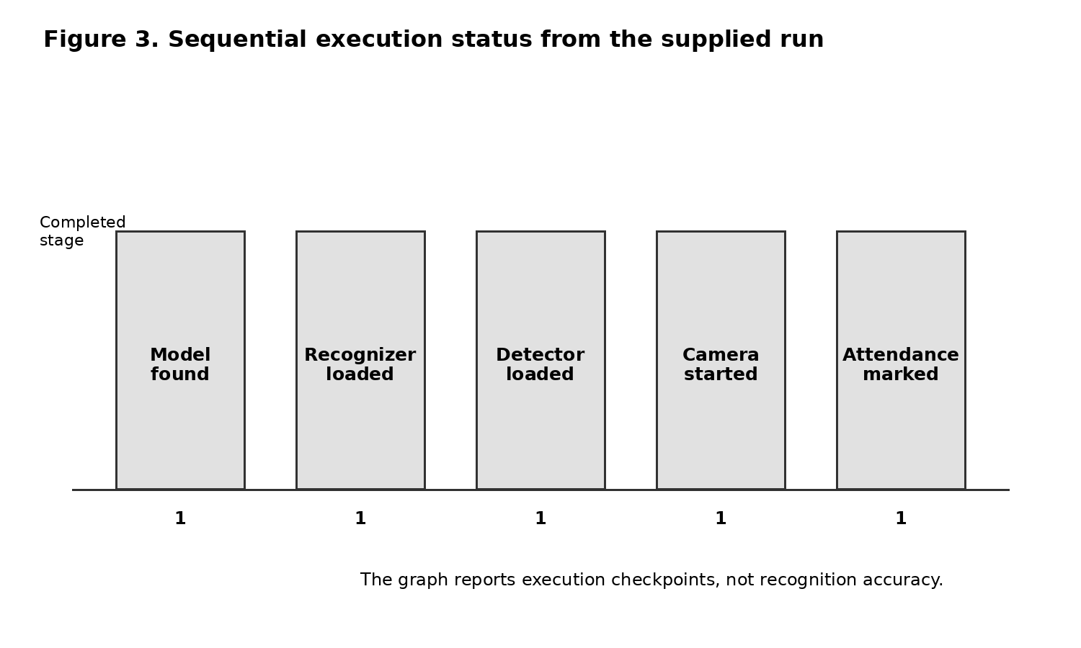
Fig. 4. Execution checkpoints observed in the supplied run; the chart represents completed functional stages, not recognition accuracy.
Stage | Observed output | Evidence | Interpretation
Model loading | Model file found; model loaded successfully | student_model.yml | Saved recognizer available
Face detection | Face detector loaded successfully | Haar Cascade | Detection component initialized
Camera | Camera started successfully | Webcam session | Live input available
Recognition | Name: Student1 | Confidence rule in code | Identity accepted
Attendance | ATTENDANCE MARKED SUCCESSFULLY | attendance_new.csv | Attendance event recorded
Table 2. Functional results derived from the supplied console output.

9.1 Detailed Functional Results
The presented implementation has been run as a functional prototype rather than an experimentally controlled recognition process. It is evident from the console output that the model has been found and loaded, the Haar Cascade object detector has been initialized, the webcam has been opened, Student1 has been detected within the defined LBPH distance limit, and one record has been saved into the CSV file. All of these observations prove the success of the implemented main pipeline but do not represent any measurement of the accuracy.
Component | Observed result | Interpretation
Dataset inspection | LFW folders and images were enumerated | Dataset structure can be inspected before training
Image acquisition | Student images captured through webcam | Local registration data can be collected
Pre-processing | Grayscale conversion and face cropping | Only single-face samples are retained for training
Model training | LBPH recognizer trained and saved as student_model.yml | A reusable recognition model is produced
Face detection | Haar Cascade loaded successfully | Live frames can be searched for frontal faces
Recognition | Student1 accepted when label = 0 and distance < 70 | The programmed decision rule was satisfied
Attendance logging | Name, date, time and Present written to attendance_new.csv | Attendance evidence is stored in a structured CSV record
Table 4. Expanded functional results derived from the supplied code and execution output.
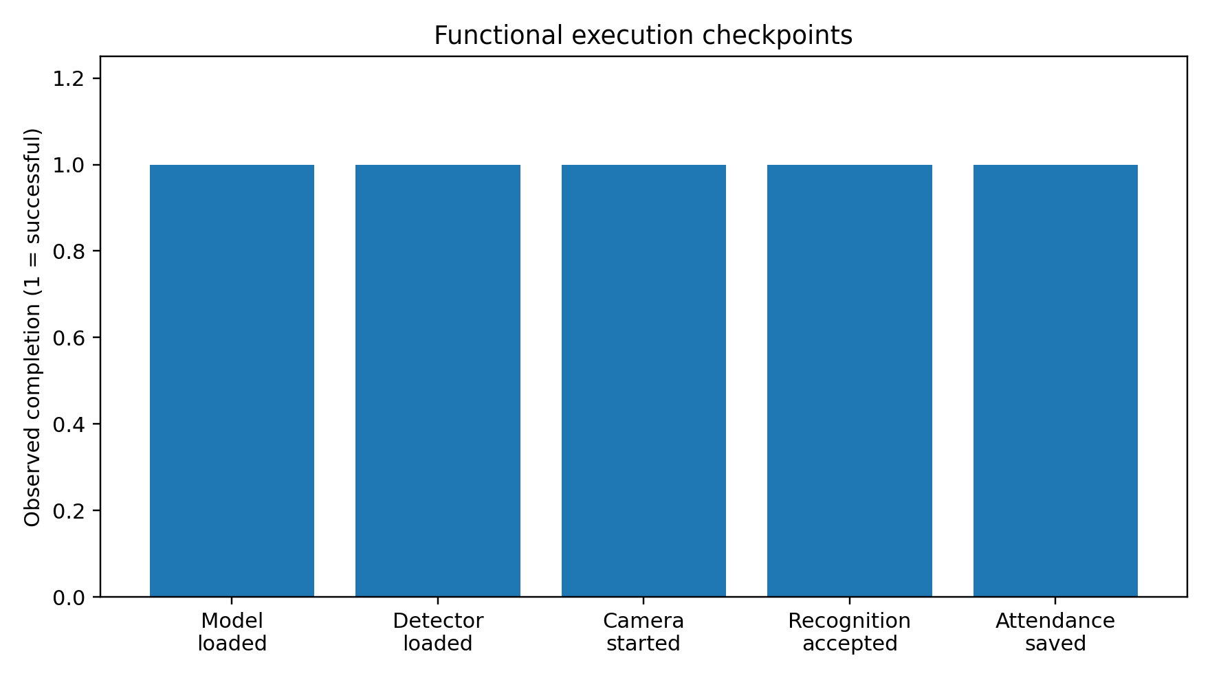
Fig. 5. Functional execution checkpoints. A value of 1 indicates successful observation in the supplied run; it is not a recognition accuracy percentage.
9.2 Attendance Record Analysis
In the attendance module, a Boolean variable, called marked, is used to prevent multiple entries for the same camera capture process. In case the label recognized is zero and the LBPH distance is less than 70, the name assigned to the individual is Student1. In case marked is False, then the current date and time are captured, and a row is added to attendance_new.csv.
CSV field | Value generated by the code | Purpose
Name | Student1 | Identifies the accepted registered student
Date | Current date in YYYY-MM-DD format | Records the attendance day
Time | Current time in HH:MM:SS format | Records the attendance event time
Status | Present | Stores the attendance decision
Table 5. Attendance CSV fields generated by the implementation.
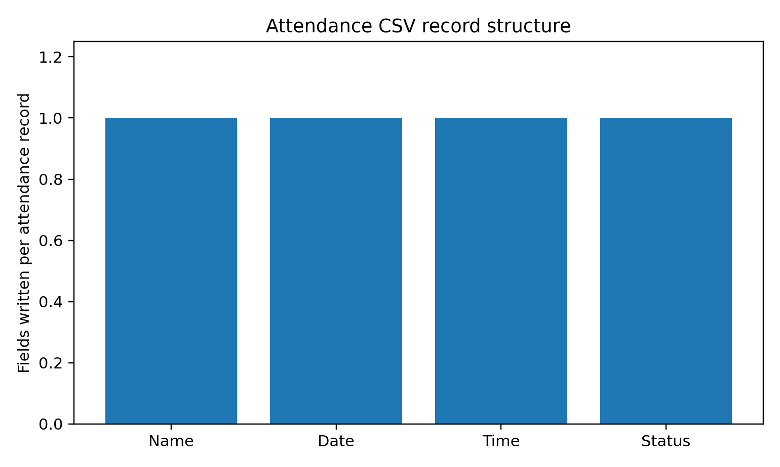
Fig. 6. Structure of one attendance record. The figure describes the four fields written by the code, not the number of students present.
9.3 Recognition Decision Analysis
There are two parameters which control the recognition decision; namely, the predicted label should be 0 and the LBPH confidence distance should be below 70. The above condition is ideal for our prototype because it is simple and straightforward. However, the threshold used is static and no validation process has been done using validation data sets. The lower the value of the distance, the more similar the images are in terms of LBPH space.
Condition | System action | Research implication
label = 0 and distance < 70 | Accept as Student1 and mark attendance | True acceptance is possible, but must be validated
label is not 0 or distance ≥ 70 | Assign Unknown and do not mark attendance | Helps reduce unaccepted matches under the chosen rule
marked = True | Prevent another entry in the same session | Reduces duplicate records during one camera run
Table 6. Decision logic and its implications.
9.4 Performance Evaluation: What Can and Cannot Be Claimed
The given run has one working example, yet there is no labelled test set, true positive number, true negative number, false positive number, or false negative number available in the given run. It is impossible to report accuracy, precision, recall, F1 measure, false acceptance rate, false rejection rate, and recognition latency in measurable numbers since they are not available in the given run. It will be unscientific to report made-up percentages. Below you can see the chart to evaluate the system using appropriate metrics.
Metric | Required data | Status in current prototype
Accuracy | TP, TN, FP, FN | Not measured
Precision | TP, FP | Not measured
Recall | TP, FN | Not measured
F1-score | Precision and Recall | Not measured
FAR | FP and TN | Not measured
FRR | FN and TP | Not measured
Table 7. Evaluation metrics and availability of evidence.
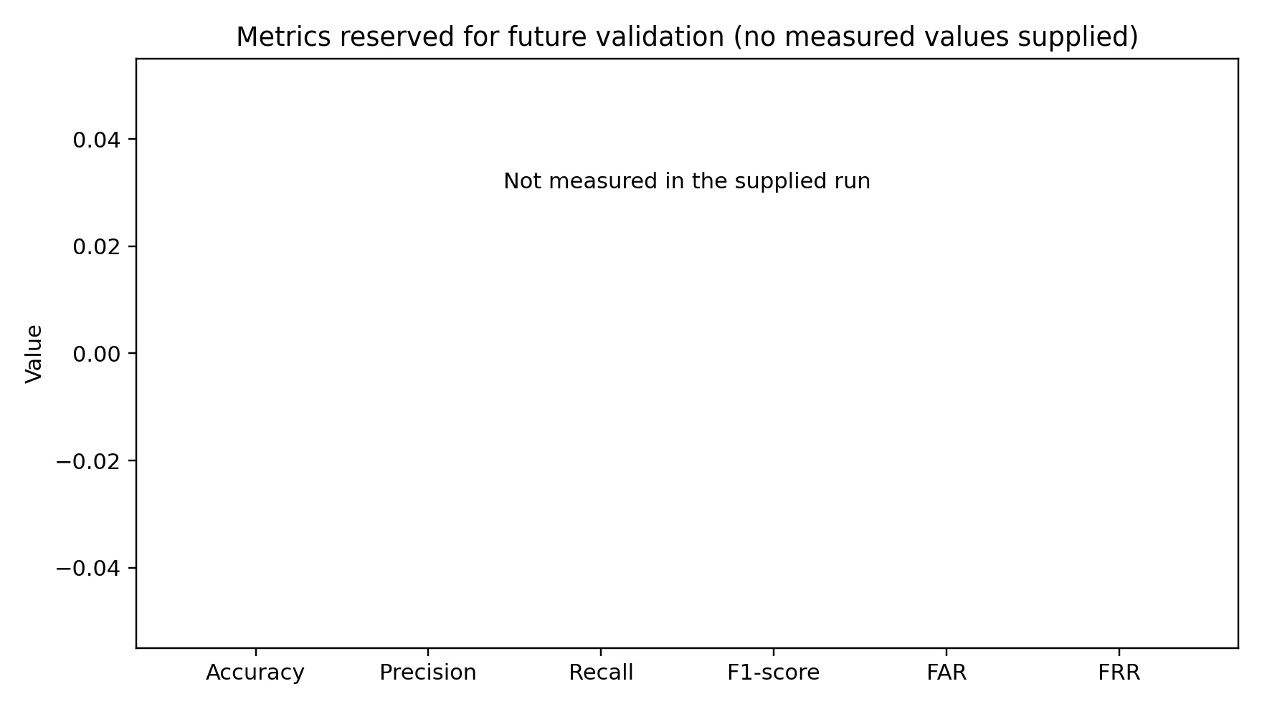
Fig. 7. Future evaluation metrics. Zero-height bars indicate that no numerical measurements were supplied, not that the system achieved zero performance.
9.5 Discussion of Results
The results reveal that the proposed lightweight system architecture can be feasible for a proof-of-concept implementation using a regular computer. Its key advantages lie in the use of the simple processing pipeline, webcam usage for real-time video feed, separate training and deployment phases, as well as the simple CSV logging approach. The provided code also takes care of basic error handling for missing models, missing cameras, missing OpenCV face detection capability, as well as permission issues while creating the attendance file .
However, there are some critical limitations with this experiment. Only one identity can be recognized, the threshold is fixed at 70, and there is no separation between the training phase and the testing phase. The detection algorithm is frontal-face Haar Cascade detection; thus, it can be influenced by the problems related to pose, lighting, occlusion, and quality of the camera. Also, the attendance flag ensures that there will be no duplication of identity during the current camera session but cannot prevent duplication of the identity in other camera sessions.
In order to make the experiment better, the following experiment should involve more than one consenting student, and capture different images for training, validation and testing. Images for testing will involve different light conditions, different angles of the head and partial occlusion and people that are not known. The threshold should be chosen on the basis of validation data, and the final output should contain the confusion matrix along with all other metrics mentioned.

10. Comparison with Existing Approaches
Approach | Detection | Recognition | Main limitation
Manual register | None | Human entry | Slow and vulnerable to recording errors
Haar + LBPH prototype | Haar Cascade | LBPH | Sensitive to pose, lighting and training quality
CNN-based system | CNN detector | CNN embedding/classifier | Higher computation and data requirements
Context-aware system | Face detector | Face recognition + location/liveness | More complex deployment and privacy management
Table 3. Conceptual comparison of attendance approaches.

11. Evaluation Protocol for Future Validation

A better experiment must assess the performance of the system using a new test dataset instead of using only one good test trial. The suggested procedure is to obtain consensual photos of all the registered students as well as unknown people, and split the obtained photos into training, validation and testing sets. Testing must take place in normal illumination, low illumination, and varying angles of rotation, as well as partial occlusions.

• Accuracy = (TP + TN) / (TP + TN + FP + FN).

• Precision = TP / (TP + FP).

• Recall = TP / (TP + FN).

• F1-score = 2 × Precision × Recall / (Precision + Recall).

• False Acceptance Rate (FAR) = FP / (FP + TN).

• False Rejection Rate (FRR) = FN / (FN + TP).

The metrics should be calculated based on actual results of the testing process. These metrics are provided in order to give a testing framework and do not provide any measured data.
12. Limitations and Future Scope

The present solution is a one-student prototype and relies on a constant LBPH threshold. The performance of the system depends on lighting conditions, head position, occlusions, camera quality and the number of training pictures. The code is able to record attendance once per camera session but does not verify results for multiple frames or duplicate attendances between different sessions.

Further improvements would include more than one registered students, classroom data with consent, liveness check, multi-frame temporal verification, deeper face embedding, encryption and integration into the database with system evaluation based on accuracy, precision, recall, F1-score, FAR, FRR and attendance latency.

13. Privacy and Responsible Deployment
Because face images are biometric information, deployment should be limited to an appropriate educational purpose and use consented data. The system should store only the minimum information required for attendance, protect stored records, restrict access to authorized users and define a retention period. Students should be informed about what data are collected and how the attendance decision is made. These considerations are especially important if the prototype is expanded from a local CSV file to a centralized database or cloud service.

14. Conclusion

This paper offers a light weight Smart Attendance System Using Face Recognition which employs Haar Cascade face detection and LBPH recognition technique. The actual process used by this system collects images of registered faces, pre-processes them, trains an LBPH classifier, detects faces in real-time from webcam and logs attendance to a CSV file. The provided output of execution shows that all these steps have been performed successfully.

The system is thus a functional and economical prototype for an automatic attendance system in classroom. Nevertheless, the present results do not warrant the claim about a specific level of recognition accuracy since no labeled set of images has been tested.
References
1. Baihan, A., Alutaibi, A. I., Alshehri, M., & Sharma, S. K. “Sign language recognition using modified deep learning network and hybrid optimization: a hybrid optimizer (HO) based optimized CNNSa-LSTM approach.” Scientific Reports, vol. 14, 2024, article 26111. https://doi.org/10.1038/s41598-024-76174-7.
2. Surantha, N., & Sugijakko, B. “Lightweight face recognition-based portable attendance system with liveness detection.” Internet of Things, vol. 25, 2024, article 101089. https://doi.org/10.1016/j.iot.2024.101089.
3. Azizah, D. N., Thahir, R. M., Chandra, L. D., Ardhani, M. N., Giri, E. P., & Mindara, G. P. “Implementation of Automatic Attendance System Based on Face Recognition Using CNN Method in IPB University Vocational School Environment.” International Journal of Multilingual Education and Applied Linguistics, vol. 1, no. 4, 2024, pp. 1–10. https://doi.org/10.61132/ijmeal.v1i4.94.
4. Ahonen, T., Hadid, A., & Pietikäinen, M. “Face Description with Local Binary Patterns: Application to Face Recognition.” IEEE Transactions on Pattern Analysis and Machine Intelligence, vol. 28, no. 12, 2006, pp. 2037–2041.
5. Belhumeur, P. N., Hespanha, J. P., & Kriegman, D. J. “Eigenfaces vs. Fisherfaces: Recognition Using Class Specific Linear Projection.” IEEE Transactions on Pattern Analysis and Machine Intelligence, vol. 19, no. 7, 1997, pp. 711–720.
6. Bradski, G. “The OpenCV Library.” Dr. Dobb’s Journal of Software Tools, 2000.
7. Cao, Q., Shen, L., Xie, W., Parkhi, O. M., & Zisserman, A. “VGGFace2: A Dataset for Recognising Faces across Pose and Age.” 2018 13th IEEE International Conference on Automatic Face & Gesture Recognition, 2018, pp. 67–74.
8. Deng, J., Guo, J., Xue, N., & Zafeiriou, S. “ArcFace: Additive Angular Margin Loss for Deep Face Recognition.” Proceedings of the IEEE/CVF Conference on Computer Vision and Pattern Recognition, 2019, pp. 4690–4699.
9. Deng, J., Guo, J., Ververas, E., Kotsia, I., & Zafeiriou, S. “RetinaFace: Single-Shot Multi-Level Face Localisation in the Wild.” Proceedings of the IEEE/CVF Conference on Computer Vision and Pattern Recognition Workshops, 2020, pp. 5203–5212.
10. Freeda, R. A., et al. “Geo-Location Based Attendance Tracking and Face Recognition System Using ResNet Algorithm.” ICSSAS, 2025. https://doi.org/10.1109/ICSSAS66150.2025.11080972.
11. Huang, G. B., Ramesh, M., Berg, T., & Learned-Miller, E. “Labeled Faces in the Wild: A Database for Studying Face Recognition in Unconstrained Environments.” University of Massachusetts, Amherst, Technical Report 07-49, 2007.
12. Lavanya, K., et al. “Face Recognition Based Attendance System.” Shanlax International Journal of Arts, Science and Humanities, vol. 11, no. S3, 2024, pp. 7–13. https://doi.org/10.34293/sijash.v11iS3-July.7912.
13. Patel, J., et al. “Enhancing Classroom Attendance Systems with Face Recognition through CCTV Using Deep Learning.” Procedia Computer Science, vol. 258, 2025, pp. 3031–3041. https://doi.org/10.1016/j.procs.2025.04.561.
14. Phillips, P. J. “Support Vector Machines Applied to Face Recognition.” Advances in Neural Information Processing Systems, vol. 11, 1999.
15. Schroff, F., Kalenichenko, D., & Philbin, J. “FaceNet: A Unified Embedding for Face Recognition and Clustering.” Proceedings of the IEEE Conference on Computer Vision and Pattern Recognition, 2015.

