AI Assistant Coding
Assignment 12.5
Name :Sahastra HT. No : 2303A52499 Batch: 50

Task Description #1 (Sorting – Merge Sort Implementation)
- Task: Use AI to generate a Python program that implements the Merge Sort algorithm.
- Instructions:
- Prompt AI to create a function merge_sort(arr) that sorts a list in ascending order.
- Ask AI to include time complexity and space complexity in the function docstring.
- Verify the generated code with test cases.
- Expected Output:
- A functional Python script implementing Merge Sort with proper documentation.

#PROMPT
""" generate a Python program that implements the Merge Sort algorithm. create a function merge_sort(arr) that sorts
a list in ascending order. Include time complexity and space complexity in the function docstring,
Verify the generated code with test cases."""

#CODE
def merge_sort(arr): """
Sorts a list in ascending order using the Merge Sort algorithm.

Time Complexity: O(n log n) - where n is the number of elements in the list. Space Complexity: O(n) - due to the temporary arrays used for merging.
"""
if len(arr) <= 1: return arr

mid = len(arr) // 2
left_half = merge_sort(arr[:mid]) right_half = merge_sort(arr[mid:])

return merge(left_half, right_half) def merge(left, right):
"""
Merges two sorted lists into a single sorted list.

Time Complexity: O(n) - where n is the total number of elements in both lists.
Space Complexity: O(n) - due to the temporary array used for merging. """
merged = []
left_index = right_index = 0

while left_index < len(left) and right_index < len(right): if left[left_index] < right[right_index]:
merged.append(left[left_index]) left_index += 1

else:
merged.append(right[right_index]) right_index += 1

# If there are remaining elements in left or right, add them to merged merged.extend(left[left_index:])
merged.extend(right[right_index:])

return merged # Test cases
if name == " main ": test_cases = [
[38, 27, 43, 3, 9, 82, 10],
[5, 2, 9, 1, 5, 6],
[12, 11, 13, 5, 6, 7],
[],
[1],
[2, 1]
]

for i, test in enumerate(test_cases): sorted_arr = merge_sort(test)
print(f"Test case {i + 1}: {sorted_arr}") meaningful_output = sorted(test)
assert sorted_arr == meaningful_output, f"Test case {i + 1} failed: expected
{meaningful_output}, got {sorted_arr}" print("All test cases passed!")

#OUTPUT
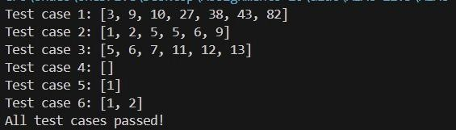
Task Description #2 (Searching – Binary Search with AI Optimization)
- Task: Use AI to create a binary search function that finds a target element in a sorted list.
- Instructions:
- Prompt AI to create a function binary_search(arr, target) returning the index of the target or -1 if not found.
- Include docstrings explaining best, average, and worst-case complexities.
- Test with various inputs.
- Expected Output:
- Python code implementing binary search with AI- generated comments and docstrings.

#PROMPT
""" create a python function binary_search(arr,target) returning the index of the target or -1 if not found.
Include docstrings explaining best, average, and worst-case complexities. Test with various inputs."""

#CODE
def binary_search(arr, target): """

Performs binary search on a sorted list to find the index of the target element.

Time Complexity:
- Best Case: O(1) - when the target is at the middle of the list.
- Average Case: O(log n) - where n is the number of elements in the list.
- Worst Case: O(log n) - when the target is not present in the list or is at one of the ends.

Space Complexity: O(1) - as we are using a constant amount of space for variables. """
left, right = 0, len(arr) - 1

while left <= right:
mid = left + (right - left) // 2

if arr[mid] == target:
return mid
elif arr[mid] < target: left = mid + 1
else:
right = mid - 1

return -1 # Test cases
if _name_ == "_main_": test_cases = [
([1, 2, 3, 4, 5], 3), # target in the middle
([1, 2, 3, 4, 5], 1), # target at the beginning
([1, 2, 3, 4, 5], 5), # target at the end
([1, 2, 3, 4, 5], 6), # target not in the list ([], 1), # empty list
([1], 1), # single element list with target

([1], 0) # single element list without target
]
for i, (arr, target) in enumerate(test_cases):
result = binary_search(arr, target)
print(f"Test case {i + 1}: array={arr}, target={target}, result={result}") if target in arr:
expected = arr.index(target)
assert result == expected, f"Test case {i + 1} failed: expected {expected}, got {result}" else:
assert result == -1, f"Test case {i + 1} failed: expected -1, got {result}" print("All test cases passed!")

#OUTPUT
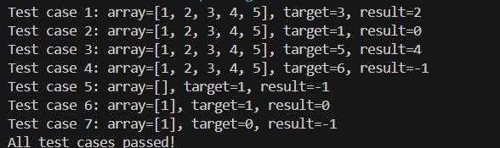
Task Description #3: Smart Healthcare Appointment Scheduling System
A healthcare platform maintains appointment records containing
appointment ID, patient name, doctor name, appointment time, and consultation fee. The system needs to:
- Search appointments using appointment ID.
- Sort appointments based on time or consultation fee. Student Task
  - Use AI to recommend suitable searching and sorting algorithms.
  - Justify the selected algorithms.

  - Implement the algorithms in Python. #PROMPT
"""healthcare platform containins appointment ID, patient name, doctor name, appointment time,
and consultation fee. Implement a python program that allows users to perform the following operations:
- Search appointments using appointment ID.
- Sort appointments based on time or consultation fee.
recommend suitable searching and sorting algorithms.Justify the selected algorithms."""

#CODE
class Appointment:
def _init_(self, appointment_id, patient_name, doctor_name, appointment_time, consultation_fee):
self.appointment_id = appointment_id self.patient_name = patient_name self.doctor_name = doctor_name
self.appointment_time = appointment_time self.consultation_fee = consultation_fee
class HealthcarePlatform: def _init_(self):
self.appointments = []

def add_appointment(self, appointment): self.appointments.append(appointment)

def search_appointment_by_id(self, appointment_id):

"""
Searches for an appointment by its ID using linear search.

Time Complexity: O(n) - where n is the number of appointments.
Space Complexity: O(1) - as we are using a constant amount of space for variables.
"""
for appointment in self.appointments:
if appointment.appointment_id == appointment_id: return appointment
return None

def sort_appointments_by_time(self): """
Sorts appointments based on appointment time using Merge Sort.

Time Complexity: O(n log n) - where n is the number of appointments. Space Complexity: O(n) - due to the temporary arrays used for merging. """
self.appointments = merge_sort(self.appointments, key=lambda x: x.appointment_time)

def sort_appointments_by_fee(self): """
Sorts appointments based on consultation fee using Merge Sort.

Time Complexity: O(n log n) - where n is the number of appointments.

Space Complexity: O(n) - due to the temporary arrays used for merging. """
self.appointments = merge_sort(self.appointments, key=lambda x: x.consultation_fee)
def merge_sort(arr, key): if len(arr) <= 1:
return arr

mid = len(arr) // 2
left_half = merge_sort(arr[:mid], key) right_half = merge_sort(arr[mid:], key)

return merge(left_half, right_half, key) def merge(left, right, key):
merged = []
left_index = right_index = 0

while left_index < len(left) and right_index < len(right): if key(left[left_index]) < key(right[right_index]):
merged.append(left[left_index]) left_index += 1
else:
merged.append(right[right_index]) right_index += 1

merged.extend(left[left_index:]) merged.extend(right[right_index:])

return merged # Test cases
if _name_ == "_main_":
platform = HealthcarePlatform()
platform.add_appointment(Appointment(1, "Alice", "Dr. Smith", "2023-10-01 10:00", 100))
platform.add_appointment(Appointment(2, "Bob", "Dr. Jones", "2023-10-01 11:00", 150))
platform.add_appointment(Appointment(3, "Charlie", "Dr. Brown", "2023- 10-01 09:00", 120))

# Search for an appointment
appointment = platform.search_appointment_by_id(2)
print(f"Search result for appointment ID 2: {appointment.patient_name if appointment else 'Not found'}")

# Sort appointments by time
platform.sort_appointments_by_time() print("Appointments sorted by time:") for appt in platform.appointments:
print(f"{appt.patient_name} - {appt.appointment_time}")

# Sort appointments by fee
platform.sort_appointments_by_fee() print("Appointments sorted by consultation fee:") for appt in platform.appointments:

print(f"{appt.patient_name} - {appt.consultation_fee}")

#OUTPUT
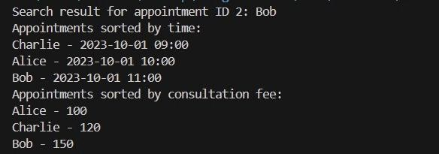
Task Description #4: Railway Ticket Reservation System Scenario
A railway reservation system stores booking details such as ticket
ID, passenger name, train number, seat number, and travel date. The system must:
- Search tickets using ticket ID.
- Sort bookings based on travel date or seat number. Student Task
  - Identify efficient algorithms using AI assistance.
  - Justify the algorithm choices.
  - Implement searching and sorting in Python. #PROMPT
""" A railway reservation system stores booking details such as ticket ID, passenger name, train number, seat number, and travel date. The
Generate a python function that allows users to perform the following operations:
- Search tickets using ticket ID.
- Sort bookings based on travel date or seat number.
Recommend suitable searching and sorting algorithms. Justify the selected algorithms."""

#CODE

def _init_(self, ticket_id, passenger_name, train_number, seat_number, travel_date):
self.ticket_id = ticket_id self.passenger_name = passenger_name self.train_number = train_number self.seat_number = seat_number
self.travel_date = travel_date class RailwayReservationSystem:
def _init_(self): self.bookings = []

def add_booking(self, booking): self.bookings.append(booking)

def search_ticket_by_id(self, ticket_id): """
Searches for a ticket by its ID using linear search.

Time Complexity: O(n) - where n is the number of bookings.
Space Complexity: O(1) - as we are using a constant amount of space for variables.
"""
for booking in self.bookings:
if booking.ticket_id == ticket_id: return booking
return None

def sort_bookings_by_date(self): """
Sorts bookings based on travel date using Merge Sort.

Time Complexity: O(n log n) - where n is the number of bookings.
Space Complexity: O(n) - due to the temporary arrays used for merging. """
self.bookings = merge_sort(self.bookings, key=lambda x: x.travel_date)

def sort_bookings_by_seat_number(self): """
Sorts bookings based on seat number using Merge Sort.

Time Complexity: O(n log n) - where n is the number of bookings.
Space Complexity: O(n) - due to the temporary arrays used for merging. """
self.bookings = merge_sort(self.bookings, key=lambda x: x.seat_number) def merge_sort(arr, key):
if len(arr) <= 1: return arr

mid = len(arr) // 2
left_half = merge_sort(arr[:mid], key) right_half = merge_sort(arr[mid:], key)

return merge(left_half, right_half, key)

def merge(left, right, key): merged = []
left_index = right_index = 0

while left_index < len(left) and right_index < len(right): if key(left[left_index]) < key(right[right_index]):
merged.append(left[left_index]) left_index += 1
else:
merged.append(right[right_index]) right_index += 1

# If there are remaining elements in left or right, add them to merged merged.extend(left[left_index:])
merged.extend(right[right_index:])

return merged # Test cases
if _name_ == "_main_":
reservation_system = RailwayReservationSystem()

# Adding bookings
reservation_system.add_booking(Booking("T001", "Alice", "TrainA", 12, "2023-10-01"))
reservation_system.add_booking(Booking("T002", "Bob", "TrainB", 5, "2023-
09-15"))

reservation_system.add_booking(Booking("T003", "Charlie", "TrainA", 8, "2023-10-05"))

# Searching for a ticket
ticket = reservation_system.search_ticket_by_id("T002")
print(f"Search result for T002: {ticket.passenger_name if ticket else 'Not found'}")

# Sorting bookings by travel date
reservation_system.sort_bookings_by_date() print("Bookings sorted by travel date:")
for booking in reservation_system.bookings:
print(f"{booking.passenger_name} - {booking.travel_date}")

# Sorting bookings by seat number
reservation_system.sort_bookings_by_seat_number() print("Bookings sorted by seat number:")
for booking in reservation_system.bookings:
print(f"{booking.passenger_name} - Seat {booking.seat_number}")

#OUTPUT
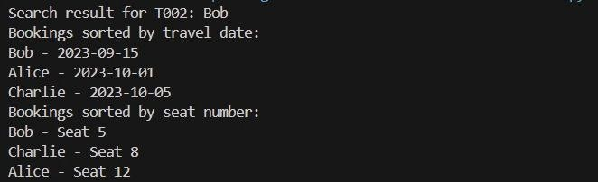

Task Description #5: Smart Hostel Room Allocation System
A hostel management system stores student room allocation details including student ID, room number, floor, and allocation date. The system needs to:
- Search allocation details using student ID.
- Sort records based on room number or allocation date. Student Task
  - Use AI to suggest optimized algorithms.
  - Justify the selections.
  - Implement the solution in Python. #PROMPT
""" Generate a python program for A hostel management system that stores student room allocation details
including student ID, room number, floor, and allocation date. The system needs to:
- Search allocation details using student ID.
- Sort records based on room number or allocation date. Recommend suitable searching and sorting algorithms.
Justify the selected algorithms."""

#CODE
def merge_sort(arr, key): if len(arr) <= 1:
return arr

mid = len(arr) // 2
left_half = merge_sort(arr[:mid], key) right_half = merge_sort(arr[mid:], key)

return merge(left_half, right_half, key) def merge(left, right, key):
merged = []
left_index = right_index = 0

while left_index < len(left) and right_index < len(right): if key(left[left_index]) < key(right[right_index]):
merged.append(left[left_index]) left_index += 1
else:
merged.append(right[right_index]) right_index += 1

# If there are remaining elements in left or right, add them to merged merged.extend(left[left_index:])
merged.extend(right[right_index:])

return merged class Allocation:
def _init_(self, student_id, room_number, floor, allocation_date): self.student_id = student_id
self.room_number = room_number self.floor = floor
self.allocation_date = allocation_date class HostelManagementSystem:
def _init_(self):
self.allocations = []

def add_allocation(self, allocation): self.allocations.append(allocation)

def search_allocation_by_student_id(self, student_id): """
Searches for allocation details by student ID using linear search.

Time Complexity: O(n) - where n is the number of allocations.
Space Complexity: O(1) - as we are using a constant amount of space for variables. """
for allocation in self.allocations:
if allocation.student_id == student_id: return allocation
return None

def sort_allocations_by_room_number(self): """
Sorts records based on room number using Merge Sort.

Time Complexity: O(n log n) - where n is the number of allocations.
Space Complexity: O(n) - due to the temporary arrays used for merging. """
self.allocations = merge_sort(self.allocations, key=lambda x: x.room_number)

def sort_allocations_by_allocation_date(self): """
Sorts records based on allocation date using Merge Sort.

Time Complexity: O(n log n) - where n is the number of allocations.

Space Complexity: O(n) - due to the temporary arrays used for merging. """
self.allocations = merge_sort(self.allocations, key=lambda x: x.allocation_date) # Test cases
if _name_ == "_main_":
hms = HostelManagementSystem()
hms.add_allocation(Allocation("S001", "101", "1st", "2023-09-01"))
hms.add_allocation(Allocation("S002", "102", "1st", "2023-09-02"))
hms.add_allocation(Allocation("S003", "201", "2nd", "2023-09-03"))

# Test search
allocation = hms.search_allocation_by_student_id("S002")
print(f"Search result for student ID 'S002': {allocation.room_number if allocation else 'Not found'}")

# Test sorting by room number
hms.sort_allocations_by_room_number() print("Allocations sorted by room number:") for alloc in hms.allocations:
print(f"Student ID: {alloc.student_id}, Room Number: {alloc.room_number}")

# Test sorting by allocation date
hms.sort_allocations_by_allocation_date() print("Allocations sorted by allocation date:") for alloc in hms.allocations:
print(f"Student ID: {alloc.student_id}, Allocation Date: {alloc.allocation_date}")

#OUTPUT

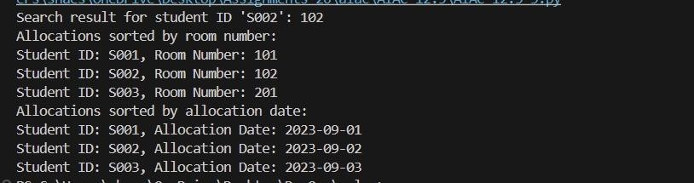
Task Description #6: Online Movie Streaming Platform
A streaming service maintains movie records with movie ID, title, genre, rating, and release year. The platform needs to:
- Search movies by movie ID.
- Sort movies based on rating or release year. Student Task
  - Recommend searching and sorting algorithms using AI.
  - Justify the chosen algorithms.
  - Implement Python functions. #PROMPT
"""streaming service maintains movie records with movie ID, title, genre, rating, and release year.
Generate a python program that allows users to perform the following operations:
- Search movies by movie ID.
- Sort movies based on rating or release year. Recommend suitable searching and sorting algorithms. Justify the selected algorithms."""

#CODE
class Movie:
def _init_(self, movie_id, title, genre, rating, release_year): self.movie_id = movie_id
self.title = title

self.genre = genre self.rating = rating
self.release_year = release_year class StreamingService:
def _init_(self): self.movies = []

def add_movie(self, movie): self.movies.append(movie)

def search_movie_by_id(self, movie_id): """
Searches for a movie by its ID using linear search.

Time Complexity: O(n) - where n is the number of movies.
Space Complexity: O(1) - as we are using a constant amount of space for variables. """
for movie in self.movies:
if movie.movie_id == movie_id: return movie
return None

def sort_movies_by_rating(self): """
Sorts movies based on rating using Merge Sort.

Time Complexity: O(n log n) - where n is the number of movies.
Space Complexity: O(n) - due to the temporary arrays used for merging. """

self.movies = merge_sort(self.movies, key=lambda x: x.rating)

def sort_movies_by_release_year(self): """
Sorts movies based on release year using Merge Sort.

Time Complexity: O(n log n) - where n is the number of movies.
Space Complexity: O(n) - due to the temporary arrays used for merging. """
self.movies = merge_sort(self.movies, key=lambda x: x.release_year) def merge_sort(arr, key):
if len(arr) <= 1: return arr

mid = len(arr) // 2
left_half = merge_sort(arr[:mid], key) right_half = merge_sort(arr[mid:], key)

return merge(left_half, right_half, key) def merge(left, right, key):
merged = []
left_index = right_index = 0

while left_index < len(left) and right_index < len(right): if key(left[left_index]) < key(right[right_index]):
merged.append(left[left_index]) left_index += 1
else:
merged.append(right[right_index])

right_index += 1

# If there are remaining elements in left or right, add them to merged merged.extend(left[left_index:])
merged.extend(right[right_index:])

return merged # Test cases
if _name_ == "_main_":
streaming_service = StreamingService()
streaming_service.add_movie(Movie(1, "Inception", "Sci-Fi", 8.8, 2010))
streaming_service.add_movie(Movie(2, "The Matrix", "Sci-Fi", 8.7, 1999))
streaming_service.add_movie(Movie(3, "Interstellar", "Sci-Fi", 8.6, 2014))
streaming_service.add_movie(Movie(4, "The Godfather", "Crime", 9.2, 1972))

# Search for a movie by ID
movie = streaming_service.search_movie_by_id(2) if movie:
print(f"Movie found: {movie.title} ({movie.release_year}) - Rating: {movie.rating}") else:
print("Movie not found.")

# Sort movies by rating
streaming_service.sort_movies_by_rating() print("\nMovies sorted by rating:")
for movie in streaming_service.movies:
print(f"{movie.title} ({movie.release_year}) - Rating: {movie.rating}")

# Sort movies by release year

streaming_service.sort_movies_by_release_year() print("\nMovies sorted by release year:")
for movie in streaming_service.movies:
print(f"{movie.title} ({movie.release_year}) - Rating: {movie.rating}")

#OUTPUT
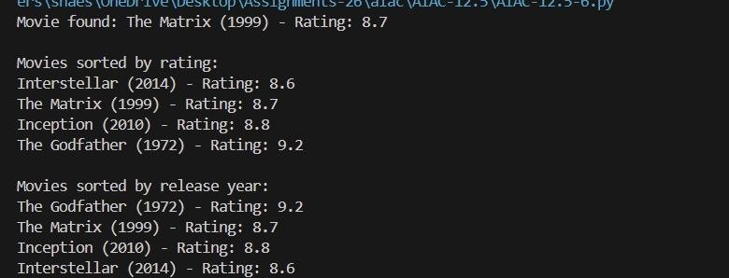

Task Description #7: Smart Agriculture Crop Monitoring System
An agriculture monitoring system stores crop data with crop ID, crop name, soil moisture level, temperature, and yield estimate. Farmers need to:
- Search crop details using crop ID.
- Sort crops based on moisture level or yield estimate. Student Task
  - Use AI-assisted reasoning to select algorithms.
  - Justify algorithm suitability.
  - Implement searching and sorting in Python.

#PROMPT
"""An agriculture monitoring system stores crop data with crop ID, crop name, soil moisture level, temperature, and yield estimate.

Generate a python program that allows users to perform the following operations:
- Search crop details using crop ID.
- Sort crops based on moisture level or yield estimate. Recommend suitable searching and sorting algorithms. Justify the selected algorithms."""

#CODE
class Crop:
def init (self, crop_id, crop_name, soil_moisture_level, temperature, yield_estimate): self.crop_id = crop_id
self.crop_name = crop_name
self.soil_moisture_level = soil_moisture_level self.temperature = temperature
self.yield_estimate = yield_estimate class Agriculture:
def init (self): self.crops = []

def add_crop(self, crop): self.crops.append(crop)

def search_crop_by_id(self, crop_id): """
Searches for crop details by crop ID using linear search.

Time Complexity: O(n) - where n is the number of crops.
Space Complexity: O(1) - as we are using a constant amount of space for variables. """
for crop in self.crops:
if crop.crop_id == crop_id:

return crop return None

def sort_crops_by_moisture_level(self): """
Sorts crops based on soil moisture level using Merge Sort.

Time Complexity: O(n log n) - where n is the number of crops.
Space Complexity: O(n) - due to the temporary arrays used for merging. """
self.crops = merge_sort(self.crops, key=lambda x: x.soil_moisture_level)

def sort_crops_by_yield_estimate(self): """
Sorts crops based on yield estimate using Merge Sort.

Time Complexity: O(n log n) - where n is the number of crops.
Space Complexity: O(n) - due to the temporary arrays used for merging. """
self.crops = merge_sort(self.crops, key=lambda x: x.yield_estimate) def merge_sort(arr, key):
if len(arr) <= 1: return arr

mid = len(arr) // 2
left_half = merge_sort(arr[:mid], key) right_half = merge_sort(arr[mid:], key)

return merge(left_half, right_half, key)

def merge(left, right, key): merged = []
left_index = right_index = 0

while left_index < len(left) and right_index < len(right): if key(left[left_index]) < key(right[right_index]):
merged.append(left[left_index]) left_index += 1
else:
merged.append(right[right_index]) right_index += 1

# If there are remaining elements in left or right, add them to merged merged.extend(left[left_index:])
merged.extend(right[right_index:])

return merged
# Justification for selected algorithms:
# 1. Linear Search: We use linear search for searching crop details by crop ID because it is simple to implement and works well for small datasets. Since the number of crops may not be very large, linear search is efficient enough for this use case.
# 2. Merge Sort: We use merge sort for sorting crops based on soil moisture level and yield estimate because it is a stable sorting algorithm with a time complexity of O(n log n) in the worst case. Merge sort is efficient for sorting large datasets and can handle different types of data, making it suitable for our crop data. Additionally, merge sort does not require additional space for in-place sorting, which can be beneficial when dealing with larger
datasets. #Test cases
if name == " main ":
agriculture_system = Agriculture()

# Adding sample crops

agriculture_system.add_crop(Crop(1, "Wheat", 30, 25, 100))
agriculture_system.add_crop(Crop(2, "Corn", 40, 28, 150))
agriculture_system.add_crop(Crop(3, "Rice", 20, 22, 120))

# Searching for a crop by ID
crop = agriculture_system.search_crop_by_id(2) if crop:
print(f"Crop found: {crop.crop_name}, Soil Moisture Level: {crop.soil_moisture_level}, Yield Estimate: {crop.yield_estimate}")
else:
print("Crop not found.")

# Sorting crops by soil moisture level
agriculture_system.sort_crops_by_moisture_level() print("Crops sorted by soil moisture level:")
for crop in agriculture_system.crops:
print(f"{crop.crop_name}: {crop.soil_moisture_level}")

# Sorting crops by yield estimate
agriculture_system.sort_crops_by_yield_estimate() print("Crops sorted by yield estimate:")
for crop in agriculture_system.crops:
print(f"{crop.crop_name}: {crop.yield_estimate}")
#OUTPUT
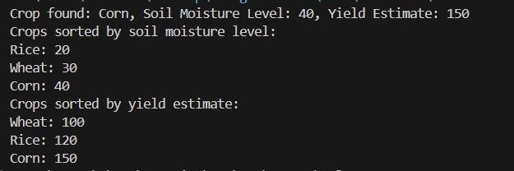

Task Description #8: Airport Flight Management System
An airport system stores flight information including flight ID, airline name, departure time, arrival time, and status. The system must:
- Search flight details using flight ID.
- Sort flights based on departure time or arrival time. Student Task
  - Use AI to recommend algorithms.
  - Justify the algorithm selection.
  - Implement searching and sorting logic in Python. #PROMPT
""" An airport system stores flight information including flight ID, airline name, departure time, arrival time, and status. Generate a python program that allows users to perform the following operations:
- Search flight details using flight ID.
- Sort flights based on departure time or arrival time""”
#CODE
class Flight:
def _init_(self, flight_id, airline_name, departure_time, arrival_time, status): self.flight_id = flight_id
self.airline_name = airline_name self.departure_time = departure_time self.arrival_time = arrival_time self.status = status
class AirportSystem: def _init_(self):
self.flights = []

def add_flight(self, flight): self.flights.append(flight)

def search_flight_by_id(self, flight_id): """
Searches for flight details by flight ID using linear search.

Time Complexity: O(n) - where n is the number of flights.
Space Complexity: O(1) - as we are using a constant amount of space for variables. """
for flight in self.flights:
if flight.flight_id == flight_id: return flight
return None

def sort_flights_by_departure_time(self): """
Sorts flights based on departure time using Merge Sort.

Time Complexity: O(n log n) - where n is the number of flights.
Space Complexity: O(n) - due to the temporary arrays used for merging. """
self.flights = merge_sort(self.flights, key=lambda x: x.departure_time)

def sort_flights_by_arrival_time(self): """
Sorts flights based on arrival time using Merge Sort.

Time Complexity: O(n log n) - where n is the number of flights.
Space Complexity: O(n) - due to the temporary arrays used for merging. """

self.flights = merge_sort(self.flights, key=lambda x: x.arrival_time) def merge_sort(arr, key):
if len(arr) <= 1: return arr

mid = len(arr) // 2
left_half = merge_sort(arr[:mid], key) right_half = merge_sort(arr[mid:], key)

return merge(left_half, right_half, key) def merge(left, right, key):
merged = []
left_index = right_index = 0

while left_index < len(left) and right_index < len(right): if key(left[left_index]) <= key(right[right_index]):
merged.append(left[left_index]) left_index += 1
else:
merged.append(right[right_index]) right_index += 1

merged.extend(left[left_index:])
merged.extend(right[right_index:])

return merged # Example usage
if _name_ == "_main_":
airport_system = AirportSystem()

# Adding some flights
airport_system.add_flight(Flight("FL001", "Airline A", "08:00", "10:00", "On Time")) airport_system.add_flight(Flight("FL002", "Airline B", "09:00", "11:00", "Delayed")) airport_system.add_flight(Flight("FL003", "Airline C", "07:30", "09:30", "On Time"))

# Searching for a flight by ID
flight = airport_system.search_flight_by_id("FL002") if flight:
print(f"Flight found: {flight.airline_name}, Departure: {flight.departure_time}, Arrival:
{flight.arrival_time}, Status: {flight.status}") else:
print("Flight not found.")

# Sorting flights by departure time
airport_system.sort_flights_by_departure_time() print("\nFlights sorted by departure time:")
for flight in airport_system.flights: print(f"{flight.flight_id}: {flight.departure_time}")

# Sorting flights by arrival time
airport_system.sort_flights_by_arrival_time() print("\nFlights sorted by arrival time:")
for flight in airport_system.flights: print(f"{flight.flight_id}: {flight.arrival_time}")

#OUTPUT
