PROJECT

DISASTER RECOVERY WITH IBM CLOUD SERVERS

PROJECT OBJECTIVES :

* **Data Protection**:
  + Ensure the integrity and availability of critical data hosted on IBM Cloud Virtual Servers during and after a disaster.
* **Business Continuity**:
  + Minimize downtime and disruptions to maintain essential business functions.
* **Recovery Time Objective (RTO)**:
  + Define and meet specific RTO targets for different applications and services to ensure timely recovery.
* **Recovery Point Objective (RPO)**:
  + Determine and meet RPO requirements to minimize data loss during recovery.
* **Cost-Effective Solutions**:
  + Implement cost-effective disaster recovery solutions that meet your organization's needs while staying within budget constraints.
* **Redundancy and Failover**:
  + Set up redundancy and failover configurations to ensure that critical services are available even if one location or server fails.
* **Compliance**:
  + Ensure that your disaster recovery strategies align with industry-specific regulations and compliance requirements.
* **Data Security**:
  + Maintain data security during and after a disaster by implementing encryption and access controls.
* **Resource Allocation**:
  + Allocate necessary resources (personnel, hardware, software, and network) to support the disaster recovery plan.
* **Documentation**:
* Create and maintain comprehensive documentation of the disaster recovery strategies and procedures.

PROJECT DEFINITION:

This project focuses on implementing a robust disaster recovery strategy utilizing IBM Virtual Servers. The primary objective is to ensure business continuity by safeguarding critical data, applications, and services in the event of unforeseen disruptions. The project encompasses designing and deploying comprehensive backup, replication, and recovery solutions tailored to the capabilities of IBM Virtual Servers. The result will be a resilient and agile disaster recovery plan that minimizes downtime, preserves data integrity, and ensures uninterrupted business operations.

This project is dedicated to crafting a comprehensive Disaster Recovery Plan (DRP) using IBM Cloud Virtual Servers, with a primary mission to safeguard business operations. Its core objective is to ensure uninterrupted continuity for on-premises virtual machines, even in the face of unforeseen events. The project’s key components include the establishment of robust backup strategies, meticulous replication configuration, rigorous recovery process testing, and the unwavering commitment to minimizing downtime. It encompases the formulation of the disaster recovery strategy, execution of backup and replication protocols, validation of recovery procedures, and the unwavering pursuit of seamless business continuity.

**Design Thinking**:

**Disaster Recovery Strategy:**

1. Empathize:

- Understand the needs and concerns of your organization, employees, customers, and other stakeholders during a disaster. This might involve conducting interviews, surveys, or workshops to gather insights.

- Develop personas or user profiles to represent the different stakeholders involved in disaster recovery.

2. Define:

- Clearly define the scope and objectives of your disaster recovery strategy. What are the critical systems, data, and processes that need protection?

- Identify the key performance indicators (KPIs) that will measure the success of your strategy, such as recovery time objectives (RTO) and recovery point objectives (RPO).

3. Ideate:

- Brainstorm creative solutions for disaster recovery that meet the identified needs and objectives. Encourage diverse perspectives and ideas from team members.

- Consider both technological and non-technological solutions. This could involve backup and data replication technologies, but also communication plans, emergency response protocols, and employee support mechanisms.

4. Prototype:

- Create prototypes or models of your disaster recovery strategy. These could be in the form of simulations, tabletop exercises, or simplified plans.

- Test these prototypes in controlled scenarios to identify potential weaknesses and areas for improvement.

5. Test and Iterate:

- Conduct realistic disaster recovery drills and exercises to evaluate the effectiveness of your strategy.

- Collect feedback from participants and stakeholders and use it to refine and improve the plan.

- Continuously iterate and update your disaster recovery strategy based on lessons learned and changes in technology or business processes.

6. Implement:

- Once your disaster recovery strategy has been refined and tested, implement it across your organization.

- Ensure that everyone involved understands their roles and responsibilities in the event of a disaster.

- Regularly update and maintain your disaster recovery documentation and procedures.

7. Monitor and Maintain:

- Continuously monitor the performance of your disaster recovery strategy and make adjustments as needed.

- Stay informed about emerging threats and technologies that may impact your strategy.

- Conduct periodic reviews and audits to ensure compliance and effectiveness.

8. Communicate:

- Maintain open and transparent communication with all stakeholders about the disaster recovery strategy.

- Educate employees and stakeholders on their roles and responsibilities.

- Provide regular updates on the status of the disaster recovery plan and any changes made.

**Backup Configuration**:

1. Empathize:

- Understand the specific data and configuration needs of your organization, as well as the challenges and pain points associated with the current backup process for on-premises VMs.

- Engage with IT administrators, data owners, and other stakeholders to gather insights into what data and configurations are considered critical, how often they need to be backed up, and any issues they face with the existing backup procedures.

2. Define:

- Clearly define the goals and objectives of your backup configuration for on-premises VMs.

- Identify critical data, system configurations, and applications that require regular backup.

- Determine the required backup frequency and retention periods based on business and compliance needs.

3. Ideate:

- Brainstorm creative solutions for configuring backups that address the identified needs and objectives.

- Consider backup tools, scheduling options, and storage solutions that are suitable for on-premises VMs.

- Explore backup automation and integration with monitoring systems to streamline the process.

4. Prototype:

- Create prototypes or models of the proposed backup configuration.

- Test these prototypes with a subset of on-premises VMs to ensure they meet the desired backup frequency and data retention requirements.

- Collect feedback from IT administrators and other users to identify areas for improvement.

5. Test and Iterate:

- Conduct full-scale backup and recovery tests for on-premises VMs to validate the effectiveness of your backup configuration.

- Continuously iterate based on user feedback and test results.

- Be open to adjusting your configuration as you learn more about what works best.

6. Implement:

- Roll out the finalized backup configuration for all on-premises VMs based on the lessons learned during testing and iteration.

- Ensure that backup procedures are well-documented and easily accessible to IT staff responsible for managing VMs.

- Provide training and support to ensure the effective use of the backup solution.

7. Monitor and Maintain:

- Continuously monitor the performance of your backup configuration for on-premises VMs.

- Set up alerts and reporting mechanisms to detect and address backup issues promptly.

- Regularly review and update backup processes to adapt to changes in VM configurations and business requirements.

8. Communicate:

- Maintain clear and transparent communication with stakeholders regarding the on-premises VM backup efforts.

- Educate IT staff and data owners about the benefits of the new backup configuration and provide support as needed.

- Encourage ongoing feedback to ensure that the configuration remains aligned with evolving business needs.

**Replication Setup**:

1. Empathize:

- Understand the specific replication needs of your organization and the challenges faced with maintaining up-to-date copies of data and virtual machine images.

- Engage with IT administrators, data owners, and other stakeholders to gather insights into the importance of data and VM images, recovery time objectives (RTOs), and potential issues with existing replication processes.

2.Define:

- Clearly define the goals and objectives of your replication setup to IBM Cloud Virtual Servers.

- Identify critical data, VM images, and applications that require replication.

- Determine the desired RTOs and recovery point objectives (RPOs) based on business and compliance requirements.

3. Ideate:

- Brainstorm creative solutions for setting up replication that addresses the identified needs and objectives.

- Consider replication tools, technologies, and methodologies that are compatible with IBM Cloud Virtual Servers.

- Explore automation and orchestration capabilities to streamline the replication process.

4. Prototype:

- Create prototypes or models of the proposed replication setup.

- Test these prototypes with a subset of data and VM images to ensure they meet the desired RTOs and RPOs.

- Collect feedback from IT administrators and stakeholders to identify areas for improvement.

5. Test and Iterate:

- Conduct full-scale replication tests to validate the effectiveness of your setup.

- Continuously iterate based on user feedback and test results.

- Be open to adjusting your configuration as you learn more about what works best.

6. Implement:

- Roll out the finalized replication setup for all critical data and VM images to IBM Cloud Virtual Servers based on the lessons learned during testing and iteration.

- Ensure that replication procedures are well-documented and easily accessible to IT staff responsible for managing the setup.

- Provide training and support to ensure the effective use of the replication solution.

7. Monitor and Maintain:

- Continuously monitor the performance of your replication setup.

- Set up alerts and reporting mechanisms to detect and address replication issues promptly.

- Regularly review and update replication processes to adapt to changes in data and VM image requirements.

8. Communicate:

- Maintain clear and transparent communication with stakeholders regarding the replication efforts.

- Educate IT staff and data owners about the benefits of the new replication setup and provide support as needed.

- Encourage ongoing feedback to ensure that the setup remains aligned with evolving business needs.

**Recovery Testing:**

1. Empathize:

- Understand the objectives and concerns of your organization when it comes to recovery testing.

- Engage with key stakeholders, including IT administrators, business leaders, and compliance teams, to gather insights into recovery testing needs and challenges.

- Identify the critical systems, data, and processes that must be tested for recovery.

2. Define:

- Clearly define the goals and objectives of your recovery testing plan.

- Identify the key performance indicators (KPIs) and success criteria for recovery testing.

- Determine the scope of testing, including which systems or processes will be tested and the frequency of testing.

3. Ideate:

- Brainstorm creative solutions for conducting recovery testing that address the identified needs and objectives.

- Consider different recovery testing methodologies, such as full-scale simulations, tabletop exercises, or partial system recoveries.

- Explore the use of automation tools and scripts to streamline testing processes.

4. Prototype:

- Create prototypes or models of the recovery testing scenarios and procedures.

- Test these prototypes with a subset of systems or processes to ensure they meet the desired objectives.

- Collect feedback from participants and stakeholders to identify areas for improvement.

5.Test and Iterate:

- Conduct full-scale recovery tests to validate the effectiveness of your testing plan.

- Continuously iterate based on feedback and test results.

- Be open to adjusting your testing scenarios and procedures as you learn more about what works best.

6. Implement:

- Roll out the finalized recovery testing plan based on the lessons learned during testing and iteration.

- Ensure that recovery testing procedures are well-documented and easily accessible to the testing teams.

- Provide training and support to ensure that recovery testing is conducted effectively.

7. Monitor and Maintain:

- Continuously monitor the performance of your recovery testing plan.

- Set up alerts and reporting mechanisms to detect and address issues in the testing process.

- Regularly review and update testing scenarios to adapt to changes in systems or processes.

8. Communicate:

- Maintain clear and transparent communication with stakeholders regarding recovery testing efforts.

- Educate employees and relevant teams about the importance of recovery testing and their roles in the process.

- Encourage ongoing feedback to ensure that the testing plan remains aligned with evolving business needs.

**Business Continuity:**

1. Empathize:

- Understand the needs and concerns of various stakeholders in your organization regarding business continuity.

- Engage with employees, department heads, customers, suppliers, and other key stakeholders to gather insights into what aspects of the business are critical, what challenges they face, and what their expectations are during a disruption.

2. Define:

- Clearly define the scope and objectives of your business continuity plan.

- Identify critical business functions, processes, and resources that must be protected and maintained.

- Determine the maximum allowable downtime (recovery time objectives) and acceptable data loss (recovery point objectives) for each critical component.

3. Ideate:

- Brainstorm creative solutions for ensuring business continuity that address the identified needs and objectives.

- Consider alternative strategies for redundancy, disaster recovery, remote work, and communication.

- Explore both technological and non-technological solutions, such as off-site backup locations and crisis communication plans.

4. Prototype:

- Create prototypes or models of your business continuity plan components.

- Test these prototypes in simulated scenarios or tabletop exercises to ensure they meet recovery objectives.

- Gather feedback from participants and stakeholders to identify areas for improvement.

5. Test and Iterate:

- Conduct realistic business continuity drills and exercises to evaluate the effectiveness of your plan.

- Continuously iterate based on feedback and test results.

- Be open to adjusting your plan as you learn more about what works best.

6. Implement:

- Roll out the finalized business continuity plan based on the lessons learned during testing and iteration.

- Ensure that employees understand their roles and responsibilities in the event of a disruption.

- Regularly update and maintain your plan to reflect changes in technology, processes, and business priorities.

7. Monitor and Maintain:

- Continuously monitor the performance of your business continuity plan.

- Set up alerts and reporting mechanisms to detect and address issues in real-time.

- Conduct regular reviews and audits to ensure compliance and effectiveness.

8. Communicate:

- Maintain open and transparent communication with all stakeholders about the business continuity plan.

- Educate employees and stakeholders about the plan and how it impacts their roles.

- Provide regular updates on the status of the plan and any changes made.

PROJECT DEFINITION:

Disaster recovery with IBM Cloud virtual servers is a critical aspect of ensuring business continuity and data resilience. IBM Cloud offers various services and features to help you implement an effective disaster recovery plan for your virtual servers. Here's an overview of the key components and innovations that matter in detail :

* INTRODUCTION:

Disaster recovery (DR) is the process of restoring access to data and applications after a disaster. DR plans and solutions help businesses minimize downtime and financial losses in the event of a disaster.

IBM Virtual Servers offer a variety of DR solutions that can be tailored to meet the specific needs of each business. These solutions include:

Replication: Replication involves copying data from one server to another in real time or on a scheduled basis. This allows businesses to quickly restore access to data and applications in the event of a disaster at the primary site.

Backup and restore: Backup and restore involves creating copies of data and applications and storing them in a safe location. In the event of a disaster, the data and applications can be restored from backup.

Cloud DR: Cloud DR involves using cloud-based resources to provide disaster recovery protection. This can be a cost-effective and scalable option for businesses of all sizes.

* Presentation Goals
* Provide an understanding of what disaster recovery is and why it's crucial for business continuity.
* Explain what IBM Virtual Servers are and their significance in the context of disaster recovery.
* Highlight the built-in disaster recovery features of IBM Virtual Servers.
* Discuss various disaster recovery solutions that can be implemented using IBM Virtual Servers.
* Summarize the main points and key takeaways from the presentation.
* Key objective
* Ensure uninterrupted business operations during and after disruptive events.
* Safeguard critical data from loss or corruption.
* Minimize system and application downtime to meet Recovery Time Objectives (RTO).
* Develop a crisis management plan for immediate disaster response.
* Conduct regular DR drills to assess and improve preparedness.
* Maintain records of successful DR operations for reference and reporting.
* Benefits of using IBM Virtual Servers for DR

There are many benefits to using IBM Virtual Servers for disaster recovery,

* Flexibility: IBM Virtual Servers offer a variety of DR solutions that can be customized to meet the specific needs of each business.
* Scalability: IBM Virtual Servers can be scaled to meet the changing needs of businesses. This makes them a good choice for businesses of all sizes.
* Reliability: IBM Virtual Servers are built on a reliable and secure platform. This helps businesses ensure that their data and applications are protected in the event of a disaster.
* Affordability: IBM Virtual Servers are a cost-effective DR solution. Businesses can choose the DR solution that best meets their needs and budget.
* Replication
* Replication is a common DR strategy that involves copying data from one server to another in real time or on a scheduled basis. This allows businesses to quickly restore access to data and applications in the event of a disaster at the primary site.
* IBM Virtual Servers offer a variety of replication solutions, including:
* IBM Cloud Hyper Protect Virtual Servers: IBM Cloud Hyper Protect Virtual Servers offer a fully managed DR solution that uses replication to protect data and applications.
* IBM Cloud Power Virtual Servers: IBM Cloud Power Virtual Servers offer a variety of replication options, including synchronous replication, asynchronous replication, and remote copy.
* IBM Power Systems Private Cloud: IBM Power Systems Private Cloud offers a variety of replication options for IBM Power Systems servers.
* Innovation Techniques
* Utilize Al and machine learning to predict potential failures and proactively take action to prevent downtime.
* Implement automated orchestration tools to streamline the DR process, reducing manual intervention.
* Leverage SDS solutions to provide flexibility and scalability for storage resources in DR scenarios.
* Implement APIs for seamless integration between DR systems and IBM Virtual Servers, enabling rapid failover.
* Integrate DevOps practices and laC to automate DR provisioning and configuration.
* Backup and restore
* Backup and restore is a DR strategy that involves creating copies of data and applications and storing them in a safe location. In the event of a disaster, the data and applications can be restored from backup.
* IBM Virtual Servers offer a variety of backup and restore solutions, including:
* IBM Cloud Backup Service: IBM Cloud Backup Service is a fully managed backup and recovery service that can be used to protect data on IBM Virtual Servers.
* IBM Tivoli Storage Manager: IBM Tivoli Storage Manager is a backup and recovery software solution that can be used to protect data on IBM Virtual Servers.
* IBM Spectrum Protect: IBM Spectrum Protect is a backup and recovery software solution that can be used to protect data on IBM Virtual Servers.
* Cloud DR
* Cloud DR is a DR strategy that involves using cloud-based resources to provide disaster recovery protection. This can be a cost-effective and scalable option for businesses of all sizes.
* IBM Virtual Servers offer a variety of cloud DR solutions, including:
* IBM Cloud Disaster Recovery as a Service: IBM Cloud Disaster Recovery as a Service is a fully managed DR service that can be used to protect data and applications on IBM Virtual Servers.
* IBM Cloud Hyper Protect Virtual Servers: IBM Cloud Hyper Protect Virtual Servers offer a fully managed DR solution that uses replication to protect data and applications.
* IBM Cloud DR Orchestration: IBM Cloud DR Orchestration is a software solution that can be used to automate and manage DR processes for IBM Virtual Servers.
* Benefits Of Cloud DR
* Eliminates the need for dedicated physical DR sites, reducing capital expenses.
* Easily scales resources up or down in the cloud to match your DR needs.
* Provides flexibility in choosing recovery locations and strategies.
* Enables faster recovery times compared to traditional DR approaches.
* Reduces the complexity associated with traditional DR solutions.
* Provides global accessibility to data and applications for remote users.
* Helps prevent disasters through proactive monitoring and mitigation.
* Achivements
* Achieved minimal downtime during disaster events, ensuring business continuity.
* Successfully recovered critical systems and data within the defined Recovery Time Objectives (RTO).
* Ensured the integrity of data with a recovery process that maintains data consistency.
* Implemented redundant IBM Virtual Server configurations to reduce the risk of hardware failures.
* Defined incident response procedures to address unforeseen challenges promptly.
* Ensured that critical business processes continued even in the face of disruptions.
* Conclusion:
* BM Virtual Servers offer a variety of DR solutions that can be tailored to meet the specific needs of each business. These solutions include replication, backup and restore, and cloud DR.
* By using IBM Virtual Servers for DR, businesses can minimize downtime and financial losses in the event of a disaster.

DEVELOPMENT PART 1

# Introduction:

Disaster recovery planning for IBM Virtual Services is of paramount importance in today's technology-driven business landscape. As organizations increasingly rely on virtual services hosted in

cloud and virtualized environments, ensuring the availability and resilience of these services is critical for maintaining business continuity and data integrity. Here's an overview of the importance of disaster recovery planning and the objectives and scope of the project:

# Importance of Disaster Recovery Planning for IBM Virtual Services:

1. **Business Continuity**: IBM Virtual Services play a significant role in delivering essential applications, data, and services for businesses. Any disruption in these services can result in downtime, lost revenue, and damage to reputation. Disaster recovery planning is essential to minimize downtime and maintain essential operations during unforeseen events.
2. **Data Protection:** IBM Virtual Services often house critical data. Disaster recovery planning ensures that data is backed up and can be quickly restored in case of data loss due to natural disasters, human error, or cyberattacks.
3. **Compliance and Regulations:** Many industries are subject to regulatory requirements regarding data protection and business continuity. Disaster recovery planning helps organizations meet these compliance standards and avoid potential legal and financial consequences.
4. **Risk Mitigation:** By identifying potential risks and vulnerabilities, disaster recovery planning enables proactive risk mitigation. This includes measures like data replication, backup, and failover strategies.
5. **Customer Trust:** Customers and clients expect consistent service. A well-executed disaster

recovery plan demonstrates a commitment to reliability and can enhance customer trust and loyalty.

# Objectives and Scope of the Project:

The primary objectives and scope of the disaster recovery project for IBM Virtual Services are as follows:

1. **Define Recovery Objectives:** Establish clear Recovery Time Objectives (RTO) and Recovery Point Objectives (RPO) for critical applications and services. This defines the maximum allowable downtime and data loss in case of a disaster.
2. **IBM Cloud Foundry Integration:** Leverage IBM Cloud Foundry as the primary platform for disaster recovery. Ensure that it can seamlessly support failover, data synchronization, and backup processes.
3. **Data Protection:** Implement robust data protection mechanisms, including regular backups, data replication, and encryption, to safeguard critical data.
4. **Application Failover:** Develop strategies for application failover, ensuring that critical applications can quickly switch to redundant systems or backup locations during a disaster.
5. **Testing and Validation:** Establish a regular testing schedule to ensure the effectiveness of the disaster recovery plan. This includes both simulated tests and live drills.
6. **Documentation:** Create a comprehensive disaster recovery plan document that includes detailed procedures, contact information, and configuration details.
7. **Training:** Provide training to the disaster recovery team to ensure they understand their roles and responsibilities during a disaster event.
8. **Budget and Resource Allocation:** Estimate the budget required for the project, allocate necessary resources, and secure approval from management.
9. **Compliance:** Ensure that the disaster recovery plan aligns with relevant compliance standards and regulations applicable to the organization.
10. **Risk Management:** Identify potential risks and develop mitigation strategies to minimize project- related risks.
11. **Project Timeline:** Develop a timeline that outlines key milestones and deadlines for the project.

This project will be a comprehensive effort to establish a robust disaster recovery plan for IBM Virtual Services, covering critical aspects such as data protection, application resilience, and compliance

adherence to safeguard the organization's business operations and data assets in the face of unexpected disruptions.

# Project Setup:

To create an effective disaster recovery plan for IBM Virtual Services, it's crucial to have a clear

understanding of the current setup, including applications, data, and configurations. Here's how you can define the existing setup:

# Inventory of Applications:

* + List all applications and services hosted on IBM Virtual Services. Include both internally developed and third-party applications.
  + Document their criticality to business operations. Identify which applications are mission-critical and which are less essential.

# Data Sources and Data Types:

* + Identify the sources of data within the virtual services, such as databases, file storage, and cloud- based data.
  + Categorize data types, including sensitive and non-sensitive data, customer data, financial records, and intellectual property.

# Infrastructure Configuration:

* + Document the technical specifications of the infrastructure, including servers, virtual machines, storage systems, and networking components.
  + Describe the virtualization technologies and cloud services in use.

# Network Architecture:

* + Provide an overview of the network topology, including the connections between virtual services and other on-premises or cloud environments.
  + Identify any network security measures in place.

# Access Control and Authentication:

* + Explain the access control mechanisms, such as user accounts, roles, and authentication methods.
  + Note any privileged access or administrative roles.

# Backup and Disaster Recovery Tools:

* + Detail the existing backup and disaster recovery tools, if any, that are currently in use.
  + Describe how backups are scheduled, and data recovery is performed.

# Identifying Potential Risks and Vulnerabilities:

Understanding the potential risks and vulnerabilities in the current setup is crucial for disaster

recovery planning. These risks can vary depending on the nature of your business and the technology landscape, but here are some common areas to consider:

# Natural Disasters:

* + Geographic location can expose the virtual services to risks like earthquakes, floods, hurricanes, and wildfires.
  + Evaluate the resilience of data centers to withstand such disasters.

# Hardware Failures:

* + Hardware components, such as servers, storage, or networking equipment, can fail, leading to service disruptions.
  + Identify single points of failure and areas lacking redundancy.

# Software Failures:

* + Software bugs or misconfigurations can lead to application downtime or data corruption.
  + Assess software quality and the presence of timely software updates and patches.

# Cybersecurity Threats:

* + The virtual services are vulnerable to cyberattacks, including malware, ransomware, and data breaches.
  + Evaluate the strength of security measures, such as firewalls, intrusion detection systems, and access controls.

# Human Error:

* + Mistakes made by employees or administrators can lead to data loss or service disruptions.
  + Evaluate training and procedures in place to mitigate human errors.

# Operational Risks:

* + Assess operational risks, such as capacity planning, resource scaling, and change management procedures.
  + Consider whether there are processes in place to handle unforeseen operational issues.

# Third-Party Dependencies:

* + Identify any third-party services or components that your virtual services rely on. Assess the potential risks associated with these dependencies.

# Regulatory and Compliance Risks:

* + Evaluate whether the virtual services comply with relevant industry-specific regulations and standards. Non-compliance can result in legal and financial consequences.

By thoroughly defining the current setup and identifying potential risks and vulnerabilities, you'll be better equipped to design a disaster recovery plan that addresses these specific challenges and ensures the continuity of your IBM Virtual Services. Disaster Recovery Requirements:

Determining recovery time objectives (RTO) and recovery point objectives (RPO) is a critical step in disaster recovery planning. These metrics help define the maximum allowable downtime and data loss for different components of your IBM Virtual Services. Additionally, identifying critical

applications and data is essential to prioritize the recovery efforts. Here's how to approach these requirements:

# Define Recovery Time Objectives (RTO):

RTO is the maximum acceptable time it takes to recover a component or service after a disaster. The RTO is typically expressed in hours or minutes and varies depending on the criticality of the component. To determine RTO:

* + **Gather Stakeholder Input:** Consult with key stakeholders, including department heads and IT staff, to understand their expectations for recovery times.
  + **Categorize Components:** Categorize the components and services into different tiers based on their importance to the business. For example:
    - Tier 1: Mission-critical components with an RTO of near-zero or a few minutes.
    - Tier 2: Important components with an RTO of a few hours.
    - Tier 3: Less critical components with an RTO of several hours.
  + **Document RTO for Each Tier:** Assign specific RTO values to each tier based on the discussions with stakeholders. For example, Tier 1 may have an RTO of 15 minutes, Tier 2 an RTO of 4 hours, and Tier 3 an RTO of 24 hours.

# Define Recovery Point Objectives (RPO):

RPO is the maximum acceptable data loss in case of a disaster. It defines the point in time to which data must be recovered to ensure minimal loss. To determine RPO:

* + **Assess Data Change Rates:** Analyze the rate at which data changes for each component. For

example, databases with frequent transactions may have a low RPO, while non-critical systems with infrequent data updates may have a higher RPO.

* + **Categorize Components:** Like with RTO, categorize components into tiers based on their data criticality.
  + **Document RPO for Each Tier:** Assign specific RPO values to each tier. For example, Tier 1 may have an RPO of 15 minutes, Tier 2 an RPO of 4 hours, and Tier 3 an RPO of 24 hours.

1. Identify Critical Applications and Data:
   * Application Assessment: Work closely with department heads and users to identify applications that are critical to daily business operations. This might include customer-facing applications, order processing systems, and financial applications.
   * Data Assessment: Identify the data that these critical applications depend on. This can include customer databases, transaction records, financial records, and any other data that, if lost, would severely impact the business.
   * Catalog Criticality: Categorize critical applications and data into the same tiers used for RTO and RPO definitions. Ensure that critical applications and data align with the appropriate recovery

objectives.

DEVELOPMENT PART 2

# INTRODUCTION:

Configuring replication of data and virtual machine (VM) images from on-premises to IBM Cloud Virtual Servers is a crucial step in building a robust disaster recovery plan. Below are the steps for implementing data replication and testing recovery procedures in this context:

# IMPLEMENTING DATA REPLICATION TO IBM CLOUD VIRTUAL SERVER:

1. **Choose Replication Tools:** Select a suitable replication tool or service that can efficiently transfer your data and VM images to IBM Cloud Virtual Servers. IBM offers several cloud services and tools that can assist in this process.

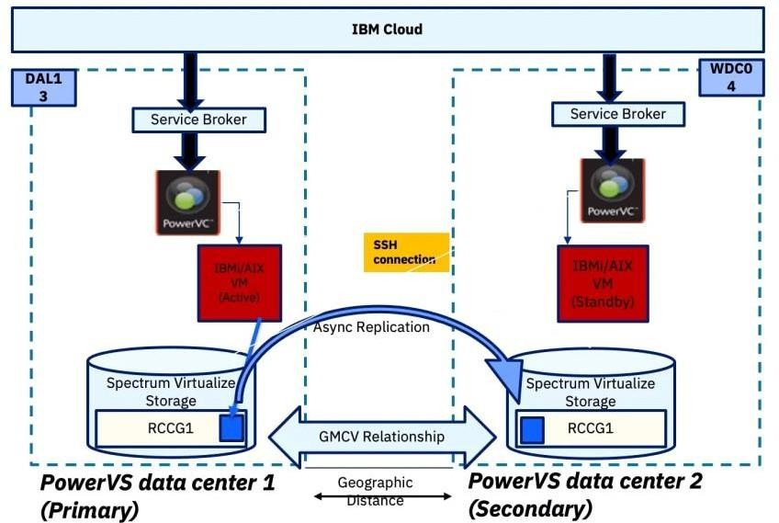

1. **Connect On-Premises and Cloud Environments:** Establish a secure network connection between your on-premises infrastructure and IBM Cloud using VPN or dedicated connectivity options.

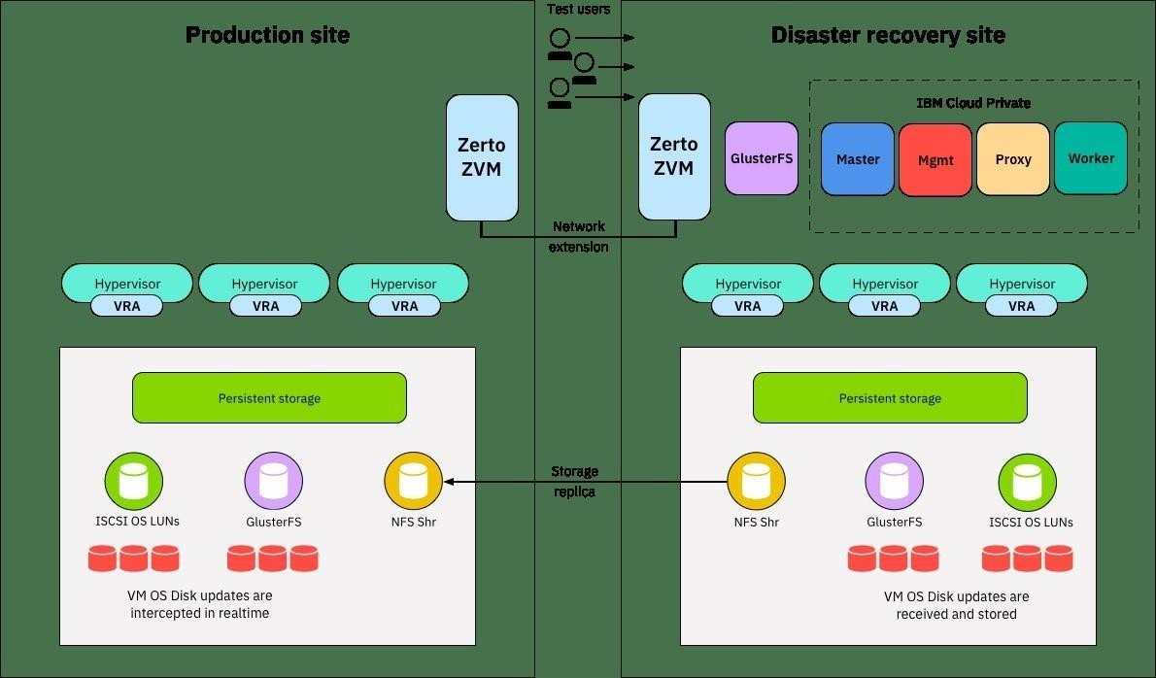

1. **Data Backup and Replication:** Regularly back up your critical data to on-premises storage solutions. Configure replication tasks to periodically synchronize your on-premises data with IBM Cloud. This process may involve using IBM Cloud

Object Storage or block storage services to store replicated data.

1. **Replicate Virtual Machine Images:** Utilize VM image replication tools to create copies of your on-premises VMs in IBM Cloud Virtual Servers. Ensure that VM images are updated in near real-time to minimize data loss in the event of a disaster.

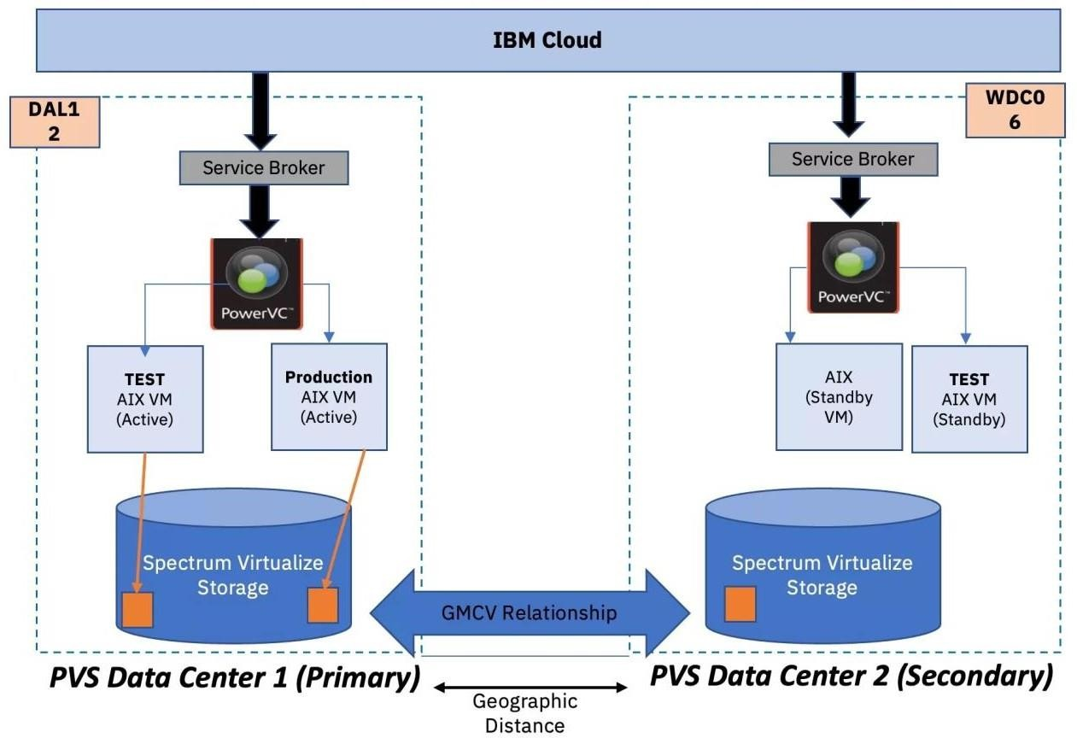

1. **Encryption and Security:** Encrypt data during transfer to ensure the security and privacy of sensitive information.

# TESTING RECOVERY PROCEDURES:

1. **Recovery Plan Documentation:** Ensure that you have detailed documentation of your recovery plan, including step- by-step procedures for restoring data and VMs in the IBM Cloud environment.
2. **Test Scenario Definition:** Define the disaster scenario you want to simulate during the recovery test. For example, you could simulate a complete data center outage, hardware failure, or a catastrophic data loss event.
3. **Isolate Testing Environment:** Set up an isolated testing environment in IBM Cloud for the recovery test. This environment should closely resemble your production environment.
4. **Execute Recovery Procedures:** Follow the recovery procedures outlined in your documentation to restore data and VM images to the IBM Cloud environment. This should include:
   1. Restoring data from replicated backups.
   2. Spinning up VMs from the replicated VM images.
   3. Configuring network and access settings as needed.
5. **Monitoring and Verification:** Continuously monitor the recovery process to identify any issues or unexpected complications.
6. **Data Validation:** Validate the integrity of the recovered data and applications to ensure they function as expected.
7. **Failback Planning:** Develop a plan for reverting back to your on-premises environment when the disaster scenario is resolved. Test this process as well.
8. **Documentation and Reporting:** Document the results of the recovery test, including any issues encountered and lessons learned.

Revise your disaster recovery plan based on the insights gained during testing.

1. **Regular Testing:** Conduct recovery tests regularly to ensure that your disaster recovery plan remains effective and up-to- date. This testing should account for changes in your

infrastructure and applications.

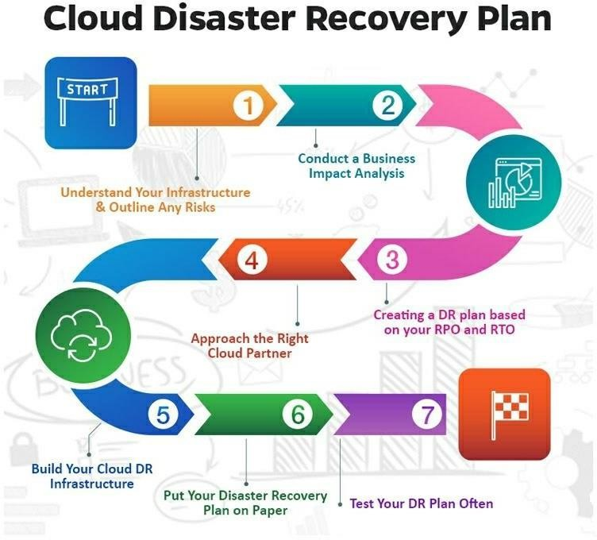

# CONCLUSION:

In conclusion, disaster recovery with cloud services, such as IBM Cloud Virtual Servers, involves implementing data replication for business-critical information and

thoroughly testing recovery procedures. This strategy ensures data and application availability in the face of unforeseen disasters or outages. Regular testing, documentation, and adaptation of the plan are essential for maintaining a robust and reliable disaster recovery solution that aligns with your evolving business needs and technological changes.