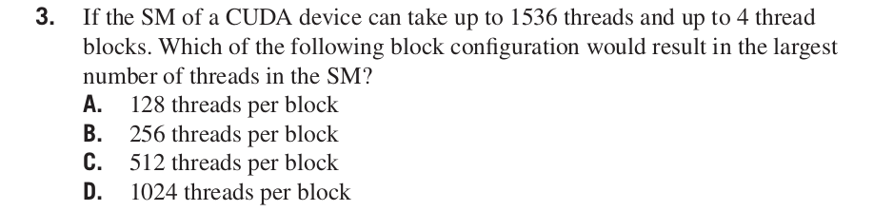

Answer: **C.** 512 threads per block

3 blocks of 512 threads each would give 1536 threads. Hence C is the correct answer.

As the SM can only take up to 4 thread blocks configurations of 128 and 256 threads per block would give 512 and 1024 threads in the SM respectively thus not effectively utilizing the resources of the SM. The configuration of 1024 per block would exceed our limitation of 1536 threads with just 2 thread blocks.

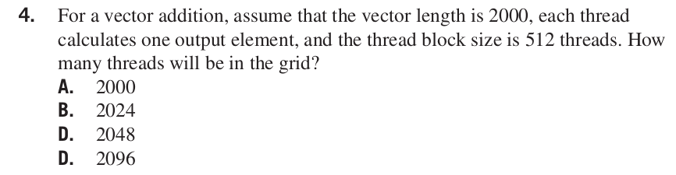

Answer: **C.** 2048

There will be a total of 4 thread blocks amounting to 2048 threads. The programmer should use if statement to prevent the extra 48 threads from taking effect.

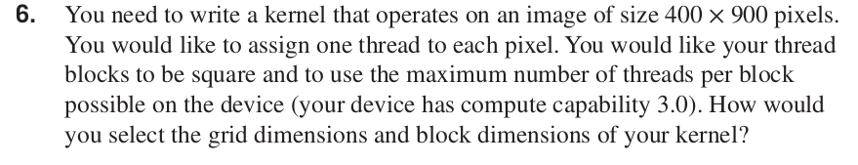

Answer:

**Block dimension: 32 x 32**

blockDim.x=32, blockDim.y=32, blockDim.z=1

**Grid dimension: 377 blocks**

gridDim.x=13, gridDim.y=29, gridDim.z=1

In CUDA 3.0 each thread block can have upto 1024 threads. 32 x 32 block size would fit contraints of square thread blocks and to use the maximum number of threads per block.

Assuming that the image is 400 pixels in horizontal direction and 900 pixels in vertical direction, we will need 13 blocks(ceil(400/32.0)) in horizontal direction and 29 blocks(ceil(900/32.0)) in vertical direction resulting in 377(13*29) blocks.



Answer: **26048 idle threads.**

We generate 416 x 928 threads to process 400 x 900 pixels. This results in 26048 idle threads.

(416×928)−(400×900) = 26048

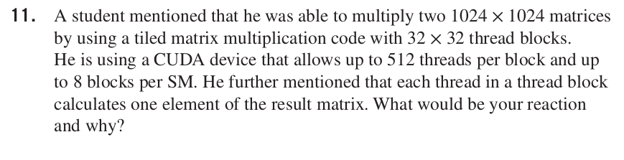

Answer:

32 x 32 thread blocks results in 1024 threads per block, but the student says that he is using a CUDA device that only allows up to 512 threads per block. Hence there is a contradiction among the student’s statements.