

Cognifyz IT Solutions Pvt. Ltd
Data Analysis Internship Program

Restaurant Dataset - Detailed
Findings & Insights Report

Covering Level 1, Level 2, and Level 3 Task Lists
Dataset: Dataset.csv | 9,551 restaurants | 21 attributes
Tools: Python, Pandas, NumPy, Matplotlib, Seaborn, Jupyter Notebook, VS Code

Prepared as part of the Cognifyz Technologies Data Analysis Internship
By: BIMLESH KUMAR SAH
Email: sahbimlesh9@gmail.com

Executive Summary
This report presents a complete analysis of the Cognifyz Technologies restaurant dataset (9,551 restaurants across 141 cities and multiple countries), addressing every task in the Level 1, Level 2, and Level 3 task lists. The dataset skews heavily toward India — particularly New Delhi — and toward budget-friendly, North Indian and Chinese cuisine restaurants, with a long international tail. Ten key findings emerge, spanning cuisine popularity, pricing, service availability, geography, restaurant chains, and the relationship between votes and ratings.

Sn. No. | Task | Key Findings
1 | Top Cuisines | North Indian (41.5%), Chinese (28.6%), Fast Food (20.8%)
2 | City Analysis | New Delhi has the most restaurants (5,473); London/Tampa Bay lead average rating among cities with 20+ restaurants
3 | Price Range | 46.5% of restaurants are in the cheapest price range
4 | Online Delivery | Only 25.7% offer it, but they rate ~0.79 stars higher on average
5 | Ratings Distribution | 3.0–3.9 is the most common range; avg. 156.77 votes/restaurant
6 | Cuisine Combinations | Chinese & North Indian is the top multi-cuisine pairing; Japanese & Sushi rates highest
7 | Geographic Analysis | Restaurants cluster overwhelmingly around New Delhi/NCR
8 | Restaurant Chains | Cafe Coffee Day has the most outlets (83); Chili's has the highest avg. rating (4.58) among major chains
9 | Review Analysis | Restaurants gained positive review around average (2487), good (2096); Correlation of -0.47 b/w review length & rating
10 | Votes Analysis | Weak positive correlation (0.31); Toit has the most votes (10,934)
11 | Price vs. Services | Table booking rises with price; online delivery peaks at mid-range and falls at the top end

Level 1: Foundational Analysis
Level 1 covers the basic descriptive landscape of the dataset: cuisine popularity, city-level patterns, pricing
distribution, and online delivery adoption.

LEVEL 1 | TASK 1
TASK: Top Cuisines
- Determine the top three most common cuisines in the dataset.
- Calculate the percentage of restaurants that serve each of the top cuisines.
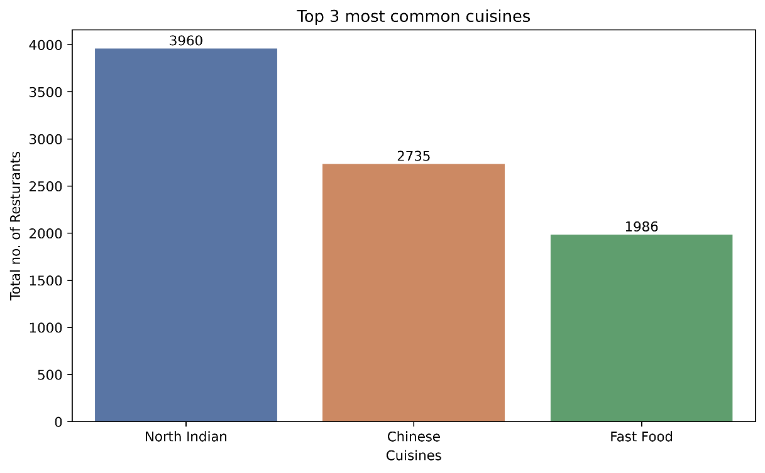
Figure 1.1 - Top 3 most common cuisines by restaurant count

Finding & Insights:
- North Indian is the most common cuisine, served by 41.5% of restaurants (3,960 restaurants).
- Chinese is the second most common cuisine, served by 28.6% of restaurants (2,735 restaurants).
- Fast Food ranks third, served by 20.8% of restaurants (1,986 restaurants).

Together these three cuisines appear far more often than any others, reflecting the dataset's concentration in Indian cities where North Indian and Chinese are near-universal menu staples, often served in combination at the same restaurant

LEVEL 1 | TASK 2
TASK: City Analysis
- Identify the city with the highest number of restaurants.
- Calculate the average rating for restaurants in each city.
- Determine the city with the highest average rating.
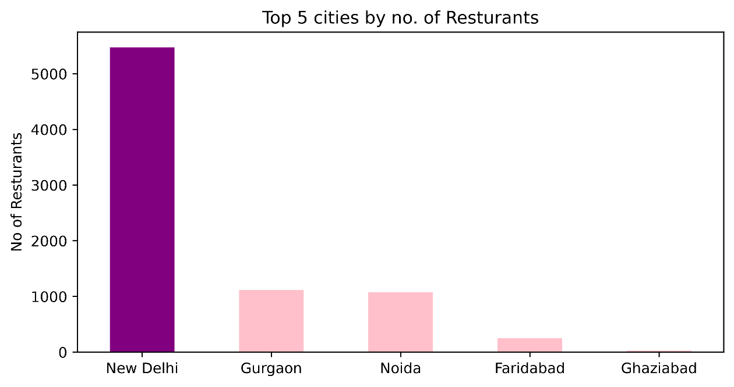
Figure 1.2 - Top 5 Cities by number of restaurants
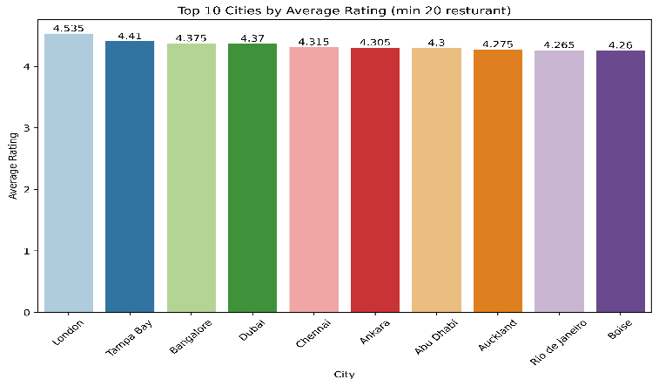
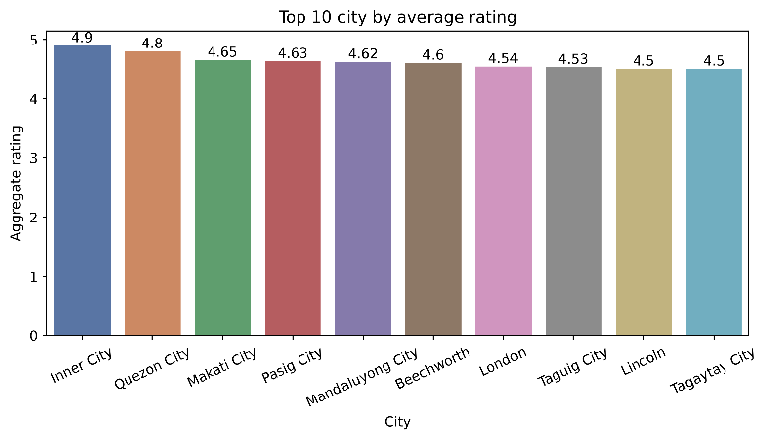

Figure 1.2 - Top 10 Cities by number of avg. rating Figure 1.3 - Top 10 Cities by avg. rating (min 20 restaurants)

Finding & Insights:
- New Delhi has the most restaurants (5,473), representing about 57% of the whole dataset.
- Inner City has the highest average rating (4.90), but it is based on only 2 restaurants.
- Among cities with at least 20 restaurants, the top-rated cities are London (4.54), Orlando (4.48), Tampa Bay (4.41) and Bangalore (4.34).
Notably, none of these (London, Orlando, Tampa Bay) are the high-volume Indian markets, suggesting rating quality does not simply track restaurant density.

LEVEL 1 | TASK 3
TASK: Price Range Distribution
- Create a histogram or bar chart to visualize the distribution of price ranges among the restaurants.
- Calculate the percentage of restaurants in each price range category.

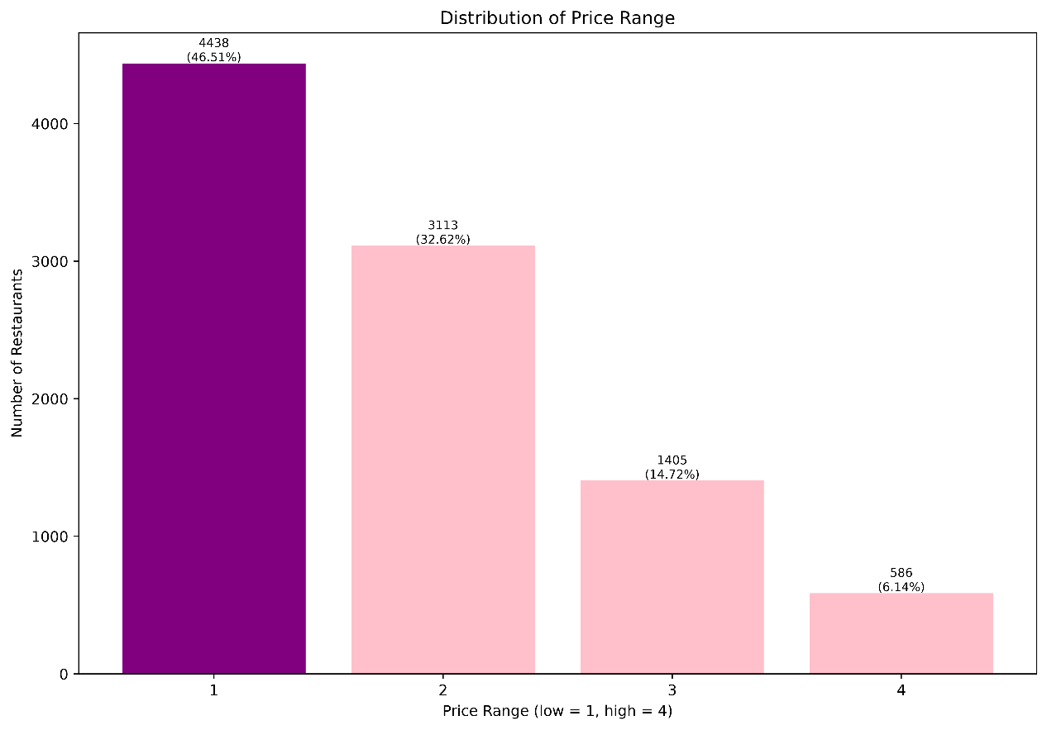
Figure 1.4 - Distribution of restaurants by price range (1 = lowest, 4 = highest)

Finding & Insights:
- Nearly half of all restaurants (46.51%) sit in price range 1, the cheapest tier.
- The count decreases steadily as price rises: 32.62% in range 2, 14.72% in range 3, and only 6.14% in range 4.
The market represented in this dataset is heavily weighted toward budget and mid-range dining, with premium establishments a distinct minority.

LEVEL 1 | TASK 4
TASK: Online Delivery
- Determine the percentage of restaurants that offer online delivery.
- Compare the average ratings of restaurants with and without online delivery.
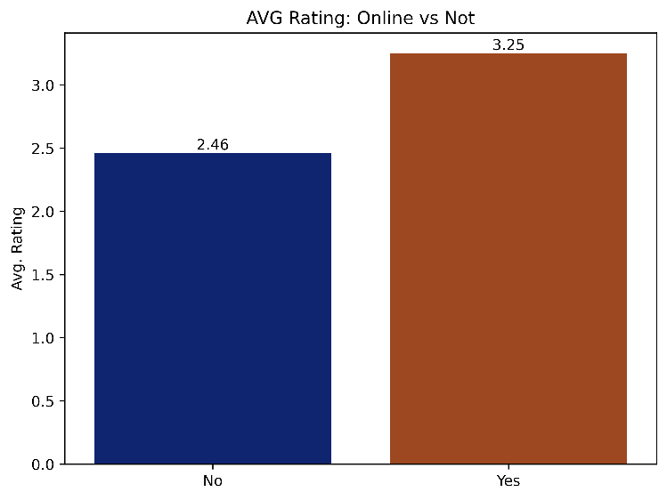
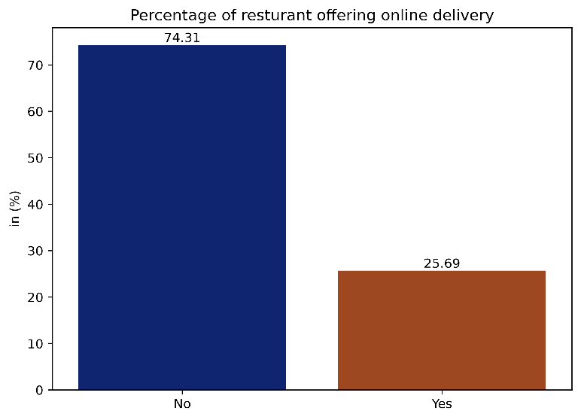

Figure 1.5 Percentage (%) of restaurant offering online delivery Figure 1.6 Average rating for restaurants without vs. with online delivery

Finding & Insights:
- Only 25.7% of restaurants offer online delivery.
- Restaurants that offer online delivery have a higher average rating (3.25) compared to those that do not (2.46), a difference of about 0.79 stars.
This is a correlation rather than a proven cause: it likely reflects that larger, better-resourced, and
more professionally run restaurants are both more likely to invest in delivery infrastructure and more likely
to be rated well, rather than delivery itself driving up ratings

Level 2: Intermediate Analysis
Level 2 digs deeper into rating behaviour, cuisine pairing patterns, spatial distribution, and the presence and
performance of restaurant chains.

LEVEL 2 | TASK 1
TASK: Restaurant Ratings
- Analyse the distribution of aggregate ratings and determine the most common rating range.
- Calculate the average number of votes received by restaurants.

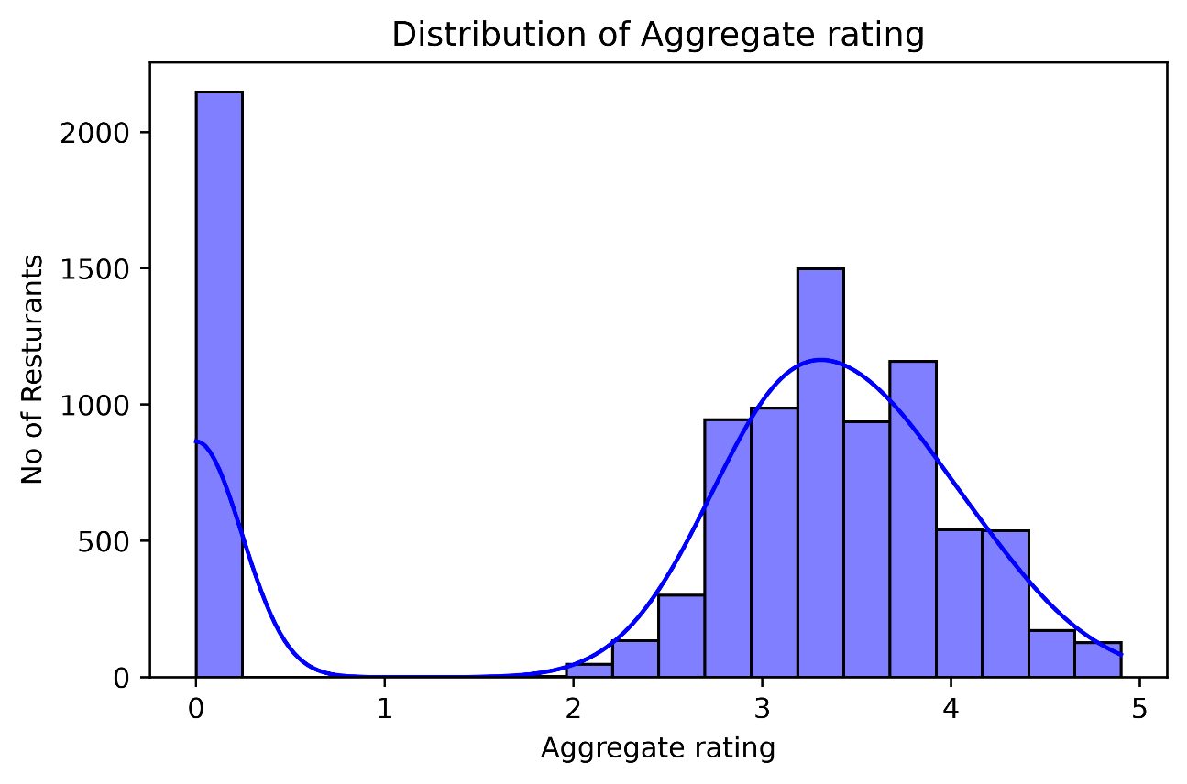
Figure 2.1 - Distribution of Aggregate rating

Finding & Insights:
- The most common rating band is 3.0-3.9, covering 4,583 restaurants (about 48% of the dataset).
- A large secondary group of 2,148 restaurants (22.5%) show a rating of 0, meaning they are 'Not rated’ they simply have not yet accumulated votes, rather than being poorly reviewed.
- Very few restaurants fall in the 1.0-1.9 range (just 3), indicating outright poor ratings are rare once restaurant has enough votes to be rated at all.
- The average number of votes per restaurant is 156.77.

LEVEL 2 | TASK 2
TASK: Cuisine Combinations
- Identify the most common combinations of cuisines in the dataset.
- Determine if certain cuisine combinations tend to have higher ratings.
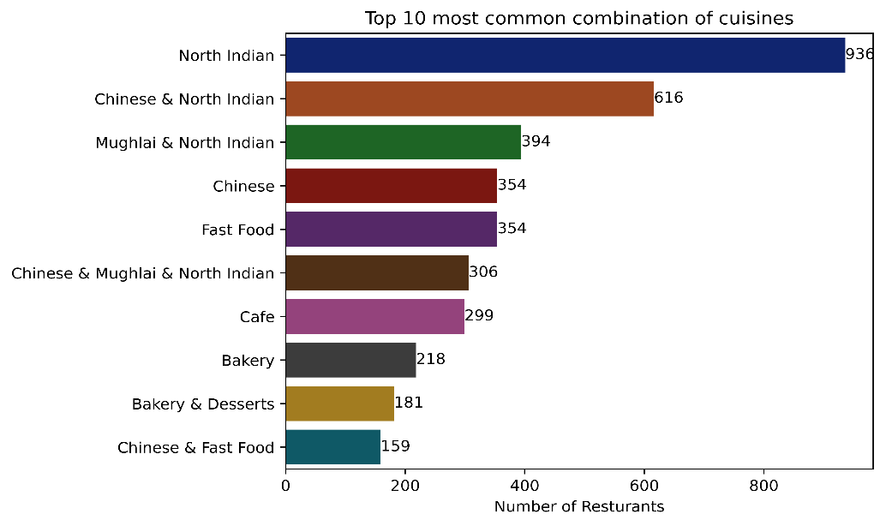
Figure 2.2 – Most common cuisines

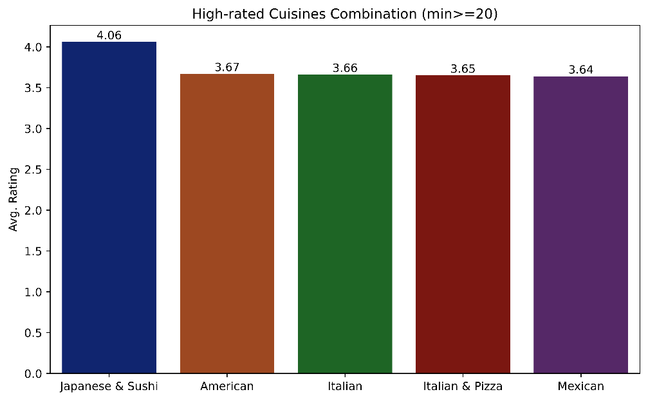
Figure 2.3 – High-rated Cuisines combination
Finding & Insights:
- Single-cuisine 'North Indian' listings are the single most common entry (936 restaurants), but the most common multi-cuisine combination is Chinese & North Indian (616 restaurants) - a very typical pairing on Indian restaurant menus.
- Restricting to combinations with at least 20 restaurants for reliability, Japanese & Sushi restaurants achieve the highest average rating (4.06), followed by American (3.67), Italian (3.66), Italian & Pizza (3.65), and Mexican (3.64).
Focused international cuisines tend to outrate the ubiquitous North Indian/Chinese combinations, possibly reflecting a smaller, more specialized, and more consistent group of restaurants serving them.

LEVEL 2 | TASK 3
TASK: Geographic Analysis
- Plot the locations of restaurants on a map using longitude and latitude coordinates.
- Identify any patterns or clusters of restaurants in specific areas.
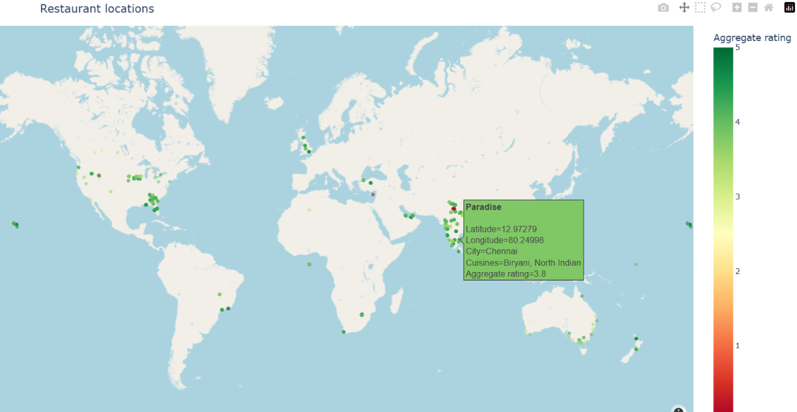
Figure 2.4 – Location of Restaurants on world map

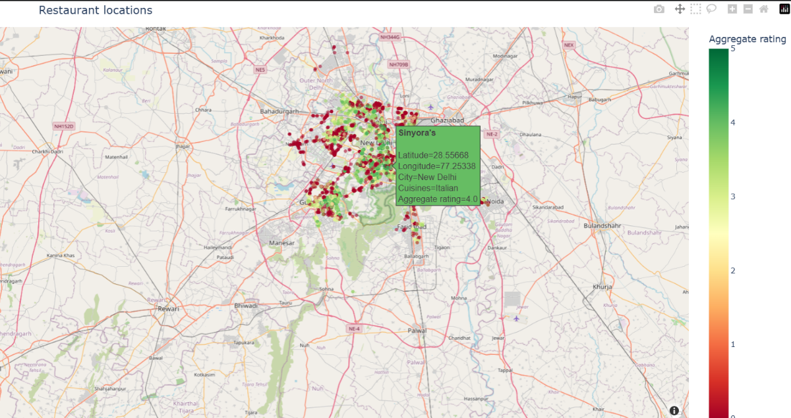
Figure 2.5 – Clustering of Restaurants in New Delhi
Finding & Insights:
- Restaurant locations cluster overwhelmingly around a single point at approximately 77.2°E, 28.6°N - the New Delhi/NCR region — with over 1,600.
Beyond this dense core, a much smaller number of restaurants are scattered across other global regions (the US, UK, UAE, Australia, and elsewhere), each forming their own small, sparse clusters. This confirms the dataset is heavily India-centric, with international restaurants forming a long, thin tail. No strong visual relationship is apparent between geographic location and rating (colours are well-mixed within the dense cluster)

LEVEL 2 | TASK 4
TASK: Restaurant Chains
- Identify if there are any restaurant chains present in the dataset.
- Analyse the ratings and popularity of different restaurant chains.

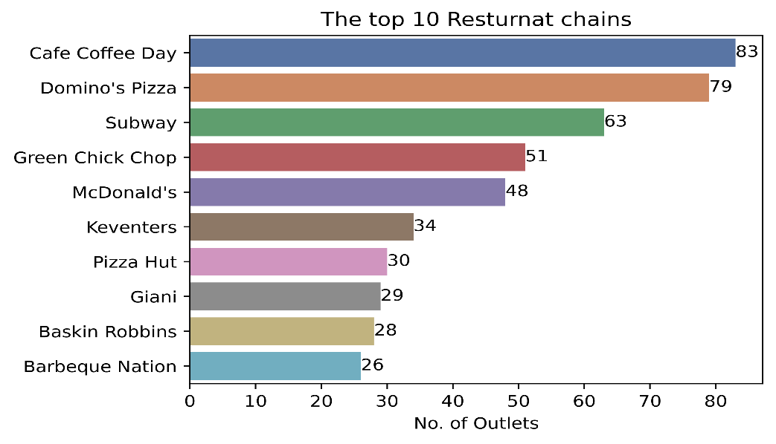
Figure 2.6 – Chains of top 10 restaurants

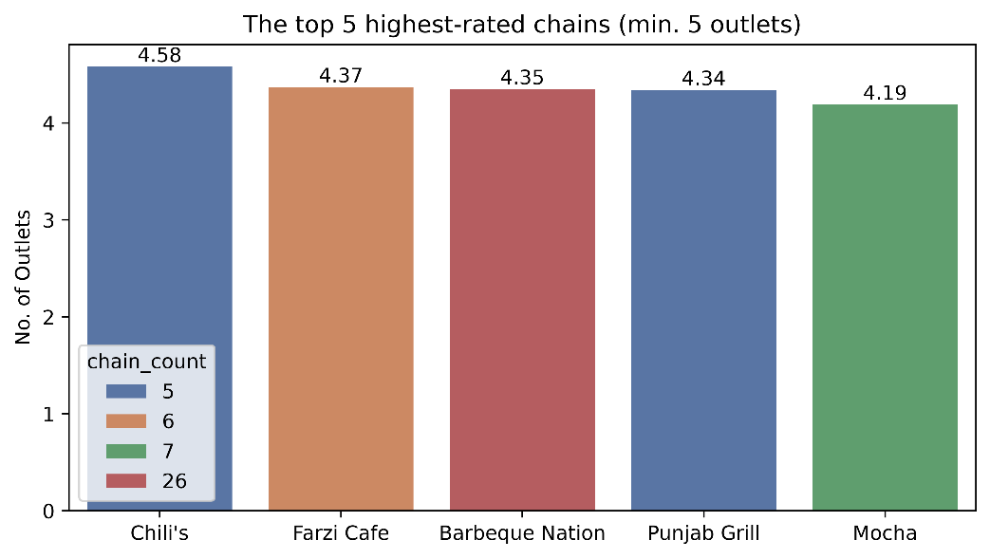
Figure 2.7 – Top high-rated chains

Finding & Insights:
- 734 restaurant names appear more than once in the dataset, indicating meaningful chain presence.
- Cafe Coffee Day (83 outlets), Domino's Pizza (79), and Subway (63) have the largest footprints - all quick-service or cafe-style chains suited to rapid expansion.
- However, footprint size does not track quality quite the opposite, in fact. The three largest chains all rate mediocre-to-poor: Café Coffee Day averages 2.42, Domino's Pizza 2.74, and Subway 2.91.
- Among chains with at least 5 outlets, Chili's (4.58), Farzi Cafe (4.37), and Barbeque Nation (4.35) have the highest average ratings instead - casual and family-dining chains clearly outperform the high-volume quick-service names on customer satisfaction.

Level 3: Advanced Analysis
Level 3 examines vote behaviour and the interplay between price positioning and the services a restaurant
chooses to offer.

LEVEL 3 | TASK 1
TASK: Restaurant Reviews
- Analyze the text reviews to identify the most common positive and negative keywords.
- Calculate the average length of reviews and explore if there is a relationship between review length and rating.

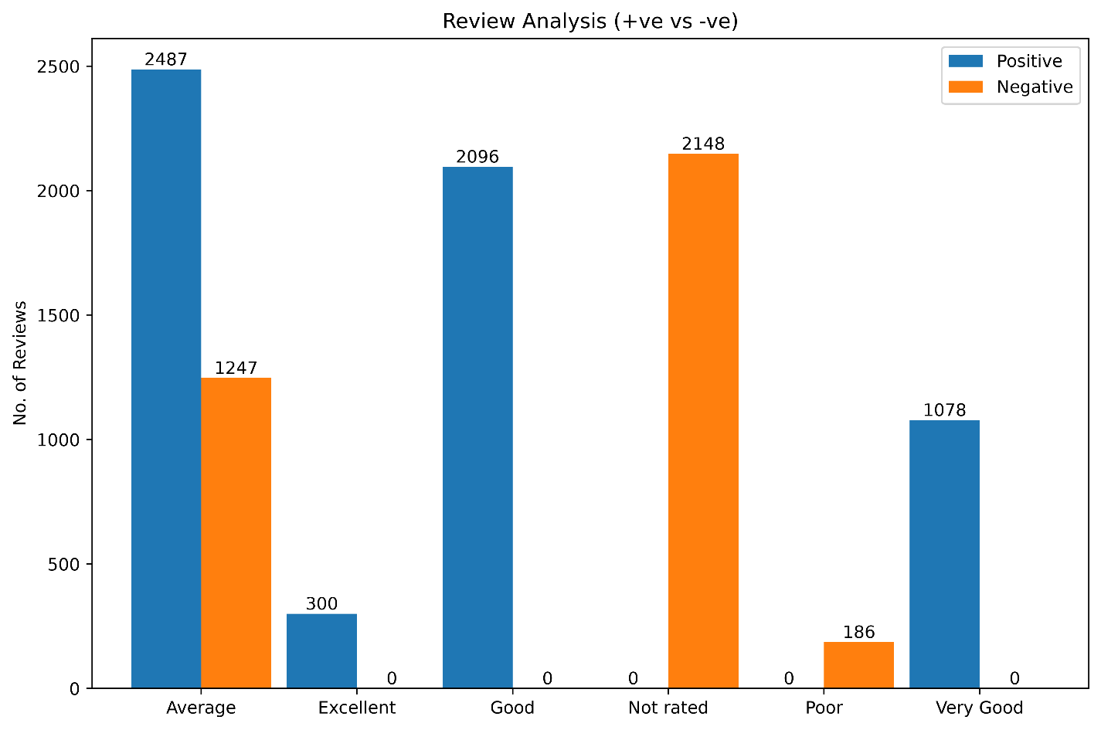
Figure 3.1 – Review Analysis

Finding & Insights:
- The Dataset has no specific column to analyse the review. But here, I am using Rating Text as the review.
- Most of the restaurants gained positive review concentrated more around average (2487), good (2096) followed by very good and excellent. However, the large number of Not Rated (2,148) restaurants suggests that many establishments have limited customer feedback and engagement.
- The correlation of -0.47 shows that there is a negative relationship between review length and rating means longer reviews associated with lower ratings

LEVEL 3 | TASK 2
TASK: Vote Analysis
- Identify the restaurants with the highest and lowest number of votes.
- Analyze if there is a correlation between the number of votes and the rating of a restaurant

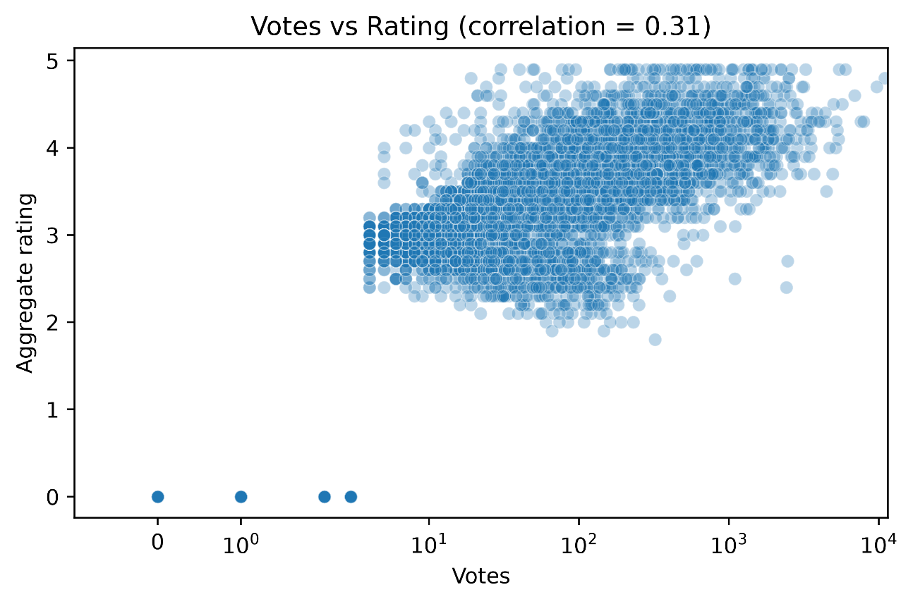
Figure 3.2 – Voting vs Rating

Finding & Insights:
- Toit, a brewery/restaurant in Bangalore, has the highest vote count in the dataset (10,934 votes) with a strong 4.8 rating.
- At the other end, a large number of restaurants (2,148, matching the 'Not rated' group from Level 2 Task 1) have 0 votes.
- The correlation between votes and rating is 0.31 — a weak-to-moderate positive relationship.
More-voted restaurants do tend to rate somewhat higher on average, but the relationship is far from deterministic: many highly rated restaurants have very few votes, and vote count alone is not a reliable predictor of quality.

LEVEL 3 | TASK 3
TASK: Price Range vs. Online Delivery and Table Booking
- Analyze if there is a relationship between price range and the availability of online delivery and table booking.
- Determine if higher-priced restaurants are more likely to offer these services.

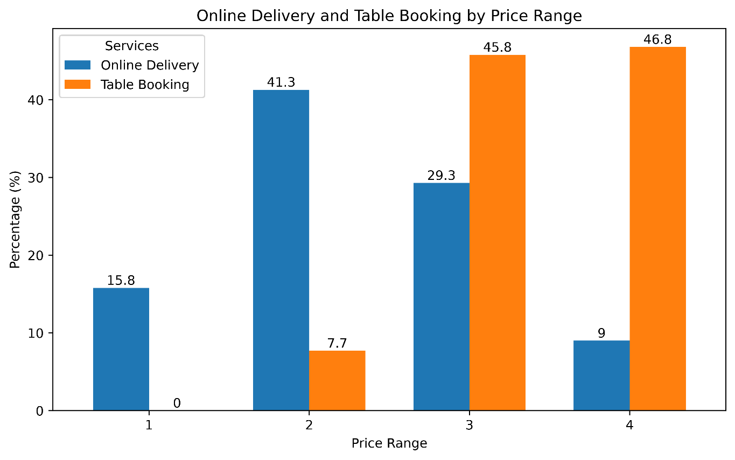
Figure 3.3 – Price Range vs. Online Delivery & Table Booking

Finding & Insights:
 | Online Delivery % | Table Booking %
Price Range
1 (low) | 15.8 | 0.0
2 | 41.3 | 7.7
3 | 29.2 | 45.7
4 (high) | 9.0 | 46.8

- The two services follow opposite trends as price increases.
- Table booking rises sharply and monotonically with price — from 0% at price range 1 up to 45.8% at range 3 and 46.8% at range 4 — consistent with reservations being a natural fit for higher-end, sit-down dining.
- Online delivery, by contrast, peaks in the middle of the price spectrum (41.3% at price range 2) and then drops sharply at the top (9.0% at price range 4).
In short: higher-priced restaurants are much more likely to offer table booking, but less likely to offer online delivery — the opposite of a simple 'more expensive means more services' pattern.

Conclusions
The dataset is heavily concentrated in New Delhi and North Indian/Chinese cuisine, so citywide or cuisine-wide comparisons should be read with that skew in mind - smaller cities and cuisines have far less data to average over.

- Popularity (restaurant count, chain size, vote count) and quality (rating) are related but distinct dimensions. The most common cuisines and the largest chains are not the highest-rated; specialized cuisines (Japanese & Sushi) and mid-size casual chains (Chili's, Farzi Cafe) punch above their weight on rating.

- Service offerings do not scale uniformly with price. Table booking is a clear marker of higher-end dining, but online delivery is most common among mid-priced restaurants and largely absent from fine dining likely reflecting the operational and brand fit of delivery for casual/fast dining versus a sit-down experience.

- Vote count is a weak proxy for quality (correlation of 0.31) and should not be used alone to judge a restaurant; a large share of the dataset (22.5%) has no votes at all yet.

- Restaurants offering online delivery rate meaningfully higher on average, which may be more a sign of overall restaurant investment/capability than a direct effect of delivery itself.

